Lab Sheet: Form Validation in ASP.NET Core MVC

Student details
Full name
Student number
Section
Date

Your unique values
Every student's work must be different. Fill in this table first, then use these exact values wherever a task says your name, your student number or your email.
What | Your value | Example
Your full name |  | Juan Dela Cruz
Your first name |  | Juan
Your last name, lowercase, no spaces |  | delacruz
Your student number, as YYYY-NNNN |  | 2026-0147
Your email |  | juan.delacruz@school.edu
Your repository name: school-app- + your last name |  | school-app-delacruz

If your real student number doesn't have the form YYYY-NNNN, use your enrollment year, a dash, and the last 4 digits of your student number.

How to complete and submit
1. Do the tasks in order. Each one builds on the one before it.
2. Type every command in the Codespace Terminal. To run the app type dotnet run; to stop it, click the Terminal and press Ctrl+C.
3. Fill in every Answer box with exactly what you see on your screen.
4. Take every Screenshot listed. Your name must be visible in each one: you add it to the menu bar in Task 0.
5. At the end (Task 10), push your code to GitHub and submit this sheet, your screenshots and your repository link to the LMS.
Your work is checked against your unique values. A screenshot or answer without your own name, student number or email does not count.

Task 0: Set up the project
0.1 Open a Codespace
1. Go to github.com and sign in.
2. Click + (top right) > New repository.
3. Repository name: your repository name (for example school-app-delacruz). Tick Add a README file and click Create repository.
4. Click the green Code button > Codespaces tab > Create codespace on main. Wait until VS Code opens with a Terminal at the bottom.
5. In the Terminal, type:
dotnet --version

0.2 Create the MVC project
dotnet new mvc -o SchoolApp
cd SchoolApp
dotnet new gitignore

From now on, type every command inside the SchoolApp folder. After a restart, type cd SchoolApp first.
0.3 Install the tools and packages (one line at a time)
dotnet tool install --global dotnet-ef
dotnet tool install --global dotnet-aspnet-codegenerator

dotnet add package Microsoft.EntityFrameworkCore.Sqlite
dotnet add package Microsoft.EntityFrameworkCore.SqlServer
dotnet add package Microsoft.EntityFrameworkCore.Design
dotnet add package Microsoft.EntityFrameworkCore.Tools
dotnet add package Microsoft.VisualStudio.Web.CodeGeneration.Design

0.4 Add the Student model
In the Explorer, right-click SchoolApp > Models > New File..., name it Student.cs, paste this code and press Ctrl+S.
📄 Models/Student.cs
namespace SchoolApp.Models
{
public class Student
{
// The primary key. The database numbers each student by itself.
public int StudentId { get; set; }

// The ? means "this field may be empty". No rules yet.
public string? StudentNo { get; set; }
public string? Name { get; set; }
public string? Email { get; set; }
public string? Phone { get; set; }
public int? Age { get; set; }
public DateTime? BirthDate { get; set; }
}
}

0.5 Generate the controller and pages (the second command is one long line)
dotnet build

dotnet aspnet-codegenerator controller -name StudentsController -m Student -dc SchoolApp.Data.SchoolAppContext --relativeFolderPath Controllers --useDefaultLayout --referenceScriptLibraries --databaseProvider sqlite

0.6 Create the database
dotnet ef migrations add InitialCreate
dotnet ef database update

0.7 Put your name in the menu bar
📄 Views/Shared/_Layout.cshtml
1. Find this line:
<a class="navbar-brand" asp-area="" asp-controller="Home" asp-action="Index">SchoolApp</a>

2. Change the text SchoolApp to SchoolApp - followed by your full name:
<a class="navbar-brand" asp-area="" asp-controller="Home" asp-action="Index">SchoolApp - Juan Dela Cruz</a>

3. Find the <li> for Privacy and add this right under it:
<li class="nav-item">
<a class="nav-link text-dark" asp-controller="Students" asp-action="Index">Students</a>
</li>

0.8 Run the app
dotnet run

Click Open in Browser in the pop-up (or Ports tab > globe icon), then click Students in the menu.
Answer
Question | Your answer
What did dotnet --version print? | 10.0.401
What is the full web address of your Students page? | https://supernatural-cauldron-qv6gpq4qrp7x2xj45-5035.app.github.dev/Students/Create
What text is in the menu bar at the top left? | SchoolApp - Ezekiel Evangelista

Screenshot 0: the Students page, showing your name in the menu bar and the address bar.
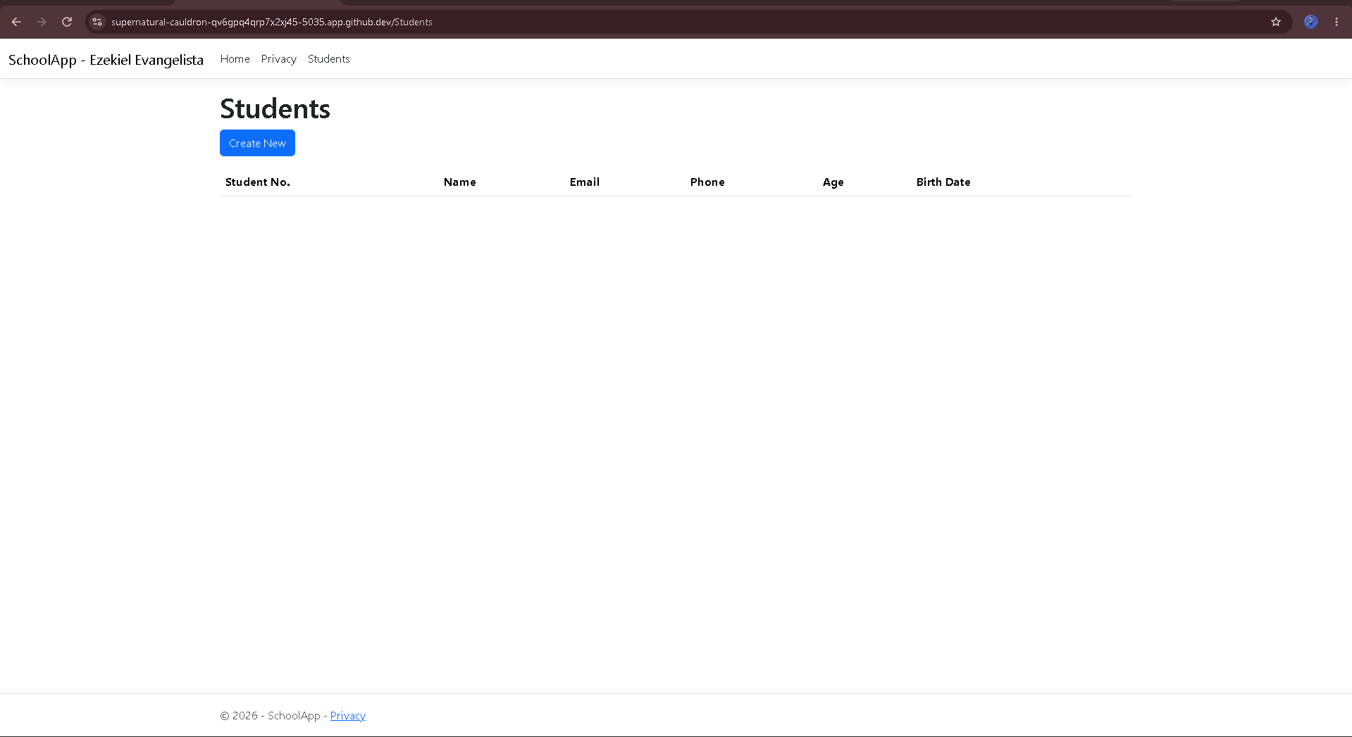
If something goes wrong:
- command not found: run export PATH="$PATH:$HOME/.dotnet/tools" and try again.
- NU1202 ... not compatible: add --version 8.* (use the first number from dotnet --version) to the failing dotnet add package or dotnet tool install line.
- Could not find project: type cd SchoolApp.
- 502 Bad Gateway in the browser: wait a few seconds and refresh.

Task 1: See the problem
1. Run the app and open Students > Create New.
2. Type only your first name in Name. Leave every other field empty. Click Create.
3. Click Create New again. Type hello for Email and 500 for Age. Leave the rest empty. Click Create.
Answer
Question | Your answer
Were both students saved? (Yes / No) | yes
How many rows does the Students list show now? | 2

Screenshot 1: the Students list with both bad rows. Keep these rows until Task 5.
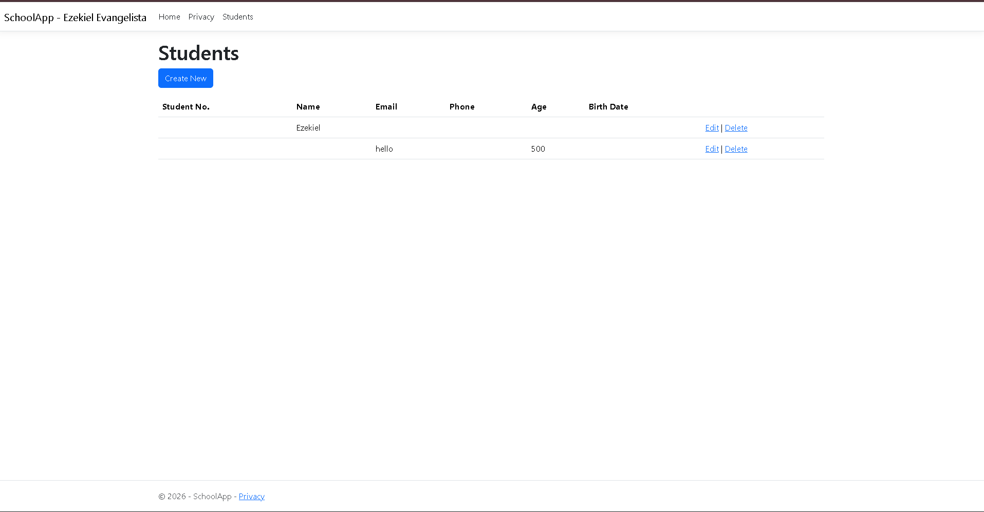

Task 2: Required fields and maximum length
📄 Models/Student.cs
1. Add this line at the very top, above namespace:
using System.ComponentModel.DataAnnotations;

2. Replace the Name line with:
// [Required]: must not be empty
[Required]
// [StringLength(100)]: at most 100 characters
[StringLength(100)]
public string? Name { get; set; }

3. Save, stop the app (Ctrl+C) and run it again (dotnet run).
4. Open Create New, leave Name empty, and click Create.
5. Try to type more than 100 characters in Name.
Answer
Question | Your answer
What message appeared under Name when it was empty? | The name field is required.
Was the student saved? (Yes / No) | no
What happened when you typed more than 100 characters? | nothing
In StudentsController.cs, which line decides whether the student is saved? (copy it) | if (ModelState.IsValid)

Screenshot 2: the Create page with the red message under Name, with your name in the menu bar.
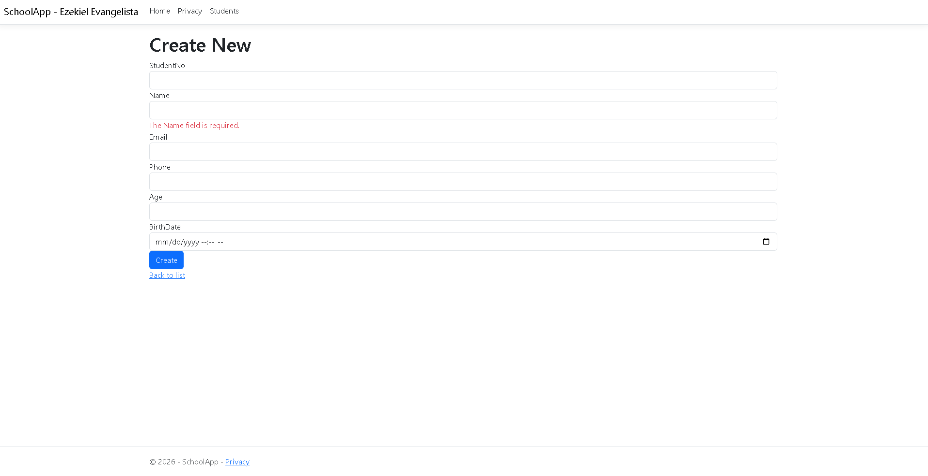

Task 3: Format checks for email, phone and age
📄 Models/Student.cs: replace the Email, Phone and Age lines with:
// [Required] + [EmailAddress]: must be given and must look like an email
[Required]
[EmailAddress]
public string? Email { get; set; }

// [Phone]: must look like a phone number (optional)
[Phone]
public string? Phone { get; set; }

// [Range(16, 60)]: the number must be from 16 to 60
[Range(16, 60)]
public int? Age { get; set; }

Save, stop the app and run it again. Open Create New and type each value below, then click Create. Write the exact message you see.
Answer
Field | Type this | Message you saw
Email | (leave empty) | The Email field is not a valid e-mail address.
Email | your first name, lowercase, with no @ | The Email field is not a valid e-mail address.
Phone | abc | nothing
Age | 500 | The field Age must be between 16 and 60.
Age | 15 | The field Age must be between 16 and 60.
Age | your real age | nothing

Question | Your answer
Which message appeared only after the page reloaded? | The Phone field is not a valid phone number.

Now add yourself. Create a student with your full name, your email, and your real age. Leave Student No empty for now. Click Create.
Screenshot 3: the Students list showing your own row.
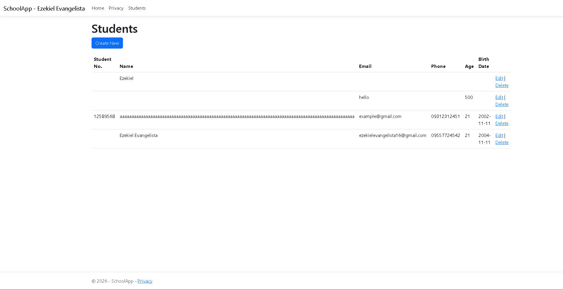

Task 4: Your own messages and labels
📄 Models/Student.cs: replace the Name, Email, Phone and Age blocks with the code below.
Unique task: in the Name message, replace Juan with your first name.
// [Display(Name = ...)]: the label shown on the form
[Display(Name = "Full Name")]
// ErrorMessage: your own message. Put YOUR first name after the dash.
[Required(ErrorMessage = "Please enter the student's name. - Juan")]
[StringLength(100, ErrorMessage = "The name can't be longer than 100 characters.")]
public string? Name { get; set; }

[Display(Name = "Email Address")]
[Required(ErrorMessage = "Please enter an email address.")]
[EmailAddress(ErrorMessage = "Please enter a valid email, like ana@example.com.")]
public string? Email { get; set; }

[Display(Name = "Phone Number")]
[Phone(ErrorMessage = "Please enter a valid phone number.")]
public string? Phone { get; set; }

[Range(16, 60, ErrorMessage = "Age must be from 16 to 60.")]
public int? Age { get; set; }

Save, stop the app and run it again. Open Create New, leave everything empty and click Create.
Answer
Question | Your answer
What label is shown above the first name box now? | Full Name
Copy the message shown under Full Name | Please enter the student's name. - Ezekiel
Copy the message shown under Email Address | Please enter an email address.

Screenshot 4: the Create page showing your own Name message with your first name.
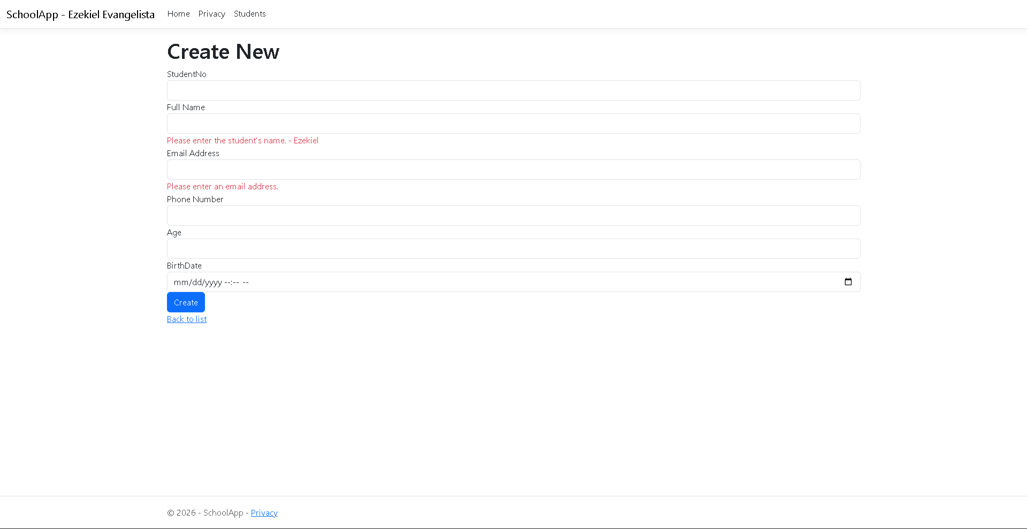

Task 5: A pattern for the student number
📄 Models/Student.cs: replace the StudentNo line with:
[Display(Name = "Student No.")]
[Required(ErrorMessage = "Please enter the student number.")]
// ^ start, \d{4} four digits, - a dash, \d{4} four digits, $ end
[RegularExpression(@"^\d{4}-\d{4}$", ErrorMessage = "Use the format 2026-0001.")]
public string? StudentNo { get; set; }

Save, stop the app and run it again. Open Create New and test:
Answer
Type this in Student No. | Message you saw
26-1 | Use the format 2026-0001.
your student number without the dash | Use the format 2026-0001.
your student number (YYYY-NNNN) | nothing

5.1 Clean up and update the database
1. In the Students list, delete the two bad rows from Task 1.
2. Edit your own row: type your student number in Student No. and click Save.
3. Stop the app and run:
dotnet ef migrations add AddValidationRules
dotnet ef database update

Answer
Question | Your answer
What did the last line of dotnet ef database update say? | The name 'AddValidationRules' is used by an existing migration.
How many rows are in the Students list now? | 2

If it fails with NOT NULL constraint failed: a row still has an empty required field. Fix or delete it in the app, then run dotnet ef database update again.

Task 6: Confirm the email
6.1 📄 Models/Student.cs
Add this line under the first using line:
using System.ComponentModel.DataAnnotations.Schema;

Add this right after the Email property:
[Display(Name = "Confirm Email")]
[Required(ErrorMessage = "Please type the email again.")]
// [NotMapped]: form only, not saved as a column
[NotMapped]
// [Compare("Email")]: must be exactly the same as Email
[Compare("Email", ErrorMessage = "Emails do not match.")]
public string? ConfirmEmail { get; set; }

6.2 📄 Controllers/StudentsController.cs: add ConfirmEmail to [Bind(...)] in both POST methods.
public async Task<IActionResult> Create([Bind("StudentId,StudentNo,Name,Email,ConfirmEmail,Phone,Age,BirthDate")] Student student)

public async Task<IActionResult> Edit(int id, [Bind("StudentId,StudentNo,Name,Email,ConfirmEmail,Phone,Age,BirthDate")] Student student)

6.3 📄 Views/Students/Create.cshtml and 📄 Views/Students/Edit.cshtml: add this right under the Email form-group, in both files:
<div class="form-group">
<label asp-for="ConfirmEmail" class="control-label"></label>
<input asp-for="ConfirmEmail" class="form-control" />
<span asp-validation-for="ConfirmEmail" class="text-danger"></span>
</div>

Save, stop the app and run it again. Open Create New.
Answer
Test | Message you saw
Email = your email, Confirm Email = your email with one letter changed | Emails do not match.
Email and Confirm Email both = your email (fill in the other required fields too) | no error, and the student is saved.

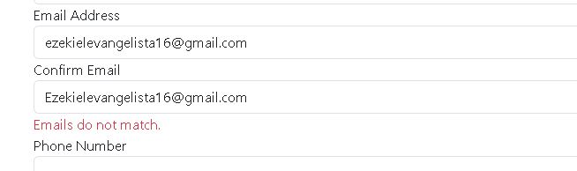Task 7: Browser messages on and off
📄 Views/Students/Create.cshtml: find this at the very bottom:
@section Scripts {
@{await Html.RenderPartialAsync("_ValidationScriptsPartial");}
}

1. Turn the scripts off by wrapping the middle line in @* ... *@:
@section Scripts {
@* @{await Html.RenderPartialAsync("_ValidationScriptsPartial");} *@
}

2. Save, stop the app and run it again. Open Create New, leave Full Name empty, and click Create.
3. Turn the scripts back on: remove the @* and *@ you added. Save and run again.
Answer
Question | Your answer
With the scripts off, did the page reload before the message appeared? (Yes / No) | yes
With the scripts off, was the student saved? (Yes / No) | no
What does this prove about server-side validation? (one sentence) | Even when the browser’s checks are turned off, the server still checks the rules and rejects invalid data before it’s saved.

Task 8: Your own rule: no birth dates in the future
8.1 In the Explorer, right-click SchoolApp > New Folder... and name it Validation. Right-click Validation > New File... and name it NotFutureDateAttribute.cs. Paste this code and save.
📄 Validation/NotFutureDateAttribute.cs
using System.ComponentModel.DataAnnotations;

namespace SchoolApp.Validation
{
// Our own rule. It inherits from ValidationAttribute, like [Required] does.
public class NotFutureDateAttribute : ValidationAttribute
{
// Runs on the server when the form is saved; value = what the user entered
protected override ValidationResult? IsValid(object? value, ValidationContext validationContext)
{
// A date later than today fails the rule
if (value is DateTime date && date.Date > DateTime.Today)
{
return new ValidationResult(ErrorMessage ?? "The date can't be in the future.");
}

// Anything else passes (an empty date too)
return ValidationResult.Success;
}
}
}

8.2 📄 Models/Student.cs: add this with the other using lines:
using SchoolApp.Validation;

Replace the BirthDate line with:
[Display(Name = "Birth Date")]
// Shows a date picker without the time
[DataType(DataType.Date)]
// Our custom rule from Validation/NotFutureDateAttribute.cs
[NotFutureDate(ErrorMessage = "Birth date can't be in the future.")]
public DateTime? BirthDate { get; set; }

Save, stop the app and run it again.
Answer
Test | Message you saw
Create New with Birth Date = tomorrow | Birth date can't be in the future.
Edit your own row: Birth Date = your real birthday, then Save (type your email in Confirm Email too) | none. Your real birthday is in the past, so the NotFutureDate rule passes, and the row saves.

Question | Your answer
Did the birth date message appear before or after the page reloaded? | after

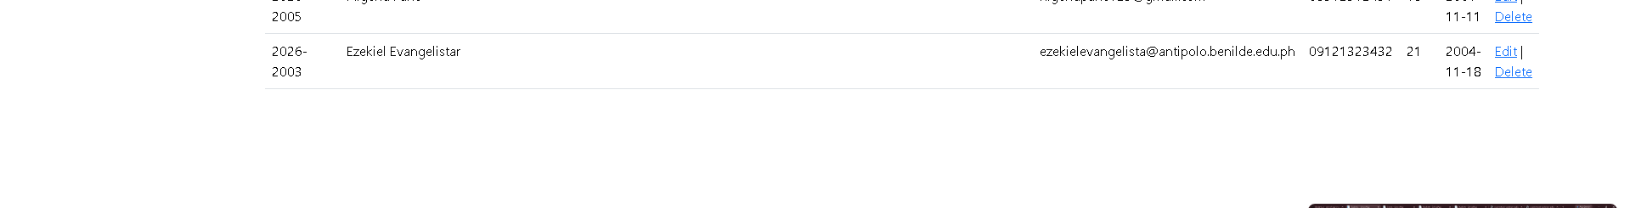.

Task 9: Email already used
📄 Controllers/StudentsController.cs
9.1 In the [HttpPost] Create method, add this above if (ModelState.IsValid):
// Is there already a student with this email?
if (await _context.Student.AnyAsync(s => s.Email == student.Email))
{
// Put an error on Email; the student is not saved
ModelState.AddModelError("Email", "This email is already registered.");
}

9.2 In the [HttpPost] Edit method, add this right after the if (id != student.StudentId) check:
This email is already registered.
Save, stop the app and run it again. Open Create New and fill in every field correctly, using your email in Email and Confirm Email. Click Create.
Answer
Question | Your answer
What message appeared under Email Address? | This email is already registered.
Was the student saved? (Yes / No) | no
Change only the email to a new one and click Create. What happened? | created

If you see 'SchoolAppContext' does not contain a definition for 'Student': open Data/SchoolAppContext.cs, check the name after DbSet<...>, and use that name instead of Student.

Task 10: Save your work to GitHub
Stop the app (Ctrl+C), then type these lines one at a time. In the commit line, replace Juan Dela Cruz with your full name.
git add .
git commit -m "Form validation lab - Juan Dela Cruz"
git push

Open your repository on github.com and refresh the page.
Answer
Question | Your answer
Your repository link (for example https://github.com/yourusername/school-app-delacruz) | https://github.com/yalesta420/school-app-evangelista
The commit message shown on GitHub | git commit -m "Form validation lab - Ezekiel Evangelista"  git[main 195e024] Form validation lab - Ezekiel Evangelista  99 files changed, 84364 insertions(+)  create mode 100644 SchoolApp/.gitignore  create mode 100644 SchoolApp/Controllers/HomeController.cs  create mode 100644 SchoolApp/Controllers/StudentsController.cs  create mode 100644 SchoolApp/Data/SchoolAppContext.cs  create mode 100644 SchoolApp/Migrations/20261101022149_InitialCreate.Designer.cs  create mode 100644 SchoolApp/Migrations/20261101022149_InitialCreate.cs  create mode 100644 SchoolApp/Migrations/20261101022804_AddValidationRules.Designer.cs  create mode 100644 SchoolApp/Migrations/20261101022804_AddValidationRules.cs  create mode 100644 SchoolApp/Migrations/20261101023335_AddFormatRules.Designer.cs  create mode 100644 SchoolApp/Migrations/20261101023335_AddFormatRules.cs  create mode 100644 SchoolApp/Migrations/20261101024853_AddStudentNoPattern.Designer.cs  create mode 100644 SchoolApp/Migrations/20261101024853_AddStudentNoPattern.cs  create mode 100644 SchoolApp/Migrations/20261104123423_AddConfirmEmail.Designer.cs  create mode 100644 SchoolApp/Migrations/20261104123423_AddConfirmEmail.cs  create mode 100644 SchoolApp/Migrations/SchoolAppContextModelSnapshot.cs  create mode 100644 SchoolApp/Models/ErrorViewModel.cs  create mode 100644 SchoolApp/Models/Student.cs  create mode 100644 SchoolApp/Program.cs  create mode 100644 SchoolApp/Properties/launchSettings.json  create mode 100644 SchoolApp/SchoolApp.csproj  create mode 100644 SchoolApp/Validation/NotFutureDateAttribute.cs  create mode 100644 SchoolApp/Views/Home/Index.cshtml  create mode 100644 SchoolApp/Views/Home/Privacy.cshtml  create mode 100644 SchoolApp/Views/Shared/Error.cshtml  create mode 100644 SchoolApp/Views/Shared/_Layout.cshtml  create mode 100644 SchoolApp/Views/Shared/_Layout.cshtml.css  create mode 100644 SchoolApp/Views/Shared/_ValidationScriptsPartial.cshtml  create mode 100644 SchoolApp/Views/Students/Create.cshtml  create mode 100644 SchoolApp/Views/Students/Delete.cshtml  create mode 100644 SchoolApp/Views/Students/Edit.cshtml  create mode 100644 SchoolApp/Views/Students/Index.cshtml  create mode 100644 SchoolApp/Views/_ViewImports.cshtml  create mode 100644 SchoolApp/Views/_ViewStart.cshtml  create mode 100644 SchoolApp/appsettings.Development.json  create mode 100644 SchoolApp/appsettings.json  create mode 100644 SchoolApp/school.db  create mode 100644 SchoolApp/wwwroot/css/site.css  create mode 100644 SchoolApp/wwwroot/favicon.ico  create mode 100644 SchoolApp/wwwroot/js/site.js  create mode 100644 SchoolApp/wwwroot/lib/bootstrap/LICENSE  create mode 100644 SchoolApp/wwwroot/lib/bootstrap/dist/css/bootstrap-grid.css  create mode 100644 SchoolApp/wwwroot/lib/bootstrap/dist/css/bootstrap-grid.css.map  create mode 100644 SchoolApp/wwwroot/lib/bootstrap/dist/css/bootstrap-grid.min.css  create mode 100644 SchoolApp/wwwroot/lib/bootstrap/dist/css/bootstrap-grid.min.css.map  create mode 100644 SchoolApp/wwwroot/lib/bootstrap/dist/css/bootstrap-grid.rtl.css  create mode 100644 SchoolApp/wwwroot/lib/bootstrap/dist/css/bootstrap-grid.rtl.css.map  create mode 100644 SchoolApp/wwwroot/lib/bootstrap/dist/css/bootstrap-grid.rtl.min.css  create mode 100644 SchoolApp/wwwroot/lib/bootstrap/dist/css/bootstrap-grid.rtl.min.css.map  create mode 100644 SchoolApp/wwwroot/lib/bootstrap/dist/css/bootstrap-reboot.css  create mode 100644 SchoolApp/wwwroot/lib/bootstrap/dist/css/bootstrap-reboot.css.map  create mode 100644 SchoolApp/wwwroot/lib/bootstrap/dist/css/bootstrap-reboot.min.css  create mode 100644 SchoolApp/wwwroot/lib/bootstrap/dist/css/bootstrap-reboot.min.css.map  create mode 100644 SchoolApp/wwwroot/lib/bootstrap/dist/css/bootstrap-reboot.rtl.css  create mode 100644 SchoolApp/wwwroot/lib/bootstrap/dist/css/bootstrap-reboot.rtl.css.map  create mode 100644 SchoolApp/wwwroot/lib/bootstrap/dist/css/bootstrap-reboot.rtl.min.css  create mode 100644 SchoolApp/wwwroot/lib/bootstrap/dist/css/bootstrap-reboot.rtl.min.css.map  create mode 100644 SchoolApp/wwwroot/lib/bootstrap/dist/css/bootstrap-utilities.css  create mode 100644 SchoolApp/wwwroot/lib/bootstrap/dist/css/bootstrap-utilities.css.map  create mode 100644 SchoolApp/wwwroot/lib/bootstrap/dist/css/bootstrap-utilities.min.css  create mode 100644 SchoolApp/wwwroot/lib/bootstrap/dist/css/bootstrap-utilities.min.css.map  create mode 100644 SchoolApp/wwwroot/lib/bootstrap/dist/css/bootstrap-utilities.rtl.css  create mode 100644 SchoolApp/wwwroot/lib/bootstrap/dist/css/bootstrap-utilities.rtl.css.map  create mode 100644 SchoolApp/wwwroot/lib/bootstrap/dist/css/bootstrap-utilities.rtl.min.css  create mode 100644 SchoolApp/wwwroot/lib/bootstrap/dist/css/bootstrap-utilities.rtl.min.css.map  create mode 100644 SchoolApp/wwwroot/lib/bootstrap/dist/css/bootstrap.css  create mode 100644 SchoolApp/wwwroot/lib/bootstrap/dist/css/bootstrap.css.map  create mode 100644 SchoolApp/wwwroot/lib/bootstrap/dist/css/bootstrap.min.css  create mode 100644 SchoolApp/wwwroot/lib/bootstrap/dist/css/bootstrap.min.css.map  create mode 100644 SchoolApp/wwwroot/lib/bootstrap/dist/css/bootstrap.rtl.css  create mode 100644 SchoolApp/wwwroot/lib/bootstrap/dist/css/bootstrap.rtl.css.map  create mode 100644 SchoolApp/wwwroot/lib/bootstrap/dist/css/bootstrap.rtl.min.css  create mode 100644 SchoolApp/wwwroot/lib/bootstrap/dist/css/bootstrap.rtl.min.css.map  create mode 100644 SchoolApp/wwwroot/lib/bootstrap/dist/js/bootstrap.bundle.js  create mode 100644 SchoolApp/wwwroot/lib/bootstrap/dist/js/bootstrap.bundle.js.map  create mode 100644 SchoolApp/wwwroot/lib/bootstrap/dist/js/bootstrap.bundle.min.js  create mode 100644 SchoolApp/wwwroot/lib/bootstrap/dist/js/bootstrap.bundle.min.js.map  create mode 100644 SchoolApp/wwwroot/lib/bootstrap/dist/js/bootstrap.esm.js  create mode 100644 SchoolApp/wwwroot/lib/bootstrap/dist/js/bootstrap.esm.js.map  create mode 100644 SchoolApp/wwwroot/lib/bootstrap/dist/js/bootstrap.esm.min.js  create mode 100644 SchoolApp/wwwroot/lib/bootstrap/dist/js/bootstrap.esm.min.js.map  create mode 100644 SchoolApp/wwwroot/lib/bootstrap/dist/js/bootstrap.js  create mode 100644 SchoolApp/wwwroot/lib/bootstrap/dist/js/bootstrap.js.map  create mode 100644 SchoolApp/wwwroot/lib/bootstrap/dist/js/bootstrap.min.js  create mode 100644 SchoolApp/wwwroot/lib/bootstrap/dist/js/bootstrap.min.js.map  create mode 100644 SchoolApp/wwwroot/lib/jquery-validation-unobtrusive/LICENSE.txt  create mode 100644 SchoolApp/wwwroot/lib/jquery-validation-unobtrusive/dist/jquery.validate.unobtrusive.js  create mode 100644 SchoolApp/wwwroot/lib/jquery-validation-unobtrusive/dist/jquery.validate.unobtrusive.min.js  create mode 100644 SchoolApp/wwwroot/lib/jquery-validation/LICENSE.md  create mode 100644 SchoolApp/wwwroot/lib/jquery-validation/dist/additional-methods.js  create mode 100644 SchoolApp/wwwroot/lib/jquery-validation/dist/additional-methods.min.js  create mode 100644 SchoolApp/wwwroot/lib/jquery-validation/dist/jquery.validate.js  create mode 100644 SchoolApp/wwwroot/lib/jquery-validation/dist/jquery.validate.min.js  create mode 100644 SchoolApp/wwwroot/lib/jquery/LICENSE.txt  create mode 100644 SchoolApp/wwwroot/lib/jquery/dist/jquery.js  create mode 100644 SchoolApp/wwwroot/lib/jquery/dist/jquery.min.js  create mode 100644 SchoolApp/wwwroot/lib/jquery/dist/jquery.min.map  create mode 100644 SchoolApp/wwwroot/lib/jquery/dist/jquery.slim.js  create mode 100644 SchoolApp/wwwroot/lib/jquery/dist/jquery.slim.min.js  create mode 100644 SchoolApp/wwwroot/lib/jquery/dist/jquery.slim.min.map

Screenshot 8: your repository page on GitHub, showing your commit message.

Submission checklist
Tick each item before you submit to the LMS.
☐ Student details and Your unique values are filled in
☐ Every Answer box in Tasks 0 to 10 is filled in
☐ Screenshots 0 to 8 are attached, and your name is visible in each one
☐ The menu bar shows SchoolApp - + your full name
☐ The Full Name message ends with your first name (Task 4)
☐ Your own row is in the Students list with your student number, email and real birth date
☐ Your code is pushed to GitHub, and the repository link is in Task 10

What your teacher will check
Check | Where
Your full name in the menu bar | Views/Shared/_Layout.cshtml in your repository, and every screenshot
Your first name in the Name message | Models/Student.cs in your repository, and Screenshot 4
All 9 kinds of rules are in the model | Models/Student.cs and Validation/NotFutureDateAttribute.cs
The email check is in both Create and Edit | Controllers/StudentsController.cs
Your answers match your screenshots | This sheet
The commit has your full name | Your repository's commit history

