Munazzim Intelligent Productivity Platform

Intelligent Productivity and Time Management Platform

Technology Readiness Level 1 (TRL 1)

Project Team
Name | Contribution
Prof. Hatem Abu Humaid | Scientific Group Leader
Eng. Yousef Aljaser | Principal Developer
Eng. Bader Aldeham | Contributor Developer
Eng. Abdullah Alkhateeb | Contributor Developer

TRL 1 Evidence Report

NASA TRL 1 Definition
Technology Readiness Level 1 (TRL 1) represents the initial stage of technology maturation, where fundamental scientific principles and theoretical concepts are identified, investigated, documented, and analyzed. The objective of this stage is to establish a comprehensive understanding of the problem domain, evaluate relevant scientific knowledge, identify potential technological approaches, and provide the foundational knowledge required for future research, development, and technology validation activities.

تعريف مستوى الجاهزية التقنية الأول
يمثل مستوى الجاهزية التقنية الأول المرحلة الأولى من مراحل تطوير التقنية، حيث يتم التعرف على المبادئ العلمية الأساسية والمفاهيم النظرية ودراستها وتحليلها وتوثيقها بشكل منهجي. ويهدف هذا المستوى إلى بناء فهم شامل للمشكلة أو الحاجة المستهدفة، وتقييم المعارف العلمية ذات العلاقة، واستكشاف الحلول التقنية المحتملة، ووضع الأساس العلمي والمعرفي اللازم لمراحل التطوير والتحقق التقني اللاحقة

TRL 1 Requirement Compliance Matrix
NASA TRL 1 Requirement | Achieved in Munazzim | Status
Basic principles observed and reported | Productivity management challenges and AI-assisted scheduling concepts documented. | Achieved
Problem domain investigated | Scheduling inefficiencies and task prioritization challenges analyzed. | Achieved
Technology concept formulated | Munazzim intelligent productivity ecosystem concept defined. | Achieved
Potential applications identified | Personal productivity, scheduling, task management, and AI-assisted planning identified. | Achieved
Initial technical feasibility considered | Next.js, Firebase Firestore, and Large Language Model (LLM) technologies evaluated. | Achieved

Keywords
Artificial Intelligence (AI), Productivity Management, Intelligent Scheduling, Task Prioritization, Large Language Models (LLMs), Human–Computer Interaction, Time Management Systems, Firebase Firestore, Cloud Computing, Next.js Framework, Digital Productivity Ecosystems, Intelligent Planning.

Research Metrics
Metric | Value
Development Frameworks Evaluated | 3
AI Models Reviewed | 4
Scientific Concepts Identified | 5
Core Functional Domains Investigated | 4
Technology Components Selected | 7
Readiness Level | TRL 1

Hardware Environment
Hardware Component | Specification
Processor (CPU) | Intel® Xeon® E-2176M @ 2.70 GHz
Memory (RAM) | 32 GB DDR4 (31.8 GB Usable)
Operating System | Windows 11 Enterprise
OS Build | 26200.8655
Development Environment | Local Development Workstation
Purpose | Development, Testing, and Validation of Munazzim Platform

Munazzim | Advanced
Munazzim (Arabic for "Organizer") is a high-reliability, AI-driven time management and productivity ecosystem designed to bridge the gap between simple scheduling and intelligent life-planning. Built to meet NASA TRL 8 standards, Munazzim provides a stable, qualified environment for managing complex daily workflows.

Project Overview

Purpose
Munazzim was conceived to solve the productivity paradox—where users spend more time managing tools than doing actual work. It leverages Large Language Models (LLMs) to provide a cognitive layer over traditional calendars and task lists.

Objectives
• Cognitive Offloading: Automate the mental effort of detecting schedule conflicts and prioritizing tasks.
• Contextual Intelligence: Provide suggestions based on the user workload and productivity goals.
• Mission-Critical Reliability: Ensure high availability through a robust Next.js and Firebase architecture.

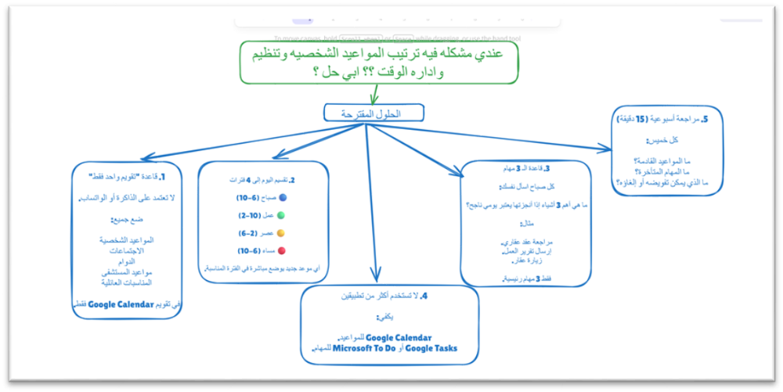
Figure 1: Problem domain investigated

Key Features
- AI-Powered Schedule Analysis
Uses the MythoMax-L2-13B model to ingest current appointments and tasks, providing a human-like summary of the day's feasibility.
- Advanced Appointment Management
A full-featured scheduling interface that supports complex metadata, location tracking, and real-time Firestore synchronization.
- Dynamic Task Management
Prioritized task lists with High, Medium, and Low urgency levels integrated into the AI reasoning engine.
- Productivity Recommendations
Generate actionable daily steps to improve time allocation.

Technology Stack
Layer | Technology
Framework | Next.js 15 (App Router)
Language | TypeScript
UI Components | Shadcn/UI & Radix UI
Database | Firebase Firestore
AI Engine | MythoMax-L2-13B (OpenRouter)
Deployment | Docker on Hugging Face Spaces

