Munazzim Intelligent Productivity Platform

Intelligent Productivity and Time Management Platform

Technology Readiness Level 2 (TRL 2)

Project Team
Name | Contribution
Prof. Hatem Abu Humaid | Scientific Group Leader
Eng. Yousef Aljaser | Principal Developer
Eng. Abdulrahman Aljaber | Contributor Developer
Eng. Bader Aldeham | Contributor Developer
Eng. Abdullah Alkhateeb | Contributor Developer

TRL 2 Evidence Report

TRL 2 Definition
Technology Readiness Level 2 (TRL 2) is achieved when initial engineering design activities are performed to transform concepts and ideas into practical technical representations. At this stage, engineering models, architectural designs, workflow diagrams, system structures, and preliminary implementation plans are developed to define how the technology will operate in different environments. The objective is to establish a clear engineering vision and prepare the technical foundation for future prototype development and validation activities.
تعريف مستوى الجاهزية التقنية الثاني
يمثل مستوى الجاهزية التقنية الثاني مرحلة تحويل الفكرة التقنية من مفهوم نظري إلى تمثيل هندسي أولي يمكن دراسته وتحليله. في هذه المرحلة يتم تطوير النماذج الأولية للمفاهيم، والتصاميم المعمارية، والمخططات الهندسية، وتحديد المكونات التقنية الأساسية للنظام. ويهدف هذا المستوى إلى بناء تصور هندسي واضح للتقنية ووضع الأساس الفني اللازم للانتقال إلى مراحل إثبات المفهوم والتطوير اللاحقة

TRL 2 Requirement Compliance Matrix
TRL 2 Requirement | Achieved in Munazzim | Status
Engineering concept formulated | AI-powered productivity platform concept established | Achieved
Initial engineering design completed | Initial system concept and workflow defined (Figure 2) | Achieved
Technical models prepared | System architecture documented and represented (Figure 2 and Figure 4) | Achieved
Technology components selected | Core technologies identified and evaluated Technology Selection Table (Figure 3) | Achieved
Software architecture established | Multi-layer architecture defined Software Architecture Diagram (Figure 4) | Achieved
Source code management established | Repository created and configured GitHub Repository (Figure 5) | Achieved
Development Environment established | Development environment prepared and validated (Figure 6) | Achieved
Future capabilities defined | Platform capabilities documented | Achieved

Keywords
Artificial Intelligence (AI), Software Architecture, System Design, Engineering Modeling, Productivity Management, Intelligent Scheduling, Task Prioritization, Cloud Computing, Firebase Firestore, Next.js Framework, OpenRouter, Human–Computer Interaction.

Research Metrics
Metric | Value
Engineering Models Developed | 4
Architecture Layers Defined | 5
Technology Components Selected | 9
Core Functional Domains Identified | 5
Development Platforms Utilized | 4
Readiness Level | TRL 2

Hardware Environment
Hardware Component | Specification
Processor (CPU) | Intel® Xeon® E-2176M @ 2.70 GHz
Memory (RAM) | 32 GB DDR4 (31.8 GB Usable)
Operating System | Windows 11 Enterprise
OS Build | 26200.8655
Development Environment | Local Development Workstation
Purpose | System Design, Development, Validation, and Testing

1. Project Overview
Munazzim is an AI-powered time management and productivity platform designed to help users organize appointments, manage tasks, and improve daily productivity through intelligent scheduling recommendations.
The system integrates modern web technologies, cloud infrastructure, and large language models to provide a smart assistant capable of supporting users in planning and managing their daily activities.

2. Problem Statement
Many users struggle with managing appointments efficiently, organizing daily tasks, prioritizing activities, avoiding scheduling conflicts, and maintaining consistent productivity.
Existing solutions often provide static scheduling tools without intelligent analysis or personalized recommendations. Munazzim aims to address these challenges through an AI-assisted productivity platform.

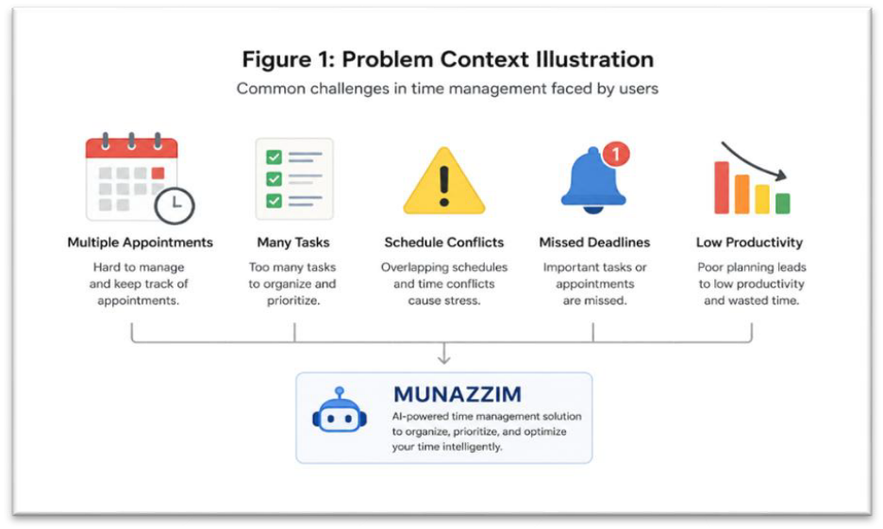
Figure 1: Problem Illustration

3. Basic Scientific and Technical Principles
The project is based on the following principles:
- Time Management Theory
- Productivity Optimization Techniques
- Task Prioritization Methodologies
- Artificial Intelligence and Natural Language Processing
- Cloud-Based Software Architecture
- Human-Computer Interaction Principles
These principles provide the foundation for the development of the Munazzim platform.

4. Initial System Concept
The initial concept is to create a centralized platform where users can:
- Create and manage appointments
- Create and track tasks
- Receive AI-generated recommendations
- Analyze productivity patterns
- Improve daily planning and scheduling

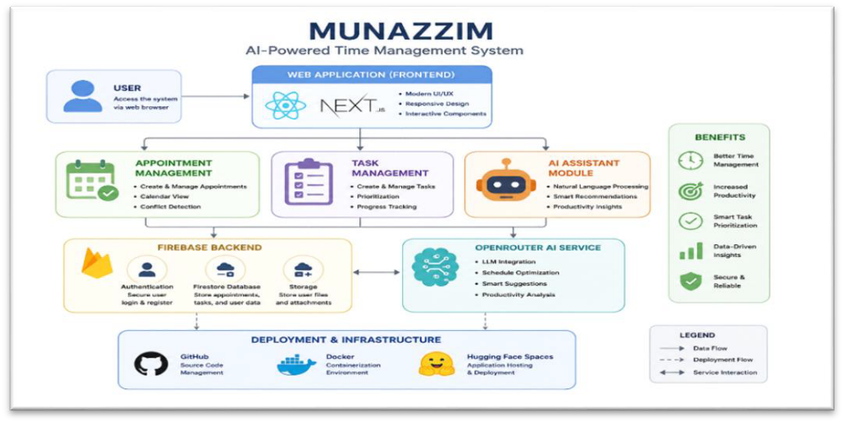
Figure 2: System Architecture Diagram

5. Technology Selection

Component | Technology
Frontend | Next.js
User Interface | React
Backend Services | Firebase
Database | Firestore
Authentication | Firebase Authentication
AI Integration | OpenRouter
Source Control | GitHub
Deployment | Hugging Face Spaces
Containerization | Docker

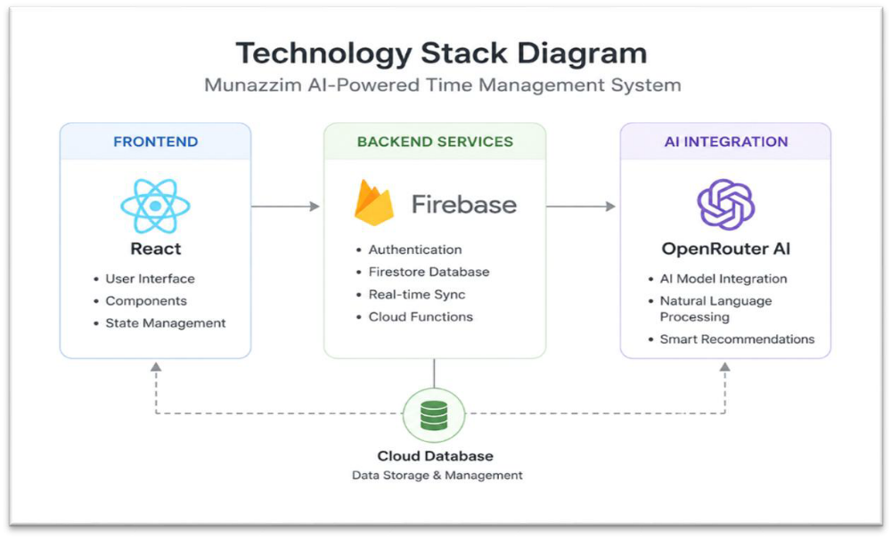
Figure 3: Technology Stack Diagram

6. Software Architecture
Preliminary software architecture has been defined to support future development activities.
The architecture consists of:
- User Interface Layer
- Application Logic Layer
- Firebase Backend Layer
- AI Processing Layer
- Cloud Deployment Layer
This architecture establishes the technical foundation for future implementation and testing.
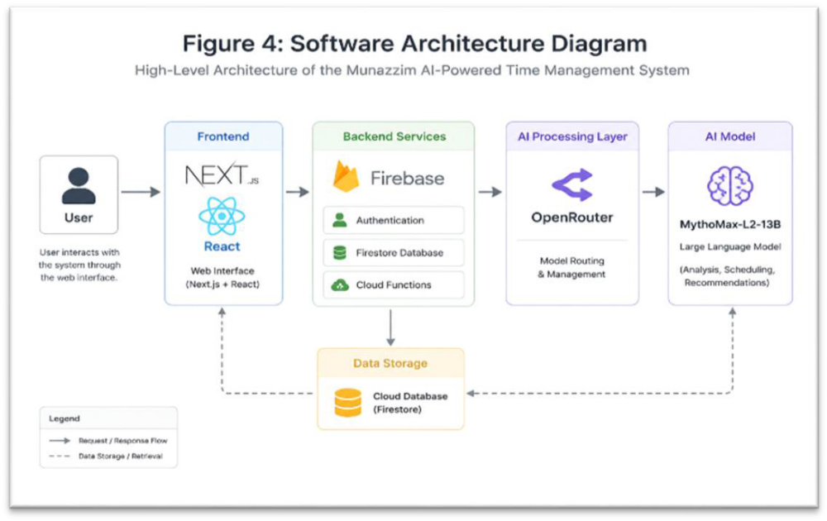
Figure 4: Software Architecture Diagram

7. Repository Establishment
A source code repository has been established to support software development and version control activities.
Repository capabilities include:
- Source Code Management
- Version Tracking
- Collaboration Support
- Development History Documentation
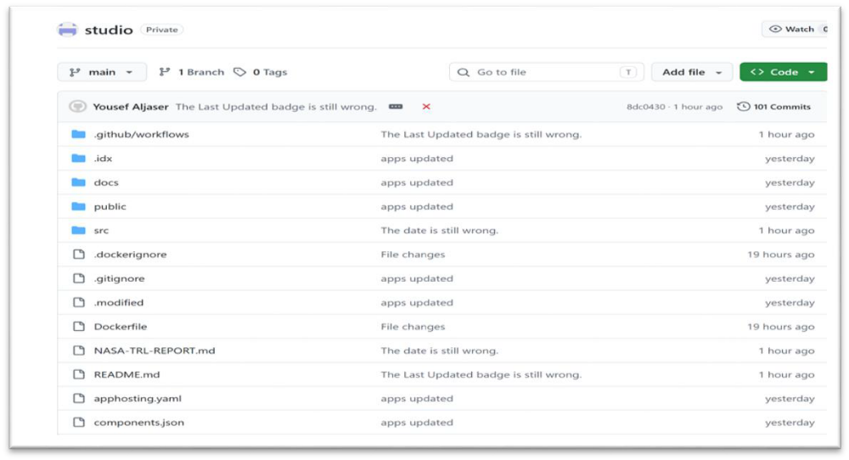
Figure 5: GitHub Repository

8. Development Environment
The Munazzim project utilizes a modern cloud-based development environment supported by GitHub, Firebase, Docker, and Hugging Face Spaces.
These technologies provide the necessary infrastructure for future software development, testing, deployment, and maintenance activities.
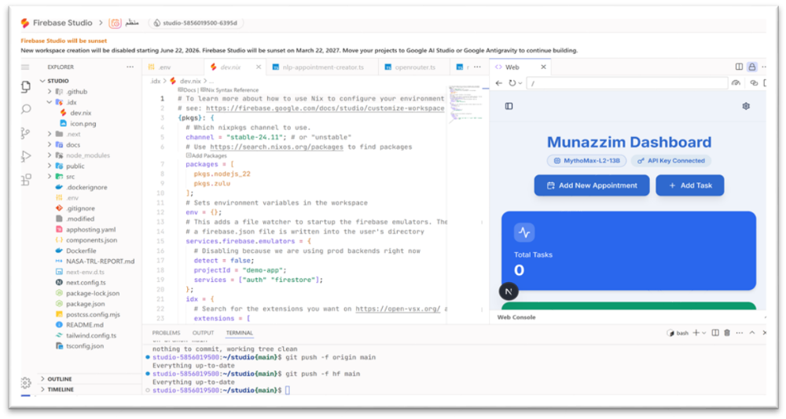
Figure 6: Development Environment

9. Expected System Capabilities
The future system is expected to provide:
- Appointment Management
- Task Management
- Productivity Monitoring
- AI-Assisted Recommendations
- Conflict Detection
- Intelligent Scheduling Support
These capabilities define the intended operational objectives of the platform.

10. TRL 2 Assessment
Evidence demonstrates that:
- The software concept has been identified.
- The basic principles have been documented.
- The core technologies have been selected.
- The preliminary architecture has been established.
- Development infrastructure has been prepared.
Therefore, the Munazzim system satisfies the requirements Software Technology Readiness.

11. References
- Firebase Documentation.
- Next.js Documentation.
- React Documentation.
- OpenRouter Documentation.
- GitHub Documentation.
- Docker Documentation.
- Hugging Face Spaces Documentation.

