Q1.

Code:

|  |
| --- |
| ***package Q_01;  import javax.swing.*;  public class Q1 {  public static void main(String[] args) {  JFrame frame=new JFrame();  frame.setSize(800,600);  frame.setTitle("Welcome to java");  frame.setVisible(true);  } }*** |

Output:

Q2.

Code:

|  |
| --- |
| ***package Q_02;  import javax.swing.*; import java.util.Scanner;  public class Q2 {  public static void main(String[] args) {  Scanner name=new Scanner(System.in);  System.out.println("Enter first name");  String firstname= name.next();  System.out.println("Enter last name");  String lastname= name.next();   JFrame frame=new JFrame();  frame.setSize(800,600);  frame.setTitle(firstname+" "+lastname);  frame.setVisible(true);   } }***  ***}*** |

Output:

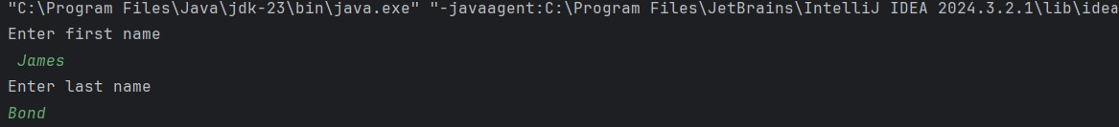

Q3.

Code:

|  |
| --- |
| ***package Q_03;  import java.util.Scanner;  public class Q3 {  public static void main(String[] args) {  Scanner name=new Scanner(System.in);  System.out.println("Enter first name");  String firstname= name.next();  System.out.println("Enter middle name");  String middleName= name.next();  System.out.println("Enter last name");  String lastname= name.next();   String initial=middleName.substring(0,1);  System.out.println(firstname+" "+initial+" "+lastname);  } }***  ***}*** |

Output:

Q4.

Code:

|  |
| --- |
| ***package Q_04;  import java.text.SimpleDateFormat; import java.util.Date;  public class Q4 {  public static void main(String[] args) {  Date today=new Date();  System.out.println(today);  SimpleDateFormat sdf=new SimpleDateFormat("dd MMMM yyyy");  System.out.println(sdf.format(today));   } }*** |

Output:

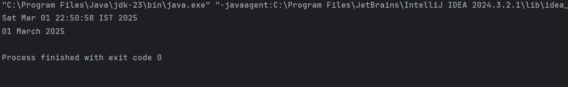

Q5.

Code:

|  |
| --- |
| ***package Q_05;  import java.text.SimpleDateFormat; import java.util.Date;  public class Q5 {  public static void main(String[] args) {  Date today=new Date();  System.out.println(today);  SimpleDateFormat sdf=new SimpleDateFormat("EEEE, MMMM dd, yyyy");  System.out.println(sdf.format(today));   } }*** |

Output:

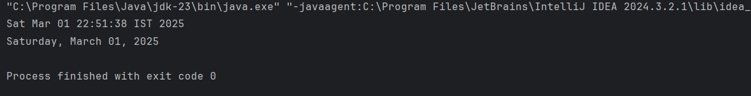

Q6.

Code:

|  |
| --- |
| ***package Q_06;  import javax.swing.*; import java.util.Scanner;  public class Q6 {  public static void main(String[] args) {  JFrame frame = new JFrame();  Scanner scanner = new Scanner(System.in);   System.out.println("Enter the frame width ");  int width = scanner.nextInt();  System.out.println("Enter the height");  int height = scanner.nextInt();   frame.setSize(width, height);  frame.setVisible(true);  } }*** |

Output:

Q7.

Code:

|  |
| --- |
| ***package Q_07;  import javax.swing.*; import java.text.SimpleDateFormat; import java.util.Date;  public class Q7 {  public static void main(String[] args) {  JFrame frame = new JFrame();  Date date = new Date();  SimpleDateFormat sdf = new SimpleDateFormat("HH:mm:ss a");   String title = sdf.format(date);   frame.setSize(300, 200);  frame.setTitle(title);  frame.setVisible(true);  } }*** |

Output:

Q8.

Code:

|  |
| --- |
| ***package Q_08;  import java.util.Scanner;  public class Q8 {  public static void main(String[] args) {  Scanner scanner = new Scanner(System.in);   // Get user input  System.out.print("Enter a string with an exclamation mark: ");  String input = scanner.nextLine();   // Find the index of '!' in the string  int index = input.indexOf('!');   if (index != -1) {  // Split the string into two parts  String part1 = input.substring(0, index).trim();  String part2 = input.substring(index + 1).trim();   // Print the results  System.out.println(part1);  System.out.println(part2);  } else {  System.out.println("The input does not contain an exclamation mark!");  }   scanner.close();  } }*** |

Output:

Q9.

Code:

|  |
| --- |
| ***package Q_09;  import java.util.Scanner;  public class Q9 {  public static void main(String[] args) {  Scanner scanner = new Scanner(System.in);   System.out.print("Enter a string: ");  String input = scanner.nextLine();   int length = input.length();   char firstChar = input.charAt(0);  char lastChar = input.charAt(length - 1);   System.out.println(length);  System.out.println(firstChar);  System.out.println(lastChar);   scanner.close();  } }*** |

Output:



Q10.

Code:

|  |
| --- |
| ***package Q_10;  import java.util.Scanner;  public class Q10 {  public static void main(String[] args) {  Scanner scanner = new Scanner(System.in);   System.out.print("Enter an odd-length word: ");  String input = scanner.nextLine();   if (input.length() % 2 == 1) {   int middleIndex = input.length() / 2;    System.out.println(input.charAt(middleIndex));  } else {  System.out.println("Please enter a word with an odd number of characters.");  }   scanner.close();  } }*** |

Output:

Q11.

Code:

|  |
| --- |
| ***package Q_11;  import java.util.Scanner;  public class Q11 {  public static void main(String[] args) {  Scanner scanner = new Scanner(System.in);   System.out.print("Enter your full name (First Middle Last): ");  String input = scanner.nextLine();   String[] parts = input.split(" ");   if (parts.length == 3) {  String firstName = parts[0];  String middleInitial = parts[1].charAt(0) + ".";  String lastName = parts[2];   System.out.println(lastName + ", " + firstName + " " + middleInitial);  } else {  System.out.println("Please enter a valid full name with first, middle, and last names.");  }   scanner.close();  } }*** |

Output:



Q12.

Code:

|  |
| --- |
| ***package Q_12;  import javax.swing.*;  public class Q12 {  public static void main(String[] args) {  JFrame frame = new JFrame("My First Frame");   frame.setSize(300, 200);   frame.setLocation(100, 50);   frame.setDefaultCloseOperation(JFrame.EXIT_ON_CLOSE);   frame.setVisible(true);  } }*** |

Output:

