Legaspino, Rhealyn 11/17/2024

yall3n LAB Activity

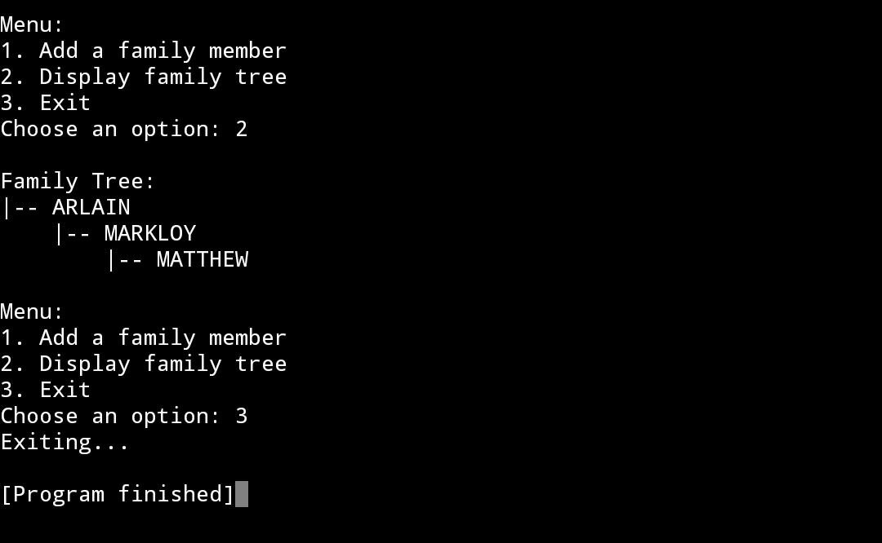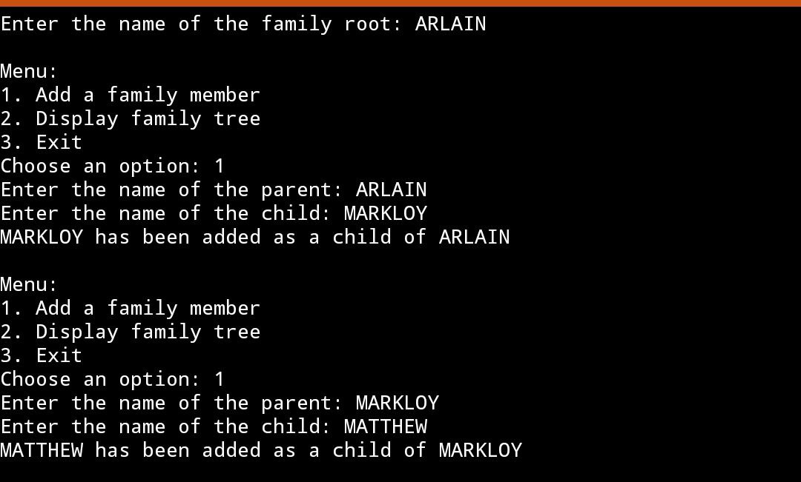

**Family Tree**

The Family Tree Application is a Java-based console application that uses a tree data structure to represent relationships within a family. Each family member is a node, and their relationships are represented by parent-child connections.

This code provides a simple yet functional example of how tree data structures can be applied to real-world problems, such as managing and visualizing hierarchical data. The code creates and manages a family tree using a tree structure. It allows users to add family members dynamically, search for specific members, and display the entire family tree in a hierarchical format. It also provides an interactive menu for easy user interaction.

I created this application to demonstrate the practical application of tree data structures in representing hierarchical relationships. Family trees are a common example of hierarchical data, and this project serves as a clear and concise illustration of how tree structures can be used to manage and manipulate such data efficiently. The application is also useful for personal organization of family information.

This application can be used by individuals to organize and visualize their family lineage. It promotes an understanding of hierarchical data structures and encourages exploration of programming concepts through practical examples.