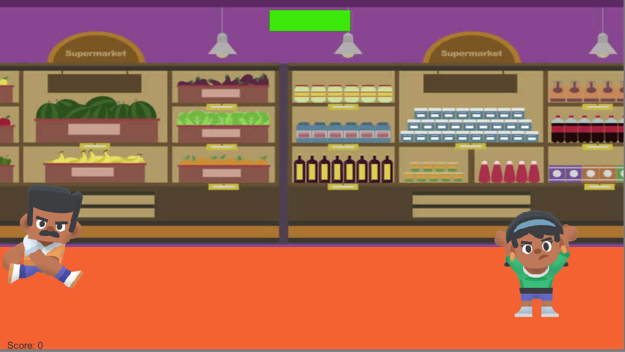Features and GamePlay:

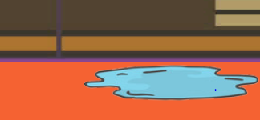

Player: The player can be played using

Jump- Space

Move left: left arrow

Move right: right arrow

Health Bar (green bar at the top): Enemies will reduce the players health bar by 2, you die if health bar reaches 0

Score: You gain 5 points for dodging enemies

Enemies: Either a customer, or a puddle, jump over to avoid enemies

To win the game: you must avoid enemies and reach Karen, to eventually have the final boss match

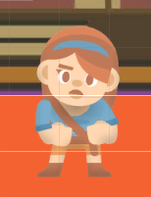

When found: you must reach her and then you win the level.

How to run the game:

1. Download Unity
2. In the handed in folder. Click on application to run the game, the source code is located in the SuperMarket Nightmare Folder

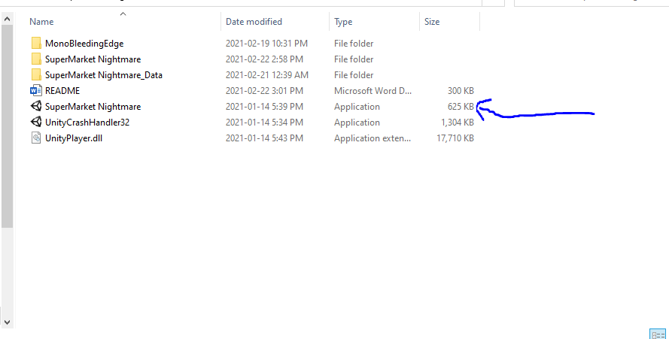

1. You will then be promoted with this modal, Assign the resolution to 1920x1080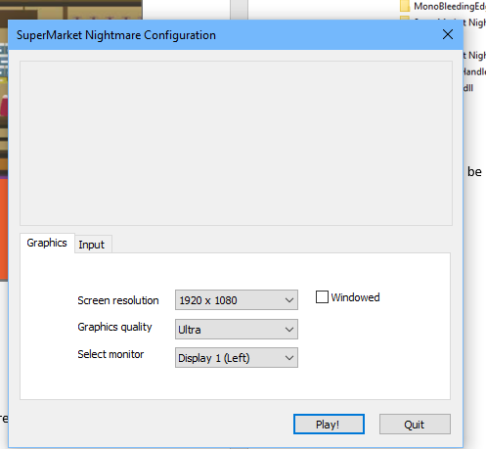
2. Click Play