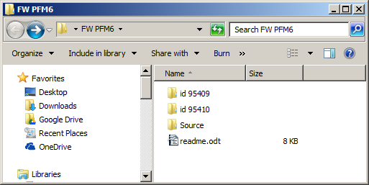Table 1: FW PFM6 folder contents

- The FW PFM6 folder contains the PFM6 firmware components

- Source >> Project folder for bootloader (Iap) and the firmware itself ( Pfm6Ctrl )
- id 95409 folder ( FW PFM6 HEX ), containing the V 1.13 firmware build
- id 95410 folder ( FW PFM6 BL HEX) with complete installation image, containing bootloader, firmware (id 95409) and formatted internal flash drive with setup configuration setup
- It is absolutely essential. that the image id. 95410 ( V112img.hex ) is used for initial programming of the board. Tu update previous versions, only firmware image ( Pfm6Ctrl.hex ) can be used.

- System requirements

- Compiled with Keil uVision V5.15
- Uploaded with STMicroelectronics flash loader
- Isolated USB > serial adapter needed id. 75820
- For succesful compiling, do not alter the Source folder structure

- Differences to the previous version

- id. string now contains >v 1.13 Jun 15 2016, <ECF65ED6>
- modified QSP pattern, according to I-4007, S-664

