**UFMFRR-15-M Machine Vision**

**Tutorial Two Exercises**

1.

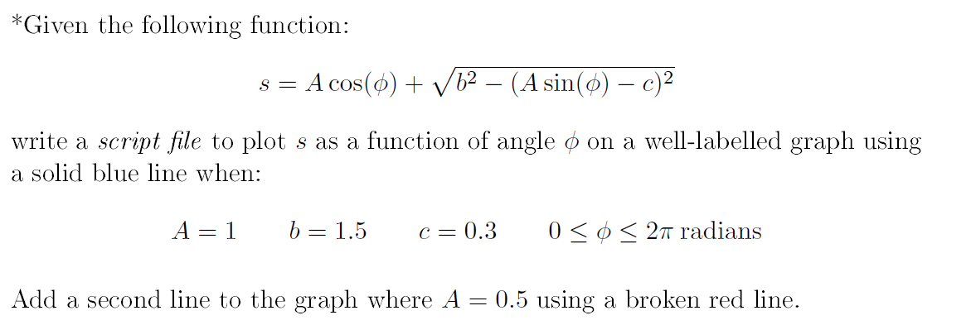

2. Visual recognition is a topical machine vision problem. Conduct a short literature review on image recognition (or image classification) and use a line chart and a bar chart with the matplotlib package to summarise performance of different methods that competed in previous ImageNet Large Scale Visual Recognition Challenges (ILSVRC). You are required to review at least 3 different methods. Use legends, axes and title labels to improve readability of the plots. Use a short paragraph to explain your plot.

3. Upload any colour image from your local disk to your Colab python session. Then

* Read this image with OpenCV (cv2.imread)
* Display this colour image using the matplotlib method (matplotlib.pyplot.imshow), you will notice that the colour does not display as expected.
  + Explain what you observe
  + Write code to fix this yourself
* Find an OpenCV method to achieve this (refer to the OpenCV documentation)
* Convert this image to greyscale using OpenCV (refer to the OpenCV documentation)
* Resize this greyscale image to height/2 * width/2
* Crop the central region of the colour image such that the destination size is height/2 * width/2
* Display the colour image, the greyscale image, the resized greyscale image and the cropped colour image as 2 * 2 tiles. Use figure titles appropriately.

|  |  |
| --- | --- |
|  |  |
|  |  |

* Save these images to your Google Drive.