Interfacing Relay with 8051 using Keil C – AT89C51

In some electronic applications we need to switch or control high voltages or high currents. In these cases we may use electromagnetic or solid state relays. For example, it can be used to control home appliances using low power electronic circuits.

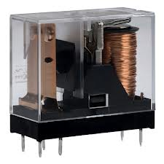
An electromagnetic relay is a switch which is used to switch High Voltage or Current using Low power circuits. It magnetically isolates low power circuits from high power circuits. It is activated by energizing a electromagnet, coil wounded on a soft iron core. A relay should not be directly connected to a microcontroller, it needs a driving circuit due to the following reasons.
- A microcontroller will not able to supply current required for the proper working of a relay. The maximum current that A89C51 microcontroller can sink is 15mA while a relay needs about 50 – 100mA current.
- A relay is activated by energizing its coil. Microcontroller may stop working by the negative voltages produced in the relay due to its back emf.

Interfacing Relay with 8051 using Transistor
Transistor is wired as a switch. which drives the relay. The transistor will be in OFF state when the when the pin P2.0 is in LOW state. When 1 is written to P2.0 current will flow to the base of the transistor and the relay energises.
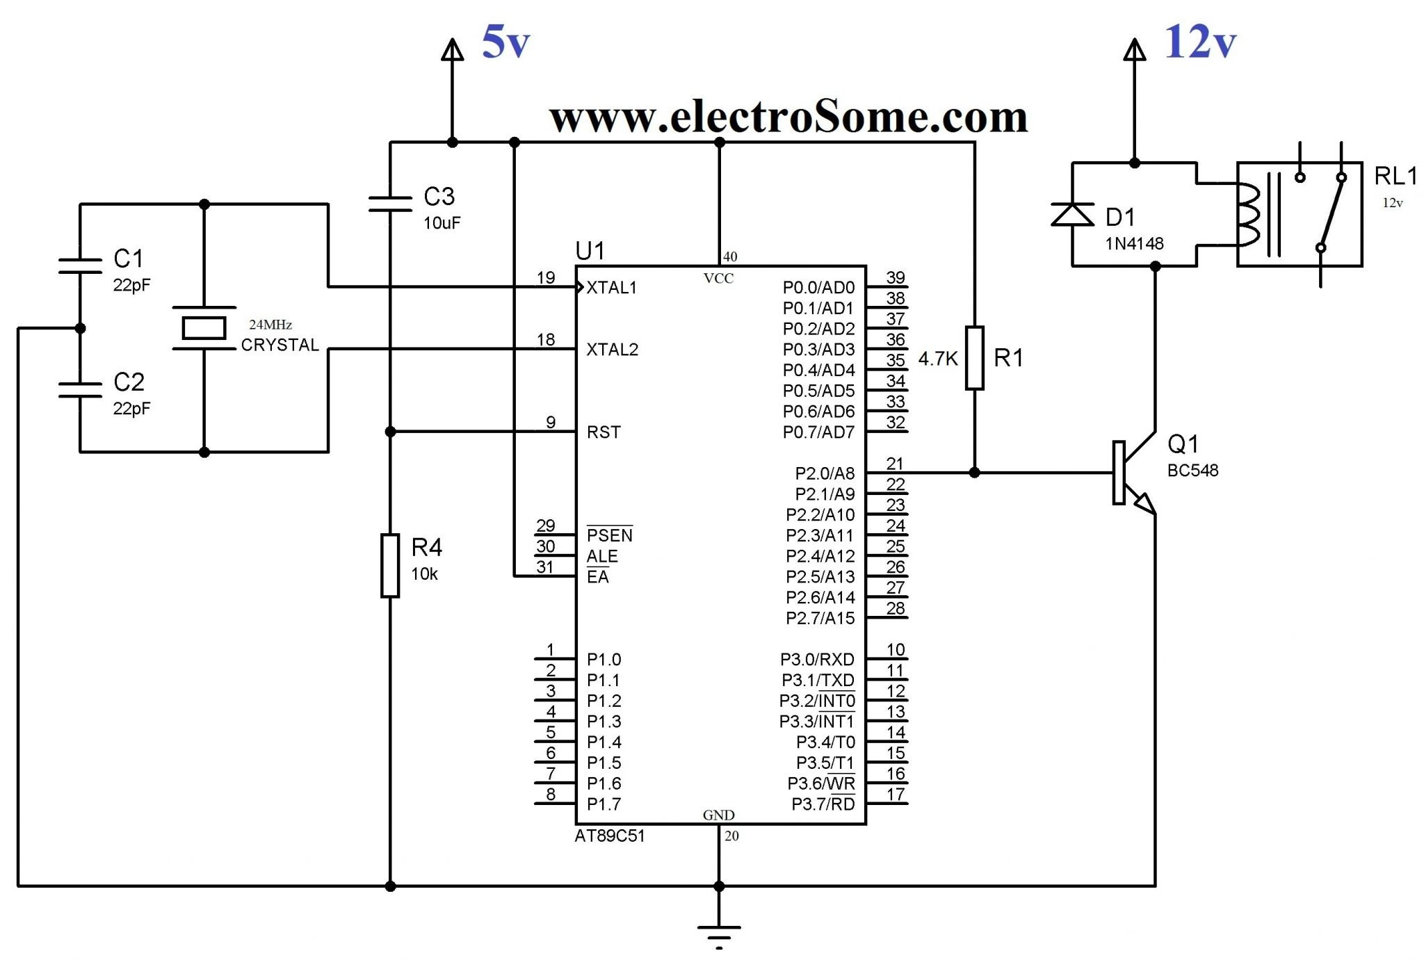

Interfacing Relay with 8051 using ULN2003
When we need more than one relays, using transistors and diodes become bulky. In these cases we can use ULN drivers. These are monolithic IC s consists of High Voltage High Current Darlington transistor arrays. When using these driver ICs we don’t need to connect freewheeling diode as they have built in clamp diodes. Here we are using ULN2003 for demostration.

