class04.R
yasoohaitham
2026-01-16
x <- 1:50
plot(x)
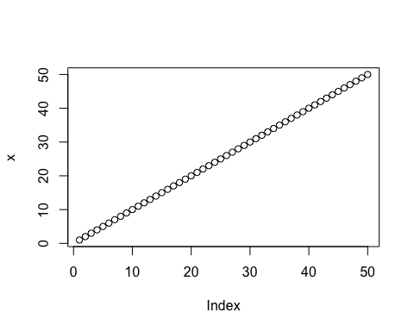
plot(x, sin(x),typ="l", col="blue", lwd=3, xlab="is it lunch time")
