R Notebook

This is an [R Markdown](http://rmarkdown.rstudio.com) Notebook. When you execute code within the notebook, the results appear beneath the code.

Try executing this chunk by clicking the *Run* button within the chunk or by placing your cursor inside it and pressing *Ctrl+Shift+Enter*.

plot(cars)

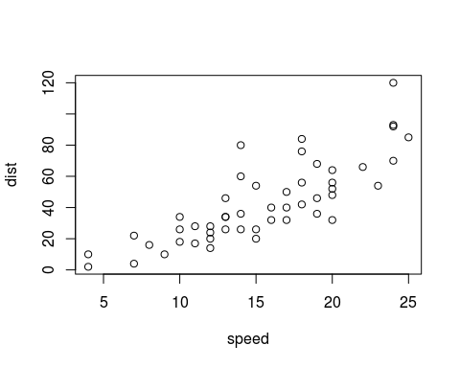

Add a new chunk by clicking the *Insert Chunk* button on the toolbar or by pressing *Ctrl+Alt+I*.

When you save the notebook, an HTML file containing the code and output will be saved alongside it (click the *Preview* button or press *Ctrl+Shift+K* to preview the HTML file).

library(dplyr, quietly = TRUE)

##   
## Attaching package: 'dplyr'

## The following objects are masked from 'package:stats':  
##   
## filter, lag

## The following objects are masked from 'package:base':  
##   
## intersect, setdiff, setequal, union

data(mtcars)  
head(mtcars, 4)

## mpg cyl disp hp drat wt qsec vs am gear carb  
## Mazda RX4 21.0 6 160 110 3.90 2.620 16.46 0 1 4 4  
## Mazda RX4 Wag 21.0 6 160 110 3.90 2.875 17.02 0 1 4 4  
## Datsun 710 22.8 4 108 93 3.85 2.320 18.61 1 1 4 1  
## Hornet 4 Drive 21.4 6 258 110 3.08 3.215 19.44 1 0 3 1

per_cyl <- mtcars %>%  
 group_by(cyl) %>%  
 summarise(disp.avg = mean(cyl),  
 carb.max = max(carb))  
  
per_cyl

## # A tibble: 3 × 3  
## cyl disp.avg carb.max  
## <dbl> <dbl> <dbl>  
## 1 4 4 2  
## 2 6 6 6  
## 3 8 8 8

Et cela donne graphiquement:

library(ggplot2)  
  
mtcars <- mtcars %>%  
 mutate(cyl = as.factor(cyl))  
  
print(qplot(cyl, mpg, data = mtcars, geom = "boxplot"))

