
Practical Record File
TSEC-0
Student Name: Md Yasir Faridi
________________________________
System ID: 2024247711
________________________________
Section:E (G2)
________________________________
Subject: Technical Skill Enhancement Course - 0
1

​
Index Page
Problem No. | Problem Name | Page No.
1 | Kadane's Algorithm | 3
2 | Spirally traversing a matrix | 5
3 | isomorphic strings | 7
4 | Longest prefix suffix | 10
5 | First n fibonacci | 12
6 | Tower of Hanoi | 13
7 | Search an element in sorted and rotated array | 15
8 | Sorted and Rotated Minimum | 17
9 | Quick Sort | 19
10 | Merge Sort | 21
11 | Detect Loop in linked list | 23
12 | Rotate a Linked List | 26
2

1. Kadane's Algorithm
You are given an integer array arr[]. You need to find the maximum sum of a subarray (containing at least one element) in the array arr[].
Note : A subarray is a continuous part of an array.
1.1 Examples
Example 1 | Input: arr[] = [2, 3, -8, 7, -1, 2, 3]  Output: 11  Explanation: The subarray [7, -1, 2, 3] has the largest sum 11.
Example 2 | Input: arr[] = [-2, -4]  Output: -2  Explanation: The subarray [-2] has the largest sum -2.
Example 3 | Input: arr[] = [5, 4, 1, 7, 8]  Output: 25  Explanation: The subarray [5, 4, 1, 7, 8] has the largest sum 25.
3

1.2 Constraints
●​1 ≤ arr.size() ≤ 105
●​-104 ≤ arr[i] ≤ 104
​
2. Source Code
Solution — JAVA
class Solution {
public:
int maxSubarraySum(vector<int> &arr) { int maxSum = INT_MIN;
int currSum = 0;
for (int i = 0; i < arr.size(); i++) { currSum += arr[i];
maxSum = max(maxSum, currSum);
} }; | } if (currSum < 0) currSum = 0;  return maxSum;

​
3. Acceptance Screenshot
4

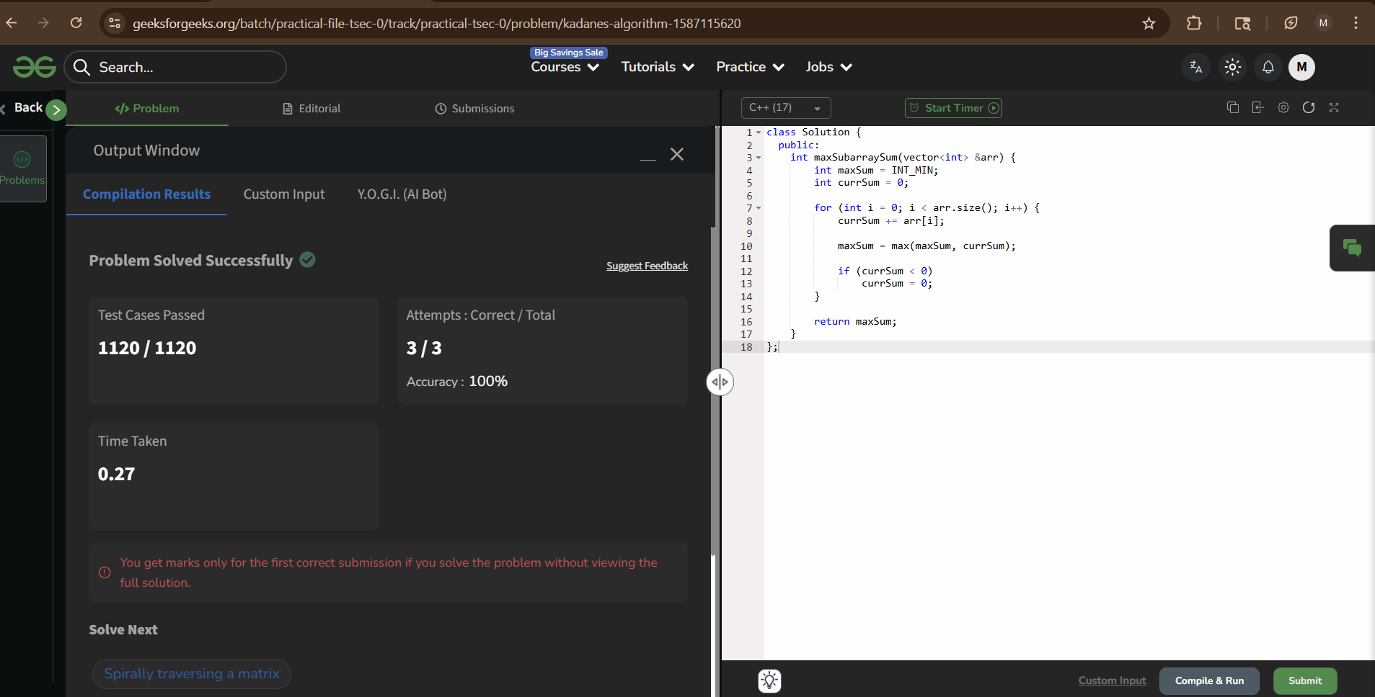
2. Spirally traversing a matrix
You are given a rectangular matrix mat[][] of size n x m, and your task is to return an

array while traversing the matrix in spiral form.
2.1 Examples
Input: mat[][] = [[1, 2, 3, 4], [5, 6, 7, 8], [9, 10, 11, 12], [13, 14, 15, 16]] Output: [1, 2, 3, 4, 8, 12, 16, 15, 14, 13, 9, 5, 6, 7, 11, 10]
Explanation:
5

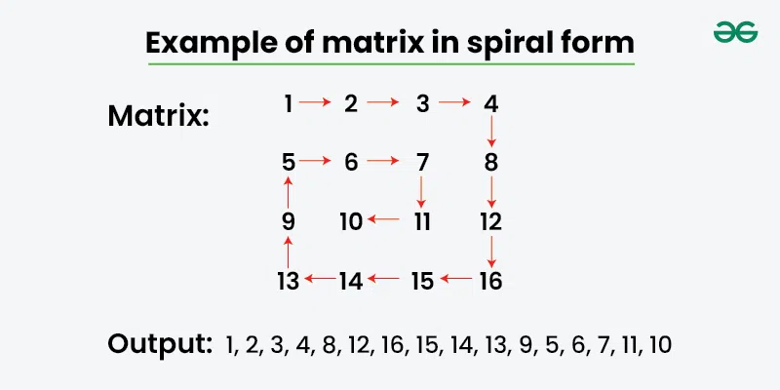

2.2 Constraints
●​1 ≤ n, m ≤1000
●​0 ≤ mat[i][j] ≤100
​
2. Source Code
Solution — JAVA
class Solution {
public:
vector<int> spirallyTraverse(vector<vector<int>> &mat) { vector<int> result;
int top = 0, bottom = mat.size() - 1; int left = 0, right = mat[0].size() - 1;
while (top <= bottom && left <= right) {
// Move right along top row
for (int i = left; i <= right; i++)
result.push_back(mat[top][i]);
top++;
// Move down along right column
for (int i = top; i <= bottom; i++)
result.push_back(mat[i][right]);
right--;
// Move left along bottom row (if row still exists) if (top <= bottom) {
6

} }; | } } for (int i = right; i >= left; i--) result.push_back(mat[bottom][i]); bottom--; // Move up along left column (if column still exists) if (left <= right) { for (int i = bottom; i >= top; i--) result.push_back(mat[i][left]); left++; }  return result;

3. Acceptance Screenshot
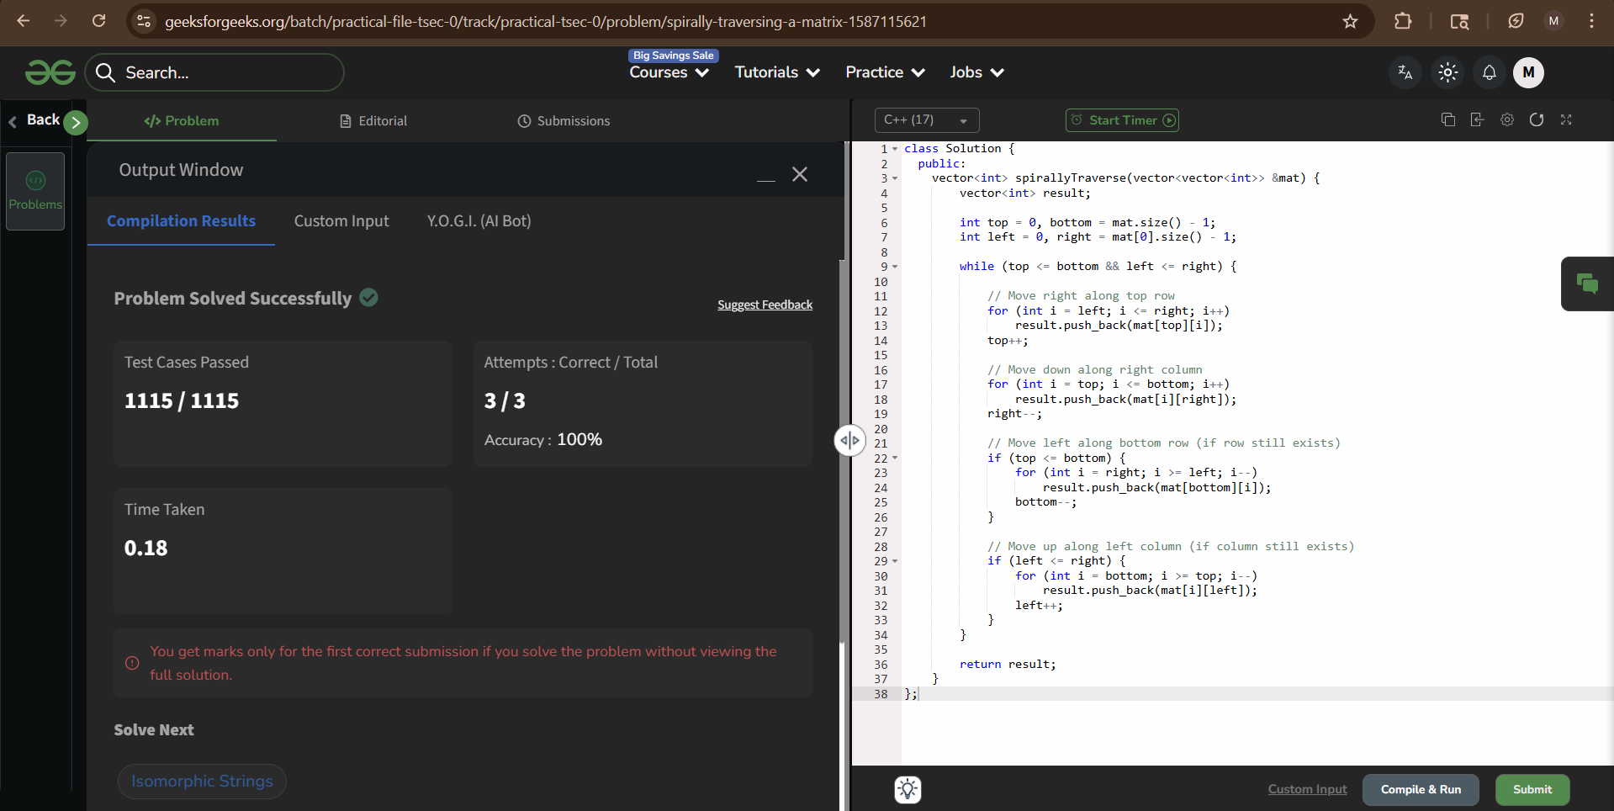
3. Isomorphic Strings
Given two strings s1 and s2 consisting of only lowercase English letters

and of equal length, check if these two strings are isomorphic to each other.

If the characters in s1 can be changed to get s2, then two strings, s1
and s2 are isomorphic. A character must be completely swapped out for
another character while maintaining the order of the characters. A
7

character may map to itself, but no two characters may map to the

same character.
3.1 Examples
Example 1 | Input: s1 = "aab", s2 = "xxy"  Output: true  Explanation: Each character in s1 can be consistently mapped to a unique character in s2 (a → x, b → y).
Example 2 | Input: s1 = "aab", s2 = "xyz"  Output: false  Explanation: Same character 'a' in s1 maps to two different characters 'x' and 'y' in s2.
Example 3 | Input: s1 = "abc", s2 = "xxz"  Output: false  Explanation: Two different characters 'a' and 'b' in s1 maps with same character 'x' in s2.
3.2 Constraints
●​1 ≤ s1.size() = s2.size() ≤ 105
​
2. Source Code
Solution — JAVA
8

class Solution {
public:
bool areIsomorphic(string &s1, string &s2) { unordered_map<char, char> s1_to_s2, s2_to_s1;
for (int i = 0; i < s1.size(); i++) {
char c1 = s1[i], c2 = s2[i];
// Check s1 -> s2 mapping
if (s1_to_s2.count(c1)) {
if (s1_to_s2[c1] != c2)
return false; // 'a' was mapped to 'x', now trying to map to 'y'
} else {
s1_to_s2[c1] = c2;
}
// Check s2 -> s1 mapping
if (s2_to_s1.count(c2)) {
if (s2_to_s1[c2] != c1)
return false; // two different chars mapping to same char
} else {
s2_to_s1[c2] = c1;
}
}
return true;
}
};
3. Acceptance Screenshot
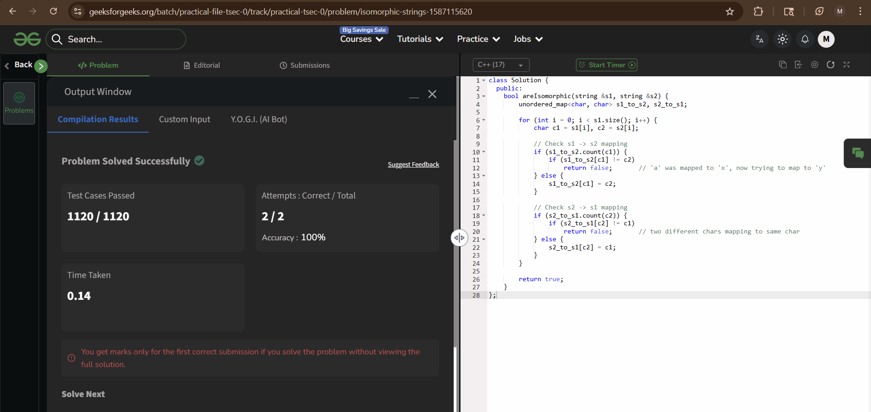
9

4. Longest Prefix Suffix
Given a string s, of lowercase english alphabets, find the length of the

longest proper prefix which is also a suffix. Note: Prefix and suffix can

be overlapping but they should not be equal to the entire string.
4.1 Examples
Example 1 | Input: s = "abab"  Output: 2  Explanation: The string "ab" is the longest prefix and suffix.
Example 2 | Input: s = "aabcdaabc"  Output: 4  Explanation: The string "aabc" is the longest prefix and suffix.
Example 3 | Input: s = "aaaa"  Output: 3  Explanation: "aaa" is the longest prefix and suffix.
4.2 Constraints
●​1 ≤ s.size() ≤ 106
​
10

2. Source Code
Solution — JAVA
class Solution {
public:
int getLPSLength(string &s) {
int n = s.size();
vector<int> lps(n, 0);
int len = 0; // length of previous longest prefix-suffix int i = 1;
while (i < n) {
if (s[i] == s[len]) {
lps[i] = ++len;
i++;
} else {
if (len != 0)
len = lps[len - 1]; // fall back, don't move i else {
lps[i] = 0;
i++;
}
}
}
} }; | return lps[n - 1];

3. Acceptance Screenshot
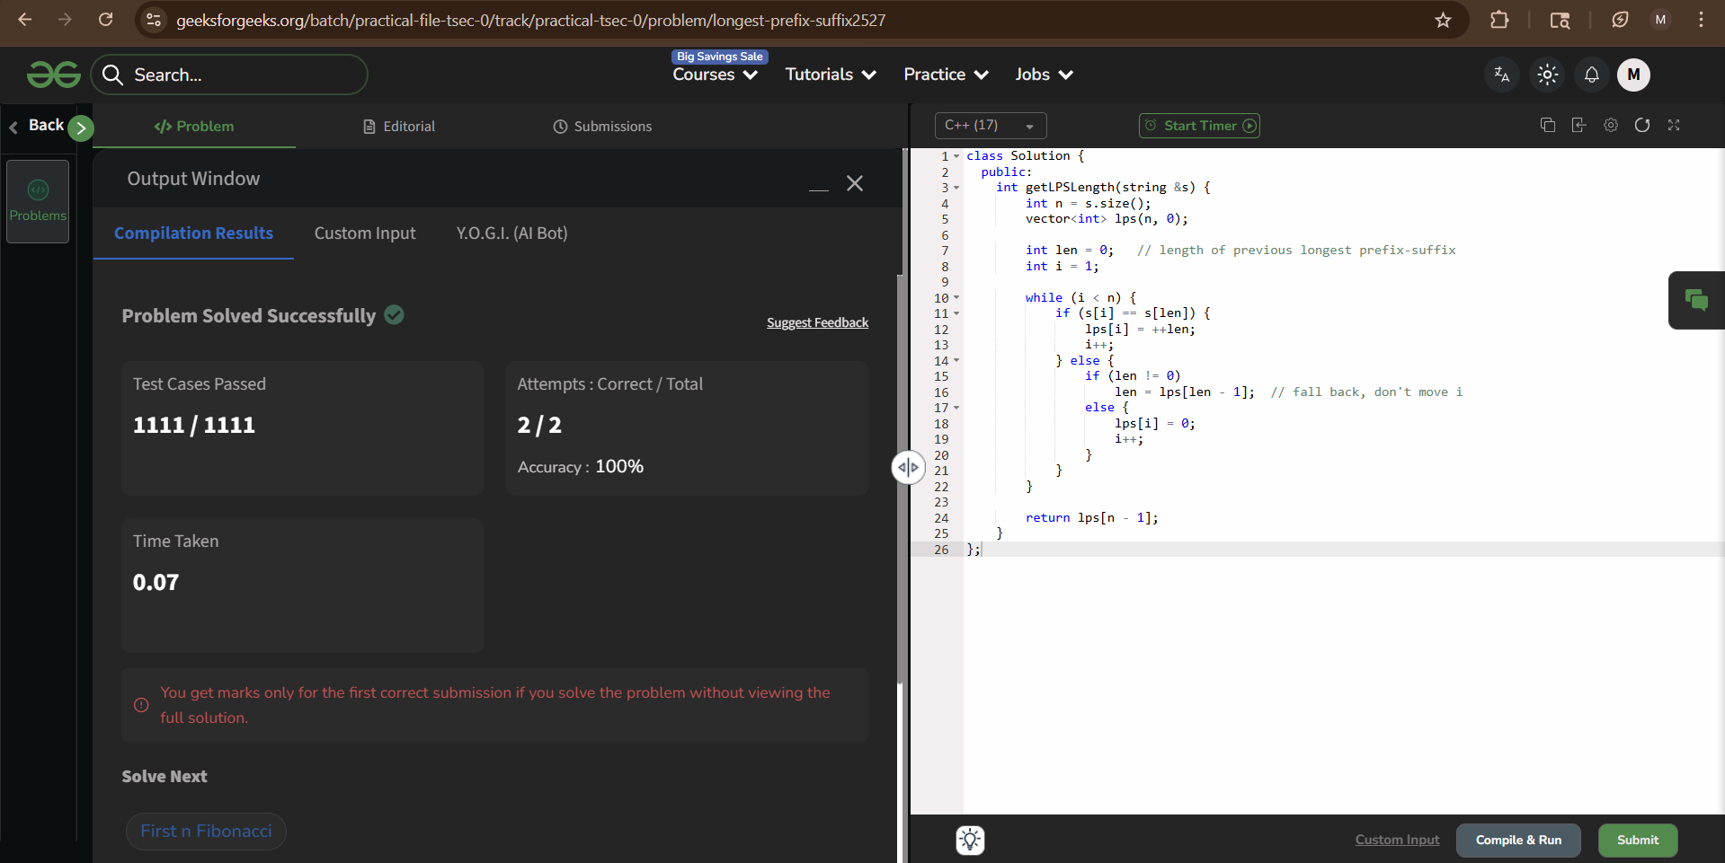
11

5.First n Fibonacci
Given a number n, return an array containing the first n Fibonacci numbers.

Note: The first two numbers of the series are 0 and 1.
5.1 Examples
Example 1 | Input: n = 5  Output: [0, 1, 1, 2, 3]
Example 2 | Input: n = 7  Output: [0, 1, 1, 2, 3, 5, 8]
Example 3 | Input: n = 2  Output: [0, 1]
5.2 Constraints
●​1 <= n <= 30
​
2. Source Code
Solution — JAVA
class Solution {
public:
vector<int> fibonacciNumbers(int n) { vector<int> fib(n);
fib[0] = 0;
12

if (n == 1) return fib;
fib[1] = 1;
for (int i = 2; i < n; i++)
fib[i] = fib[i-1] + fib[i-2];
} }; | return fib;

3. Acceptance Screenshot
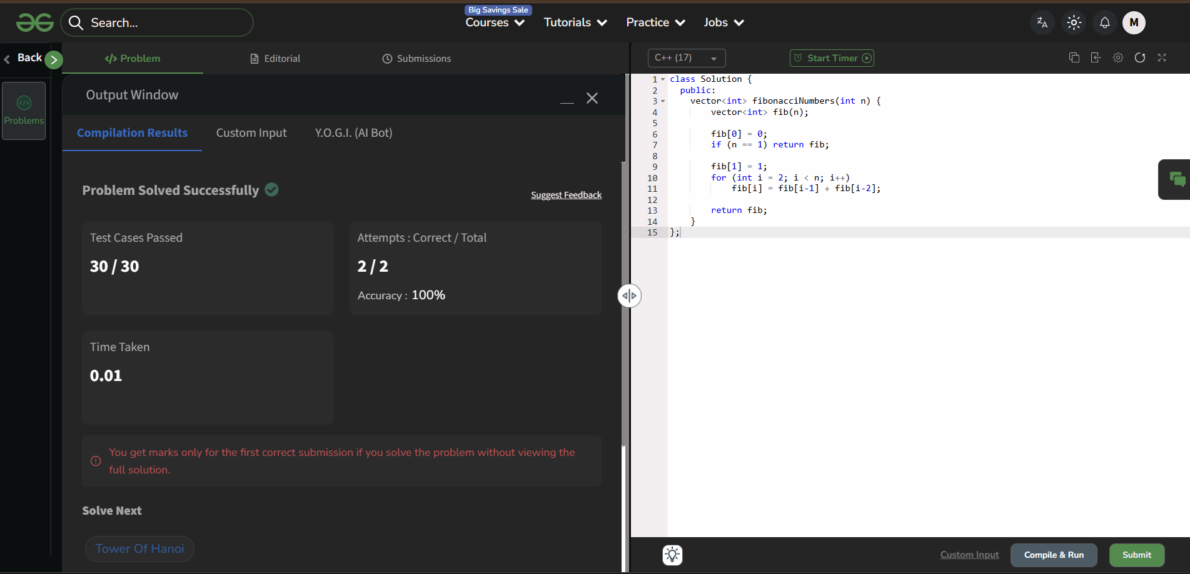
6. Tower Of Hanoi
You are given n disks placed on a starting rod (from), with the smallest

disk on top and the largest at the bottom. There are three rods: the

stariing rod(from), the target rod (to), and an auxiliary rod (aux).

You have to calculate the minimum numberof moves required to transfer

all n disks from the starting rod to the target rod, following these rules:

1. Only one disk can be moved at a time.
13

2.A disk can only be placed on top of a larger disk or on an empty

rod.

Return the minimum number of moves needed to complete the task.
6.1 Examples
Example 1 | Input: n = 2  Output: 3  Explanation: For n = 2, total 3 steps will be taken. Steps are as follows -  move disk 1 from rod 1 to rod 2  move disk 2 from rod 1 to rod 3  move disk 1 from rod 2 to rod 3
Example 2 | Input: n = 3  Output: 7  Explanation: For n = 3, total 7 steps will be taken.Steps are as follows -  move disk 1 from rod 1 to rod 3  move disk 2 from rod 1 to rod 2  move disk 1 from rod 3 to rod 2  move disk 3 from rod 1 to rod 3  move disk 1 from rod 2 to rod 1  move disk 2 from rod 2 to rod 3  move disk 1 from rod 1 to rod 3
Example 3 | Input: n = 0  Output: 0  Explanation: Total 0 steps will be taken.
6.2 Constraints
14

●​ 0 ≤ n ≤ 20

●​

​
2. Source Code
Solution — JAVA
class Solution {
public:
int towerOfHanoi(int n, int from, int to, int aux) { if (n == 0) return 0;
return (1 << n) - 1; // 2^n - 1
}
};
3. Acceptance Screenshot
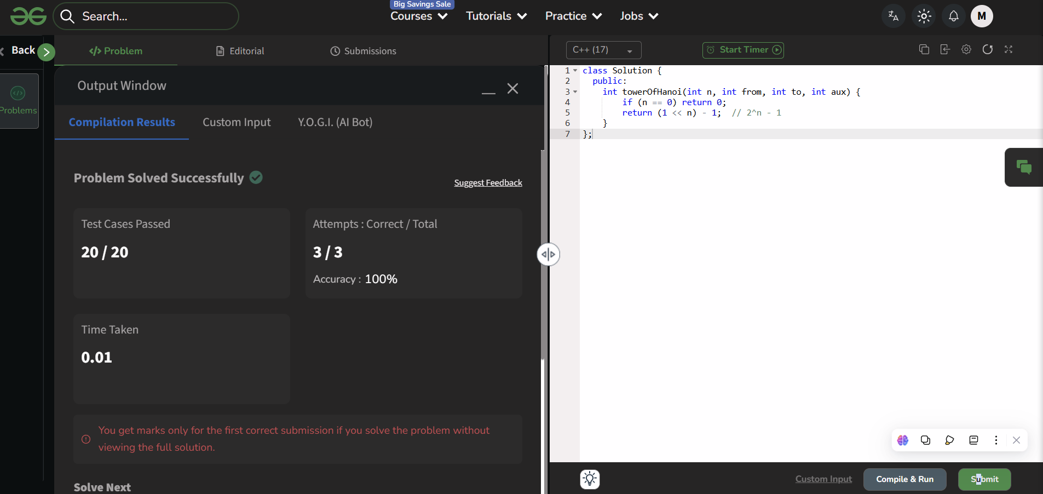
7. Search an element in sorted and rotated array
Given a sorted and rotated array A of N distinct elements which are rotated at some

point, and given an element K. The task is to find the index of the given element K in

array A.
15

7.1 Examples
Example 1 | Input:  N = 9  A[] = {5,6,7,8,9,10,1,2,3}  K = 10  Output: 5  Explanation: 10 is found at index 5.
Example 2 | Input:  N = 3  A[] = {3,1,2}  K = 1  Output: 1
7.2 Constraints
1 ≤ N ≤ 107
0 ≤ Ai ≤ 108
1 ≤ K ≤ 108​
2. Source Code
Solution — JAVA
int Search(vector<int> vec, int K) { int low = 0, high = vec.size() - 1;
while (low <= high) {
int mid = low + (high - low) / 2;
16

if (vec[mid] == K)
return mid;
} | } // Left half is sorted if (vec[low] <= vec[mid]) { if (K >= vec[low] && K < vec[mid]) high = mid - 1; // K lies in left half else low = mid + 1; // K lies in right half } // Right half is sorted else { if (K > vec[mid] && K <= vec[high]) low = mid + 1; // K lies in right half else high = mid - 1; // K lies in left half }  return -1; // K not found

3. Acceptance Screenshot
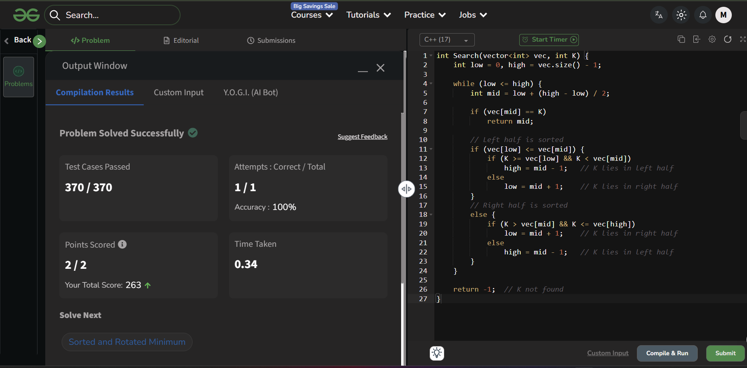
8. Sorted and Rotated Minimum
A sorted arrayof distinct elements arr[] is rotated at some unknown

point, the task is to find the minimum element in it.
17

8.1 Examples
Example 1 | Input: arr[] = [5, 6, 1, 2, 3, 4]  Output: 1  Explanation: 1 is the minimum element in the array.
Example 2 | Input: arr[] = [3, 1, 2]  Output: 1  Explanation: Here 1 is the minimum element.
Example 3 | Input: arr[] = [4, 2, 3]  Output: 2  Explanation: Here 2 is the minimum element.
8.2 Constraints
1 ≤ N ≤ 107
0 ≤ Ai ≤ 108
1 ≤ K ≤ 108
2. Source Code
Solution — JAVA
class Solution {
public:
int findMin(vector<int>& arr) {
int low = 0, high = arr.size() - 1;
while (low < high) {
int mid = low + (high - low) / 2;
} | if (arr[mid] > arr[high]) low = mid + 1;  else  high = mid;

18

} }; | return arr[low];

3. Acceptance Screenshot
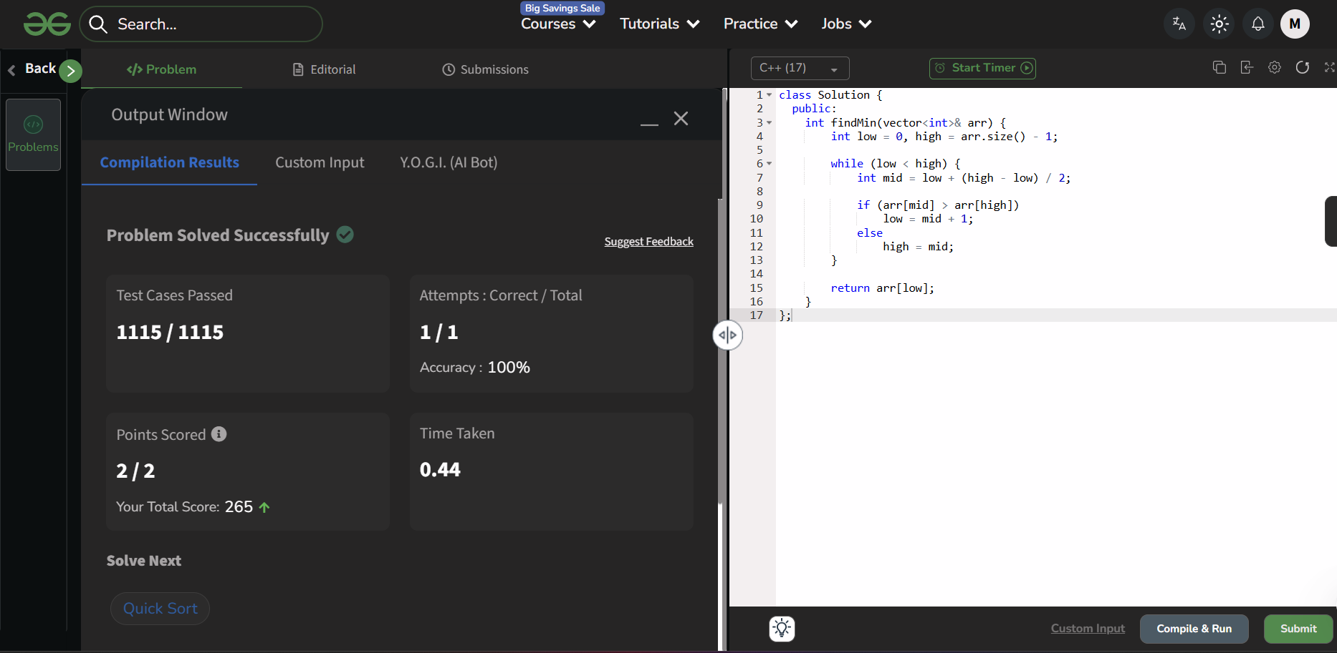
9.Quick Sort
Implement Quick Sort, a Divide and Conquer algorithm, to sort an array,

arr[] in ascending order.​

Given an array arr[], with starting index low and ending index high,

complete the functions partition() and quickSort().​

Use the last element as the pivot, so that all elements less than or equal to the

pivot come before it, and elements greater than the pivot follow it.

Note: low and high are inclusive.
9.1 Examples
Example 1 | Input: arr[] = [4, 1, 3, 9, 7]
19

Output: [1, 3, 4, 7, 9]
Explanation: After sorting, all elements are arranged in ascending order.
Example 2 | Input: arr[] = [2, 1, 6, 10, 4, 1, 3, 9, 7]  Output: [1, 1, 2, 3, 4, 6, 7, 9, 10]  Explanation: Duplicate elements (1) are retained in sorted order.
Example 3 | Input: arr[] = [5, 5, 5, 5]  Output: [5, 5, 5, 5]  Explanation: All elements are identical, so the array remains unchanged.
9.2 Constraints
1 ≤ arr.size() ≤ 105
1 ≤ arr[i] ≤ 105
2. Source Code
Solution — JAVA
#include <bits/stdc++.h>
using namespace std;
class Solution {
public:
// Function to partition the array around the pivot (last element) int partition(vector<int>& arr, int low, int high) {
int pivot = arr[high];
int i = low - 1;
for (int j = low; j < high; j++) {
if (arr[j] <= pivot) {
i++;
swap(arr[i], arr[j]);
}
}
swap(arr[i + 1], arr[high]);
return i + 1;
20

}
// Function to implement QuickSort algorithm
void quickSort(vector<int>& arr, int low, int high) { if (low < high) {
int pi = partition(arr, low, high);
quickSort(arr, low, pi - 1);
quickSort(arr, pi + 1, high);
}
}
};
3. Acceptance Screenshot
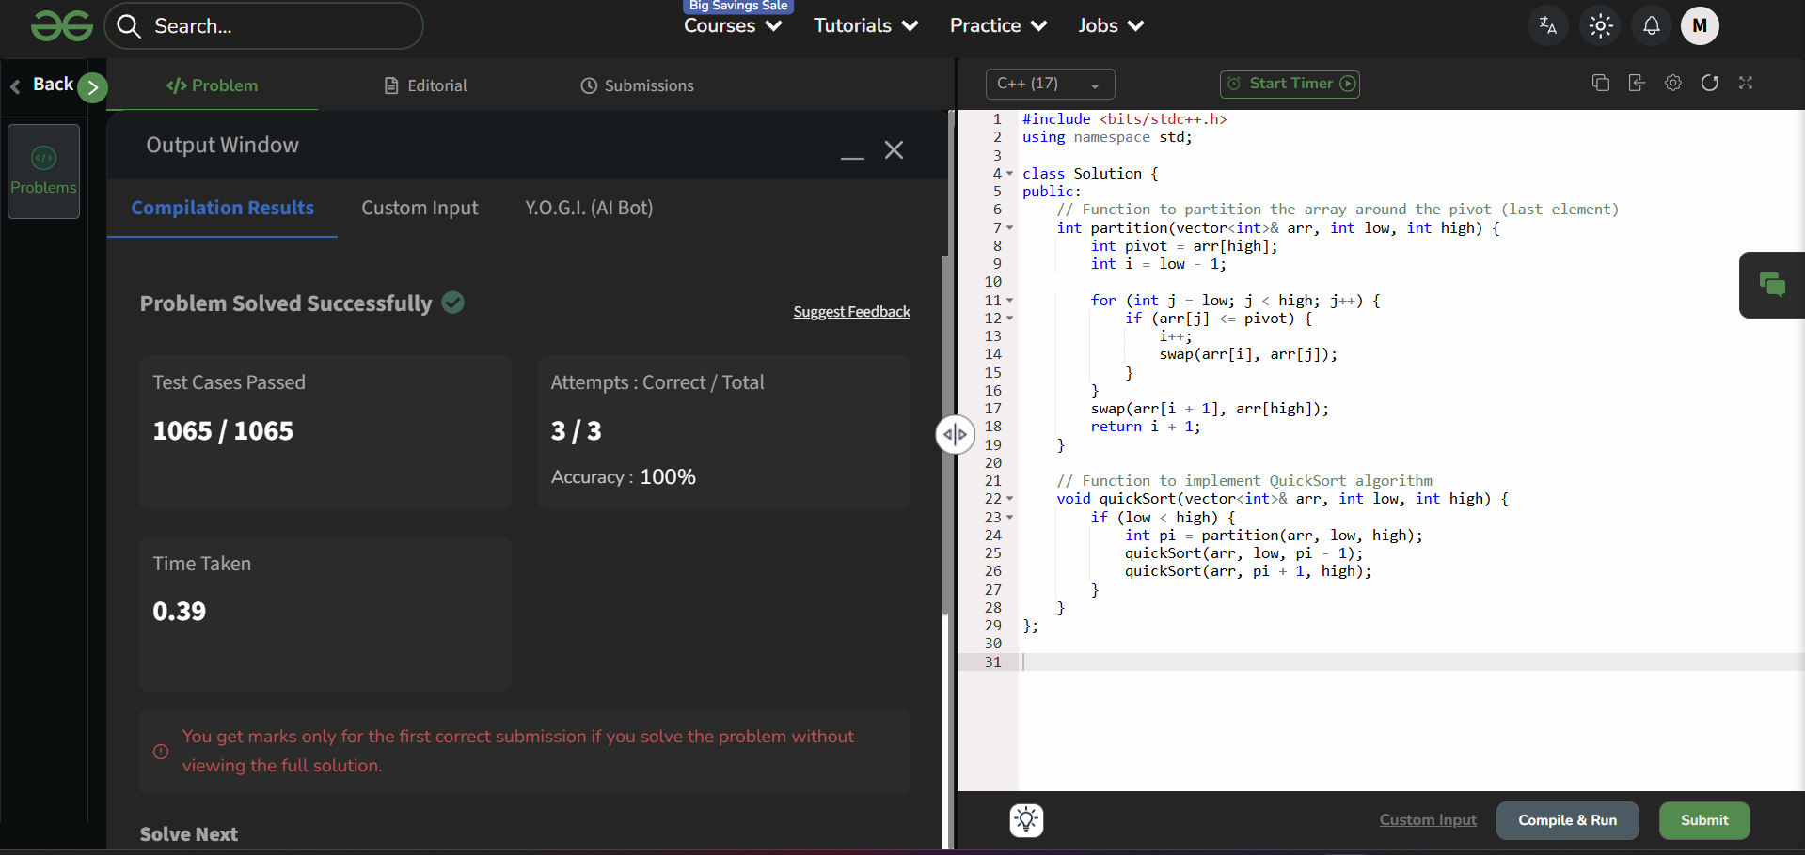
10.Merge Sort
Given an array arr[], its starting position l and its ending position r. Sort the array using
the merge sort algorithm.
10.1 Examples
Example 1 | Input: arr[] = [4, 1, 3, 9, 7]  Output: [1, 3, 4, 7, 9]  Explanation: We get the sorted array after using merge sort
Example 2 | Input: arr[] = [10, 9, 8, 7, 6, 5, 4, 3, 2, 1] Output: [1, 2, 3, 4, 5, 6, 7, 8, 9, 10]
21

Explanation: We get the sorted array after using merge sort
10.2 Constraints
1 ≤ arr.size() ≤ 105
1 ≤ arr[i] ≤ 105
2. Source Code
Solution — JAVA
class Solution {
public:
void merge(vector<int>& arr, int l, int mid, int r) { vector<int> temp;
int i = l, j = mid + 1;
while (i <= mid && j <= r) {
if (arr[i] <= arr[j])
temp.push_back(arr[i++]);
else
temp.push_back(arr[j++]);
}
while (i <= mid) temp.push_back(arr[i++]); while (j <= r) temp.push_back(arr[j++]);
} | for (int k = 0; k < temp.size(); k++) arr[l + k] = temp[k];
void mergeSort(vector<int>& arr, int l, int r) { if (l >= r) return;
int mid = l + (r - l) / 2;
} }; | mergeSort(arr, l, mid); // sort left half mergeSort(arr, mid + 1, r); // sort right half merge(arr, l, mid, r); // merge both halves

3. Acceptance Screenshot
22

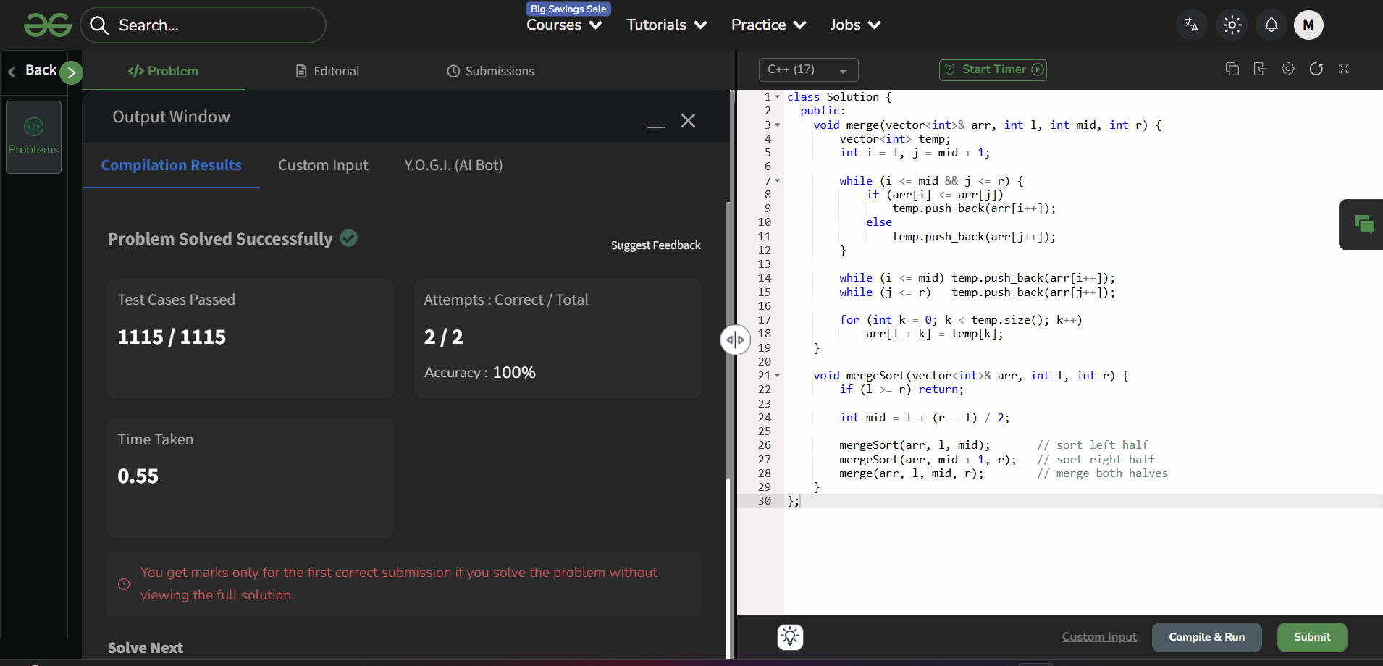
11.Detect Loop in linked list
You are given the head of a singly linked list. You have to determine

whether the given linked list contains a loop or not.A loop exists in a

linked list if the next pointer of the last node points to any other node

in the list (including itself), rather than being null.

Note: Internally, pos(1 based index) is used to denote the position of the

node that tail's next pointer is connected to. If pos = 0, it means the last

node points to null. Note that pos is not passed as a parameter.
11.1 Examples
Example 1 | Input: pos = 2,
23

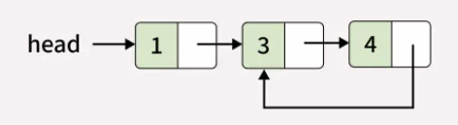
Output: true
Explanation: There exists a loop as last node is connected back to the second node.
Example 2 | Input: pos = 0,    Output: false  Explanation: There exists no loop in given linked list.
Example 3 | Input: pos = 1,  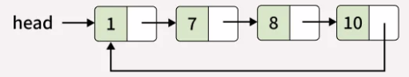  Output: true  Explanation: There exists a loop as last node is connected back to the first node.
11.2 Constraints
1 ≤ number of nodes ≤ 105
1 ≤ node->data ≤ 103
0 ≤ pos ≤ number of nodes
24

2. Source Code
Solution — JAVA
/*
class Node {
public:
int data;
Node *next;
Node(int x) {
data = x;
next = NULL;
}
} */
class Solution {
public:
bool detectLoop(Node* head) {
Node* slow = head;
Node* fast = head;
while (fast != NULL && fast->next != NULL) { slow = slow->next;
fast = fast->next->next;
} }; | } if (slow == fast) return true;  return false;

3. Acceptance Screenshot
25

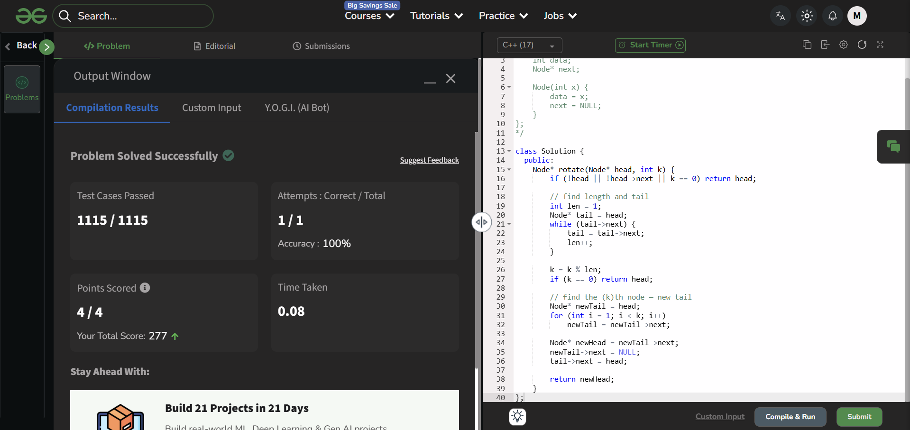
12.Rotate a Linked List
You are given the head of a singly linked list, you have to left rotate the linked list k

times. Return the head of the modified linked list.
12.1 Examples
Example 1 | Input: k = 4,    Output: 50 -> 10 -> 20 -> 30 -> 40 Explanation:  Rotate 1:20 -> 30 -> 40 -> 50 -> 10 Rotate 2:30 -> 40 -> 50 -> 10 -> 20 Rotate 3:40 -> 50 -> 10 -> 20 -> 30 Rotate 4:50 -> 10 -> 20 -> 30 -> 40
26

 | 
Example 2 | Input: k = 6,    Output: 30 -> 40 -> 10 -> 20  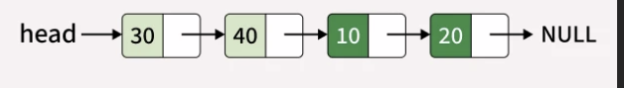
12.2 Constraints
1 ≤ number of nodes ≤ 105
0 ≤ k ≤ 109
0 ≤ node.data ≤ 109
2. Source Code
Solution — JAVA
/*
class Node {
int data;
Node* next;
Node(int x) {
data = x;
next = NULL;
27

}
};
*/
class Solution {
public:
Node* rotate(Node* head, int k) {
if (!head || !head->next || k == 0) return head;
// find length and tail
int len = 1;
Node* tail = head;
while (tail->next) {
tail = tail->next;
len++;
}
k = k % len;
if (k == 0) return head;
// find the (k)th node — new tail
Node* newTail = head;
for (int i = 1; i < k; i++)
newTail = newTail->next;
Node* newHead = newTail->next;
newTail->next = NULL;
tail->next = head;
} }; | return newHead;

3. Acceptance Screenshot

28

