Marianne LaRosa
Combinatorics
4/10/06

Latin Squares, Magic Squares, and Sudoku

Section 1: Latin Squares

1.1: “The subject of Latin squares is an old one and it abounds with unsolved problems, many of them up to 200 years old.” The study of Latin squares may have started with the movements and placements of pieces on a chess board. The first written use of Latin squares was to solve a problem involving the four court cards in a deck of playing cards. The problem is to place the 16 court cards so that no row, column, or diagonal has a card from the same suit or rank. The enumeration of solutions to this problem was published in 1723. Euler was the first person to discuss the enumeration of different order Latin squares and also was the first to develop Latin squares systematically. In 1779, he proposed the 36 officer problem, which was not proved to be unsolvable until the 1900s. This problem involved 36 officers, each with a rank and a regiment. There are six each of the six ranks and there are six regiments where each of the six soldiers of each rank has a different regiment. The question asks if it is possible to place the officers in a square such that no row or column has two officers with the same rank or regiment.

1.2: “A Latin square is an nxn table filled with n different symbols in such a way that each symbol occurs exactly once in each row and exactly once in each column.” The order of an nxn Latin square is n. A reduced Latin square is a Latin square that has the first row and the first column in natural order. Here are some examples of different order Latin squares.
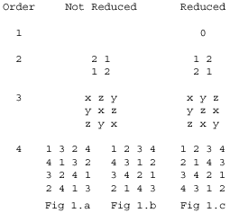
Note that there are no Latin squares of order 1 that are not reduced. Also note that Fig 1.c is a reduced Latin square obtained by permuting the rows and columns of Fig 1.a. The second and third columns of Fig 1.a are swapped to form Fig 1.b. Then the second and fourth rows of Fig 1.b are swapped to form Fig 1.c.

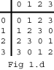
Latin squares can also be used to show a group table of a binary operation on a group. Fig 1.d shows the group table of addition modulus four on {0, 1, 2, 3}. This is a reduced Latin square of order 4.

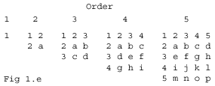
1.3: The enumeration of all the possible Latin squares for orders greater than 5 or 6 is fairly complex. Instead of counting every possible Latin square, it makes the problem a bit easier by counting only reduced Latin squares and then using this result to come up with the total number of possible Latin squares for a specific order. The number of reduced Latin squares becomes very large as order increases and many calculations for the number of reduced Latin squares of orders greater than 6 are executed by computers. Fig 1.e shows the basic structure for all reduced Latin squares of orders 1 to 5 inclusively. Note that there is only one reduced Latin square for orders 1, 2, and 3. The element a in the order two square can only be 1. In the order three square, the 3 can only be placed in the a spot so b and c must be 1 and d must be 2. In the order four square, note that c can be either 1 or 3. If c is 1, then a is 3, b is 4, and there is one resulting reduced Latin square. If c is 3, we note that b can be either 1 or 4. If c is 3 and b is 1, a is 4, d is 1, g is 3, and there is one resulting reduced Latin square. If c is 3 and b is 4, a is 1, d is 4, g is 3, and e can be either 1 or 2 so there are two resulting reduced Latin squares. Thus there are a total of four reduced Latin squares of order four. Note that using this method takes much longer for order five and larger Latin squares because there are a greater number of arrangements. There are 56 reduced Latin squares of order five, 9,408 of order six, 16,942,080 of order seven, and 535,281,401,856 of order eight. The number of reduced Latin squares for a particular order allows us to calculate the total number of Latin squares for that order.

Theorem: The total number of Latin squares of order n is equal to n!(n-1)! times the number of reduced Latin squares of order n.
Proof: An order n reduced Latin square has n rows and n columns. To form any Latin square of order n, reduced or not reduced, we can permute the rows and columns of a reduced Latin square of order n. There are n! ways to permute the n columns and n! ways to permute the n rows. So there are (n!)² ways to permute the columns and then the rows to form all the possible Latin squares of order n. However, this ends up over counting. After the columns and rows have been permuted, the top row of the Latin square is of the form a₁, a₂, a₃,…, a_{n}. Instead of doing this by our series of column and then row permutations, we first permute the columns so that the top row is of the form a₁, a₂, a₃,…, a_{n}. Then we can permute the rows so that we end up with the same Latin square. To correct this problem, we make the first row fixed after permuting the columns so that there is only one way to end up with the Latin square that has a top row of a₁, a₂, a₃,…, a_{n}. So there are (n-1)! ways to permute the rows and not n!. Note that one reduced Latin square cannot be obtained from another different reduced Latin square by permuting columns and rows. Thus there are n!(n-1)! ways to permute the columns and then the rows of the reduced Latin squares to form all the possible Latin squares. Therefore, the total number of Latin squares of order n is equal to n!(n-1)! times the number of reduced Latin squares of order n. ☺

1.4: Latin squares can be used to create magic squares. In the 1700s, Euler developed a method for creating magic squares from two orthogonal Latin squares.

Def: Two Latin squares A and B are orthogonal if each of the n² ordered pairs (A_{ij}, B_{ij}) occurs exactly once for all 1 ≤ i, j ≤ n. A_{ij} is the value in the ith row and the jth column of Latin square A and B_{ij} is the value in the ith row and the jth column of Latin square B. We can form a Graeco-Latin square, or an Euler square, by making a table of the ordered pairs formed from two orthogonal Latin squares.

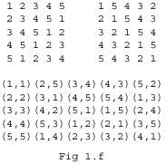
Refer back to Fig 1.a and Fig 1.b. Looking at the first column and the first row, the two Latin squares form the ordered pair (1,1). Now looking at the last column and the third row, the two Latin squares again form the ordered pair (1,1). Thus these two Latin squares are not orthogonal. Also note that there are no pairs of orthogonal Latin squares of orders one or two. The two order three Latin squares in the same diagram are orthogonal because no ordered pair is repeated. Fig 1.f shows two order five orthogonal Latin squares and the Graeco-Latin square formed by their ordered pairs. Graeco-Latin squares can be used to form magic squares, though magic squares formed in this way do not always share the same properties as many other magic squares. We will discuss these methods in later sections which focus on the formation of magic squares and other squares that share similar properties.

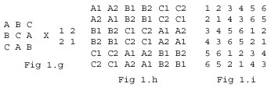
1.5: It is fairly simple to construct Graeco-Latin squares of orders three, four and five. There are no Graeco-Latin squares of orders one, two, or six, but we can create larger order Graeco-Latin squares by using two different methods, the direct product and the singular direct product. The direct product, AXB, combines a Latin square A of order x and a Latin square B of order y to produce a Latin square of order x*y. If two Latin squares A and C of order x are orthogonal and two Latin squares B and D of order y are orthogonal, then AXB and CXD are also orthogonal. AXB and CXD can then be used to created a Graeco-Latin square of order x*y. Fig 1.g shows two Latin squares, one of order three and one of order two. Fig 1.h shows the direct product of these two Latin squares. Note that there are nine 2x2 sub-squares in Fig 1.h. Each 2x2 sub-square corresponds to one of the nine values in the order three Latin square. The order two Latin square is repeated in each of the 2x2 sub-squares and each value is preceded by the corresponding value from the order three Latin square. Fig 1.i is the same as Fig 1.h except that each symbol A1, A2,…, C2 is replaced by 1, 2,…, 6. Note that there are no orthogonal pairs of order two Latin squares so a pair of orthogonal Latin squares of order six cannot be created using this method. The singular direct product requires three Latin squares, one of order k, one of order n, and one of order n+m. The Latin square of order n+m contains a Latin square of order m. This produces a Latin square of order m+nk. If this operation is performed on two trios of Latin squares where each of the three is orthogonal to the Latin square of the same order in the other trio, then the resulting two Latin squares will be orthogonal.

1.6: Referring back to section 1.1, we would like to solve the 16 court card problem. We have the four aces, four kings, four queens, and four jacks from a playing card deck which are each of a different suit, hearts, spades, clubs, and diamonds. We would like to place the cards in four rows of four cards each such that there is only one card of each suit and each rank in every row, every column, and both of the main diagonals. In other words, we are looking for a pair of orthogonal diagonal Latin squares of order four.

Def: A Latin square is left semi-diagonal if a₁₁, a₂₂,…,a_{nn} are distinct values and is right semi-diagonal if a_{1n}, a_{2(n-1)},…, a_{n1} are distinct values where a_{ij} is the value in the ith row and the ith column of a Latin square. A Latin square is diagonal if it is both left semi-diagonal and right semi-diagonal.

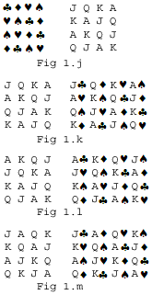
First take a diagonal Latin square of order four which has the four suits as symbols. We can swap the rows or the columns of this Latin square and then change the symbols to the four ranks in order to obtain a diagonal Latin square of order four that is orthogonal to the first. We then form a Graeco-Latin square where an ordered pair is replaced by a card that has both a suit and a rank. Fig 1.j shows an order four diagonal Latin square composed of the four card suits. This also shows the same Latin square composed of card ranks where clubs are replaced by jacks, diamonds are replaced by queens, hearts are replaced by kings, and spades are replaced by aces. Note that these two Latin squares are most certainly not orthogonal. Fig 1.k shows the order four Latin square obtained by fixing the first row of the Latin square in Fig 1.j and permuting the remaining three rows so that the third row is now the second row, the fourth row is now the third row, and the second row is now the fourth row. Fig 1.l shows the Latin square obtained by swapping the symbols in Fig 1.k. Jacks are replaced with aces, queens are replaced with kings, kings are replaced with queens, and aces are replaced with jacks. Fig 1.m shows the Latin square obtained by fixing the first column of the Latin square in Fig 1.j and permuting the remaining columns so that the fourth column is now the second column, the second column is now the third column, and the third column is now the fourth column. Fig 1.k, 1.l, and 1.m all show Graeco-Latin squares that solve our original problem because they combine a diagonal Latin square of the four card suits with an orthogonal diagonal Latin square of the four card ranks.

Section 2: Magic Squares

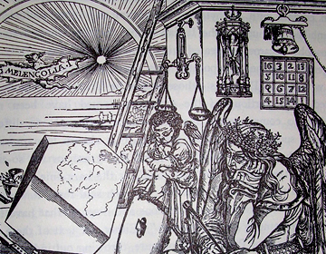
2.1: The study of magic squares dates back to ancient times. They were used by Arabian astrologers in the calculation of horoscopes as early as the 9th century. Examples also were found in Chinese literature in the 1100s, which were copied from older documents. A 3x3 magic square appears in the Loh-Shu, the scroll of the river Loh. Loh-Shu is linked to Fuh-Hi, the mythical founder of China, who is reported to have lived between 2858 and 2733BC. In the scroll, odd numbers are represented with white dots and even numbers are represented with black dots. White is tied to the yang, or heaven, and black is tied to the yin, or earth. This magic square also appears on the back of a turtle in a Chinese story where discovering that the rows, columns, and diagonals all add up to 15 is a key for solving a problem. Magic squares also appear in the Yih-King, an ancient Chinese document that Confucius (551-479BC) wrote an appendix to, and the painting “Melancholia,” which was finished by Albert Dürer in 1514.

Def: A magic square is an nxn square containing exactly one of each number from 1 to n² where all of the rows, all of the columns, and both main diagonals add up to the same number. The order of an nxn magic square is n. There are also variations of magic squares where only the numbers 1 to n are used and also semi-magic squares where only the rows and columns but not the diagonals add up to the same number. Note that there are no magic squares of order 2 because numbers cannot be placed such that the rows and columns both have the same sum.

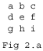
2.2: There are several different ways to construct magic squares. The construction is slightly different for even and odd orders. The simplest magic squares besides the trivial order 1 square are the order 3 magic squares. Fig 2.a will be used to show how values can be arranged to form a magic square of order 3.

Theorem: The least element cannot occupy the center (e in Fig 2.a) of a magic square of order 3. Note that this proof can also be extended to apply to magic squares of any odd order, except the trivial order 1 magic square.
Proof: First note that (1) a+e+i = S, (2) d+e+f = S, (3) g+e+c = S, (4) a+d+g = S, and (5) c+f+i = S because all of the rows, all of the columns, and both of the main diagonals in a magic square add up to the same number, which we will refer to as S. Adding together equations (1), (2), and (3) and subtracting equations (4) and (5), we obtain e = S/3. Substituting 3e into equation (1), we get a+e+i = 3e so a+i = 2e, or in other words, e is the average of a and i. This means that the sum of a and i must be even. Assume, for a contradiction, that e is the least element. Then both a and i are larger than e. But e is the average of a and i, so either a or i must be less than e because no two values can be equal. This is a contradiction, so e cannot be the least element. Therefore, the least element cannot occupy the center of a magic square of order 3. ☺

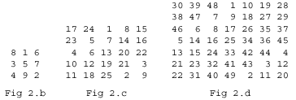
2.3: The construction of odd order magic squares is fairly simple. Start by placing the 1 in the center cell of the top row. Place each consecutive number one cell up and to the right of the previous cell. The bottom row is up from the top row and the leftmost column is to the right of the rightmost column. If a cell one cell up and to the right of a previous cell is already filled, place the next number one cell down from the previous cell instead. Examples of this construction are shown in Fig 2.b, 2.c, and 2.d for orders 3, 5, and 7 respectively. Note that the sum of each row, each column, and both of the main diagonals equals n(n²+1)/2. This sum is 15 for Fig 2.b, 65 for Fig 2.c, and 175 for Fig 2.d. Also note that the sum of any two numbers of an equal, linear distance from the center of the square is equal to n²+1. For example, 8+2 = 4+6 = 3+7 = 10 = 3²+1 in Fig 2.b, 24+2 = 1+25 = 7+19 = 10+16 = 26 = 5²+1 in Fig 2.c, and 19+31 = 48+2 = 6+44 = 5+45 = 24+26 = 21+29 = 50 = 7²+1 in Fig 2.d.

2.4: The construction of even order magic squares is a bit more complicated. There are several different ways to construct even order magic squares. The first two methods are dependent on the order of the magic square.

Def: A magic square is singly even if its order is of the form 2(2m+1) and is doubly even if its order is of the form 4m where m is a positive integer.

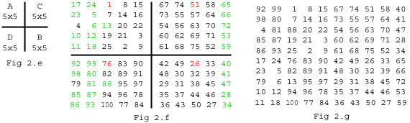
In order to construct a singly even magic square, we first divide the square into four equal quarters and label them A, B, C, and D as in Fig 2.e. Then fill each sub-square, in A-B-C-D order, using the same method as the construction of odd order magic squares starting with the least available number. An example of starting values for each of the four sub-squares is shown in Fig 2.f with each starting value highlighted in red. This will yield a square, such as the order 2(2*2+1) = 10 square shown in Fig 2.f, whose columns all add up to the same number, but a few numbers need to be swapped before the rows and each of the diagonals add up to the same number as well. In order to pick the cells that need to be swapped, we look at the sub-squares A and C. In the middle row of A, take m consecutive cells starting one cell in from the left. In all the other rows of A, take m consecutive cells starting from the leftmost cell. These cells must be swapped with the cells in D that are in the same position. For example, in Fig 2.f, 17 is swapped with 92, 6 is swapped with 81, 13 is swapped with 88, and 12 is swapped with 87. After these cells have been swapped, take the rightmost m-1 columns of C and swap them with the m-1 rightmost columns of B. In Fig 2.f, this means 65 swaps with 40 and 53 swaps with 28. Note that because Fig 2.f shows an order 10 square so m=2, which means only one column needs swapping in C and two cells per row in A need swapping. All of the cells that need to be swapped are highlighted green in Fig 2.f. After all cells have been swapped, the resulting square is a magic square. The finished magic square is shown in Fig 2.g.

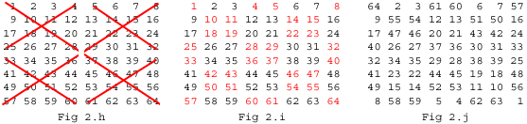
In order to construct a doubly even order magic square, start by placing a 1 in the top left cell and write the numbers in natural order across each row. When one row is finished, start the next row by placing the least available number in the leftmost cell. Now some of the cells must be swapped with their complement where a number and its complement add up to n²+1. To find which cells need to be swapped, we take the main diagonals of each 4x4 sub-square. These diagonals are shown for the order 4*2 = 8 square in Fig 2.h. The numbers which need to be swapped with their complements are highlighted in red in Fig 2.i. For example, 4 swaps with 61, 43 swaps with 22, 11 swaps with 54, and 25 swaps with 40. After the numbers in the main diagonals of each 4x4 sub-square have been swapped with their complements, the resulting square is a magic square. A magic square of order 8 constructed with this method is shown in Fig 2.j. Note that the sum of two cells which are equidistant from the center of the magic square equals n²+1, which is 65 = 64+1 = 6+59 = 29+36 = 34+31 in Fig 2.j.

2.5: Magic squares can also be constructed with a set of sub-squares that are also magic squares. These magic squares are similar to Sudoku puzzles and have their own specific method for construction.

Def: A composite magic square is an nxn magic square made of j² mxm sub-squares that are also magic squares. Note that n = j*m because there are j rows and j columns each of which contains m rows or m columns respectively. For simplicity’s sake, we will look specifically at order 9 composite magic squares, which are of the smallest possible order for composite magic squares besides the trivial square containing only one cell.
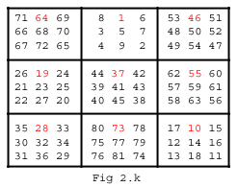
First divide the square into j² sub-squares, or in the case of n=9, three sub-squares. Assign a number to each sub-square by creating a magic square of order j. This is the order in which each sub-square will be filled. Starting with the first sub-square, create a magic square of order m, or in this case order 3, starting with the number 1. Recall sections 2.3 and 2.4 for creating magic squares of odd and even orders. Refer specifically to Fig 2.b for the construction of a composite magic square of order 9. Now go to the next sub-square and create another magic square of order m starting with the least available number. Repeat this process until all of the sub-squares are full. An example of a composite magic square of order 9 constructed using this method is shown in Fig 2.k. The starting value of each sub-square is highlighted in red.

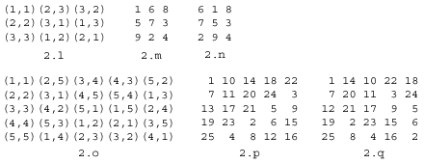
2.6: Magic squares and semi-magic squares can be created from Graeco-Latin squares. For a reminder of how Graeco-Latin squares are constructed, refer to section 1.4. In order to turn a Graeco-Latin square of order n, with pairs of (1,1),…, (n,n), into a magic square or semi-magic square of order n, we take each pair (a,b) and replace it with the number (a-1)n+b. This makes all of the rows and columns add up to the same number and also makes each number 1,…, n appear only once in the square. However, the main diagonals may not add up to the same number, but we can swap the columns in order to meet this constraint. Using this method, Fig 2.m is a semi-magic square obtained from the Latin square in Fig 2.l and Fig 2.p is a semi-magic square obtained from the Latin square in Fig 2.o. Fig 2.n is a magic square obtained by permuting the columns of the semi-magic square in Fig 2.m and Fig 2.q is a magic square obtained by permuting the columns of the semi-magic square in Fig 2.p. Both of these magic squares also have both main diagonals add up to the same number as the rows and columns.

Theorem: If there is an orthogonal pair of diagonal Latin squares of order n, then an nxn magic square can be constructed with only one each of the integers from 0 to n²-1.
Proof: First note that all the rows, all the columns, and both the main diagonals of a diagonal Latin square have the same sum. Take two orthogonal diagonal Latin squares of order n that contain the values 0,…, n-1. Each of the rows, columns, and main diagonals in A have the same sum and this is also true for B. Instead of creating a normal Graeco-Latin square with these Latin squares, create a number ab instead of each ordered pair (a,b) where a is the first digit and b is the second digit of a base n number. We want to create a new square by converting each of these numbers to base 10, which is the same as taking the number ab and changing it to an+b. Because there are n² distinct (a,b) pairs in the Graeco-Latin square formed by the two original Latin squares, the numbers ab will also be distinct and the corresponding base 10 numbers will also be distinct. The smallest number ab will be 00 and the largest number ab will be (n-1)(n-1), so the smallest base 10 number appearing in the new square will be 0 and the largest base 10 number appearing in the new square will be (n-1)n+(n-1) = n²-1. Because there are n2 distinct numbers in the new square ranging from 0 to n²-1, the new square will have only one of each integer from 0 to n²-1. We also know that because all we have done is changed our number base that the rows, columns, and main diagonals have the same sum. Therefore, if there is an orthogonal pair of diagonal Latin squares of order n, then an nxn magic square can be constructed with only one each of the integers from 0 to n²-1. ☺

Section 3: Sudoku

3.1: Sudoku squares are similar to composite magic squares in shape however, solving a Sudoku puzzle has nothing to do with adding numbers. Sudoku was not originally a Japanese creation. The first know Sudoku puzzle was called Number Place and was published in 1979 in a New York puzzle magazine called Dell Pencil Puzzles & Word Games. The company Nikoli published the same kind of puzzle in a Japanese puzzle magazine in 1984 under the name sunji wa dokushin ni kagiru. This was later shortened to Sudoku, which means single number. Only a single number goes into each cell of a Sudoku. The puzzle became more popular in Japan with 15 Sudoku magazines and 30 Sudoku books currently being published on a monthly basis. Wayne Gould, a former Hong Kong judge, learned of Sudoku puzzles in a 1997 trip to Japan. He then designed computer programs over a few years to create Sudoku puzzles of varying difficulty levels. He provided these puzzles to newspapers over the world, the first of which was The Times in London in 2004. The Sudoku craze has recently returned to the United States and the puzzles are currently published in many American magazines.

Def: A Sudoku is a 9x9 Latin square with the numbers 1 to 9 as symbols that has an additional restriction where each of the nine 3x3 sub-squares contains exactly one of each of the numbers 1 to 9.

3.2: In order for a Sudoku to be a good puzzle, some numbers are left out so that there is a unique solution but it is appropriately difficult. The difficulty of the puzzle depends on how many numbers are left out and which numbers are left out. There are several strategies for finding the unique solution to a Sudoku puzzle. Fig 3.a gives a simple, unsolved Sudoku puzzle. One way to work on solving a Sudoku puzzle is to pick a number and see which cells it cannot be placed in. An example of this is shown in Fig 3.b. Cells are shaded pink if the number 6 appears in its row, column, or 3x3 sub-square. Note that the bottom left sub-square does not contain a 6 and only has one cell that is not shaded pink or occupied by another number. The red 6 is the only place where a 6 can go in this sub-square. Also note that the rightmost sub-square in the middle row does not contain a 6 and has only one cell that is not shaded pink or occupied by another number. This cell must also be occupied by a 6. Another way to work on solving a Sudoku puzzle is to look at one cell and see which numbers can be placed there. An example of this is shown in Fig 3.c. Looking at the red cell, there is a 9 and a 6 in the same sub-square, a 1, 2, 5, and 7 in the same row, and a 4 and an 8 in the same column. The only number that is not in the same row, column, or sub-square as this cell is 3, so a 3 must go in the red cell. We can also fill in gaps when there is only one empty cell remaining in a row, column, or sub-square. Fig 3.d has three red squares. The leftmost red square is the last empty cell in a column so it must be occupied by a 9. The middle red square is the last empty cell in a sub-square so it must be occupied by a 2. The rightmost red square is the last empty cell in a row so it must be occupied by a 9. If these three methods do not yield any results, there is another method for working on solving Sudoku puzzles that takes a bit more time. The green numbers in Fig 3.d are small numbers that are penciled into Sudoku puzzles when more than one value can logically belong in a cell. Sometimes writing these numbers in each empty cell will make it clearer where certain numbers can and cannot be placed.
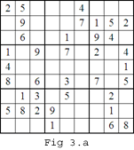
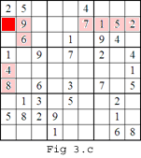
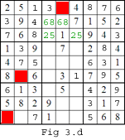
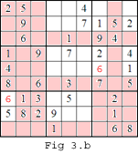
Closing

Latin squares, magic squares, and Sudoku share similar ties though the three are very different. Though magic squares are centuries older than Latin squares, it is possible to create magic squares of nearly any order from an orthogonal pair of Latin squares. It is also much more difficult to count the number of magic squares or Sudoku than it is to count the number of Latin squares. Enumerating all the possible magic squares is difficult because it is sometimes difficult to decide which squares count as a magic square and which do not. Though Sudoku are very similar to Latin squares, the number of possible Sudoku has only been enumerated by brute force where every possible Sudoku arrangement is examined. These three types of squares have many applications in recreational mathematics, though their practicality may be arguable. Sudoku puzzles have become especially popular and magic squares are also an interesting activity for grade school mathematics. Though Sudoku puzzles have just begun to undergo inspection, hopefully future years will see as much research dedicated to Sudoku as has been dedicated to Latin squares and magic squares. ☺

