Dipayan Ghosh
Math 297Q
6 April 2006

The Four-Color Problem and its Theory

Beginnings

Despite all of their quantitative and historical experience in mathematics, it is a certainty that very few mathematicians have heard of the name Francis Guthrie. In fact, mathematics was not even the prime academic field in which he made most of his money – besides being a mathematician, he was also a distinguished lawyer and botanist, a knowledgeable man of his times, in whose honor the South African flora Guthriea capensis and Erica guthriei were named. But Guthrie is most renowned neither for botany nor for law. Every mathematician will have heard of the Four-Color Problem at some point. Guthrie’s most famous work is, indeed, his conjecture regarding the Four-Color Problem.
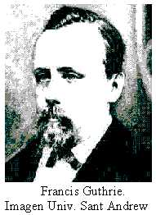
Augustus de Morgan, professor of mathematics at the University College in London and co-father of the science of logic (with Gregory Boole) through his De Morgan Laws, wrote in a letter dating back to 1852, “A student of mine…says, that if a figure be any how divided and the compartments differently coloured so that figures with any portion of common boundary line are differently coloured – four colours may be wanted but not more.” In other words, Guthrie’s conjecture about the Four-Color Problem is that if a geometric shape or figure (like a plane) with divided sections (such as a map) is colored so that each section (or ‘nation’) has a color that is different from the color of any section that it is adjacent to, then at most four colors are required to color the map.
The student that de Morgan referred to in his letter was Frederick Guthrie, younger brother of Francis. Frederick had submitted Francis’ conjecture to de Morgan with his brother’s permission. Unfortunately, the letter, addressed by de Morgan to a fellow mathematician regarded as a genius, Sir Rowan Hamilton, was not received with much interest. Hamilton, who as then a professor at Trinity College in Dublin, is considered today to be the greatest scientist that Ireland has ever produced, and was the first non-American nominated for the American Academy of Science. A few days later the letter was received, however, Hamilton responded by stating that he would not be tackling de Morgan’s problem involving a “quaternion of colours.”
But this would not stop the growth of popularity of the Four-Color Problem. De Morgan quickly circulated the problem along with Francis Guthrie’s proposed conjecture through mathematical societies and to tens of distinguished professors so much so that he, instead of Guthrie, is now thought of as the originator of the problem. It was not until a Frederick Guthrie article in the Proceedings of the Royal Society of Edinburgh was published that Francis received credit for the problem and conjecture. Since then, the alternate name for the Four-Color Problem has been Guthrie’s Problem. A few simple examples of four-color maps follow.

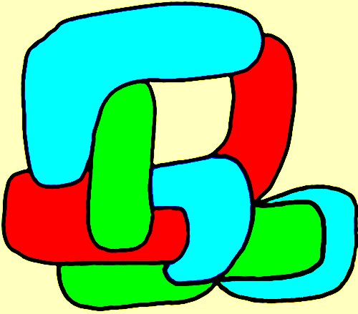
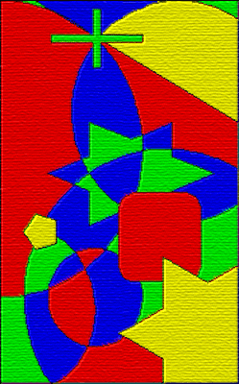

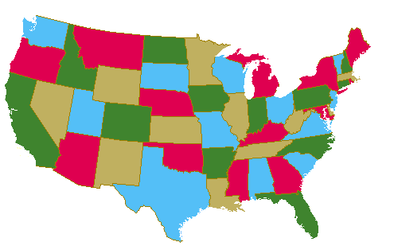

The First Paper and New Ideas

Once the problem had largely been expressed to the mathematical community, enthusiasm was not lost, but no attempted proofs of the Four-Color Problem appeared until 1879. The first paper on the problem, however, appeared as soon as 1878 and was written by the talented British mathematician Arthur Cayley, who worked most in algebra. He attempted to induce more interest for the problem and vigorous searching for its conjecture.
Thus, on 13 June 1878, Cayley attended a meeting of the London Mathematical Society and asked the members if they knew of a proof of the conjecture. In his paper, published in late 1878 and entitled On the Colourings of Maps, Cayley postulated why this problem appears to be so difficult. Of course, there was no proof, let alone any published material about the Four-Color Problem, before he published his paper.
A year later, however, one of the members of the London Mathematical Society, a lawyer named Alfred Kempe, published a paper in which he claimed to have proven Guthrie’s conjecture that only four colors are required to color a map with the specified rules of coloring. In fact, the ‘proof’ was proven to be fallacious eleven years later by Percy Heawood, and Kempe is best known today for his false proof.
Yet this is a poor assessment of Kempe’s paper; the computer-aided proof developed about one hundred years later utilizes a few of the key ideas elucidated by the Kempe ‘proof.’ In the paper in which he published the proof, Kempe introduced two fundamental ideas that have been central to the study of the Four Color Theorem ever since it was released.
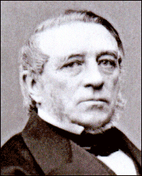
This first of these ideas is the concept of unavoidability. This states that it is impossible to construct a map without the appearance of at least one of four particular (unavoidable) configurations, where a configuration of a map is defined as some arrangement of the sections (or nations) in a graph. These configurations under concern with the concept of unavoidability consist of a region with two neighbors, one with three neighbors, one with four neighbors, and one with five neighbors; at least one must be found in any map.
The second idea is the concept of reducibility. In his paper that included the attempted proof of Guthrie’s conjecture, Kempe showed that if a graph G (which is essentially defined as a map) requires at least five colors and G contains a region with four or fewer neighbors, then there must be a map G which requires five colors even though G’ has fewer regions than G. From this Kempe was able to prove that any map can be five-colored. His error in attempting to prove that a map can always be four-colored occurred when he tried to prove his reducibility criterion for a map containing a region with five or fewer neighbors. Kempe’s short list of unavoidable configurations had to be extended and the 1976 proof analyzed 1,936 distinct cases with a computer to show that each was reducible.
Though Kempe is regrettably most well-known for his embarrassing failure, he was proposed for election to the Royal Society in the year he published his paper and described as “distinguished for his knowledge of and discoveries in kinematics,” and even after the exposure of his oversight by Heawood, in 1897, was elected to the Council of the Royal Society and subsequently became Treasurer of the Society.
The man who proved Kempe wrong also published the first mathematically true formula on the Four-Color Problem in history. Percy Heawood not only exposed the fault of the Kempe proof, but also formulated the Heawood Conjecture, from which followed the Five-Color Theorem, stating that at most five colors may be needed to color a map.
Heawood was a lecturer of mathematics at Durham University and worked at Durham University all his life, eventually getting promoted to Chair of Mathematics in 1911. He was a well-rounded mathematician; Heawood was a member of the Senate from 1905 and served as Vice-Chancellor from 1926 to 1928 and did not retire until 1939 when he was 78.
Heawood spent 60 years of his life working on the Four-Color Problem. He published his first paper on the Four-Color Theorem, entitled Map Colour Theorems, in 1890, when he pointed out the mistake in Kempe’s proof. He stated that he, however, could not add anything to the field, and that all he could say was that Kempe’s proof was incorrect. In the same paper he uses some of Kempe’s ideas on reducibility and unavoidability and proves that five colors suffice.

The Five Color Theorem – Proof

Initially, one associates a graph G to a given map. This means that one puts a vertex in each region of the map and subsequently connects two vertices with an edge when the corresponding regions share a border. The problem is then translated into a graph coloring problem: one has to paint the vertices of the graph so that no edge has endpoints of the same color. The diagram that follows is an exmaple of one such representation of a graph.

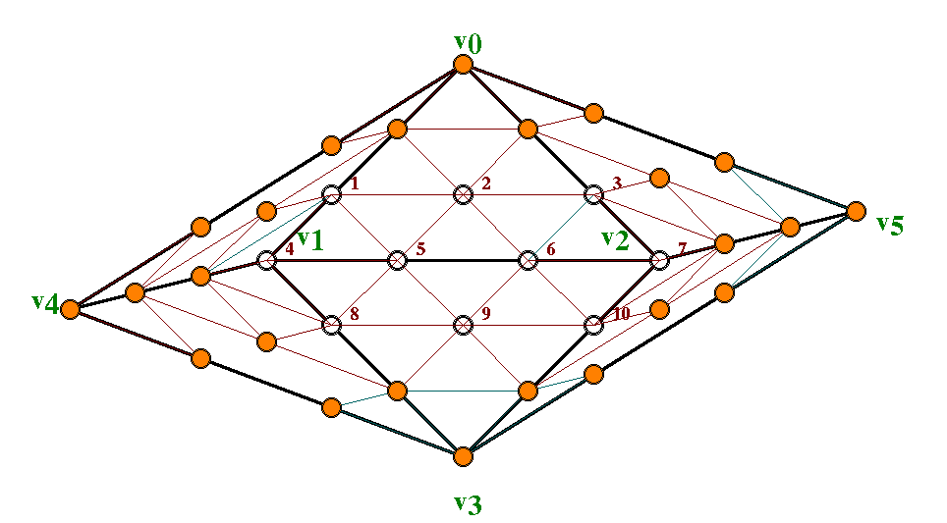
This proof considers a minimum counterexample graph G with the fewest number of vertices which cannot be five-colored. It then uses Euler Characteristics to show that there must be a vertex V shared by at most five edges, and is also based on the fact that G is planar. That is, it may be embedded in the plane without intersecting edges
Now, one must remove V from G. The graph obtained this way is called V’ and has fewer vertices than G. Thus it can be assumed by induction that it can be colored with only five colors. Now look at the five vertices V₁, V₂, V₃, V₄, V₅ that were adjacent to V in a cyclical order. If one were not to use five colors on the vertices, then obviously one could paint V in a consistent way to render the graph five-colored
Let it be that V₁, V₂, V₃, V₄, and V₅ are colored with colors 1, 2, 3, 4, 5 respectively
Now consider the subgraph G₁₃ (G one-three) of V', consisting of the vertices that are colored with colors 1 and 3 only, and edges connecting two of them. Assuming that V₁ and V₃ are in different connected components of G₁₃, the coloration containing V₁ can be reversed, thus assigning color 1 to V which completes the task
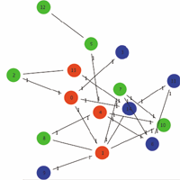
If, in contrast, V₁ and V₃ lie in the same connected component of G₁₃, then a path in G₁₃ that joins them (that is, a sequence of edges and vertices painted only with colors 1 and 3) can be found.
Now consider the subgraph G₂₄ of V' that consists of the vertices colored with colors 2 and 4 only. Apply the same mehods and arguments as in the above case. Then one is able to reverse a coloration on a subgraph of G₂₄ and paint V with, for instance, color 2, or one can connect V₂ and V₄ with a path containing vertices colored with colors 2 and 4 only. The latter possibility is obviously impossible, because a path specified as such would intersect the path we constructed in G₁₃.
Therefore, it is possible for G to be five-colored, contrary to the initial assumption.

One other result from the same paper considered empires, countries which have a number of colonies which must all be colored with the same color. Heawood proved that if an empire contains at most r disjoint portions then on a surface of connectivity h, a map can be colored with at most
{6r + 1 + √ (24h +(6r + 1)² - 72)} / 2
colors. He gave a map with 12 countries, each in two disjoint parts, which required 12 colors.
Another important formula to come from Heawood’s paper was one in which he formulated the equation that determines the chromatic number of a graph G – the smallest number of colors y(g) required to color the vertices of G so that no two adjacent vertices share the same color – that has a certain genus – the largest number of nonintersecting closed curves that can be drawn on the surface of a graph (surface because the graph may be a 3-dimensional form, such as a sphere) without separating it. The formula he generated was

.

The first few values for g = 0, 1 … are 4, 7, 8, 9, 10, 11, and so on. Heawood wrote on the four color problem several more times, in 1897, 1932, 1936, 1943, and 1944.
The general consensus of mathematicians is that three colors are obviously inadequate in some cases. For example, consider the case in which a circular nation is surrounded by three or more conncted nations that ‘wind’ around it. In this case, four colors are required to draw the map. It is also agreed that the proof that five colors suffice when drawing a map using the rules specified by the Four-Color Problem, which was what Heawood proved.
In 1879, however, another attempted proof of the Four-Color Theorem appeared, this time published by Peter Guthrie Tait, a Scottish mathematician and physicist most famous for his infulential, groundbreaking energy physics textbook titled Treatise on Natural Philosophy, published by Baron Kelvin and Tait. But Tait’s proof was also disproved, by Julius Peterson. There then followed a period of time during which there was relatively little activity in the field, as few new ideas were developed.

The Drive into the Twentieth Century

The search for avoidable sets began in 1904 with work of Weinicke. Veblen, who published a paper eight years later on the Four Color Conjecture which generalized Heawood’s work, renewed interest in the Four-Color Problem in the United States.
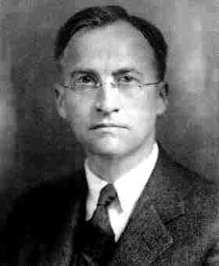
The next major contriution came from George Birkhoff. A Harvard student and later a Harvard professor, Birkhoff was one of the groundbreaking American mathematicians of his generation, best known for what is now called the ergodic theorem. In fact, he was considered by most to be the preeminent mathematician of his time when he was in his prime. Birkhoff introduced the concept of reducibility, as defined before. Later developments in the Four-Color Problem were largely rooted in Birkhoff’s ideas.
In 1922, Philip Franklin published several more examples of unavoidable sets, first discussed by Kempe, and used Birkhoff’s and Kempe’s prior ideas of and developments on reducibility to prove that any map with at most 25 regions can be four-colored. Afterwards, the number of regions which resulted in a four-colorable map was slowly increased. Reynolds increased the upper bound of regions to 27 in 1926, Winn to 35, Ore and Stemple to 39 and Mayer to 95; these developments came during a stretch of over half a century, however.

Theory

What can definitely be said regarding the Four-Color Problem? There is no simple proof by hand. However, the following can be determined.
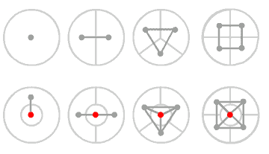
Consider the idea that a map can be shown as a network of nodes, where each region is represented by a node and each boundary between the regions is represented by a link.

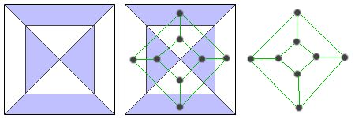

Now, consider the following information:

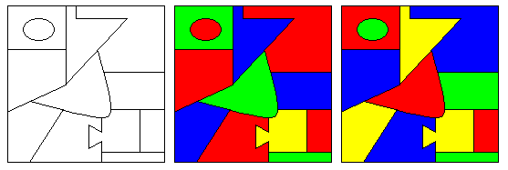
Above on the left is a skeleton map that needs coloring. In the middle and on the right are two possible colorings of the skeleton example. In general, there are many possible ways to color a map using four colors. One way of looking at the Four-Color Problem is by asking: “Are there any ways to create a map that requires five colors to be colored so that no two adjacent nations are colored with the same color?
The middle coloring example is created using an aggressive method of map coloring – a color is applied to a random region, a different one is applied to the adjacent region, and so on. No new colors are used until so required. Once a color exhausted, however, another color is used.
The coloring example on the right side counts the regions. Then, the number of regions is divided by four, and one of each color is applied to the number of regions that most closely equals the resulting quotient. For example, above, there are twelve regions. Thus, each of the colors blue, green, red and yellow are applied 12/4 = 3 times in the map.
We can color the maps using five colors, of course, but we only require four. But is it possible to create a scenario in a planar map coloring such as the one below where four colors do not seem to be enough? (Note that there is a different pattern that does color the map using four colors, shown on the left). The map that illustrates this dilemma is shown on the right.

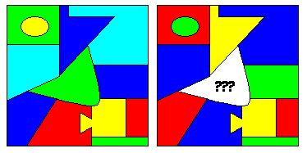

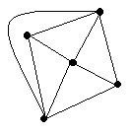
A simple proof of this theorem has eluded mathematicians for centuries, but here is a proof that the four color theorem is true, and that there is no planar map that needs 5 or more colors. First, it must be proven that five dots can never simply be connected (with no intersections). Below is a quadrangle with four of these five dots. The last dot is either inside or outside this quadrangle, and both scenarios completely surround a point before the final connection can be made.

Thus it is impossible for a map of exactly five regions to require 5 colours, because any such map must have each region connected to every single other region. Otherwise only 4 colours are needed
One may also notice that when entirely connecting any four dots, one dot is completely cut off from outside.
This fact leads directly to a proof of the Four Color Theorem. Though Guthrie’s conjecture has not been proven on paper, Appel and Haken in 1977 finally formulated a computer-assisted proof. However, because much of the proof consisted of a far-reaching analysis of many discrete cases by hand and by a computer, some mathematicians still do not accept it. No flaws have yet been found though, and thus the proof appears valid. Their computer-assisted proof utilized the ideas presented in this paper proof.
When one draws a map one region at a time, and only colors a region when forced to do so, one can never have more than three colored blocks exposed at a time. Thus, a fifth color will never be necessary
Now it is known that four vertices on the exterior is an upper bound, and that therefore 1,2 and 3 vertices are accessible. It is also known that vertices 1, 2, 3, and 4 are collapsible, unlike five vertices on the exterior.
To summarize, a map’s graph can always be constructed so that it is ‘exterial,’ (no dot is placed within a region closed off by edges). Graphs that are not fully ‘on’ are weak. There are only a finite number of possibilities when constructing future graphs.

Bibliography

Graph colourings / Roy Nelson & Robin J. Wilson (editors). Cambridge: Addison-Wesley, 1990.

Coloring theories / Steve Fisk. New York: American Mathematical Society, 1989

Four Color Theorem : History, Topological Foundations and Idea of Proof / Rudolf Fritsch, Gerda Fritsch ; translated by Julie Peschke. New York: Springer-Verlag, 1998

Graph Coloring Problems / Tommy R. Jensen, Bjarne Toft. New York: Wiley-Interscience, 1985.

