Dipayan Ghosh
Math 297Q
1 May 2006

The Four-Color Problem
Idea of Proof, Five Color Theorem, and other Notes

Beginnings

Despite all of their quantitative and historical experience in mathematics, it is a certainty that very few mathematicians have heard of the name Francis Guthrie. In fact, mathematics was not even the prime academic field in which he made most of his money – besides being a mathematician, he was also a distinguished lawyer and botanist, a knowledgeable man of his times, in whose honor the South African flora Guthriea capensis and Erica guthriei were named. But Guthrie is most renowned neither for botany nor for law. Every mathematician will have heard of the Four-Color Problem at some point. Guthrie’s most famous work is, indeed, his conjecture regarding the Four-Color Problem [FrF].
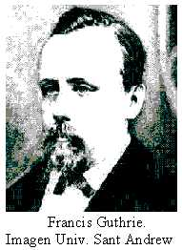
Augustus de Morgan, professor of mathematics at the University College in London and co-father of the science of logic (with Gregory Boole) through his De Morgan Laws, wrote in a letter dating back to 1852, “A student of mine…says, that if a figure be any how divided and the compartments differently coloured so that figures with any portion of common boundary line are differently coloured – four colours may be wanted but not more.” In other words, Guthrie’s conjecture about the Four-Color Problem states that if a plane with divided sections (such as a map) is colored so that each section (or nation) has a color that is different from the color of any section that it is adjacent to, then at most four colors are required to color the map [FrF].
De Morgan quickly circulated the problem along with Francis Guthrie’s proposed conjecture through mathematical societies and to tens of distinguished professors so much so that he, instead of Guthrie, is now thought of as the originator of the problem. It was not until a Frederick Guthrie article in the Proceedings of the Royal Society of Edinburgh was published that Francis received credit for the problem and conjecture. Since then, the alternate name for the Four-Color Problem has been Guthrie’s Problem.
A few simple examples of four-color maps follow.

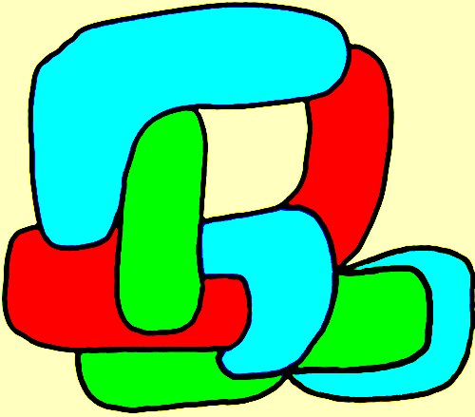
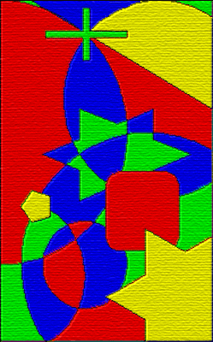

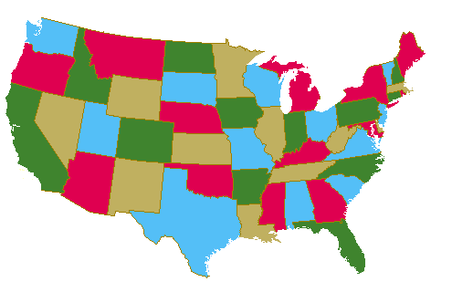

Some Key Concepts

It is essential at this point to understand some key concepts of graph theory and the four-color problem. Specifically, the following terms are definitions that allow us to progress through to the proof of the Five Color Theorem, which will follow.
A map, as described above, any plane separated into regions (e.g. political map of the provinces of some state). More specifically, it is a connected plane (and does not necessarily have to have regions – it may have one region). Furthermore, for some map, the chromatic number of the map is defined to be the minimum number of colors needed to color its regions such that no two neighboring regions are assigned identical colors [NeW].
Every map also has a corresponding graph. A graph G consists of a finite non-empty set of V vertices and a finite set of E distinct edges. See the image below for a map and its corresponding graph [NeW].
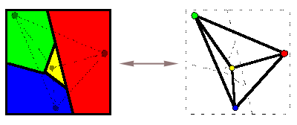

In this image, note that for each region in the map, the graph has a matching vertex, and that each such matching pair has the same color. Note also that for every border region represented in the map, we have an edge in the graph. Thus, while we know that in a four-colorable map there can be no two adjacent regions sharing the same color, we know also that in a four-colorable graph there can be no two vertices connected by an edge that share the same color.
Our focus in this paper will be on planar graphs – those which can be embedded in the plane so that no two edges intersect geometrically except at a vertex to which they are both incident [JeT]. An example of the inverse of this – a nonplanar graph, is shown below, while one example of a planar graph is that shown in the last figure above.
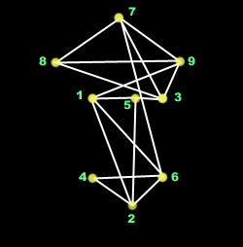

Nonplanar Graph

In this example, observe that the edge connecting vertices 1 and 6 intersects with the edge connecting vertices 5 and 2, though not at a vertex.
A bipartite graph is one whose vertex set can be partitioned into two sets so that each edge joins a vertex of the first set to a vertex of the second set [JeT]. The notation for a bipartite graph is the variable letter followed by the number of vertices contained in the first vertex set, and then the number of vertices contained in the second vertex set. The example below can be referred to as G4,5.


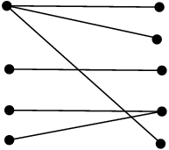
To lead to the Kuratowski Theorem, we look at two more ideas. The first is that of homeomorphic graphs – two graphs which can be obtained from the same graph by inserting vertices into edges. This means that, for example, some edge E is divided into two new edges, E1 and E2, such that there is a newly added vertex between them, V.

Secondly, we consider the idea of contractible graphs. An edge contraction is the deletion of an edge, E, such that all edges incident at the two vertices, V1 and V2, that E connected, become incident at a new vertex V12, which becomes the fusion of V1 with V2. If a graph H can be obtained from G by a succession of edge contractions, then G is said to be contractible to H.
Bipartite Graph G4,5
A graph is said to be connected if there is a path joining each pair of vertices of the graph. In other words, there must be a path from one vertex to any other vertex in the graph. For example, if a graph can be expressed as the union of two disjoint graphs, then it is not connected. This type of graph would be called disconnected. It is easy to see now that all disconnected graphs can be split up into a number of connected subgraphs, or portions of larger graphs. Subgraphs that are split up in this manner are called components.
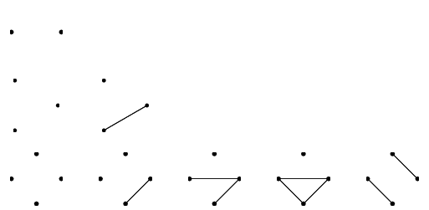
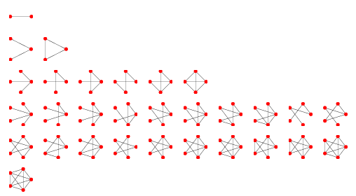
A disconnected graph
Connected graphs

Finally, we define the complete graph K to be a graph in which all vertices are connected to all other vertices in the graph. More specifically, we say that a complete graph with v vertices has v-1 edges incident at each vertex [JeT]. An example of the complete graph K5 is shown as part of the Kuratowski Theorem, below. Complete graphs are generally noted using the variable K.

Kuratowski’s Theorem

Though its proof is too lengthy for us to include in this paper, the statement of the proof is included below. The knowledge of which graphs are planar and which are not will aid us in our discussion and proof of the five color theorem later.
Kuratowski’s Theorem states:
A graph G is planar if and only if either
  - G has no subgraph homeomorphic to K5 or K3,3
  - G has no subgraph contractible to K5 or K3,3
where K5 is the complete graph of order 5 (below left) and K3,3 is the complete bipartite graph with 3 vertices in each of the two vertex sets (below right) [NeW].
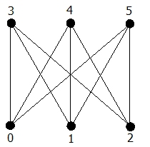
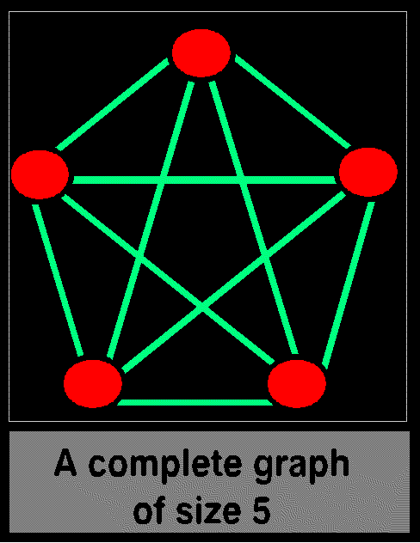

Complete bipartite graph K3,3 (right)

The First Paper and New Ideas

Once the problem had largely been expressed to the mathematical community by de Morgan, enthusiasm was not lost, but no attempted proofs of the Four-Color Problem appeared until 1879. The first paper on the problem, however, appeared as soon as 1878 and was written by the talented British mathematician Arthur Cayley, who worked most in algebra. He attempted to induce more interest for the problem and vigorous searching for its conjecture.
A year later, Alfred Kempe, published a paper in which he claimed to have proven Guthrie’s conjecture that only four colors are required to color a map with the specified rules of coloring. In fact, the ‘proof’ was proven to be fallacious eleven years later by Percy Heawood, and Kempe is best known today for his false proof.
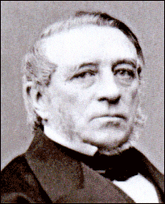
Yet this is a poor assessment of Kempe’s paper; the computer-aided proof developed about one hundred years later utilizes a few of the key ideas elucidated by the Kempe ‘proof.’ In the paper in which he published the proof, Kempe introduced two fundamental ideas that have been central to the study of the Four Color Theorem ever since it was released [FrF].
The first of these ideas is the concept of unavoidability. This states that it is impossible to construct a map without the appearance of at least one of four particular (unavoidable) configurations, where a configuration of a map is defined as some arrangement of the sections (or nations) in a graph. These configurations under concern with the concept of unavoidability consist of a region with two neighbors, one with three neighbors, one with four neighbors, and one with five neighbors; at least one must be found in any map.
Alfred Kempe
The second idea is the concept of reducibility. In his paper that included the attempted proof of Guthrie’s conjecture, Kempe showed that if a graph G requires at least five colors and G contains a region with four or fewer neighbors, then there must be a map G which requires five colors even though G’ has fewer regions than G. From this Kempe was able to prove that any map can be five-colored. His error in attempting to prove that a map can always be four-colored occurred when he tried to prove his reducibility criterion for a map containing a region with five or fewer neighbors. Kempe’s short list of unavoidable configurations had to be extended and the 1976 computer-aided proof of the four-color problem, which will soon follow, analyzed 1,936 distinct cases with a computer to show that each was reducible [JeT].
The man who proved Kempe wrong also published a very important mathematical formula involving colorations of maps. Percy Heawood, lecturer of mathematics at Durham University, not only exposed the fault of the Kempe proof, but also formulated the Heawood Conjecture, from which followed the five-color Theorem, stating that at most five colors may be needed to color a map. In the proof, he uses some of Kempe’s ideas on reducibility and unavoidability and proves that five colors suffice.

The Five Color Theorem – Proof

Initially, one associates a graph G to a given map. This means that one puts a vertex in each region of the map and subsequently connects two vertices with an edge when the corresponding regions share a border. The problem is then translated into a graph coloring problem: one has to paint the vertices of the graph so that no edge has endpoints of the same color. We use the same process as was described above in the map of four regions.
Note also that we must have a planar graph. No constant coloration theorems apply to nonplanar graphs because if there are enough intersecting edges, we may need as many colors as there are vertices in the graph (as in the complete graph K5, which requires five colors to be graph-colored).
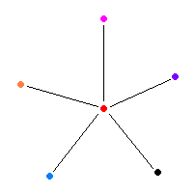
This proof presumes a minimum counterexample graph G with the fewest number of vertices which cannot be five-colored. It then shows that there must be a vertex V shared by at most five edges. The proof also assumes that G is planar as described above. That is, it must be embedded in the plane so that its edges do not intercsect except at vertices. The five edges that are incident at V are also incident at, respectively, V₁, V₂, V₃, V₄, and V₅, as shown in the figure below.

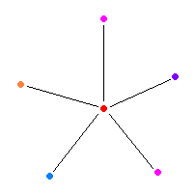
Now, one must remove V from G. The graph obtained this way is called G’. It is easy to see that G’ has fewer vertices than G as we took one away. Thus it can be assumed by induction that it can be colored with only five colors, since we no longer have a central vertex V surrounded by five differently colored vertices. Now look at the five vertices V₁, V₂, V₃, V₄, V₅ that were adjacent to V in a cyclical order. If one were not to use five colors on the vertices, then obviously one could paint V in a consistent way to render the graph five-colored. This is because the five vertices V₁, V₂, V₃, V₄, and V₅ would be colored using at most four colors, and the fifth color could be given to the central vertex V. This is illustrated on the right.

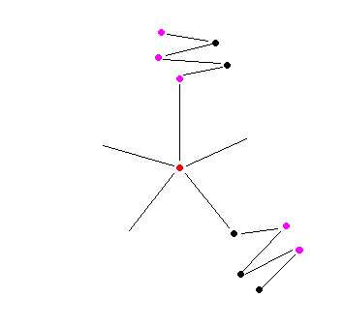

Therefore, let it be that V₁, V₂, V₃, V₄, and V₅ are colored with colors 1, 2, 3, 4, 5 respectively.
Now consider the subgraph G₁₃ (G one-three) of G’, consisting of the vertices that are colored with colors 1 and 3 only, and edges connecting two of them. Note that V₁ and V₃ can either be in the same connected component or in different ones.
Let us first assume that V₁ and V₃ are in different connected components of G₁₃, as shown in the figure above on the right. Then the coloration of the connected component containing V₁ can be reversed. All of the vertices of color 1 in the connected component containing V₁ take on color 3, while the vertices of color 3 take on color 1. In this way, we change the the coloration of the five verticies surrounding V such that only four colors (1, 2, 4, and 5) are used and the fifth color, 3, may be used to color V. This is illustrated below, at left.
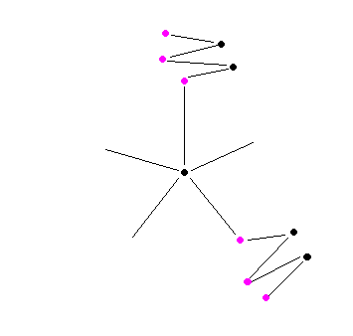
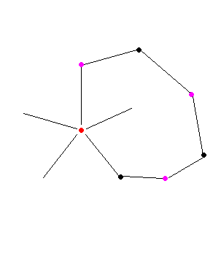
If, in contrast, V₁ and V₃ lie in the same connected component of G₁₃, then a path in G₁₃ that joins them (that is, a sequence of edges and vertices painted alternately with colors 1 and 3) can be found (see right).
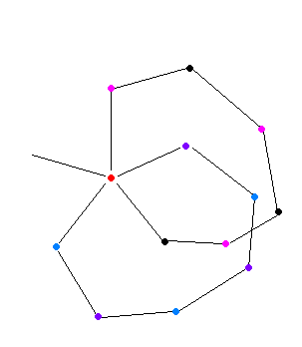
Now consider the subgraph G₂₄ of G' that consists of the vertices colored with colors 2 and 4 only. Apply the same method as in the above case. Then one is able to reverse a coloration on a subgraph of G₂₄ and paint V with, for instance, color 2, if V₂ and V₄ lie in different connected components, or one can connect V₂ and V₄ with a path containing vertices colored with colors 2 and 4 alternately if V₂ and V₄ lie in the same connected component.
However, the latter possibility is impossible. A path specified as such would intersect the path we constructed in G₁₃. When these paths intersect, we have a nonplanar graph (such as the complete graph K5 shown before), which does not qualify for the specifications given by either the four color theorem or the five color theorem. This is shown on the right.
Therefore, it is possible for G to be five-colored, contrary to the initial assumption [CNS].

Genus and the Heawood Conjecture

One other result from the same paper considered empires, countries which have a number of colonies which must all be colored with the same color. Heawood proved that if an empire contains at most r disjoint portions then on a surface of connectivity h, a map can be colored with at most

{6r + 1 + √ (24h +(6r + 1)² - 72)} / 2

colors. He gave a map with 12 countries, each in two disjoint parts, which required 12 colors. Empires on maps must be represented by nonplanar graphs in graph form, as two separate parts must be colored the same color [F].
Another important formula to come from Heawood’s paper was one in which he formulated the equation that determines the chromatic number of a graph G – the smallest number of colors y(g) required to color the vertices of G so that no two adjacent vertices share the same color – that has a certain genus – the largest number of nonintersecting closed curves that can be drawn on the surface of a graph (surface because the graph may be a 3-dimensional form, such as a sphere) without separating it. The formula he generated was

.
Heawood Conjecture

This formula, however, applies only to closed surfaces with positive genus, and thus spheres, planes, and other forms of genus one (as will be shown later) do not apply to this formula [WiY].
The first few values for g = 0, 1, 2, 3, 4, 5 are 4, 7, 8, 9, 10, and 11. Another way of describing the genus of a graph is that it is the minimum number of handles that must be added to the surface that the graph is on to embed the graph without any crossings. A crossing is defined as a pair of intersecting edges, while a graph is embeddable on a surface if its vertices and edges can be arranged on it without any crossings. We thus know that a planar graph has a genus of zero because no such handles exist. In this context, the genus is more or less an integer representing the maximum number of cuttings along closed simple curves without rendering the resultant manifold disconnected [BCGR].
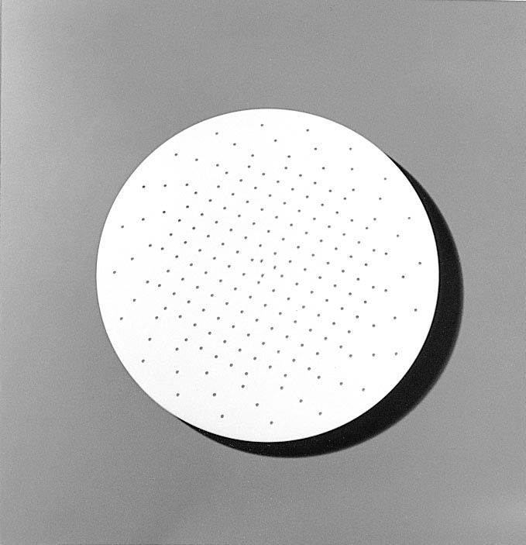
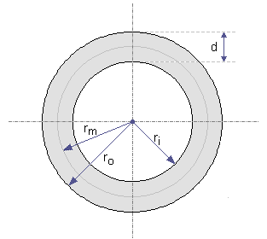
Surfaces of objects such as the sphere, disc, or annulus have a genus of zero; they have no handles and any maps on their surfaces can be represented by planar graphs.
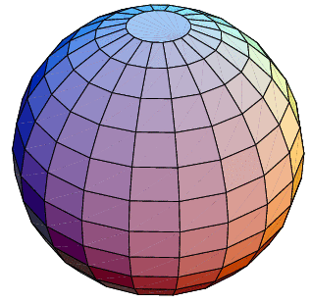

Sphere
Disc
Annulus
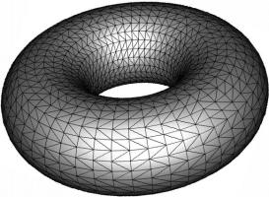
A torus, on the other hand, has a genus of one, because such a handle does exist; the hole in the middle of a three-dimensional torus qualifies it as a genus-one form. When the above formula is applied, the output is 7, and 7 is indeed at most the number of colors required to graph-color the torus. This is easily seen in the example below.
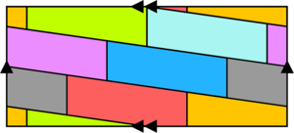
By joining the single arrows together and the double arrows together, one obtains a torus with seven mutually touching regions; therefore seven colors are necessary. The map that is shown represents the torus because, if a torus is cut open in two places – once through its ‘side’ so that we obtain an unwound pipe, and once down the length of the pipe so that we obtain a rectangle – the opposite edges of the rectangle would have been touching in the original torus [BCGR].
Torus
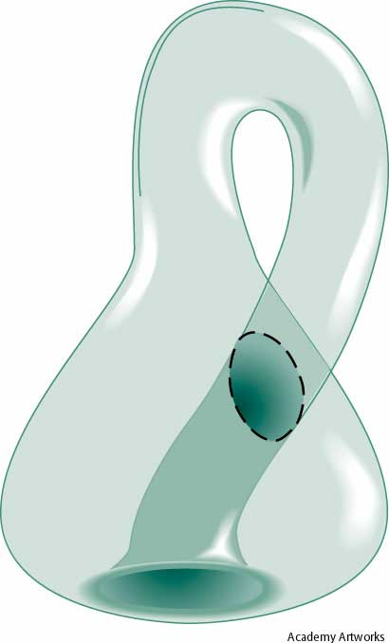
The Klein Bottle presents the only known counterexample to the Heawood Conjecture. A Klein bottle is a genus-one non-orientable surface. This means that it is a surface for which there is no distinction between its “inside” and its “outside.” To picture a Klein Bottle, we first have a bottle. We then put a hole in its bottom and extend its neck. We then also put a hole in the side of the bottle. Then, we pull the neck through the side hole and connect it to the bottom hole.
This example is an exception to the Heawood conjecture because it is non-orientable. As another illustration of non-orientability, imagine an image, , that can be moved around a surface such as a Klein Bottle. If it is moved along a certain path around the bottle and then is moved back to where it started, it may appear as a newly oriented image, . Note that this new orientation is specifically the mirror image of the original [BCGR].
Klein Bottle

Attempted Disproofs of the Four Color Theorem

In general, the simplest attempted counterexamples to the four color theorem attempt to create one region which touches all other regions. This forces the remaining regions to be colored with only three colors. Because the four color theorem is true, this is always possible [F].
This trick can be generalized: there are many maps where if the colors of some regions are selected beforehand, it becomes impossible to color the remaining regions without exceeding four colors. However, as the disprovers of disproofs have shown, color restriction is not transitive; a region only has to be colored differently from regions it touches directly, not regions touching regions that it touches. This is, indeed, how disprovers think, but they forget to realize that the colorations of their graphs are not transitive [F].

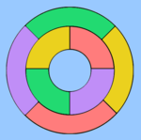
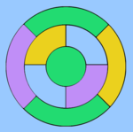

References

[BCGR] M. Boittin, E. Callahan, D.Goldberg, J. Remes, “A Multi-Disciplinary Exploration of Non-Orientable Surfaces,” (1998).
http://www.math.ohio-state.edu/~fiedorow/math655/yale/

[CNS] N. Chiba, T. Nishizeki, N. Saito, “A Linear Algorithm For Five-Coloring A Planar Graph: Lecture Notes in Computer Science: Graph Theory and Algorithms,” (1980).

[F] S. Fisk, “Coloring Theories,” (1989), 31-44.

[FrF] R. Fritsch and G. Fritsch, “Four Color Theorem: History, Topological Foundations and Idea of Proof,” (1998), 1-41, 99-114.

[JeT] T. Jensen and B. Toft, “Graph Coloring Problems,” (1985), 1-51.

[NeW] R. Nelson and R. Wilson (eds.), “Graph Colourings,” (1990), 1-9.

[WiY] J. William and T. Youngs, “Proof of the Heawood Conjecture for Non-Orientable Surfaces,” (1970).

