**CS 263 WT Labcycle**

**YAMAGIRI SALEEMBASHA Y20CS190 CSE-C**

**1.**

**a. Create a web page having the background in green and title “My First Page”.**

**b. Create a web page of pink colour and display a moving message in red colour.**

**c. Design a web page containing text, in form of paragraphs giving suitable heading style .**

<!DOCTYPE html>

<html>

<head>

<title>My First Page</title>

</head>

<body style="background-color: green">

<p>This is paragraph</p>

<h1>heading</h1>

</body>

</html>

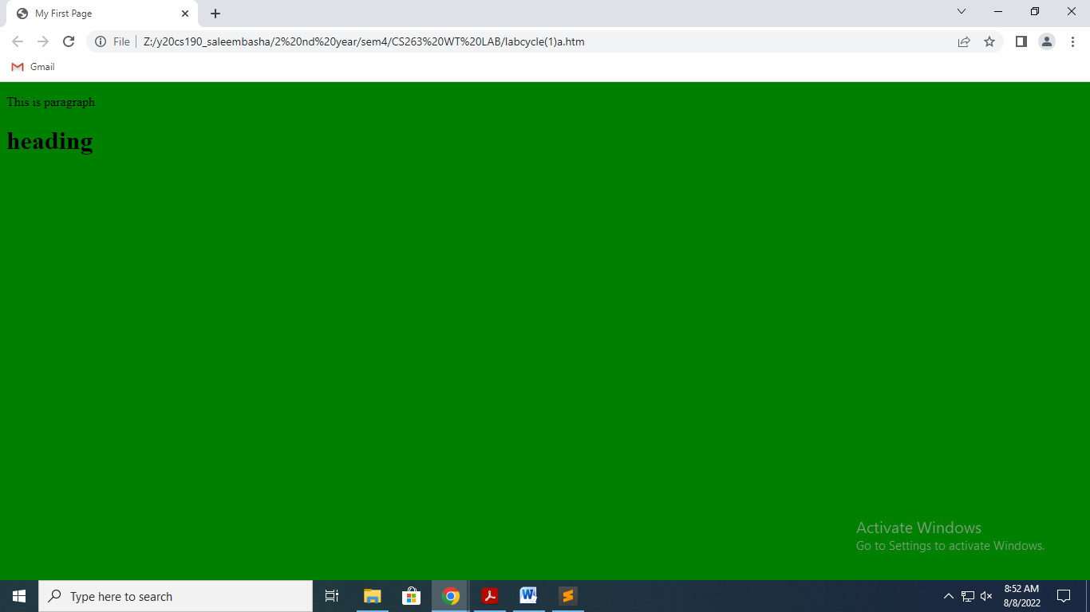

<!DOCTYPE html>

<html>

<body style="background-color: pink">

<marquee direction="right">WELCOME</marquee>

</body>

</html>

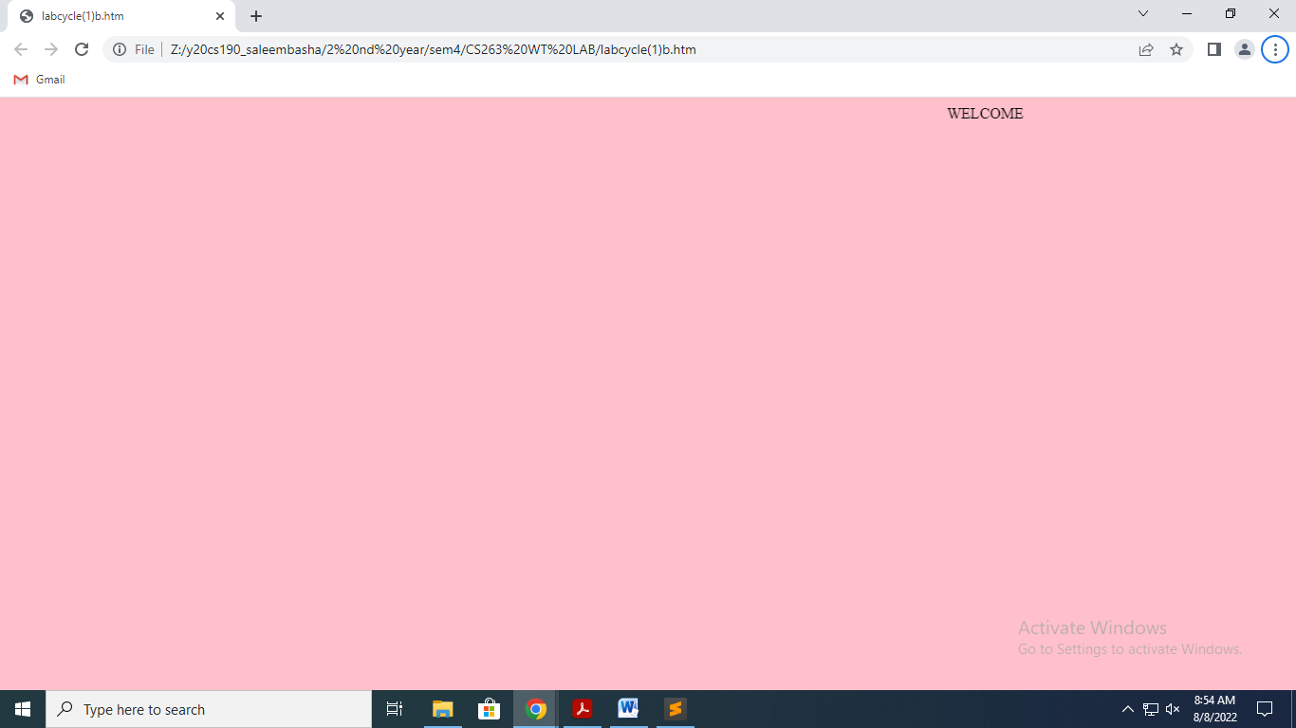

**2.**

**a. Create a web page which displays WELCOME text using heading tags(h1 to h6)**

**b. Create a web page which displays WELCOME text using <b> tag**

**c. Create a web page which displays h2o and x2+y2 using <sup> tag and <sub> tag.**

<!DOCTYPE html>

<html>

<body>

<h1>WELCOME</h1>

<h2>WELCOME</h2>

<h3>WELCOME</h3>

<h4>WELCOME</h4>

<h5>WELCOME</h5>

<h6>WELCOME</h6>

<b>WELCOME</b>

<p>h<sub>2</sub>o</p>

<p>x<sup>2</sup>+y<sup>2</sup></p>

</body>

</html>

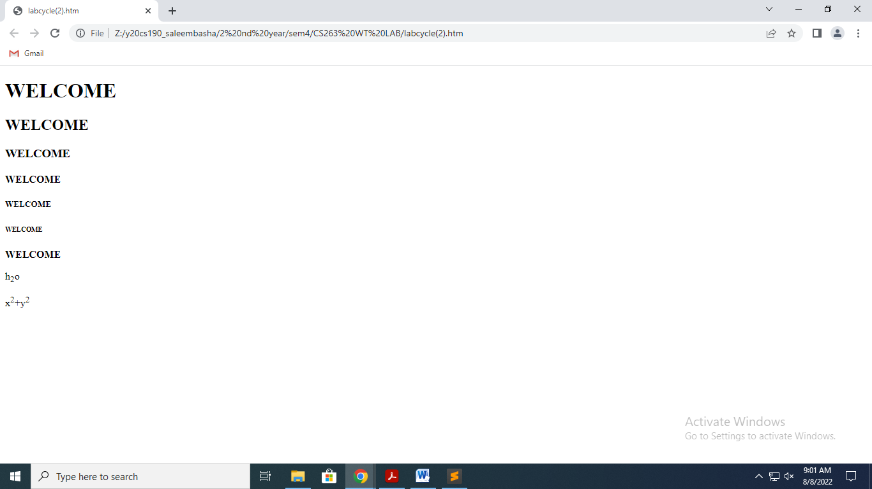

**3.**

**a. Create a web page to show different attributes of Font tag.**

**b. Create a web page to show different attributes: italics, bold, underline.**

**c. Design a web page having background colour yellow and giving text colour red .**

<!DOCTYPE html>

<html>

<head>

<title>3</title>

<style>

body{

background-color: yellow;

color: red

}

</style>

</head>

<body>

<h1 style="font-family: Verdana, sans-serif;">Microsoft</h1>

<p style="font-weight: bold;">Microsoft Corporation is an American multinational technology corporation which produces computer software, consumer electronics, personal computers, and related services headquartered at the Microsoft Redmond campus located in Redmond, Washington, United States. </p>

<p style="font-style: normal;">Its best-known software products are the Windows line of operating systems, the Microsoft Office suite, and the Internet Explorer and Edge web browsers.</p>

<p style="font-variant:small-caps; "> Its flagship hardware products are the Xbox video game consoles and the Microsoft Surface lineup of touchscreen personal computers</p>

<p style="font-size: 40px;">this is all about microsoft</p>

<p style="font-size: 2.5em; /* 40px/16=2.5em */">thank you</p>

<p><i>italic text</i></p>

<p><b>bold text</b></p>

<p><u>underlined text</u></p>

</body>

</html>

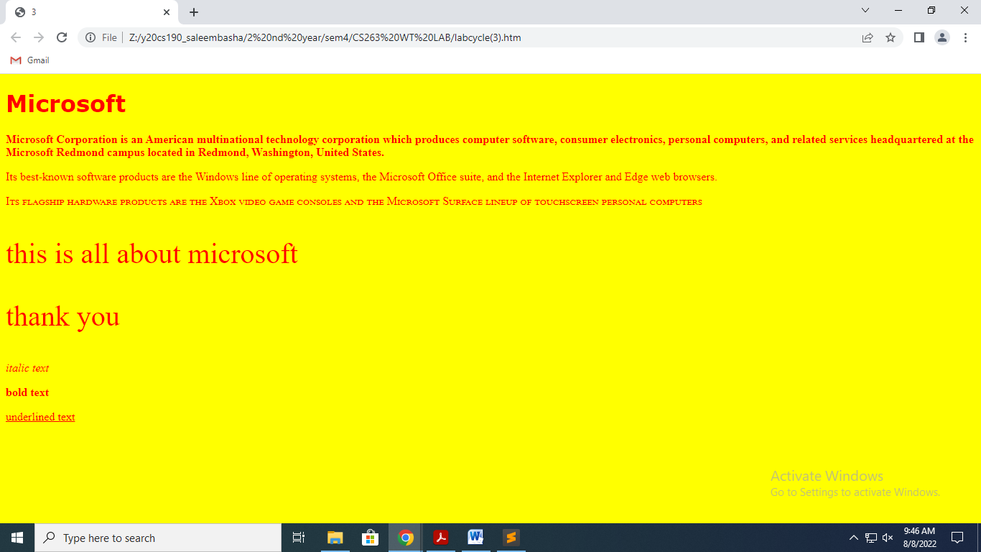

**4.**

**a. Create a web page using href attribute of anchor tag & the attribute: alink, vlink etc.**

**b. Create links on the words e.g. ―Wi-Fi and ―LAN‖ to link them to Wikipedia pages.**

**c. Create a web page with appropriate content and insert an image towards the left hand side of the page. When user clicks on the image, it should open another Web page.**

<!DOCTYPE html>

<html>

<head>

<title>4</title>

<style>

div{

text-align: center;

font-size: 30px;

}

</style>

</head>

<body vlink="green" alink="yellow">

<a href="https://www.google.co.in/"><img src="https://play-lh.googleusercontent.com/aFWiT2lTa9CYBpyPjfgfNHd0r5puwKRGj2rHpdPTNrz2N9LXgN_MbLjePd1OTc0E8Rl1=w240-h480-rw" style="float:left;"></a>

<div>

<a href="https://www.google.co.in/">google</a>

<p>The HTML body vlink Attribute is used to specify a color of a visited link in a Document.</p>

<p>The HTML body alink Attribute is used to specify the color of an active link in a document.</p>

<a href="https://en.wikipedia.org/wiki/Wi-Fi">―Wi-Fi </a><br>

<a href="https://en.wikipedia.org/wiki/Local_area_network">―LAN‖ </a>

</div>

</body>

</html>

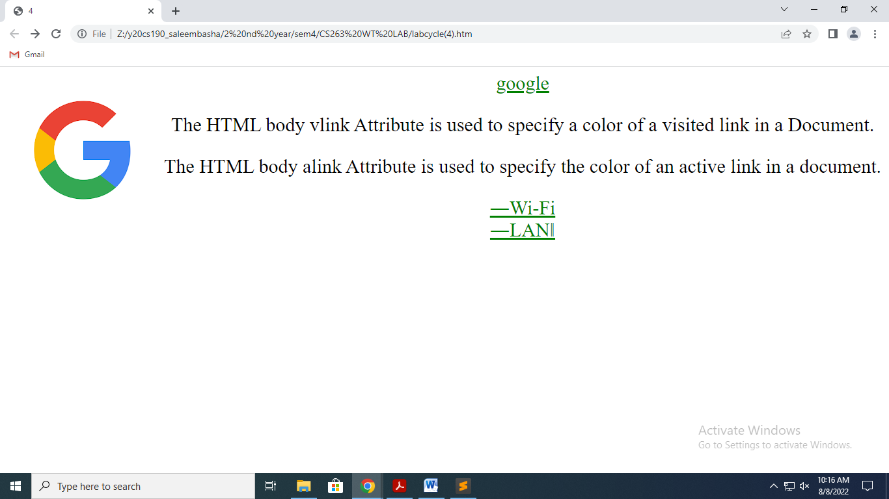

**5.**

**a. Create a web page, showing an ordered list of the names of five of your friends.**

**b. Create a web page containing a nested list showing the content page of any book**

**c. Create a web page, showing an unordered list of names of five of your friends**

**<!DOCTYPE html>**

**<html>**

**<head>**

**<title>5</title>**

**</head>**

**<body>**

**<ol>**

**Friends names:**

**<li>Uday</li>**

**<li>Kaushik</li>**

**<li>Shoheb</li>**

**<li>Akram</li>**

**<li>Ali</li>**

**</ol>**

**<ol>**

**contents:**

**<li>Unit 1</li>**

**<ol><li>Introduction to HTML5</li>**

**<ol><li> Part - I.**

**</li>**

**<li>Part - II.</li></ol>**

**<li>Cascading Style Sheets (CSS)</li>**

**<ol><li>Part- I</li>**

**<li>Part- II</li>**

**</ol> </ol></ol><ul>**

**Friends names:**

**<li>Uday</li>**

**<li>Kaushik</li>**

**<li>Shoheb</li>**

**<li>Akram</li>**

**<li>Ali</li>**

**</ul>**

**</body>**

**</html>**

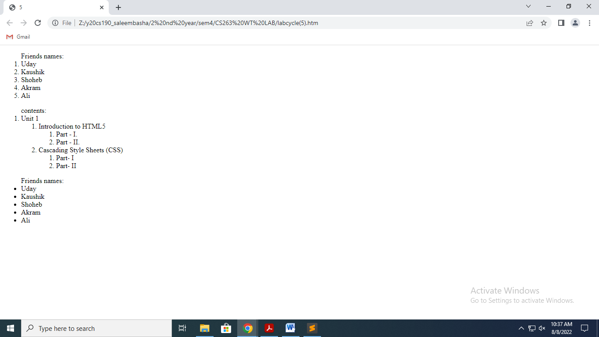

**6. a. Create a table to show your class timetable using rowspan and colspan attributes.**

**b. Use tables to provide layout to your HTML page describing your college infrastructure.**

**c. Create a web page in the following table fields**

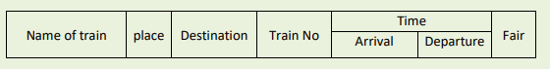

<!DOCTYPE html>

<html>

<head>

<title>II/IV th B.tech., timetable(R20)-R.V.R. & J.C. College Of Engineering</title>

</head>

<style>

table, th, td {

border:1px solid black;

margin-top: 200px;

}

td{

text-align: center;

}

</style>

<body><center>

<table>

<tr>

<th>DAY </th>

<th>8:00-9:00 </th>

<th>9:00-10:00 </th>

<th>10:00-11:00</th>

<th>11:00-12:00</th>

<th>12:00-1:00 </th>

<th>1:00-2:00 </th>

<th>2:00-3:00 </th>

</tr>

<tr>

<td>MON </td>

<td colspan="3">WT lab</td>

<td rowspan="6"><pre>

L

U

N

C

H

</pre>

</td>

<td>DBMS</td>

<td>OS</td>

<td>WT</td>

</tr>

<tr>

<td>TUE </td>

<td>SE</td>

<td>E&HV</td>

<td>CS</td>

<td colspan="3">DBMS LAB</td>

</tr>

<tr>

<td>WED </td>

<td>CBA</td>

<td>DBMS</td>

<td>WT</td>

<td>SE</td>

<td>CS</td>

<td>OS</td>

</tr>

<tr>

<td>THU</td>

<td>SE</td>

<td>OS</td>

<td>DBMS</td>

<td>SOC</td>

<td>CS</td>

<td>CBA</td>

</tr>

<tr>

<td>FRI</td>

<td colspan="3">CS LAB</td>

<td>CS</td>

<td>DBMS</td>

<td>WT</td>

</tr>

<tr>

<td>SAT</td>

<td colspan="2">SOC LAB</td>

<td>WT</td>

<td>E&HV</td>

<td colspan="2">COMPETITIVE CODING</td>

</tr>

</table>

</center>

</body>

</html>

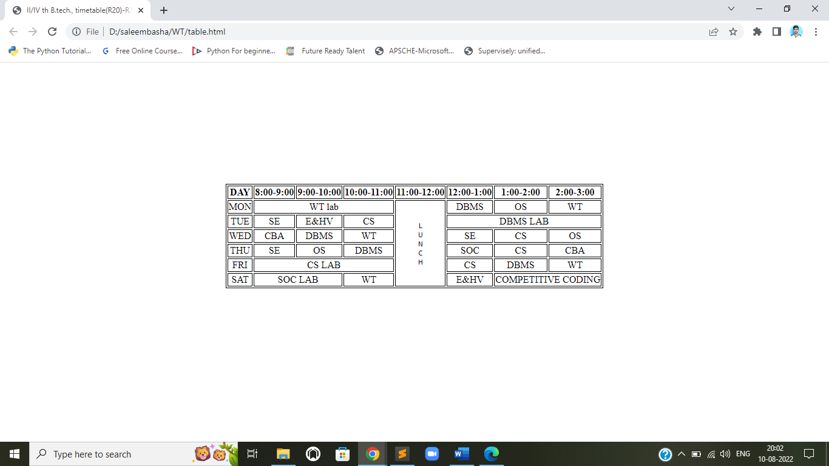

**b)**

<!DOCTYPE html>

<html>

<head>

<title>R.V.R. & J.C.College of Engineering Infrastructure</title>

</head>

<body>

<h1 style="color:green;text-align:center">R.V.R. & J.C.College of Engineering Infrastructure</h1>

<center><table height="100%" width="100%">

<tr >

<td style="width:600px;background-color:lightgreen;">

<h1><u>courses</u></h1>

<h2>B.Tech.,<h2>

<h4>1. Chemical Engineering<br>

2. Civil Engineering<br>

3. Computer Science & Business Systems<br>

4. Computer Science & Engineering<br>

5. Computer Science & Engineering (Artificial Intelligence & Machine Learning)<br>

6. Computer Science & Engineering (Data Science)<br>

7. Computer Science & Engineering (Internet of Things)<br>

8. Electrical & Electronics Engineering<br>

9. Electronics & Communication Engineering<br>

10. Information Technology<br>

11. Mechanical Engineering</h4>

<h2>M.Tech<br>

MBA<br>

MCA<br>

</h2>

</td>

<td style="background-color:yellow;">

<h1><u>facilities<br></u></h1>

<h3>1.Central Library.<br>

2.Departmental Library.<br>

3.Men's Hostel.<br>

4.Girl's Hostel.<br>

5.Canteen.<br>

6.Medical Facilities.<br>

7.Open Air Theater.<br>

8.NCC.<br>

9.NSS.<br>

10.Computer Centers.<br>

11.E-Classroom.<br>

12.Stores.<br>

13.Seminar Halls.<br>

14.Sports.<br>

</h3><br><br><br><br></td>

<td style="background-color:pink;">

<h1><u>Buildings<br></u></h1>

<h3>1.Cyber Block.<br>

2.Digital Block.<br>

3.Hi-Tech Block.<br>

4.Main Block.<br>

5.Decinal Block.<br>

6.Silver Jubilee Block.<br><br><br><br><br><br><br><br><br><br><br><br>

</h3></td></tr></center></table></body></html>

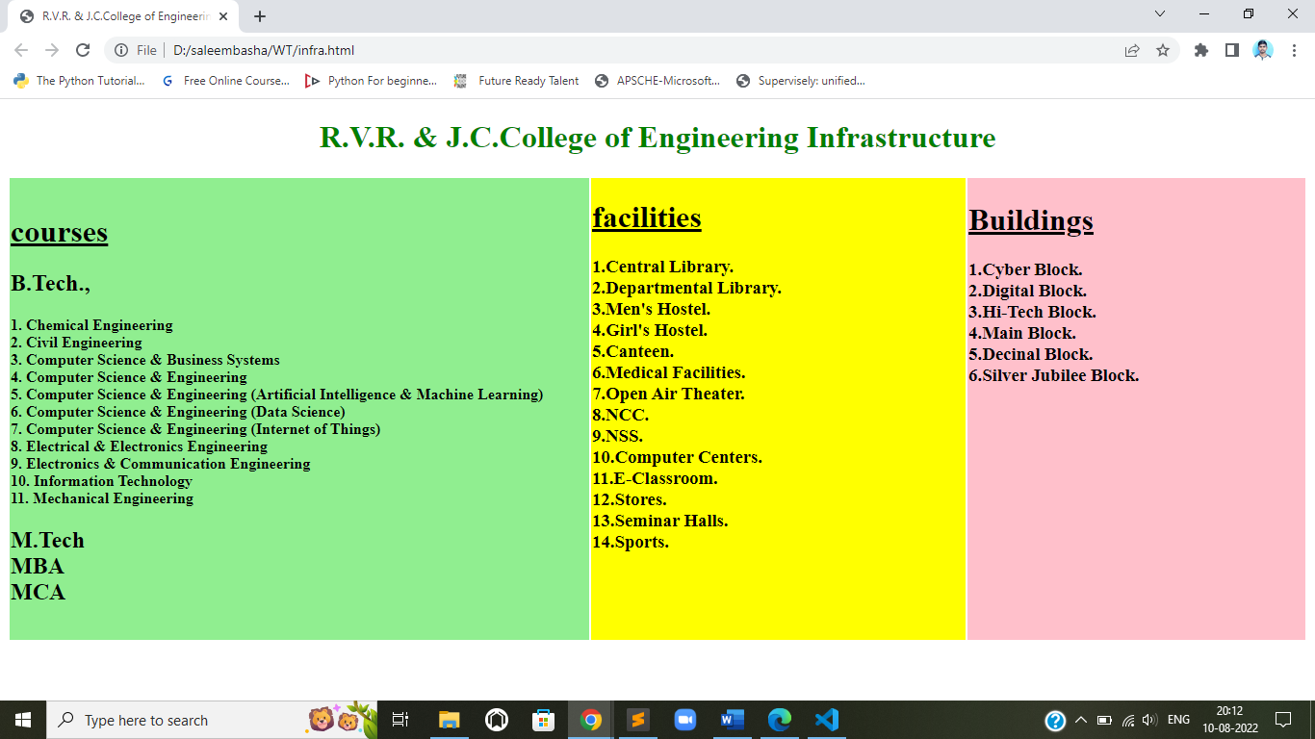

**c)**

**<!DOCTYPE html>**

**<html>**

**<head>**

**<title>6</title>**

**<style>**

**table,th{**

**border: 1px solid black;**

**border-collapse: 1px solid black;**

**margin-top: 200px;**

**}**

**</style>**

**</head>**

**<body>**

**<center>**

**<table>**

**<tr>**

**<th rowspan="2">Name of train</th>**

**<th rowspan="2">place</th>**

**<th rowspan="2">Destination</th>**

**<th rowspan="2">Train No</th>**

**<th colspan="2">Time</th>**

**<th rowspan="2">Fair</th>**

**</tr>**

**<tr>**

**<th>Arrival</th>**

**<th>Departure</th>**

**</tr>**

**</table>**

**</center>**

**</body>**

**</html>**

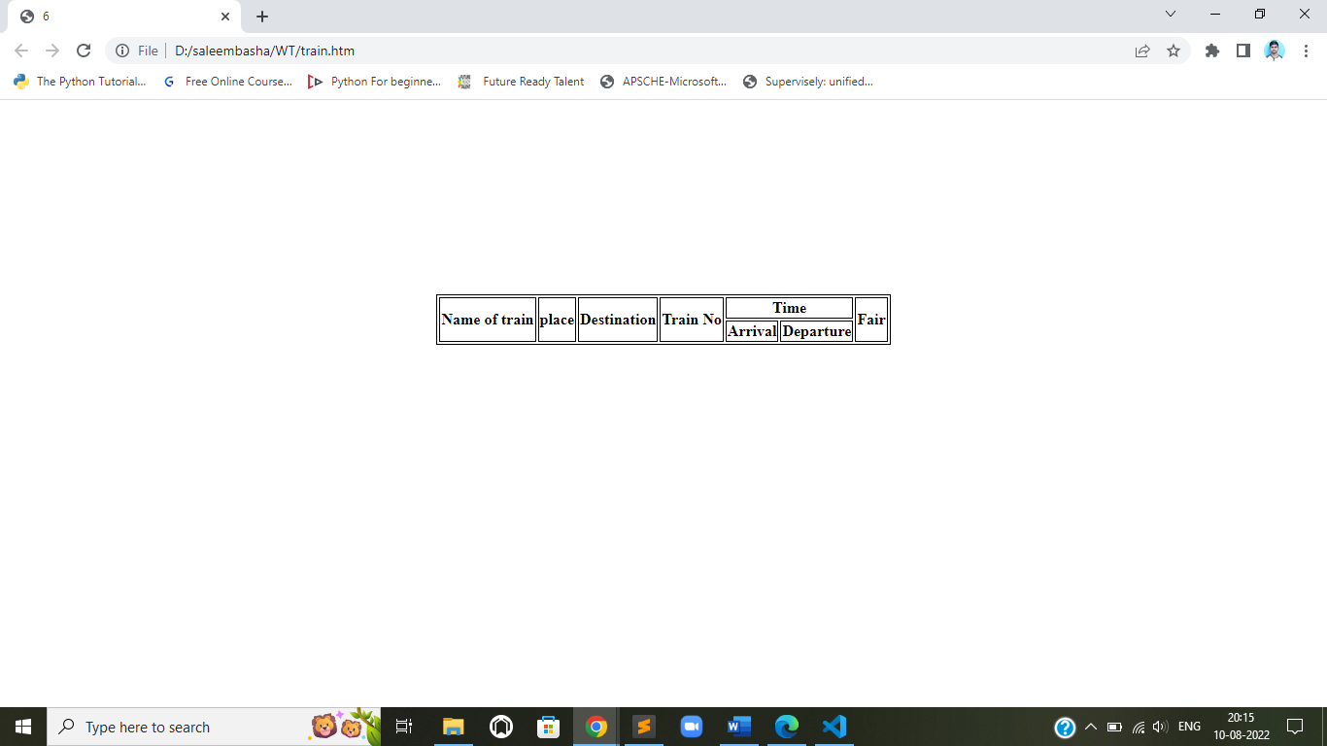

**7. a. Develop a web page having two frames that divide the Web page into two equal rows.**

**b. Develop a web page having two frames that divide the Web page into two equal rows and then divide the second row into two equal columns.**

**c. Develop a web page having frames as described in the above web page and then fill each frame with a different background color .**

<!DOCTYPE html>

<head>

    <title>7</title>

</head>

    <frameset rows="50%,50%">

        <frame src="orange.htm">

        <frameset cols="50%,50%" >

            <frame src="white.htm">

            <frame src="green.htm">

        </frameset>

    </frameset>

</html>

<!DOCTYPE html>

<body style="background-color: orange;">

</body>

</html>

<!DOCTYPE html>

<body style="background-color: white;">

</body>

</html>

<!DOCTYPE html>

<body style="background-color: green;">

</body>

</html>

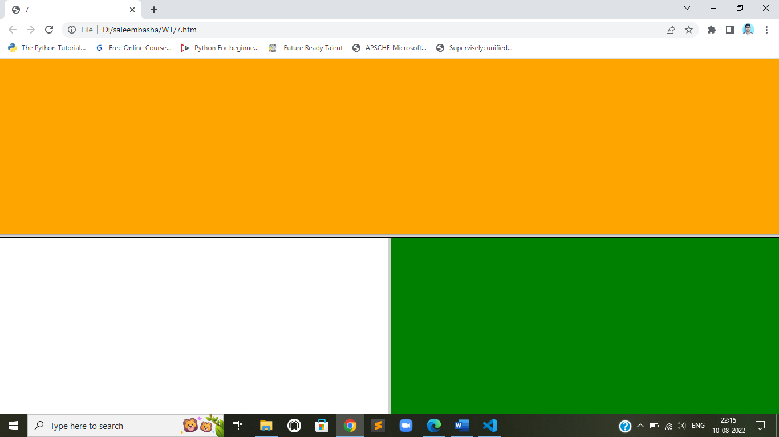

**8. a. Create your bio-data form on a web page using all input types**

**b. Create a web page having radio buttons labeled as name of colours. Clicking on each radio button should change the colour of the Web page**

**c. Embed Audio and Video into your web page .**

    <!DOCTYPE html>

    <html>

    <head>

    <style>

    .bor{

    border: 1px solid black;

      padding: 15px 10px;

      width: 450px;

      box-sizing: border-box;

      position: relative;

      left:40%;

      top: 70px;

    }

    input{

    margin-left: 20px;

    cursor: pointer;

    }

    </style>

    </head>

    <body>

    <div class="bor">

    <h2>Bio-data form!</h2>

    <form method="get">

    <label>first name:</label>

    <input type="text" class="space"><br><br>

    <label>last name:</label>

    <input type="text" class="space"><br><br>

    <label>Gender:</label>

    <input type="radio" class="space">

    <label>Male</label>

    <input type="radio">

    <label>Female</label><br><br>

    <label>DOB :</label>

    <input type="date" class="space"><br><br>

    <label>Phone number:</label>

    <input type="text" class="space"><br><br>

    <label>email ID:</label>

    <input type="text" class="space"><br><br>

    <label>Languages Known :</label>

    <input type="checkbox">

    <label>Telugu</label>

    <input type="checkbox">

    <label>Hindi</label>

    <input type="checkbox">

    <label>English</label><br><br>

    <label>Profile pic:</label>

    <input type="file"  class="space" ><br><br><br>

    <input type="submit" value="register" style="margin-right: 50px">

    <a href="datepicker.htm"><input type="button" value="Reset"></a>

    </form>

    </div>

    </body>

    </html>

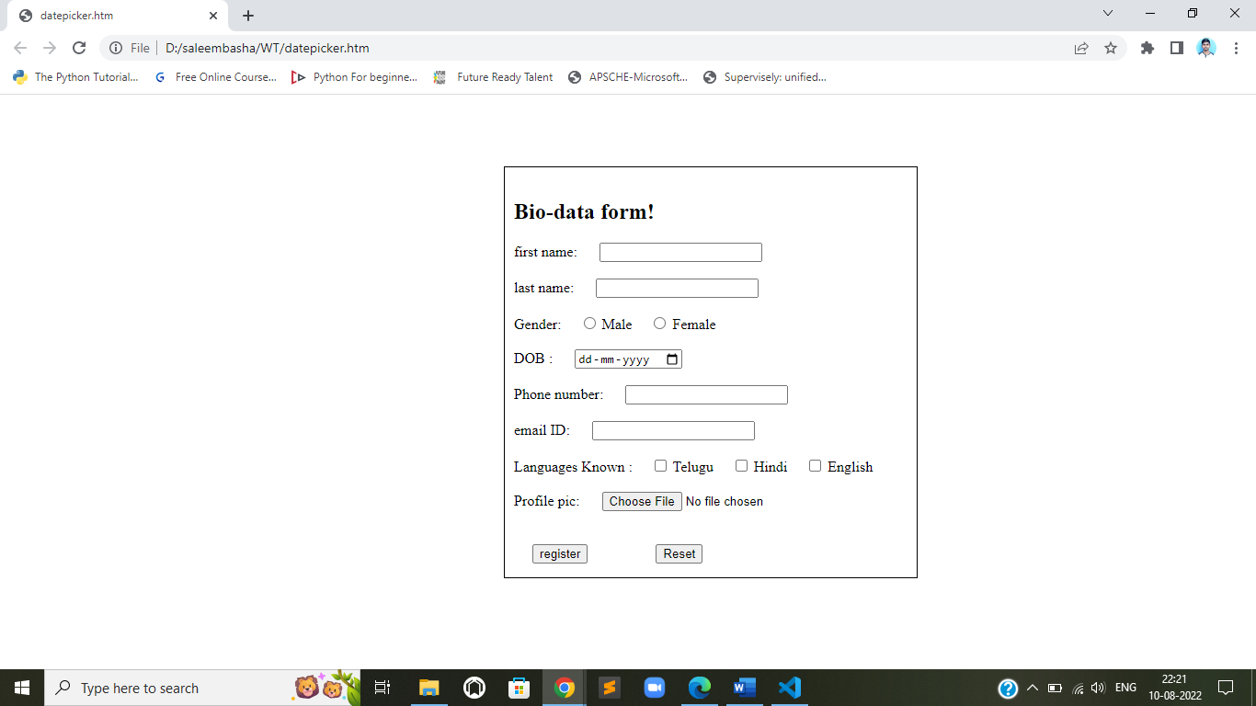

<html>

<head>

<title>

Change background color

</title>

</head>

<body>

<form>

<input type="radio" onClick="document.bgColor='red' " > Red

<br>

<input type="radio" onClick="document.bgColor='green'" > Green

<br>

<input type="radio" onClick="document.bgColor='blue'" >Blue

<br>

</form>

<audio controls><source src="1660151208691-voicemaker.in-speech.mp3" type="audio/mpeg"></audio><br>

<video width="320" height="240" controls>

    <source src="Street - 19627.mp4" type="video/mp4">

</video>

</body>

<html>

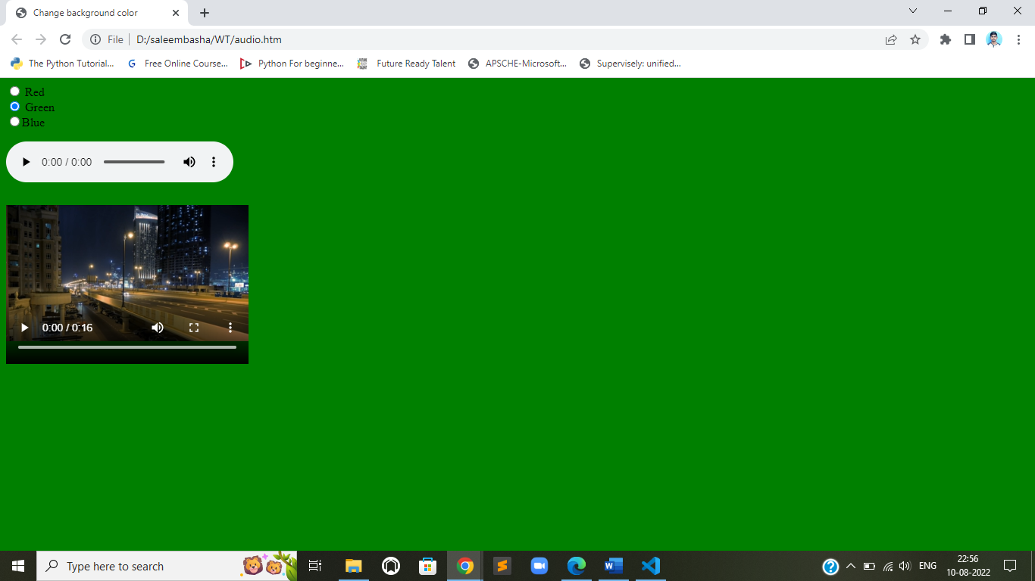

**9. Create a webpage which displays the class time table and apply the following effects on the table:**

**a. For the table header apply blue as the background colour and white for the colour of the text in the table header.**

**b. Display days in a week (Mon, Tue etc...) in bold format with the first letter in the day name in uppercase.**

**c. Display lunch slightly in bigger font other than the remaining text.**

<!DOCTYPE html>

<html>

<head>

<title>II/IV th B.tech., timetable(R20)-R.V.R. & J.C. College Of Engineering</title>

</head>

<style>

table, th, td {

border:1px solid black;

margin-top: 200px;

}

th{

    background-color: blue;

    color: white;

}

td{

text-align: center;

}

</style>

<body><center>

<table>

<tr>

<th>DAY        </th>

<th>8:00-9:00  </th>

<th>9:00-10:00 </th>

<th>10:00-11:00</th>

<th>11:00-12:00</th>

<th>12:00-1:00  </th>

<th>1:00-2:00  </th>

<th>2:00-3:00  </th>

</tr>

<tr>

<td><b>MON</b></td>

<td colspan="3">WT lab</td>

<td rowspan="6" style="font-size: 30px;"><pre>

L

U

N

C

H

</pre>

</td>

<td>DBMS</td>

<td>OS</td>

<td>WT</td>

</tr>

<tr>

<td><b>TUE</b></td>

<td>SE</td>

<td>E&HV</td>

<td>CS</td>

<td  colspan="3">DBMS LAB</td>

</tr>

<tr>

<td><b>WED</b></td>

<td>CBA</td>

<td>DBMS</td>

<td>WT</td>

<td>SE</td>

<td>CS</td>

<td>OS</td>

</tr>

<tr>

<td><b>THU</b></td>

<td>SE</td>

<td>OS</td>

<td>DBMS</td>

<td>SOC</td>

<td>CS</td>

<td>CBA</td>

</tr>

<tr>

<td><b>FRI</b></td>

<td colspan="3">CS LAB</td>

<td>CS</td>

<td>DBMS</td>

<td>WT</td>

</tr>

<tr>

<td><b>SAT</b></td>

<td colspan="2">SOC LAB</td>

<td>WT</td>

<td>E&HV</td>

<td colspan="2">COMPETITIVE CODING</td>

</tr>

</table>

</center>

</body>

</html>

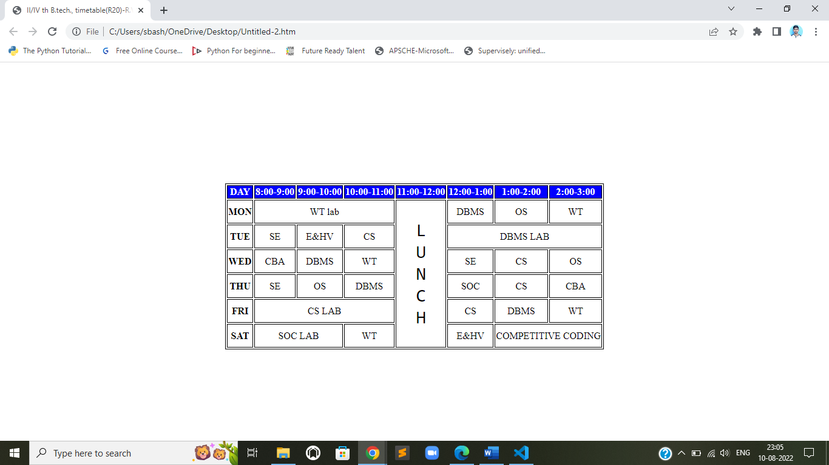

**10.**

**a. Create a webpage which displays "Hello World" with font size 20 pixels, bold format, in "Times New Roman" font and green in colour using inline CSS, embedded CSS and external CSS.**

**Inline css :**

<!DOCTYPE html>

<html>

<body>

 <p style="font-size: 20px; font-family:'Times New Roman', Times, serif ; color: green; " > hello world </p>

</body>

</html>

**Internal CSS :**

<!DOCTYPE html>

<html>

<head>

    <style>

        p{

            color: green;

            font-size: 20px;

            font-family: 'Times New Roman', Times, serif;

        }

    </style

</head>

<body>

    <p>hello world</p>

</body>

</html>

**External CSS:**

<!DOCTYPE html>

<html>

<head>

    <link rel="stylesheet" href="style.css">

</head>

<body>

    <P>hello world</P>

</body>

</html>

Style.css file

p{

    font-family: 'Times New Roman', Times, serif;

    color: green;

    font-size: 20px;

}

**OUTPUT:**

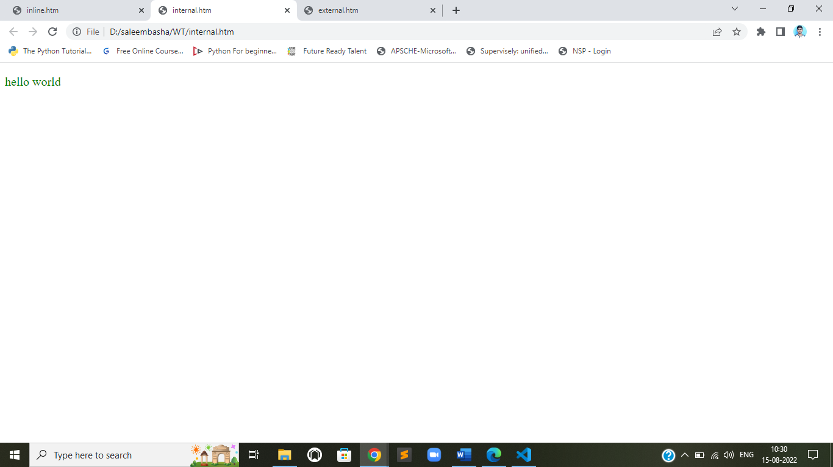

**b. Create a web page containing two images, where one image overlaps another image by using the z-index CSS property.**

<!DOCTYPE html>

<html>

<head>

    <style>

        .img1 {

  position: absolute;

  left: 0px;

  top: 0px;

  z-index: -1;

}

.img2 {

  position: absolute;

  left: 100px;

  top: 100px;

  z-index: 2;

}

    </style>

</head>

<body>

    <img src="correct.png"  class="img1">

    <img src="home.png" class="img2"><br>

    <p><b><center> the one with high z-index will be shown on top </center></b></p>

</body>

</html>

**OUTPUT:**

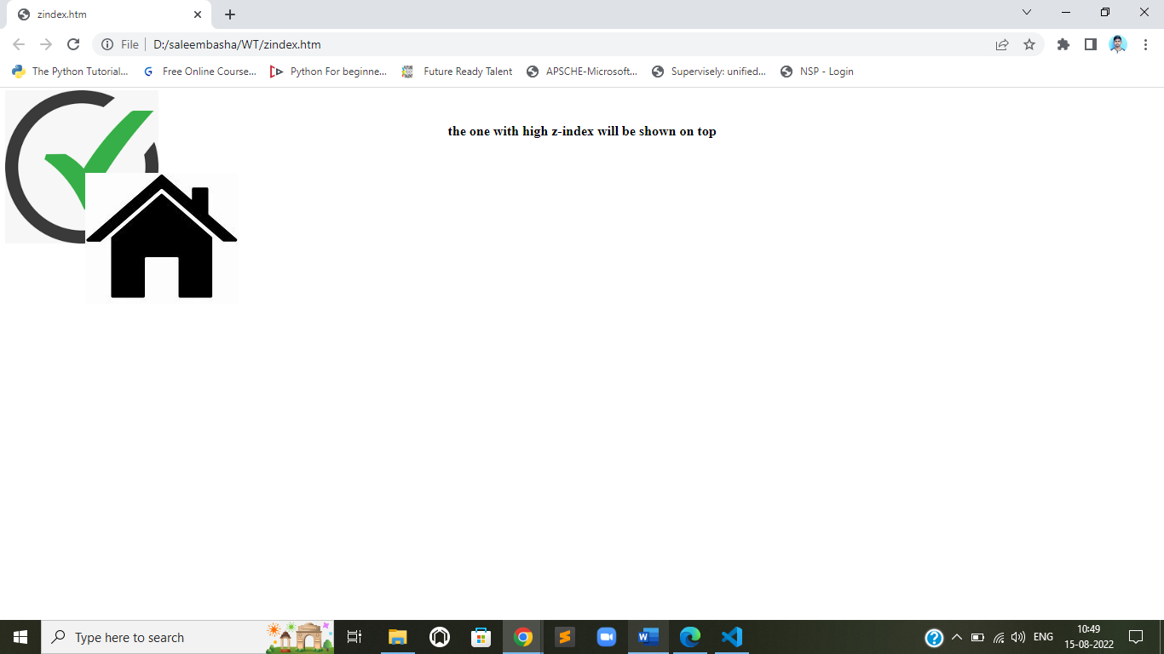

**c. Demonstrate the usage of CSS Inheritance and Specificity with an example.**

<!DOCTYPE html>

<html>

<head>

<style>

span {

  color: blue;

  border: 1px solid black;

}

.extra span {

  border: inherit;

}

</style>

</head>

<body>

<div>

  Here is <span>an example of css inheritanace</span> which is blue, as span elements are set to be.

</div>

<div class="extra" style="color:green">

   Here is <span>an example of css inheritanace</span> which is green, as span elements are set to be blue.

</div>

<div style="color:red">

  Here is <span>a span element</span> which is blue, as span elements are set to be.

</div>

<p>in this example Sets the border for span elements , except those inside elements with class="extra":

</p>

</body>

</html>

**OUTPUT:**

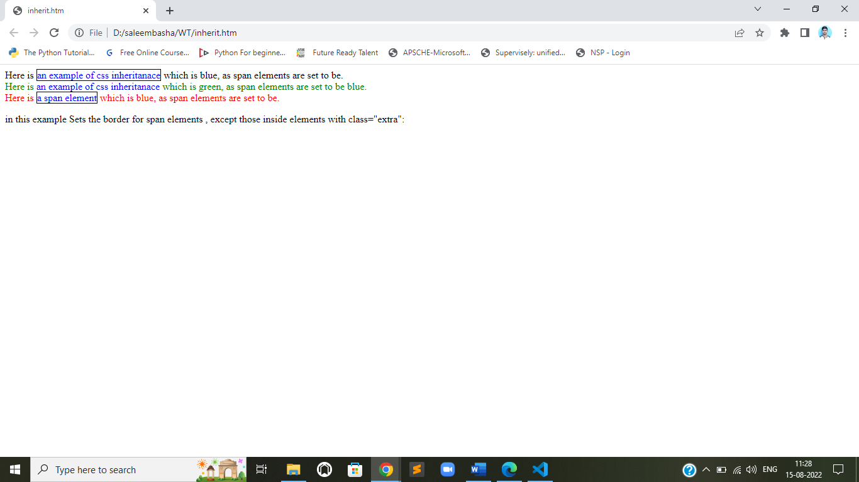

**11.**

**a. Create a div element with a width and height of 500px. Create a diagonal linear gradient using the colors of the rainbow—Red, Orange, Yellow, Green, Blue, Indigo, Violet. (Linear Gradient)**

<!DOCTYPE html>

<html>

<head>

    <style>

        div{

                text-align: center;

                width: 500px;

                height: 500px;

                border: 1px solid black;

                background-image: linear-gradient(to right top, red,orange,yellow,green,blue,indigo,violet);

            }

    </style>

</head>

<body>

  <center><div><h1>example of division element</h1></div></center>

</body>

</html>

**OUTPUT:**

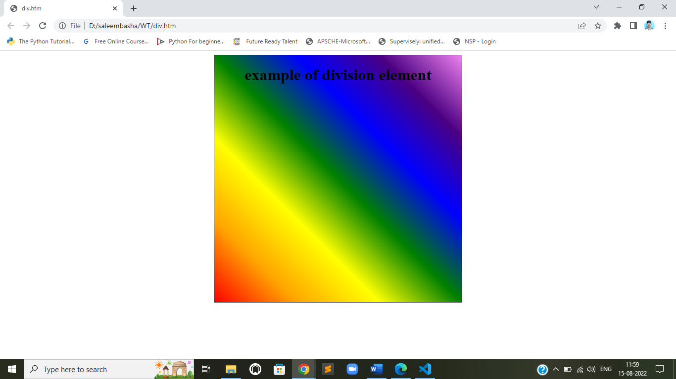

**b. Create a div element with a width and height of 500px. Create a radial gradient with three colors. Start the gradient in the bottom-left corner with the colors changing as they move along the gradient line to the right. (Radial Gradient)**

<!DOCTYPE html>

<html>

    <head>

        <style>

            div{

                width: 500px;

                height: 500px;

                border: 1px solid black;

                background-image: radial-gradient(rgb(255, 0, 0),rgb(0, 255, 0),rgb(0, 0, 255));

            }

        </style>

    </head>

    <body>

        <center>

        <div>

            <h2>example of division</h2>

        </div>

    </center>

    </body>

</html>

**OUTPUT:**

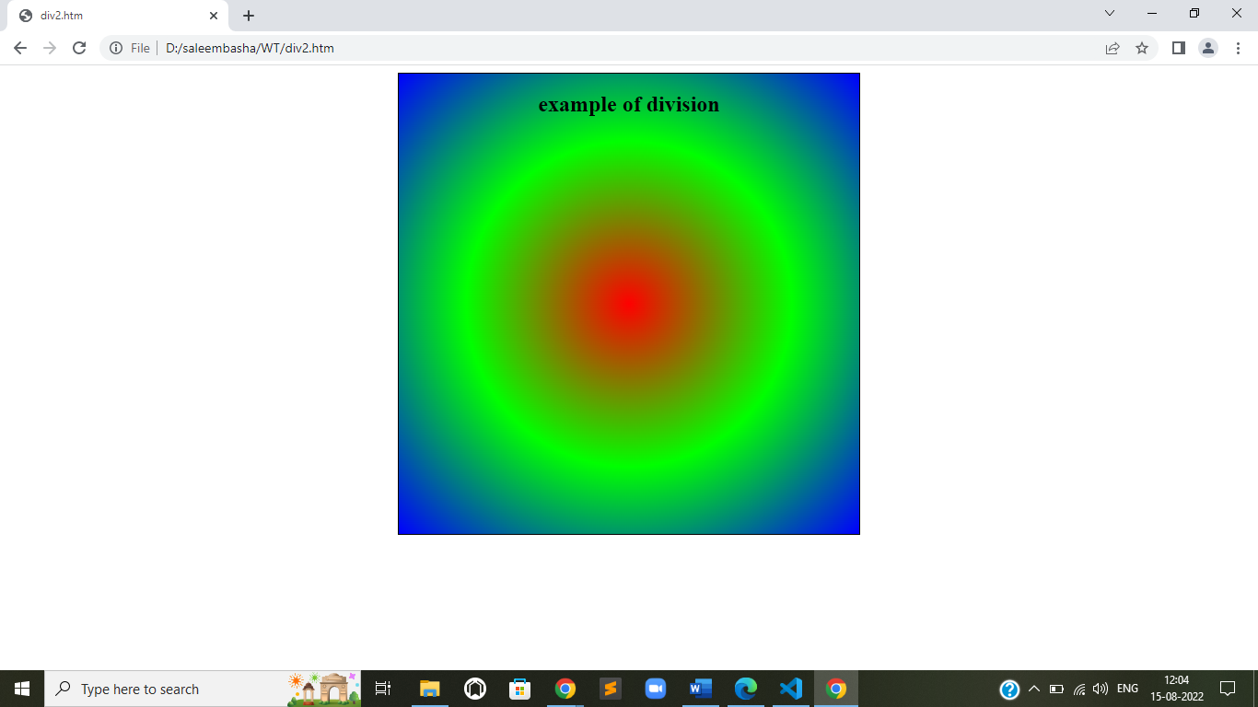

**c. Create an infinite animation of an element moving in a square pattern. (Animation).**

<!DOCTYPE html>

<html>

<head>

    <style>

        div {

            width: 200px;

            height: 100px;

            background: red;

            position: relative;

            animation: mymove 3s infinite;

        }

        @keyframes mymove {

            from {

                left: 0px;

            }

            to {

                left: 1150px;

            }

        }

    </style>

</head>

<body>

    <center>

        <h1>Animation</h1>

    </center>

    <p>Moves a rectangle from 0px to 1150px left. The animation lasts for 3 seconds. It then starts over again, and go on forever (infinite).</p>

    <div></div>

</body>

</html>

**OUTPUT:**

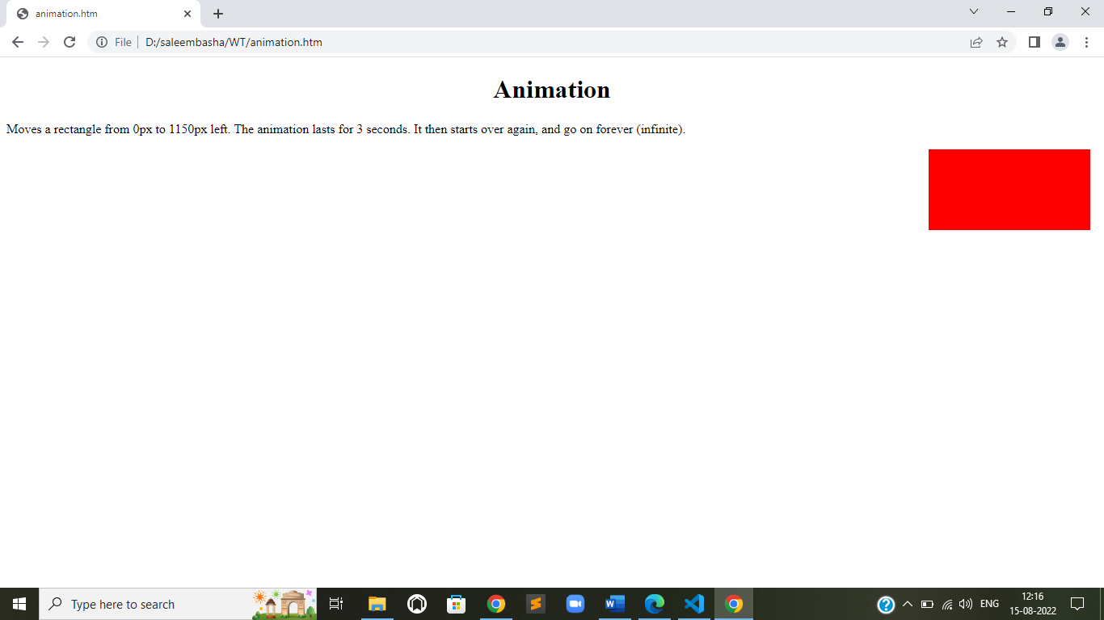

**JAVA SCRIPT :**

**1. Write a java scripts to**

**a) Find the given year is leap year or not**

<!DOCTYPE html>

<html>

<head>

    <script>

        function find() {

            var m = document.getElementById('year').value;

            var bol = true;

            if (m % 4 == 0) {

                if (m % 100 == 0) {

                    if (m % 400 == 0) {

                        bol = true;

                    } else {

                        bol = false;

                    }

                } else {

                    bol = true;

                }

            } else {

                bol = false;

            }

            if (bol) {

                document.getElementById('ans').innerText = "The Year " + m + " is a LEAP YEAR";

            } else {

                document.getElementById('ans').innerText = "The Year " + m + " is NOT a LEAP YEAR";

            }

        }

    </script>

    <style>

        div {

            text-align: center;

        }

        body {

            background-image: url('jsbg.png');

            background-repeat: no-repeat;

            background-attachment: fixed;

            background-size: 100% 100%;

        }

    </style>

    </style>

</head>

<body style="color: rgb(0, 255, 0);">

    <div>

        <h1>

            leap year predictor:

        </h1>

        <label>Enter any year</label>

        <input type="number" id="year">

        <button onclick="find()">Find</button>

        <h1 id="ans" style="color: rgb(47, 158, 47);"></h1>

    </div>

</body>

</html>

**OUTPUT:**

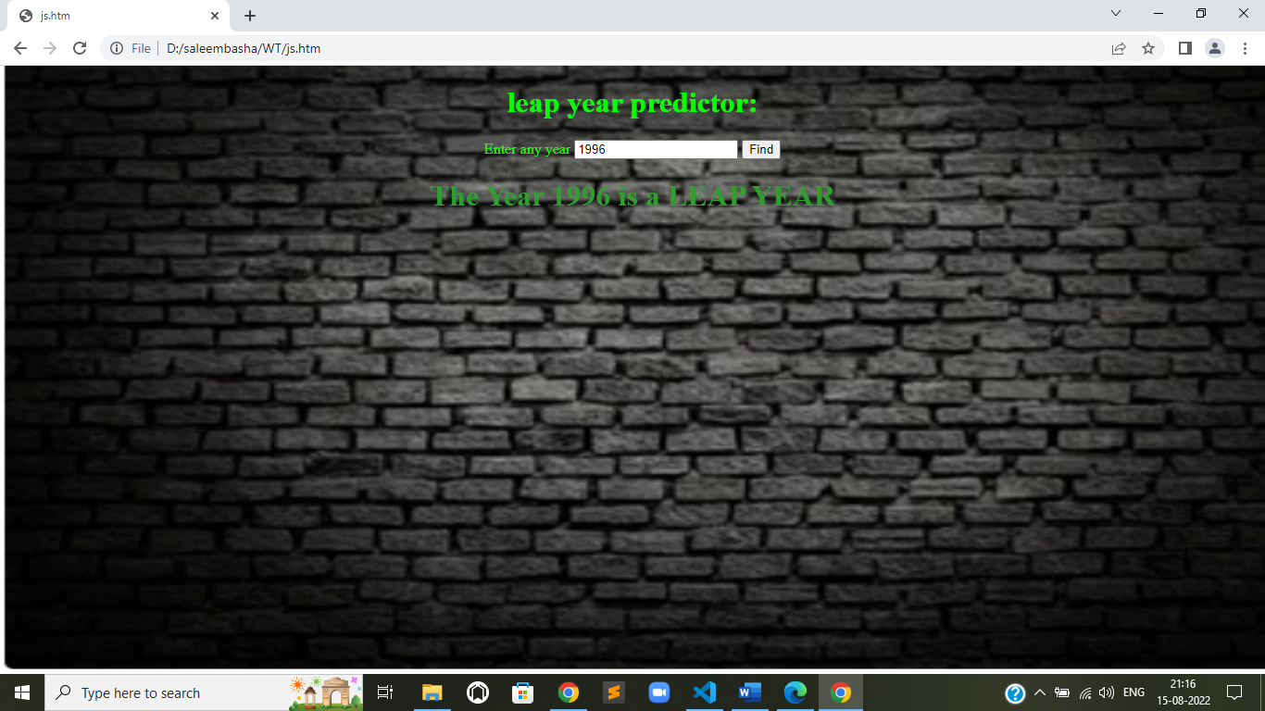

**b) Compute the biggest of three numbers**

<!DOCTYPE html>

<html>

<head>

    <script>

        function find() {

            var a = Number(document.getElementById('n1').value);

            var b = Number(document.getElementById('n2').value);

            var c = Number(document.getElementById('n3').value);

            let max;

            max = (a > b) ? (a > c ? a : c) : (b > c ? b : c);

            document.getElementById('ans').innerText = "Maximum number is " + max;

        }

    </script>

    <style>

        div {

            text-align: center;

        }

    </style>

</head>

<body vlink="red" alink="green" style="color: rgb(0, 255, 115);">

    <div>

        <h1>

            Determine maximum of three numbers

        </h1>

        <div style="text-align:center ;">

            <label>Enter the three numbers</label>

            <input type="number" id="n1">

            <input type="number" id="n2">

            <input type="number" id="n3"><br><br>

        </div>

        <button onclick="find()">Find</button>

        <h1 id="ans" style="color: rgb(47, 158, 47);"></h1>

    </div>

</body>

</html>

**OUTPUT:**

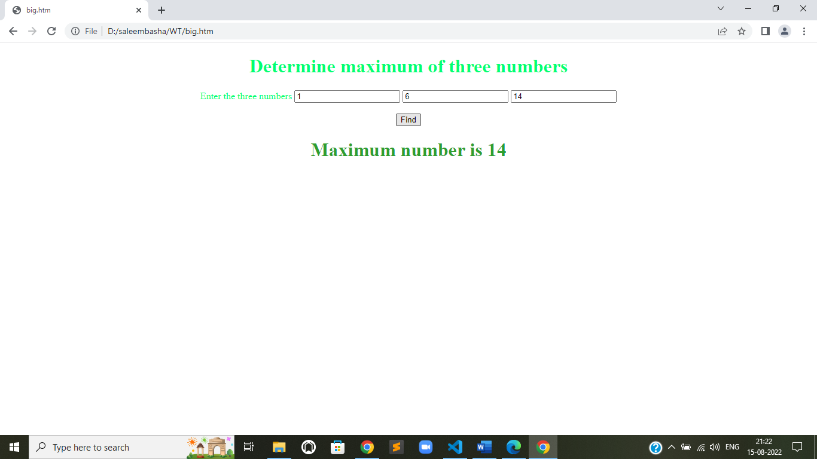

**c) Perform the arithmetic operations using switch statement.**

<!DOCTYPE html>

<html>

<head>

    <script>

        function find() {

            var a = Number(document.getElementById('n1').value);

            var b = document.getElementById('n2').value;

            var c = Number(document.getElementById('n3').value);

            let max;

            switch (b) {

                case '+':

                    max = a + c;

                    break;

                case '-':

                    max = a - c;

                    break;

                case '*':

                    max = a * c;

                    break;

                case '/':

                    max = a / c;

                    break;

                default:

                    document.getElementById('ans').innerText = "Incorrect oprator or operand";

            }

            document.getElementById('ans').innerText = "The resultant value will be : " + max;

        }

    </script>

    <style>

        div {

            text-align: center;

        }

    </style>

</head>

<body style="color: rgb(0, 255, 115);">

    <div>

        <h1>

            Artimetic operators using Switch statement

        </h1>

        <div style="text-align:center ;">

            <label>Enter the three numbers</label>

            <input type="number" id="n1" placeholder="Enter a number">

            <input type="text" id="n2" placeholder="Enter the operator">

            <input type="number" id="n3" placeholder="Enter a number"><br><br>

        </div>

        <button onclick="find()">Find</button>

        <h1 id="ans" style="color: rgb(47, 158, 47);"></h1>

    </div>

</body>

</html>

**OUTPUT:**

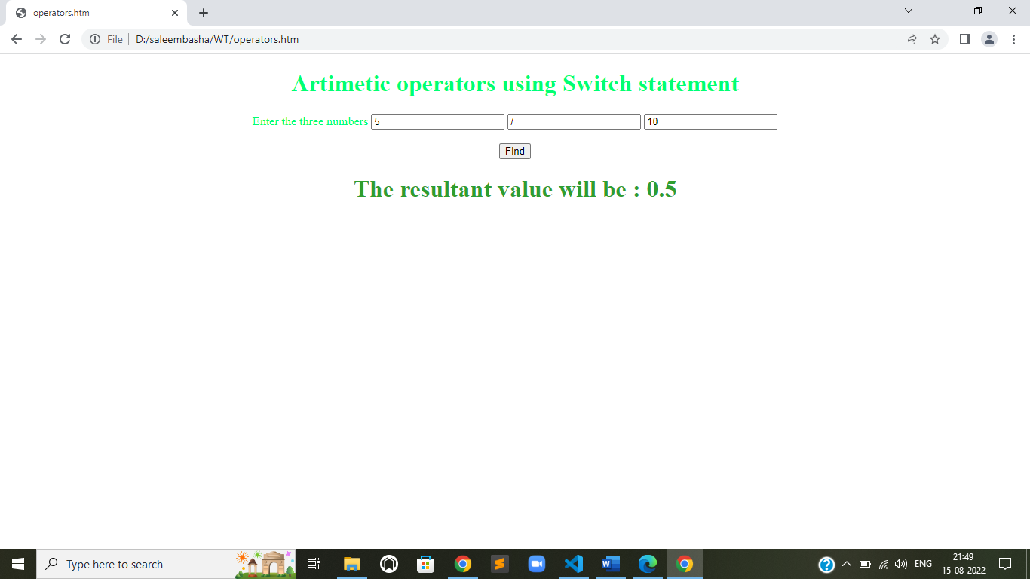

**2. Write a java script to**

**a) Calculate the sum of the digits of a give number**

<!DOCTYPE html>

<html>

<head>

    <title>

        HTML body vlink Attribute

    </title>

    <script>

        function find() {

            var a = document.getElementById('n1').value;

            let s = 0;

            try {

                for (let i = 0; i < a.length; i++) {

                    s += Number(a[i]);

                }

                document.getElementById('ans').innerText = "Sum of Digits of " + a + " is " + s;

            } catch (Error) {

                document.getElementById('ans').innerText = "Input Error."

            }

        }

    </script>

    <style>

        div {

            text-align: center;

        }

    </style>

</head>

<!-- body tag starts here -->

<body vlink="red" alink="green" style="color: rgb(0, 255, 115);">

    <div>

        <h1>

            Sum of the digits of Given Number

        </h1>

        <div style="text-align:center ;">

            <label>Enter the number</label>

            <input type="number" id="n1" placeholder="Enter the number:">

            <br><br>

        </div>

        <button onclick="find()">Find</button>

        <h1 id="ans" style="color: rgb(47, 158, 47);"></h1>

    </div>

</body>

</html>

**OUTPUT:**

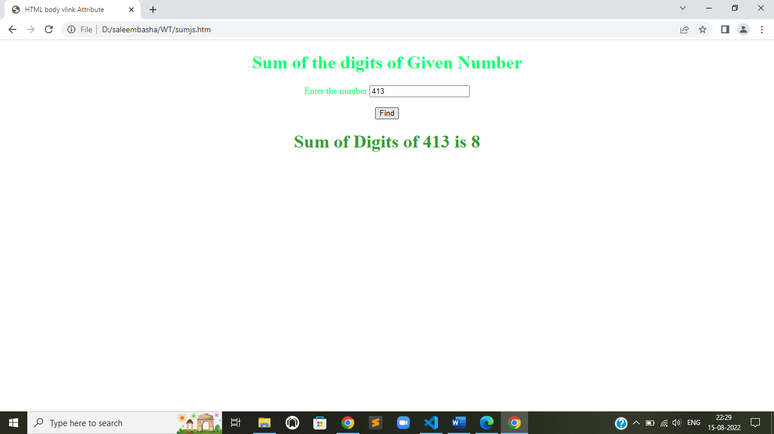

**b) Reverse of a given number**

<!DOCTYPE html>

<html>

<head>

    <title>

        HTML body vlink Attribute

    </title>

    <script>

        function find() {

            var a = document.getElementById('n1').value;

            let s = "";

            try {

                for (let i = (a.length - 1); i >= 0; i--) {

                    s += a[i];

                }

                document.getElementById('ans').innerText = "Reverse of " + a + " is " + s;

            } catch (err) {

                document.getElementById('ans').innerText = "Input Error."

            }

        }

    </script>

    <style>

        div {

            text-align: center;

        }

    </style>

</head>

<!-- body tag starts here -->

<body vlink="red" alink="green" style="color: rgb(0, 255, 115);">

    <div>

        <h1>

            Reverse of Given Number

        </h1>

        <div style="text-align:center ;">

            <label>Enter the number</label>

            <input type="number" id="n1" placeholder="Enter the number:">

            <br><br>

        </div>

        <button onclick="find()">Find</button>

        <h1 id="ans" style="color: rgb(47, 158, 47);"></h1>

    </div>

</body>

</html>

**OUPUT:**

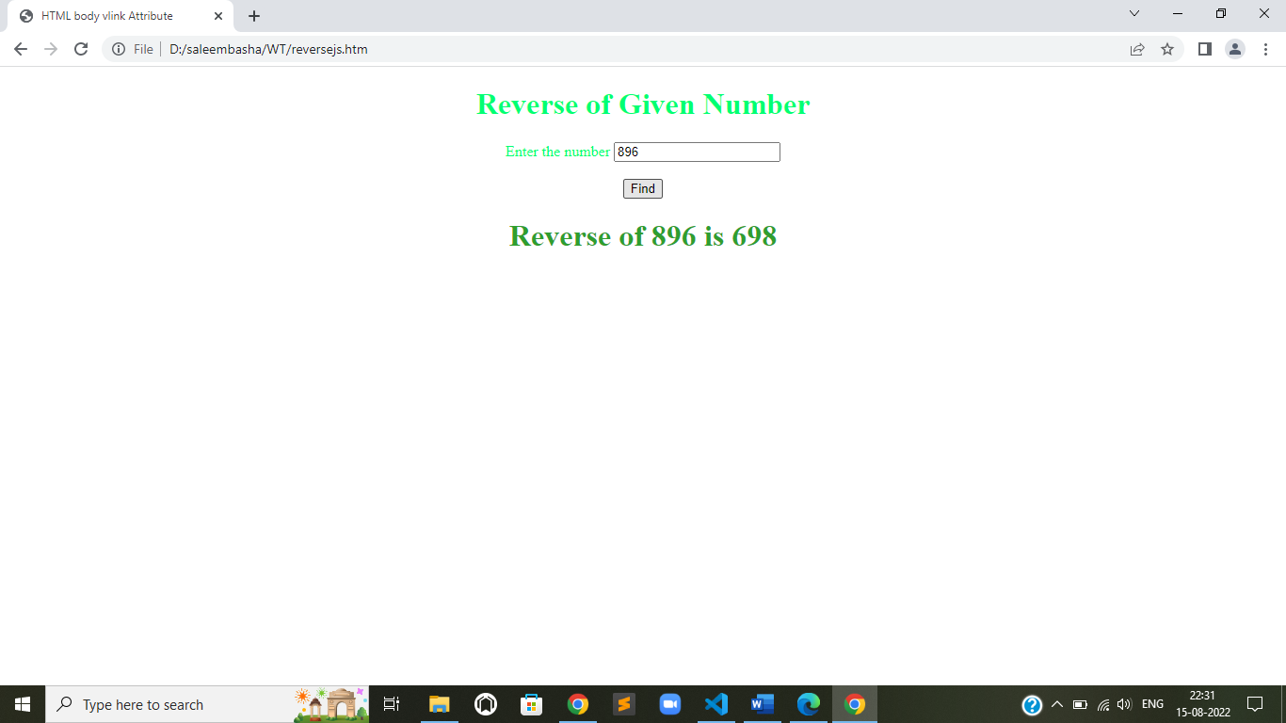

**c) Print the first 10 natural numbers except 5.**

<!DOCTYPE html>

<html>

<head>

    <title>

        title

    </title>

    <script>

        function find() {

            var a = 10;

            let bo, k = 0;

            let m = "";

            for (let i = 1; i <= a; i++) {

                bo = true;

                for (let j = 1; j < i; j++) {

                    if (i == 5) {

                        bo = false;

                        continue;

                    } else {

                        bo = true;

                    }

                }

                if (bo == true) {

                    m += " " + i;

                }

            }

            document.getElementById('ans').innerText = "The first 10 natural numbers are " + m

        }

    </script>

    <style>

        div {

            text-align: center;

        }

    </style>

</head>

<!-- body tag starts here -->

<body vlink="red" alink="green" style="color: rgb(0, 255, 115);">

    <div>

        <h1>

            first 10 Natural Numbers except 5

        </h1>

        <button onclick="find()">click here to display first 10 natural numbers except 5</button>

        <h1 id="ans" style="color: rgb(47, 158, 47);"></h1>

    </div>

</body>

</html>

**OUPUT:**

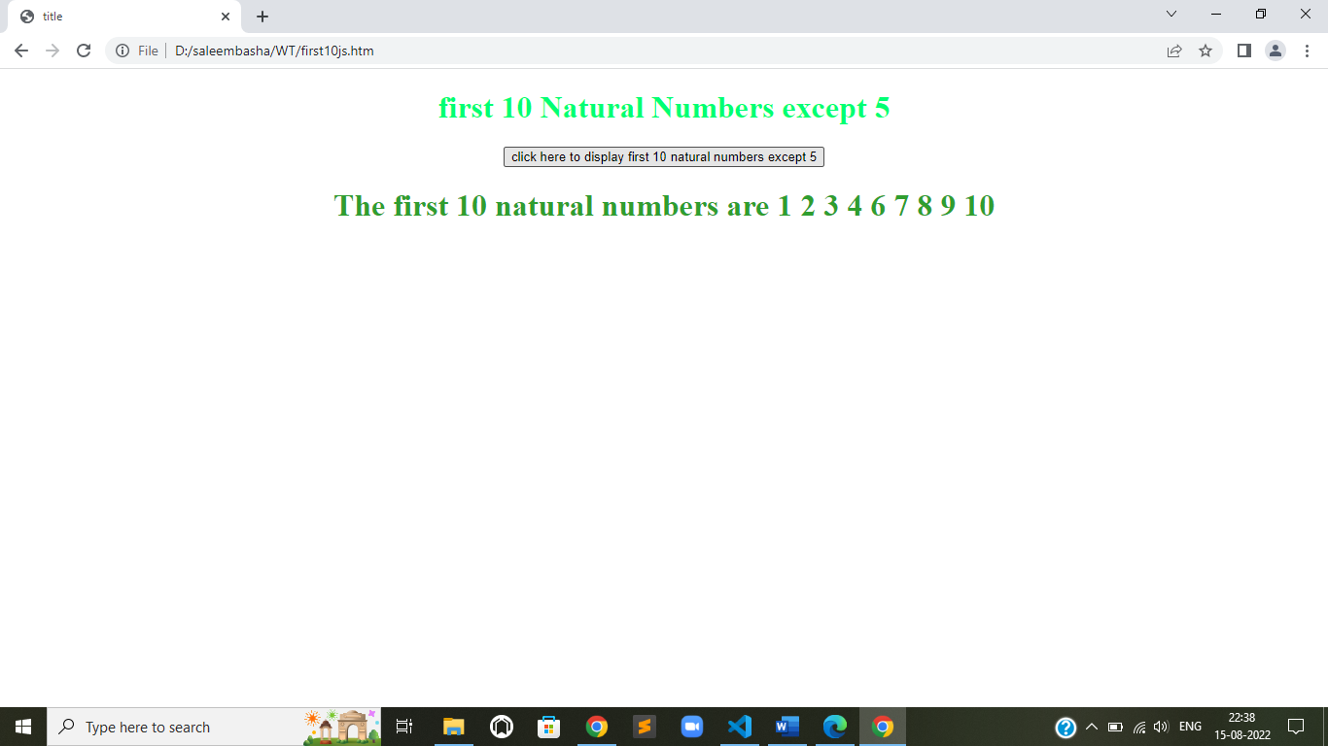

**3. Write a java script to**

**a) Generate random numbers using user defined function**

<!DOCTYPE html>

<html>

<head>

    <title>

        title

    </title>

    <script>

        function find() {

            let m = Math.round(Math.random() * 100);

            document.getElementById('ans').innerText = "Generated Number: " + m;

        }

    </script>

    <style>

        div {

            text-align: center;

        }

    </style>

</head>

<!-- body tag starts here -->

<body vlink="red" alink="green" style="color: rgb(0, 255, 115);">

    <div>

        <h1>

            Click To generate a random number between 1 and 100

        </h1>

        <button onclick="find()">Click Here!</button>

        <h1 id="ans" style="color: rgb(47, 158, 47);"></h1>

    </div>

</body>

</html>

**OUTPUT:**

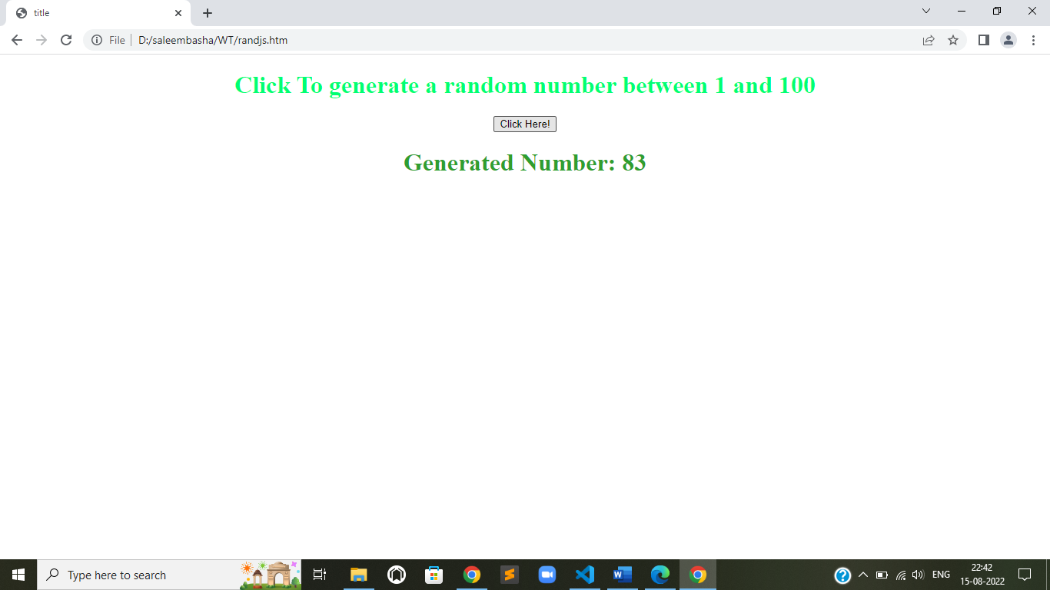

**b) Find the factorial of a given number using Recursive function .**

**OUTPUT:**

<html>

<head>

    <title>

        title

    </title>

    <script>

        function recur(m) {

            if (m == 1) {

                return (1);

            } else {

                return (m * recur(m - 1));

            }

        }

        function find() {

            let m = Number(document.getElementById('n1').value);

            let res = recur(m);

            document.getElementById('ans').innerText = "The Factorial of " + m + " is " + res;

        }

    </script>

    <style>

        div {

            text-align: center;

        }

    </style>

</head>

<!-- body tag starts here -->

<body vlink="red" alink="green" style="color: rgb(0, 255, 115);">

    <div>

        <h1>

            Factorial of a number

        </h1>

        <div style="text-align:center ;">

            <label>Enter the number</label>

            <input type="number" id="n1" placeholder="Enter a number"><br><br>

        </div>

        <button onclick="find()">Click Here!</button>

        <h1 id="ans" style="color: rgb(47, 158, 47);"></h1>

    </div>

</body>

</html>

**OUTPUT:**

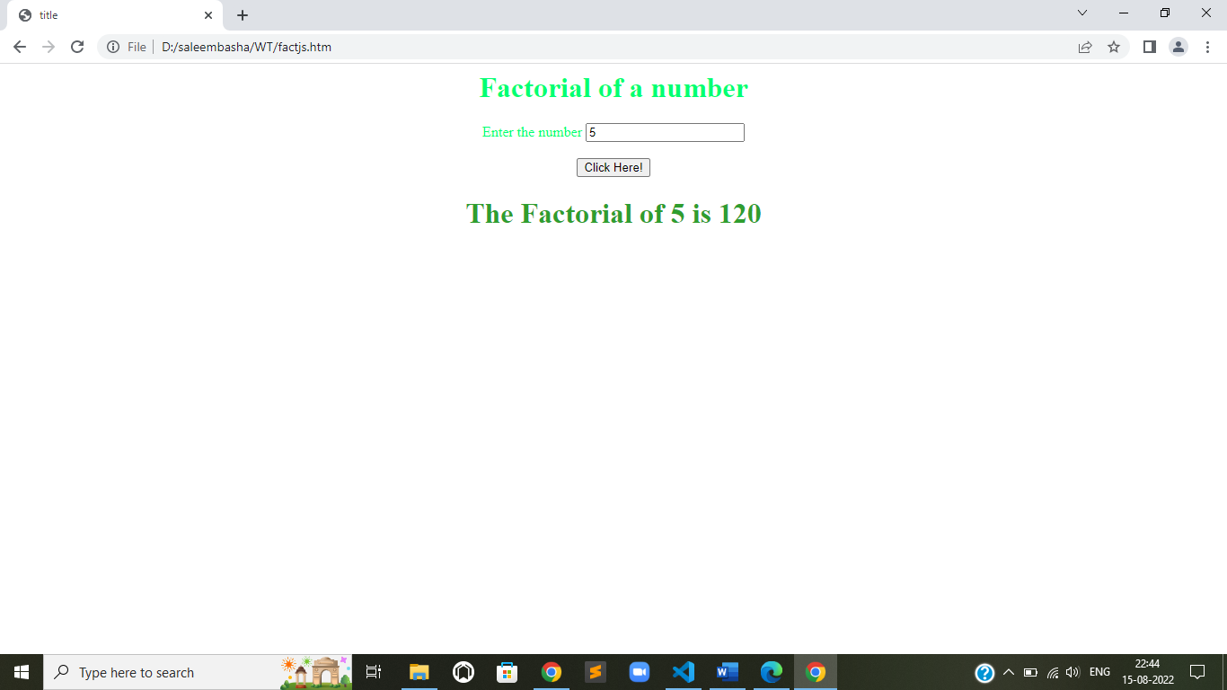

**c) Display a random Image by clicking a button.**

<!DOCTYPE html>

<html>

<head>

    <title>

        title

    </title>

    <script>

        function find() {

            let m = [

                'https://tse4.mm.bing.net/th/id/OIP.orHTGDKDou_DcpvxN3XMZAHaFj?w=209&h=180&c=7&r=0&o=5&pid=1.7',

                'https://tse2.mm.bing.net/th/id/OIP.-B6eSIWqGLILwsD7FO8HPAHaE8?w=236&h=180&c=7&r=0&o=5&pid=1.7',

                'https://tse3.mm.bing.net/th/id/OIP.-edFDcSqlon5xMykpg5qMgHaEK?w=331&h=187&c=7&r=0&o=5&pid=1.7',

                'https://tse1.mm.bing.net/th/id/OIP.2MiPiSxYdz8dCerAtSR9nwHaEK?w=298&h=180&c=7&r=0&o=5&pid=1.7',

                'https://tse1.mm.bing.net/th/id/OIP.gnIVmCY09Uugf2wmep4qkAHaEo?w=269&h=180&c=7&r=0&o=5&pid=1.7'

            ];

            let n = Math.round(Math.random() * 4);

            document.getElementById('im').src = m[n];

        }

    </script>

    <style>

        div {

            text-align: center;

        }

    </style>

</head>

<!-- body tag starts here -->

<body vlink="red" alink="green" style="color: rgb(0, 255, 115);">

    <div>

        <h1>

            Random Images

        </h1>

        <div style="text-align:center ;">

            <!-- <label>Enter the number</label>

    <input type="number" id="n1" placeholder="Enter a number"><br><br> -->

            <img src="library-bg1.jpg" id='im' width="200px" height="150px" alt="cant load the image">

        </div>

        <button onclick="find()">Click Here!</button>

        <h1 id="ans" style="color: rgb(47, 158, 47);"></h1>

    </div>

</body>

</html>

**OUTPUT:**

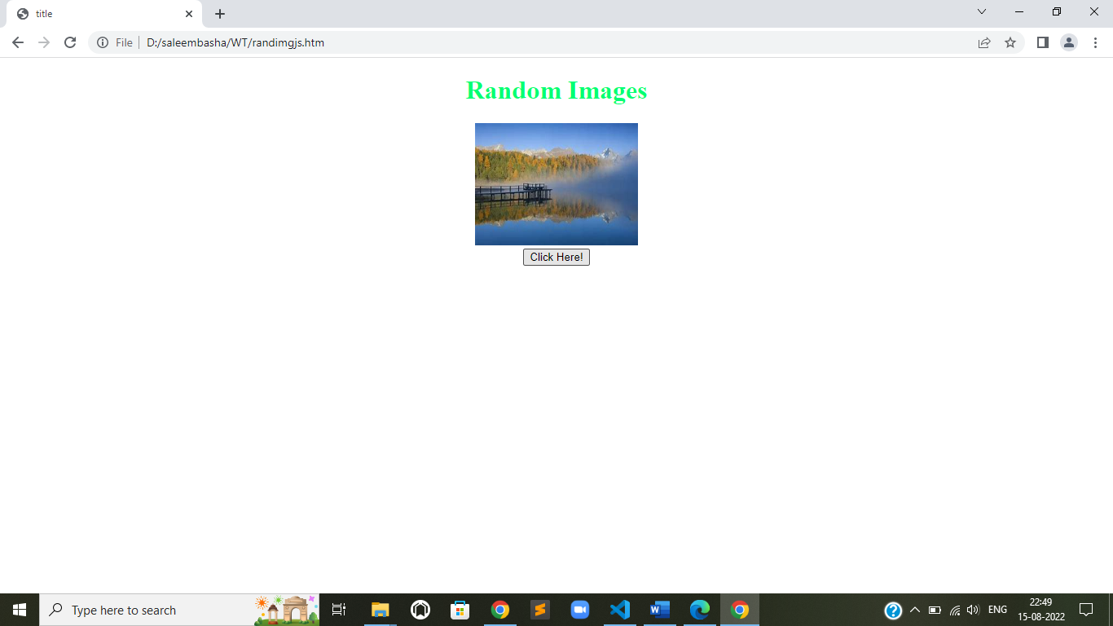

**4. Write a java script to**

**a) Sort the array element using bubble sort technique .**

function bubble(a) {

    for (let i = 0; i < a.length; i++) {

        for (let j = i; j < a.length; j++) {

            if (a[i] > a[j]) {

                let temp = a[i];

                a[i] = a[j];

                a[j] = temp;

            }

        }

    }

    return a;

}

console.log(bubble([5, 1, 3, 2, 4]));

**Output:-**

**[ 1, 2, 3, 4, 5 ]**

**b) Search a given element in the set of elements using binary search technique.**

function bin(arr, e) {

    let low = 0,

        high = arr.length - 1,

        mid, temp = 0;

    while (low <= high) {

        mid = Math.floor((low + high) / 2);

        if (arr[mid] > e) {

            high = mid - 1;

        } else if (arr[mid] < e) {

            low = mid + 1;

        } else {

            console.log("element found at postion: " + mid);

            temp = 1

            break;

        }

    }

    if (temp == 0)

        console.log("element Not Found");

}

bin([1, 2, 3, 4, 5], 1);

**output:-**

**element found at position: 0**

**C) Compute i) addition of two matrices**

let N = 3;

// This function adds A[][] and B[][], and stores

// the result in C[][]

function add(A, B, C) {

    let i, j;

    for (i = 0; i < N; i++)

        for (j = 0; j < N; j++)

            C[i][j] = A[i][j] + B[i][j];

}

// Driver code

let A = [[1, 1, 1, 1],

         [2, 2, 2, 2],

         [3, 3, 3, 3]];

let B = [[1, 1, 1, 1],

         [2, 2, 2, 2],

         [3, 3, 3, 3]];

// To store result

let C = new Array(N);

for (let k = 0; k < N; k++)

    C[k] = new Array(N);

let i, j;

add(A, B, C);

console.log("Result matrix is <br>");

for (i = 0; i < N; i++) {

    for (j = 0; j < N; j++)

        process.stdout.write(C[i][j] + " ");

    console.log('\n');

}

**Output:**

**Result matrix is :**

**2 2 2**

**4 4 4**

**6 6 6**

**ii) multiplication of two matrices.**

var R1 = 3;

// number of rows in Matrix-1

var C1 = 3;

// number of columns in Matrix-1

var R2 = 3;

// number of rows in Matrix-2

var C2 = 3;

// number of columns in Matrix-2

// This function multiplies mat1[][]

// and mat2[][], and stores the result

// in res[][]

function mulMat(mat1, mat2)

{

    // To store result

    var rslt = Array(R1).fill(0).map(()=>new Array(C2).fill(0));

    console.log("Multiplication of given two matrices is:");

    var i = 0;

    var j = 0;

    var k = 0;

    for (i = 0; i < R1; i++)

    {

        for (j = 0; j < C2; j++)

        {

            rslt[i][j] = 0;

            for (k = 0; k < R2; k++)

            {

                rslt[i][j] += mat1[i][k] * mat2[k][j];

            }

            process.stdout.write(rslt[i][j] + " ");

        }

        console.log("");

    }

}

// Driver program

var mat1 = [[1, 2, 3], [4, 5, 6], [7, 8, 9]];

var mat2 = [[1, 2, 3], [4, 5, 6], [7, 8, 9]];

if (C1 != R2)

{

    console.log("The number of columns in Matrix-1 must be equal to the number of rows in Matrix-2");

    console.log("Please update the global variables according to your array dimension");

}

else

{

    mulMat(mat1, mat2);

}

**Output:-**

**Multiplication of given two matrices is:**

**30 36 42**

**66 81 96**

**102 126 150**

**5. Write a java script to**

**a) Implement string operations using String object .**

let s = "saleem basha";

console.log('string concatination : ' + ('Hello ').concat(s));

console.log('string length: ' + s.length);

console.log('get character at a index:' + s.charAt(2));

console.log('ascii value of character: ' + s.charCodeAt(2));

console.log('Trim function: ' + "  hello uday  ".trim());

console.log('upper case: ' + s.toUpperCase());

console.log('Lower case: ' + s.toLowerCase());

console.log('substring: ' + s.substring(2, 4));

console.log('slice operator: ' + s.slice(2, 5));

console.log('split :' + s.split('a'));

console.log('to get index of \'a\': ' + s.indexOf('a'));

console.log('Search a substring: ' + s.search('le'));

console.log("replaces a with z: " + s.replace('a', 'z', 2));

**OUTPUT:**

**string concatination : Hello Saleem basha**

**string length: 12**

**get character at a index:l**

**ascii value of character: 108**

**Trim function: hello saleem**

**upper case: SALEEM BASHA**

**Lower case: Saleem basha**

**substring: le**

**slice operator: lee**

**split :s,leem b,sh**

**to get index of 'a': 1**

**Search a substring: 2**

**replaces a with z: szleem bzshz**

**b) Implement the mathematical operations using Math object.**

console.log('round :'+Math.round(1.3));

console.log('ciel : '+Math.ceil(1.3));

console.log('floor  : '+Math.floor(1.3));

console.log('truncate: '+Math.trunc(1.6));

console.log('square root: '+Math.sqrt(2));

console.log('pi value'+Math.PI);

console.log("random number: "+Math.random());

console.log("max :"+Math.max(1,2,3,3,4,10));

console.log("min :"+Math.min(1,2,3,3,4,10));

console.log("sine value : "+Math.sin(90));

console.log("logarithm : "+Math.log(10));

console.log("power: "+Math.pow(2,3));

**output:-**

**round : 1**

**ciel : 2**

**floor  : 1**

**truncate: 1**

**square root: 1.4142135623730951**

**pi value3.141592653589793**

**random number: 0.8701921379186475**

**max :10**

**min :1**

**sine value : 0.8939966636005579**

**logarithm : 2.302585092994046**

**power: 8**

**c) Display Greeting messages using Date object.**

<!DOCTYPE html>

<html>

<head>

    <style>

        p {

            text-align: center;

        }

        body {

            background-color: darkgrey;

        }

    </style>

</head>

<body>

    <p id="demo"></p>

    <script>

        var today = new Date()

        var curHr = today.getHours()

        if (curHr >= 0 && curHr < 6) {

            document.getElementById("demo").innerHTML = 'What are you doing that early?';

        } else if (curHr >= 6 && curHr <= 12) {

            document.getElementById("demo").innerHTML = 'Good Morning saleem';

        } else if (curHr >= 12 && curHr < 17) {

            document.getElementById("demo").innerHTML = 'Good Afternoon saleem';

        } else {

            document.getElementById("demo").innerHTML = 'Good Evening saleem';

        }

    </script>

</body>

</html>

**OUTPUT:**

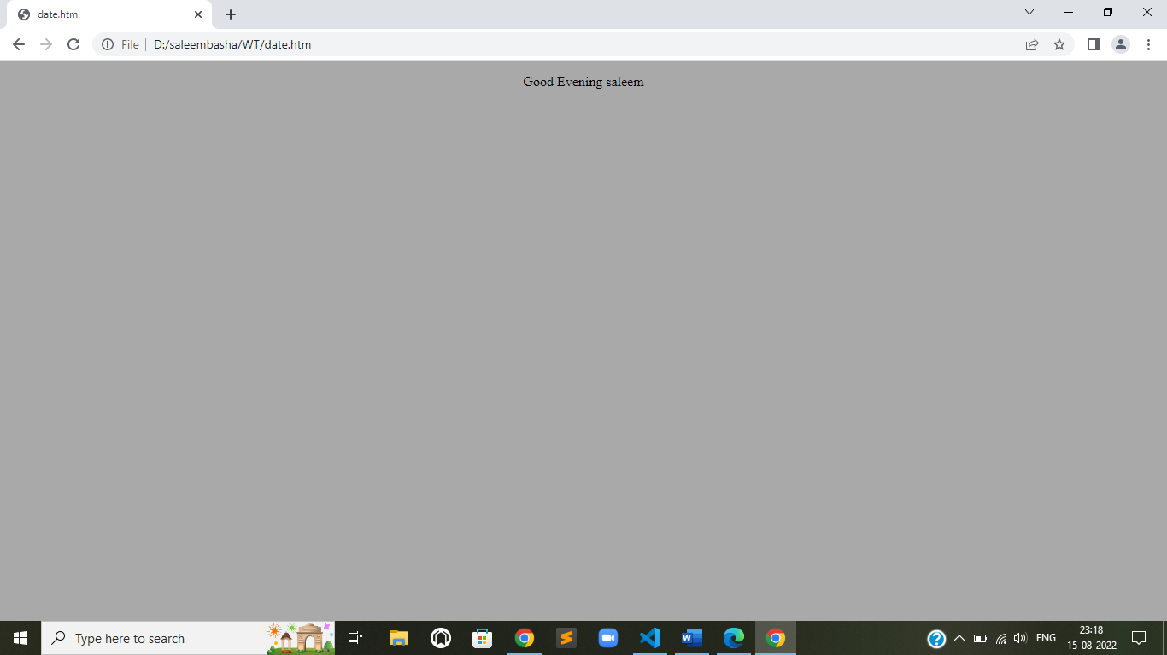

**6. demonstrate collect objects**

**a) All collection .**

**b) Children collection.**

**c) Anchor collection.**

<!DOCTYPE html>

<html>

<body style="background-color:lightpink;">

    <h2>JavaScript HTML DOM</h2>

    <p>Hello World!</p>

    <p>Hello Norway!</p>

    <p>Click the button to change the color of all p elements.</p>

    <a name="html">HTML Tutorial</a><br>

    <a name="css">CSS Tutorial</a><br>

    <a name="xml">XML Tutorial</a><br>

    <p>The content of the first anchor in this document is:</p>

    <p id="demo"></p>

    <button onclick="myFunction()">Try it</button>

    <button onclick="mFunction()">Change</button>

    <script>

        function myFunction() {

            const myCollection = document.getElementsByTagName("p");

            for (let i = 0; i < myCollection.length; i++) {

                myCollection[i].style.color = "blue";

            }

        }

        function mFunction() {

            const collection = document.body.children;

            for (let i = 0; i < collection.length; i++) {

                collection[i].style.backgroundColor = "red";

            }

        }

        let content = document.getElementsByTagName("a")[0].innerHTML;

        document.getElementById("demo").innerHTML = content;

    </script>

</body>

</html>

**OUTPUT:**

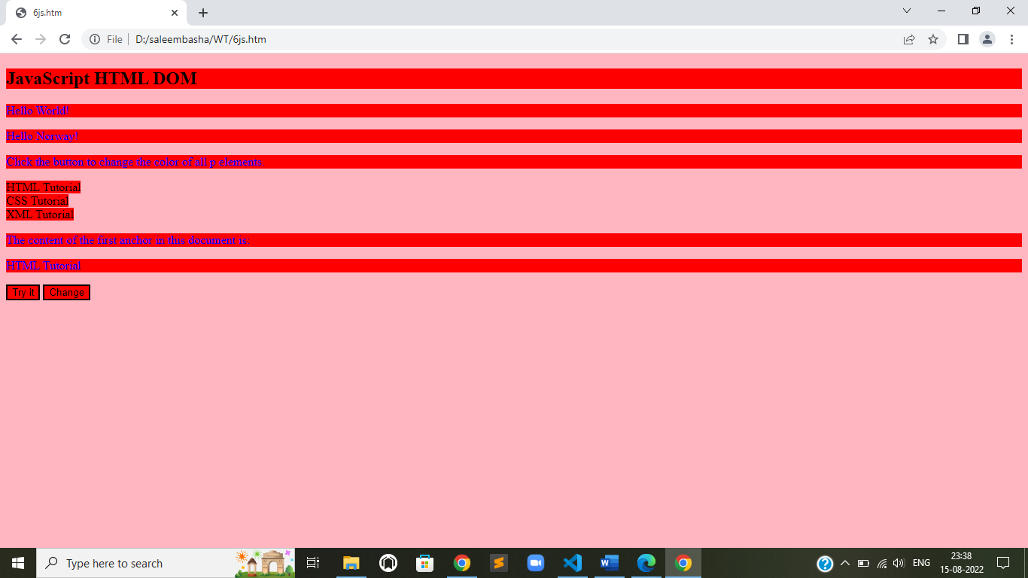

**7. Demonstrate event model**

**a) Form events (onchange, onfocus ,onblur).**

<!DOCTYPE html>

<html>

<head>

    <title>trail6</title>

    <style>

        p,

        input,

        label {

            text-align: center;

            font-size: 30px;

        }

        body {

            background-color: darkgrey;

        }

    </style>

    <script>

        function myFunction(val) {

            alert("The input value has changed. The new value is: " + val);

        }

    </script>

</head>

<body>

    <center>

        <p>Modify the text in the input field, then click outside the field to fire the onchange event.</p>

        <label>Enter some text: </label>

        <input type="text" name="txt" value="Hello" onchange="myFunction(this.value)">

        <br><br>

        <p>Onfocus event in js ---- click ont he textfield</p>

        <label>Enter the text:</label>

        <input type="text" id="foc" onfocus="document.getElementById('foc').style.backgroundColor='green'">

        <br><br>

        <p>on blur function --- click on the input and leave it to see the fuctionality</p>

        <label>Enter the text:</label>

        <input id="blr" type="text" onblur="document.getElementById('blr').style.backgroundColor='yellow'">

    </center>

</body>

</html>

**OUTPUT:**

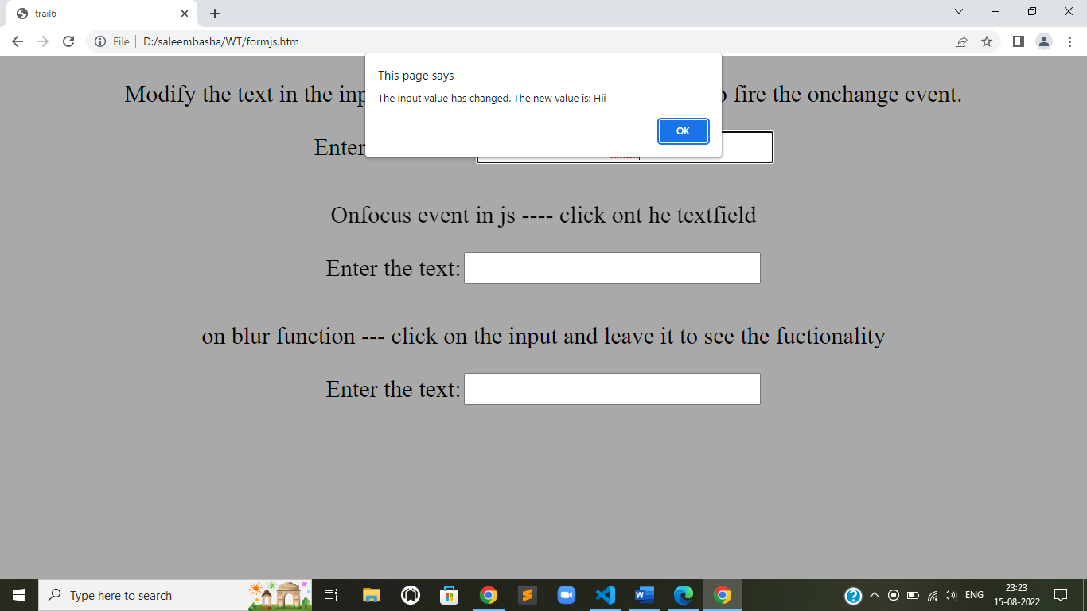

**b) Mouse events (onclick, onmouesedown, onmoueseup, onmouesemove, onmoueseover).**

<!DOCTYPE html>

<html>

<head>

    <title>trail6</title>

    <style>

        p,

        input,

        label {

            text-align: center;

            font-size: 30px;

        }

        body {

            background-color: darkgrey;

        }

    </style>

    <script>

        function myFunction(val) {

            alert("Mouse is clicked on the input");

        }

    </script>

</head>

<body>

    <center>

        <p>onmouseclick in the input field a alert box will appear</p>

        <label>Enter some text: </label>

        <input type="text" name="txt" value="Hello" onmousedown="myFunction(this.value)">

        <br><br>

        <p>onclick event in js ---- click ont he textfield</p>

        <label>Enter the text:</label>

        <input type="text" id="foc" onclick="document.getElementById('foc').style.backgroundColor='green'">

        <br><br>

        <p>on blur function --- click on the input and leave it to see the fuctionality</p>

        <label>Enter the text:</label>

        <input id="blr" type="text" onmouseup="document.getElementById('blr').style.backgroundColor='yellow'">

        <br><br>

        <input type="submit" id="but" onmouseover="document.getElementById('but').style.backgroundColor='gold'"><br><br>

        <input type="submit" id="butt" onmousemove="document.getElementById('butt').style.backgroundColor='red'"><br><br>

    </center>

</body>

</html>

**OUTPUT:**

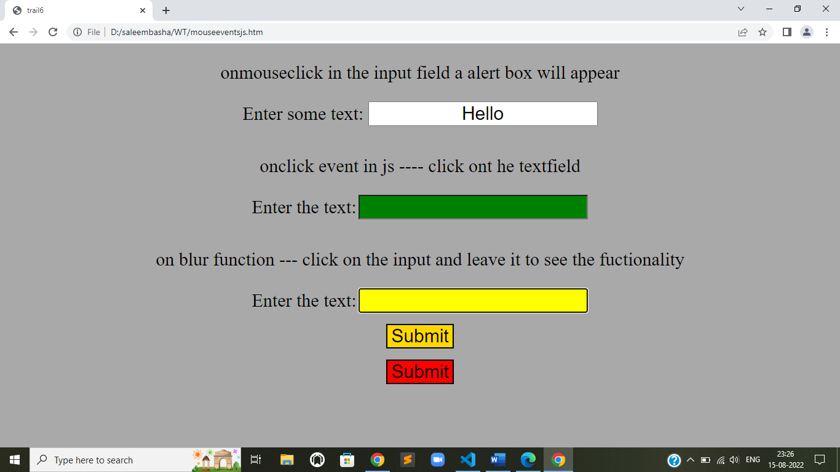

**c) Event bubbling.**

<!DOCTYPE html>

<html>

<head>

    <title>

        Bubbling Event in Javascript

    </title>

    <style>

        button {

            height: 90px;

            width: 150px;

        }

    </style>

</head>

<body>

    <h2>Event bubbling is to hadle an event by more than one element whether event happens on single element</h2>

    <h2>Bubbling Event in Javascript</h2>

    <div id="parent">

        <button>

          <h2>Parent</h2>

      </button>

        <button id="child">

<p>Child</p>

      </button>

    </div><br>

    <script>

        document.getElementById(

            "child").addEventListener("click", function() {

            alert("You clicked the Child element!");

        }, false);

        document.getElementById(

            "parent").addEventListener("click", function() {

            alert("You clicked the parent element!");

        }, false);

    </script>

</body>

</html>

**OUTPUT:**

