Notes
Friday, July 16, 2021
10:10 AM
Same template. Alexa is the IC.
Org id 140
  - templates
  - Phases
  - Vitals
  - Taskflows
  - Deadline chains
  - Deadline reminders
  - DocGens
  - Instruction fields

From <https://app.slack.com/client/T031E6GFG/C01QC37GPRC/thread/GQNM48X1V-1626390511.032000>

Main project is here: https://app.filevine.com/#/project/6450235/activity
140 is the new Shard B Org ID.
From 7119 in Shard A to 140 in Shard B.

Can I get access to 140 in Shard B?
This is loaded in 7119_FedEx_II_r1

Old staging - old prod.
Every org/client, shared resources
Bobbygarcia has their org.

Staging2.

FV to FV overview
Monday, July 19, 2021
11:02 AM
Usually US to Canada, but this is shard A to shard B.
They usually happen because the client messed up on templating/mapping, they are combining firms in FV, they are splitting firms in FV, or they are changing regions.

  - Create the org
  - Pull the templates in
  - Create import batches (ALL)
  - Pull scripts and see what is there.
  - Fv to fv things
  - Insert_execution_order
  - Update
  - Merge
  - No custom contacts so skipped to customtemplateprocedureinserts
  - Project custom views
  - Insert reference project customfield metadata
  - Run generate project custom views

  - Refresh views

Test 1
Friday, July 23, 2021
9:41 AM
Ask IC about lots of tabs we have no data for. So either backup or metal team messed up. OR new templates added?, new or created from backup or missing data. Have the metal team check for those tabs. Ask Alex to ask the metal team and depending on what they say ask the client:
- usp_insert_staging_AllegationsDamages
- usp_insert_staging_EEOC
- usp_insert_staging_InitialAssessment
- [usp_insert_staging_Investigation] -- this one has a generic script
- [usp_insert_staging_PlaintiffPeople]
- usp_insert_staging_Post60DayAnalysis
- [usp_insert_staging_SignificantDevs]

----------------------------------------------------------------------------------------------------------
Jeremiah was IC and then left.

Shard a to shard b. task. 2FA wasn't on shardA. Moved over but little to no contact with the client. Met with jason very briefly with bhavin. What the move looks like, etc.

Not intimately familiar - another person on team reached out about build edits.

The scripts we run build view from FV to FV table data.
- New tabs
- Missing data - DMRE team. Ask Kevin to pass this along.
----------------------------------------------------------------------------------------------------------
Which template is correct? A or B? all these mismatch, which one to use.

No data for those tabs, probably going to use shard.
way less sections on shard B.

If they don't match, don't touch it until you know what you're doing.

Data structure matches shard B. only templates that match shard b template. Data was.

Guess:
They built up whole new template system on shard b.
Ic pulled wrong stuff possibly?
Didn't copy shard A and just built it from scratch maybe.

- Shard a is wrong and make shard b off that (IC first)
- Shard b wrong and pull new DB because we missed a lot.
----------------------------------------------------------------------------------------------------------

Test 1 load
Thursday, August 5, 2021
4:25 PM
Exception During ProcessBatch Marking [FedexB_Test1 _FedexB_Test1_Projects___9909] Error System.NullReferenceException: Object reference not set to an instance of an object.
at Filevine.Services.ProjectCreator.createReplacementValuesForProject(Project project) in C:\BuildAgent\work\1fb3dbe1601e3b50\Filevine.Services\ProjectCreator.cs:line 463
at Filevine.Services.ProjectCreator.<MassCreate>b__38_9(Project project) in C:\BuildAgent\work\1fb3dbe1601e3b50\Filevine.Services\ProjectCreator.cs:line 242
at System.Collections.Generic.List`1.ForEach(Action`1 action)
at Filevine.Services.ProjectCreator.MassCreate(Int32 orgID, List`1 items, ConcurrentBag`1 validations) in C:\BuildAgent\work\1fb3dbe1601e3b50\Filevine.Services\ProjectCreator.cs:line 239
at Filevine.Services.Import.Importers.ProjectImporter.ImportChunk(String workerID) in C:\BuildAgent\work\1fb3dbe1601e3b50\Filevine.Services\Import\Importers\ProjectImporter.cs:line 164
at Filevine.Services.Import.ImportProcessingService.ProcessBatch(Int32 importBatchID) in C:\BuildAgent\work\1fb3dbe1601e3b50\Filevine.Services\Import\ImportProcessingService.cs:line 57

From <https://app.slack.com/client/T031E6GFG/C01HQ7F6T6C/thread/D0290NNNRFG-1628264489.012800>

Got system error on projects
Exception During ProcessBatch Marking [FedexB_Test1 _FedexB_Test1_Projects___9909] Error System.Data.Entity.Infrastructure.DbUpdateException: An error occurred while updating the entries. See the inner exception for details. ---> System.Data.Entity.Core.UpdateException: An error occurred while updating the entries. See the inner exception for details. ---> System.Data.SqlClient.SqlException: The INSERT statement conflicted with the FOREIGN KEY constraint "FK_Project_CustomProjectType". The conflict occurred in database "Filevine", table "dbo.CustomProjectType", column 'ID'.
The statement has been terminated.
at System.Data.SqlClient.SqlConnection.OnError(SqlException exception, Boolean breakConnection, Action`1 wrapCloseInAction)
at System.Data.SqlClient.SqlInternalConnection.OnError(SqlException exception, Boolean breakConnection, Action`1 wrapCloseInAction)
at System.Data.SqlClient.TdsParser.ThrowExceptionAndWarning(TdsParserStateObject stateObj, Boolean callerHasConnectionLock, Boolean asyncClose)
at System.Data.SqlClient.TdsParser.TryRun(RunBehavior runBehavior, SqlCommand cmdHandler, SqlDataReader dataStream, BulkCopySimpleResultSet bulkCopyHandler, TdsParserStateObject stateObj, Boolean& dataReady)
at System.Data.SqlClient.SqlDataReader.TryConsumeMetaData()
at System.Data.SqlClient.SqlDataReader.get_MetaData()
at System.Data.SqlClient.SqlCommand.FinishExecuteReader(SqlDataReader ds, RunBehavior runBehavior, String resetOptionsString, Boolean isInternal, Boolean forDescribeParameterEncryption, Boolean shouldCacheForAlwaysEncrypted)
at System.Data.SqlClient.SqlCommand.RunExecuteReaderTds(CommandBehavior cmdBehavior, RunBehavior runBehavior, Boolean returnStream, Boolean async, Int32 timeout, Task& task, Boolean asyncWrite, Boolean inRetry, SqlDataReader ds, Boolean describeParameterEncryptionRequest)
at System.Data.SqlClient.SqlCommand.RunExecuteReader(CommandBehavior cmdBehavior, RunBehavior runBehavior, Boolean returnStream, String method, TaskCompletionSource`1 completion, Int32 timeout, Task& task, Boolean& usedCache, Boolean asyncWrite, Boolean inRetry)
at System.Data.SqlClient.SqlCommand.RunExecuteReader(CommandBehavior cmdBehavior, RunBehavior runBehavior, Boolean returnStream, String method)
at System.Data.SqlClient.SqlCommand.ExecuteReader(CommandBehavior behavior, String method)
at System.Data.SqlClient.SqlCommand.ExecuteDbDataReader(CommandBehavior behavior)
at System.Data.Common.DbCommand.ExecuteReader(CommandBehavior behavior)
at System.Data.Entity.Infrastructure.Interception.DbCommandDispatcher.<Reader>b__c(DbCommand t, DbCommandInterceptionContext`1 c)
at System.Data.Entity.Infrastructure.Interception.InternalDispatcher`1.Dispatch[TTarget,TInterceptionContext,TResult](TTarget target, Func`3 operation, TInterceptionContext interceptionContext, Action`3 executing, Action`3 executed)
at System.Data.Entity.Infrastructure.Interception.DbCommandDispatcher.Reader(DbCommand command, DbCommandInterceptionContext interceptionContext)
at System.Data.Entity.Internal.InterceptableDbCommand.ExecuteDbDataReader(CommandBehavior behavior)
at System.Data.Common.DbCommand.ExecuteReader(CommandBehavior behavior)
at System.Data.Entity.Core.Mapping.Update.Internal.DynamicUpdateCommand.Execute(Dictionary`2 identifierValues, List`1 generatedValues)
at System.Data.Entity.Core.Mapping.Update.Internal.UpdateTranslator.Update()
--- End of inner exception stack trace ---
at System.Data.Entity.Core.Mapping.Update.Internal.UpdateTranslator.Update()
at System.Data.Entity.Core.EntityClient.Internal.EntityAdapter.<Update>b__2(UpdateTranslator ut)
at System.Data.Entity.Core.EntityClient.Internal.EntityAdapter.Update[T](T noChangesResult, Func`2 updateFunction)
at System.Data.Entity.Core.EntityClient.Internal.EntityAdapter.Update()
at System.Data.Entity.Core.Objects.ObjectContext.<SaveChangesToStore>b__35()
4:15
at System.Data.Entity.Core.Objects.ObjectContext.ExecuteInTransaction[T](Func`1 func, IDbExecutionStrategy executionStrategy, Boolean startLocalTransaction, Boolean releaseConnectionOnSuccess)
at System.Data.Entity.Core.Objects.ObjectContext.SaveChangesToStore(SaveOptions options, IDbExecutionStrategy executionStrategy, Boolean startLocalTransaction)
at System.Data.Entity.Core.Objects.ObjectContext.<>c__DisplayClass2a.<SaveChangesInternal>b__27()
at System.Data.Entity.SqlServer.DefaultSqlExecutionStrategy.Execute[TResult](Func`1 operation)
at System.Data.Entity.Core.Objects.ObjectContext.SaveChangesInternal(SaveOptions options, Boolean executeInExistingTransaction)
at System.Data.Entity.Core.Objects.ObjectContext.SaveChanges(SaveOptions options)
at System.Data.Entity.Internal.InternalContext.SaveChanges()
--- End of inner exception stack trace ---
at System.Data.Entity.Internal.InternalContext.SaveChanges()
at System.Data.Entity.Internal.LazyInternalContext.SaveChanges()
at Filevine.Data.FilevineContext.SaveChanges() in C:\BuildAgent\work\1fb3dbe1601e3b50\Filevine.Data.EF\FilevineContext.cs:line 384
Entity of type "Project" could not be saved.
Process
Filevine.WindowsService.ImportService
Machine
FV-MIGRATION-ST

From <https://app.slack.com/client/T031E6GFG/C01HQ7F6T6C/thread/G01D2ETQNP7-1628195167.106500>

What's left
Monday, August 9, 2021
2:42 PM

Permissions: dupes? Review with Rob
Documents: need docscan

No litigationtaskflows
No instructions
No

Major issues
Friday, September 17, 2021
3:05 PM
Contact list didn't come over. For case summary. Contact users.

This is not my fault or scripting. It's data issue.

Customdatapersonlist. Select top 1000 rows. No data.

Personlistitems too. Nothing came over. METAL team.

How to figure this out…
__fv_projectcustomfieldmetadata. Top 1000

Section, field selection, displayname. Only really care about section.

Where section = 'CaseSummary'

Go to field selectors and not gonna be there, no data.

He went to case summary on the test

The responsibleprofessional field.

And find it in the projectcustomfieldmetadata where section like '%casesummary%'
and fieldselector like responsibleprofessional .

Find the values all empty. Column there but no data.

That tells rob there is bug in script or table not popped.

So check table.

Field type is person… should be person list.

Customdataperson.

Customsection table and id.

SELECt from customsection where sectionselector = 'casesummary'
3 for 3 templates
SELECt *
FROM custom field where fieldselector = 'responsibleprofessional'

There's 2.

Then back in customdataperson
Where customselectionid in ('','','')
And customfieldID in the 2 from above
Gives everybody.
32 people total.

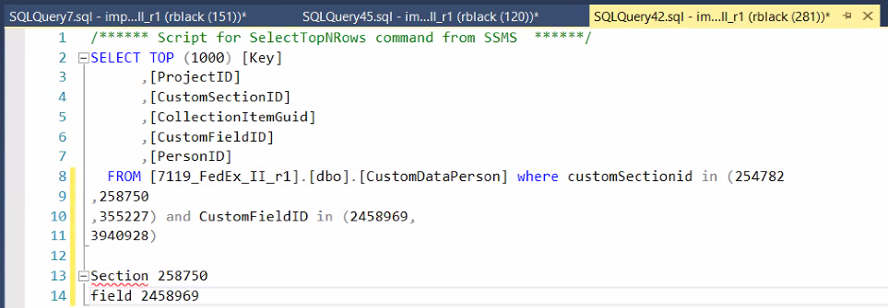
I need to go ask metal team for customdataperson and customdatapersonlist. They are empty. Csv's. know they are there, can see in prod.
--------------
Docs
--------------
Issue was script.
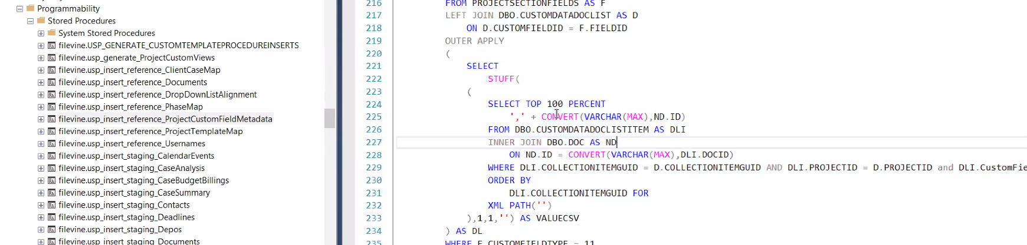
was pointing to pt1.docs.

So now data is pulled. It was missing but it's there.

Rebuild test and data should be in view now.

