**ITEM MAINTENANCE MANUAL**

**Access to Logon Screen**

Access to the Logon Screen will be via:

* Short cut in the email requesting approval; or
* http://172.29.64.7/logistics/default.asp; or
* "AV Item Maintenance (Testing) in the Audio Visual Tab on the Intranet Portal.



**Logon Screen**

When you access the link, you will get the following screen

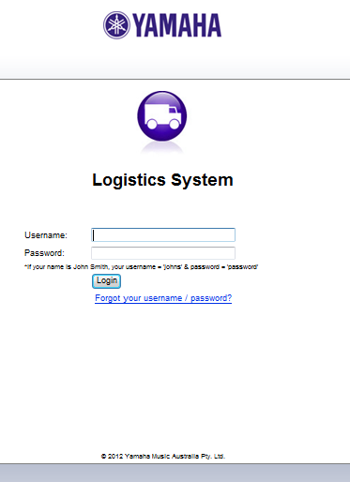

Please enter your Username and Password.

**Item Maintenance Screen**

The next screen will provide:

* an overview of all outstanding items that will have to be completed;
* When the status is changed to “Completed”, all the prior items that have been approved will be listed.
* You will be able to search by Item Name/Item Code/Description/GMC Code in either the “Completed” or “Open” Status

“Open “– List all SKU’s that have incomplete Item Maintenance

“Complete” – Lists all SKU’s that have completed Item Maintenance

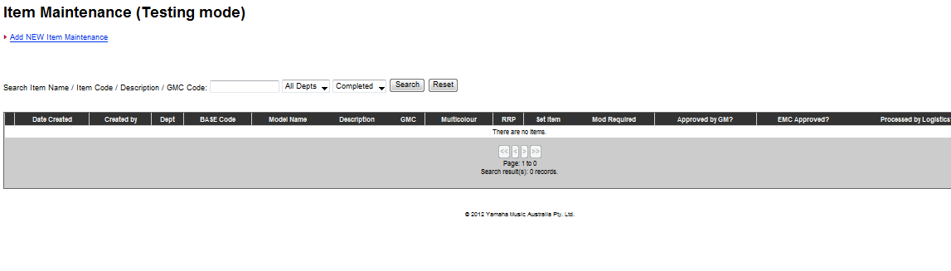

**Entry of New Item**

On the first screen, on the top left of the screen, Click on the **“Add NEW Item Maintenance”.**

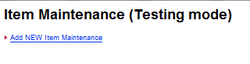

A new screen with details for the new SKU’s will appear. All items marked with Red Asterisks (“*”) are compulsory fields and will have to be completed for the data entry to be valid.

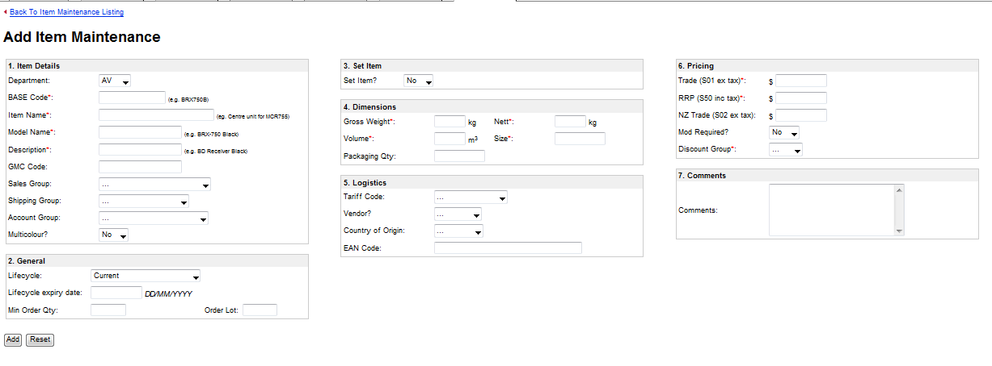

**Colour Variants**

If there are the Colour Variants, in the Multicolour change the field to “Yes” and options will appear to enter colour details of the same product. To add more colour options place the cursor on the **“+ colour”** to add more lines.

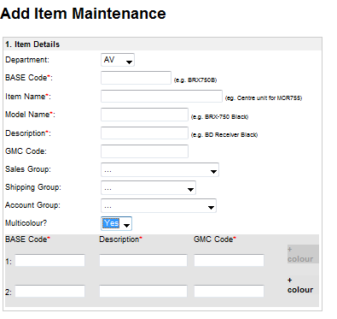

**Set Item**

If the SKU is a SET item change the Set Item dropbox to “Yes” and a field will appear to note the components to the Set Item. The **“BASE Code”** and **“Qty”** are compulsory fields. More components can be added using the **“+set item”**

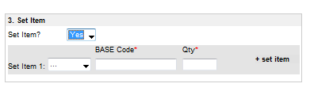

**Hard wiring and Plug Adaptor Modifications**

If the item requires a change in the Powere Adaptor or a Hard wired modification, in the Mods Required? field change the dropbox to “Yes”

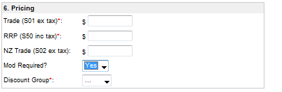

**Completion**

To complete the Item Maintenance and commence the approval process, click on the “Add” button at the bottom of the screen



If the compulsory fields have not bee completed, the incomplete fields will be highlighted in yellow and the a message displayed as to the incomplete fields.

