* **Table of contents:**

|  |  |
| --- | --- |
| Title | Page Number |
| Participants | Page #2 |
| The Task | Page #2 |
| Introduction | Page #2 |
| Objectives | Page #3 |
| Methodology | Page #3 |
| Tools | Page #3 |
| GUI discussion | Page #4 & #5& #6  & #7 |
| Conclusion | Page #8 |
| References | Page #8 |

**The Task ::**

The task involved developing a Peer-to-Peer (P2P) Application using Java Socket Programming. The application facilitates chatting between multiple clients over a network. The project was divided into two parts:

Part 1: Implementing a P2P Chatting Application using UDP Sockets.

Part 2: Enhancing the application with TCP Socket Programming and adding additional features.

* **Introduction:**

The project aimed to create a user-friendly application for real-time communication between users connected to the same network. It utilized Java Socket Programming to establish communication channels between clients and facilitate message exchange.

* **Objectives:**

The main objectives of the project were:

* To develop a P2P Chatting Application using UDP Sockets.
* To enhance the application with TCP Socket Programming for improved reliability.
* To implement additional features such as message archiving, message deletion, and user authentication.
* To create a user-friendly GUI for seamless interaction with the application.
* **Methodology:**

The project was implemented using Java programming language in Eclipse IDE. The methodology involved the following steps:

* Designing the GUI interface using Swing components for user interaction.
* Implementing socket programming concepts to establish communication channels between clients.
* Adding functionalities for sending and receiving messages, including timestamping and message coloring.
* Implementing message archiving and deletion functionalities as per the project requirements.
* Incorporating user authentication using a TCP server and maintaining an active client list.
* **Tools:**
* Netbeans (java language )
* Swing Framework: for creating the graphical user interface.
* Java Socket Programming: for establishing communication between clients.
* TCP and UDP Protocols: for network communication.
* **GUI:**

***Part1:***

sending and receiving messages :

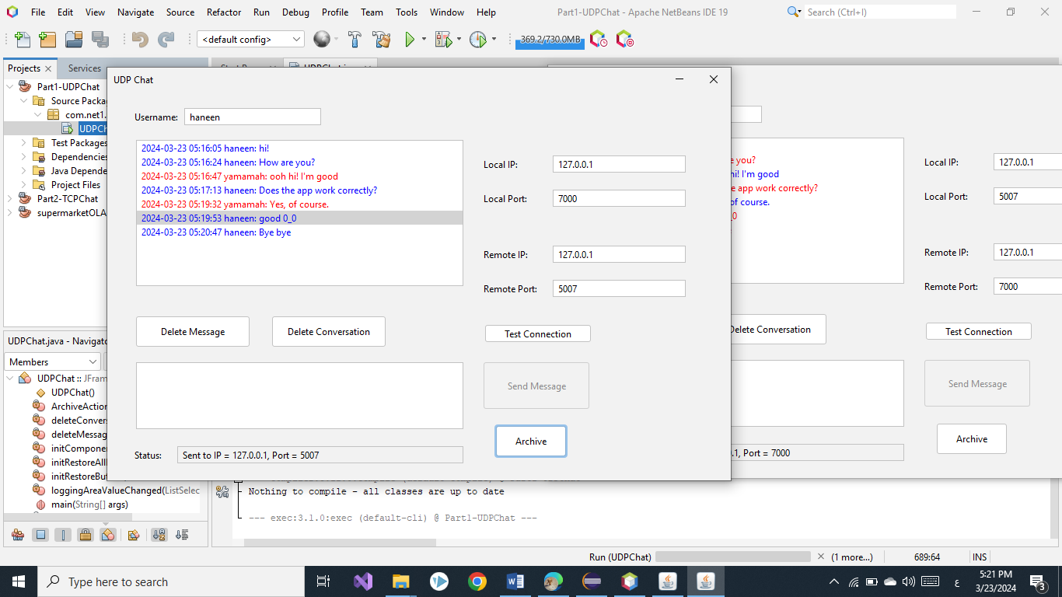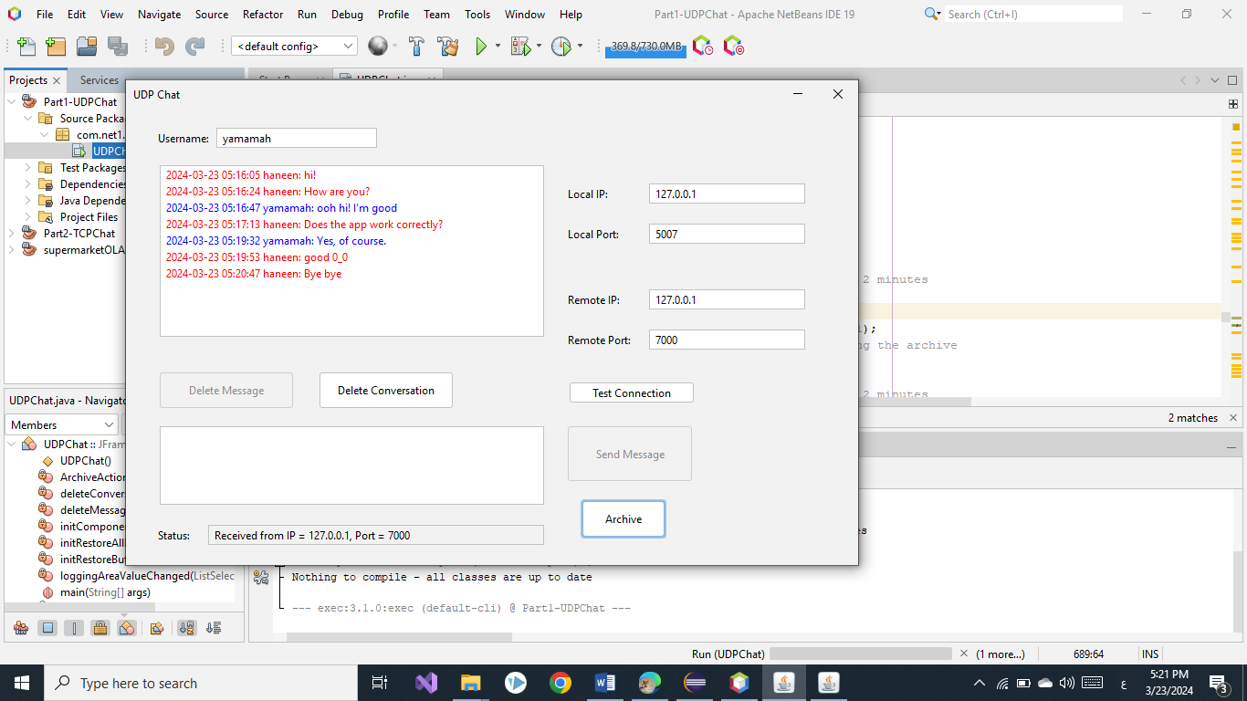

Delete and restore message:

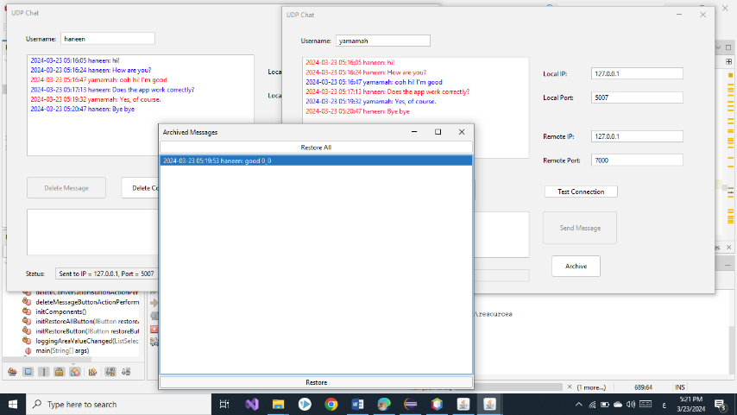

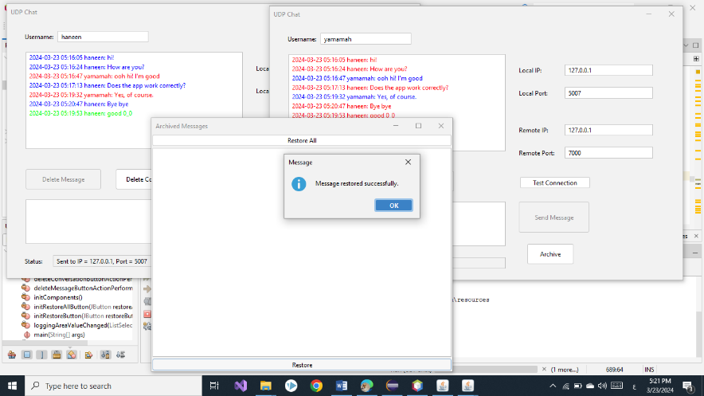

The message is deleted automatically after 2 minutes:

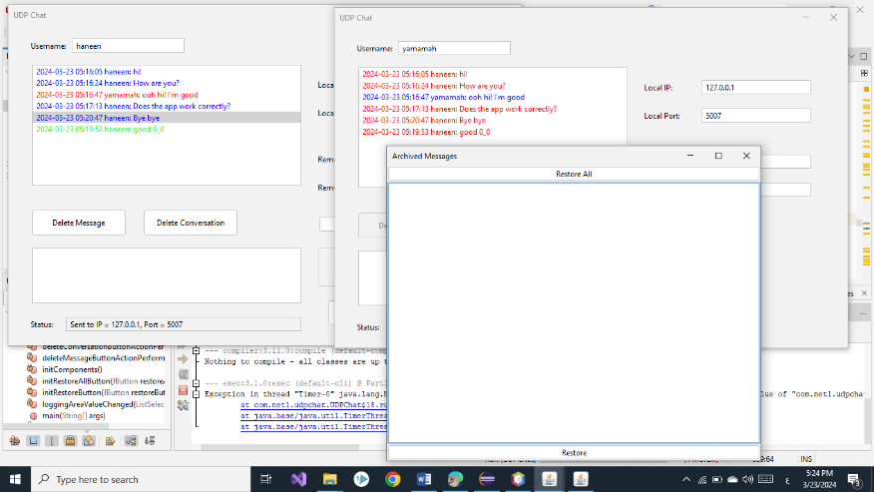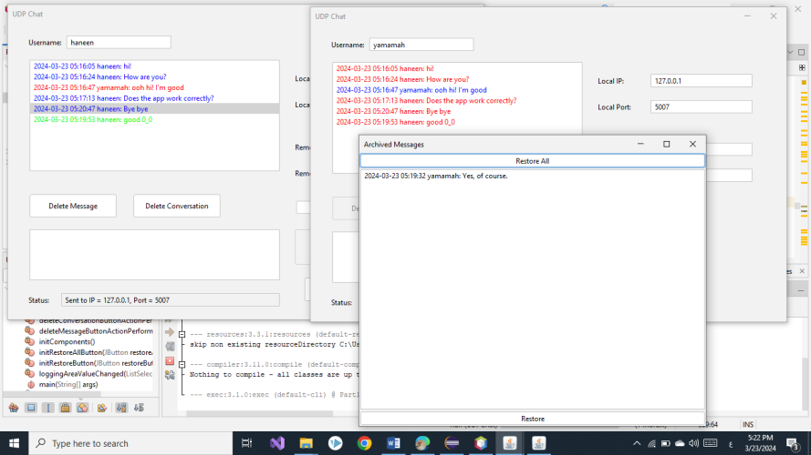

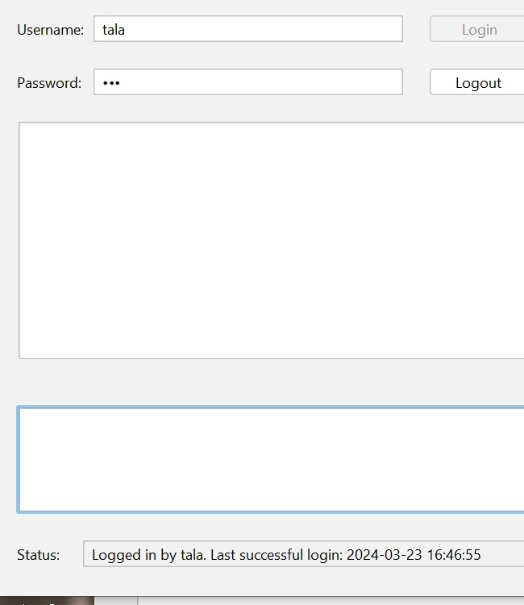

***Part2:***

After login in , the application display on the GUI

last time you have successfully logged on..

option on the server side to add new users,

and their corresponding passwords

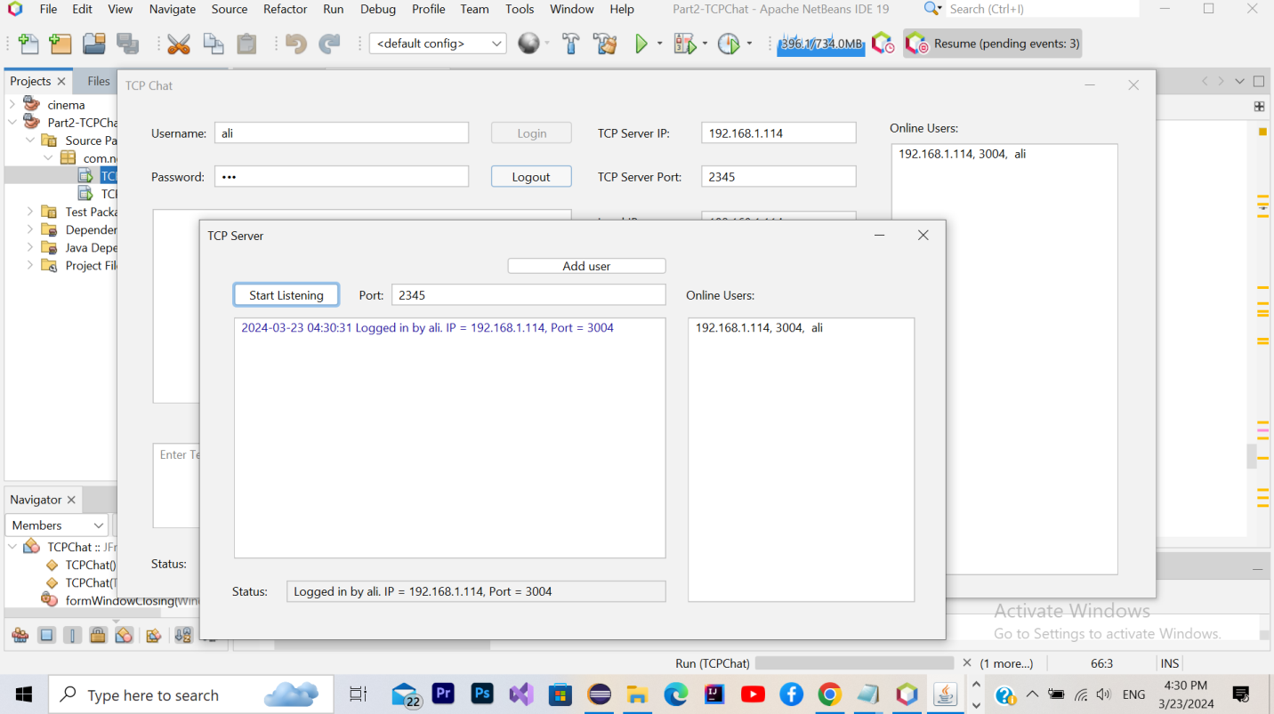

logout button.

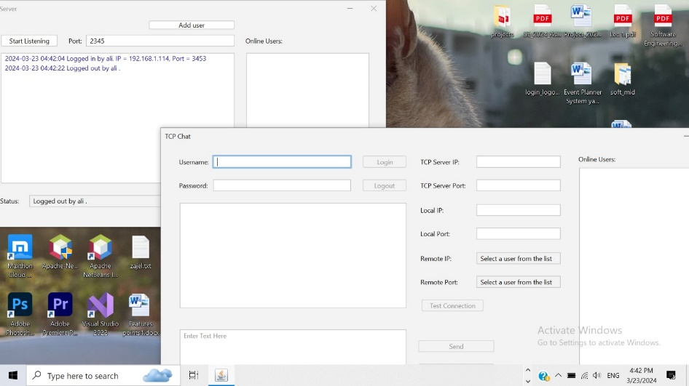

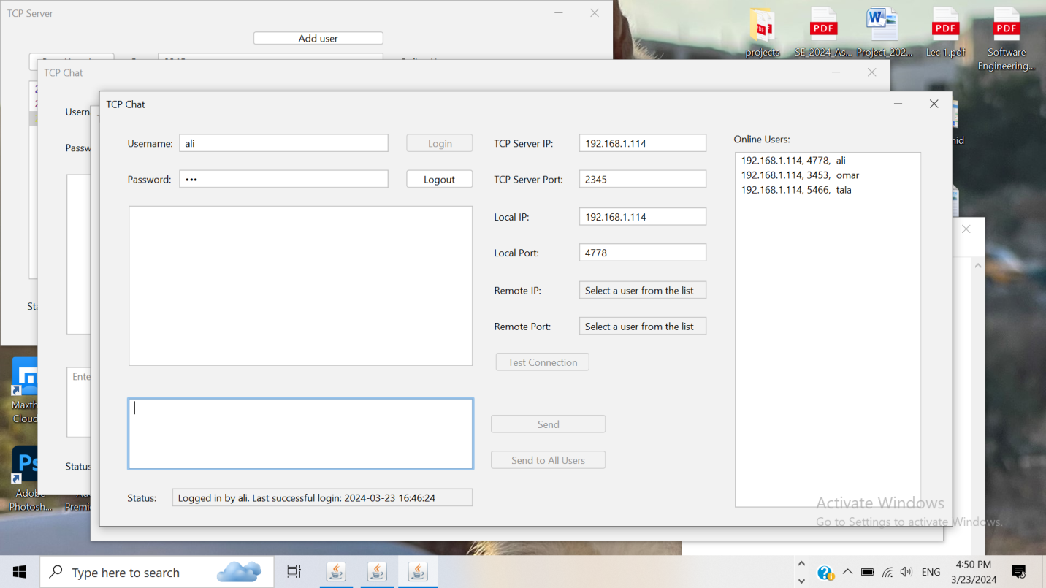

different test color for each user.

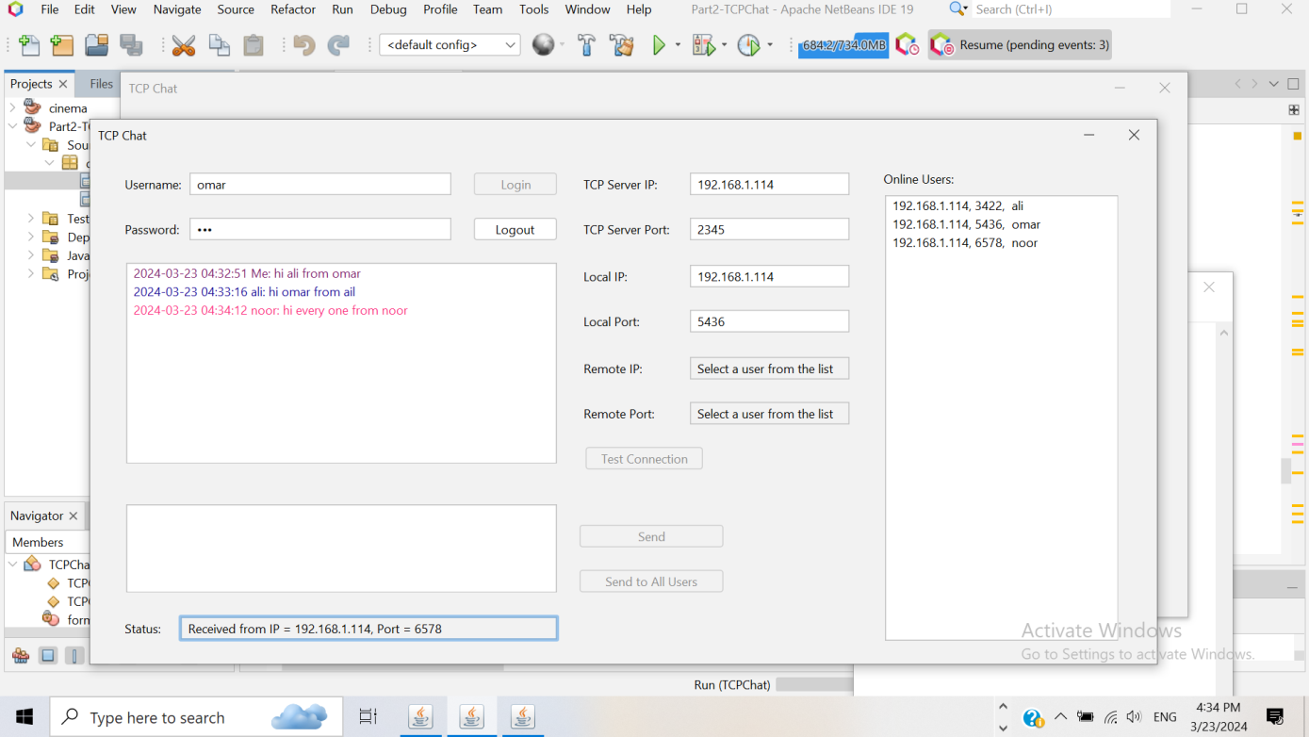

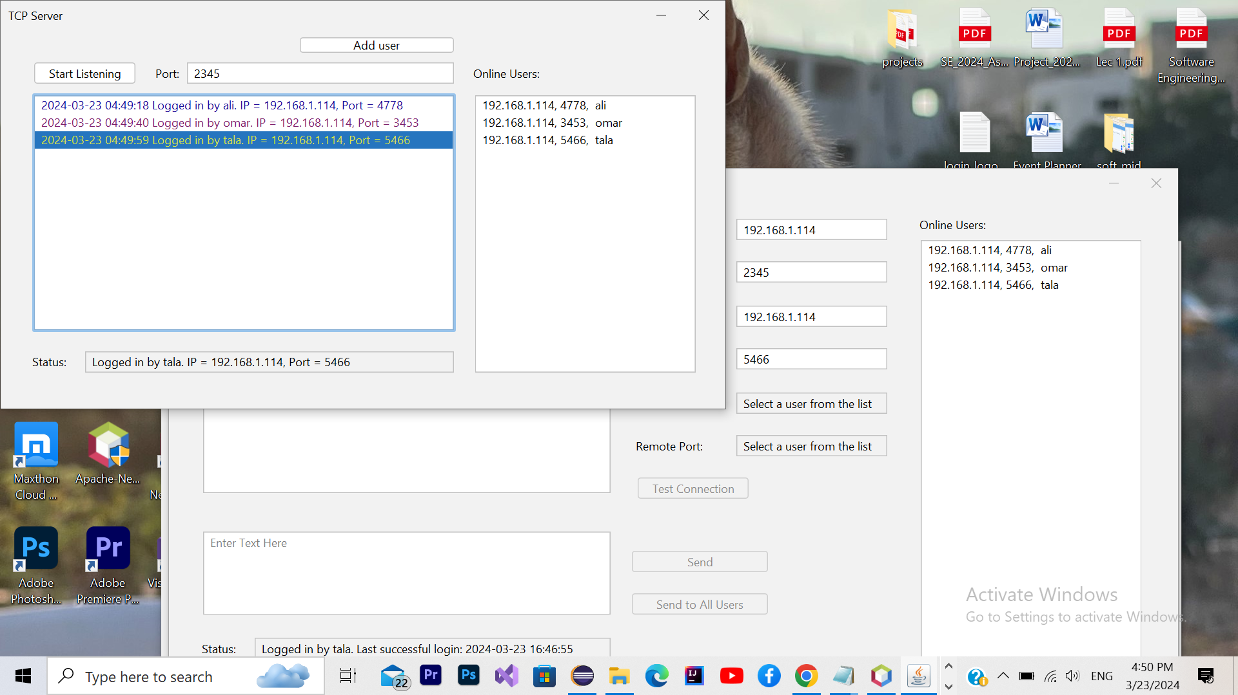

* **Conclusion:**

The project successfully achieved its objectives by implementing a robust P2P Chatting Application using Java Socket Programming. The application provides users with a seamless chatting experience with features such as message archiving, deletion, and user authentication. The graphical user interface ensures ease of use and enhances user experience.

* **References:**

1. Computer Networks slides by Dr.saed Tarapiah
2. Stack Overflow.
3. YouTube tutorials.
4. Online resources on Socket Programming