**Face Recognition Classification of Expressions by Machine Learning**

**Yaman Jain**

*UG Student at Amity University Madhya Pradesh*

*------------------------------------------------------***------------------------------------------------------*

**Abstract**

The human face is the most important feature in determining a person's identity. Even twins have their own distinct features. To distinguish each other, face recognition and identification are essential. A face recognition system is a biometric-based verification system for determining a person's identity. Face recognition is now widely used in a variety of applications, including phone unlocking, criminal identification, and even home security. This technology is more secure because it does not require any external dependencies such as a key or a card, instead relying just on a facial image. Face detection and face identification are the two steps of a human recognition system. This paper explains how to use deep learning to design and develop a face recognition system. In Python, I'm using OpenCV. Deep learning is a method for performing facial recognition that, due to its great accuracy, appears to be an adequate method for doing so. The proposed facial recognition system's accuracy is demonstrated through experimental findings.

**1. Introduction**

Artificial intelligence has advanced at a breakneck pace in recent years. Self-driving cars and self-service supermarkets have both been deployed in recent years. Computer vision and artificial intelligence are inextricably intertwined. Humans use vision to adapt to and understand the settings in which they live, whereas computer vision works to duplicate human vision but in an electronic format to perceive and interpret an image. Not only does computer vision operate as an eye to see, but it also has to react. It must be capable of detecting, identifying, and processing pictures in the same way as human vision does. When a person walks into the path of a moving car, for example, the driver must react fast. From the perspective of a driver's vision, his brain goes through three major steps: identifying, processing, and deciding, and the goal of computer vision is to automate these processes. Vision, on the other hand, is an essential component of intellect. There are numerous components to vision.

Coordination, memory, recall, reasoning, estimating, recognition, and other skills are all included. A system that merely has one of these abilities is not considered a vision. Human systems are imitated by computer vision. Because our world is three-dimensional but our visual sensors typically provide two-dimensional images, it is more challenging for a computer to assess an object in three dimensions.

**2. Overview**

Coordination, memory, recall, reasoning, estimating, recognition, and other skills are all included. A system that merely has one of these abilities is not considered a vision. Human systems are imitated by computer vision. Because our world is three-dimensional but our visual sensors typically provide two-dimensional images, it is more challenging for a computer to assess an object in three dimensions.Deep learning is a subset of machine learning which is derived from running multiple layers of ML algorithms together at the same time. Note: The terms machine learning and deep learning are often used interchangeably. Most machine learning today is actually conceived at the deep learning level.

**3. Face Recognition**

A way of recognising or validating a person's identification by glancing at their face is known as facial recognition. Face recognition technology may be used to identify people in images, films, and in real time.

This technology is currently employed in a variety of areas, and many smartphones include a feature that allows them to open only when they identify their owner's face. Biometric security includes facial recognition.

Biometric software includes voice recognition, fingerprint recognition, and ocular retina or iris identification.

Although the technology is mostly used for security and law enforcement, other uses are becoming more popular.

Deep learning algorithms are used in the facial recognition technology to recognise and compare the face with a database.

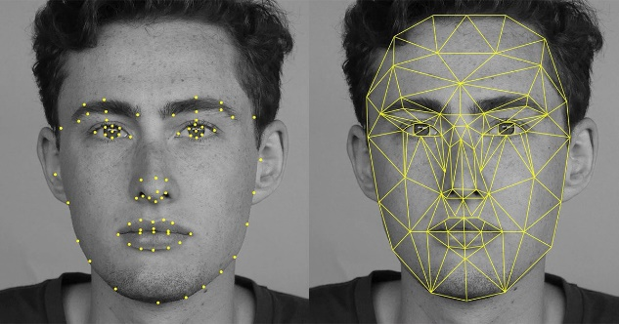

Face Recognition

Fig 3.1

**4. Methodology**

**4.1 Description of Dataset:**

The images is to be converted in the form of data frame by using libraries and python function.

**Steps of conversion of image to training dataset**

**Step 1:** Import libraries shown in fig 1

**Step 2:** Store the location of the directory in for of string and define categories shown in fig 2

**Step 3:** Use the libraries os, numpy shown in fig 3

**Step 4:** Convert the train_data list in data frame

**Steps of conversion of image to testing dataset**

**Step 1:** Store the location of the directory in for of string and define categories shown in fig 4

**Step 2:** Use the libraries os, numpy shown in fig 5

**Step 3:** Convert the test_data list in data frame

**4.2 Preprocessing**

Data preprocessing is the procedure for preparing raw data for use in a machine learning model. It's the first and most important step in building a machine learning model.

It is not always the case that we come across clean and prepared data when working on a machine learning project. And, before doing any data-related activity, it is necessary to clean the data and format it. As a result, we use a data pretreatment activity for this.

Real-world data sometimes contains noise, missing values, and is in an unsuitable format that cannot be used directly in machine learning models. Data preparation is a necessary step in the cleaning process.

the data and preparing it for a machine learning model, which also improves the accuracy

**5. Machine learning Algorithm**

Machine learning algorithms are mathematical model mapping approaches that are used to discover or understand underlying patterns in data. Machine learning is a set of computing algorithms that can learn from existing data to perform pattern identification, classification, and prediction on data (training set).

Machine learning techniques used:

1. Linear Regession
2. SVM
3. Logistic Regression
4. Decision tree
5. Random Forest
6. Lasso
7. Ridge
8. Naïve Bayes

**5.1 Linear Regression**

The most fundamental and widely used type of predictive analysis is linear regression. The goal of regression is to look at two things: (1) Is it possible to forecast an outcome (dependent) variable using a set of predictor variables? (2) Which variables in particular are significant predictors of the outcome variable, and how do they influence the outcome variable (as indicated by the size and sign of the beta estimates)? These regression estimations are used to illustrate how one dependent variable interacts with one or more independent variables. The formula defines the simplest form of the regression equation with one dependent and one independent variable.

y = c + b*x,

where

y = estimated dependent variable score

c = constant

b = regression coefficient

x = score on the independent variable.

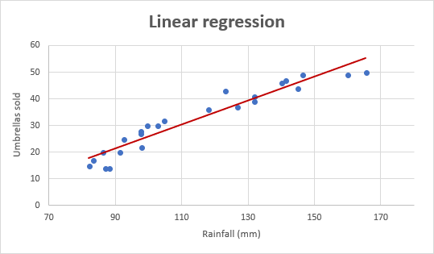

Linear Regression

Fig 5.1

**5.2 SVM**

The "Support Vector Machine" (SVM) is a supervised machine learning technique that can solve classification and regression problems. It is, however, mostly employed to solve categorization difficulties. Each data item is plotted as a point in n-dimensional space (where n is the number of features you have), with the value of each feature being the value of a certain coordinate in the SVM algorithm. Then we accomplish classification by locating the hyper-plane that clearly distinguishes the two classes (look at the below snapshot).

Support Vector machine

Fig 5.2

**5.3 Logistic Regression**

Another supervised machine learning approach for binary classification issues is logistic regression (when target is categorical). Logistic regression is best thought of as a linear regression for classification issues. In order to model a binary output variable, logistic regression employs the logistic function given below (Tolles & Meurer, 2016). The range of logistic regression is confined between 0 and 1. This is the major distinction between linear and logistic regression. In addition, logistic regression does not require a linear connection between input and output variables, unlike linear regression. This is because the odds ratio was transformed into a nonlinear log form.



Sigmoid funtion

Fig 5.3

**5.4 Decision tree**

For classification and regression, Decision Trees (DTs) are a non-parametric supervised learning approach. The objective is to learn basic decision rules from data attributes to develop a model that predicts the value of a target variable. A tree is an approximation to a piecewise constant.

Decision trees, for example, learn from data in the example below.

Using a series of if-then-else decision rules, approximate a sine curve. The decision criteria get more complicated as the tree grows deeper, and the model becomes more accurate.

Decision Tree Regression

Fig 5.4

**5.5 Random Forest**

A random forest is a meta estimator that employs averaging to increase predicted accuracy and control over-fitting by fitting a number of decision tree classifiers on various sub-samples of the dataset.

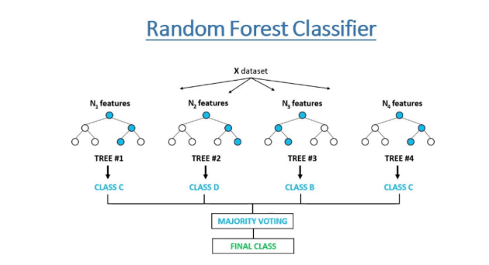

Random Forest Classifier

Fig 5.5

**5.6 Lasso**

For linear regression models, Lasso regression analysis is a shrinkage and variable selection approach. The purpose of lasso regression is to find the subset of predictors that produces the least amount of prediction error for a quantitative response variable.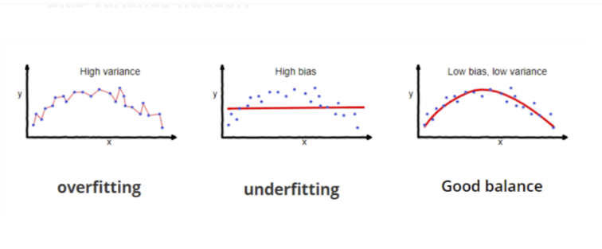

Problem graph

Fig 5.6

**5.7 Ridge**

Ridge regression is a model tuning technique that may be used to analyse data with multicollinearity. L2 regularisation is achieved using this approach. When there is a problem with multicollinearity, least-squares is unbiased, and variances are significant, resulting in projected values that are distant from the actual values.

**5.8 Naïve Bayes**

The phrase "naive Bayes" refers to all classification methods that are based on Bayes' Theorem. For the uninitiated, classification algorithms are algorithms that categorise fresh observations into predetermined groups.

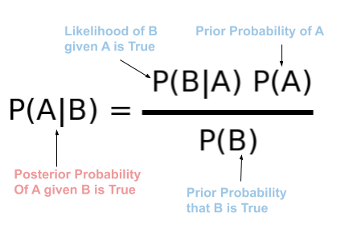

Naïve Bayes formula

Fig 5.8

**6. Dataset**

For analytic and prediction purposes, a collection of data items that may be processed by a computer as a single unit.

Angry expression



Sad expression

We work with numbers in machine learning, thus to create a numerical dataset, we apply the code in fig 3 to scale the image to 25 by 25 pixels. It generates the numbers in the columns.

The size of the dataset defines each pixel's information as a number between 0 and 255. Each image is transformed into a dataset that contains pixel information.

**6.1 Feature scaling**

Dataset is converted to same scale so our model accuracy increase and use less resource by Feature scaling the range of dataset is become 0 to 1.

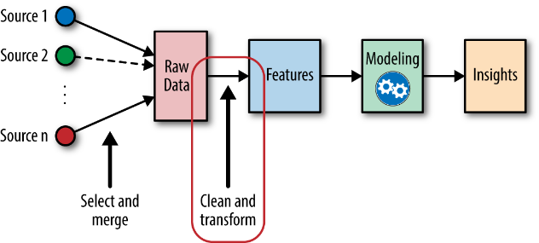

Flow to Feature Scaling

Fig 6.1.1

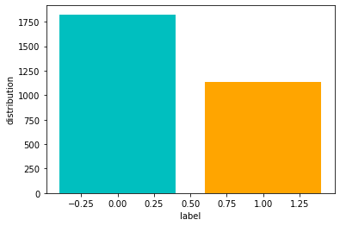

Happy

Sad

Classification of label dataset

Fig 6.1.2

**Applying all the algorithms**

|  |  |  |
| --- | --- | --- |
| SNo. | Regression and Classification | Accuracy % |
| 1 | Naïve bayes | 60.4 |
| 2 | Linear regression | 38 |
| 3 | Logistic Regression | 4.7 |
| 5 | Random Forest | 65 |
| 6 | Decision Tree | 100 |
| 7 | SVM | 47 |
| 8 | Lasso Regression | 0 |
| 9 | Ridge Regression | 37 |

**Comparison of Applied algorithm**

Table 1

**Graphical representation of Applied algorithm**

Fig 6.2

Label Columns defined as 0 and 1 where 0 indicates the Happy expression and 1 indicates the Sad expression

And Other columns depict the pixel of each image

**7. Model Evaluation and Result**

Model evaluation is the process of using different evaluation metrics to understand a machine learning model's performance, as well as its strengths and weaknesses.

* Table

  Description automatically generatedConfusion Matrix
* Accuracy
* Precision
* Recall
* Specificity
* F1 Score
* PR curve
* ROC curve

|  |  |  |  |  |  |  |
| --- | --- | --- | --- | --- | --- | --- |
| SNo. | Algorithm | Accuracy % | Precision % | Recall % | Specificity % | F1 score % |
| 1 | Decision Tree | 59 | 61 | 88 | 88 | 72 |
| 2 | SVM | 54 | 60 | 66 | 66 | 63 |
| 3 | Random Forest | 59 | 61 | 89 | 89 | 73 |
| 4 | Naïve Bayes | 52 | 61 | 63 | 63 | 62 |
| 5 | Logistic Regression | 53 | 61 | 67 | 67 | 64 |

**Comparison Analysis Model evaluation**

Table 2

**Model Evaluation for Decision Tree**

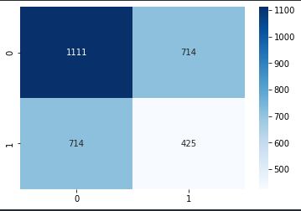

**Confusion matrix for decision tree**

Fig 16

**ROC curve**

Fig 17

**PR Curve**

Fig 18

**Heat Map**

Fig 19

**8. Conclusion and future work:**

This study provided new FER research, allowing us to stay up to date on the most recent discoveries in this field. We've discussed many CNN and CNN-LSTM architectures lately offered by various researchers, as well as various databases comprising spontaneous photos taken in the real world and others created in laboratories in order to have and accomplish accurate emotion recognition. We also give a debate that highlights the high rate attained by researchers, indicating that robots will be increasingly capable of reading emotions in the future, implying that human-machine contact will become more natural. FERs are one of the most essential ways to get information about someone's emotional state, This study provided new FER research, allowing us to stay up to date on the most recent breakthroughs in the field. We've discussed many CNN and CNN-LSTM architectures lately offered by various researchers, as well as various databases comprising spontaneous photos taken in the real world and others created in laboratories, in order to have and accomplish accurate emotion recognition. We also give a debate that demonstrates the high rate achieved by researchers, highlighting the fact that robots will be more capable of reading emotions in the future, implying that human-machine contact will become more natural. FER are one of the most essential techniques to provide information on an individual's emotional state, however

**References**

[1] E. Sariyanidi, H. Gunes, et A. Cavallaro, « Automatic Analysis of Facial Affect: A Survey of Registration, Representation, and Recognition », IEEE Trans. Pattern Anal. Mach. Intell., oct. 2014, doi: 10.1109/TPAMI.2014.2366127.

[2] C.-N. Anagnostopoulos, T. Iliou, et I. Giannoukos, « Features and classifiers for emotion recognition from speech: a survey from 2000 to 2011 », Artif. Intell. Rev., vol. 43, no 2, p. 155‑177, févr. 2015, doi: 10.1007/s10462-012-9368-5.

[3] L. Shu et al., « A Review of Emotion Recognition Using Physiological Signals

[4] C. Marechal et al., « Survey on AI-Based Multimodal Methods for Emotion Detection », in High-Performance Modelling and Simulation for Big Data

Applications: Selected Results of the COST Action IC1406 cHiPSet, J. Kołodziej et H. González-Vélez, Éd. Cham: Springer International Publishing, 2019, p. 307‑324.

[5] M. H. Alkawaz, D. Mohamad, A. H. Basori, et T. Saba, « Blend Shape Interpolation and FACS for Realistic Avatar », 3D Res., vol. 6, no 1, p. 6, janv. 2015, doi: 10.1007/s13319-015-0038-7.

[6] P. V. Rouast, M. Adam, et R. Chiong, « Recognition: Insights and New Developments », IEEE Trans. Affect. Comput., p. 1‑1, 2018, doi: 10.1109/TAFFC.2018.2890471.

[7] C. Shan, S. Gong, et P. W. McOwan, « Facial expression recognition based on Local Binary Patterns: A comprehensive study », Image Vis. Comput., vol. 27, no 6, p. 803‑816, mai 2009, doi: 10.1016/j.imavis.2008.08.005.

[8] T. Jabid, M. H. Kabir, et O. Chae, « Robust Facial Expression Recognition Based on Local Directional Pattern », ETRI J., vol. 32, no 5, p. 694 Wafa Mellouk et al. / Procedia Computer Science 175 (2020) 689–694 6 Author name / Procedia Computer Science 00 (2018) 000–000 784‑794, 2010, doi: 10.4218/etrij.10.1510.0132.

[9] S. Zhang, L. Li, et Z. Zhao, « Facial expression recognition based on Gabor wavelets and sparse representation », in 2012 IEEE 11th International Conference on Signal Processing, oct. 2012, vol. 2, p. 816‑819, doi: 10.1109/ICoSP.2012.6491706.

[10] R. Gross, I. Matthews, J. Cohn, T. Kanade, et S. Baker, « Multi-PIE », Proc. Int. Conf. Autom. Face Gesture Recognit. Int. Conf. Autom. Face Gesture Recognit., vol. 28, no 5, p. 807‑813, mai 2010, doi: 10.1016/j.imavis.2009.08.002.

[11] M. Pantic, M. Valstar, R. Rademaker, et L. Maat, « Web-based database for facial expression analysis », in 2005 IEEE International Conference on Multimedia and Expo, juill. 2005, p. 5 pp.-, doi: 10.1109/ICME.2005.1521424.

[12] M. F. Valstar, B. Jiang, M. Mehu, M. Pantic, et K. Scherer, « The first facial expression recognition and analysis challenge », in Face and Gesture 2011, mars 2011, p. 921‑926, doi: 10.1109/FG.2011.5771374.

[13] A. Dhall, R. Goecke, S. Lucey, et T. Gedeon, « Static facial expression analysis in tough conditions: Data, evaluation protocol and benchmark », in 2011 IEEE International Conference on Computer Vision Workshops (ICCV Workshops), nov. 2011, p. 2106‑2112, doi: 10.1109/ICCVW.2011.6130508.

[14] P. Lucey, J. F. Cohn, T. Kanade, J. Saragih, Z. Ambadar, et I. Matthews, « The Extended Cohn-Kanade Dataset (CK+): A complete dataset for action unit and emotion-specified expression », in 2010 IEEE Computer Society Conference on Computer Vision and Pattern Recognition - Workshops, juin 2010, p. 94‑101, doi: 10.1109/CVPRW.2010.5543262.

[15] I. J. Goodfellow et al., « Challenges in Representation Learning: A Report on Three Machine Learning Contests », in Neural Information Processing, Berlin, Heidelberg, 2013, p. 117‑124, doi: 10.1007/978-3-642-42051-1_16.