Logistic Regression:
Penalized Multinomial Regression

20001 samples
49 predictor
3 classes: 'Gt30', 'Lt30', 'No'

No pre-processing
Resampling: Cross-Validated (10 fold)
Summary of sample sizes: 18000, 18002, 18002, 18001, 18001, 18001, ...
Resampling results across tuning parameters:

decay logLoss AUC prAUC Accuracy Kappa Mean_F1 Mean_Sensitivity
0e+00 0.9093884 0.6388648 0.4327195 0.5670214 0.1480182 0.3648268 0.3906472
1e-04 0.9093884 0.6388650 0.4327243 0.5670214 0.1480182 0.3648268 0.3906472
1e-01 0.9094902 0.6387308 0.4325670 0.5664715 0.1471736 0.3657930 0.3903850
Mean_Specificity Mean_Pos_Pred_Value Mean_Neg_Pred_Value Mean_Precision Mean_Recall
0.7143849 0.5469218 0.7432607 0.5469218 0.3906472
0.7143849 0.5469218 0.7432607 0.5469218 0.3906472
0.7141241 0.5229414 0.7427057 0.5229414 0.3903850
Mean_Detection_Rate Mean_Balanced_Accuracy
0.1890071 0.5525161
0.1890071 0.5525161
0.1888238 0.5522546

Accuracy was used to select the optimal model using the largest value.
The final value used for the model was decay = 1e-04.

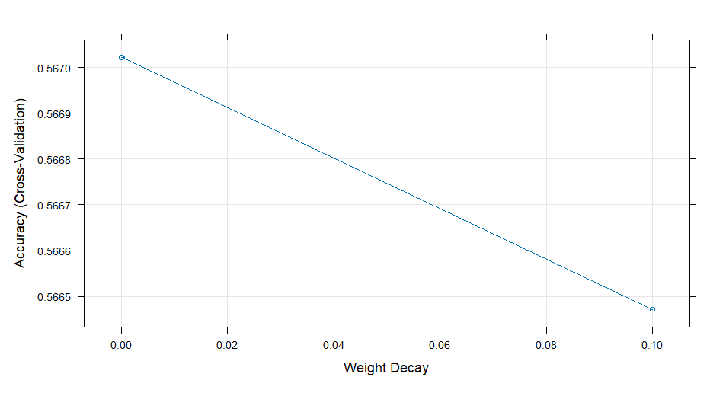
Linear Discriminant Analysis:
Linear Discriminant Analysis

20001 samples
49 predictor
3 classes: 'Gt30', 'Lt30', 'No'

No pre-processing
Resampling: Cross-Validated (10 fold)
Summary of sample sizes: 18000, 18002, 18002, 18001, 18001, 18001, ...
Resampling results:

logLoss AUC prAUC Accuracy Kappa Mean_F1 Mean_Sensitivity
0.9094525 0.6393349 0.4332583 0.5666714 0.1478475 0.3655619 0.3905934
Mean_Specificity Mean_Pos_Pred_Value Mean_Neg_Pred_Value Mean_Precision Mean_Recall
0.7143525 0.4404825 0.7429303 0.4404825 0.3905934
Mean_Detection_Rate Mean_Balanced_Accuracy
0.1888905 0.5524729

PLS-DA
Partial Least Squares

20001 samples
49 predictor
3 classes: 'Gt30', 'Lt30', 'No'

No pre-processing
Resampling: Cross-Validated (10 fold)
Summary of sample sizes: 18000, 18002, 18002, 18001, 18001, 18001, ...
Resampling results across tuning parameters:

ncomp logLoss AUC prAUC Accuracy Kappa Mean_F1 Mean_Sensitivity
1 1.0048922 0.6224474 0.4188919 0.5550732 0.1086497 NaN 0.3741385
2 1.0010083 0.6303443 0.4265965 0.5669715 0.1416552 NaN 0.3873723
3 1.0000455 0.6369803 0.4302866 0.5678717 0.1431216 NaN 0.3879987
4 0.9994902 0.6380928 0.4313699 0.5685720 0.1475269 NaN 0.3899645
5 0.9992683 0.6387833 0.4320839 0.5675215 0.1461694 NaN 0.3894967
6 0.9991195 0.6389893 0.4322603 0.5665718 0.1448483 NaN 0.3888726
7 0.9989868 0.6390924 0.4322580 0.5661718 0.1434930 NaN 0.3883714
8 0.9989328 0.6391797 0.4325014 0.5666720 0.1441773 NaN 0.3886486
9 0.9988970 0.6393695 0.4325944 0.5662221 0.1433238 NaN 0.3882510
10 0.9988781 0.6394443 0.4327433 0.5660218 0.1427187 NaN 0.3880426
11 0.9988647 0.6395185 0.4327907 0.5666721 0.1443743 NaN 0.3886992
12 0.9988517 0.6394829 0.4327628 0.5672717 0.1455061 NaN 0.3891728
13 0.9988540 0.6393437 0.4327224 0.5669218 0.1447649 NaN 0.3888544
14 0.9988585 0.6392902 0.4327473 0.5670218 0.1449657 NaN 0.3889503
15 0.9988538 0.6393070 0.4327369 0.5668219 0.1447446 NaN 0.3888933
Mean_Specificity Mean_Pos_Pred_Value Mean_Neg_Pred_Value Mean_Precision Mean_Recall
0.7012747 NaN 0.7341129 NaN 0.3741385
0.7121011 NaN 0.7449222 NaN 0.3873723
0.7124987 NaN 0.7457298 NaN 0.3879987
0.7140194 NaN 0.7454590 NaN 0.3899645
0.7136278 NaN 0.7441461 NaN 0.3894967
0.7133294 NaN 0.7434751 NaN 0.3888726
0.7128236 NaN 0.7429913 NaN 0.3883714
0.7130067 NaN 0.7434741 NaN 0.3886486
0.7127765 NaN 0.7432420 NaN 0.3882510
0.7125493 NaN 0.7429629 NaN 0.3880426
0.7131000 NaN 0.7435746 NaN 0.3886992
0.7134375 NaN 0.7440612 NaN 0.3891728
0.7132172 NaN 0.7438001 NaN 0.3888544
0.7132685 NaN 0.7438548 NaN 0.3889503
0.7131974 NaN 0.7435599 NaN 0.3888933
Mean_Detection_Rate Mean_Balanced_Accuracy
0.1850244 0.5377066
0.1889905 0.5497367
0.1892906 0.5502487
0.1895240 0.5519920
0.1891738 0.5515623
0.1888573 0.5511010
0.1887239 0.5505975
0.1888907 0.5508276
0.1887407 0.5505138
0.1886739 0.5502959
0.1888907 0.5508996
0.1890906 0.5513052
0.1889739 0.5510358
0.1890073 0.5511094
0.1889406 0.5510453

Accuracy was used to select the optimal model using the largest value.
The final value used for the model was ncomp = 4.

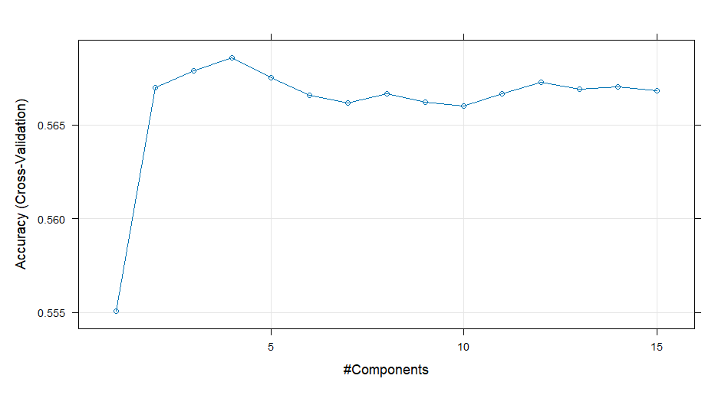

Lasso (glmnet α=1)
glmnet

20001 samples
49 predictor
3 classes: 'Gt30', 'Lt30', 'No'

No pre-processing
Resampling: Cross-Validated (10 fold)
Summary of sample sizes: 18000, 18002, 18002, 18001, 18001, 18001, ...
Resampling results across tuning parameters:

lambda logLoss AUC prAUC Accuracy Kappa Mean_F1 Mean_Sensitivity
0.00010000 0.9090354 0.6394568 0.4329538 0.5663216 0.1460799 0.3643543 0.3899093
0.05272632 0.9324903 0.5977986 0.2565964 0.5362732 0.0000000 NaN 0.3333333
0.10535263 0.9492244 0.5977986 0.2565964 0.5362732 0.0000000 NaN 0.3333333
0.15797895 0.9511321 0.5000000 0.0000000 0.5362732 0.0000000 NaN 0.3333333
0.21060526 0.9511321 0.5000000 0.0000000 0.5362732 0.0000000 NaN 0.3333333
0.26323158 0.9511321 0.5000000 0.0000000 0.5362732 0.0000000 NaN 0.3333333
0.31585789 0.9511321 0.5000000 0.0000000 0.5362732 0.0000000 NaN 0.3333333
0.36848421 0.9511321 0.5000000 0.0000000 0.5362732 0.0000000 NaN 0.3333333
0.42111053 0.9511321 0.5000000 0.0000000 0.5362732 0.0000000 NaN 0.3333333
0.47373684 0.9511321 0.5000000 0.0000000 0.5362732 0.0000000 NaN 0.3333333
0.52636316 0.9511321 0.5000000 0.0000000 0.5362732 0.0000000 NaN 0.3333333
0.57898947 0.9511321 0.5000000 0.0000000 0.5362732 0.0000000 NaN 0.3333333
0.63161579 0.9511321 0.5000000 0.0000000 0.5362732 0.0000000 NaN 0.3333333
0.68424211 0.9511321 0.5000000 0.0000000 0.5362732 0.0000000 NaN 0.3333333
0.73686842 0.9511321 0.5000000 0.0000000 0.5362732 0.0000000 NaN 0.3333333
0.78949474 0.9511321 0.5000000 0.0000000 0.5362732 0.0000000 NaN 0.3333333
0.84212105 0.9511321 0.5000000 0.0000000 0.5362732 0.0000000 NaN 0.3333333
0.89474737 0.9511321 0.5000000 0.0000000 0.5362732 0.0000000 NaN 0.3333333
0.94737368 0.9511321 0.5000000 0.0000000 0.5362732 0.0000000 NaN 0.3333333
1.00000000 0.9511321 0.5000000 0.0000000 0.5362732 0.0000000 NaN 0.3333333
Mean_Specificity Mean_Pos_Pred_Value Mean_Neg_Pred_Value Mean_Precision Mean_Recall
0.7137166 0.6231868 0.7425699 0.6231868 0.3899093
0.6666667 NaN NaN NaN 0.3333333
0.6666667 NaN NaN NaN 0.3333333
0.6666667 NaN NaN NaN 0.3333333
0.6666667 NaN NaN NaN 0.3333333
0.6666667 NaN NaN NaN 0.3333333
0.6666667 NaN NaN NaN 0.3333333
0.6666667 NaN NaN NaN 0.3333333
0.6666667 NaN NaN NaN 0.3333333
0.6666667 NaN NaN NaN 0.3333333
0.6666667 NaN NaN NaN 0.3333333
0.6666667 NaN NaN NaN 0.3333333
0.6666667 NaN NaN NaN 0.3333333
0.6666667 NaN NaN NaN 0.3333333
0.6666667 NaN NaN NaN 0.3333333
0.6666667 NaN NaN NaN 0.3333333
0.6666667 NaN NaN NaN 0.3333333
0.6666667 NaN NaN NaN 0.3333333
0.6666667 NaN NaN NaN 0.3333333
0.6666667 NaN NaN NaN 0.3333333
Mean_Detection_Rate Mean_Balanced_Accuracy
0.1887739 0.551813
0.1787577 0.500000
0.1787577 0.500000
0.1787577 0.500000
0.1787577 0.500000
0.1787577 0.500000
0.1787577 0.500000
0.1787577 0.500000
0.1787577 0.500000
0.1787577 0.500000
0.1787577 0.500000
0.1787577 0.500000
0.1787577 0.500000
0.1787577 0.500000
0.1787577 0.500000
0.1787577 0.500000
0.1787577 0.500000
0.1787577 0.500000
0.1787577 0.500000
0.1787577 0.500000

Tuning parameter 'alpha' was held constant at a value of 1
Accuracy was used to select the optimal model using the largest value.
The final values used for the model were alpha = 1 and lambda = 1e-04.
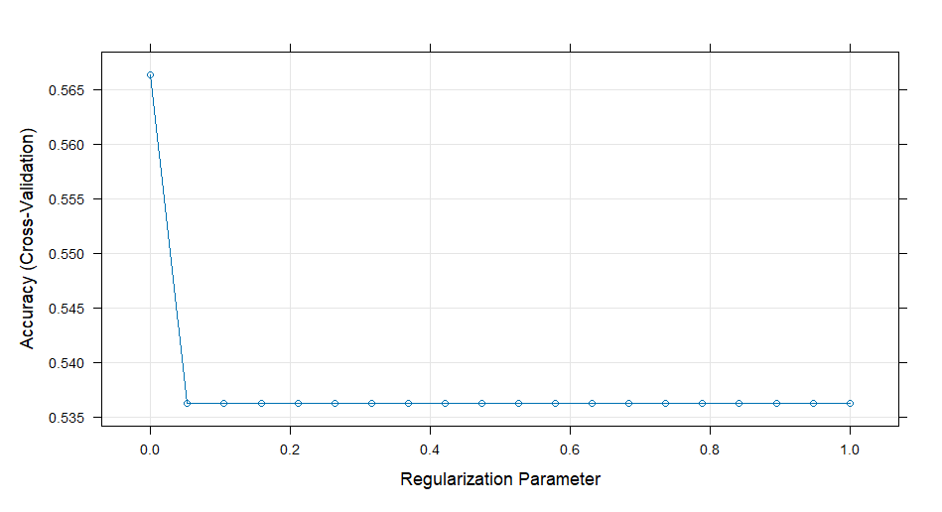
Ridge (glmnet α=0)
glmnet

20001 samples
49 predictor
3 classes: 'Gt30', 'Lt30', 'No'

No pre-processing
Resampling: Cross-Validated (10 fold)
Summary of sample sizes: 18000, 18002, 18002, 18001, 18001, 18001, ...
Resampling results across tuning parameters:

lambda logLoss AUC prAUC Accuracy Kappa Mean_F1
0.00010000 0.9089617 0.6394368 0.4329965 0.5663717 0.14494997 0.3698071
0.05272632 0.9091368 0.6398082 0.4328149 0.5674717 0.14176134 NaN
0.10535263 0.9102856 0.6396548 0.4325196 0.5668714 0.13462206 NaN
0.15797895 0.9116820 0.6393068 0.4318977 0.5650717 0.12604186 NaN
0.21060526 0.9131066 0.6389218 0.4314079 0.5627716 0.11619911 NaN
0.26323158 0.9144873 0.6385428 0.4308653 0.5618221 0.10959718 NaN
0.31585789 0.9157978 0.6381666 0.4304982 0.5608722 0.10325445 NaN
0.36848421 0.9170280 0.6378144 0.4301164 0.5596723 0.09674231 NaN
0.42111053 0.9181849 0.6374875 0.4297405 0.5577225 0.08886939 NaN
0.47373684 0.9192645 0.6371872 0.4294730 0.5571725 0.08435877 NaN
0.52636316 0.9202803 0.6368845 0.4291571 0.5565725 0.07990256 NaN
0.57898947 0.9212333 0.6366047 0.4288644 0.5554228 0.07426129 NaN
0.63161579 0.9221278 0.6363511 0.4286908 0.5543228 0.06939890 NaN
0.68424211 0.9229703 0.6360852 0.4284182 0.5531224 0.06410961 NaN
0.73686842 0.9237683 0.6358413 0.4282070 0.5525726 0.06075514 NaN
0.78949474 0.9245242 0.6356166 0.4280019 0.5513227 0.05581509 NaN
0.84212105 0.9252225 0.6354048 0.4277237 0.5503227 0.05172326 NaN
0.89474737 0.9258943 0.6352063 0.4275334 0.5491224 0.04716550 NaN
0.94737368 0.9265384 0.6350088 0.4273555 0.5478222 0.04279825 NaN
1.00000000 0.9271316 0.6348192 0.4272017 0.5468224 0.03868670 NaN
Mean_Sensitivity Mean_Specificity Mean_Pos_Pred_Value Mean_Neg_Pred_Value Mean_Precision
0.3891756 0.7133268 0.5830156 0.7429794 0.5830156
0.3875981 0.7119410 NaN 0.7448801 NaN
0.3844495 0.7094023 NaN 0.7462403 NaN
0.3808411 0.7064994 NaN 0.7462217 NaN
0.3768206 0.7032056 NaN 0.7456373 NaN
0.3740770 0.7009863 NaN 0.7469426 NaN
0.3714678 0.6988813 NaN 0.7485042 NaN
0.3689389 0.6966903 NaN 0.7490935 NaN
0.3658598 0.6941575 NaN 0.7488864 NaN
0.3641217 0.6926516 NaN 0.7504782 NaN
0.3623530 0.6912138 NaN 0.7529780 NaN
0.3601582 0.6894323 NaN 0.7547453 NaN
0.3583304 0.6878838 NaN 0.7555446 NaN
0.3563733 0.6862007 NaN 0.7562854 NaN
0.3551231 0.6851307 NaN 0.7584602 NaN
0.3533030 0.6835886 NaN 0.7589783 NaN
0.3517227 0.6823610 NaN 0.7611884 NaN
0.3500347 0.6809686 NaN 0.7620223 NaN
0.3483851 0.6796705 NaN 0.7624198 NaN
0.3469059 0.6784018 NaN 0.7635484 NaN
Mean_Recall Mean_Detection_Rate Mean_Balanced_Accuracy
0.3891756 0.1887906 0.5512512
0.3875981 0.1891572 0.5497696
0.3844495 0.1889571 0.5469259
0.3808411 0.1883572 0.5436702
0.3768206 0.1875905 0.5400131
0.3740770 0.1872740 0.5375316
0.3714678 0.1869574 0.5351745
0.3689389 0.1865574 0.5328146
0.3658598 0.1859075 0.5300086
0.3641217 0.1857242 0.5283867
0.3623530 0.1855242 0.5267834
0.3601582 0.1851409 0.5247952
0.3583304 0.1847743 0.5231071
0.3563733 0.1843741 0.5212870
0.3551231 0.1841909 0.5201269
0.3533030 0.1837742 0.5184458
0.3517227 0.1834409 0.5170419
0.3500347 0.1830408 0.5155016
0.3483851 0.1826074 0.5140278
0.3469059 0.1822741 0.5126538

Tuning parameter 'alpha' was held constant at a value of 0
Accuracy was used to select the optimal model using the largest value.
The final values used for the model were alpha = 0 and lambda = 0.05272632.
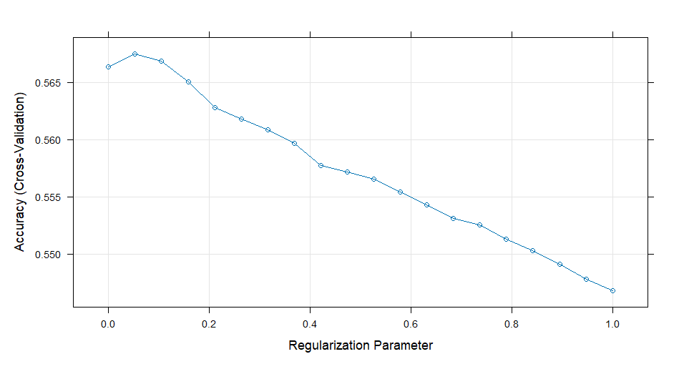
Elastic Net (α ∈ [0,1])
glmnet

20001 samples
49 predictor
3 classes: 'Gt30', 'Lt30', 'No'

No pre-processing
Resampling: Cross-Validated (10 fold)
Summary of sample sizes: 18000, 18002, 18002, 18001, 18001, 18001, ...
Resampling results across tuning parameters:

alpha lambda logLoss AUC prAUC Accuracy Kappa Mean_F1
0.00 0.00010000 0.9089617 0.6394368 0.4329965 0.5663717 0.144949972 0.3698071
0.00 0.05272632 0.9091368 0.6398082 0.4328149 0.5674717 0.141761341 NaN
0.00 0.10535263 0.9102856 0.6396548 0.4325196 0.5668714 0.134622063 NaN
0.00 0.15797895 0.9116820 0.6393068 0.4318977 0.5650717 0.126041858 NaN
0.00 0.21060526 0.9131066 0.6389218 0.4314079 0.5627716 0.116199115 NaN
0.00 0.26323158 0.9144873 0.6385428 0.4308653 0.5618221 0.109597183 NaN
0.00 0.31585789 0.9157978 0.6381666 0.4304982 0.5608722 0.103254447 NaN
0.00 0.36848421 0.9170280 0.6378144 0.4301164 0.5596723 0.096742315 NaN
0.00 0.42111053 0.9181849 0.6374875 0.4297405 0.5577225 0.088869389 NaN
0.00 0.47373684 0.9192645 0.6371872 0.4294730 0.5571725 0.084358767 NaN
0.00 0.52636316 0.9202803 0.6368845 0.4291571 0.5565725 0.079902558 NaN
0.00 0.57898947 0.9212333 0.6366047 0.4288644 0.5554228 0.074261291 NaN
0.00 0.63161579 0.9221278 0.6363511 0.4286908 0.5543228 0.069398897 NaN
0.00 0.68424211 0.9229703 0.6360852 0.4284182 0.5531224 0.064109614 NaN
0.00 0.73686842 0.9237683 0.6358413 0.4282070 0.5525726 0.060755143 NaN
0.00 0.78949474 0.9245242 0.6356166 0.4280019 0.5513227 0.055815091 NaN
0.00 0.84212105 0.9252225 0.6354048 0.4277237 0.5503227 0.051723257 NaN
0.00 0.89474737 0.9258943 0.6352063 0.4275334 0.5491224 0.047165495 NaN
0.00 0.94737368 0.9265384 0.6350088 0.4273555 0.5478222 0.042798248 NaN
0.00 1.00000000 0.9271316 0.6348192 0.4272017 0.5468224 0.038686703 NaN
0.25 0.00010000 0.9090062 0.6394804 0.4330168 0.5666715 0.146511614 0.3678410
0.25 0.05272632 0.9163587 0.6353732 0.4271533 0.5648225 0.119472403 NaN
0.25 0.10535263 0.9257916 0.6240866 0.4217598 0.5547735 0.077823445 NaN
0.25 0.15797895 0.9320043 0.6226175 0.4215765 0.5376729 0.004549936 NaN
0.25 0.21060526 0.9379934 0.6085121 0.2849220 0.5362732 0.000000000 NaN
0.25 0.26323158 0.9415127 0.5977986 0.2565964 0.5362732 0.000000000 NaN
0.25 0.31585789 0.9446528 0.5977986 0.2565964 0.5362732 0.000000000 NaN
0.25 0.36848421 0.9475748 0.5977986 0.2565964 0.5362732 0.000000000 NaN
0.25 0.42111053 0.9502426 0.5977986 0.2565964 0.5362732 0.000000000 NaN
0.25 0.47373684 0.9511321 0.5000000 0.0000000 0.5362732 0.000000000 NaN
0.25 0.52636316 0.9511321 0.5000000 0.0000000 0.5362732 0.000000000 NaN
0.25 0.57898947 0.9511321 0.5000000 0.0000000 0.5362732 0.000000000 NaN
0.25 0.63161579 0.9511321 0.5000000 0.0000000 0.5362732 0.000000000 NaN
0.25 0.68424211 0.9511321 0.5000000 0.0000000 0.5362732 0.000000000 NaN
0.25 0.73686842 0.9511321 0.5000000 0.0000000 0.5362732 0.000000000 NaN
0.25 0.78949474 0.9511321 0.5000000 0.0000000 0.5362732 0.000000000 NaN
0.25 0.84212105 0.9511321 0.5000000 0.0000000 0.5362732 0.000000000 NaN
0.25 0.89474737 0.9511321 0.5000000 0.0000000 0.5362732 0.000000000 NaN
0.25 0.94737368 0.9511321 0.5000000 0.0000000 0.5362732 0.000000000 NaN
0.25 1.00000000 0.9511321 0.5000000 0.0000000 0.5362732 0.000000000 NaN
0.50 0.00010000 0.9090206 0.6394689 0.4329801 0.5665216 0.146343602 0.3674759
0.50 0.05272632 0.9238136 0.6235581 0.4214458 0.5583232 0.092056672 NaN
0.50 0.10535263 0.9347880 0.6006643 0.2613292 0.5362732 0.000000000 NaN
0.50 0.15797895 0.9419148 0.5977986 0.2565964 0.5362732 0.000000000 NaN
0.50 0.21060526 0.9497478 0.5977986 0.2565964 0.5362732 0.000000000 NaN
0.50 0.26323158 0.9511321 0.5000000 0.0000000 0.5362732 0.000000000 NaN
0.50 0.31585789 0.9511321 0.5000000 0.0000000 0.5362732 0.000000000 NaN
0.50 0.36848421 0.9511321 0.5000000 0.0000000 0.5362732 0.000000000 NaN
0.50 0.42111053 0.9511321 0.5000000 0.0000000 0.5362732 0.000000000 NaN
0.50 0.47373684 0.9511321 0.5000000 0.0000000 0.5362732 0.000000000 NaN
0.50 0.52636316 0.9511321 0.5000000 0.0000000 0.5362732 0.000000000 NaN
0.50 0.57898947 0.9511321 0.5000000 0.0000000 0.5362732 0.000000000 NaN
0.50 0.63161579 0.9511321 0.5000000 0.0000000 0.5362732 0.000000000 NaN
0.50 0.68424211 0.9511321 0.5000000 0.0000000 0.5362732 0.000000000 NaN
0.50 0.73686842 0.9511321 0.5000000 0.0000000 0.5362732 0.000000000 NaN
0.50 0.78949474 0.9511321 0.5000000 0.0000000 0.5362732 0.000000000 NaN
0.50 0.84212105 0.9511321 0.5000000 0.0000000 0.5362732 0.000000000 NaN
0.50 0.89474737 0.9511321 0.5000000 0.0000000 0.5362732 0.000000000 NaN
0.50 0.94737368 0.9511321 0.5000000 0.0000000 0.5362732 0.000000000 NaN
0.50 1.00000000 0.9511321 0.5000000 0.0000000 0.5362732 0.000000000 NaN
0.75 0.00010000 0.9090197 0.6394837 0.4329723 0.5664216 0.146178226 0.3675680
0.75 0.05272632 0.9283668 0.6231372 0.4226768 0.5506229 0.053541843 NaN
Mean_Sensitivity Mean_Specificity Mean_Pos_Pred_Value Mean_Neg_Pred_Value Mean_Precision
0.3891756 0.7133268 0.5830156 0.7429794 0.5830156
0.3875981 0.7119410 NaN 0.7448801 NaN
0.3844495 0.7094023 NaN 0.7462403 NaN
0.3808411 0.7064994 NaN 0.7462217 NaN
0.3768206 0.7032056 NaN 0.7456373 NaN
0.3740770 0.7009863 NaN 0.7469426 NaN
0.3714678 0.6988813 NaN 0.7485042 NaN
0.3689389 0.6966903 NaN 0.7490935 NaN
0.3658598 0.6941575 NaN 0.7488864 NaN
0.3641217 0.6926516 NaN 0.7504782 NaN
0.3623530 0.6912138 NaN 0.7529780 NaN
0.3601582 0.6894323 NaN 0.7547453 NaN
0.3583304 0.6878838 NaN 0.7555446 NaN
0.3563733 0.6862007 NaN 0.7562854 NaN
0.3551231 0.6851307 NaN 0.7584602 NaN
0.3533030 0.6835886 NaN 0.7589783 NaN
0.3517227 0.6823610 NaN 0.7611884 NaN
0.3500347 0.6809686 NaN 0.7620223 NaN
0.3483851 0.6796705 NaN 0.7624198 NaN
0.3469059 0.6784018 NaN 0.7635484 NaN
0.3899799 0.7138435 0.6100140 0.7429510 0.6100140
0.3778438 0.7043066 NaN 0.7497468 NaN
0.3614360 0.6907505 NaN 0.7491656 NaN
0.3348595 0.6680570 NaN 0.7889288 NaN
0.3333333 0.6666667 NaN NaN NaN
0.3333333 0.6666667 NaN NaN NaN
0.3333333 0.6666667 NaN NaN NaN
0.3333333 0.6666667 NaN NaN NaN
0.3333333 0.6666667 NaN NaN NaN
0.3333333 0.6666667 NaN NaN NaN
0.3333333 0.6666667 NaN NaN NaN
0.3333333 0.6666667 NaN NaN NaN
0.3333333 0.6666667 NaN NaN NaN
0.3333333 0.6666667 NaN NaN NaN
0.3333333 0.6666667 NaN NaN NaN
0.3333333 0.6666667 NaN NaN NaN
0.3333333 0.6666667 NaN NaN NaN
0.3333333 0.6666667 NaN NaN NaN
0.3333333 0.6666667 NaN NaN NaN
0.3333333 0.6666667 NaN NaN NaN
0.3899036 0.7138085 0.6097856 0.7428285 0.6097856
0.3668558 0.6953574 NaN 0.7500601 NaN
0.3333333 0.6666667 NaN NaN NaN
0.3333333 0.6666667 NaN NaN NaN
0.3333333 0.6666667 NaN NaN NaN
0.3333333 0.6666667 NaN NaN NaN
0.3333333 0.6666667 NaN NaN NaN
0.3333333 0.6666667 NaN NaN NaN
0.3333333 0.6666667 NaN NaN NaN
0.3333333 0.6666667 NaN NaN NaN
0.3333333 0.6666667 NaN NaN NaN
0.3333333 0.6666667 NaN NaN NaN
0.3333333 0.6666667 NaN NaN NaN
0.3333333 0.6666667 NaN NaN NaN
0.3333333 0.6666667 NaN NaN NaN
0.3333333 0.6666667 NaN NaN NaN
0.3333333 0.6666667 NaN NaN NaN
0.3333333 0.6666667 NaN NaN NaN
0.3333333 0.6666667 NaN NaN NaN
0.3333333 0.6666667 NaN NaN NaN
0.3898414 0.7137574 0.6096807 0.7427189 0.6096807
0.3519925 0.6831786 NaN 0.7662683 NaN
Mean_Recall Mean_Detection_Rate Mean_Balanced_Accuracy
0.3891756 0.1887906 0.5512512
0.3875981 0.1891572 0.5497696
0.3844495 0.1889571 0.5469259
0.3808411 0.1883572 0.5436702
0.3768206 0.1875905 0.5400131
0.3740770 0.1872740 0.5375316
0.3714678 0.1869574 0.5351745
0.3689389 0.1865574 0.5328146
0.3658598 0.1859075 0.5300086
0.3641217 0.1857242 0.5283867
0.3623530 0.1855242 0.5267834
0.3601582 0.1851409 0.5247952
0.3583304 0.1847743 0.5231071
0.3563733 0.1843741 0.5212870
0.3551231 0.1841909 0.5201269
0.3533030 0.1837742 0.5184458
0.3517227 0.1834409 0.5170419
0.3500347 0.1830408 0.5155016
0.3483851 0.1826074 0.5140278
0.3469059 0.1822741 0.5126538
0.3899799 0.1888905 0.5519117
0.3778438 0.1882742 0.5410752
0.3614360 0.1849245 0.5260933
0.3348595 0.1792243 0.5014583
0.3333333 0.1787577 0.5000000
0.3333333 0.1787577 0.5000000
0.3333333 0.1787577 0.5000000
0.3333333 0.1787577 0.5000000
0.3333333 0.1787577 0.5000000
0.3333333 0.1787577 0.5000000
0.3333333 0.1787577 0.5000000
0.3333333 0.1787577 0.5000000
0.3333333 0.1787577 0.5000000
0.3333333 0.1787577 0.5000000
0.3333333 0.1787577 0.5000000
0.3333333 0.1787577 0.5000000
0.3333333 0.1787577 0.5000000
0.3333333 0.1787577 0.5000000
0.3333333 0.1787577 0.5000000
0.3333333 0.1787577 0.5000000
0.3899036 0.1888405 0.5518561
0.3668558 0.1861077 0.5311066
0.3333333 0.1787577 0.5000000
0.3333333 0.1787577 0.5000000
0.3333333 0.1787577 0.5000000
0.3333333 0.1787577 0.5000000
0.3333333 0.1787577 0.5000000
0.3333333 0.1787577 0.5000000
0.3333333 0.1787577 0.5000000
0.3333333 0.1787577 0.5000000
0.3333333 0.1787577 0.5000000
0.3333333 0.1787577 0.5000000
0.3333333 0.1787577 0.5000000
0.3333333 0.1787577 0.5000000
0.3333333 0.1787577 0.5000000
0.3333333 0.1787577 0.5000000
0.3333333 0.1787577 0.5000000
0.3333333 0.1787577 0.5000000
0.3333333 0.1787577 0.5000000
0.3333333 0.1787577 0.5000000
0.3898414 0.1888072 0.5517994
0.3519925 0.1835410 0.5175856
[ reached 'max' / getOption("max.print") -- omitted 38 rows ]

Accuracy was used to select the optimal model using the largest value.
The final values used for the model were alpha = 0 and lambda = 0.05272632.
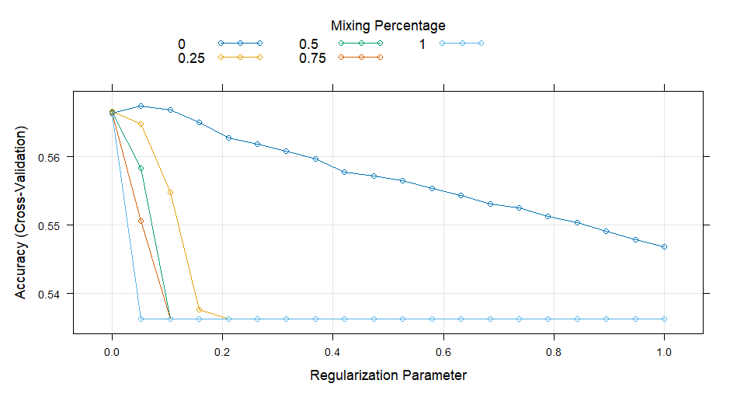

Nonlinear Discriminant Analysis (mda)
Mixture Discriminant Analysis

20001 samples
49 predictor
3 classes: 'Gt30', 'Lt30', 'No'

No pre-processing
Resampling: Cross-Validated (10 fold)
Summary of sample sizes: 18000, 18002, 18002, 18001, 18001, 18001, ...
Resampling results across tuning parameters:

subclasses logLoss AUC prAUC Accuracy Kappa Mean_F1 Mean_Sensitivity
2 1.008801 0.6261505 0.4229903 0.5645225 0.1522622 0.3733940 0.3932175
3 1.148972 0.5924313 0.3950414 0.5285286 0.1025233 0.3574700 0.3751460
4 1.424148 0.5830512 0.3870292 0.5217783 0.1059926 0.3689135 0.3794399
Mean_Specificity Mean_Pos_Pred_Value Mean_Neg_Pred_Value Mean_Precision Mean_Recall
0.7162260 0.4240253 0.7408643 0.4240253 0.3932175
0.7008601 0.3906292 0.7163072 0.3906292 0.3751460
0.7025746 0.3910498 0.7153425 0.3910498 0.3794399
Mean_Detection_Rate Mean_Balanced_Accuracy
0.1881742 0.5547218
0.1761762 0.5380030
0.1739261 0.5410072

Accuracy was used to select the optimal model using the largest value.
The final value used for the model was subclasses = 2.
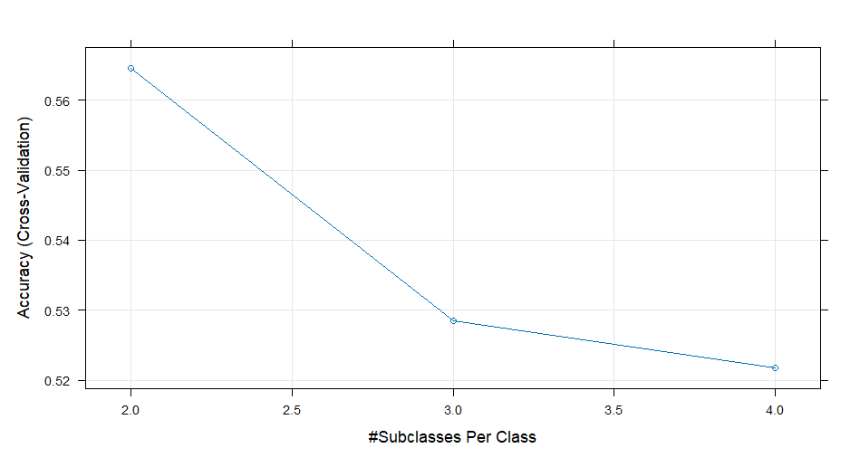

Neural Network
Neural Network

20001 samples
49 predictor
3 classes: 'Gt30', 'Lt30', 'No'

No pre-processing
Resampling: Cross-Validated (10 fold)
Summary of sample sizes: 18000, 18002, 18002, 18001, 18001, 18001, ...
Resampling results across tuning parameters:

size decay logLoss AUC prAUC Accuracy Kappa Mean_F1
1 0e+00 0.9208026 0.6181473 0.3640949 0.5532705 0.09397922 NaN
1 1e-04 0.9185749 0.6215215 0.3594489 0.5592717 0.15708964 NaN
1 1e-01 0.9181094 0.6260045 0.4148380 0.5576742 0.12727656 NaN
3 0e+00 0.9174566 0.6317559 0.4229705 0.5633720 0.15000704 0.3845024
3 1e-04 0.9204231 0.6247573 0.4104757 0.5594727 0.14109849 NaN
3 1e-01 0.9158618 0.6312466 0.4260106 0.5645235 0.14703663 0.3761454
5 0e+00 0.9264914 0.6226292 0.4182538 0.5568724 0.14100119 0.3778867
5 1e-04 0.9254587 0.6233854 0.4181479 0.5582209 0.14218934 NaN
5 1e-01 0.9197612 0.6282368 0.4224199 0.5572725 0.13607693 NaN
Mean_Sensitivity Mean_Specificity Mean_Pos_Pred_Value Mean_Neg_Pred_Value Mean_Precision
0.3699599 0.6975789 NaN 0.7401555 NaN
0.3955806 0.7189348 NaN 0.7378198 NaN
0.3832950 0.7088316 NaN 0.7387612 NaN
0.3918717 0.7156612 0.5246215 0.7394729 0.5246215
0.3882457 0.7125843 NaN 0.7353522 NaN
0.3905388 0.7142694 0.5295001 0.7404034 0.5295001
0.3885887 0.7128272 0.4319026 0.7326888 0.4319026
0.3891665 0.7129415 NaN 0.7328944 NaN
0.3862559 0.7109015 NaN 0.7326332 NaN
Mean_Recall Mean_Detection_Rate Mean_Balanced_Accuracy
0.3699599 0.1844235 0.5337694
0.3955806 0.1864239 0.5572577
0.3832950 0.1858914 0.5460633
0.3918717 0.1877907 0.5537664
0.3882457 0.1864909 0.5504150
0.3905388 0.1881745 0.5524041
0.3885887 0.1856241 0.5507080
0.3891665 0.1860736 0.5510540
0.3862559 0.1857575 0.5485787

Accuracy was used to select the optimal model using the largest value.
The final values used for the model were size = 3 and decay = 0.1.

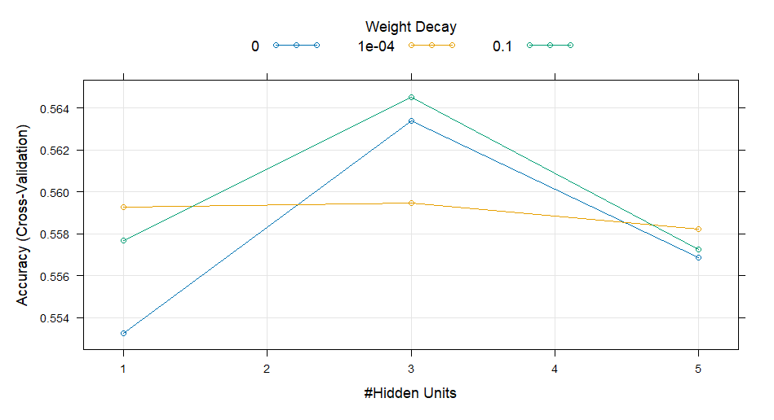

Flexible Discriminant Analysis
Flexible Discriminant Analysis

20001 samples
49 predictor
3 classes: 'Gt30', 'Lt30', 'No'

No pre-processing
Resampling: Cross-Validated (10 fold)
Summary of sample sizes: 18000, 18002, 18002, 18001, 18001, 18001, ...
Resampling results across tuning parameters:

nprune logLoss AUC prAUC Accuracy Kappa Mean_F1 Mean_Sensitivity
2 0.9270689 0.5883729 0.1454636 0.5551220 0.1573352 NaN 0.3957692
3 0.9250280 0.5974190 0.3347926 0.5662212 0.1681385 NaN 0.3995731
4 0.9143914 0.6109686 0.3599637 0.5658717 0.1696743 NaN 0.4001967
6 0.9064717 0.6329062 0.4312298 0.5673720 0.1614652 0.3864908 0.4020813
7 0.9047025 0.6370919 0.4408475 0.5676719 0.1550691 0.3808087 0.3988003
8 0.9021651 0.6448839 0.4451743 0.5662717 0.1522778 0.3810426 0.3980845
10 0.9005711 0.6484497 0.4460087 0.5690712 0.1549047 0.3829934 0.3998599
11 0.9002184 0.6498917 0.4480240 0.5677715 0.1550054 0.3861172 0.4009665
12 0.8989822 0.6526671 0.4496719 0.5697711 0.1601975 0.3888209 0.4030794
14 0.8977333 0.6541945 0.4514011 0.5696716 0.1601467 0.3891841 0.4032380
Mean_Specificity Mean_Pos_Pred_Value Mean_Neg_Pred_Value Mean_Precision Mean_Recall
0.7197027 NaN 0.7327386 NaN 0.3957692
0.7224395 NaN 0.7408829 NaN 0.3995731
0.7231947 NaN 0.7408359 NaN 0.4001967
0.7193421 0.4903173 0.7450667 0.4903173 0.4020813
0.7168531 0.4749188 0.7482047 0.4749188 0.3988003
0.7159286 0.4689731 0.7461315 0.4689731 0.3980845
0.7164447 0.4709421 0.7500346 0.4709421 0.3998599
0.7165075 0.4748195 0.7478725 0.4748195 0.4009665
0.7182893 0.4764236 0.7496797 0.4764236 0.4030794
0.7182789 0.4746477 0.7497467 0.4746477 0.4032380
Mean_Detection_Rate Mean_Balanced_Accuracy
0.1850407 0.5577359
0.1887404 0.5610063
0.1886239 0.5616957
0.1891240 0.5607117
0.1892240 0.5578267
0.1887572 0.5570066
0.1896904 0.5581523
0.1892572 0.5587370
0.1899237 0.5606843
0.1898905 0.5607585

Tuning parameter 'degree' was held constant at a value of 1
Accuracy was used to select the optimal model using the largest value.
The final values used for the model were degree = 1 and nprune = 12.
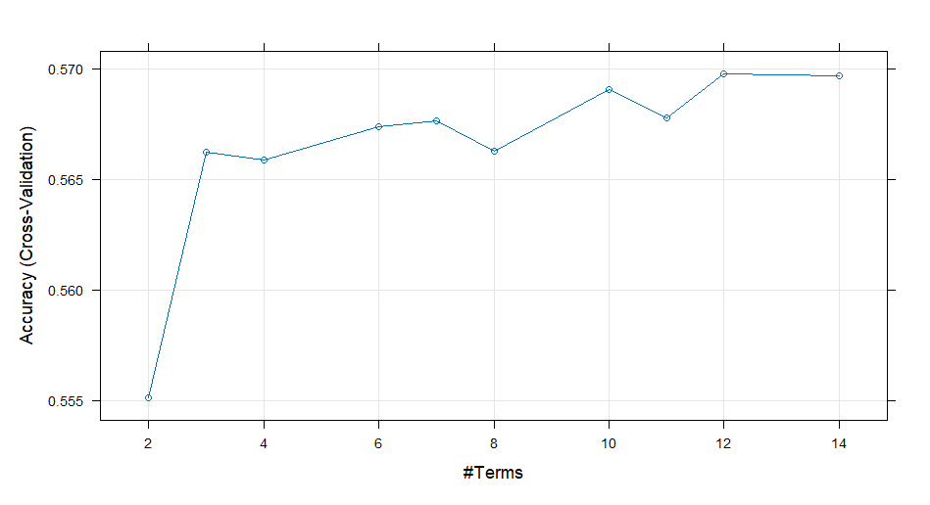

Support Vector Machine (RBF)
Support Vector Machines with Radial Basis Function Kernel

20001 samples
49 predictor
3 classes: 'Gt30', 'Lt30', 'No'

No pre-processing
Resampling: Cross-Validated (10 fold)
Summary of sample sizes: 18000, 18002, 18002, 18001, 18001, 18001, ...
Resampling results across tuning parameters:

C logLoss AUC prAUC Accuracy Kappa Mean_F1 Mean_Sensitivity
0.25 0.9170157 0.6265010 0.4264614 0.5689710 0.1553330 NaN 0.3930727
0.50 0.9155954 0.6268923 0.4274964 0.5711720 0.1524492 NaN 0.3917657
1.00 0.9150991 0.6265884 0.4271886 0.5719723 0.1504651 NaN 0.3908834
Mean_Specificity Mean_Pos_Pred_Value Mean_Neg_Pred_Value Mean_Precision Mean_Recall
0.7171811 NaN 0.7454847 NaN 0.3930727
0.7156387 NaN 0.7484153 NaN 0.3917657
0.7147292 NaN 0.7499978 NaN 0.3908834
Mean_Detection_Rate Mean_Balanced_Accuracy
0.1896570 0.5551269
0.1903907 0.5537022
0.1906574 0.5528063

Tuning parameter 'sigma' was held constant at a value of 0.01166314
Accuracy was used to select the optimal model using the largest value.
The final values used for the model were sigma = 0.01166314 and C = 1.
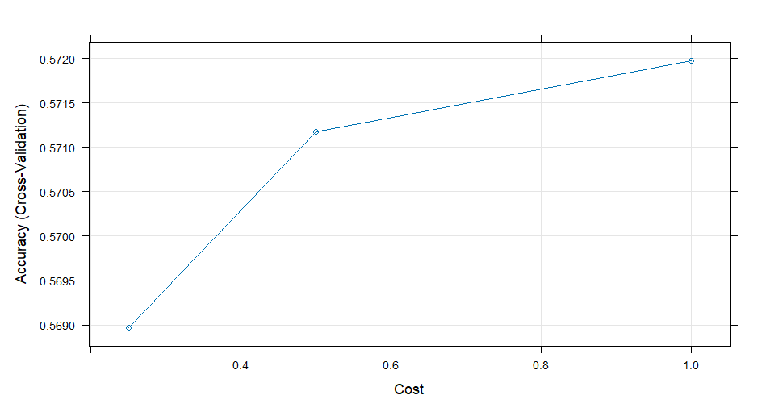
KNN classifier
k-Nearest Neighbors

20001 samples
49 predictor
3 classes: 'Gt30', 'Lt30', 'No'

No pre-processing
Resampling: Cross-Validated (10 fold)
Summary of sample sizes: 18000, 18002, 18002, 18001, 18001, 18001, ...
Resampling results across tuning parameters:

k logLoss AUC prAUC Accuracy Kappa Mean_F1 Mean_Sensitivity
5 4.483633 0.5629837 0.3623798 0.5075777 0.09059686 0.3741802 0.3774264
7 3.048099 0.5692437 0.3794293 0.5181250 0.09045453 0.3679010 0.3757490
9 2.361662 0.5755664 0.3868861 0.5285246 0.09863767 0.3646214 0.3769617
11 1.922571 0.5806652 0.3916656 0.5314238 0.09504387 0.3552518 0.3729405
13 1.661323 0.5847411 0.3948447 0.5382739 0.10247301 0.3554445 0.3755253
15 1.492370 0.5875490 0.3974083 0.5394736 0.09837999 0.3497302 0.3725309
17 1.370050 0.5904049 0.3993311 0.5420736 0.09826161 0.3472184 0.3725520
19 1.290253 0.5923140 0.4010921 0.5419749 0.09463354 0.3437214 0.3703610
21 1.211350 0.5932705 0.4006469 0.5453730 0.09870166 0.3473765 0.3722608
23 1.162832 0.5950816 0.4027345 0.5482724 0.10137828 0.3461422 0.3725502
25 1.121850 0.5965214 0.4031844 0.5467228 0.09608166 0.3414504 0.3702235
27 1.072955 0.5990713 0.4042908 0.5495220 0.09849653 0.3412571 0.3711259
29 1.046930 0.5992774 0.4043482 0.5506227 0.09819416 0.3397461 0.3709355
31 1.032483 0.5988891 0.4046056 0.5502226 0.09572133 0.3385602 0.3700477
33 1.017987 0.5991717 0.4053817 0.5513732 0.09635344 0.3370571 0.3700379
Mean_Specificity Mean_Pos_Pred_Value Mean_Neg_Pred_Value Mean_Precision Mean_Recall
0.6971363 0.3894394 0.7031747 0.3894394 0.3774264
0.6964363 0.3987439 0.7050334 0.3987439 0.3757490
0.6988391 0.4036815 0.7106635 0.4036815 0.3769617
0.6976071 0.3953862 0.7115444 0.3953862 0.3729405
0.6997740 0.4048218 0.7160884 0.4048218 0.3755253
0.6983692 0.3940948 0.7163862 0.3940948 0.3725309
0.6981020 0.4131571 0.7183380 0.4131571 0.3725520
0.6969696 0.4029792 0.7184061 0.4029792 0.3703610
0.6980726 0.4162867 0.7216012 0.4162867 0.3722608
0.6989659 0.4258372 0.7251687 0.4258372 0.3725502
0.6972845 0.4141994 0.7237055 0.4141994 0.3702235
0.6978861 0.4134731 0.7267310 0.4134731 0.3711259
0.6977098 0.4354578 0.7285655 0.4354578 0.3709355
0.6968422 0.4519914 0.7279558 0.4519914 0.3700477
0.6969708 0.4578242 0.7293433 0.4578242 0.3700379
Mean_Detection_Rate Mean_Balanced_Accuracy
0.1691926 0.5372813
0.1727083 0.5360927
0.1761749 0.5379004
0.1771413 0.5352738
0.1794246 0.5376496
0.1798245 0.5354501
0.1806912 0.5353270
0.1806583 0.5336653
0.1817910 0.5351667
0.1827575 0.5357581
0.1822409 0.5337540
0.1831740 0.5345060
0.1835409 0.5343226
0.1834075 0.5334450
0.1837911 0.5335044

Accuracy was used to select the optimal model using the largest value.
The final value used for the model was k = 33.

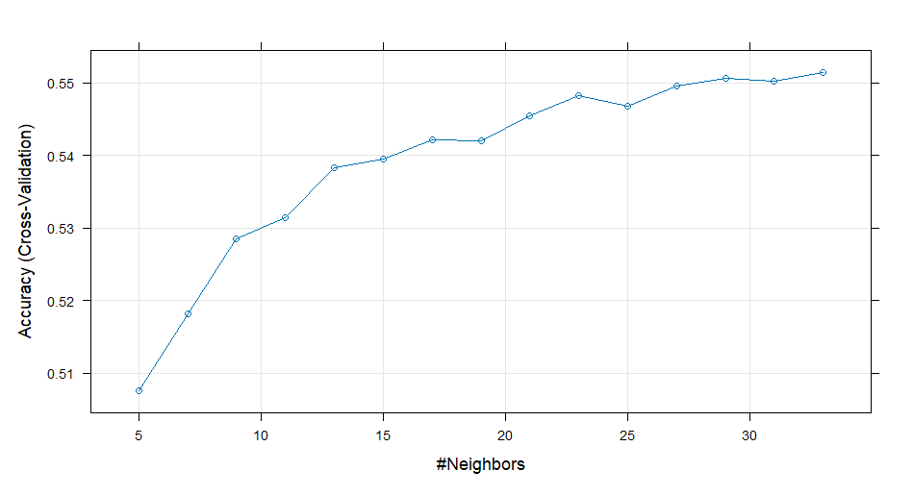

Naive Bayes
Naive Bayes

20001 samples
49 predictor
3 classes: 'Gt30', 'Lt30', 'No'

No pre-processing
Resampling: Cross-Validated (10 fold)
Summary of sample sizes: 18000, 18002, 18002, 18001, 18001, 18001, ...
Resampling results across tuning parameters:

usekernel logLoss AUC prAUC Accuracy Kappa Mean_F1
FALSE 1.374147 0.6088181 0.4046647 0.5054252 1.350068e-01 0.4038377
TRUE 3.411264 0.6354824 0.4289284 0.5362232 2.341291e-05 NaN
Mean_Sensitivity Mean_Specificity Mean_Pos_Pred_Value Mean_Neg_Pred_Value Mean_Precision
0.4058371 0.7147321 0.4066305 0.7178953 0.4066305
0.3334155 0.6666686 0.3455244 0.6232452 0.3455244
Mean_Recall Mean_Detection_Rate Mean_Balanced_Accuracy
0.4058371 0.1684751 0.5602846
0.3334155 0.1787411 0.5000420

Tuning parameter 'laplace' was held constant at a value of 0
Tuning parameter 'adjust' was
held constant at a value of 1
Accuracy was used to select the optimal model using the largest value.
The final values used for the model were laplace = 0, usekernel = TRUE and adjust = 1.
