**Week #1**

**Study and understand the basic networking tools - Wireshark, Tcpdump, Ping, Traceroute.**

|  |
| --- |
| **Learn and Understand Network Tools**  **1. Wireshark**  • Perform and analyze Ping PDU capture  • Examine HTTP packet capture  • Analyze HTTP packet capture using filter  **2. Tcpdump**  • Capture packets  **3. Ping**  • Test the connectivity between 2 systems  **4. Traceroute**  • Perform traceroute checks  **5. Nmap**  • Explore an entire network |

**IMPORTANT INSTRUCTIONS:**

• This manual is written for Ubuntu Linux OS only. You can also execute these experiments on VirtualBox or VMWare platform.

• For few tasks, you may need to create 2 VMs for experimental setup. • Perform **sudo apt-get update** before installing any tool or utility.

• Install any tool or utility using the command **sudo apt-get install name_of_the_tool** • Take screenshots wherever necessary and upload it to Edmodo as a single PDF file. (Refer general guidelines for submission requirements).

• To define an IP address for your machine (e.g., Section – ‘a’ & Serial number is 1, then your IP address should be 10.0.1.1. Section – ‘h’ & & Serial number is 23, then your IP address should be 10.0.8.23) – applicable only for relevant tasks (which doesn’t requires internet connectivity to execute the tasks).

**Task 1: Linux Interface Configuration (ifconfig / IP command)**

**Step 1:** To display status of all active network interfaces.

**ifconfig** (or) **ip addr show**

Analyze and fill the following table:

**ip address table:**

|  |  |  |  |
| --- | --- | --- | --- |
| **Interface name** | **IP address**  **(IPv4 / IPv6)** | **MAC address** |  |
| **eth0** | **10.0.2.15** | **08:00:27:db:96:6a** |  |
| **lo** | **127.0.0.1** | **NONE** |  |
|  |  |  |  |

**Step 2:** To assign an IP address to an interface, use the following command. **sudo ifconfig interface_name 10.0.your_section.your_sno netmask 255.255.255.0** (or) **sudo ip addr add 10.0.your_section.your_sno /24 dev interface_name**

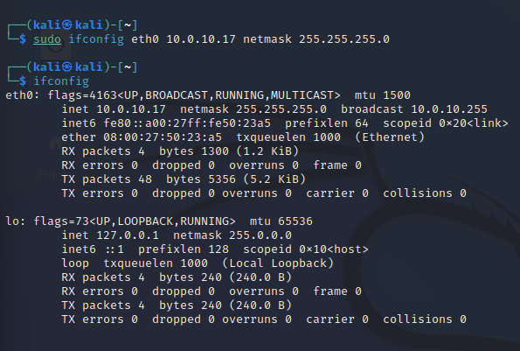

**Step 3:** To activate / deactivate a network interface, type.

**sudo ifconfig interface_name down**

**sudo ifconfig interface_name up**

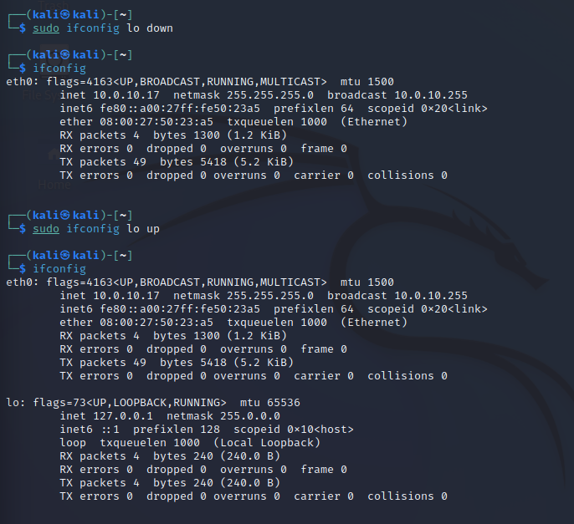

**Step 4:** To show the current neighbor table in kernel, type

**ip neigh**

**Task 2: Ping PDU (Packet Data Units or Packets) Capture**

**Step 1:** Assign an IP address to the system (Host).

Note: IP address of your system should be 10.0.your_section.your_sno.

**Step 2:** Launch Wireshark and select ‘any’ interface

**Step 3:** In terminal, type **ping 10.0.your_section.your_sno**

**Observations to be made**

**Step 4:** Analyze the following in Terminal

• TTL = 64

• Protocol used by ping = icmp

• Time = 0.019ms

**Step 5:** Analyze the following in Wireshark

On Packet List Pane, select the first echo packet on the list. On Packet Details Pane, click on each of the four “+” to expand the information. Analyze the frames with the first echo request and echo reply and complete the table below.

|  |  |  |
| --- | --- | --- |
| **Details** | **First Echo Request** | **First Echo Reply** |
| Frame Number | 9 | 10 |
| Source IP address | 10.0.10.17 | 10.0.10.17 |
| Destination IP address | 10.0.10.17 | 10.0.10.17 |
| ICMP Type Value | 8 | 0 |
| ICMP Code Value | 0 | 0 |
| Source Ethernet Address | 0 | 0 |
| Destination Ethernet Address | 0 | 0 |
| Internet Protocol Version | 4 | 4 |
| Time To Live (TTL) Value | 64 | 64 |

**Task 3: HTTP PDU Capture**

**Using Wireshark’s Filter feature**

**Step 1:** Launch Wireshark and select ‘any’ interface. On the Filter toolbar, type-in ‘http’ and press enter

**Step 2:** Open Firefox browser, and browse www.flipkart.com

**Observations to be made**

**Step 3:** Analyze the first (interaction of host to the web server) and second frame (response of server to the client). By analyzing the filtered frames, complete the table below:

|  |  |  |
| --- | --- | --- |
| **Details** | **First Echo Request** | **First Echo Reply** |
| Frame Number | 245 | 247 |
| Source Port | 46180 | 80 |
| Destination Port | 80 | 48210 |
| Source IP address | 10.0.10.17 | 117.18.237.29 |
| Destination IP address | 117.18.237.29 | 10.0.10.17 |
| Source Ethernet Address |  |  |
| Destination Ethernet Address |  |  |

**Step 4:** Analyze the HTTP request and response and complete the table below.

|  |  |  |  |
| --- | --- | --- | --- |
| **HTTP Request** |  | **HTTP Response** |  |
| Get | /success.txt?ipv4 | Server | 200 OK |

|  |  |  |  |
| --- | --- | --- | --- |
| Host | detectportal.firefox.com | Content-Type | text/plain |
| User-Agent | Mozilla/5.0 (X11; Linux x86_64; rv:91.0) Gecko/20100101 Firefox/91.0 | Date | Thu, 19 Jan 2023 18:45:32 GMT |
| Accept-Language | en-US,en;q=0.5 | Location | www.google.com |
| Accept-Encoding | gzip, deflate | Content-Length | 8 |
| Connection | keep-alive | Connection | keep-alive |

**Using Wireshark’s Follow TCP Stream**

**Step 1:** Make sure the filter is blank. Right-click any packet inside the Packet List Pane, then select ‘Follow TCP Stream’. For demo purpose, a packet containing the HTTP GET request “GET / HTTP / 1.1” can be selected.

Step 2: Upon following a TCP stream, screenshot the whole window.

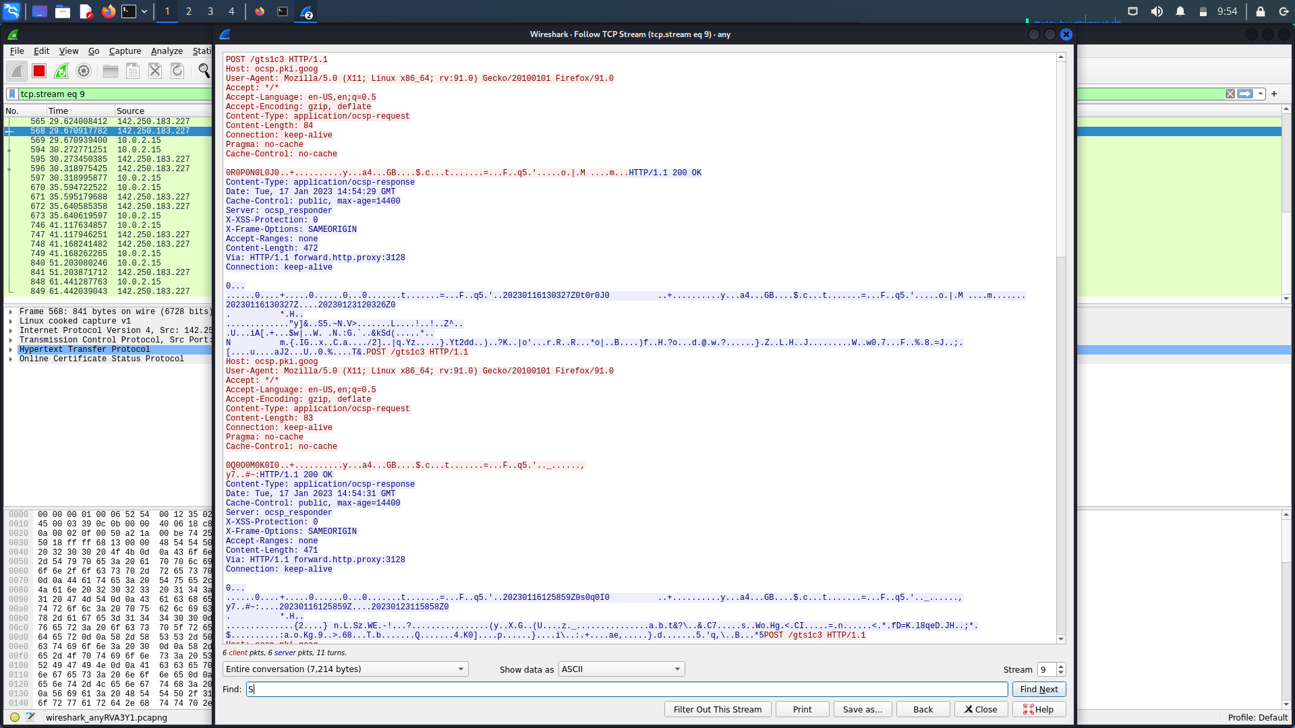

**Task 4: Capturing packets with tcpdump**

**Step 1:** Use the command **tcpdump -D** to see which interfaces are available for capture. **sudo tcpdump -D**

**Step 2:** Capture all packets in any interface by running this command:

**sudo tcpdump -i any**

Note: Perform some pinging operation while giving above command. Also type www.google.com in browser.

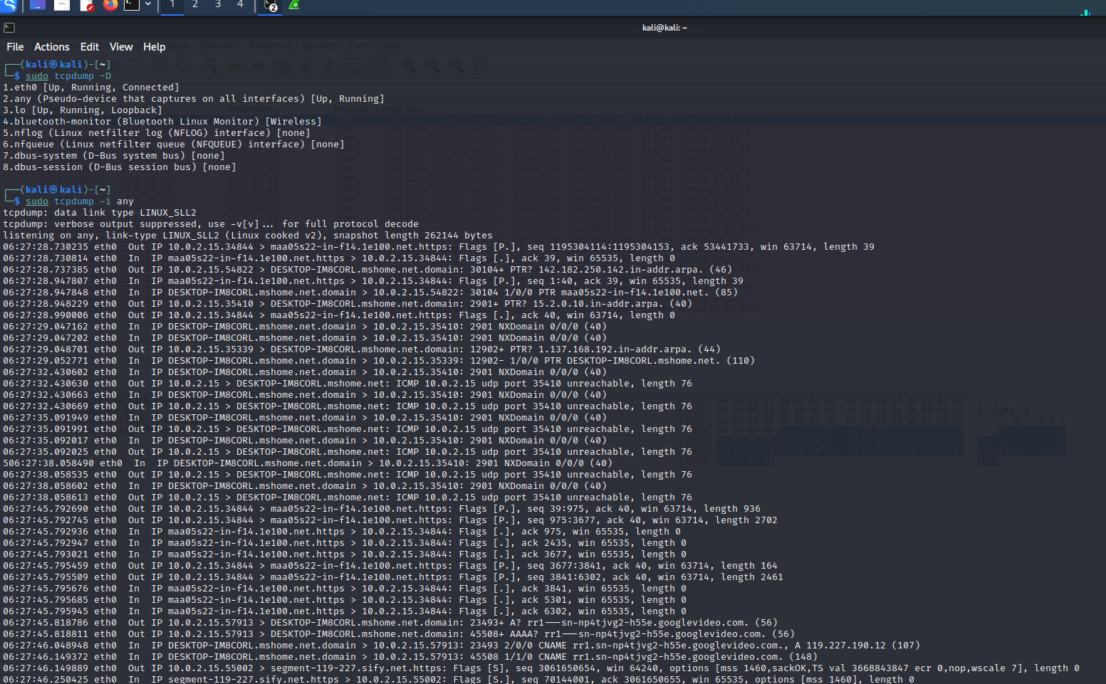

**Observation**

**Step 3:** Understand the output format.

**Step 4:** To filter packets based on protocol, specifying the protocol in the command line. For example, capture ICMP packets only by using this command:

**sudo tcpdump -i any -c5 icmp**

**Step 5:** Check the packet content. For example, inspect the HTTP content of a web request like this:

**sudo tcpdump -i any -c10 -nn -A port 80**

**Step 6:** To save packets to a file instead of displaying them on screen, use the option -w: **sudo tcpdump -i any -c10 -nn -w webserver.pcap port 80**

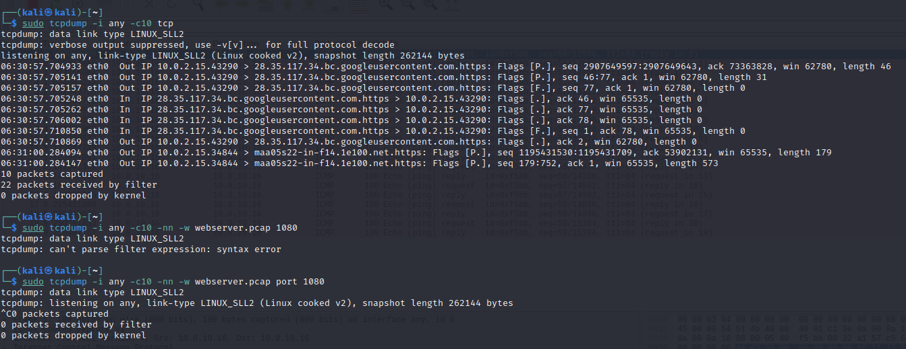

**Task 5: Perform Traceroute checks**

**Step 1:** Run the traceroute using the following command.

**sudo traceroute www.google.com**

**Step 2:** Analyze destination address of google.com and no. of hops

**Step 3:** To speed up the process, you can disable the mapping of IP addresses with hostnames by using the *-n* option

**sudo traceroute -n www.google.com** 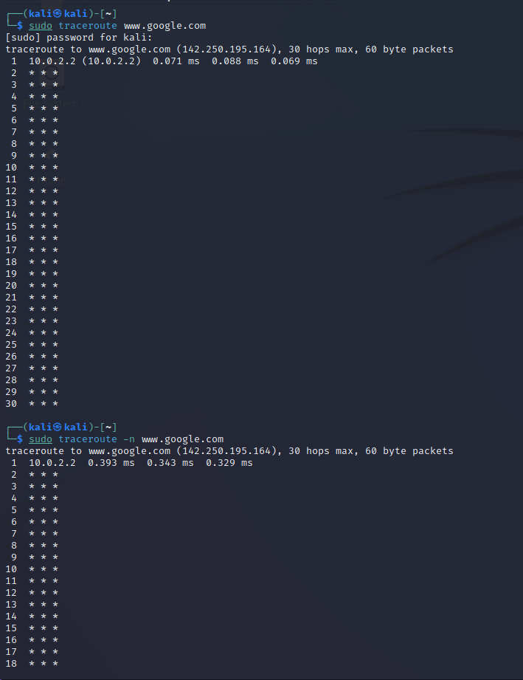

**Step 4:** The -I option is necessary so that the traceroute uses ICMP.

**sudo traceroute -I www.google.com**

**Step 5:** By default, traceroute uses icmp (ping) packets. If you’d rather test a TCP connection to gather data more relevant to web server, you can use the -T flag.

**sudo traceroute -T www.google.com**

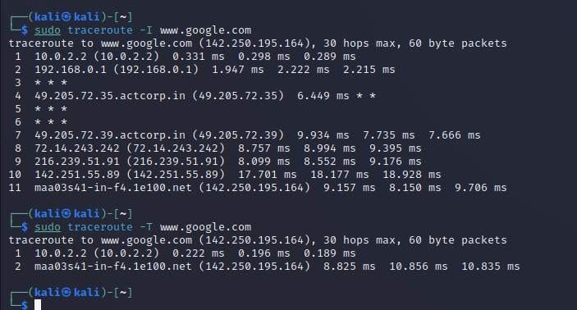

**Task 6: Explore an entire network for information (Nmap)**

**Step 1:** You can scan a host using its host name or IP address, for instance. **nmap www.pes.edu**

**Step 2:** Alternatively, use an IP address to scan.

**nmap 163.53.78.128**

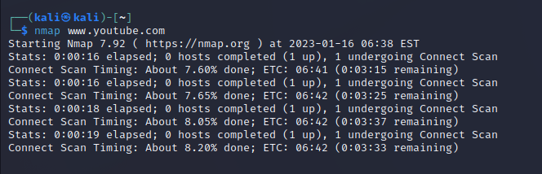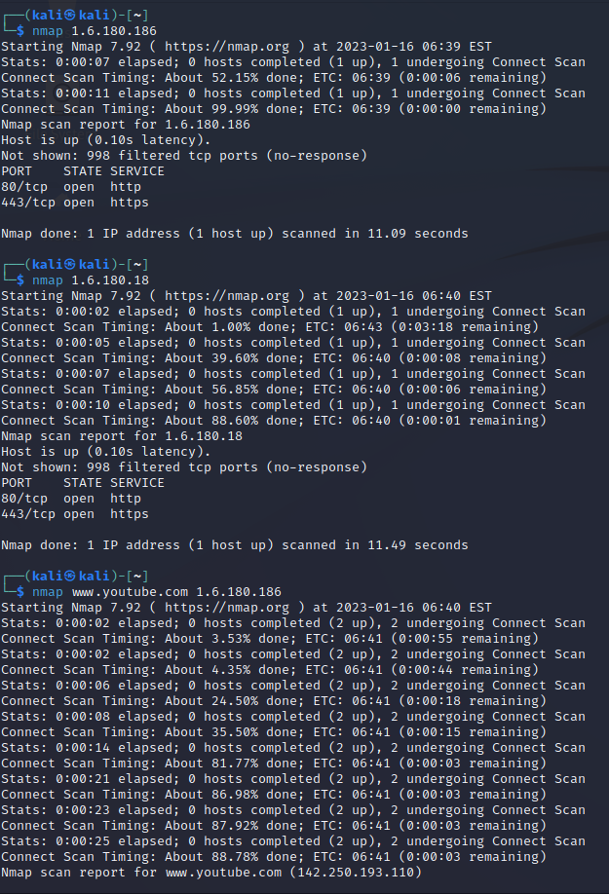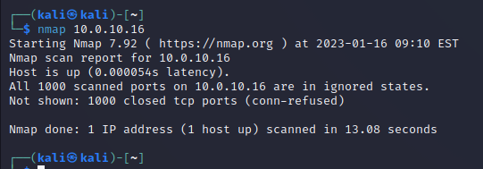

**Step 3:** Scan multiple IP address or subnet (IPv4)

**nmap 192.168.1.1 192.168.1.2 192.168.1.3**

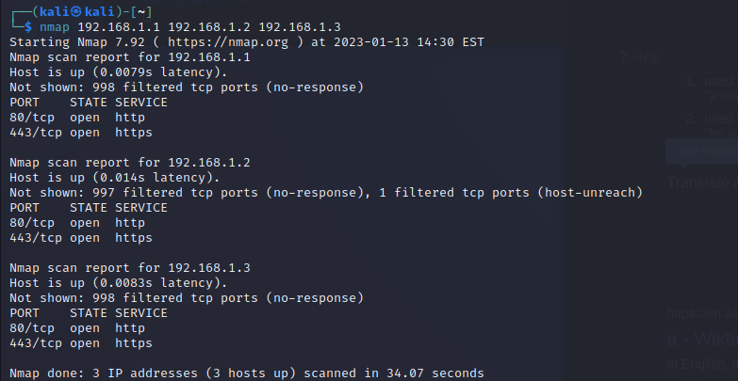

**Questions on above observations:**

1) Is your browser running HTTP version 1.0 or 1.1? What version of HTTP is the server? 1.1

2) When was the HTML file that you are retrieving last modified at the server?  
3) How to tell ping to exit after a specified number of ECHO_REQUEST packets? 4) How will you identify remote host apps and OS?