**MPCA LAB WEEK-2**

**Name: Yaman Gupta**

**SRN: PES2UG21CS619**

**Date: 25/01/2023**

**Q1) Write a program in ARM71TDMI-ISA to copy a block of N data items from Location A to Location B.**

1. **Use Full word (.word directive)**
2. **Use Half word (Hword directive)**
3. **Use Byte wise (.Byte directive)**

**Code and Output :**

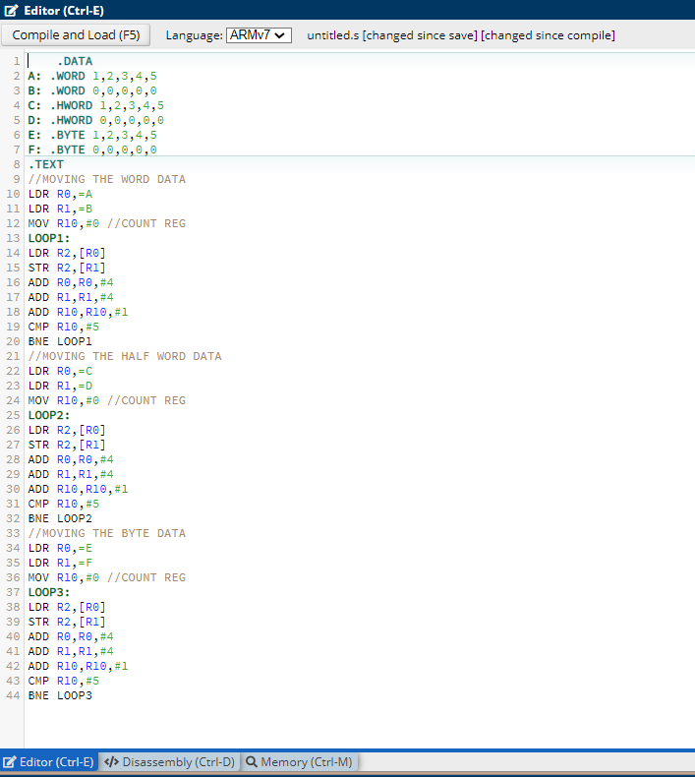

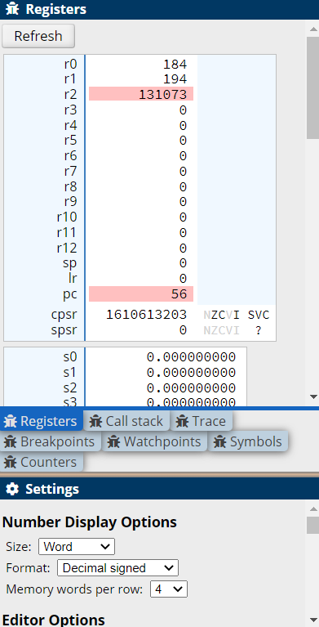

**Q2) Write a program in ARM7TDMI-ISA to find the sum of N data items in the memory. Store the result in the memory location.**

1. **Use Full word (.word directive)**
2. **Use Half word (.Hword directive)**
3. **Use Byte wise (.Byte directive)**

**Code and Output :**

**i)**

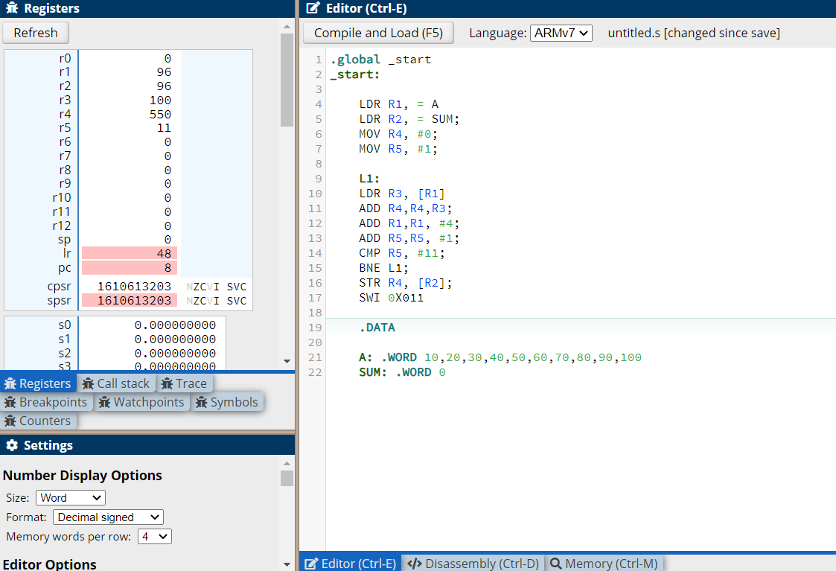

**ii)**

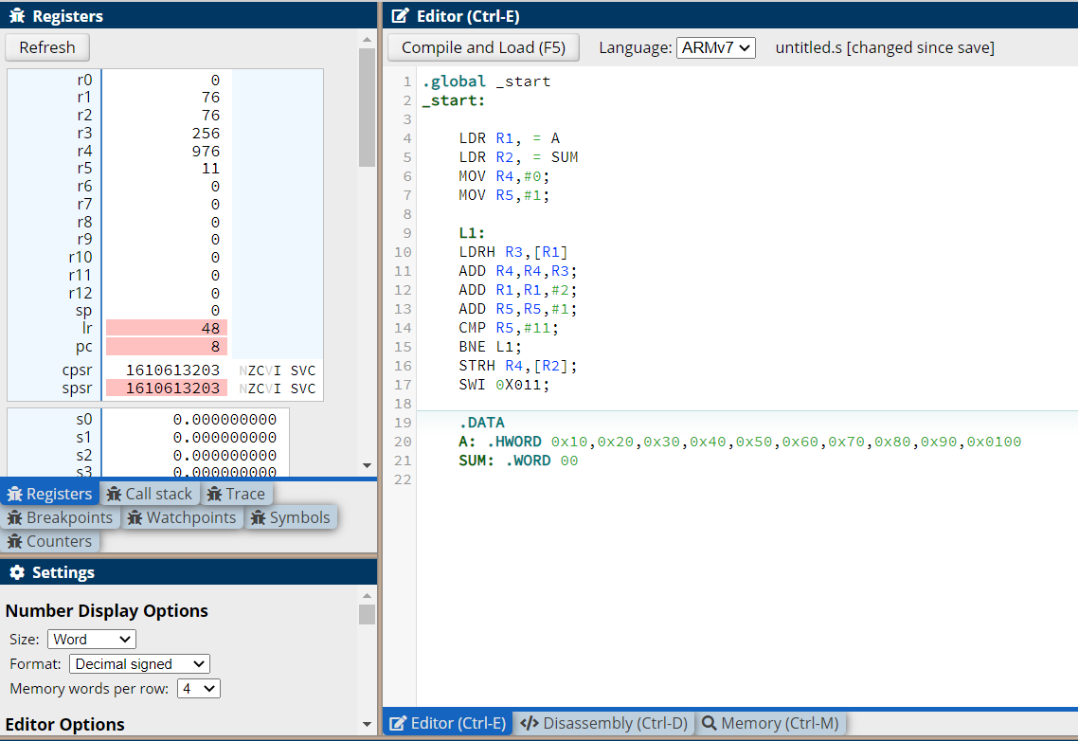

**iii)**

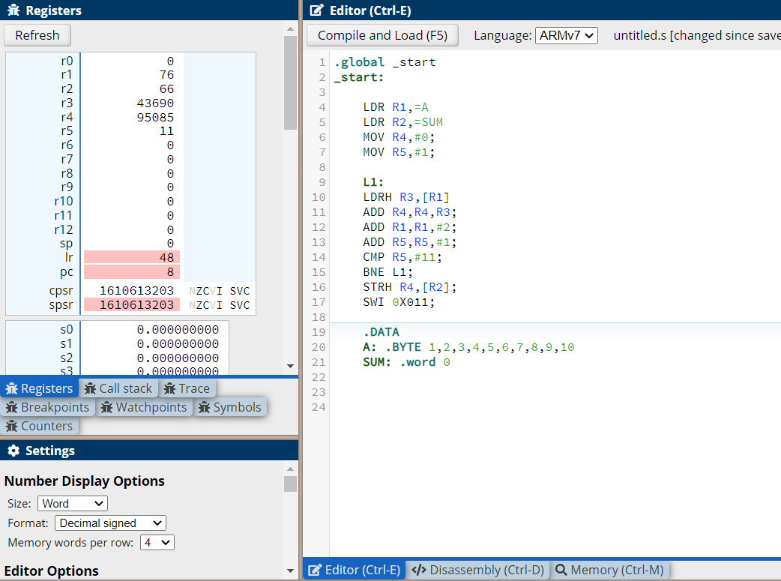

**Q3) Write a program in ARM7TDMI-ISA to find the sum of N natural numbers. Store the result in the memory location**

**Code and Output :**

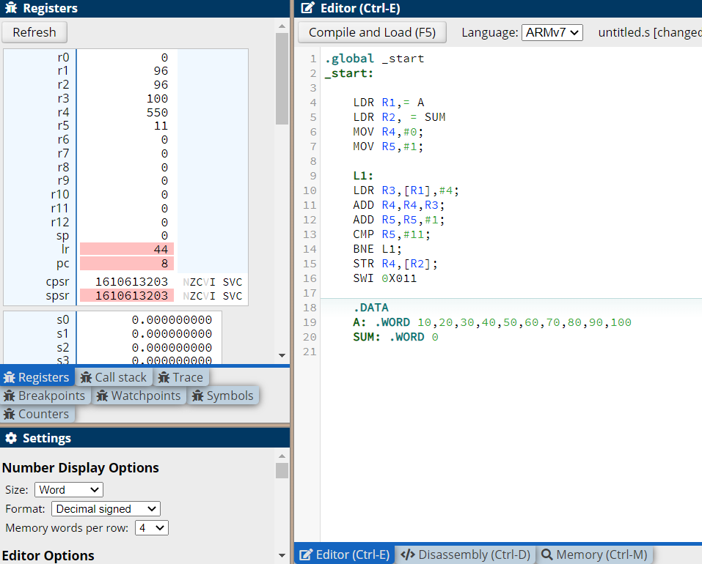

**Q4) Write a program in ARM7TDMI-ISA to find the product of two 32-bit numbers using barrel shifters.**

**Code and Output :**

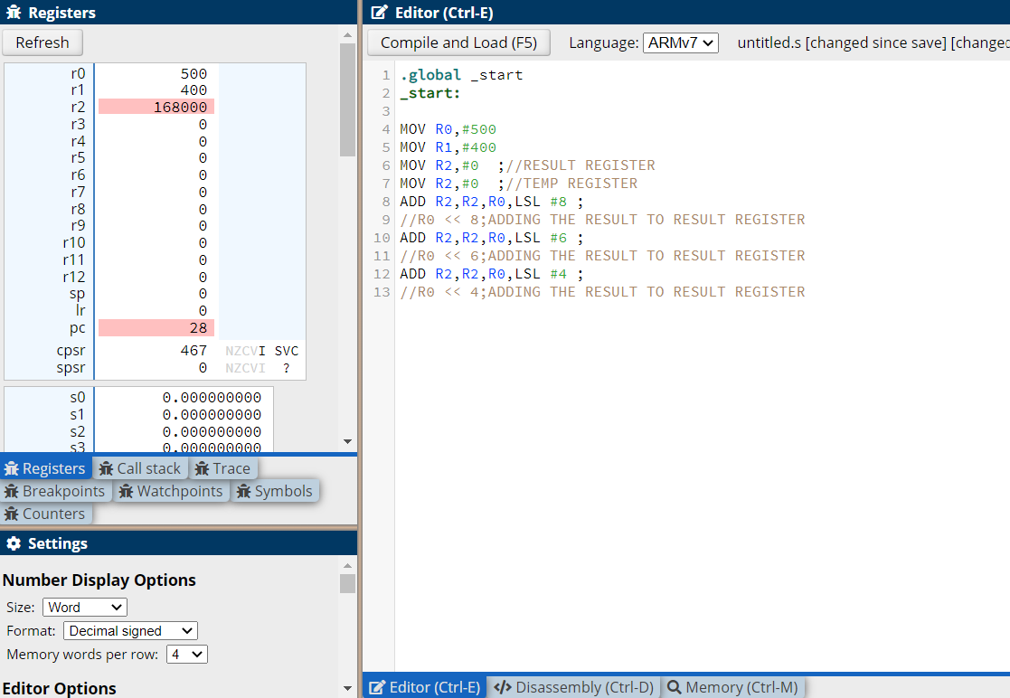

**Q5) Convert the following statement in C language into an ALP using ARM7TDMI – ISA.  
  
      IF([A]==[B]) then C=[A]+[B];  
      ELSE IF ([B]==[C]) D=[A]-[B];  
      ELSE E=[A]*[B]**

**Where A,B C, D & E are memory locations.**

**Code and Output :**

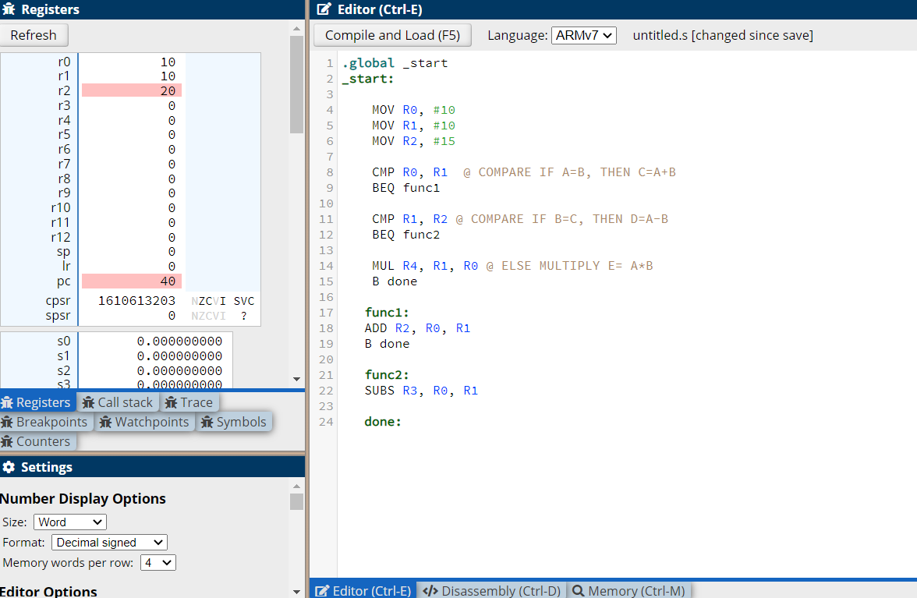

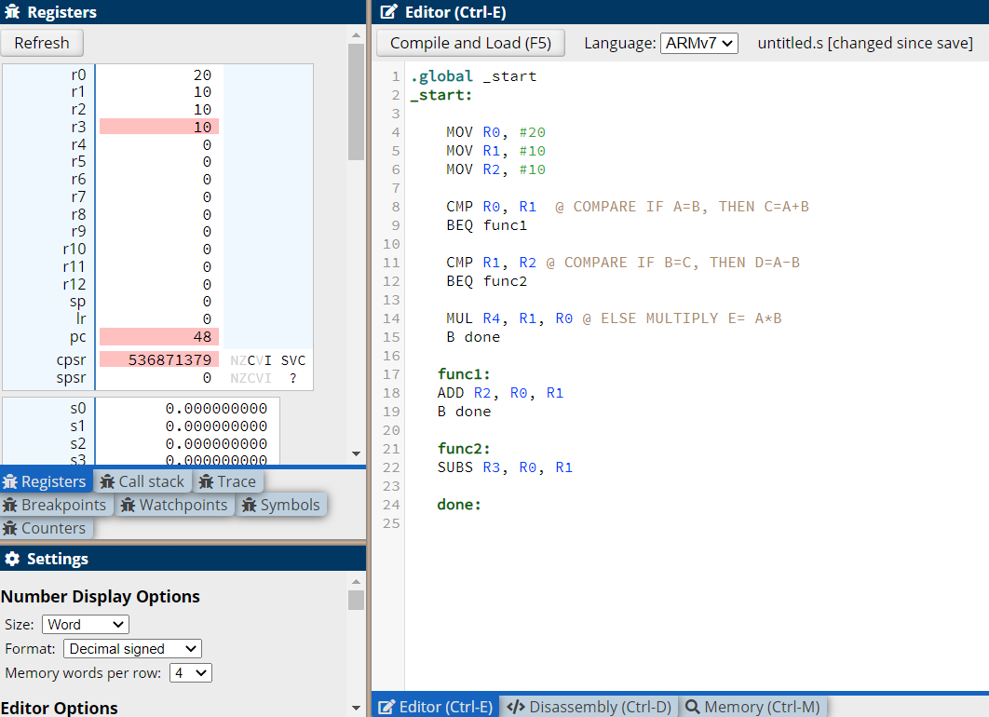

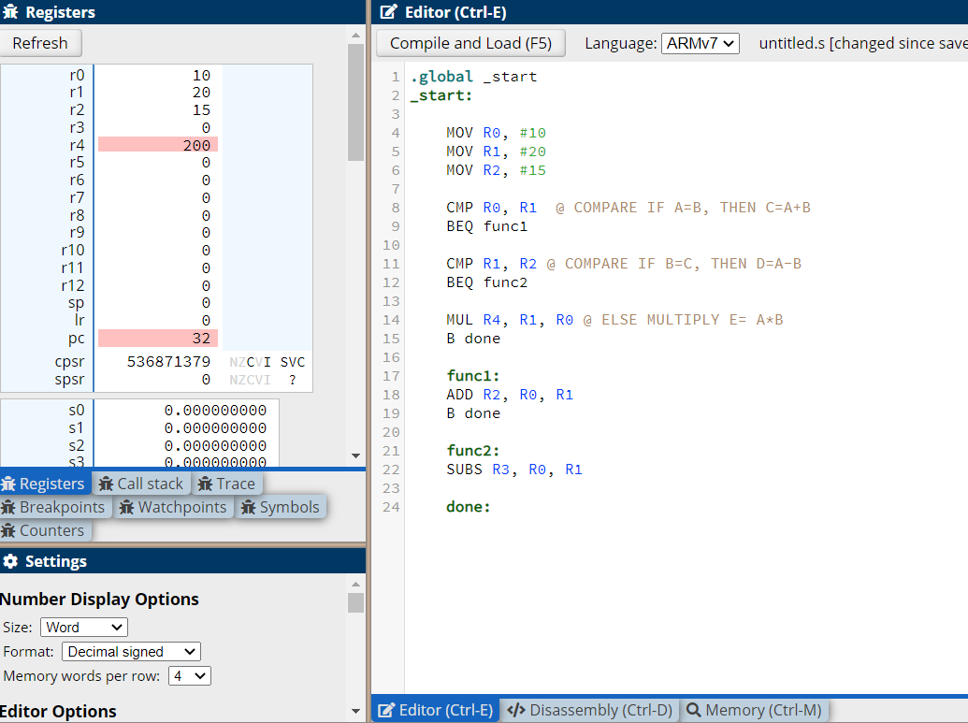

**Q6) Write a program in ARM7TDMI-ISA to find the factorial of a number.**

**Code and Output:**

