# Microprocessor and Computer Architecture

**UE21CS251B**

# 4th Semester, Academic Year 2022-23

Date:

| Name: Yaman Gupta | SRN:PES2UG21CS619 | Section:J |
| --- | --- | --- |

Week# 3 Program Number: 1

Title of the Program

# Generate Fibonacci Series and store them in an array.

1. ARM Assembly Code

.data

a: .word 0,0,0,0,0,0,0,0,0,0

.text

LDR r0,=a MOV r1,#0 MOV r2,#1 MOV r4,#2

STMIA r0!,{r1,r2}

BL fib B exit

fib:

loop:

LDMDB r0,{r1,r2} ADD r3,r1,r2

STR r3,[r0],#4 ADD r4,r4,#1 CMP r4,#11

BNE loop MOV PC,LR

exit:

.end

1. Output Screen Shots (One)

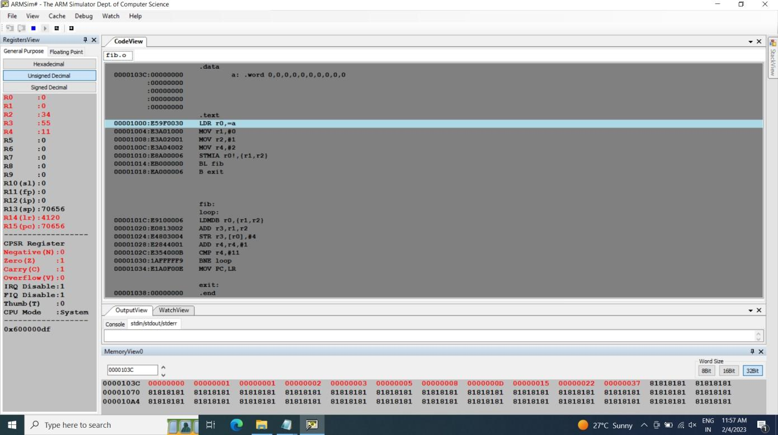

# Microprocessor and Computer Architecture UE21CS251B

**4th Semester, Academic Year 2022-23**

Date:

| Name: Yaman | SRN:PES2UG21CS619 | Section:J |
| --- | --- | --- |

Week# 3 Program Number: 2

Title of the Program

# Write an ALP to find smallest number in an array of n 32- bit numbers

1. ARM Assembly Code

.data

a: .word 16,10,32,52,4,9,20,13,90

b: .word -1

.text

LDR r0,=a LDR r1,[r0],#4

LDR r4,=b MOV r3,#1

loop:

LDR r2,[r0],#4 CMP r1,r2 MOVGT r1,r2 ADD r3,r3,#1 CMP r3,#9

BNE loop B exit

exit:

STR r1,[r4]

swi 0x11

.end

1. Output Screen Shots (One)

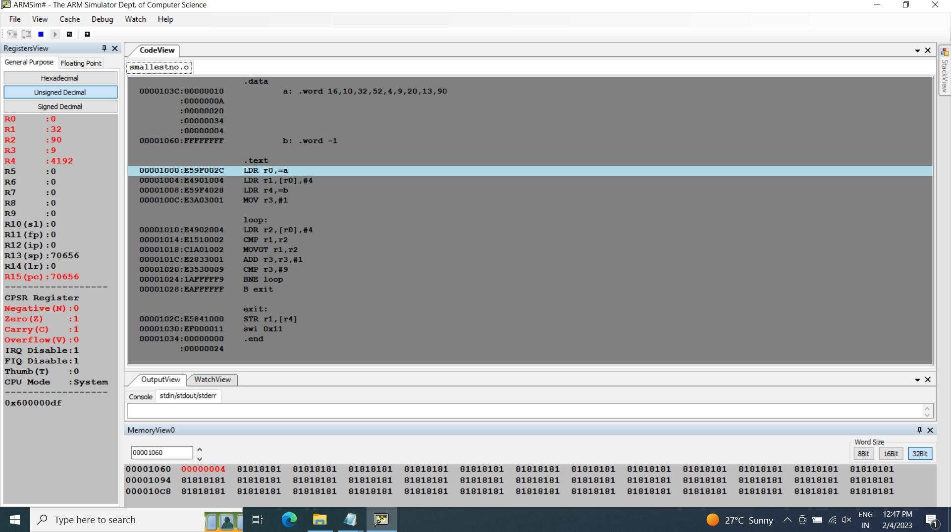

# Microprocessor and Computer Architecture UE21CS251B

**4th Semester, Academic Year 2022-23**

Date:

| Name: YAMAN | SRN:PES2UG21CS619 | Section:J |
| --- | --- | --- |

|  |  |  |
| --- | --- | --- |

Week# 2 Program Number: 3

Title of the Program

# To perform Convolution using MUL instruction (Addition of multiplication of respective numbers of loc A and loc B)

1. ARM Assembly Code

.data

a: .word 1,2,3,4,5,6,7,8,9

b: .word 10,20,30,40,50,60,70,80,90

c: .word 0

.text

LDR r0,=a LDR r1,=b LDR r2,=c MOV r5,#0 MOV r6,#1

loop:

LDR r3,[r0],#4

LDR r4,[r1],#4 MUL r7,r3,r4 ADD r5,r5,r7 ADD r6,r6,#1 CMP r6,#10

BNE loop B exit

exit:

STR r5,[r2]

swi 0x11

.end

1. Output Screen Shot (One)

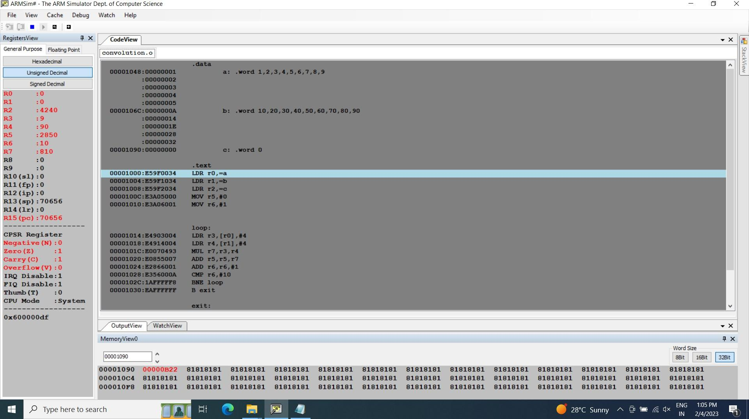

# Microprocessor and Computer Architecture UE21CS251B

**4th Semester, Academic Year 2022-23**

Date:

| Name: YAMAN | SRN:PES2UG21CS619 | Section-J |
| --- | --- | --- |

Week# 2 Program Number: 4

Title of the Program

# To perform Convolution using MLA instruction (Addition of multiplication of respective numbers of loc A and loc B).

1. ARM Assembly Code

.data

a: .word 1,2,3,4,5,6,7,8,9

b: .word 10,20,30,40,50,60,70,80,90

c: .word 0

.text

LDR r0,=a LDR r1,=b LDR r2,=c MOV r5,#0 MOV r6,#1

loop:

LDR r3,[r0],#4

LDR r4,[r1],#4 MLA r5,r3,r4,r5 ADD r6,r6,#1 CMP r6,#10

BNE loop B exit

exit:

STR r5,[r2]

swi 0x11

.end

1. Output Screen Shot (One)

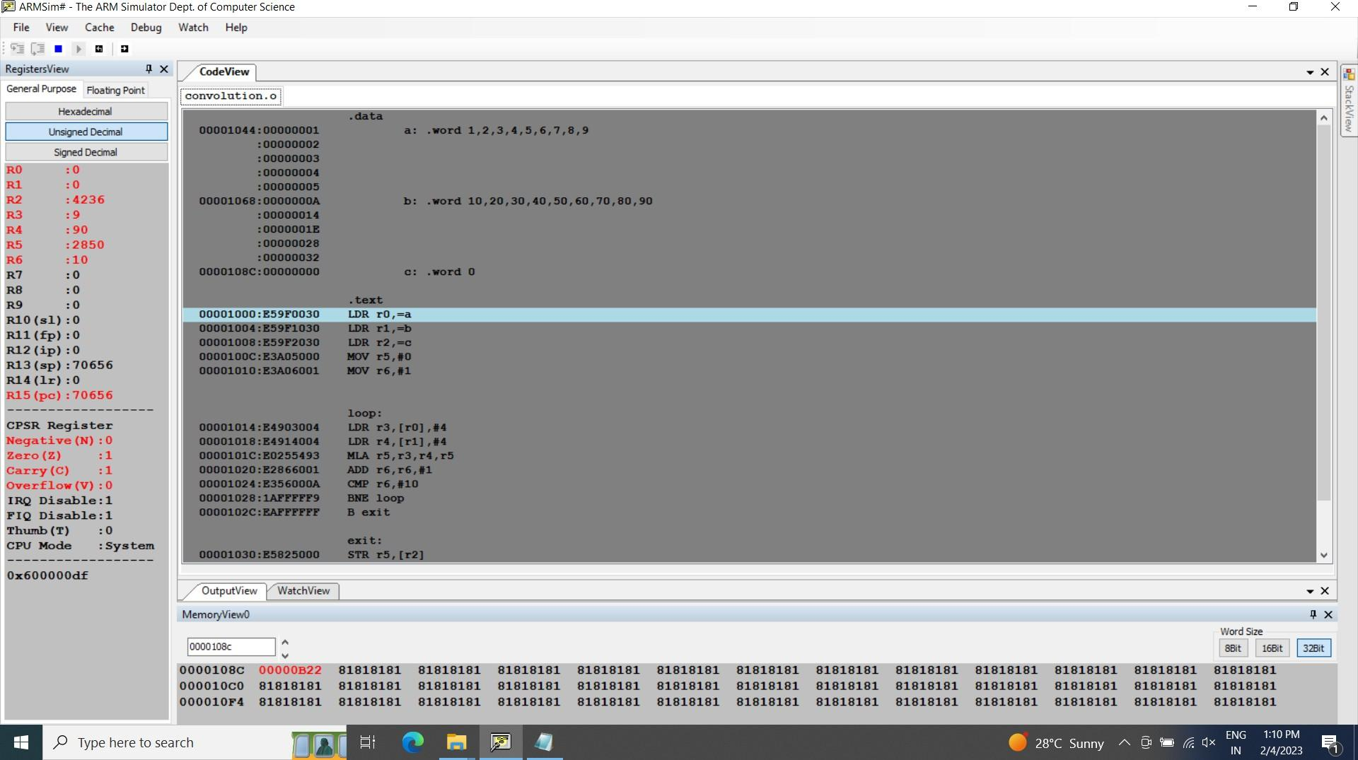

# Microprocessor and Computer Architecture UE21CS251B

**4th Semester, Academic Year 2022-23**

Date:

| Name: YAMAN | SRN:PES2UG21CS619 | Section:J |
| --- | --- | --- |

Week# 2 Program Number: 5

Title of the Program

# Write an ALP to find mul (add( a,b),c)

1. ARM Assembly Code

.data

a: .word 0

stk: .word 0

.text

LDR r0,=a MOV r1,#10

MOV r2,#20 MOV r3,#30

BL mulADD /*mul(add(10,20),30)*/ STR r6,[r0]

B exit

mulADD:

LDR r4,=stk STR LR,[r4]

BL add

MUL r6,r5,r3 LDR LR,[r4] MOV PC,LR

add:

ADD r5,r2,r1 MOV PC,LR

exit:

.end

1. Output Screen Shot (One)

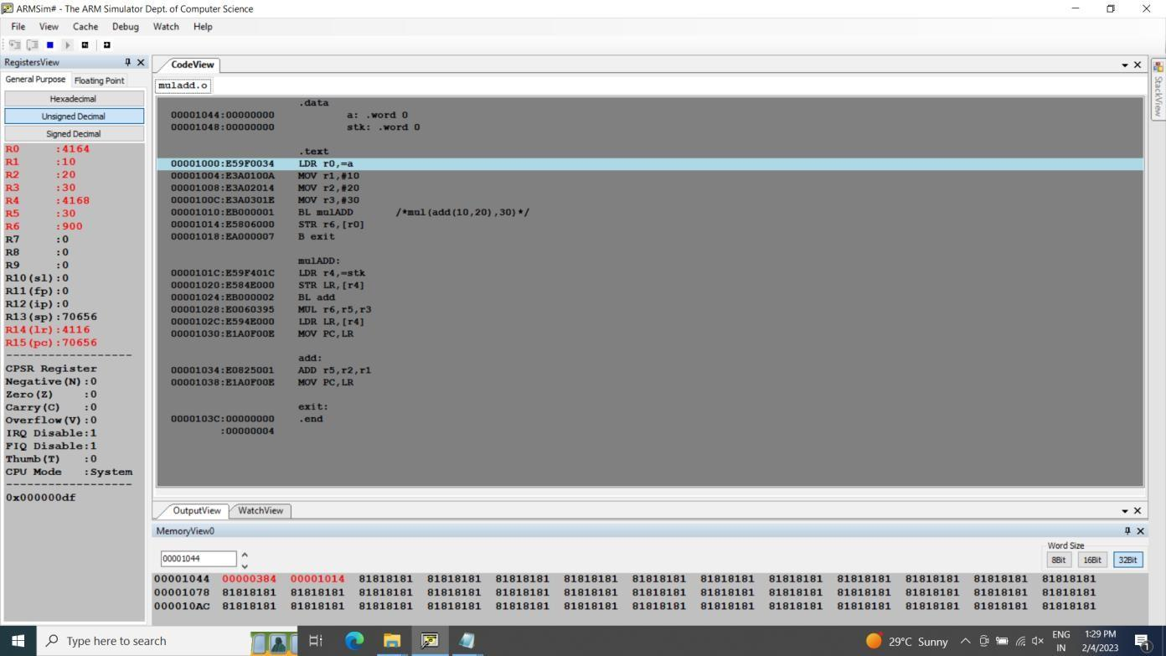

# Microprocessor and Computer Architecture UE21CS251B

**4th Semester, Academic Year 2022-23**

Date:

| Name: YAMAN | SRN:PES2UG21CS619 | Section:J |
| --- | --- | --- |

|  |  |  |
| --- | --- | --- |

Week# 2 Program Number: 6

Title of the Program

# Write an ALP to find factorial using subroutine

1. ARM Assembly Code

.data

a: .word 0

.text

LDR r0,=a MOV r1,#10

BL fact STR r2,[r0]

B exit

fact:

MOV r2,#1

loop:

MUL r2,r2,r1

SUB r1,r1,#1 CMP r1,#0

BGT loop MOV PC,LR

exit:

.end

1. Output Screen Shot (One)

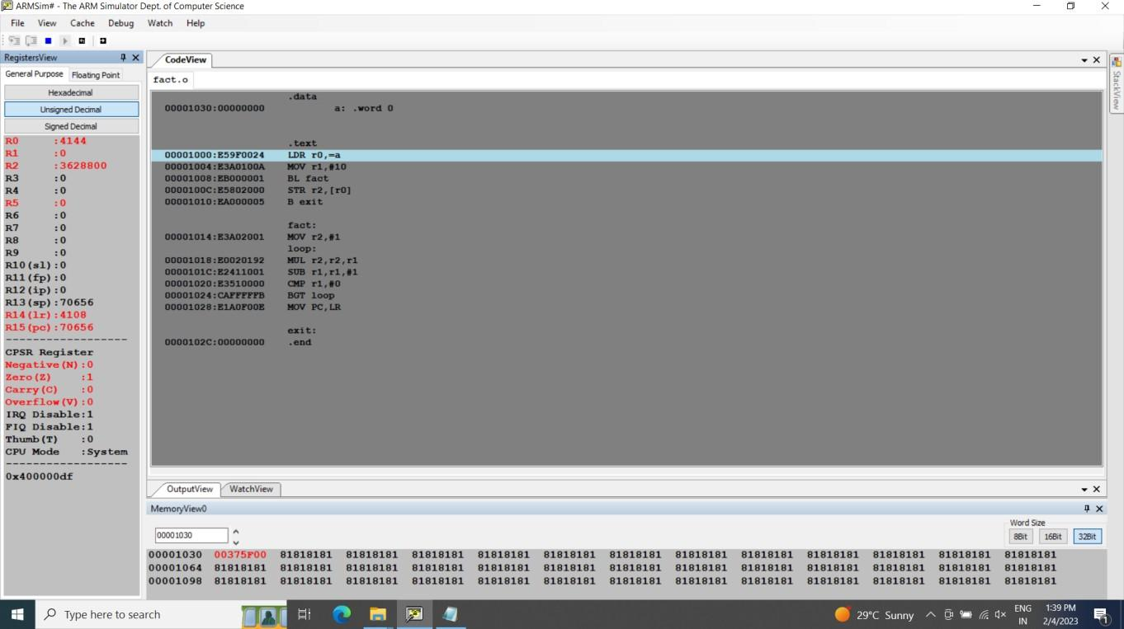

# Microprocessor and Computer Architecture UE21CS251B

**4th Semester, Academic Year 2022-23**

Date:

| Name: YAMAN | SRN:PES2UG21CS619 | Section:J |
| --- | --- | --- |

Week# 2 Program Number: 7

Title of the Program

# Write an ALP to perform multiplication using shift method (without using MUL)

1. ARM Assembly Code

.text

@25 multiplied by 56 MOV r0,#25

MOV r2,r0,LSL #6

SUB r2,r2,r0,LSL #3

.end

1. Output Screen Shot (One)

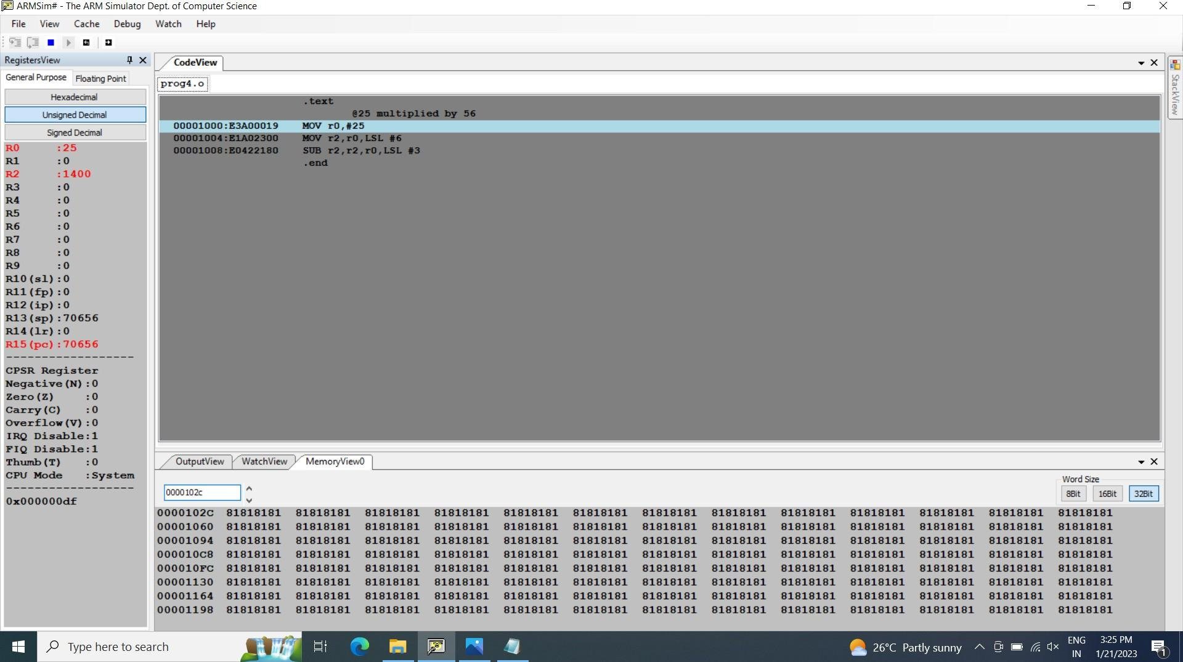

# Disclaimer:

* The programs and output submitted is duly written, verified and executed by me.
* I have not copied from any of my peers nor from the external resource such as internet.
* If found plagiarized, I will abide with the disciplinary action of the University.

Signature:YAMAN

Name:YAMAN

SRN:PES2UG21CS619

Section: J

Date:08/02/2023