**Microprocessor and Computer Architecture**

**UE21CS251B**

**4th Semester, Academic Year 2022-23**

Date:

| Name: Yaman Gupta | SRN:PES2UG21CS619 | Section:J |
| --- | --- | --- |

Week#_____4______ Program Number: ____1__

Title of the Program

**Write an ALP to read from a 2D array such that B=a[i] [j]**

I.ARM Assembly Code

.DATA

A: .WORD 1,2

.WORD 4,5

B: .WORD 0,0

.WORD 0,0

.TEXT

LDR R0,=A

LDR R1,=B

MOV R2,#0

MOV R3,#4

MOV R6,#4

LOOP1: MOV R4,#0

CMP R2,#2

BNE LOOP2

BEQ END

LOOP2: LDR R5,[R0],R3

STR R5,[R1]

ADD R1,R1,R6

CMP R4,#1

ADD R4,R4,#1

BNE LOOP2

ADDEQ R2,R2,#1

BEQ LOOP1

END: SWI 0x011

II. Output Screen Shots (One) 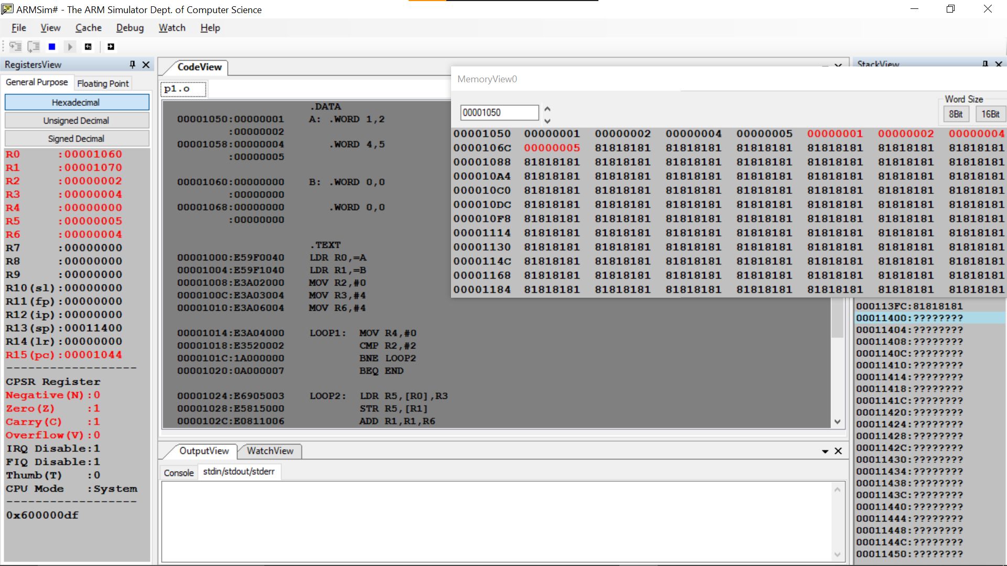**Microprocessor and Computer Architecture**

**UE21CS251B**

**4th Semester, Academic Year 2022-23**

Date:

| Name: Yaman Gupta | SRN:  PES2UG21CS619 | Section:J |
| --- | --- | --- |

Week#_____4______ Program Number: ____2___

Title of the Program

**Write an ALP to implement C[k]=a[i]+b[j]**

I.ARM Assembly Code

.DATA

A: .WORD 1,2,3,36,87

B: .WORD 5,9,8,7,6

C: .WORD 0,0,0,0,0

.TEXT

LDR R0,=A

LDR R1,=B

LDR R2,=C

MOV R3,#4

MOV R8,#1

LOOP: LDR R4,[R0],R3

LDR R5,[R1],R3

ADD R6,R4,R5

STR R6,[R2]

ADD R2,R2,#4

CMP R8,#5

ADD R8,R8,#1

BNE LOOP

SWI 0x011

II. Output Screen Shots (One)

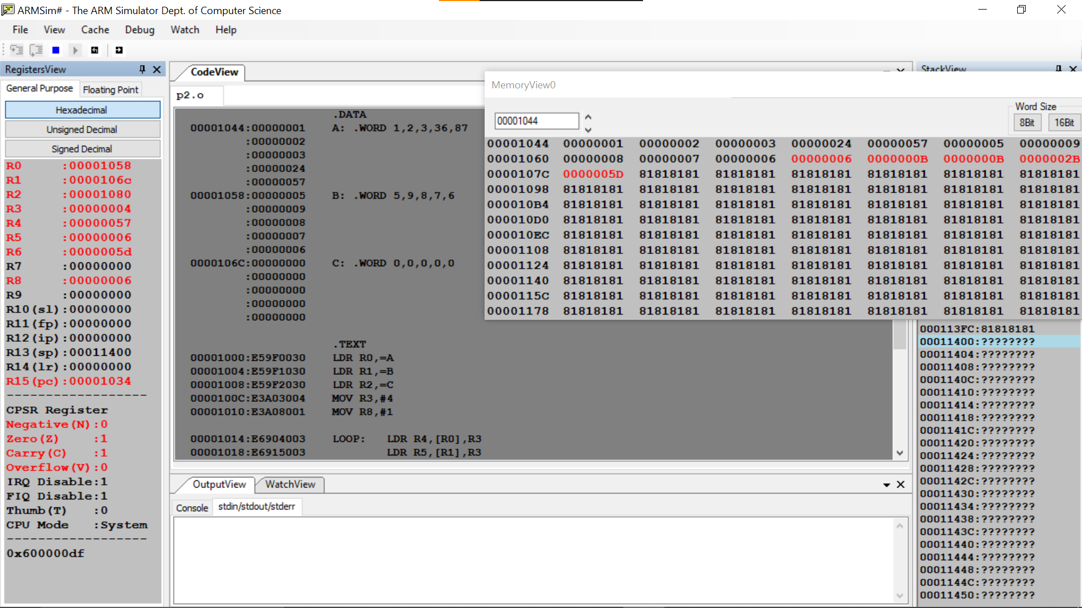

**Microprocessor and Computer Architecture**

**UE21CS251B**

**4th Semester, Academic Year 2022-23**

Date:

| Name: Yaman Gupta | SRN:PES2UG21CS619 | Section:J |
| --- | --- | --- |

Week#_____4______ Program Number: ____3__

Title of the Program

**Write an ALP to implement Sum[i]+=a[i][j]**

I.ARM Assembly Code

.DATA

A: .WORD 1,2,3,4,5

.WORD 2,3,52,3,5

.WORD 294,6,8,3,2

SUM: .WORD 0,0,0

.TEXT

LDR R0,=A

LDR R1,=SUM

MOV R2,#0

MOV R3,#4

MOV R6,#4

MOV R7,#0

LOOP1: MOV R4,#1

CMP R2,#3

BNE LOOP2

BEQ END

LOOP2: LDR R5,[R0],R3

ADD R7,R7,R5

CMP R4,#5

ADD R4,R4,#1

BNE LOOP2

ADDEQ R2,R2,#1

STREQ R7,[R1]

ADDEQ R1,R1,#4

MOVEQ R7,#0

BEQ LOOP1

END: SWI 0x011

II. Output Screen Shot (One)

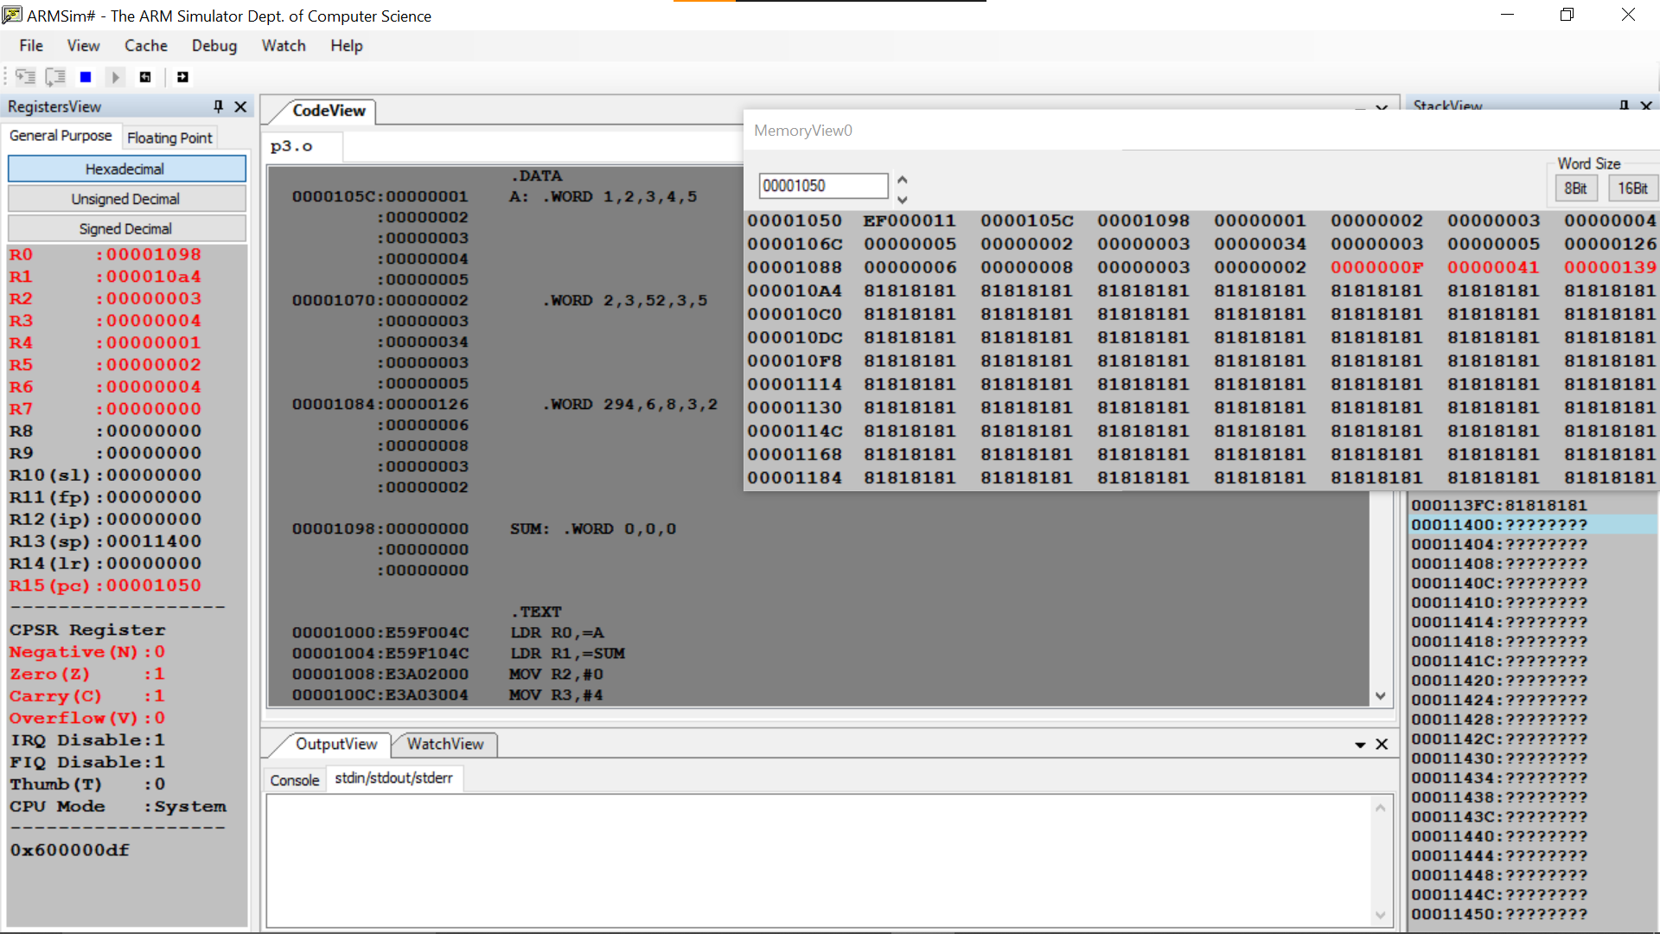

**Microprocessor and Computer Architecture**

**UE21CS251B**

**4th Semester, Academic Year 2022-23**

Date:

| Name: Yaman Gupta | SRN:  PES2UG21CS619 | Section:J |
| --- | --- | --- |

Week#_____4______ Program Number: ____4___

Title of the Program

**Write an ALP to implement c[k] = a[i] * b[j]**

I.ARM Assembly Code

.DATA

A: .WORD 1,2,3,36,87

B: .WORD 5,9,8,7,6

C: .WORD 0,0,0,0,0

.TEXT

LDR R0,=A

LDR R1,=B

LDR R2,=C

MOV R3,#4

MOV R8,#1

LOOP: LDR R4,[R0],R3

LDR R5,[R1],R3

MUL R6,R4,R5

STR R6,[R2]

ADD R2,R2,#4

CMP R8,#5

ADD R8,R8,#1

BNE LOOP

SWI 0x011

II. Output Screen Shot (One)

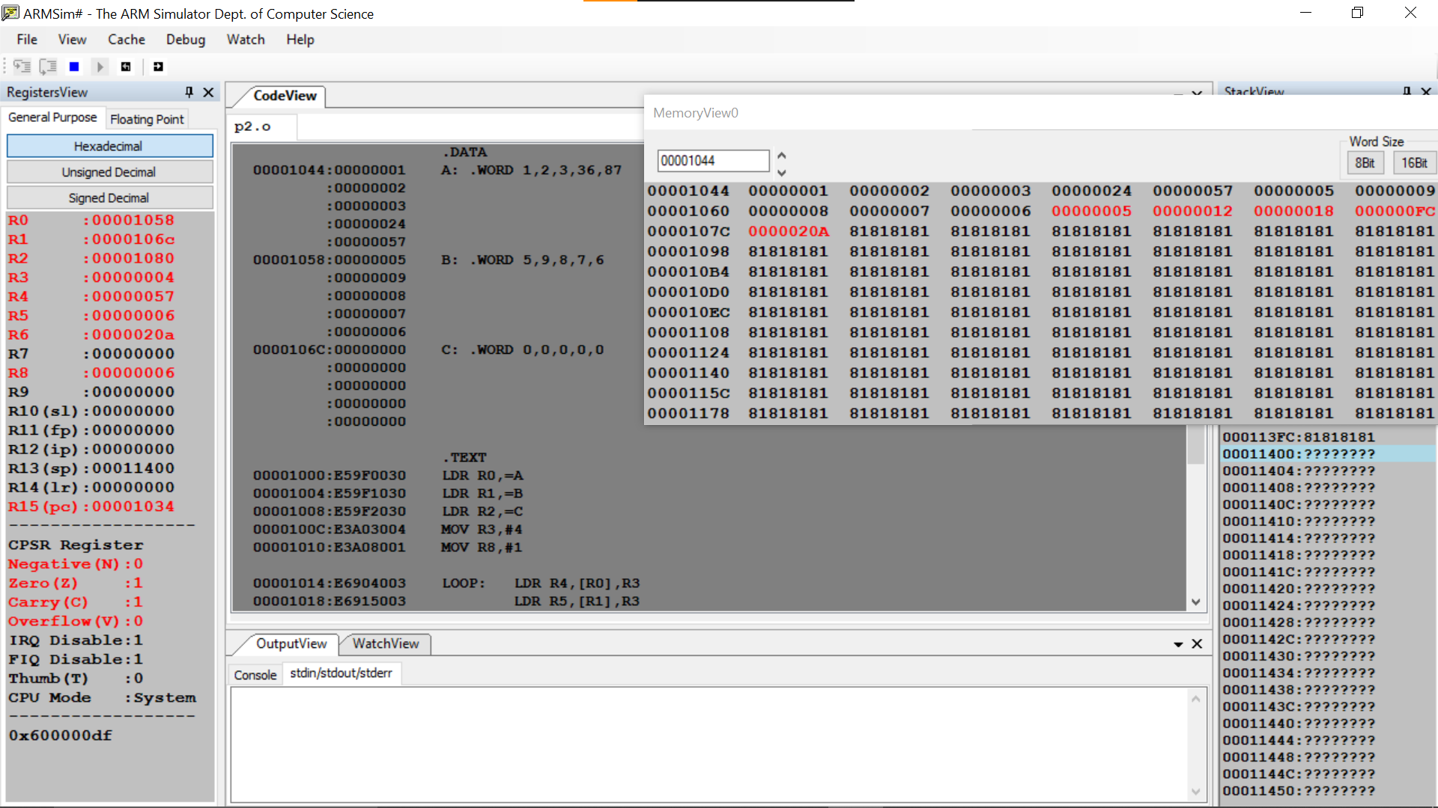

**Microprocessor and Computer Architecture**

**UE21CS251B**

**4th Semester, Academic Year 2022-23**

Date:

| Name:Yaman Gupta | SRN:  PES2UG21CS619 | Section:J |
| --- | --- | --- |

Week#_____4______ Program Number: ____5__

Title of the Program

**Write an ALP to implement C[i][j]=a[i][j]+b[i][j]**

I.ARM Assembly Code

.DATA

A: .WORD 1,2,3,4,5

.WORD 2,3,52,3,5

.WORD 294,6,8,3,2

B: .WORD 2,3,5,2,4

.WORD 4,6,2,654,2

.WORD 2,35,32,35,2

C: .WORD 0,0,0,0,0

.WORD 0,0,0,0,0

.WORD 0,0,0,0,0

.TEXT

LDR R0,=A

LDR R1,=B

LDR R8,=C

MOV R2,#0

MOV R3,#4

MOV R6,#4

LOOP1: MOV R4,#1

CMP R2,#3

BNE LOOP2

BEQ END

LOOP2: LDR R5,[R0],R3

LDR R7,[R1],R3

ADD R9,R5,R7

STR R9,[R8]

ADD R8,R8,#4

CMP R4,#5

ADD R4,R4,#1

ADDEQ R2,R2,#1

BEQ LOOP1

BNE LOOP2

END: SWI 0x011

II. Output Screen Shot (One)

