**Microprocessor and Computer Architecture Laboratory**

**UE19CS256**

**-21**

**4th Semester, Academic Year 2020**

|  | Date: |  |
| --- | --- | --- |
|  |  |  |
| Name: YAMAN | SRN: | Section: |
|  | PES2UG21CS619 | J |
|  |  |
|  |  |  |

Week#____6_______ Program Number: ____1__

**Write an ALP to find the length of a given string**

I. ARM Assembly Code (1).

.data

a:.asciz "Assignment"

.text

ldr r0,=a

mov r1,#0

loop:

ldrb r2,[r0],#1

cmp r2,#0

beq finish

add r1,r1,#1

b loop

finish: swi 0x011

.end

II. Output Screen Shot (One Example of your choice)

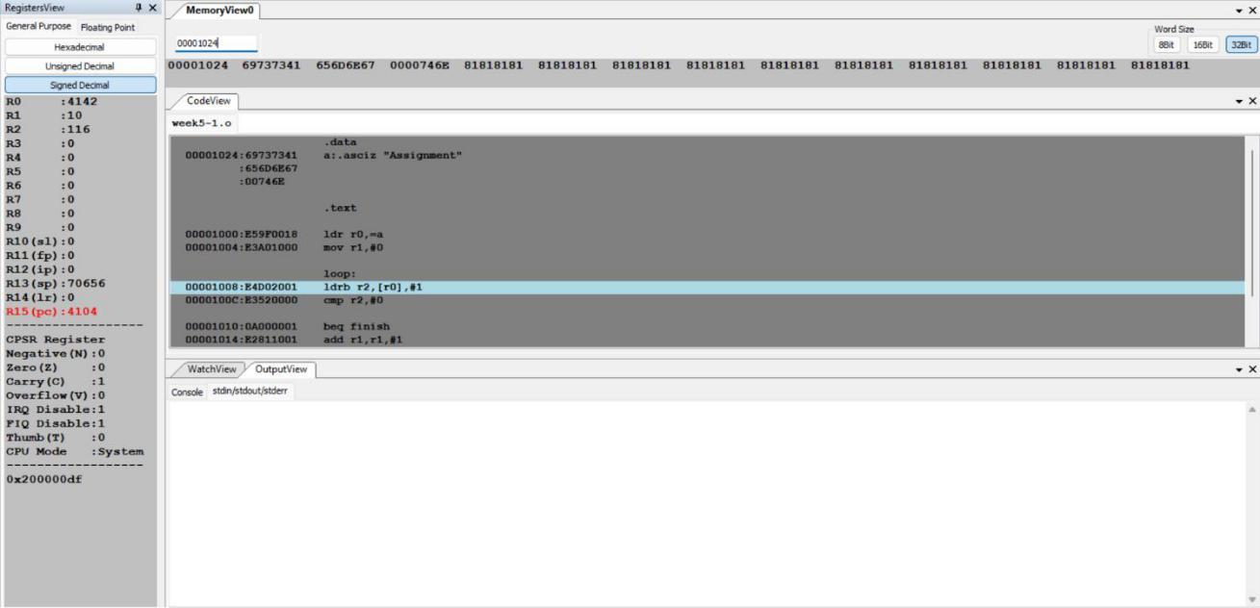

**4th Semester, Academic Year 2020**

**Microprocessor and Computer Architecture Laboratory**

**UE19CS256**

**-21**

Date:



Name: yaman

SRN:

PES2UG21CS619



Section:

j

Week#____6______ Program Number: ____2__

**Write an ALP to copy string from one location to another**

I. ARM Assembly Code (1).

.data

source: .asciz "shrey"

destination: .asciz "oooo"

.text

ldr r1,=source

ldr r0,=destination

copy: ldrb r2,[r1],#1

strb r2,[r0],#1

cmp r2,#0

bne copy

ldr R0,=source

ldr r0,=destination

swi 0x02

swi 0x011

.end

II. Output Screen Shot (One Example of your choice)

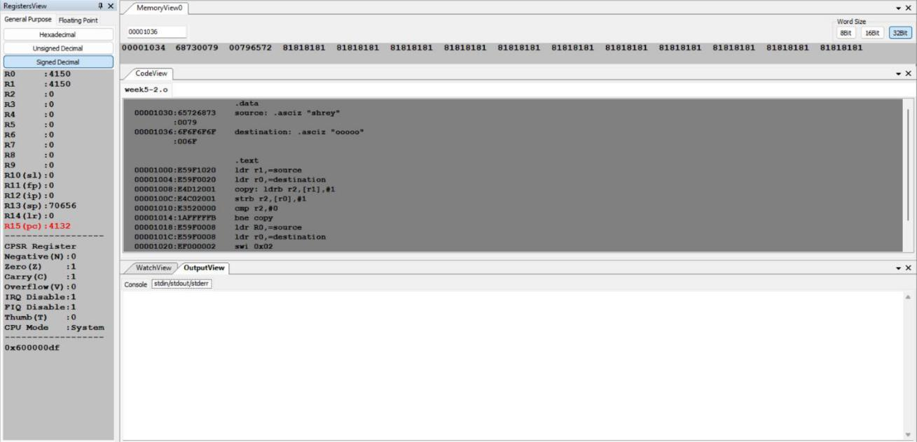

**4th Semester, Academic Year 2020**

|  | Date: |  |
| --- | --- | --- |
|  |  |  |
| Name: yaman | SRN: | Section: |
|  | PES2UG21CS619 | j |
|  |  |  |

Week#____6_______ Program Number: ____3__

**Write an ALP to find whether a given character is present in a string.**

1. ARM Assembly Code (1).

.data

**Microprocessor and Computer Architecture Laboratory**

**UE19CS256**

**-21**

string : .asciz "subjecccttt"

character : .asciz "c"

success : .asciz "Character found"

failure : .asciz "Character not found"

.text

ldr r0,=string

ldr r5,=string

ldr r1, = character

ldr r6,= character

ldrb r3,[r1]

ldrb r7,[r6]

mov r8,#0

l1: ldrb r2,[r0],#1

cmp r3,r2

beq found

cmp r2,#0

bne l1

b notFound

found: ldr r0,=success

swi 0x02

1. loop swi 0x011

notFound : ldr r0,= failure swi 0x02

b loop swi 0x011

loop: ldrb r4,[r5],#1

cmp r4,#0

beq exit

cmp r4,r7

bne loop

add r8,r8,#1

1. loop exit:swi 0x011
   1. Output Screen Shot -2 (One Example of your choice)

**Microprocessor and Computer Architecture Laboratory**

**UE19CS256**

**-21**

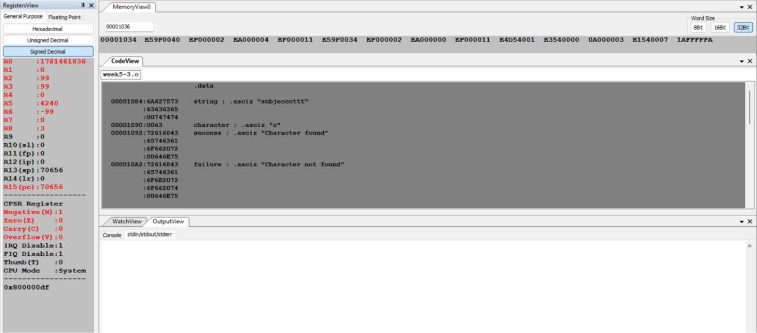

**Disclaimer:**

* The programs and output submitted is duly written, verified and executed by me.
* I have not copied from any of my peers nor from the external resource such as internet.
* If found plagiarized, I will abide with the disciplinary action of the University.

Name: yaman

SRN: PES2UG21CS619

Section: j

Date: 03-03-2023