SYMBIOTE
Authentication API Specification
Login + OTP + Token Refresh (QA)
Environment: QA | Base URL: https://api-qa.symbiotes.co.uk/api/v1
Prepared for: QA / API Testing / Frontend Integration
Scope covered in this document: login, OTP dispatch, OTP verification, access token, refresh token, cookie behavior, org/branch context resolution, seeded test accounts, negative test cases, and current known gaps.
Current implementation note: the UI shows EMAIL and PHONE/SMS selection, but the backend currently supports EMAIL OTP only. Any SMS selection will be rejected with a 400 response until SMS configuration is completed.

1. Executive Summary
Symbiote authentication uses a password-first, OTP-second login flow. A valid email/password pair does not immediately create a usable session. Instead, it creates a loginAttempt record and requires OTP verification before access and refresh tokens are issued.
Once OTP is verified, the system resolves organization and branch context, creates a session row, signs a short-lived JWT access token, generates an opaque refresh token, and returns both to the client. The refresh token is also written to an HTTP-only cookie on verify-otp and refresh.
Step 1 | Step 2 | Step 3 | Step 4 | Step 5
POST /auth/login | POST /auth/send-otp | POST /auth/verify-otp | Session created | Use access token / refresh token

Observed response envelope note
Based on the provided Postman screenshots, the API is wrapped by a global success/error response envelope containing success, statusCode, message, data, and meta. The examples in this document follow that observed behavior.
Observed implementation nuance: Postman screenshots show HTTP 201 Created on POST requests while the response body contains statusCode: 200. QA should record both the actual transport status and the JSON body statusCode during validation.

2. Plan / Subscription Model and Context Resolution
The current seeded dataset contains three subscription tiers. Authentication itself is not restricted by plan during login, but plan structure influences how org and branch context are resolved after OTP verification.
Plan | Code | Branch Model | Auth Context Notes
Tier 1 | BASIC | Single default branch | OWNER logs in at org level with branchId = null. MEMBER must resolve to an active branch membership in the default branch.
Tier 2 | GROWTH | Single default branch | Same branch model as Tier 1, but richer org structure. MEMBER users still require active branch membership.
Tier 3 | PRO | Multiple branches allowed | Org may contain multiple active branches. OWNER still gets org-level context. MEMBER resolves to first active branch membership by createdAt.

Context resolution rules
• An account may have defaultOrgId. If that organization membership is ACTIVE and the organization itself is ACTIVE, it is chosen first.
• If defaultOrgId does not resolve to a valid active membership, the first ACTIVE orgUser membership ordered by createdAt is used.
• If no active org membership exists, login verification fails with 403 Forbidden and message "No organization access."
• For orgRole = OWNER, the issued access token is org-scoped and branchId is null.
• For orgRole = MEMBER, the system must find an ACTIVE branchUser record under an ACTIVE branch; otherwise verification fails with 403 Forbidden and message "No branch access."

3. Endpoint Catalog
Method | Path | Purpose | Auth | Typical Output
POST | /auth/login | Validate email/password and create loginAttempt | Public | loginAttemptId + available methods
POST | /auth/send-otp | Generate and store OTP for a loginAttempt | Public | delivery channel + OTP TTL
POST | /auth/verify-otp | Verify OTP, resolve org/branch, create session, issue tokens | Public | accessToken + refreshToken
POST | /auth/refresh | Validate refresh token, rotate it, issue new access token | Public (token-based) | new accessToken + rotated refreshToken

4. Detailed API Specification

4.1 POST /auth/login
Purpose: validate the email/password pair and create a loginAttempt. No session and no tokens are issued at this stage.
Field | Type | Required | Notes / Validation
email | string | Yes | Must pass @IsEmail(). Value is trimmed and lowercased before lookup.
password | string | Yes | Must pass @IsString() and @MinLength(1).

Sample request
POST /api/v1/auth/login
Content-Type: application/json
{
"email": "t3.owner@demo.com",
"password": "Password@1"
}

Successful response
{
"success": true,
"statusCode": 200,
"message": "OTP required.",
"data": {
"loginAttemptId": "e83dd661-fb5b-482d-ab0c-2bb0cadce265",
"methods": [
{
"type": "EMAIL",
"masked": "t3.***@demo.com"
}
],
"expiresInSeconds": 300
},
"meta": {
"timestamp": "2026-01-21T05:38:30.011Z",
"path": "/api/v1/auth/login",
"requestId": "..."
}
}
• Account lookup is by email only.
• Account must exist, be ACTIVE, and have passwordHash populated.
• Password verification uses argon2.verify().
• Invalid email, inactive account, missing passwordHash, or wrong password all collapse to the same user-facing error: "Incorrect email or password."
• The methods array currently returns EMAIL only from backend logic.

Known frontend/backend mismatch
The provided login screen shows both email and phone options for OTP delivery. However, this implementation currently returns only EMAIL from /auth/login and only EMAIL is accepted by /auth/send-otp.

4.2 POST /auth/send-otp
Purpose: generate an OTP for an existing loginAttempt and store the hashed OTP details.
Field | Type | Required | Notes / Validation
loginAttemptId | string | Yes | Must be non-empty string and refer to an existing loginAttempt.
method | enum | Yes | Allowed DTO values: EMAIL or SMS. Current backend support: EMAIL only.

Sample request
POST /api/v1/auth/send-otp
Content-Type: application/json
{
"loginAttemptId": "e83dd661-fb5b-482d-ab0c-2bb0cadce265",
"method": "EMAIL"
}

Successful response
{
"success": true,
"statusCode": 200,
"message": "OTP generated.",
"data": {
"delivery": {
"type": "EMAIL",
"masked": "t3.***@demo.com"
},
"expiresInSeconds": 300
}
}

Behavior
• If method is omitted in service layer it defaults to EMAIL, but the controller DTO currently marks method as required; QA should send it explicitly.
• If method is anything other than EMAIL, API returns 400 with message "Only EMAIL is supported for now."
• OTP is hashed using HMAC-SHA256 over "salt:otp" with server-side pepper.
• OTP salt is random 16 bytes converted to hex.
• loginAttempt is updated with method = EMAIL, otpSalt, otpHash, otpExpiresAt, and status = OTP_SENT.
• In development configuration the OTP resolves to authConfig.devFixedOtp() or falls back to 111111.

Current implementation limitation
If request body is:
{
"loginAttemptId": "...",
"method": "SMS"
}
Expected result:
400 Bad Request
message: "Only EMAIL is supported for now."

4.3 POST /auth/verify-otp
Purpose: validate OTP, mark loginAttempt as VERIFIED, resolve org + branch context, create session, issue access token and refresh token.
Field | Type | Required | Notes / Validation
loginAttemptId | string | Yes | Must be non-empty and reference an existing loginAttempt.
otp | string | Yes | Must be exactly 6 characters by @Length(6, 6).

Sample request
POST /api/v1/auth/verify-otp
Content-Type: application/json
{
"loginAttemptId": "e83dd661-fb5b-482d-ab0c-2bb0cadce265",
"otp": "111111"
}

Successful response
{
"success": true,
"statusCode": 200,
"message": "Login successful.",
"data": {
"accessToken": "<JWT access token>",
"tokenType": "Bearer",
"expiresInSeconds": 600,
"refreshToken": "<opaque refresh token>",
"account": {
"id": "<accountId>",
"platformRole": "USER"
},
"org": {
"id": "<organizationId>",
"orgUserId": "<orgUserId>",
"orgRole": "OWNER"
},
"branch": {
"id": null,
"branchUserId": null,
"branchRole": null
},
"mfaSatisfied": true
}
}

Verification checks
• loginAttempt must exist.
• loginAttempt must not already be VERIFIED; otherwise 400 "OTP already used. Please login again."
• Account tied to loginAttempt must still be ACTIVE.
• OTP fields must have been generated first; otherwise 400 "OTP not generated yet."
• otpExpiresAt must be in the future; otherwise 400 "OTP expired. Please login again."
• Submitted OTP is hashed with stored salt + configured pepper and compared to stored otpHash.
• Mismatch returns 401 Unauthorized with message "Invalid OTP."

Cookie behavior on success
• The refresh token returned in response data is also set into an HTTP-only cookie named refresh_token.
• Cookie path is restricted to /api/v1/auth/refresh.
• sameSite = none in production; lax otherwise.
• secure = true in production because sameSite none requires secure cookies.

4.4 POST /auth/refresh
Purpose: validate the refresh token, re-check account / org / branch validity, rotate the refresh token, and issue a new access token.
Field | Type | Required | Notes / Validation
refreshToken | string | Optional | Can be sent in JSON body if cookie is unavailable. The controller first checks cookie, then body.

Token sources checked in this order
• Cookie: refresh_token
• JSON body: refreshToken
• If neither exists, service treats it as invalid / missing.

Sample request
POST /api/v1/auth/refresh
Content-Type: application/json
{
"refreshToken": "<opaque refresh token>"
}

Successful response
{
"message": "Token refreshed.",
"data": {
"accessToken": "<new JWT access token>",
"tokenType": "Bearer",
"expiresInSeconds": 600,
"refreshToken": "<rotated opaque refresh token>"
}
}

Refresh validation rules
• Refresh token must parse into tokenId.secret format.
• session must exist by refreshTokenId.
• session must not be revoked.
• session must not be expired.
• Provided refresh token must match stored argon2 hash.
• If hash verification fails, session is immediately revoked as replay/theft protection.
• Account must still be ACTIVE.
• Organization membership must still be ACTIVE and the organization itself must still be ACTIVE.
• If session.branchId is present, matching branchUser membership must still be ACTIVE under an ACTIVE branch.
• If session.branchId is null while org role resolves to MEMBER, refresh is treated as invalid and session is revoked.

5. Token and Session Model

5.1 Access token (JWT)
Access tokens are short-lived JWTs signed with JWT_ACCESS_SECRET. The payload structure is:
{
"sub": "<accountId>",
"sid": "<sessionId>",
"orgId": "<organizationId>",
"branchId": "<branchId|null>",
"orgUserId": "<orgUserId>",
"orgRole": "OWNER | MEMBER",
"branchUserId": "<branchUserId|optional>",
"branchRole": "SUPERVISOR | EMPLOYEE | null",
"platformRole": "ADMIN | USER",
"mfa": true | false
}
• sub = accountId
• sid = session table id
• orgId and orgUserId define tenant/membership scope
• branchId may be null for org-level OWNER context
• mfa is true on verify-otp and false on refresh in the current implementation

5.2 Refresh token (opaque)
Refresh tokens are not JWTs. They are opaque strings formatted as tokenId.secret and stored only as an argon2 hash in the session table.
Example shape:
<uuid>.<base64url-random-secret>
• parseRefreshTokenId() extracts the tokenId by splitting on the first dot.
• A malformed token that does not contain a sufficiently long tokenId is treated as invalid.
• Refresh tokens are rotated on every successful refresh.

5.3 Session record
• A session row is created only after successful OTP verification.
• Stored fields include accountId, organizationId, branchId, refreshTokenId, refreshTokenHash, expiresAt, and lastUsedAt.
• Revoked or expired sessions block access token usage through JwtStrategy validation.

6. Authorization / Guard Behavior
Protected APIs use JwtStrategy + JwtAuthGuard. The access token is read from the Authorization header as a Bearer token.
Authorization: Bearer <accessToken>

JwtStrategy validation sequence
• Load session by payload.sid.
• Ensure session exists, belongs to payload.sub, is not revoked, and is not expired.
• Load account and ensure account status is ACTIVE.
• If orgId + orgUserId exist, load orgUser membership and ensure membership + organization are ACTIVE.
• Populate request context with accountId, sessionId, organizationId, branchId, orgUserId, branchUserId, orgRole, branchRole, platformRole, and mfaSatisfied.

JwtAuthGuard error mapping
• Expired JWT -> AUTH_TOKEN_EXPIRED
• Malformed / invalid JWT -> AUTH_TOKEN_INVALID
• Missing Authorization header / missing token -> AUTH_TOKEN_MISSING
• Response body message for guard failures is standardized as "Authentication required."

7. Seeded QA Test Credentials
All seeded demo accounts use the same password:
Password@1
Plan / Group | Email | Platform Role | Org Role | Expected Auth Context
Platform | admin@platform.com | ADMIN | N/A | Platform admin account; no seeded org context in this seed section
Tier 1 | t1.owner@demo.com | USER | OWNER | Org-level token; branchId null
Tier 1 | t1.emp1@demo.com | USER | MEMBER | Default/single branch membership required
Tier 1 | t1.emp2@demo.com | USER | MEMBER | Default/single branch membership required
Tier 2 | t2.owner@demo.com | USER | OWNER | Org-level token; branchId null
Tier 2 | t2.supervisor@demo.com | USER | MEMBER | Branch-scoped token in single/default branch
Tier 2 | t2.emp1@demo.com | USER | MEMBER | Branch-scoped token in single/default branch
Tier 2 | t2.emp2@demo.com | USER | MEMBER | Branch-scoped token in single/default branch
Tier 3 | t3.owner@demo.com | USER | OWNER | Org-level token; branchId null
Tier 3 | t3.supervisor@demo.com | USER | MEMBER | Branch-scoped token in branch-1
Tier 3 | t3.emp1@demo.com | USER | MEMBER | Branch-scoped token in branch-1
Tier 3 | t3.emp2@demo.com | USER | MEMBER | Branch-scoped token in branch-2

8. QA Test Matrix
# | Scenario | Expected Result | Notes
1 | Valid login with seeded email/password | Success | Returns loginAttemptId and methods[EMAIL]
2 | Login with uppercase/spaced email | Success if credentials otherwise valid | Email is trimmed and lowercased before lookup
3 | Wrong password | 401 | Incorrect email or password.
4 | Unknown email | 401 | Incorrect email or password.
5 | send-otp with valid loginAttemptId and EMAIL | Success | Returns masked email and OTP TTL
6 | send-otp with SMS | 400 | Only EMAIL is supported for now.
7 | verify-otp with 111111 after send-otp | Success | Returns accessToken + refreshToken + cookie
8 | verify-otp before send-otp | 400 | OTP not generated yet.
9 | verify-otp with wrong OTP | 401 | Invalid OTP.
10 | verify-otp twice on same loginAttempt | 400 | OTP already used. Please login again.
11 | refresh using response body refreshToken | Success | Returns rotated refresh token
12 | refresh using cookie only | Success | Controller reads cookie first
13 | refresh with malformed token | 401 | Authentication required. / AUTH_REFRESH_INVALID
14 | access protected route with expired/invalid JWT | 401 | Guard returns Authentication required. with specific auth key
15 | Tier 3 member login | Success | branchId should resolve to active branch membership

9. Known Gaps / Current Non-Final Areas
• SMS / phone OTP is not finished yet. The DTO allows SMS, and the UI mockup shows it, but the service explicitly rejects non-EMAIL methods.
• Forgot-password UI screens were provided, but no forgot-password controller/service code was included in the supplied implementation set. Those screens are therefore out of scope for this specific API contract.
• Transport HTTP status and JSON body statusCode appear inconsistent in screenshots (201 vs body 200). This should be tracked as a QA observation and aligned later if required.
• The service method has a default OTP fallback of 111111 in development-style flows. That is suitable for QA/dev only and must not remain in production behavior.
• refreshCookie path is narrowly scoped to /api/v1/auth/refresh, so the refresh cookie will not be sent to unrelated endpoints.

10. Recommended Test Run Order
• POST /auth/login with a seeded account such as t3.owner@demo.com / Password@1
• Capture loginAttemptId from response data
• POST /auth/send-otp with method = EMAIL
• POST /auth/verify-otp using otp = 111111 in QA/dev flow
• Persist accessToken for protected-route testing
• Persist refreshToken or let Postman/browser store refresh_token cookie
• POST /auth/refresh and confirm refresh token rotation
• Repeat with Tier 1 owner, Tier 2 supervisor, and Tier 3 employee to validate org vs branch-scoped outcomes

Appendix A – Example Postman Payloads

Login
{
"email": "t3.owner@demo.com",
"password": "Password@1"
}

Send OTP
{
"loginAttemptId": "<loginAttemptId>",
"method": "EMAIL"
}

Verify OTP
{
"loginAttemptId": "<loginAttemptId>",
"otp": "111111"
}

Refresh
{
"refreshToken": "<refreshToken>"
}

Appendix B – Screens Provided for UI/API Traceability
The screenshots supplied with this task show the local Postman login/send-otp/verify-otp flow, the OTP already used error state, and frontend screens that currently expose both email and phone options plus forgot-password screens. These images were used as reference for documenting current behavior and mismatches.
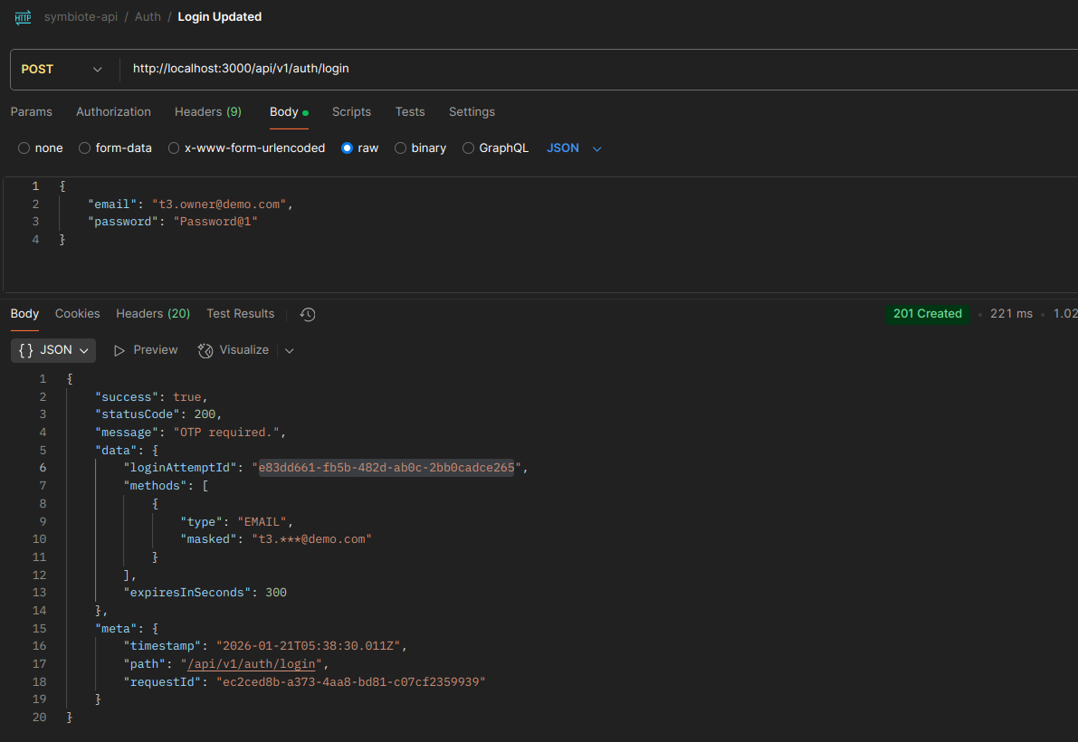
login1.png
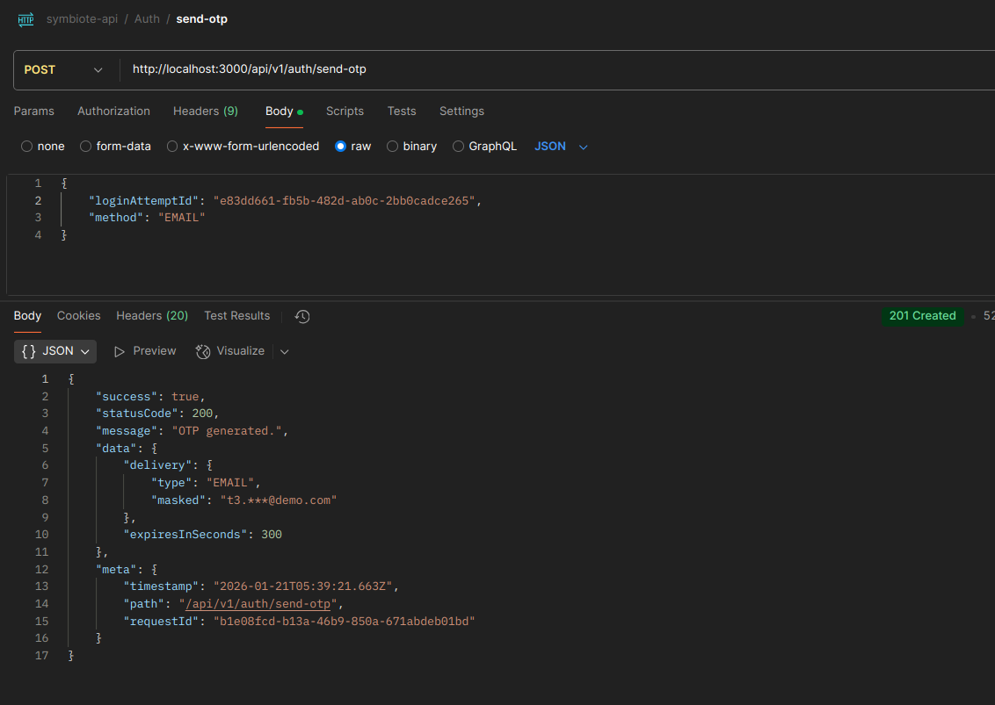
login2.png
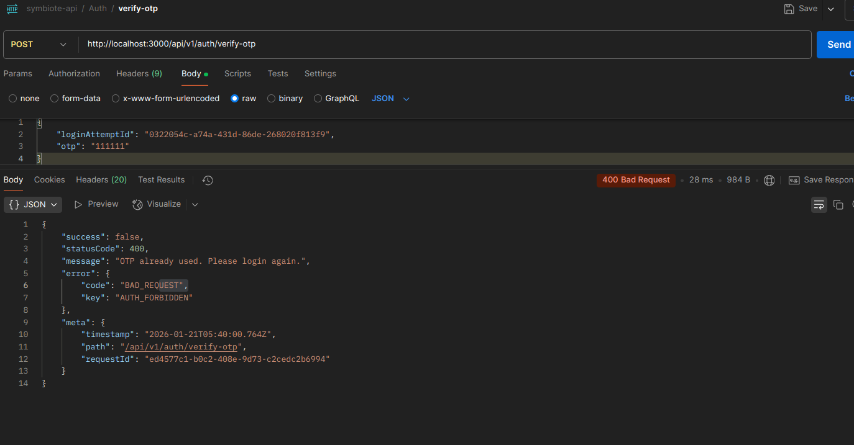
login3-otpused.png

