Buthelezi Nokwanda

Your Smart AI Chatbot - Project Documentation

# 1. Introduction

Your Smart AI Chatbot is an educational chatbot built using the no-code platform Botpress. It is designed to teach foundational AI concepts to beginners through interactive dialogue, Q&A sessions, and multimedia support. The goal is to provide a self-paced, engaging learning experience for users who want to understand AI, machine learning, NLP, and ethical considerations in AI.

# 2. Features

* ✅ No-code implementation using Botpress Studio
* ✅ 15 curated Q&A pairs on core AI concepts
* ✅ Two structured conversation flows (NLP and AI Ethics)
* ✅ Multimedia support for visual learning (e.g., diagrams)
* ✅ Intelligent follow-up handling for user questions
* ✅ Learning recommendations for further study
* ✅ Citations from trusted bootcamp materials
* ✅ Cross-linking between related concepts

**Chatbot Welcome Screen**  
This is the landing page where users start interacting with the Smart AI Chatbot.

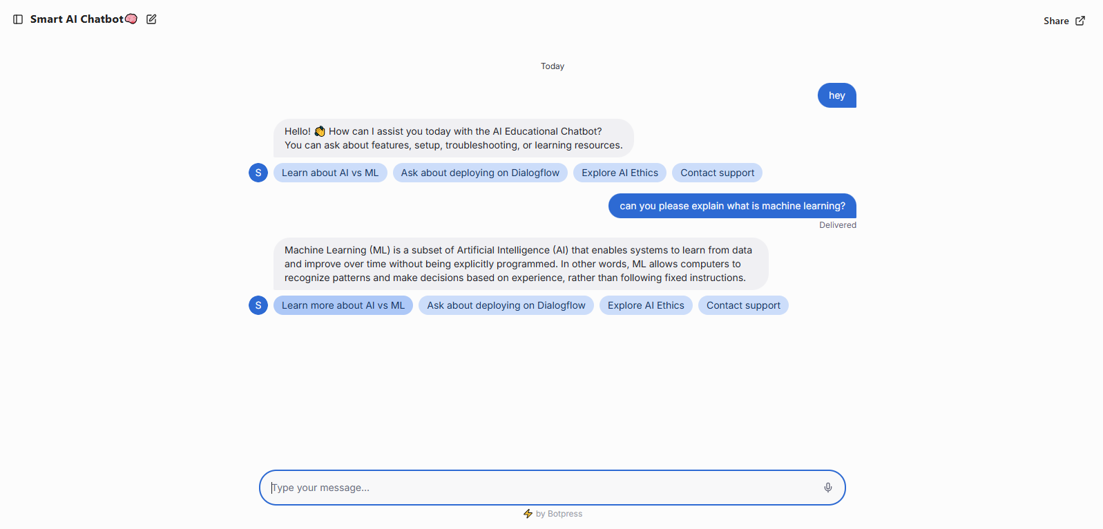

This screenshot **demonstrates the chatbot in action**, giving an educational response and offering **follow-up options** for deeper learning.

# 3. Knowledge Base (Sample Q&A)

# Your Smart AI Chatbot - 15 AI Concept Q&A Pairs

# 1. Q: What is Artificial Intelligence (AI)? A: AI is the simulation of human intelligence in machines that are designed to think, learn, and make decisions.

# 2. Q: What is Machine Learning (ML)? A: ML is a subset of AI that allows systems to learn from data and improve their performance without being explicitly programmed.

# 3. Q: What is Deep Learning? A: Deep Learning is a type of machine learning that uses neural networks with many layers to analyse complex patterns in data.

# 4. Q: What is a Neural Network? A: A neural network is a set of algorithms modeled after the human brain that is used in machine learning to recognize patterns.

# 5. Q: What is Natural Language Processing (NLP)? A: NLP is the field of AI that focuses on enabling computers to understand, interpret, and generate human language.

# 6. Q: What is Computer Vision? A: Computer vision enables machines to interpret and make decisions based on visual input like images or videos.

# 7. Q: What is Supervised Learning? A: Supervised learning is a machine learning method where the model is trained on labeled data.

# 8. Q: What is Unsupervised Learning? A: Unsupervised learning is where the model learns from data without labeled outputs, discovering hidden patterns or structures.

# 9. Q: What is Reinforcement Learning? A: It's a type of learning where an AI agent learns to make decisions by receiving rewards or penalties for its actions.

# 10. Q: What is Bias in AI? A: Bias in AI occurs when the data or algorithms produce unfair outcomes, often reflecting social or historical inequalities.

# 11. Q: What is Algorithmic Bias? A: This refers to bias that arises when an AI system makes discriminatory or prejudiced decisions due to biased data or logic.

# 12. Q: What is the Turing Test? A: The Turing Test evaluates a machine’s ability to exhibit human-like intelligence through conversation.

# 13. Q: What are the main ethical issues in AI? A: Ethical concerns include bias, privacy violations, job displacement, accountability, and misuse of AI technologies.

# 14. Q: What is Explainable AI (XAI)? A: XAI refers to AI systems designed to explain their decisions in a way humans can understand.

# 15. Q: What are real-world applications of AI? A: AI is used in healthcare, finance, self-driving cars, customer service (chatbots), facial recognition, and more.

# 4. Conversation Flows

Flow 1: Learn About NLP

- User chooses 'Learn About NLP'  
- Bot explains NLP and real-world examples  
- Bot answers related follow-up questions  
- Bot suggests: Module 3 – Introduction to NLP

Flow 2: Explore AI Ethics

- User chooses 'Explore AI Ethics'  
- Bot defines AI ethics and algorithmic bias  
- Bot handles further questions  
- Bot suggests reading: Ethics in AI by Dr. Smith

# 5. Multimedia Elements

Visuals used in the bot include:  
- Neural Network architecture diagram  
- AI vs ML vs Deep Learning (Venn Diagram)

# 6. Further Learning Suggestions

Suggested modules for learners to explore:  
- Module 3: Introduction to NLP  
- Module 5: Real-world AI Case Studies

# 7. Citations & References

- Module 2: AI Fundamentals  
- Reading: “Ethics in AI” by Dr. Smith

# 8. Botpress Deployment Instructions

* 🔹 Go to https://studio.botpress.com and log in
* 🔹 Create a new bot and name it 'Your Smart AI Chatbot'
* 🔹 Add main and subflows (e.g., Flow_NLP, Flow_Ethics)
* 🔹 Use Capture, Send Message, and Send Image blocks
* 🔹 Test the bot using the Botpress Emulator
* 🔹 Publish and share the public link

# 9. Project Outcomes

* ✅ Simplifies AI learning for beginners
* ✅ Offers an interactive and engaging learning experience
* ✅ Encourages deeper exploration with follow-up content
* ✅ Accessible across devices and platforms

# 10. Future Improvements

* 🔧 Add voice interaction or speech-to-text
* 🔧 Include quiz or assessment mode
* 🔧 Connect with external APIs for dynamic content
* 🔧 Enable chatbot analytics to track learner progress