**Chair Tips**

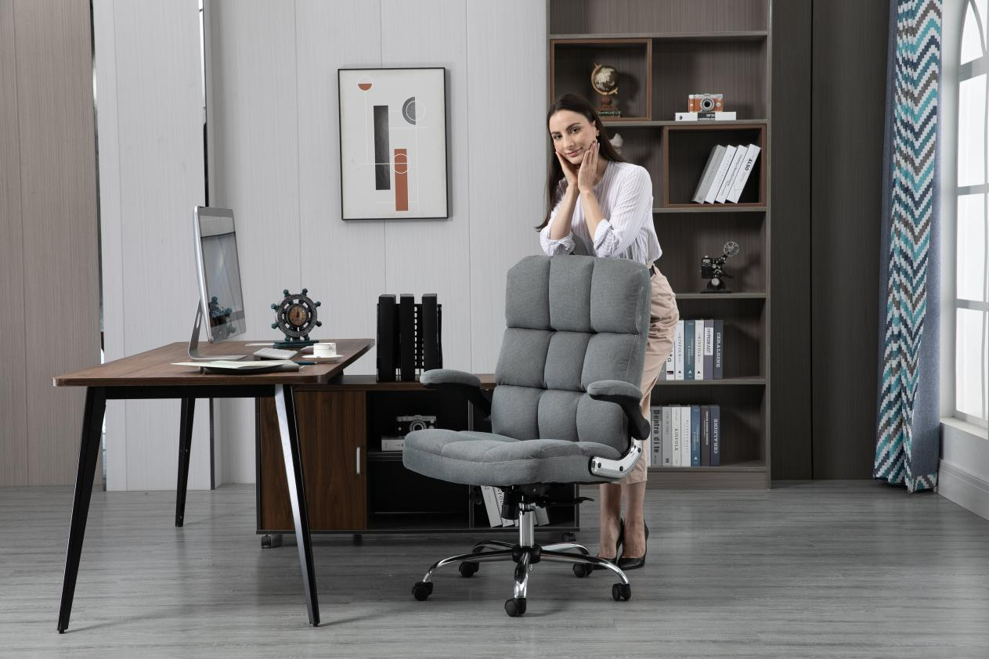

For office workers, sitting for a long time is very harmful to the body and may cause various health problems. Although everyone knows this problem, everyone is still helpless. After all, they have to earn money . Since sitting for a long time cannot be avoided, then choose a better [office chair](https://yamasoro.co/) to make sitting for a long time less painful.

If you want to sit comfortably, in fact, I strongly recommend that you try an [ergonomic desk chair](https://yamasoro.co/products/yamasoro-velvet-ergonomic-office-chair-3288), as many people may already know it.

When you looking for an ergonomic office chair:

1. First, Look at the headrest.

Generally, ergonomic chairs have a headrest, because it is convenient for us to take a nap. Companies generally have time for employees to take a break at noon, so as to ensure their work energy in the afternoon. If you don’t have a headrest, which means you’re sitting on a normal mesh chair or [executive leather office chair](https://yamasoro.co/products/yamasoro-high-back-executive-office-chair-3286), you can only sleep on your stomach, sleeping on your stomach will not only affect the respiratory system, but also affect the contours of the face, especially for some girls who have put on makeup, they can only endure not sleeping, otherwise...So, the benefits of having a headrest are here. A good nap at noon will make you more energetic in the afternoon.

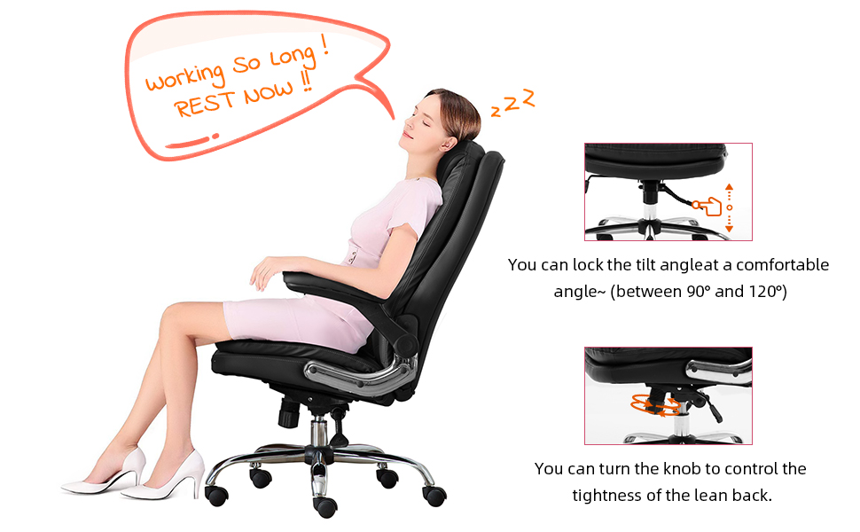

1. Second, look at the cushion.

The general cushions are sponge cushions, but in recent years the material of cushions has been developed to mesh, because the sponges can be very stuffy when sitting, especially in summer. If the cushion is made of mesh, the air permeability will be much better. In winter, you may add a cushion according to your personal needs.

1. Third, look at the backrest.

Because a person’s back cannot be straight, the correct sitting posture should be curved, and the backrest is S-shaped, which can give the waist a support, so that sitting for a long time will not be very tired.

1. Fourth, look at the handrails.

All ergonomic chairs have armrests, but some armrests can be raised and lowered or adjusted in other ways, and some cannot. When you put your hand on the armrest, see if it feels comfortable.

5. Look at the barometric pressure bar.

The quality of the air pressure rod should be very important, and it must have safety certification. Because [office chair](https://yamasoro.co/) explosions have occurred before, most of them are because the quality of the air pressure bar is not good enough . Although security certification will not guarantee it is not going to explode, I personally attach great importance to the issue of security.