**How to clean the mesh [office chair](https://yamasoro.co/)?**

Method 1:

1. Firstly, use a feather duster to clean up the dust.

2. Put a little detergent in clean water, put the rag into the water, and wring it dry.

3. Scrub the chair several times with a rag.

4. Gently scrub with a soft brush, and then wait for it drys naturally.

1. To dry quickly, you can also consider using a hair dryer, but don't blow it for too long.



Method 2:

1. Firstly, use a vacuum cleaner to fully absorb dust. If you don’t have a vacuum cleaner, use a feather duster to clean up the dust in order to remove the dust as a whole.

2. Dilute the detergent, or pour it into the water tank, and then spray the detergent on the [computer chair](https://yamasoro.co/products/yamasoro-executive-office-chair-3286).

3. Let the cleaner stay on the computer chair for a while to let the stains get rid of the fibers.

1. Pump and wash with a high-temperature cleaning machine, and then dry it with a dryer. If you don't have these electrical equipment, use a soft brush to gently scrub, and then wait for it drys naturally.

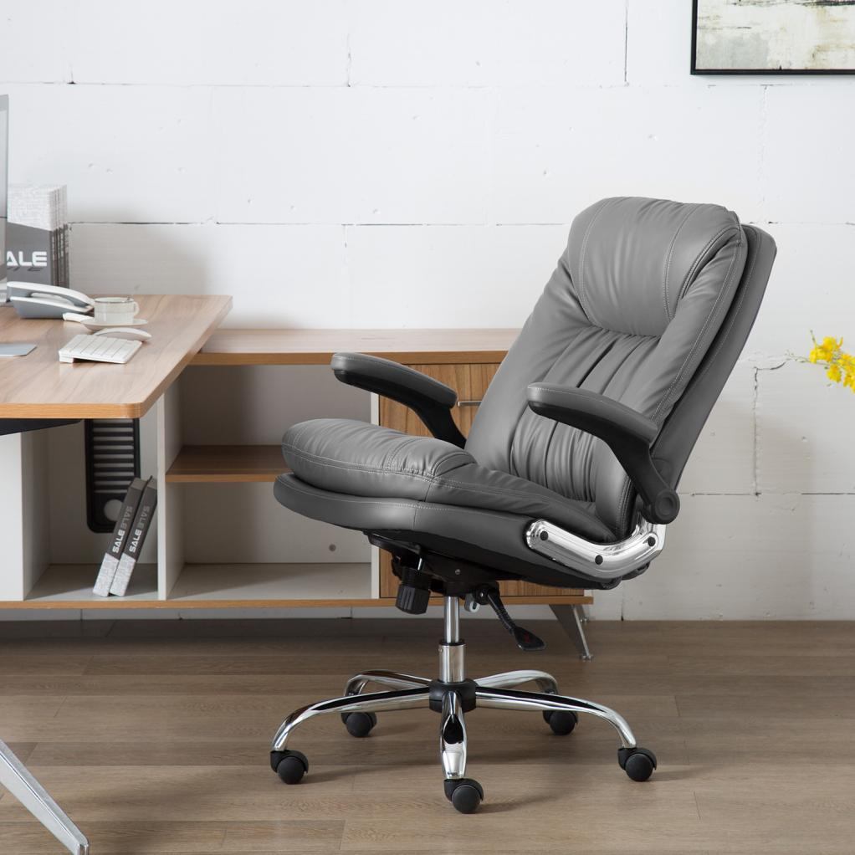

**How to choose an office chair?**

1. Comfortable headrest

Most of the mesh chairs do not have a headrest. People would habitually not rely on a headrest when working because they don't think it is necessary. In fact, in order to reduce the incidence of neck diseases, it is still necessary to pay attention to the position of the neck and maintain a comfortable posture. Choosing the right headrest could also reduce your fatigue.

1. Choose the waterfall-shaped cushion

The waterfall-shaped cushion is to avoid the right angle on the thigh root nerves and blood flow, this is how [ergonomic office chair](https://yamasoro.co/products/yamasoro-executive-office-chair-3286) shaped like. Therefore, another assessment point for ergonomic chair is whether there is a waterfall-like curvature at the front end of the seat cushion to satisfy the natural relaxation state of the thighs. The height of one palm between the root of the thigh and the cushion is required to be suitable.

1. Choose S (fitting to the spine) shape

To meet the standard sitting posture, at least one chair back is needed to support the waist. Normal people’s spine has 3 physical curves. They are not in a straight line. The neck and lumbar vertebrae are convex forward, and the thoracic vertebrae are convex backward. Therefore, if you want to meet comfort in a standard sitting posture, the back of the chair must have at least 3 support points. . The waist part needs support, but everyone's height is different, so it is necessary to be able to adjust it.