The way to fix a broken chair.

[](https://yamasoro.co/products/yamasoro-high-back-executive-office-chair-3286)

The use of the [office desk chair](https://yamasoro.co/) has not only appeared in the office, but also very common in the family. It has brought us great convenience and comfort, but there will often be problems, so how to maintain swivel chair?

Office chair repair method

1. The problem of the office chair in the use process is mainly due to the functional shortcomings or lack of various accessories. So we must know the details of the [executive leather office chair](https://yamasoro.co/products/yamasoro-high-back-executive-office-chair-3286) accessories. Generally speaking, the swivel chair accessories include backrest, soft cushion, casters, five-star feet, With the function of the chassis and the air rod, these kinds of accessories can cooperate with each other to allow us to enjoy the leisure and convenience brought by the swivel chair. If any of the components has a problem, it needs to be repaired.
2. When repairing the swivel chair, such like [ergonomic desk chair](https://yamasoro.co/products/yamasoro-velvet-ergonomic-office-chair-3288) and mesh chair, be sure to place it on a level ground. Use various tools to remove the bottom base. Generally, you can do it with a screwdriver. Then put the swivel chair on its side and pay attention to fixing it. Avoid turning left and right. Observe the chair carefully at this time. Generally, only small parts need to be replaced.

[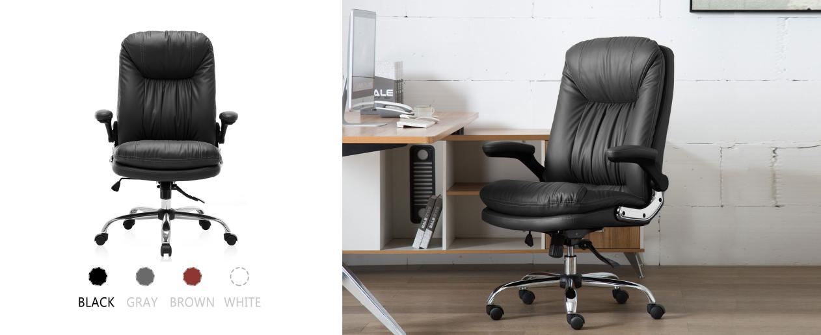](https://yamasoro.co/products/yamasoro-high-back-executive-office-chair-3286)

1. If there is a problem with the cylinder of the [executive office chair](https://yamasoro.co/), take out the existing cylinder. Care must be taken in this process, as accidents may cause damage to other parts. Use pliers to clamp the gas cylinder tube of the swivel chair, open it, then loosen the cylinder, repeat this action, knowing that the cylinder has fallen, be sure not to force the cylinder with brute force.
2. After removing the old cylinder, it is necessary to install a new one. The first thing is to find a suitable type. If the size of the cylinder is not suitable, it is also very troublesome. We can install the cylinder according to the operating manual of the swivel chair itself. This process should be cautious, the order of each component must be ensured to be correct, so as not to affect the application.
3. Finally, it needs to be assembled again. Pay attention to ensure that all small screws are in place. After assembling, adjust the height to see if the parts are normal.