Jeckie Ng (w/ Emi Le & Annie Nguyen)

Ms. Cotter

AP Physics 1

6 December 2023

Conservation of Energy Lab

**MAIN QUESTION**

How is spring compression related to gravitational potential energy?

**DESIGN**

Set up a spring cart with a stopper in front (experimental unit) on a track ramp. Measure the initial displacement (DV) at the end of the car/start of the stopper using a ruler/meter stick. Release cart from rest with varying spring compressions (IV) at base of ramp [eyeballed, with distance between each compression level being approx. the same]. Measure final displacement at start of stopper. Repeat steps for different levels of spring compressions

* Be sure to use the same spring cart, track, ruler, and person measuring for all trials to minimize variability

Analysis plan: After collecting displacement due to spring, calculate change in height and gravitational potential energy; graph gravitational potential energy/spring compression squared in order to reveal their relationship.

**Setup Diagram FBD**



**Prediction**



**DATA**

m = 0.5kg

g = 10m/s²

| Spring Compression | Initial Height (cm) | Final Height (cm) | Δh (cm) |
| --- | --- | --- | --- |
| 1 | 4.80 | 5.15 | 0.35 |
| 2 | 4.75 | 5.85 | 1.10 |
| 3 | 4.70 | 6.91 | 2.21 |

Uncertainty of measurement: ±1

Qualitative Observation: The cart slows down as it reaches its maximum height.

Possible error:

* Energy may have transferred to the environment, decreasing the car’s final height and gravitational potential energy
* Human error may have caused final heights to be measured greater, increasing the car’s gravitational potential energy.

**ANALYSIS**

A 0.5kg spring-cart on earth has a height of 0.35cm. What is its gravitational potential energy?

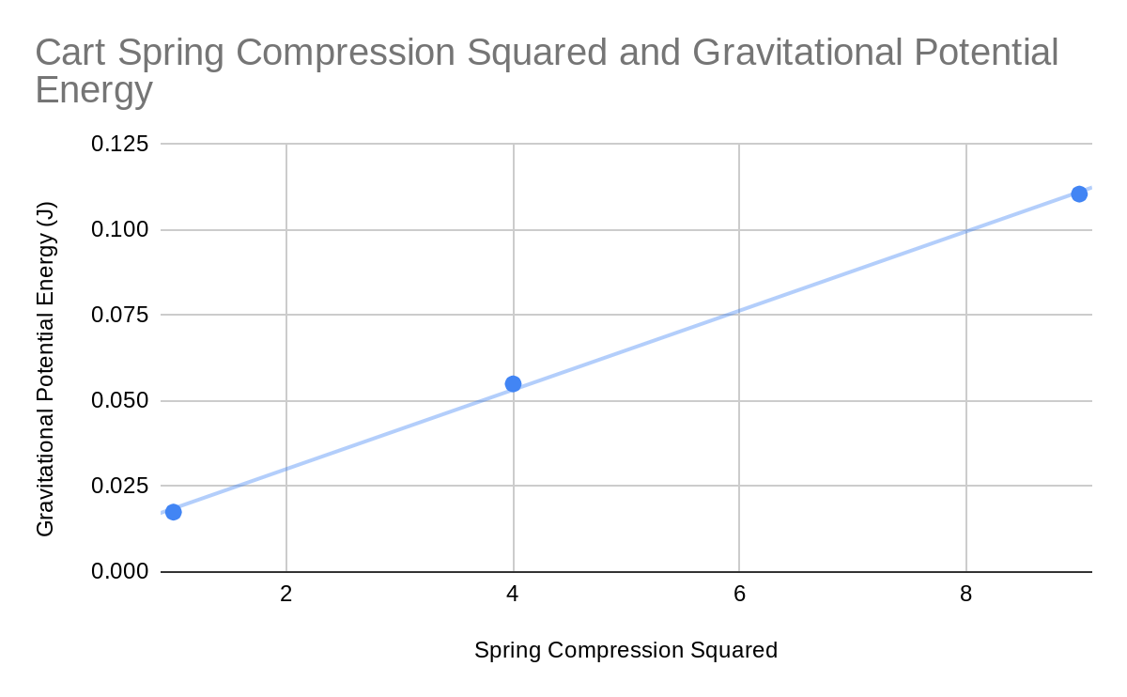

Graphed Data

| Spring Compression Squared | Gravitational Potential Energy (J) |
| --- | --- |
| 1 | 0.0175 |
| 4 | 0.055 |
| 9 | 0.1105 |

A spring compression squared of 8 gives a cart a gravitational potential energy of 0.100J, and a spring compression squared of 6 gives a cart a gravitational potential energy of 0.075J. What is the cart’s gravitational potential energy/spring compression squared slope?



Relationships Derived Mathematically:



**CONCLUSION**

Gravitational potential energy and spring compression squared have a direct relationship. This is suggested by the Ug/xs² graph’s positive and linear trendline slope of 0.01J. Since ΔE=0 within the closed system, Usi of the spring transfers to the cart’s KE, and transfers to Ugf as the cart reaches maximum height.