Minimum Arrow Rotations
Problem summary, visual explanation, and TypeScript solution
Input  Goal  One move  Output | A string S made only of ^, <, v, and >.  Rotate arrows until all arrows point in the same direction.  Rotate one chosen arrow by one step: ^ -> < -> v -> > -> ^.  Return the minimum total number of moves.
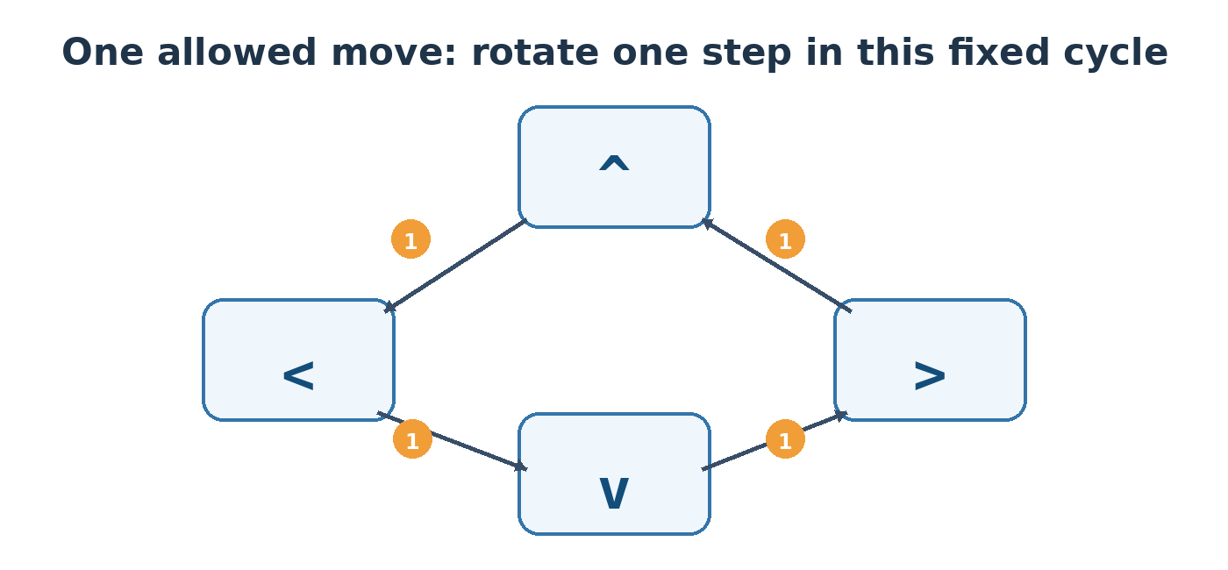
Figure 1. Each edge in the cycle costs one move.

Key idea
There are only four possible final directions. Try each one as the target, calculate how many forward rotations every arrow needs, and keep the smallest total.
For a current position current and target position target, the required moves are:
(target - current + 4) % 4
Why add 4 and use % 4? The direction indices wrap around. For example, > is index 3 and ^ is index 0, but > -> ^ takes only one move: (0 - 3 + 4) % 4 = 1.

Direction mapping
^ | < | v | >
0 | 1 | 2 | 3

Worked example
Input: S = "^vv<" | Best target: v
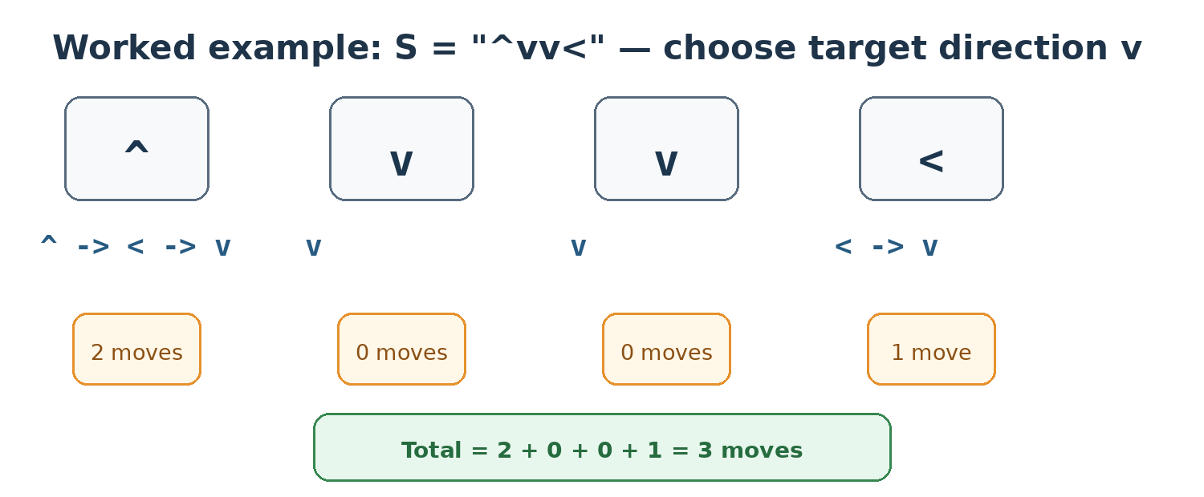

How the algorithm works
1. Represent the cycle: Map ^, <, v, and > to indices 0, 1, 2, and 3.
2. Try each target: Calculate the total cost of making every arrow point to each of the four directions.
3. Use modular distance: The formula computes only forward rotations and correctly wraps from index 3 back to index 0.
4. Choose the minimum: Return the smallest total among the four candidates.

TypeScript solution
function solution(S: string): number {
// One move follows this cycle:
// ^ -> < -> v -> > -> ^
const directions = ["^", "<", "v", ">"];
const position = new Map<string, number>();
directions.forEach((direction, index) => {
position.set(direction, index);
});
let minimumMoves = Infinity;
// Try all four possible final directions.
for (let target = 0; target < directions.length; target++) {
let moves = 0;
for (const arrow of S) {
const current = position.get(arrow)!;
moves += (target - current + 4) % 4;
}
minimumMoves = Math.min(minimumMoves, moves);
}
return minimumMoves;
}

Why Math.abs(target - current) is incorrect
The allowed rotation is one-way, not two-way. Consider current = > (index 3) and target = ^ (index 0):
Method | Calculation | Result
Correct modular formula | (0 - 3 + 4) % 4 | 1 move
Math.abs | Math.abs(0 - 3) | 3 moves (wrong)

Complexity
Time: O(4N), simplified to O(N), because the algorithm scans the string once for each of four targets. Space: O(1), because the direction map always contains only four entries.

Quick test cases
Input | Best target | Answer
"^vv<" | v | 3
"vv>>vv" | > | 4
"<<<" | < | 0

