Unit Name: NIT2112 Object Oriented Programming

Teacher: Nader Khalifa

Student Name: Yam Raj Dangar

Student ID: s4653215

This document file contains screenshots of CashReg.java file. The source code file is submitted seperately.

We need to run CashReg.java on netbeans console.

Scrrenshots of GUI:

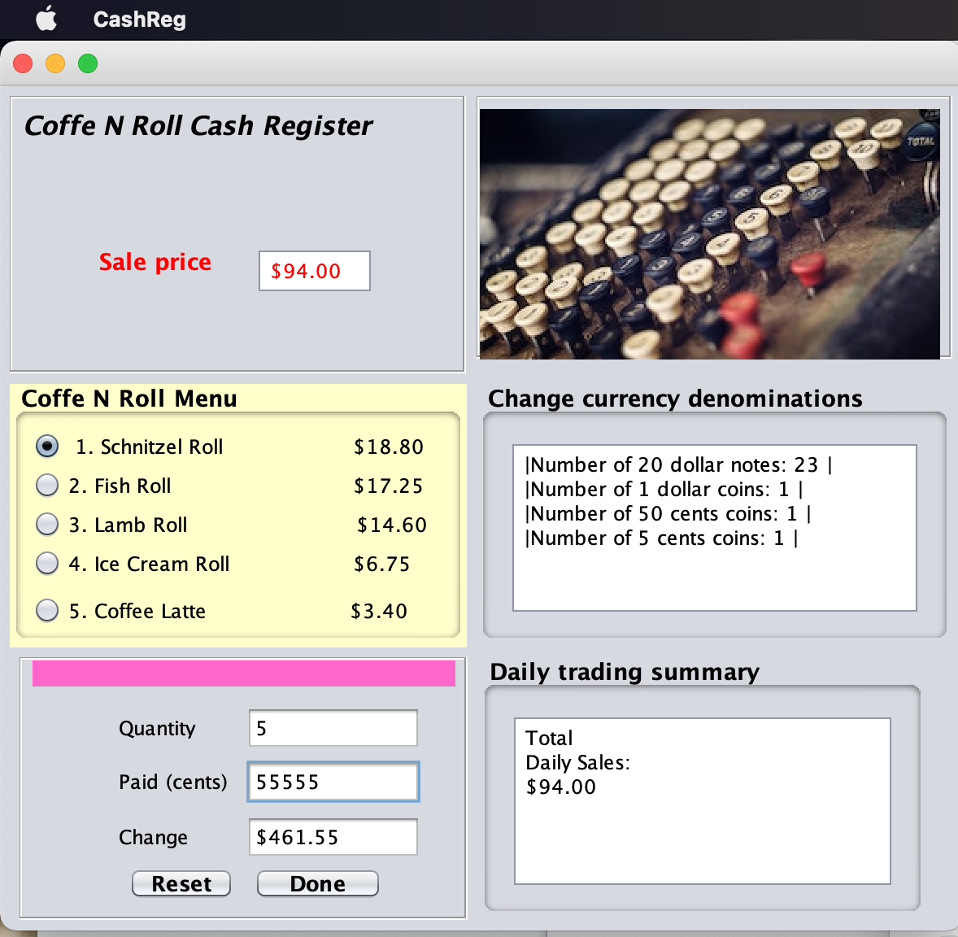

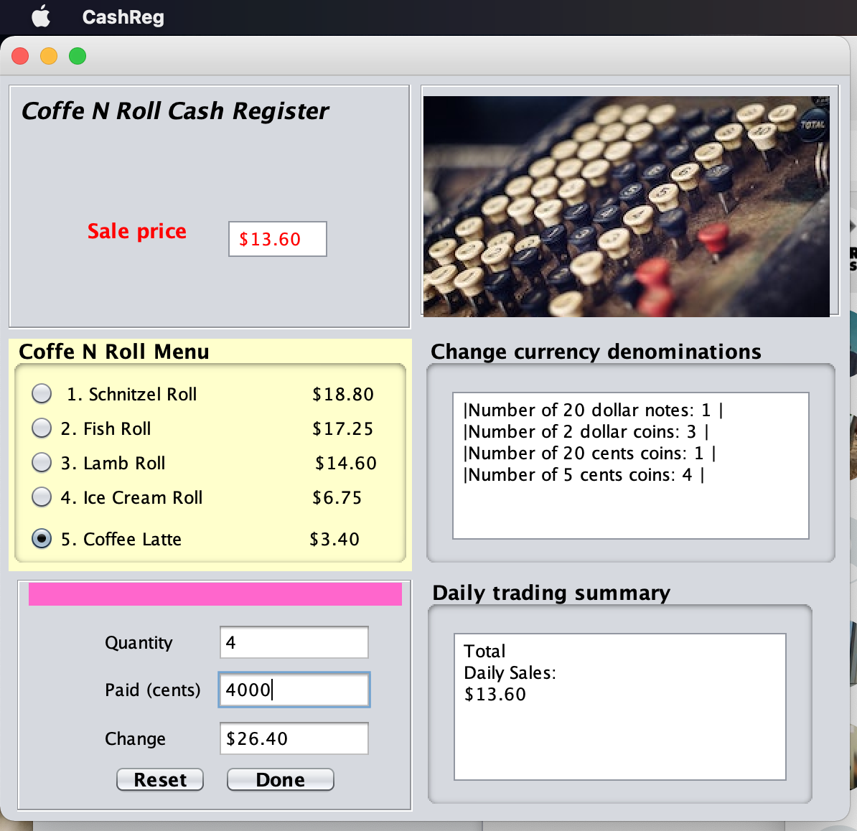

I used all 5 menu and everything worked fine. And Reset and done button also worked.

References:

1. Power point slide from VU collabrate.
2. <https://youtu.be/Ir76a-iPykQ>