Unit Name: NIT2112 Object Oriented Programming

Teacher: Nader Khalifa

Student Name: Yam Raj Dangar

Student ID: s4653215

This document file contains screenshots of .CoffeNRoll CLI. The source code file is submitted seperately.

Screenshots: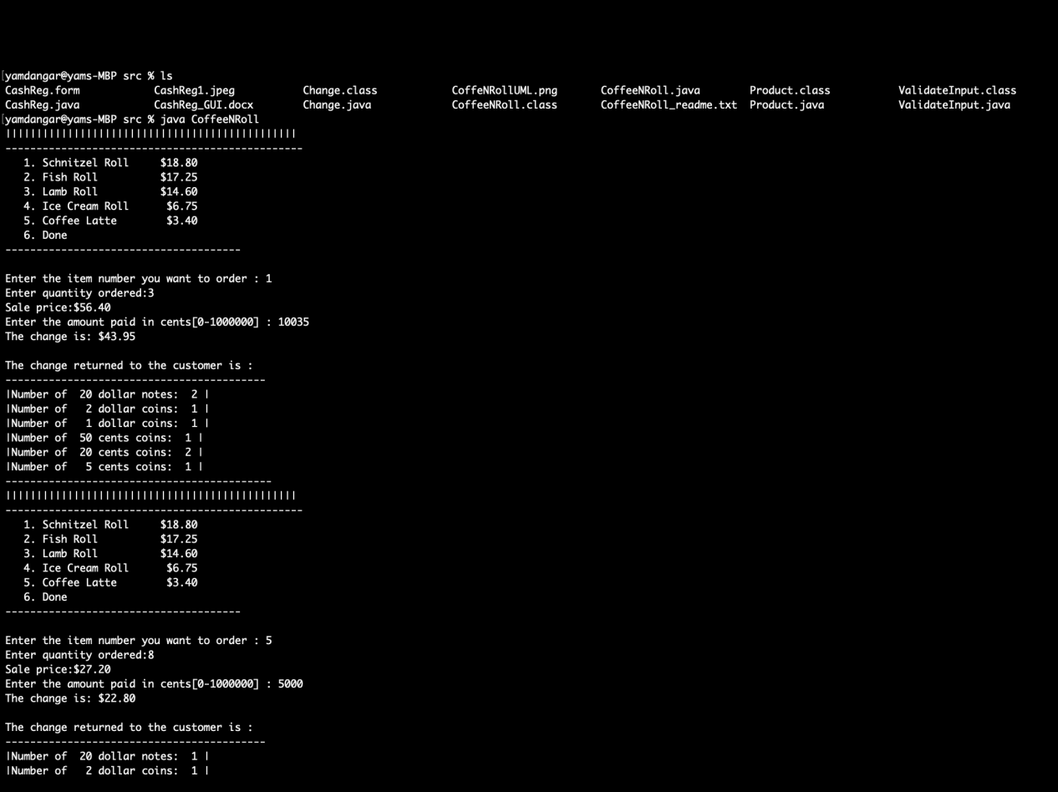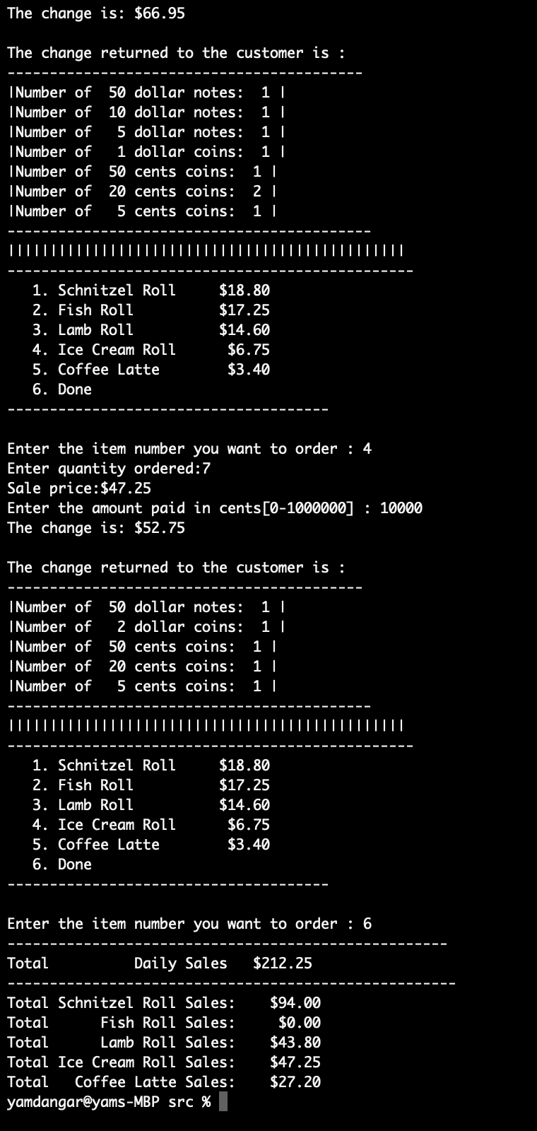

Reference:

Power Point Slide from VU collabrate.

Teachers note.