**Week 1: Gathering our existing specs and seeing limits of existing design  
Torque specs servo:**

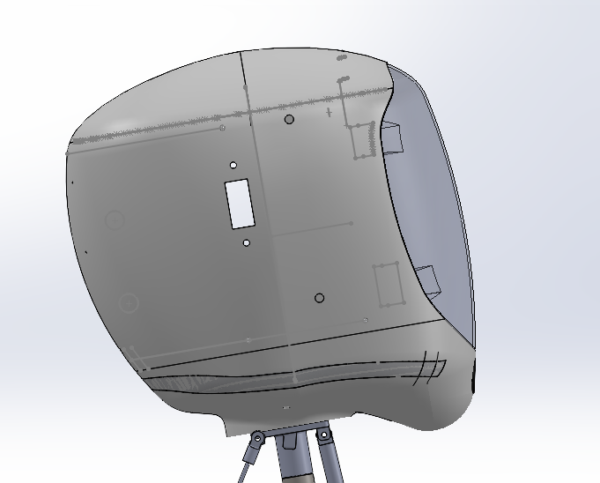

Weight of the head shell, weight of the LCD and weight of the resin mask add up to the weight of the head. The LCD would be the heaviest element in the head and we can make a rough estimation that the COM for our head would be somewhere between the LCD and the resin mask i.e. the red ‘X’ in the above diagram. Dark Green = COM LCD and Light Green = COM Mask.

Based on current design, these are the positions of our COM at the extreme ends of the range of motion.   
The head looking towards the ground is the riskiest position. Once I receive the weight of the assembled head from Anas, I can get a better estimate for what size servo would be fool proof for our design.

Our current Servo’s are rated for 25kg/cm (stall torque), that is the maximum torque our servo would be able to dish out would be a 25kg load at 1cm from the center of its rotating axis.  
  
We estimate the Head to weigh between 1-2 kgs, we have never actually measured it. A safe servo stall torque just based on the higher weight limit would be ~35 kg/cm. (Factor of Safety = 1)

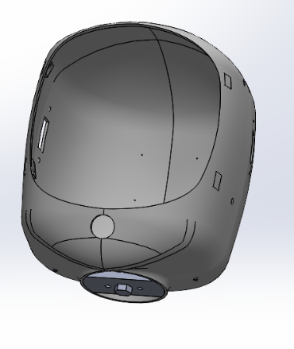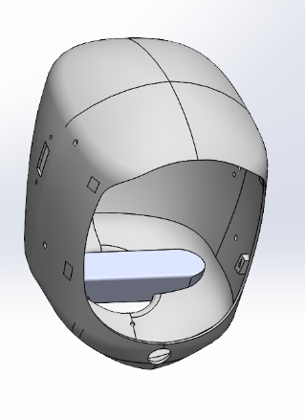

Important to have the complex loading forces at the neck spread over a large surface area to avoid premature failure, can design a more **evenly spaced out / circular neck mount. (good to have) (Nice exercise for whoever is currently working with the head)**

The servo stall torque is also the maximum force our servo can exert / hold against the spring / gas dampers. Depending on the spec we decide on for the Servo, we can play around with our damper choices.  
  
Assuming we go with a 35kg Servo, we would need to look towards gas springs rated for 10kgs.

We currently have RC Car Gas Shocks in our neck, which act as dampers but the spring with these bad boys is not very stuff so it does not do as good a job at ‘smoothening’ the motion. I tried to find a stiffness spec online for these but was not able to find one, I’ll get the Spring Constant using F = kx and get back to setting up the Static Simulation.  
  
0.5cm compression with a 200g object, k = 392 N/m

“A low-stiffness configuration allows a faster motion while the safety is ensured. A high-stiffness configuration attenuates the vibration thus improve the positioning performance. “

**[Siyang Song, Xianpai Zeng, Yu She, Junmin Wang, Hai-Jun Su,**

**Modeling and control of inherently safe robots with variable stiffness links,**

**Robotics and Autonomous Systems,**

**Volume 120,**

**2019,**

**103247,**

**ISSN 0921-8890,**

**https://doi.org/10.1016/j.robot.2019.07.017.**

**(https://www.sciencedirect.com/science/article/pii/S0921889019300752)**

**Abstract: In this paper, the modeling, control design, and trajectory planning for inherently safe robots with variable stiffness links (VSL) are investigated. Firstly, a dynamic model of VSL robots is developed using the pseudo-rigid-body model (PRBM). Based on PRBM, a feedback-linearization based controller is proposed. Extended state observer and deflection feedback are designed to improve the robustness and vibration suppression. To keep the inherent safety, a safe trajectory planning problem is formulated and the safety criterion is converted to a velocity constraint. With constraints on the jerk, acceleration, and velocity, the trajectory-planning problem is formulated as a time-optimal problem. The analytical solution of this problem is derived by optimal control theory. Experiments show the performances of motion control and vibration suppression of the proposed controller. The impact test results indicate the potential of VSL robots for applications with physical human–robot interaction.**

**Keywords: Variable stiffness link; Physical human–robot interaction; Robust control; Vibration suppression; Safe trajectory planning; Impact test]**

**Simple FEA Setup for our neck mechanism:**

Force due to gravity from the head, the gas springs modeled as springs, struts modeled as rigid linkages and pin joint at center of universal joint. Removed limit angle mates because they were messing with simulation / operator error. I give up for now, I’ll try remodelling some of the parts as simpler components and redo-ing the FEA.

**Week 2 Tasks: (More CAD-ing and actual concepts)**

We integrate the ring gear into the neck base, need to CAD a 3D-printable design. Fewer moving parts, fewer surfaces in potential contact, better chance at noise reduction.  
  
For stability, we could maintain a similar design but increase the size of the base depending on turntable sizes we find online that are larger than the current ones we have.  
  
We would also need to design mounts this larger base would sit on and attach to the extrusion. Larger base could also mean a better attachment point for the neck shroud. We would also need to alter the hole in our existing neck.  
  
I need to do some testing but when the majority of the ‘little load’ we have is concentrated on the ball carrier part of the turntable it does not wobble as much, so we can try, I want to hold off on changing turntable because I honestly believe if we get better shocks they would be game changers for the entire neck motion.

Week 2 would also include finalising the servo spec, and then sourcing gas shocks for our design. And the redesigning the neck base plate and neck-head adapter to take up the gas shocks. Need to design for our brackets to take up ball studs, verify the maximum and minimum lengths of the gas shock at the 2 extreme positions of the head to determine travel.

We would also need Anas to measure the weight for the head shell with all the components going in it kept inside the head.  
  
We can also look into getting the neck base and neck-head adapter machined.  
  
Week 2 would also be creating a prototype plan for week 3. We need to have physical proofs of concept by end of week 3 to see if we are stabler.

I will send CAD of just the previous rev of the neck in the design group with this document, if you have any alternative ideas / want clarity on the old mechanism shoot your questions in the design group. We still have till week 4 to finalise the neck.  
  
Another thing that stands out to me with the previous design is that we had majority of the dampening in only one direction (compression), when the robot looks towards the ground the motion is damped, but when he tilts his head back there is not a lot of dampening especially with our current shocks. We could for sure work on getting a 3rd dampener on the back with the servos, but this would require some additional design work. (more of a good to have)  
  
I’ll try getting the initial CAD done by Sunday night for some of the concepts and hop in a quick meeting with Anas. But this document has a lot of the concepts discussed in it.