Swapnil Acharya

StarId: ea4963aw Due: 02/05/2020

Purpose

To increase your understanding of system calls

CSCI 610  
 Advanced concepts in operating systems

Project 1

# @author Swapnil Acharya

# @since 01/23/2020

# @file Makefile

all**:** compute controller

compute**:** P1.h P1_compute.c

gcc -o compute P1.h P1_compute.c

controller**:** P1.h P1_controller.c

gcc -o controller P1.h P1_controller.c

clean**:**

rm -f compute

rm -f controller

/**

* **@author** Swapnil Acharya

* **@since** 01/23/2020

* **@file** P1.h

*/

#ifndef _P1_H_

#define _P1_H_

//number of child processes

#define MAXCP 2

//define buffer lengths for commands between parent and child processes

#define CMD_LEN 250

//commands used to communicate between controller

//and compute

#define READY "READY"

#define COMPUTE "COMPUTE"

#define DONE "DONE"

#define PRINT "PRINT"

//define process id for two child processes

#define COMPUTE_ID0 0

#define COMPUTE_ID1 1

//define increment value

#define INC 1000

#endif

/**

* **@author** Swapnil Acharya

* **@since** 01/23/2020

* **@file** P1_controller.c

*/

//include custom files

#include "P1.h"

//include standard libary

#include <stdio.h>

#include <stdlib.h>

//include required linux headers

#include <unistd.h>

#include <errno.h>

#include <sys/types.h>

//include other headers

#include <string.h>

#include <time.h>

#include <stdbool.h>

**typedef** struct _compTime**{**

time_t _startTime**;**

time_t _endTime**;**

double _totalTime**;**

**}** ComputationTime**;**

int main**(**int _argc**,** char **\***_argv**[],** char **\***_envp**[]){**

//container to hold child process computaion time

ComputationTime _cTime**[**MAXCP**];**

//intialize variables

int i **=** 0**;**

**for(**i **=** 0**;** i **<** MAXCP**;** i**++){**

_cTime**[**i**].**_startTime **=** 0**;**

_cTime**[**i**].**_endTime **=** 0**;**

_cTime**[**i**].**_totalTime **=** 0**;**

**}**

//define pipes for communication between controller and players (Compute Processes)

int _controllerWriteComputeRead**[**MAXCP**][**2**];**

int _computeWriteControllerRead**[**MAXCP**][**2**];**

//define messasge buffers for communication between parent (controller) and child (compute) processes

char _readStream**[**MAXCP**][**CMD_LEN**],** _writeStream**[**MAXCP**][**CMD_LEN**];**

//define buffers for read and write

char _readBuffer**[**CMD_LEN**];**

char _writeBuffer**[**CMD_LEN**];**

//create pipes for controller to write and computes to read

int _err**;**

**for(**i **=** 0**;** i **<** MAXCP**;** i**++){**

_err **=** pipe**(**_controllerWriteComputeRead**[**i**]);**

**if(**_err **==** 1**){**

printf**(**"Controller: Error creating _controllerWriteComputeRead[%i], errno =%d\n\n"**,**errno**,**i**);**

exit**(**1**);**

**}**

**}**

//create pipes for computes to write and contoller to read

**for(**i **=** 0**;** i **<** MAXCP**;** i**++){**

_err **=** pipe**(**_computeWriteControllerRead**[**i**]);**

**if(**_err **==** 1**){**

printf**(**"Controller: Error creating _computeWriteControllerRead[%i], errno =%d\n\n"**,**errno**,**i**);**

exit**(**2**);**

**}**

**}**

//create child processes

pid_t _processId**[**MAXCP**];**

**for(**i**=**0**;** i **<** MAXCP**;** i**++){**

//storing ids in an array,

//In parent process, the ids of child processes are stored in this array

//If this array is later accesed in parent process, the id of child processes can be accessed

_processId**[**i**]** **=** fork**();**

**if(**_processId**[**i**]** **<** 0**){**

printf**(**"Error creating child Process, Process Id =%d, Errno %d\n\n"**,**getpid**(),**errno**);**

exit**(**3**);**

**}**

**else** **if(**_processId**[**i**]** **==** 0**){** //child process

//close unused pipe ends for communication with controller

close**(**_computeWriteControllerRead**[**i**][**0**]);** //close read end of pipe used for child process to send command to parent process

close**(**_controllerWriteComputeRead**[**i**][**1**]);** //close write end of pipe used for parent process to send command to child process

//convert file/stream descriptor from integer to string

sprintf**(**_readStream**[**i**],**"%d"**,** _controllerWriteComputeRead**[**i**][**0**]);** //read stream

sprintf**(**_writeStream**[**i**],**"%d"**,** _computeWriteControllerRead**[**i**][**1**]);**//write stream

//execute compute program in child process

_err **=** execl**(**"./compute"**,**_readStream**[**i**],** _writeStream**[**i**],** **(**char **\*)NULL);**

**if(**_err **==** **-**1**){**

printf**(**"Error excuting Execl, Child PID %d, errno%d\n\n"**,**getpid**(),**errno**);**

exit**(**4**);**

**}**

**}**

**}**

//parent process

//close unsused pipes end for communication with compute processes

**for(**i **=**0**;** i **<** MAXCP**;** i**++){**

close**(**_controllerWriteComputeRead**[**i**][**0**]);** //close read end of pipe used for parent process to send command to child processes

close**(**_computeWriteControllerRead**[**i**][**1**]);**//close write end of pipe used for child process to send command to parent process

**}**

//parent process

//wait for READY command from all child(compute processes)

**for(**i **=** 0**;** i **<** MAXCP**;** i**++){**

//read

_err **=** read**(**_computeWriteControllerRead**[**i**][**0**],**_readBuffer**,**CMD_LEN**);**

**if(**_err **==** **-**1**){**

printf**(**"Error while reading from _computeWriteControllerRead[%d][0] , PID:%d, errno%d\n\n"**,**i**,**getpid**(),**errno**);**

exit**(**5**);**

**}**

//validate if read command is READY

**if(**strncmp**(**_readBuffer**,**READY**,**strlen**(**READY**))** **==** 0**){**

printf**(**"controller: %s received from child process(%d).\n"**,**READY**,**_processId**[**i**]);**

**}**

**else{**

printf**(**"Response from Compute %i mismatch. \n"**,**i**);**

exit**(**6**);**

**}**

//clear readbuffer

memset**(**_readBuffer**,**0**,**CMD_LEN**);**

**}**

//parent process

//send COMPUTE To Child processes and

//start computation time for processes

**for(**i **=** 0**;** i **<** MAXCP**;** i**++){**

//start computaion time for all compute processes

time**(&(**_cTime**[**i**].**_startTime**));**

//send COMPUTE to child process

printf**(**"controller: Sending %s to child process(%d).\n"**,**COMPUTE**,**_processId**[**i**]);**

//PUT ID = 0 to odd and 1 to even loop index and add COMPUTE command into buffer to be sent to child processes

**if(**i **%** 2 **==** 0**){**

sprintf**(**_writeBuffer**,**"%s_%i_%i"**,**COMPUTE**,**COMPUTE_ID0**,**INC**);**

**}**

**else{**

sprintf**(**_writeBuffer**,**"%s_%i_%i"**,**COMPUTE**,**COMPUTE_ID1**,**INC**);**

**}**

//send COMPUTE command and ID to child processes

_err **=** write**(**_controllerWriteComputeRead**[**i**][**1**],**_writeBuffer**,**strlen**(**_writeBuffer**)+**1**);**

**if(**_err **==** **-**1**){**

printf**(**"Error while writting to _controllerWriteComputeRead[%i][1], PID:%d, errno:%d\n\n"**,**i**,**getpid**(),** errno**);**

exit**(**7**);**

**}**

**}**

//parent process

//wait for DONE command from all child(compute processes)

**for(**i **=** 0**;** i **<** MAXCP**;** i**++){**

//read

_err **=** read**(**_computeWriteControllerRead**[**i**][**0**],**_readBuffer**,**CMD_LEN**);**

**if(**_err **==** **-**1**){**

printf**(**"Error while reading from _computeWriteControllerRead[%d][0] , PID:%d, errno%d\n\n"**,**i**,**getpid**(),**errno**);**

exit**(**8**);**

**}**

//validate if read command is DONE

**if(**strncmp**(**_readBuffer**,**DONE**,**strlen**(**DONE**))** **==** 0**){**

printf**(**"controller: %s received from child process(%d).\n"**,**DONE**,**_processId**[**i**]);**

**}**

**else{**

printf**(**"Response from Compute %i mismatch. \n"**,**i**);**

exit**(**9**);**

**}**

//Measure end time taken to recevived DONE commands from child processes

time**(&(**_cTime**[**i**].**_endTime**));**

//clear readbuffer

memset**(**_readBuffer**,**0**,**CMD_LEN**);**

**}**

//parent process

//calculate total computaion time taken for all child processes

**for(**i **=** 0**;** i **<** MAXCP**;** i**++){**

_cTime**[**i**].**_totalTime **=** difftime**(**_cTime**[**i**].**_endTime**,** _cTime**[**i**].**_startTime**);**

printf**(**"controller: Total Computaion Time for child process(%d): %f seconds\n"**,**_processId**[**i**],**_cTime**[**i**].**_totalTime**);**

**}**

//parent process

//send PRINT To Child processes and

//start computation time for processes

**for(**i **=** 0**;** i **<** MAXCP**;** i**++){**

//send PRINT to child process

printf**(**"controller: Sending %s to child process(%d).\n"**,**PRINT**,**_processId**[**i**]);**

//send PRINT command and ID to child processes

sprintf**(**_writeBuffer**,**"%s"**,**PRINT**);**

_err **=** write**(**_controllerWriteComputeRead**[**i**][**1**],**_writeBuffer**,**strlen**(**_writeBuffer**)+**1**);**

**if(**_err **==** **-**1**){**

printf**(**"Error while writting PRINT to _controllerWriteComputeRead[%i][1], PID:%d, errno:%d\n\n"**,**i**,**getpid**(),** errno**);**

exit**(**10**);**

**}**

**}**

//wait for child processes to exit

**for(**i **=** 0**;** i **<** MAXCP**;** i**++){**

int _status **=** 0**;**

waitpid**(**_processId**[**i**],&**_status**,**0**);**

**if(**WIFEXITED**(**_status**)){**

printf**(**"controller: child(%d) terminated with exit status: %d\n"**,**_processId**[**i**],**WEXITSTATUS**(**_status**));**

**}**

**}**

printf**(**"controller: Complete.\n"**);**

exit**(**11**);**

**}**

/**

* **@author** Swapnil Acharya

* **@since** 01/23/2020

* **@file** P1_compute.c

*/

//include custom files

#include "P1.h"

//include standard library

#include <stdio.h>

#include <stdlib.h>

//include required linux headers

#include <unistd.h>

#include <errno.h>

#include <sys/types.h>

//include other headers

#include <string.h>

int getRelationIsTrueCount**(**int _start**,** int _end**){**

//c => [id*INC, (id+1)*INC)

// a, b are integers in the interval (0,c)

//intialie variables

int a **=** 0**,** b **=**0**,** c **=** 0**;**

int _count **=** 0**;** //variable to hold the number of count when c^2 = a^2 + b^2 is true

**for(**c **=** _start**;** c **<** _end**;** c**++** **){**

**for(**a **=** 1**;** a **<** c**;** a**++){**

**for(**b **=** 1**;** b **<** c**;** b**++){**

int _cSquared **=** c **\*** c**;**

int _abSquared **=** **(**a **\*** a**)** **+** **(**b **\*** b**);**

**if(**_cSquared **==** _abSquared**){**

_count **=** _count **+** 1**;**

**}**

**}**

**}**

**}**

**return** _count**;**

**}**

int main**(**int _argc**,** char **\***_argv**[],** char **\***_envp**[]){**

char _readBuffer**[**CMD_LEN**];**

char _writeBuffer**[**CMD_LEN**];**

//get stream pipes

int _readPipe **=** atoi**(**_argv**[**0**]);**

int _writePipe **=** atoi**(**_argv**[**1**]);**

//sending READY to parent process

printf**(**"compute(%d): Sending %s to parent process. \n"**,**getpid**(),** READY**);**

int _error **=** write**(**_writePipe**,**READY**,**strlen**(**READY**)+**1**);**

**if(**_error **==** **-**1**){**

printf**(**"Error writting to pipe, CID: %d, errno:%d\n\n"**,**getpid**(),**errno**);**

exit**(**1**);**

**}**

//define computaion parameters

int _id **=** 0**;** //variable to hold id value

int _INC **=** 0**;** //variable too hold increment value

int _startInterval **=** 0**;**

int _endInterval **=** 0**;**

int _count **=** 0**;**

//wait for compute from parent process

_error **=** read**(**_readPipe**,**_readBuffer**,**CMD_LEN**);**

**if(**_error **==** **-** 1**){**

printf**(**"Error reading from pipe, CID:%d, errno:%d\n\n"**,**getpid**(),**errno**);**

exit**(**2**);**

**}**

**else{**

**if(**strncmp**(**_readBuffer**,**COMPUTE**,**strlen**(**COMPUTE**))** **==** 0**){**

printf**(**"compute(%d): %s recevied.\n"**,**getpid**(),**COMPUTE**);**

//extract data from buffer

char **\*** _delimiterFinder**;**

_delimiterFinder **=** strtok**(**_readBuffer**,**"_"**);** //extract compute

_delimiterFinder **=** strtok**(NULL,**"_"**);** //extract id

_id **=** atoi**(**_delimiterFinder**);** //convert id from string to integer

_delimiterFinder **=** strtok**(NULL,**"_"**);**

_INC **=** atoi**(**_delimiterFinder**);** //convert INC from string to integer

**}**

**else{**

printf**(**"Command Mismatch: %s instead of %s, CID: %d, errno:%d\n\n"**,**_readBuffer**,**COMPUTE**,**getpid**(),**errno**);**

exit**(**3**);**

**}**

**}**

//start computation

//c => [id*INC, (id+1)*INC)

_startInterval **=** _id **\*** _INC**;**

_endInterval **=** **(**_id **+** 1**)** **\*** _INC**;**

_count **=** getRelationIsTrueCount**(**_startInterval**,**_endInterval**);**

//send DONE TO Controller

printf**(**"compute(%d): Sending %s to parent process. \n"**,**getpid**(),** DONE**);**

_error **=** write**(**_writePipe**,**DONE**,**strlen**(**DONE**)+**1**);**

**if(**_error **==** **-**1**){**

printf**(**"Error writting to pipe, CID: %d, errno:%d\n\n"**,**getpid**(),**errno**);**

exit**(**4**);**

**}**

//wait for print command from parent process

_error **=** read**(**_readPipe**,**_readBuffer**,**CMD_LEN**);**

**if(**_error **==** **-** 1**){**

printf**(**"Error reading from pipe, CID:%d, errno:%d\n\n"**,**getpid**(),**errno**);**

exit**(**5**);**

**}**

**else{**

**if(**strncmp**(**_readBuffer**,**PRINT**,**strlen**(**PRINT**))** **==** 0**){**

printf**(**"compute(%d): %s recevied.\n"**,**getpid**(),**PRINT**);**

**}**

**else{**

printf**(**"Command Mismatch: %s instead of %s, CID: %d, errno:%d\n\n"**,**_readBuffer**,**COMPUTE**,**getpid**(),**errno**);**

exit**(**6**);**

**}**

**}**

//print compute parameters and resuls

printf**(**"compute(%d): For interval [%d,%d): count = %d \n"**,**getpid**(),**_startInterval**,**_endInterval**,**_count**);**

//Indicate Exit

printf**(**"compute(%d): Terminating Normally.\n"**,**getpid**());**

exit**(**10**);**

**return** 0**;**

**}**

**OUTPUTS**

**MAXCP = 2, INC = 1000**

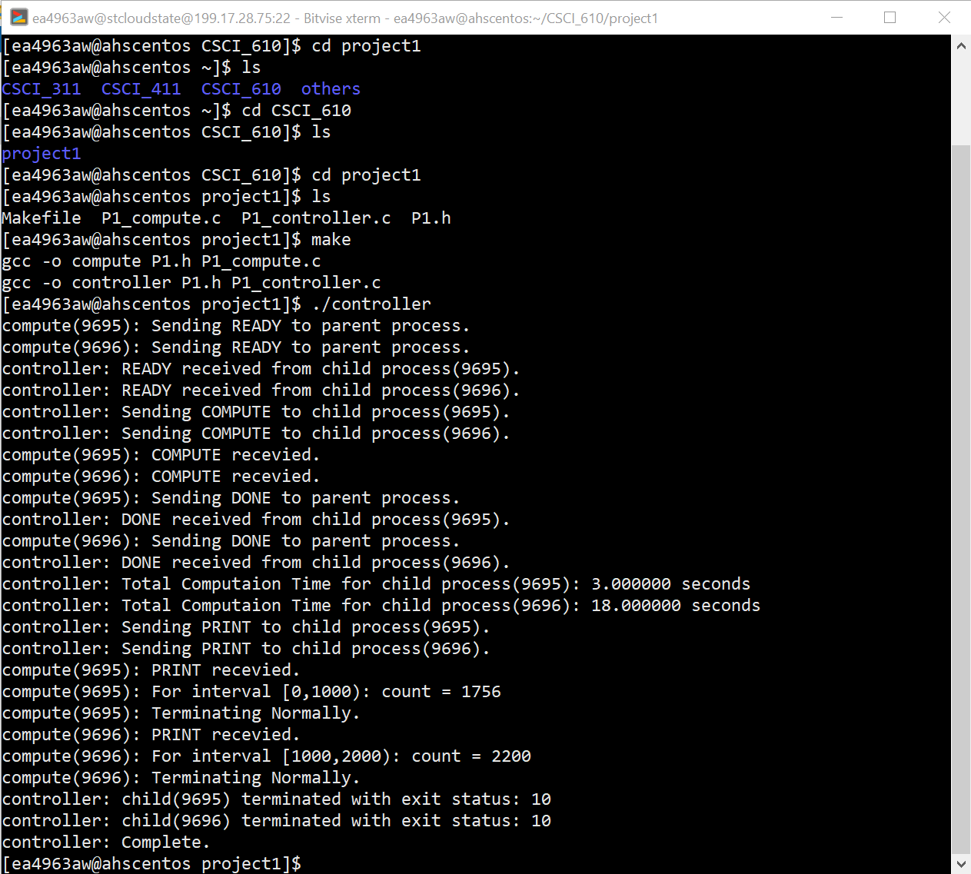

**MAXCP = 2, INC = 2000**

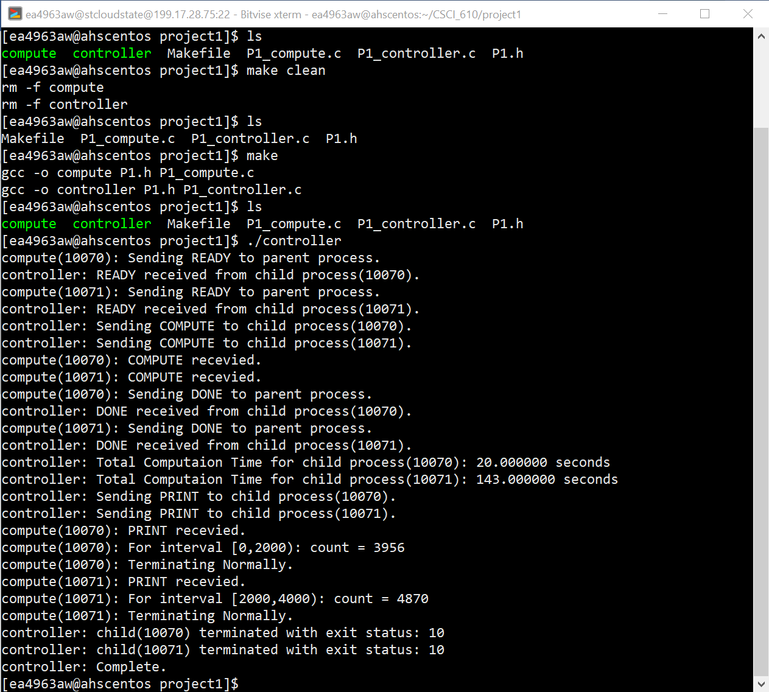

**MAXCP = 2, INC = 3000**



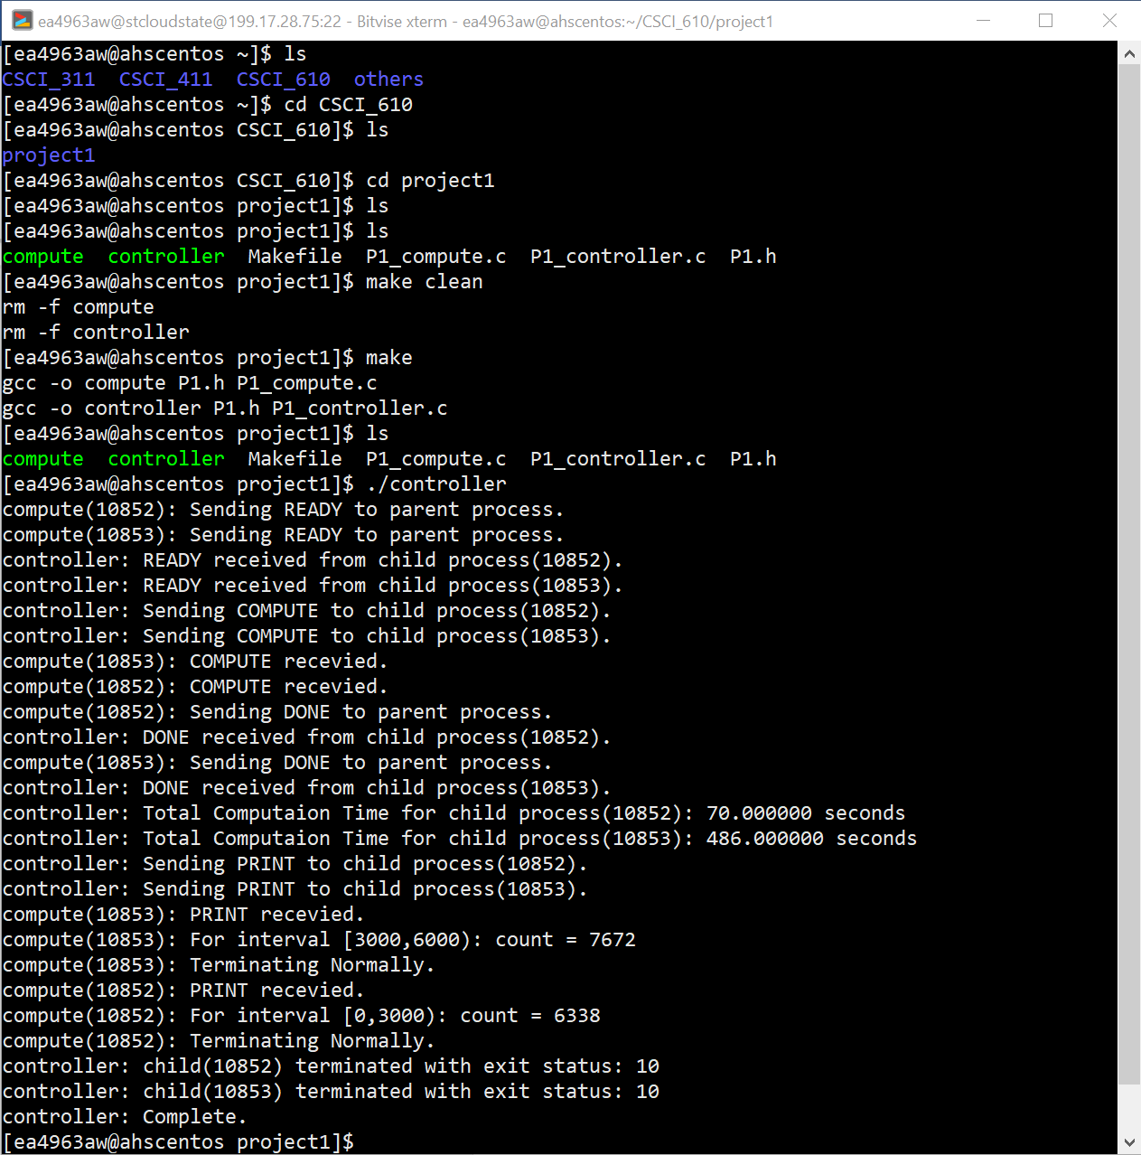

**MAXCP = 5, INC = 500**

