Swapnil Acharya

StarId: ea4963aw Due Date: 2/19/2020

Purpose

Thread Synchronization and SMTP protocol

CSCI 610  
 Advanced concepts in operating systems

Homework 1

Problem A

# @author Swapnil Acharya

# @since 02/14/2020

# @file Makefile

all**:** hw1

hw1**:** hw1_threadSyncFinal.cpp

g++ -std=c++0x -pthread -o hw1 hw1_threadSyncFinal.cpp

clean**:**

rm -f hw1

/**

\***@author** Swapnil Acharya

\***@since** 02/14/2020

\***@file** hw1_threadSyncFinal.cpp

*Description: demonstrates thread synchronization in a shared variable environment

**/

#include <stdio.h>

#include <iostream>

#include <pthread.h>

#include <unistd.h>

#include <errno.h>

#include <string>

#include <stdbool.h>

**using** **namespace** std**;**

const int MAXPEERS **=** 8**;** //MAX NUMER OF PEERS

const int SLEEP_DURATION **=** 1**;** //SLEEP_DURATION for thread synchronization

//variables for programs flow control

int MAILING_SYSTEM **=** 0**;**

int WAIT_REMOVE_COUNT **=** 0**;**

int WAIT_SET_COUNT **=** 0**;**

//Declarre mutexes

pthread_mutex_t Out **=** PTHREAD_MUTEX_INITIALIZER**;**

pthread_mutex_t Mutex1 **=** PTHREAD_MUTEX_INITIALIZER**;**

pthread_mutex_t Mutex2 **=** PTHREAD_MUTEX_INITIALIZER**;**

//declare conditional variables to be used within mutexes

pthread_cond_t Wait_For_Set_BroadCast **=** PTHREAD_COND_INITIALIZER**;**

pthread_cond_t Wait_For_Remove_BroadCast **=** PTHREAD_COND_INITIALIZER**;**

void println **(**string s**)** **{**

int _err **=** pthread_mutex_lock**(&**Out**);**

**if(**_err **==** **-**1**)**

**{**

printf**(**"PrintLn, Couldnot lock Mutex, errno =%i\n"**,**errno**);**

**}**

cout **<<** s **<<** endl**;**

_err **=** pthread_mutex_unlock**(&**Out**);**

**if(**_err **==** **-**1**)**

**{**

printf**(**"Println, Could not unlock Mutex, errno=%i\n"**,**errno**);**

**}**

**}**

class Mailbox**;**

class Letter **{**

private**:**

Mailbox**\*** recipientList**[**MAXPEERS**];**

int id**;**

int count**,** next**;**

public**:**

Letter **(**int identity**)** **{**

**for** **(**int i **=** 0**;** i **<** MAXPEERS**;** i**++)**

recipientList**[**i**]** **=** **(**Mailbox **\*)nullptr;**

id **=** identity**;**

next**=** 0**;**

count **=** 0**;**

**}**

int getId **()** **{**

**return** id**;**

**}**

void setRecipient **(**Mailbox**\*** mb**)** **{**

recipientList**[**next**++]** **=** mb**;**

**if** **(**next **>** MAXPEERS**)**

next **=** 0**;**

**}**

Mailbox**\*** getNext**(**Mailbox**\*** mb**)** **{**

int current **=** 0**;**

**while** **(**recipientList**[**current**]** **!=** mb**)**

current **=** **(**current **+** 1**)** **%** MAXPEERS**;**

next **=** **(**current **+** 1**)** **%** MAXPEERS**;**

**while** **(**recipientList**[**next**]** **==** **(**Mailbox **\*)nullptr)**

next **=** **(**next **+** 1**)** **%** MAXPEERS**;**

count**++;**

**return** **(**recipientList**[**next**]);**

**}**

void removeRecipient **(**Mailbox**\*** mb**)** **{**

int current **=** 0**;**

**while** **(**recipientList**[**current**]** **!=** mb**)**

current **=** **(**current **+** 1**)** **%** MAXPEERS**;**

recipientList**[**current**]** **=** **(**Mailbox **\*)nullptr;**

**}**

**};**

class Mailbox **{**

private**:**

Letter**\*** letter**;**

public**:**

Mailbox **()** **{**

letter **=** **(**Letter **\*)nullptr;**

**}**

void setLetter **(**Letter**\*** l**){**

letter **=** l**;**

**}**

Letter**\*** removeLetter **(**int id**){**

int _err **=** pthread_mutex_lock**(&**Mutex1**);**

**if(**_err **==** **-**1**){**

println**(**"RemoveLetter, Could not lock Mutex1"**);**

**}**

Letter**\*** myletter **=** letter**;**

**if(**MAILING_SYSTEM **==** 0**){**

//let initial remove letter requests through without any locks

myletter **=** letter**;**

letter **=** **(**Letter **\*)nullptr;**

**}**

**else** **if(**MAILING_SYSTEM **==** 1**){**

//let the second set of letter requests pass through

//conditional locks dependinf on program flow

**if(**WAIT_REMOVE_COUNT **<** MAXPEERS**-**1**){**

//In this case untill all the peers have set letters and

//now are ready to get next set of letter make them wait

//untill all the threads are waitting to get next set of letters

WAIT_REMOVE_COUNT **++;**

//wait for broadcast signal

pthread_cond_wait**(&**Wait_For_Remove_BroadCast**,&**Mutex1**);**

myletter **=** letter**;**

letter **=** **(**Letter **\*)nullptr;**

**}**

**else** **if(**WAIT_REMOVE_COUNT **==** MAXPEERS**-**1**){**

//when MAXPEERS - 1, peers are waiting to removeletter,

//let only the Peer# Maxpeers removes the letter and

//then after than broacasr removeletter signal so All

//other waiting peers can remove letters

myletter **=** letter**;**

letter **=** **(**Letter **\*)nullptr;**

WAIT_REMOVE_COUNT **=** 0**;**

//send broadcast signal

pthread_cond_broadcast**(&**Wait_For_Remove_BroadCast**);**

**}**

**}**

**if(**myletter **==** **(**Letter **\*)nullptr){**

//check to see if accessed letter in null or hasnt been set

println**(**"Peer " **+** to_string**(**id**)** **+** " : Acesses Null"**);**

**}**

_err **=** pthread_mutex_unlock**(&**Mutex1**);**

**if(**_err **==** **-**1**){**

println**(**"RemoveLetter, Could not unlock Mutex1"**);**

**}**

**return** myletter**;**

**}**

**};**

class Peer **{**

private**:**

int id**;**

int count**;**

Letter**\*** letter**;**

Mailbox**\*** mb**;**

bool _initialLockRemoval**;**

public**:**

Peer **(**int identifier**,** Mailbox**\*** mbx**){**

id **=** identifier**;**

mb **=** mbx**;**

count **=** 0**;**

**}**

int getId**(){**

**return** id**;**

**}**

void **operator** **()** **(){**

run**();**

**}**

void run **(** **)** **{**

**while** **(**count **!=** MAXPEERS**)** **{**

letter **=** mb**->**removeLetter**(**id**);**

Mailbox**\*** nextMB **=** letter**->**getNext**(**mb**);**

count**++;**

println **(**"Peer " **+** to_string**(**id**)** **+** " : has letter " **+** to_string**(**letter**->**getId**())** **+** ", count = " **+** to_string**(**count**));**

int _err **=** pthread_mutex_lock**(&**Mutex2**);**

**if(**_err **==** **-**1**){**

println**(**"Run, Could not lock Mutex2"**);**

**}**

**if(**WAIT_SET_COUNT **<** MAXPEERS**-**1**){**

// make MAXPEERS -1, wait to set their letters untill

// all (MAXPEERS - 1), threads have arrived to set letter

WAIT_SET_COUNT**++;**

//wait for boradcast signal

pthread_cond_wait**(&**Wait_For_Set_BroadCast**,&**Mutex2**);**

**if** **(**count **<** MAXPEERS**){**

nextMB **->** setLetter**(**letter**);**

**}**

**}**

**else** **if(**WAIT_SET_COUNT **==** MAXPEERS **-** 1**){**

//when the final peer#MAXPEERS arrives to set letter

//then let it set letter and then broadcast

//signal to let other waiting peers to set leters as well

**if** **(**count **<** MAXPEERS**){**

nextMB **->** setLetter**(**letter**);**

**}**

WAIT_SET_COUNT **=** 0**;**

//when first set of letter are fetched change the flow of program

MAILING_SYSTEM **=** 1**;**

//send broadcast signal

pthread_cond_broadcast**(&**Wait_For_Set_BroadCast**);**

**}**

_err **=** pthread_mutex_unlock**(&**Mutex2**);**

**if(**_err **==** **-**1**){**

println**(**"Run, Could not unlock Mutex2"**);**

**}**

**}**

**}**

**};**

/**

\***@brief** this function is used to as start routine for threads

\***@pre** this function requires a Peer object

\***@post** this function start the targeted run function for a thread

*/

void **\*** startPeerThreads**(**void **\*** _peer**){**

//typcasting void * type to Peer class type

Peer **\*** _aPeer **=** **((**Peer **\*)**_peer**);**

//stating the threads run functio

_aPeer **->** run**();**

**}**

int main **(**int argc**,** const char **\*** argv**[])** **{**

//make array letters

int i **=** 0**;**

Letter**\*** letterList**[**MAXPEERS**];**

**for(**i **=** 0**;** i **<** MAXPEERS**;** i**++){**

//make new letter and assign each letter a id

letterList**[**i**]** **=** **new** Letter**(**100**+**i**);**

**}**

//make array of mailboxes

i **=** 0**;**

Mailbox**\*** mailBoxList**[**MAXPEERS**];**

**for(**i **=** 0**;** i**<** MAXPEERS**;** i**++){**

//make new mailbox

mailBoxList**[**i**]** **=** **new** Mailbox**();**

**}**

//set all mailboxes as recipients for all Letters

i **=** 0**;**

int j **=** 0**;**

**for(**i **=** 0**;** i **<** MAXPEERS**;** i**++){**

**for(** j **=** 0**;** j **<** MAXPEERS**;** j**++){**

letterList**[**i**]->**setRecipient**(**mailBoxList**[**j**]);**

**}**

**}**

//give each mailbox a letter

i **=** 0**;**

**for(**i **=** 0**;** i **<** MAXPEERS**;** i**++){**

mailBoxList**[**i**]->**setLetter**(**letterList**[**i**]);**

**}**

//create array of peers and assign each pair 1 mailBox

i **=** 0**;**

Peer**\*** peerList**[**MAXPEERS**];**

**for(** i **=**0**;** i **<** MAXPEERS**;** i**++){**

peerList**[**i**]** **=** **new** Peer**(**i**,**mailBoxList**[**i**]);**

**}**

//create array of threads

pthread_t PeerWorkers**[**MAXPEERS**];**

i **=** 0**;**

**for(**i **=** 0**;** i **<** MAXPEERS**;** i**++){**

pthread_create**(&**PeerWorkers**[**i**],NULL,**startPeerThreads**,**peerList**[**i**]);** //start threads

**}**

println **(**"All peers are active."**);**

//join the threads into main thread

i **=** 0**;**

**for(** i **=** 0**;** i **<** MAXPEERS**;** i**++){**

pthread_join**(**PeerWorkers**[**i**],NULL);**

**}**

println **(**"All Peers have completed."**);**

printf**(**"\nDone\n"**);**

**return** 0**;**

**}**

MAXPEERS = 2 and 3

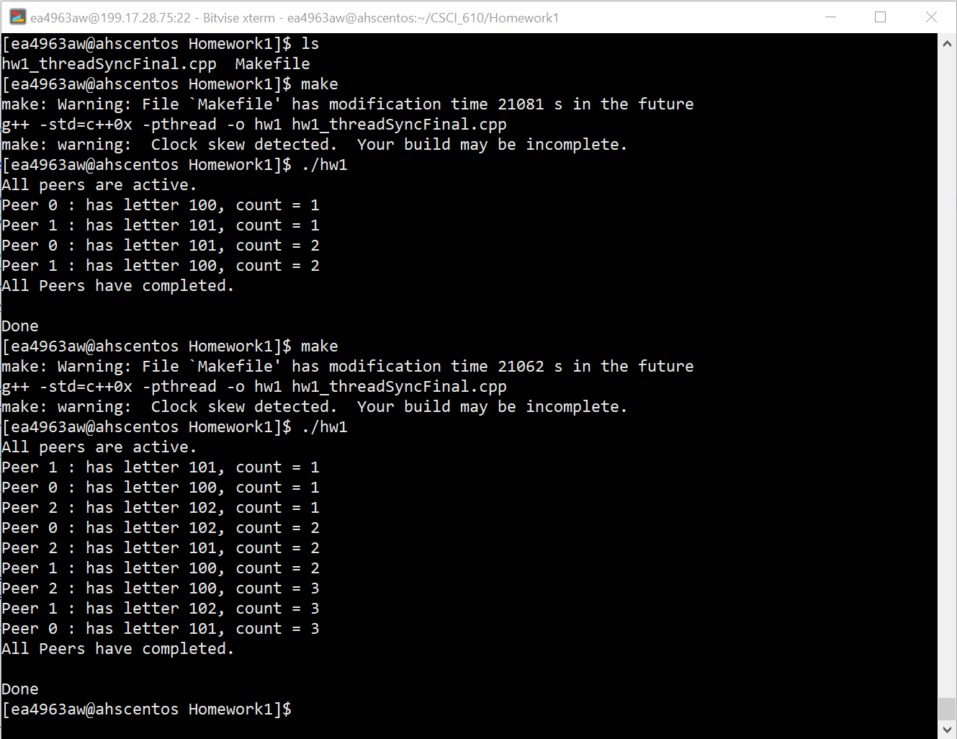

MAXPEERS = 8

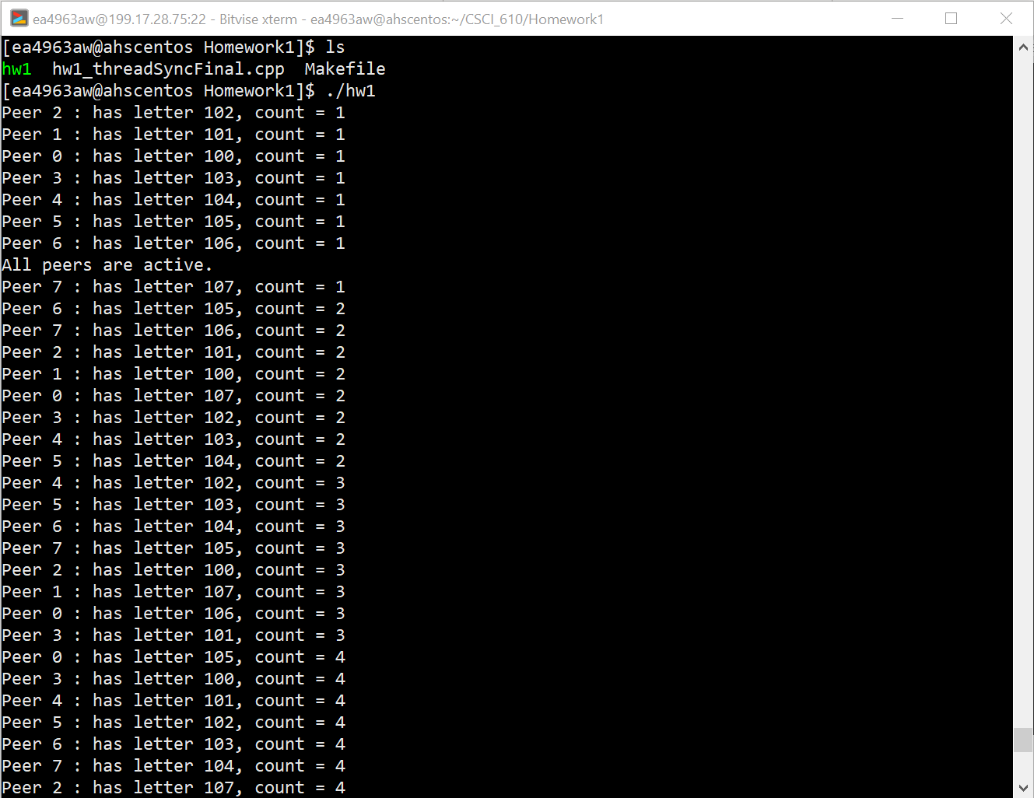

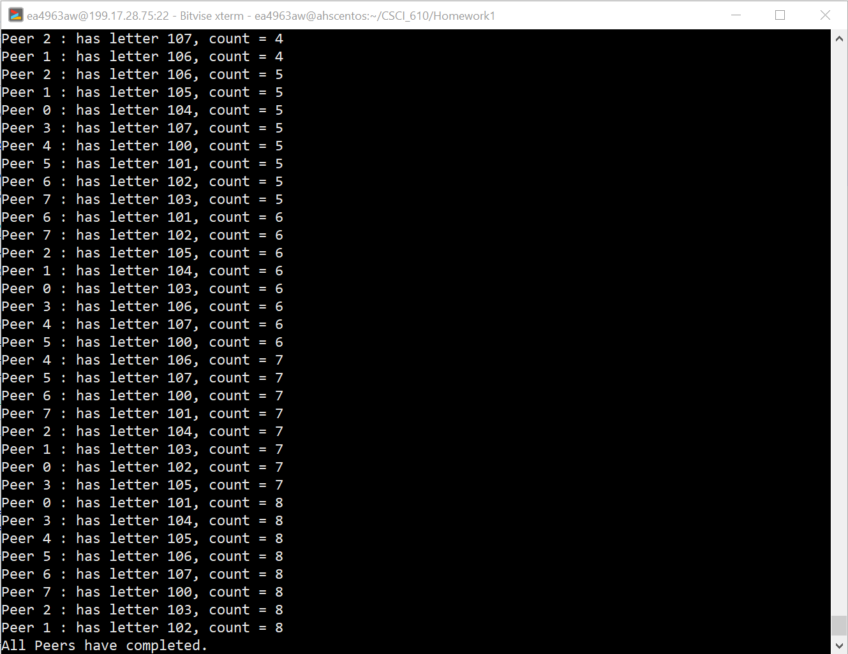

Problem B

1. What is the value of AAAA?

25

1. What is the value of BBBB?

EHLO

1. What is the value of CCCC?

MAIL FROM

1. What is the value of DDDD?  
   RCPT TO
2. What is the value of EEEE?  
   DATA