Swapnil Acharya

StarId: ea4963aw Due Date: 04/06/2020

Purpose

Distributed Hash tables and Gossiping Protocol

CSCI 610  
 Advanced concepts in operating systems

Homework 2

Problem C

**MakeFile**

all: fTable

fTable: FingerTable.h FingerTable.cpp main.cpp

g++ FingerTable.h FingerTable.cpp main.cpp -o fTable

clean:

rm -f fTable

**CODE**

/*

* @author Swapnil Acharya

* @since 03/21/2020

*/

#ifndef _FINGERTABLE_H_

#define _FINGERTABLE_H_

#include <vector>

**using** **namespace** std**;**

class FingerTable**{**

public**:**

FingerTable**();** //default constructor

FingerTable**(**int _id**);** //constructor that allows id

FingerTable**(**int _id**,** vector**<** pair**<**int**,**int**>** **>** _tbl**);** //constructor that sets node is, and finger table

FingerTable**(**int _id**,** vector**<** pair**<**int**,**int**>** **>** _tbl**,** FingerTable**\*** _link**);**

//setters

void setNodeId**(**int _id**);** //method to set node id

void setTable**(**vector**<** pair**<**int**,**int**>** **>** _tbl**);** //sset finger table node

void setNextFingerTable**(**FingerTable**\*** _link**);** //set next node address in finger table

//getters

int getNodeId**()** const**;** //get node IDs of the node

vector**<** pair**<**int**,**int**>** **>** getTable**()** const**;** //get the finger table for this node

FingerTable**\*** getNext**()** const**;** //get the next feild table address

void displayFingerTable**();** //display the finget table for this node

private**:**

int _nodeId**;** //feild to hold id of a node

vector**<** pair**<**int**,**int**>** **>** _table**;** //feild to hold feinger tble for node

FingerTable**\*** _next**;** //filed to hold next addes of the feilder table

**};**

#endif

#include "FingerTable.h"

#include <stdio.h>

#include <vector>

#include <iterator>

FingerTable**::**FingerTable**(){**

_nodeId **=** 0**;**

_next **=** **NULL;**

**}**

FingerTable**::**FingerTable**(**int _id**){**

_nodeId **=** _id**;**

_next **=** **NULL;**

**}**

FingerTable**::**FingerTable**(**int _id**,** vector**<** pair**<**int**,**int**>** **>** _tbl**){**

_nodeId **=** _id**;**

_table **=** _tbl**;**

_next **=** **NULL;**

**}**

FingerTable**::**FingerTable**(**int _id**,** vector**<** pair**<**int**,**int**>** **>** _tbl**,** FingerTable**\*** _link**){**

_nodeId **=** _id**;**

_table **=** _tbl**;**

_next **=** _link**;**

**}**

void FingerTable**::**setNodeId**(**int _id**){**

_nodeId **=** _id**;**

**}**

void FingerTable**::**setTable**(**vector**<** pair**<**int**,**int**>** **>** _tbl**){**

_table **=** _tbl**;**

**}**

void FingerTable**::**setNextFingerTable**(**FingerTable**\*** _link**){**

_next **=** _link**;**

**}**

int FingerTable**::**getNodeId**()** const**{**

**return** _nodeId**;**

**}**

vector**<** pair**<**int**,**int**>** **>** FingerTable**::**getTable**()** const**{**

**return** _table**;**

**}**

FingerTable**\*** FingerTable**::**getNext**()** const**{**

**return** _next**;**

**}**

void FingerTable**::**displayFingerTable**(){**

std**::**vector**<** pair**<**int**,**int**>** **>::**iterator _ptr**;**

printf**(**"Node: %i\n"**,**_nodeId**);**

printf**(**"---------------------\n"**);**

**for(**_ptr **=** _table**.**begin**();** _ptr **<** _table**.**end**();** _ptr**++){**

printf**(**"%i | %i\n"**,** **(\***_ptr**).**first**,** **(\***_ptr**).**second**);**

**}**

printf**(**"---------------------\n"**);**

printf**(**"\n"**);**

**}**

/*

* @author Swapnil Acharya

* @since 4/4/20

*/

#include <stdlib.h>

#include <stdio.h>

#include <vector>

#include <iterator>

#include <algorithm>

#include <math.h>

#include "FingerTable.h"

#define IDENTIFIER_SPACE 19

/*

* This function return the closeset sucessor to a given node for

* finger table construction

* @param _idList NodeList

* @param _currentSucessor the nodeid whoe sucessor is to be found

* @return return the sucessor

*/

int getClosetSucessor**(**std**::**vector**<**int**>** _idList**,** int _nodeId**){**

std**::**vector**<**int**>::**iterator _ptr**;**

_ptr **=** _idList**.**begin**();**

**for(**_ptr **=** _idList**.**begin**();** _ptr**<**_idList**.**end**();** _ptr**++){**

**if(\***_ptr **>** _nodeId**){**

**return** **\***_ptr**;** //return a sucessor than nodeId

**}**

**}**

**return** _idList**.**front**();** //if the node is the last node list it to the first node

**}**

/*

* This function generates fingertable for a given nodeId

* @param _nodeId node if for whose finger table is to be generated

* @param _idList list of nodeIds

* @return fingertable

*/

std**::**vector**<** pair**<**int**,**int**>** **>** generateFingerTable**(**int _nodeId**,** std**::**vector**<**int**>** _idList**){**

std**::**vector**<** pair**<**int**,**int**>** **>** _aTable**;**

//generate sucessor

int i **=**0**;**

int _sucessor **=** 0**;**

**for(**i **=** 1**;** i **<=** IDENTIFIER_SPACE**;** i**++){**

//get sucessor

//sucessor = (nodeId + 2^(i-1)) Mod 2^(m)

_sucessor **=** 0**;**

_sucessor **=** _nodeId **+** **(**int**)(** pow**(**2**,(**i**-**1**))** **);**

_sucessor **=** _sucessor **%** **(**int**)(**pow**(**2**,**IDENTIFIER_SPACE**));**

//if the sucessor is on the node list pussh tat node is the table

**if(**binary_search**(**_idList**.**begin**(),** _idList**.**end**(),**_sucessor**)){**

_sucessor **=** _sucessor**;**

**}**

//else get the close sucessor

**else{**

_sucessor **=** getClosetSucessor**(**_idList**,**_sucessor**);**

**}**

_aTable**.**push_back**(**make_pair**(**i**,**_sucessor**));**

**}**

**return** _aTable**;** //returnt he generated finger table

**}**

int main**(){**

std**::**vector**<**int**>** _ids**;** //vector to hold node ids

//read file

FILE **\*** _fp**;**

_fp **=** fopen**(**"nodeIDs"**,**"r"**);** //open NodeIds file for read

int _temp **=** 0**;**

//read nodeIDs from fiel to vector

**while(!**feof**(**_fp**)){**

_temp **=** 0**;**

fscanf**(**_fp**,**"%i"**,&**_temp**);**

_ids**.**push_back**(**_temp**);**

**}**

_ids**.**pop_back**();** //remove the last endline read into vector

fclose**(**_fp**);** //close the file pointer

//sort vector containing node ids

sort**(**_ids**.**begin**(),**_ids**.**end**());**

//start generating finger tables

FingerTable**\*** _head**;**

FingerTable**\*** _currPtr**;**

std**::**vector**<**int**>::**iterator _ptr**;**

//generate finger table for all node ids and put then in acircular linked list

**for(**_ptr **=** _ids**.**begin**();** _ptr **<**_ids**.**end**();** _ptr**++){**

**if(\***_ptr **==** _ids**.**front**()){**

std**::**vector**<** pair**<**int**,**int**>** **>** _tempTable **=** generateFingerTable**(\***_ptr**,**_ids**);**

FingerTable**\*** _temp **=** **new** FingerTable**(\***_ptr**,**_tempTable**);**

_head **=** _temp**;**

_currPtr **=** _temp**;**

_temp **=** **NULL;**

**}**

**else{**

std**::**vector**<** pair**<**int**,**int**>** **>** _tempTable **=** generateFingerTable**(\***_ptr**,**_ids**);**

FingerTable**\*** _temp **=** **new** FingerTable**(\***_ptr**,**_tempTable**);**

_currPtr**->**setNextFingerTable**(**_temp**);**

_currPtr **=** _temp**;**

_temp **=** **NULL;**

**}**

**}**

//linking last item's next to first item(head)

_currPtr**->**setNextFingerTable**(**_head**);**

_currPtr **=** **NULL;**

printf**(**"Finger Table Generation Completed\n\n"**);**

//search for specified finger table with nid

int _nid **=** 0**;**

//menu based finger table

//prmopt user for node id and print the finger table for nodeid

**while(**1**){**

printf**(**"Press ctrl + c to exit\n"**);**

printf**(**"Finger Table For Node: "**);**

scanf**(**"%i"**,&**_nid**);**

printf**(**"\n"**);**

_currPtr **=** _head**;**

**while(**_currPtr **!=** **NULL){**

**if(**_currPtr**->**getNodeId**()** **==** _nid**){**

_currPtr**->**displayFingerTable**();**

FingerTable**\*** _tempPtr **=** _currPtr**->**getNext**();**

int _nextNodeId **=** _tempPtr**->**getNodeId**();**

//printf("Next Node In Chain: %i\n\n",_nextNodeId);

**break;**

**}**

**else{**

_currPtr **=** _currPtr**->**getNext**();**

**}**

**}**

**}**

**return** 0**;**

**}**

OUPUT FOR NODE IDS = 377847 and 514068

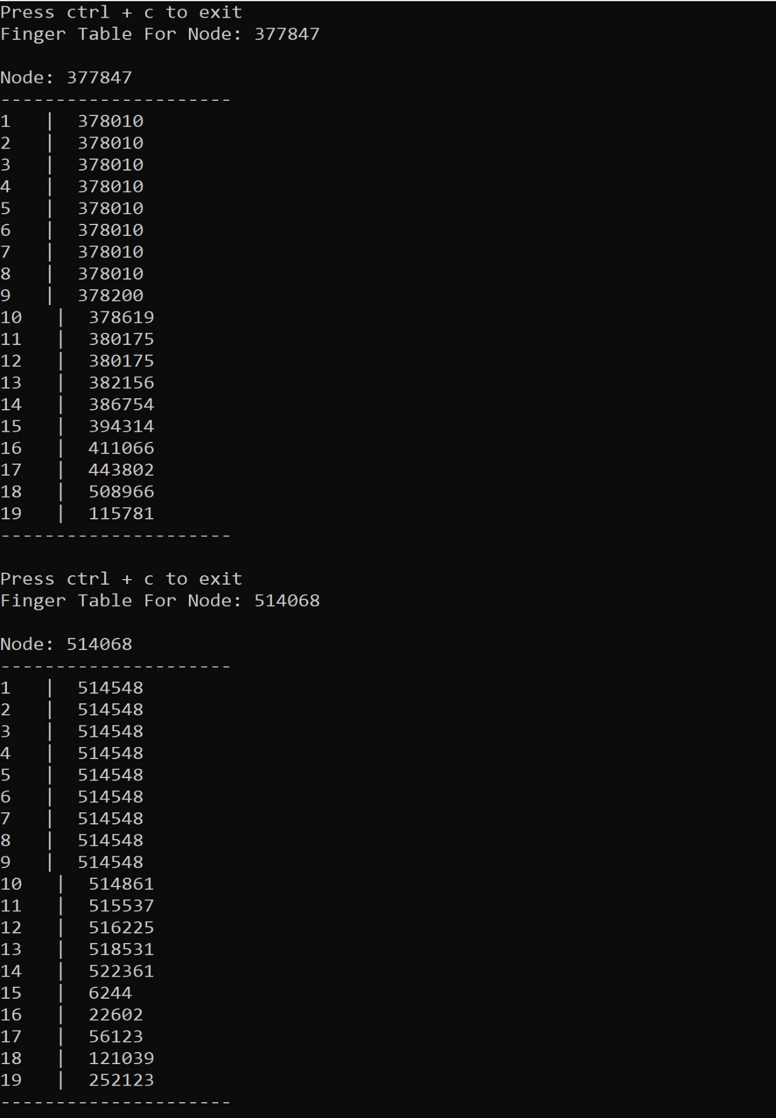

Problem D

**MakeFile**

all:spread

spread: rumorSpreading.c

gcc rumorSpreading.c -o spread

clean:

rm -f spread

**CODE**

/*

* @Author Swapnil Acharya

* @since 4/4/2020

*/

#include <stdlib.h>

#include <stdio.h>

#include <stdbool.h>

#include <string.h>

#include <time.h>

/*

* Struct to minit a node is epidemic protocol

* Stuct constains follwing feilds

* _nodeID: to store id of a node

* _isInfected: boolean variable to indicated whtere the node is infected or not

* _isRemoved: boolean variable to indicated where this node can spread infection or not

*/

**typedef** struct**{**

int _nodeId**;**

bool _isInfected**;**

bool _isRemoved**;**

**}** Node**;**

#define MAX_NODES 1000000 //total nodes used for this simulaton

#define MAX_ROUNDS 1000 //total rounds useddd in this simulation

double PSTOP**[**5**]** **=** **{**0.2**,**0.4**,**0.6**,**0.8**,**1.00**};** //probalbities where a node will stop spreading infection

/*

* This function returns the count of infected nodes in a given nodeList

* @ param _nodeList List of Nodes

* @ return count of susceptible nodes OR nodes that have not been infected

*/

int getNumberOfIgnorantNodes**(**Node**\*** _nodeList**){**

int _count **=** 0**;**

int i **=**0**;**

**for(**i **=** 0**;** i **<** MAX_NODES**;** i**++){**

//if the node is infected then increment the count

**if(** **(*(**_nodeList**+** i**)).**_isInfected **==** false **){**

_count **=** _count **+** 1**;**

**}**

**}**

**return** _count**;** //return the count of infected nodes

**}**

/* This function initialized list of nodes

* @param _nodeList List of nodes

* @return true if the inifialization is sucessfull

*/

bool initializeNodes**(**Node**\*** _nodeList**){**

int i **=** 0**;**

**for(**i **=** 0**;** i **<** MAX_NODES**;**i**++){**

**(*(**_nodeList**+**i**)).**_nodeId **=** i**;** //give nodeid value of node index

**(*(**_nodeList**+**i**)).**_isInfected **=** false**;** //initialilly set node as susceptible

**(*(**_nodeList**+**i**)).**_isRemoved **=** false**;** //initially set node so that it can continue to gossip

**}**

srand**(**time**(**0**));** //seed random to be current time

int _infectToIndex **=** rand**()** **%** MAX_NODES**;** //get a random index

**(*(**_nodeList**+**_infectToIndex**)).**_isInfected **=** true**;** //infect the randomly selected node

**return** true**;**

**}**

int main**(**int _argc**,** char **\***_argv**[]){**

//create Nodes by dynaically allocation

Node**\*** _nodeList **=** **(**Node **\*)**malloc**(**MAX_NODES **\*** **sizeof(**Node**));**

//seed random

srand**(**time**(**0**));**

//start infection by rumor spreading

printf**(**"\n\nStarted Demonstration of Epidemic Protcol,\n by spreading disease via Rumor Spreading\n\n"**);**

printf**(**"Total Nodes: %i Total ROunds: %i\n\n"**,**MAX_NODES**,**MAX_ROUNDS**);**

int i **=** 0**;**

int j **=** 0**;**

int k **=** 0**;**

float _prob **=** 0.00000**;**

double _fractionIgnorant **=** 0.0000**;**

int _ignorantNodes **=** 0**;**

int _indexToInfect **=** 0**;**

//times to find run time

time_t _startTime**,** _endTime**;**

time**(&**_startTime**);** //get current time

**for(**k **=** 0**;** k **<** 5**;** k**++){** //oop for PSTOP values

initializeNodes**(**_nodeList**);** //intialize list of nodes

**for(**i**=**0**;** i **<** MAX_ROUNDS**;** i**++){** //do for maxmum number of rounds

//EVERY NODE SELCTS RANDOM NODE TO EXCHANGE INFO

**for(**j **=** 0**;** j **<** MAX_NODES**;** j**++){**

**if(** **(** **(*(**_nodeList**+**j**)).**_isInfected **==** true**)** **&&** **(** **(*(**_nodeList**+**j**)).**_isRemoved **==** false **)** **){**

_indexToInfect **=** rand**()** **%** MAX_NODES**;** //select a random index for node to infect

//if a radomlyy selected node is not infected, then infec the node

**if(** **(*(**_nodeList**+**_indexToInfect**)).**_isInfected **==** false**){**

**(*(**_nodeList **+** _indexToInfect**)).**_isInfected **=** true**;**

**}**

//else if a node is already infected then calculate probability that it will stop spreading rumour

**else{**

_prob **=** **(**double**)** **(**rand**()** **%** MAX_NODES**)** **/** **(**double**)** MAX_NODES**;** //get a probability betwwen 0 and 1

**if(** _prob **<** PSTOP**[**k**]** **)** **{** //if the calcualted probility is less thatn the given probability

**(*(**_nodeList **+** j**)).**_isRemoved **=** true**;** //then stop the node from spreading rumors

**}**

**}**

**}**

**}**

**}**

_ignorantNodes **=** getNumberOfIgnorantNodes**(**_nodeList**);** //get number of suceptible nodes

_fractionIgnorant **=** **(**double**)**_ignorantNodes**/(**double**)**MAX_NODES**;** //get the faction os suceptible nodes

printf**(**"PSTOP: %0.2f | S: %f | IgnorantNodes: %i\n"**,**PSTOP**[**k**],**_fractionIgnorant**,**_ignorantNodes**);** //display the results

**}**

//display elapsed time

time**(&**_endTime**);**

double _elapsedTime **=** difftime**(**_endTime**,**_startTime**);**

printf**(**"ElapedTIme: %0.3f seconds\n"**,**_elapsedTime**);**

//free memory allocated in heap for Node List

free**(**_nodeList**);**

printf**(**"\nDesmostration of Epidemic Protocol Complete\n\n"**);**

**return** 0**;**

**}**

**OUPUT Part A**

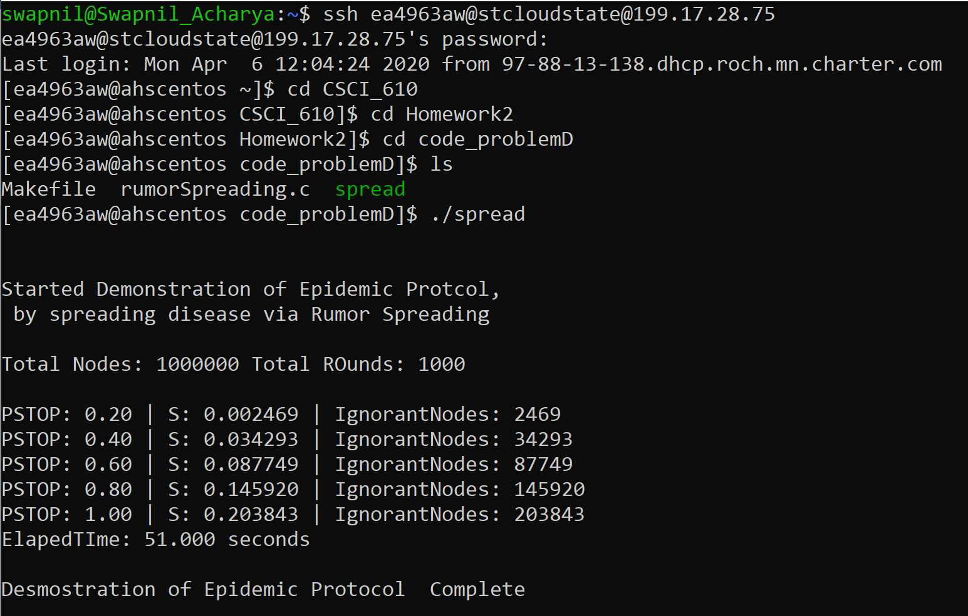

**Output Part B**

The fraction s was calculated using wolfram alpha online, please see pictures at the end of this document to see how these values were derived.

|  |  |
| --- | --- |
| **Pstop** | **s from wolfram Alpha** |
| 0.2 | 0.00251646 |
| 0.4 | 0.0340152 |
| 0.6 | 0.0878184 |
| 0.8 | 0.146578 |
| 1 | 0.203188 |

**Output Part C  
  
Part A Chart**

**Part B Chart**

**WOLFRAM ALPHA SOLITIONS:**

**PSTOP = 0.2**

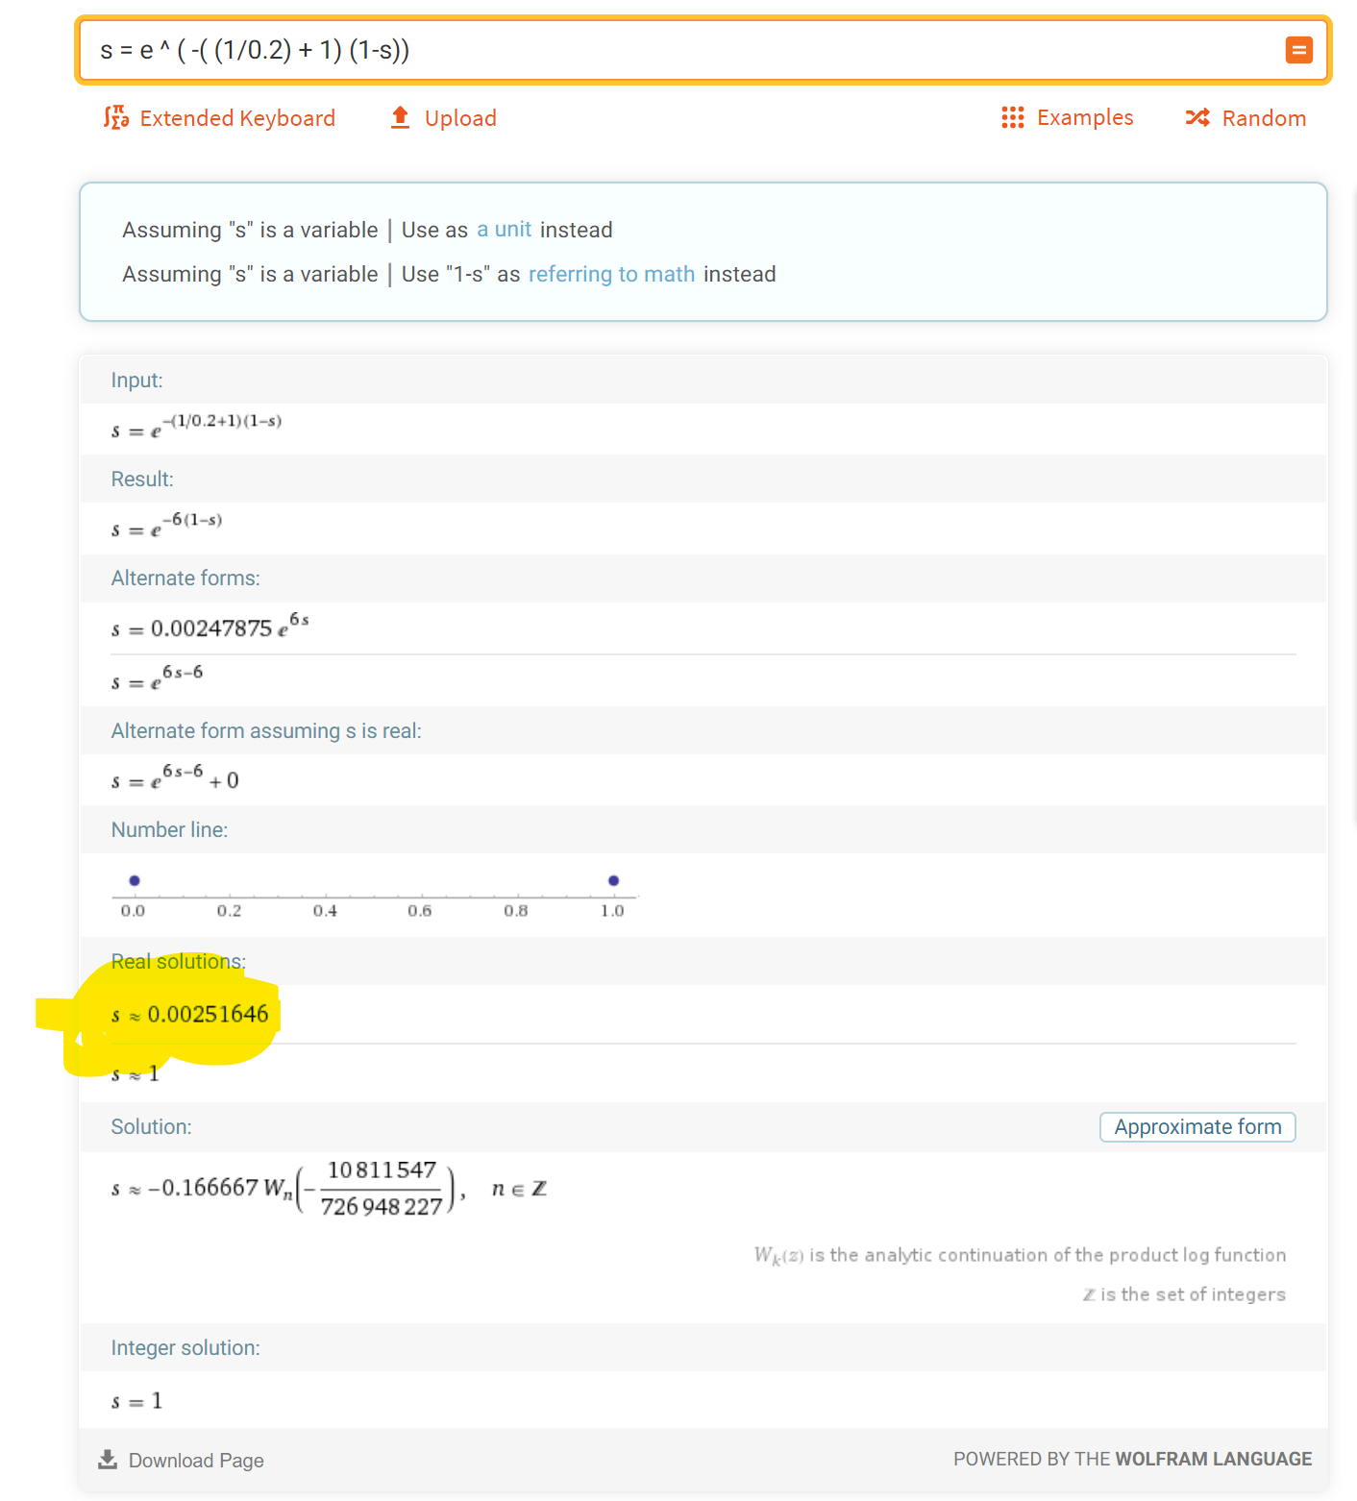

**PSTOP = 0.4**

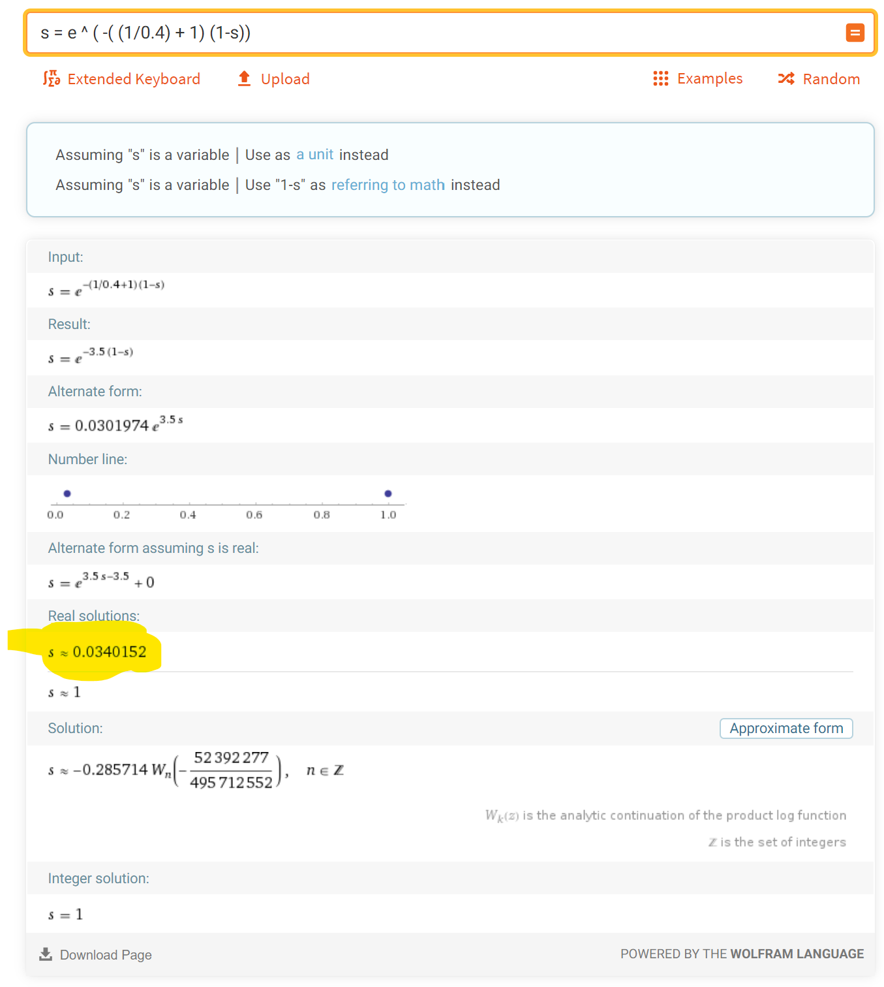

**PSTOP = 0.6**

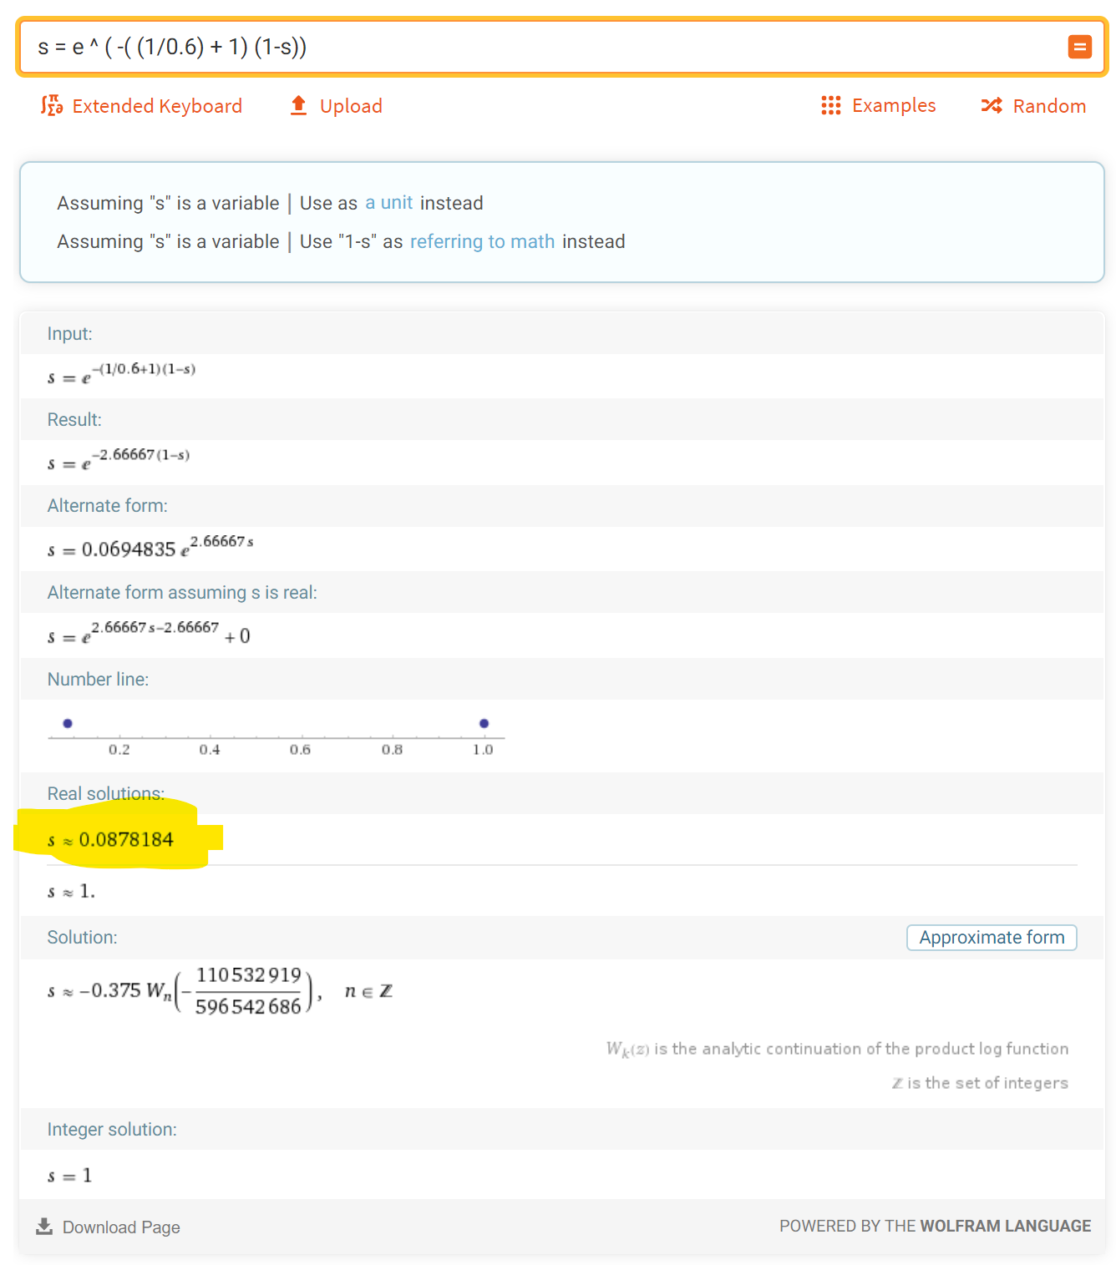

**PSTOP = 0.8**

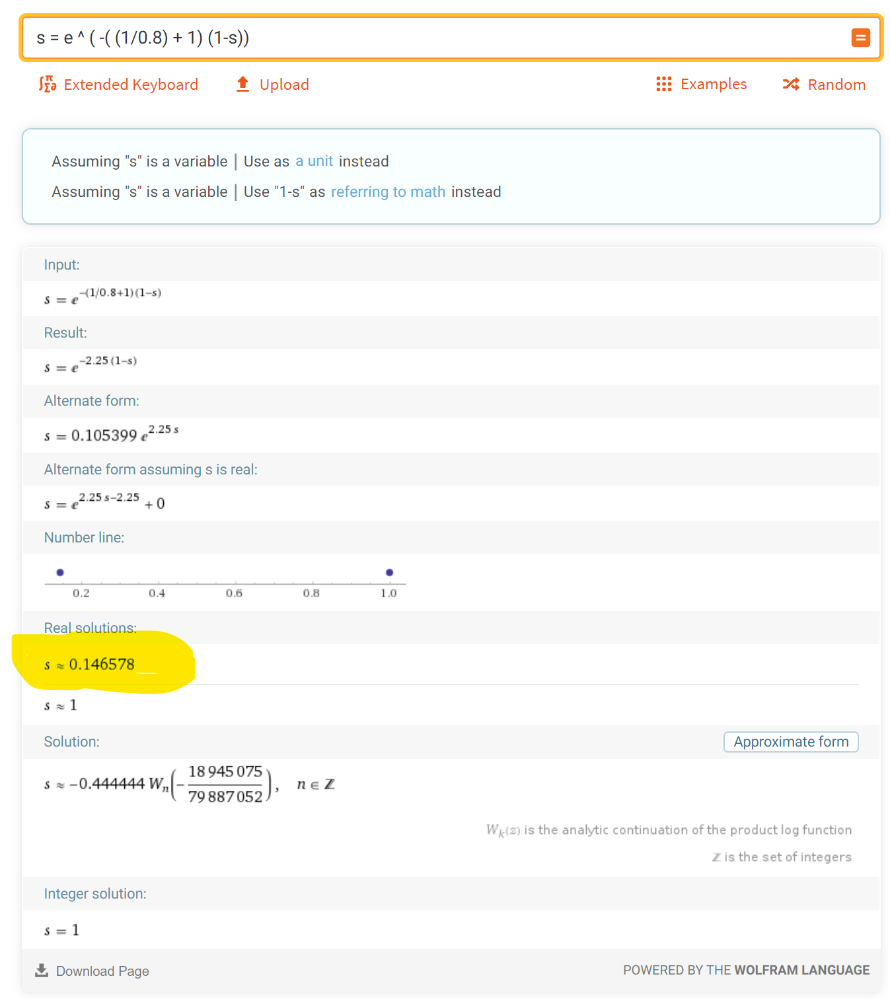

**P = 1.0**

