PhytoSense AR: Augmented-Reality Plant Disease Diagnosis Using a Field-Adapted Vision Transformer and Colour-Based Lesion Segmentation
Yameesh Nayak  B.Tech (IT), Enrollment No. 0801IT231153  Department of Information Technology  Shri G. S. Institute of Technology and Science (SGSITS)  Indore, India  0801it231153@sgsits.ac.in | Dr. Puja Gupta  Assistant Professor (Project Guide)  Department of Information Technology  Shri G. S. Institute of Technology and Science (SGSITS)  Indore, India

Abstract—Plant diseases cause substantial crop losses, and smallholder farmers often lack timely access to expert diagnosis. Deep-learning classifiers trained on the PlantVillage dataset report near-perfect accuracy, yet they degrade sharply on photographs captured in the field. This paper presents PhytoSense AR, a free, browser-based diagnosis system that overlays disease information directly on the live camera view. The system combines a colour-space leaf and lesion segmentation stage, based on HSV thresholds and the Excess-Green index, with a Vision Transformer (ViT-B/16) classifier covering 38 classes across 14 crops. To narrow the gap between laboratory and field imagery, the classifier was fine-tuned on a mixture of PlantVillage and the PlantDoc field dataset with augmentation that simulates changes in zoom, orientation, illumination and focus, and was then exported to an 8-bit quantised ONNX model of 87 MB that runs on a CPU without PyTorch. On the PlantDoc test set of 236 unseen field images, top-1 accuracy rose from 37.7 % for the original PlantVillage-only model to 76.7 % for the deployed quantised model, while accuracy on 760 held-out PlantVillage images remained at 99.9 %. End-to-end processing, including segmentation and classification, takes about 200 ms per image on a laptop CPU. The system also estimates an infected-area severity and a health score, provides treatment guidance from a curated knowledge base, and offers a multilingual assistant. The results show that domain-adaptive fine-tuning on a modest field dataset, combined with lightweight deployment, makes AR-assisted plant diagnosis practical on commodity hardware.
Index Terms—plant disease detection, vision transformer, augmented reality, domain adaptation, model quantization, precision agriculture.
I. Introduction
A. Background
Agriculture remains the principal source of livelihood for a large share of India's population, and plant diseases are one of the most persistent threats to its productivity. A global expert survey estimated that pathogens and pests reduce the yields of wheat, rice, maize, potato and soybean by roughly 17–30 % [1], with the heaviest losses in food-deficit regions. Early and correct identification of a disease decides whether a farmer applies the right treatment in time, applies an unnecessary chemical, or loses the crop. Expert diagnosis through agricultural extension officers is accurate but slow and unevenly available, especially for smallholders in rural areas.
The wide adoption of smartphones has made image-based diagnosis a realistic alternative. The release of the open PlantVillage image collection [2] enabled a series of deep-learning studies that report accuracies above 99 % for leaf-disease classification [3], [4]. These results created strong interest in mobile diagnostic tools that a farmer can use by simply photographing a leaf.
B. Problem Statement
Most published classifiers are trained and tested on PlantVillage, whose images show a single detached leaf on a uniform background under controlled lighting. Several studies have shown that models trained on such images lose much of their accuracy on photographs taken in real fields, where backgrounds are cluttered, several leaves overlap, and lighting and focus vary [3]–[6]. The present project encountered exactly this behaviour: an early prototype that used a publicly available PlantVillage-trained Vision Transformer achieved only 37.7 % top-1 accuracy on the PlantDoc field test set, although it classified the laboratory samples almost perfectly. In addition, typical classifiers return only a label; they do not show the user where the symptoms are or how much of the leaf is affected, and many prototypes depend on GPUs or paid cloud services that are impractical for farmers and for student projects.
C. Motivation
A useful field tool must therefore satisfy four conditions at once: it must work on real photographs, explain its result visually, give actionable advice, and run at no cost on ordinary hardware. Augmented reality (AR) offers a natural way to explain a result, because the diagnosis can be drawn directly over the live camera image of the leaf. Recent advances in Vision Transformers [7] and post-training quantisation [8] make it possible to run an accurate model on a CPU, which removes the need for dedicated hardware.
D. Objectives
The objectives of the project are: (i) to identify 38 disease and healthy classes across 14 crops from a leaf image; (ii) to localise the leaf and its lesions and present them as a live AR overlay; (iii) to estimate the infected-area severity and an overall health score; (iv) to provide treatment and prevention guidance and an interactive multilingual assistant; and (v) to achieve all of this with free, open-source components that run on a laptop CPU or a free cloud instance.
E. Contributions
The main contributions of this work are as follows:
- An end-to-end, zero-cost diagnosis system, PhytoSense AR, delivered as an installable Progressive Web App (PWA) that overlays the leaf outline, lesion regions and diagnosis on the live camera view.
- A training-free colour-space segmentation stage that combines HSV thresholds, the Excess-Green index and a border-based background model to localise the leaf and its lesions, from which an infected-area severity and a health score are derived.
- Field-adaptive fine-tuning of a ViT-B/16 classifier on PlantVillage and PlantDoc [6], with an explicit mapping of PlantDoc classes onto the 38-class taxonomy, which raised field accuracy from 37.7 % to 76.7 % without loss of laboratory accuracy.
- A CPU-only deployment based on an 8-bit quantised ONNX model (87 MB, about 200 ms per image), small enough for a 512 MB free cloud instance.
- A transparent evaluation that reports per-class field accuracy and states the limitations of the approach.
F. Paper Organisation
Section II reviews related work and identifies the research gap. Section III describes the proposed system and its algorithms. Section IV covers the implementation. Section V presents and discusses the results, and Section VI concludes the paper and outlines future work.
II. Literature Review
A. Classifiers Trained on Laboratory Images
Mohanty et al. [3] trained AlexNet and GoogLeNet on 54,306 PlantVillage images of 38 classes and reached 99.35 % accuracy on a held-out split. The same work showed that accuracy dropped to about 31 % on images collected from other sources, an early warning about generalisation. Ferentinos [4] evaluated several CNN architectures on 87,848 images covering 58 plant–disease combinations, including some field images, and obtained 99.53 % with VGG; the study also reported a sharp fall in accuracy when models trained on laboratory images were tested on field images. Too et al. [9] compared the fine-tuning of VGG-16, Inception-v4, ResNet and DenseNet on PlantVillage and found that DenseNet-121 offered the best accuracy with fewer parameters. Atila et al. [10] applied EfficientNet variants to PlantVillage and reported accuracies above 99 % on both the original and an augmented version. These works established strong baselines, but all of them were evaluated mainly on images from the same laboratory distribution.
B. Generalisation and Field Data
Barbedo [5] analysed the factors that limit deep learning for plant disease recognition and identified the lack of diverse, field-representative training data, background clutter, and symptom variability as the main obstacles. In a follow-up study, Barbedo [11] classified individual lesions and spots instead of whole leaves, which increased the effective size of the dataset and improved accuracy, but required lesion-level annotation. Singh et al. [6] released PlantDoc, a dataset of about 2,600 images of 13 plant species and 27 classes gathered from real-world sources, and demonstrated that models trained only on PlantVillage perform poorly on field images while fine-tuning on PlantDoc improves them considerably. Li et al. [12] reviewed deep-learning methods for plant disease detection and classification and highlighted small field datasets, early-stage symptom detection and robustness to imaging conditions as open problems. Ahmad et al. [13] surveyed more than one hundred studies and recommended that future tools be validated on field images and designed for the needs of end users.
C. Mobile and Transformer-Based Approaches
Ramcharan et al. [14] deployed a MobileNet-based object detector for cassava diseases on a smartphone and observed that performance on real-world video was lower than on curated test images, which underlines the difficulty of in-field use. Borhani et al. [15] compared Vision Transformer, CNN and hybrid models on several plant disease datasets and reported that attention-based models can match or exceed CNN accuracy, with a trade-off in inference speed. Thakur et al. [16] proposed PlantXViT, a lightweight combination of convolutional blocks and a Vision Transformer with explainability, aimed at deployment on resource-limited devices. Table I summarises the reviewed works.
TABLE I
Summary of Reviewed Works
Ref. | Approach | Data | Main limitation
[3] 2016 | AlexNet, GoogLeNet | PlantVillage | Accuracy falls to ~31 % on other sources
[4] 2018 | VGG and other CNNs | 87,848 lab + field images | Lab-trained models weak on field images
[5] 2018 | Analysis of limiting factors | Multiple | No deployable system
[9] 2019 | Fine-tuned DenseNet, ResNet | PlantVillage | Laboratory images only
[11] 2019 | Lesion-level CNN | Own field lesions | Needs lesion annotation
[14] 2019 | MobileNet detector on phone | Cassava field images | Single crop; lower accuracy on video
[6] 2020 | PlantDoc dataset, CNN fine-tuning | ~2,600 field images | Small dataset; no application
[10] 2021 | EfficientNet B0–B7 | PlantVillage | Laboratory images only
[12] 2021 | Review | — | Identifies open problems only
[15] 2022 | ViT, CNN and hybrids | Several public datasets | Speed–accuracy trade-off; no AR or advice
[16] 2022 | PlantXViT (CNN + ViT) | Several public datasets | No localisation or severity
[13] 2023 | Survey | — | Calls for field-validated tools

D. Research Gap
The reviewed literature reveals three gaps. First, most high-accuracy models are validated only on laboratory images, and the few field-oriented studies seldom deliver a working application. Second, classification-only systems do not localise symptoms or quantify severity, so the user cannot verify the result visually. Third, deployable tools frequently rely on GPUs, paid APIs or a single crop. PhytoSense AR addresses these gaps by combining field-adaptive fine-tuning, training-free lesion localisation with severity estimation, AR presentation, a treatment knowledge base and CPU-only, zero-cost deployment in one system that is evaluated on an independent field test set.
III. Proposed System and Methodology
A. System Architecture
PhytoSense AR follows a three-tier client–server architecture (Fig. 1). The client tier is a PWA written in plain JavaScript that captures camera frames, draws the AR overlay on an HTML canvas and shows results, history, the disease library and the assistant. The application tier is a Python FastAPI service that performs segmentation, classification, scoring and knowledge lookup and exposes a REST API. The data tier holds the ONNX model, a JSON knowledge base and an SQLite database of past scans; external services (Wikipedia and, optionally, Google Gemini [17]) are used only for supplementary information.
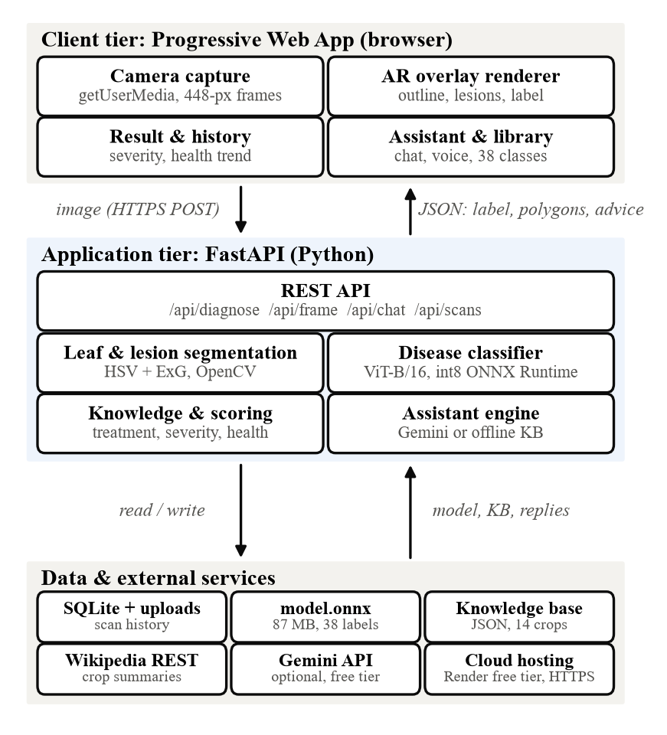
Fig. 1. Three-tier architecture of PhytoSense AR. The browser sends images over HTTPS; the FastAPI service returns the diagnosis together with leaf and lesion polygons for the AR overlay.
B. Workflow
The system operates in two modes. In live AR mode, the client downscales the camera frame so that its longer side is 448 pixels, encodes it as JPEG and posts it to /api/frame; the next frame is sent as soon as the previous response arrives, which yields about two to three overlay updates per second on a laptop CPU. These frames are not stored. In capture mode, the shutter sends the full-resolution photo to /api/diagnose; the full result, including the photo, is saved to the history. Both modes run the same pipeline, shown in Fig. 2.
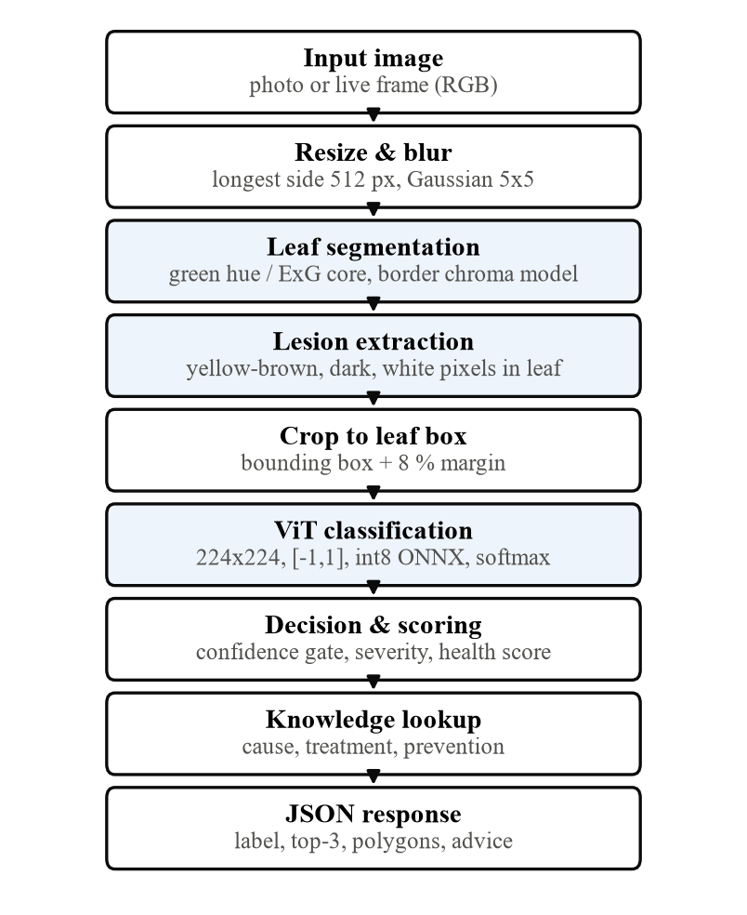
Fig. 2. Per-image diagnosis pipeline. Shaded stages perform the computer-vision and deep-learning steps; the remaining stages handle pre-processing, decision logic and response construction.
C. Leaf and Lesion Segmentation
The segmentation stage localises the leaf and its lesions without any trained model. The image is resized so that its longer side is at most 512 pixels and smoothed with a 5 × 5 Gaussian filter. Healthy tissue is detected in HSV space (OpenCV hue range 0–179) as pixels with a green hue of 33–95 that are either sufficiently saturated and bright or have a clearly positive Excess-Green index [18]:
ExG = 2G − R − B, green if ExG > 25. (1)
The largest connected green region, after morphological opening, forms the leaf core; images whose core covers less than 2 % of the frame are reported as no leaf. To include blighted margins without absorbing a brown table or soil, a background model is estimated from a six-pixel image border: the median a* and b* values in CIELAB are computed, and any pixel whose chroma lies within a distance of 9 from that median is treated as background-like. Symptom-coloured pixels (yellow, tan, brown, rust and purple-red hues) that touch the core and are not background-like are added to the leaf. If this growth exceeds three times the core area or reaches the image border on several sides, the hole-filled core alone is used. Inside a slightly eroded leaf mask, lesion pixels are those with symptom tones, dark necrotic values (V < 60) or white powdery coating (low saturation, V > 175) that are not green. After morphological opening and closing, contours smaller than 0.05 % of the leaf area are discarded and up to 40 lesion contours are simplified to polygons. The infected-area severity is
S = min(100, 100 · A_{lesion} / A_{leaf}), (2)
where A_{lesion} and A_{leaf} are the pixel areas of the lesion contours and of the leaf. The procedure is summarised in Algorithm 1.
Algorithm 1: Leaf and lesion segmentation
Input: RGB image I Output: leaf polygon, lesion polygons, bbox, S
1: I ← resize(I, max side 512); I ← GaussianBlur(I, 5×5)
2: G ← green hue ∧ (saturated ∧ bright ∨ ExG > 25)
3: core ← largest component(open(G))
4: if area(core) < 2 % of image then return no leaf
5: bg ← |(a*, b*) − median of border (a*, b*)| < 9
6: grown ← components of close(G ∨ (tone ∧ ¬bg)) touching core
7: if grown > 3·core or touches ≥ 2 borders then leaf ← fill(core)
8: else leaf ← fill(grown)
9: les ← (tone ∨ dark ∨ white) ∧ ¬G ∧ erode(leaf)
10: les ← close(open(les)); drop contours < 0.05 % of leaf
11: S ← 100·area(les) / area(leaf)
12: return polygons(leaf), polygons(les)[1..40], bbox(leaf), S

D. Disease Classification
The original image is cropped to the leaf bounding box with an 8 % margin, so that the classifier sees mainly leaf tissue, and is resized to 224 × 224 pixels with bilinear interpolation. Each channel value x ∈ [0, 255] is mapped to [−1, 1]:
x′ = x / 127.5 − 1. (3)
The classifier is a ViT-B/16 Vision Transformer [7] with 12 encoder layers, a hidden size of 768 and 12 attention heads. The image is split into 196 patches of 16 × 16 pixels, which are linearly embedded, combined with a learnable class token and position embeddings, and processed by self-attention. The class-token output is mapped to logits z_{k} for the K = 38 classes and converted to probabilities by the softmax function:
p_{k} = exp(z_{k}) / Σ_{j} exp(z_{j}), k = 1, …, K. (4)
The three most probable classes are returned. The starting checkpoint is a publicly available ViT-B/16 that had been fine-tuned on PlantVillage; Section III-E describes how it was adapted to field images.
E. Field-Adaptive Fine-Tuning
Data. Two datasets were combined (Table II). From PlantVillage [2], up to 250 images per class were drawn for training, and a disjoint set of 20 images per class was held out to test whether laboratory accuracy is retained. PlantDoc [6] supplied real-field photographs; 10 % of its training split was reserved for validation, and its official test split was used only for the final evaluation. Each of the 28 PlantDoc training classes was mapped to the equivalent label of the 38-class taxonomy (e.g. Bell_pepper leaf spot → Pepper, bell — Bacterial spot, Corn leaf blight → Corn — Northern Leaf Blight), so the application's knowledge base and interface remained unchanged. Because PlantDoc is small, each field image was presented four times per epoch, each time with a different random augmentation. All images were downscaled once so that the longer side was 384 pixels, which reduced decoding time during training.
TABLE II
Data Used for Fine-Tuning and Evaluation
Subset | Images | Use
PlantVillage training | 9,382 | Training (≤ 250 per class)
PlantVillage held-out | 760 | Test, laboratory (20 per class)
PlantDoc training | 2,108 | Training (×4 per epoch)
PlantDoc validation | 234 | Model selection
PlantDoc test (official) | 236 | Test, field images
Samples per epoch | 17,814 | 9,382 + 4 × 2,108

Augmentation. Training images were transformed by random resized cropping (scale 0.25–1.0, aspect ratio 0.7–1.4) to simulate partial leaves and varying distance, horizontal and vertical flips, rotation of up to ±25°, colour jitter (brightness and contrast 0.4, saturation 0.3, hue 0.03) to simulate sunlight, shade and different phone cameras, and Gaussian blur (σ = 0.1–2.0, probability 0.3) to simulate out-of-focus shots. Validation and test images were only resized, exactly as in the deployed application.
Optimisation. The network was trained end-to-end with the cross-entropy loss with label smoothing [19], which discourages over-confident predictions on the noisier field labels:
ℒ = −Σ_{k} q_{k} log p_{k}, q_{k} = (1 − ε)y_{k} + ε/K, (5)
where y is the one-hot target and ε = 0.1. The AdamW optimiser [20] was used with the settings in Table III. The checkpoint with the highest PlantDoc validation accuracy was kept.
TABLE III
Fine-Tuning Hyperparameters
Parameter | Value
Initial model | ViT-B/16, PlantVillage checkpoint
Optimiser | AdamW, weight decay 0.05
Learning rate / schedule | 3 × 10⁻⁵, cosine, 6 % warm-up
Batch size / epochs | 32 / 8
Loss | Cross-entropy, label smoothing 0.1
Precision / gradient clip | FP16 mixed precision / norm 1.0
Hardware | NVIDIA Tesla T4 (16 GB), Google Colab

F. Quantisation and Deployment
The selected model was exported to ONNX (opset 17) and quantised with dynamic post-training quantisation [8]: weights are stored as unsigned 8-bit integers and activations are quantised at run time. This reduces the file to 87 MB and allows inference with ONNX Runtime on the CPU, so PyTorch is not needed in production. The complete service uses about 230 MB of memory, which fits the 512 MB limit of free cloud plans.
G. Decision Logic, Severity and Health Score
The response status is no_leaf if segmentation fails, uncertain if the top-1 probability is below 0.55, and otherwise healthy or diseased according to the predicted class. For diseased leaves, severity is graded as early (S < 5 %), moderate (5 % ≤ S < 20 %) or severe (S ≥ 20 %). A health score H ∈ [5, 95] combines the urgency of the disease, taken from the knowledge base, with the measured severity:
H = clip(100 − P_{u} − 1.5S, 5, 95), (6)
where P_{u} is 25, 12 or 5 for high, medium or low urgency, respectively. A healthy leaf scores 100, or 90 if more than 10 % of its area shows discolouration.
H. Knowledge Base and Assistant
A curated JSON knowledge base contains an entry for each of the 38 classes with symptoms, cause, chemical and organic treatment, prevention measures and urgency, together with crop information and Hindi crop names; a short Wikipedia summary of the crop is added at run time. The assistant forwards the user's question, the conversation history and the current diagnosis to Google Gemini [17] under a system prompt restricted to farming topics, and can reply in nine languages (English, Hindi, Marathi, Tamil, Telugu, Kannada, Bengali, Gujarati and Punjabi). When no API key is configured or the network is unavailable, it answers from the local knowledge base instead.
I. Justification of Technology Choices
A Vision Transformer was selected because self-attention relates distant lesions across the whole leaf and transfers well from pre-training [7], [15]. ONNX Runtime with int8 weights was chosen over PyTorch to meet the memory limit of free hosting. Classical colour segmentation was preferred for localisation because pixel-level lesion annotations, which a learned segmentation model would require, are not available for the 38 classes. FastAPI provides asynchronous request handling and automatic API documentation, while a framework-free PWA keeps the client small, installable and usable on low-end Android phones.
IV. Implementation
A. Modules
The backend consists of seven Python modules: vision.py (segmentation, Algorithm 1), classifier.py (ONNX inference), diagnosis.py (pipeline, status, severity and health score), knowledge.py (knowledge base and Wikipedia lookup), assistant.py (Gemini and offline answers), db.py (SQLite history, capped at 500 scans to bound disk use) and main.py (REST endpoints for diagnosis, live frames, scan history, the disease library and chat). The frontend is organised into modules for the AR scanner and overlay renderer, the result sheet with read-aloud via the Web Speech API, the history view with a health-trend chart, the searchable disease library, and the chat assistant with voice input. A service worker caches the application shell so that the interface opens offline.
[Insert Fig. 3: Screenshot of the AR live scanner showing the dashed leaf outline, highlighted lesion patches and the floating label (crop, disease, confidence, infected %, health)]
Fig. 3. AR live scanner of PhytoSense AR on a smartphone. [Add a one-line description of the photographed leaf.]
B. Development Environment
The backend was developed in Python with FastAPI and Uvicorn, OpenCV, NumPy, Pillow and ONNX Runtime. Fine-tuning used PyTorch, Hugging Face Transformers and torchvision in a Google Colab notebook on a free Tesla T4 GPU. The frontend uses HTML5, CSS and JavaScript with the MediaDevices camera API and the Canvas 2D API. Automated tests written with pytest cover segmentation, the knowledge base, the API, the history limit and the assistant; all eight tests pass with the fine-tuned model. The service is containerised with Docker and deployed on the Render free plan, which provides the HTTPS connection that browsers require for camera access.
TABLE IV
Hardware and Software Requirements
Component | Requirement
Server CPU / RAM | Any x86-64 CPU, ≥ 512 MB RAM (≈ 230 MB used)
Server GPU | Not required
Storage | ≈ 100 MB (model 87 MB) + scan photos
Client | Smartphone or PC with camera and modern browser
Server software | Python ≥ 3.10, FastAPI, ONNX Runtime, OpenCV
Training (one-off) | Google Colab, NVIDIA T4 GPU, PyTorch
Connectivity | HTTPS; Internet only for Wikipedia and Gemini

V. Results and Discussion
A. Evaluation Protocol
Top-1 accuracy was measured on two test sets that were never used for training or model selection: the official PlantDoc test split (236 field images, 27 classes) and the 760 held-out PlantVillage images. Both sets were preprocessed exactly as in the application. The laboratory figure should be interpreted as an upper bound, because the starting checkpoint was trained by a third party on PlantVillage and may already have seen some of these images.
B. Training Behaviour
Fig. 4 shows that the training loss decreased from 1.355 to 0.711 over eight epochs. PlantDoc validation accuracy reached 76.1 % after the first epoch and peaked at 79.5 % in epoch 7, whose weights were retained. Each epoch took about 185 s on the T4 GPU, so fine-tuning completed in approximately 25 minutes.
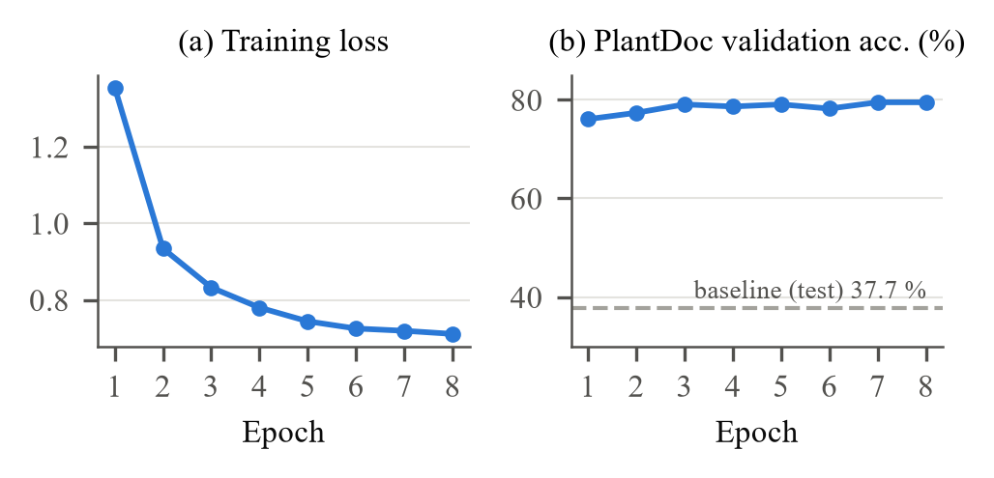
Fig. 4. Fine-tuning progress: (a) training loss (with label smoothing) and (b) accuracy on the PlantDoc validation split. The dashed line marks the original model's accuracy on the PlantDoc test set.
C. Classification Accuracy
Table V and Fig. 5 compare the original and fine-tuned models. Field accuracy approximately doubled, from 37.7 % to 75.4 % for the FP32 model and 76.7 % for the deployed int8 model, while laboratory accuracy stayed at or near 100 %. The small advantage of the int8 model corresponds to three images and lies within sampling variation; with 236 test images, the 95 % confidence interval of the int8 result is about ±5.4 percentage points. Quantisation therefore did not measurably reduce accuracy.
TABLE V
Top-1 Accuracy Before and After Fine-Tuning
Model | PlantDoc test (field) | PlantVillage held-out
Original (PlantVillage only) | 37.7 % | 100.0 %
Fine-tuned, FP32 | 75.4 % | 100.0 %
Fine-tuned, int8 ONNX (deployed) | 76.7 % | 99.9 %

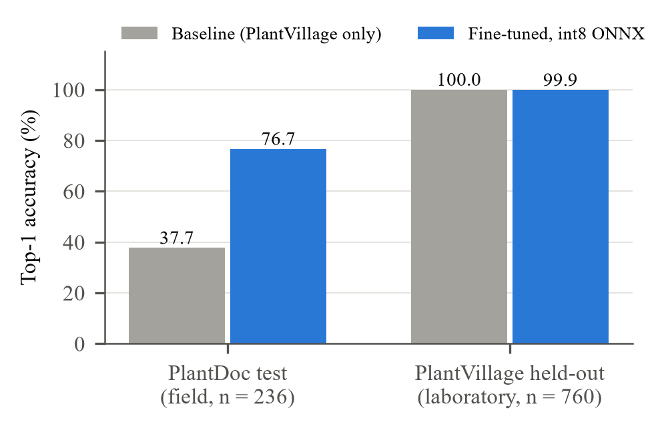
Fig. 5. Top-1 accuracy of the original and the deployed fine-tuned model on field (PlantDoc) and laboratory (PlantVillage) test images.
D. Per-Class Analysis
Fig. 6 reports per-class field accuracy. Healthy leaves of most crops, squash powdery mildew, apple scab, corn common rust and grape black rot are recognised with 88–100 % accuracy, because their symptoms or textures are visually distinctive. The weakest classes are corn gray leaf spot (25 %), potato early blight (38 %) and tomato bacterial spot (44 %). Their errors mostly fall into visually similar classes of the same crop, such as northern leaf blight versus gray leaf spot, early versus late blight, and bacterial versus Septoria leaf spot, whose small necrotic lesions are hard to separate in low-resolution field photos. Each class has only 4–12 test images, so per-class figures carry large uncertainty.
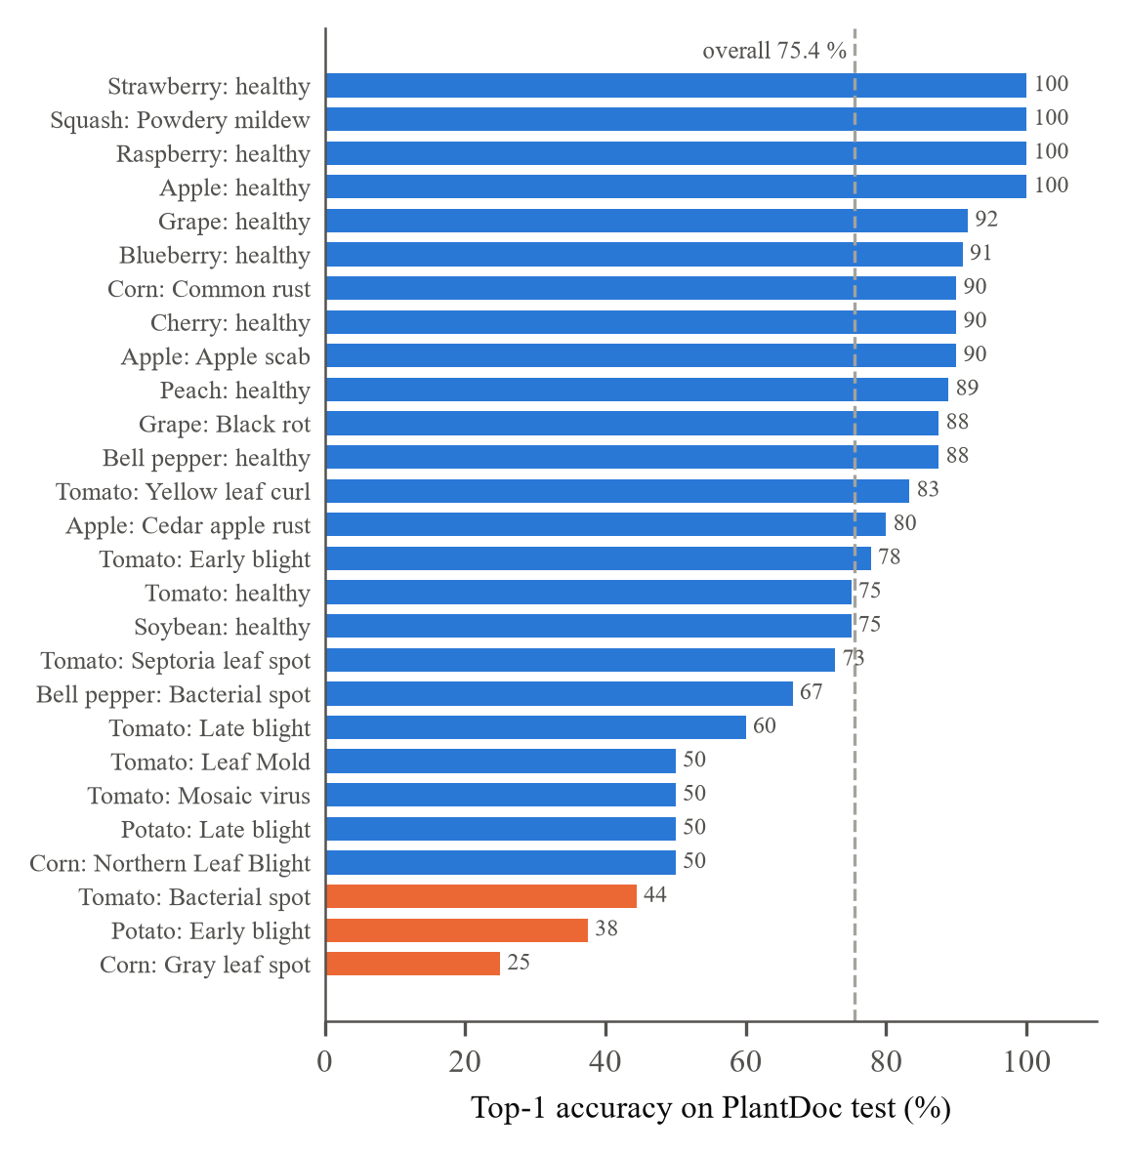
Fig. 6. Per-class top-1 accuracy of the fine-tuned model on the PlantDoc test set. Orange bars mark classes below 50 %; the dashed line marks the overall accuracy.
E. Runtime Performance
Table VI lists the runtime characteristics measured for the deployed configuration. On a laptop CPU, segmentation and classification together take about 190–200 ms per image. A separate check on 40 randomly drawn PlantVillage test images from a public mirror gave 97.5 % accuracy with a mean confidence of 90.5 %. The lower confidence compared with the original model (98.3 % mean on a similar check) is an expected effect of label smoothing and makes the 0.55 confidence threshold more selective.
TABLE VI
Runtime Characteristics of the Deployed System
Metric | Value
Model size (int8 ONNX) | 87 MB
Server memory use | ≈ 230 MB
Time per image, laptop CPU | ≈ 190–200 ms
Live AR overlay rate, laptop CPU | ≈ 2–3 updates/s
Laptop CPU used for timing | [Add CPU model here]
Time per image on Render free plan | [Add measured value here]
Users who tested the app | [Add number and feedback here]

F. Comparison with Existing Systems
Table VII compares PhytoSense AR with representative approaches from Section II. Direct numerical comparison is avoided because the cited works use different datasets, class sets and test splits. The comparison shows that the proposed system is, among these works, the only one that combines field-adapted classification, visual localisation, severity estimation, treatment advice and zero-cost CPU deployment.
TABLE VII
Feature Comparison with Existing Approaches
Feature | [3], [9], [10] | [6] | [14] | [15], [16] | Ours
Field-image training | No | Yes | Yes | Partly | Yes
Lesion localisation / AR | No | Boxes | Boxes | No | Yes
Severity estimate | No | No | No | No | Yes
Treatment advice | No | No | No | No | Yes
Multilingual assistant | No | No | No | No | Yes
Runs on CPU, no cost | — | — | Phone | Partly | Yes

[Insert Fig. 7: Screenshots of the result sheet (diagnosis, severity, health score, treatment) and the history view with the health-trend chart]
Fig. 7. Result and history screens of PhytoSense AR.
G. Discussion and Limitations
The results confirm the main hypothesis of the work: a model that is almost perfect on laboratory images can fail on field images, and modest field data combined with realistic augmentation largely closes this gap. Several limitations remain. The classifier is closed-set: a plant outside the 14 supported crops is still assigned one of the 38 labels, which the confidence threshold mitigates only partly. Ten classes, including citrus greening, grape Esca and tomato target spot, have no field training images and rely on laboratory data alone. The colour-based segmentation performs well for distinct spots, blights, rusts and mildews but is weaker for diffuse symptoms such as mosaic mottling or mite damage, and for scenes with many overlapping leaves; its severity values have not yet been validated against expert annotations [Add validation result here if performed]. Finally, the AR layer is a two-dimensional overlay on the video rather than world-anchored 3-D AR, and live mode requires a network connection to the server.
VI. Conclusion and Future Scope
This paper presented PhytoSense AR, a free AR-based system for plant disease diagnosis that combines training-free leaf and lesion segmentation, a field-adapted Vision Transformer, severity and health scoring, a treatment knowledge base and a multilingual assistant. Fine-tuning on PlantVillage and PlantDoc with field-style augmentation raised top-1 accuracy on unseen field photographs from 37.7 % to 76.7 % while keeping laboratory accuracy at 99.9 %, and int8 quantisation allowed the whole system to run on a CPU in about 200 ms per image within a free cloud instance. These results show that practical, explainable plant diagnosis does not require expensive hardware or paid services.
Future work will address the identified limitations: (i) training a lightweight instance-segmentation network such as YOLO-seg on PlantDoc annotations to localise lesions on multi-leaf scenes; (ii) running inference on the phone with ONNX Runtime Web to remove the network dependency of live mode; (iii) adding an open-set rejection stage or crop selection to handle unsupported plants; (iv) collecting field images of crops important in India, such as rice, wheat and cotton; and (v) validating the severity estimate and the usability of the application in a field study with farmers.
Acknowledgment
The author expresses sincere gratitude to Dr. Puja Gupta, Assistant Professor, Department of Information Technology, Shri G. S. Institute of Technology and Science, Indore, for her valuable guidance, constructive feedback and continuous encouragement throughout this project. The author also thanks the Department of Information Technology for providing the necessary facilities, and the creators of the PlantVillage and PlantDoc datasets for making their data openly available.
References
[1] S. Savary, L. Willocquet, S. J. Pethybridge, P. Esker, N. McRoberts, and A. Nelson, “The global burden of pathogens and pests on major food crops,” Nature Ecology & Evolution, vol. 3, no. 3, pp. 430–439, 2019.
[2] D. P. Hughes and M. Salathé, “An open access repository of images on plant health to enable the development of mobile disease diagnostics,” arXiv preprint arXiv:1511.08060, 2015.
[3] S. P. Mohanty, D. P. Hughes, and M. Salathé, “Using deep learning for image-based plant disease detection,” Frontiers in Plant Science, vol. 7, art. no. 1419, 2016.
[4] K. P. Ferentinos, “Deep learning models for plant disease detection and diagnosis,” Computers and Electronics in Agriculture, vol. 145, pp. 311–318, 2018.
[5] J. G. A. Barbedo, “Factors influencing the use of deep learning for plant disease recognition,” Biosystems Engineering, vol. 172, pp. 84–91, 2018.
[6] D. Singh, N. Jain, P. Jain, P. Kayal, S. Kumawat, and N. Batra, “PlantDoc: A dataset for visual plant disease detection,” in Proc. 7th ACM IKDD CoDS and 25th COMAD, Hyderabad, India, 2020, pp. 249–253.
[7] A. Dosovitskiy et al., “An image is worth 16x16 words: Transformers for image recognition at scale,” in Proc. Int. Conf. Learning Representations (ICLR), 2021.
[8] B. Jacob et al., “Quantization and training of neural networks for efficient integer-arithmetic-only inference,” in Proc. IEEE/CVF Conf. Computer Vision and Pattern Recognition (CVPR), 2018, pp. 2704–2713.
[9] E. C. Too, L. Yujian, S. Njuki, and L. Yingchun, “A comparative study of fine-tuning deep learning models for plant disease identification,” Computers and Electronics in Agriculture, vol. 161, pp. 272–279, 2019.
[10] Ü. Atila, M. Uçar, K. Akyol, and E. Uçar, “Plant leaf disease classification using EfficientNet deep learning model,” Ecological Informatics, vol. 61, art. no. 101182, 2021.
[11] J. G. A. Barbedo, “Plant disease identification from individual lesions and spots using deep learning,” Biosystems Engineering, vol. 180, pp. 96–107, 2019.
[12] L. Li, S. Zhang, and B. Wang, “Plant disease detection and classification by deep learning—A review,” IEEE Access, vol. 9, pp. 56683–56698, 2021.
[13] A. Ahmad, D. Saraswat, and A. El Gamal, “A survey on using deep learning techniques for plant disease diagnosis and recommendations for development of appropriate tools,” Smart Agricultural Technology, vol. 3, art. no. 100083, 2023.
[14] A. Ramcharan et al., “A mobile-based deep learning model for cassava disease diagnosis,” Frontiers in Plant Science, vol. 10, art. no. 272, 2019.
[15] Y. Borhani, J. Khoramdel, and E. Najafi, “A deep learning based approach for automated plant disease classification using vision transformer,” Scientific Reports, vol. 12, art. no. 11554, 2022.
[16] P. S. Thakur, P. Khanna, T. Sheorey, and A. Ojha, “Explainable vision transformer enabled convolutional neural network for plant disease identification: PlantXViT,” arXiv preprint arXiv:2207.07919, 2022.
[17] Gemini Team, Google, “Gemini: A family of highly capable multimodal models,” arXiv preprint arXiv:2312.11805, 2023.
[18] D. M. Woebbecke, G. E. Meyer, K. Von Bargen, and D. A. Mortensen, “Color indices for weed identification under various soil, residue, and lighting conditions,” Transactions of the ASAE, vol. 38, no. 1, pp. 259–269, 1995.
[19] C. Szegedy, V. Vanhoucke, S. Ioffe, J. Shlens, and Z. Wojna, “Rethinking the Inception architecture for computer vision,” in Proc. IEEE Conf. Computer Vision and Pattern Recognition (CVPR), 2016, pp. 2818–2826.
[20] I. Loshchilov and F. Hutter, “Decoupled weight decay regularization,” in Proc. Int. Conf. Learning Representations (ICLR), 2019.

