Crossbite

Crossbite is a buccolingual malrelationship of upper and lower teeth; it can be anterior or posterior, unilateral of bilateral. It may be associated with mandibular displacement on closing (occlusal contact deflects the mandible laterally or anteriorly to allow maximum interdigitation).   
With a lateral displacement, there is often a **centerline shift.** Conventionally, the lower teeth are described relative to the upper (if lower teeth occlude buccal to opposing teeth, a buccal crossbite exists. Conversely, if lower teeth occlude lingual to palatal cusps of upper teeth, a lingual (scissors) crossbite exists).

# Aetiology

## Skeletal Factors

* Mismatch in widths of dental arches or anteroposterior skeletal discrepancy may produce a crossbite of a complete arch segment.
  + A **lingual crossbite** is commonly found in Class II Skeletal Malocclusion
  + A **buccal and/or anterior crossbite** is commonly found in Class III Skeletal Malocclusion
  + Growth restriction of maxilla following cleft repair or of the mandible secondary to condylar trauma can lead to **buccal crossbite**

## Soft Tissue Factors

* With a digit-sucking habit the tongue position is lowered and contraction of cheeks during sucking is unopposed. This displaces the upper posterior teeth palatally and often creates a **crossbite (buccal?)**.

## Dental Factors

* Where the arch is inherently crowded the upper lateral incisor may be displaced palatally and the upper second/third molar pushed into a **scissors (lingual) crossbite**.
  + Retention of primary tooth or early loss of a primary second molar in a crowded arch can lead to permanent successor erupting in crossbite.

# Treatment

Rationale: If a crossbite is associated with a mandibular displacement, there is a functional indication for its correction, as displacing occlusal contacts may **predispose to TMJ problems** in susceptible individuals. In addition, a traumatic displacing anterior occlusion may defect a lower incisor labially and **compromise periodontal support**.

## Treatment of Anterior Crossbite

* 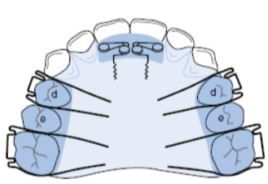Where one or two incisors are in crossbite, there is usually a mandibular displacement. Correction early in the mixed dentition is advisable provided adequate overbite exists to maintain correction.
  + Space must be present in the arch (or created by extraction) to allow alignment of tooth.
  + If tooth inclination is susceptible to tipping, an **upper removable appliance** with **buccal capping** to free the occlusion and a **Z-spring** for proclination may be used.
  + Anterior retention must be good to resist displacing force caused by the action of the spring. Alternatively, an appliance with a **screw section,** clasping the teeth to be moved overcomes this problem.
* Posttreatment, if an insufficient overbite is likely to exist, or incisor body is displaced, the treatment is better carried out with a **fixed appliance** in permanent dentition.

## Treatment of Unilateral Buccal Crossbite

* 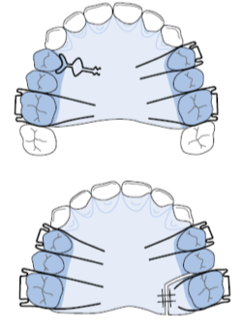An **upper removable appliance** incorporating a **T-Spring** (premolar) or a **Screw Section** (molar) may often be considered for correcting the crossbite.
  + However, where reciprocal movement of opposing teeth is needed, **fixed attachments** should be placed, and **cross-elastics** areused to achieve desired movement.
  + Where a single tooth is mildly displaced from the arch, **relief of crowding** may be necessary to aid crossbite correction.
    - In those with more marked tooth displacement, **extraction** rather than orthodontic alignment may be a better option.
* If a unilateral buccal segment crossbite is associated with mandibular displacement, this usually results from mild mismatch in widths of dental bases, sometimes because of narrowing of upper arch caused by digit sucking.
  + **Grinding** of the relevant primary teeth, where premature contact results in a mandibular displacement.
  + Otherwise, **upper arch expansion** using a **removable appliance** with **midline expansion screw** and **buccal capping**, or by a **quadhelix appliance,** may be used.

## Treatment of Bilateral Buccal Crossbite

* 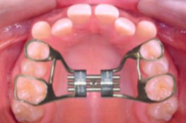A bilateral buccal crossbite is **seldom** associated with **functional problems**. Generally, as its existence indicated an underlying symmetrical transverse skeletal discrepancy, it is best accepted unless correction is planned as part of overall treatment, and **rapid expansion of midpalatal suture** should be attempted only by a specialist.
  + This is achieved by turning a **midline screw** twice daily for 2 weeks
  + Expansion of the suture must be carried out not later than in early teenage years but, based on limited data, it appears that only 25% of the expansion achieved is stable long term. In adults, **Surgically-assisted rapid palatal expansion (SARPE)** may be considered.

## Treatment of Lingual Crossbite of Single Tooth

* Crowding may displace a single tooth into lingual crossbite.
  + Once crowding is **relieved**, crossbite may be corrected by palatal movement of upper unit using a **buccally approaching spring** on a **removable appliance** provided the occlusion is disengaged.

## Treatment of Unilateral Lingual Crossbite

* **Surgical Correction** may be indicated to correct a unilateral lingual crossbite with no displacement.
* If a complete unilateral lingual crossbite is associated with mandibular displacement **lower arch expansion** and **upper arch contraction** with either **removable or fixed appliances** can produce a stable result provided a good buccal intercuspation is achieved.

## Treatment of Bilateral Lingual Crossbite

* **Surgical Correction** may be indicated to correct a complete bilateral lingual crossbite