psychological development

## Aims of treating children

1. Provide positive introduction to dentistry
2. Make child accept dental treatment
3. Provide restorative and preventative care

## Primary vs permanent teeth

* Small size
* Bulbous crowns
* Thinner enamel and dentine
* Prominent pulp horns (avoiding pulp exposure is more difficult)

Establishing effective communication with child is one of first objectives in behavior management. This requires assessment of child’s behavior.

# Theories

|  |  |  |  |
| --- | --- | --- | --- |
| **1. Psychodynamic  *– Freud*** | | **2. Psychosocial  *– Erikson*** | **3. Cognitive Development  *– Piaget*** |
| **Psychoanalytic** | **Psychosexual** |
| **ID – Pleasure Principle** | **Oral  (0 – 1 year)** | **Trust vs Mistrust  (0 – 1 year)** |  |
| * Biologic impulse * Need to eat, drink, avoid pain & reproduce * Necessary for survival | * Characterized by **Passiveness** and **dependency** | * Needs are met – Trust * Inconsistent care – mistrust |
| **Ego – Reality Principle** | **Anal  (1 – 3 year)** | **Autonomy vs Shame (2 – 3 year)** | **Sensorimotor (Birth – 2 year)** |
| * Gratification of impulses is delayed until appropriate conditions are found * Essential Executive of the personality | * Based on reality principle * Regulatory process of environment affects the behavior * Characterized by **negativism** * Language skills by 18 months (1.5 years) * Mastery over skills | * New accomplishments – Autonomy * Do everything for child – Doubt * Child should think that dentist is doing his or her choice. | * Development of **Object Concept**: * 2—3 mo.: observe object * 3—6 mo.: grab object * 6—11 mo.: reach out for hidden object |
| **Super Ego – Perfection** | **Phallic  (3 – 6 year)** | **Initiative vs Guilt  (4 – 5 year)** | **Pre-operational**  **(2 – 7 years)** |
| * Internalized representation of value and morals of the society * Judges right and wrong active * Strive for perfection. | * Curiosity of anatomical differences * Sexual identity develops * Mutilation anxiety  (خوف من اذية النفس) | * Initiative – Motor & intellectual activities * Guilt – made feel that he/she is stupid * First dental visit child wants to be successful | * Reproducing action seen in past * Imaginative (toy as symbol) * Ego centric * **Dental staff use immediate sensation rather than abstract reasoning** |
|  | **Latency  (6 – 12 year)** | **Industry vs Inferiority (6 – 11 year)** | **Concrete Operational  (7 – 11 year)** |
| * Care-free and untroubled years * Acquiring new knowledge * Cognitive skills (Mathematical, spoken & written language develops) * Physical changes in body (11—12 year) | * Industry – Encouraged to finish an effort * Inferiority – efforts considered as mess * Ortho treatment in this stage (children can define success) | * Perform mental operations which are: Flexible & Reversible * Develop dimensional and relational thinking * **Dental explanation should be illustrative (not abstract)** |
| **Genital  (12 – 18 year)** | **Identity vs Confusion (12 – 18 year)** | **Formal Operational (11 year – Adult)** |
| * Adolescence starts with the onset of puberty and ends with accomplishment of developmental task * Further divided into:   + **Early Adolescence**: [12—14 girls, 13—15 boys] group activities and sports.   + **Middle Adolescence**: [14—16] Turmoil of adolescence, intellectualization & new ideas, becomes independent   + **Late Adolescence**: [17—18] Ego identity | * Mature mentally and capable of constructing theories and philosophies * New interpersonal dimension emerging  |  |  |  | | --- | --- | --- | | **Ego** +ve |  | **Confusion** -ve |  * Ortho treatment done only when child want it. | * Solving problems * Can see things from different perspectives * Systematic search for solution * Deals with abstract concepts * Understand concept of health, disease & prevention |

1. **Hierarchy of Needs – *Abraham Maslow***

**Characteristics of Self Actualization**:  
1. Perceive and accept reality  
2. Spontaneous in thoughts  
3. Problem centered  
4. Humor  
5. Creative  
6. Welfare of humanity  
7. Interpersonal relationship  
**Behaviors of people who attained Self Actualization**:  
a. Try something new  
b. Work hard  
c. Honest  
d. Assume responsibilty

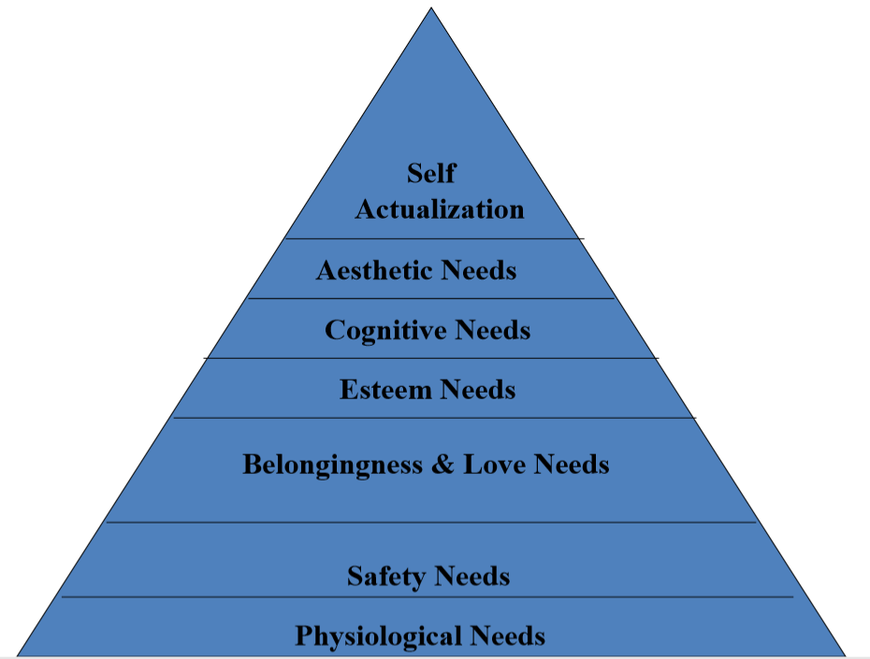

1. **Behavior Learning Theories**

|  |  |
| --- | --- |
| **Classic Conditioning – *Ivan Pavlov*** | **Operant Conditioning – *Skinner*** |
| * Unassociated stimuli produce a reflexive behavior * Association of one stimulus with other * **Mode of learning**: *Learning by association*      * **Reinforced** – when there is associated between conditioned and unconditioned stimulus * **Extinction** – when there is no association. | * **Positive Reinforcement**   + Direct: reward and social approval   + Vicarious: observing someone receiving reward   + Self-administered: self-praise * **Negative Reinforcement**   + Removal of negative stimulus after the response is achieved * **Omission**   + Removal of pleasant stimulus (as a consequence of bad temper) * **Punishment**   + Unpleasant stimulus is present. Problems:     - Timid & oversensitive child     - Behavioral inflexibility     - Avoid the situation     - Learning punishment methods |
| **Dental Management** | **Dental Management** |
| * Dentist office should look different * Dentist should have a different appearance * Childs first dental visit should be different | * Positive and Negative reinforcements is used in dental office * Punishment (not as effective as reinforcement)   + Mild form is voice control   + Withdrawal of privileges or parental disapproval |