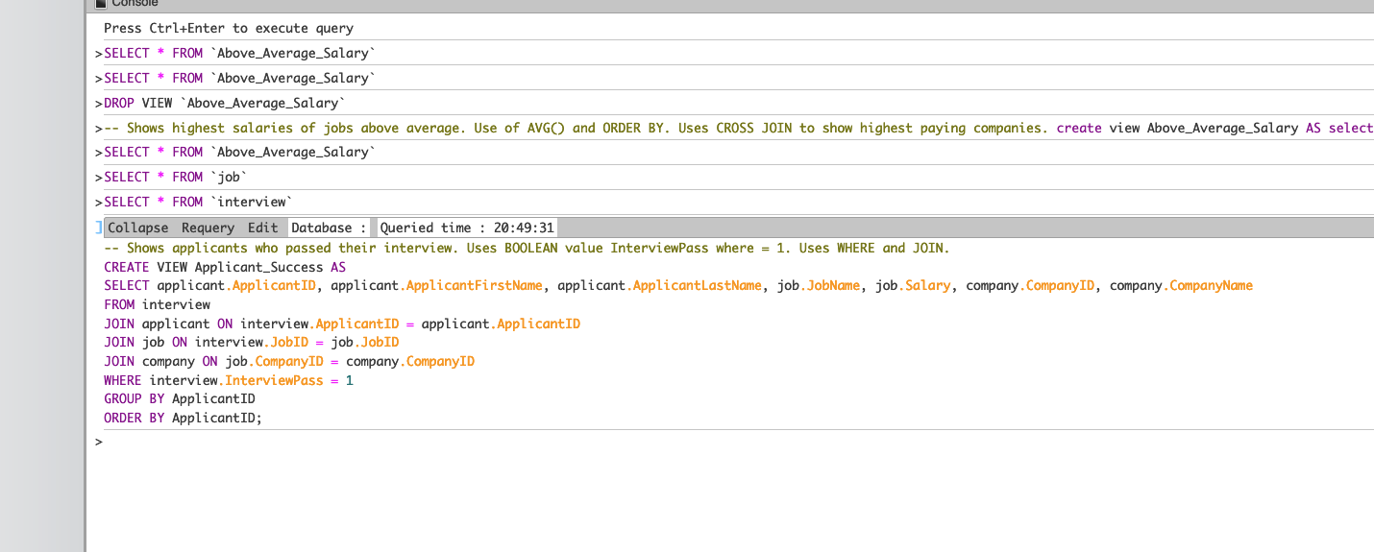

**Applicant_Success**

Shows applicants who passed their interview. This is useful for businesses to see who got hired and the companies that hired them, Uses WHERE clause and JOIN, as well as ORDER BY so it starts with ApplicantID 1. Determines whether an Applicant has passed using Boolean; 1 for pass, 0 for fail.

**OUTPUT**:

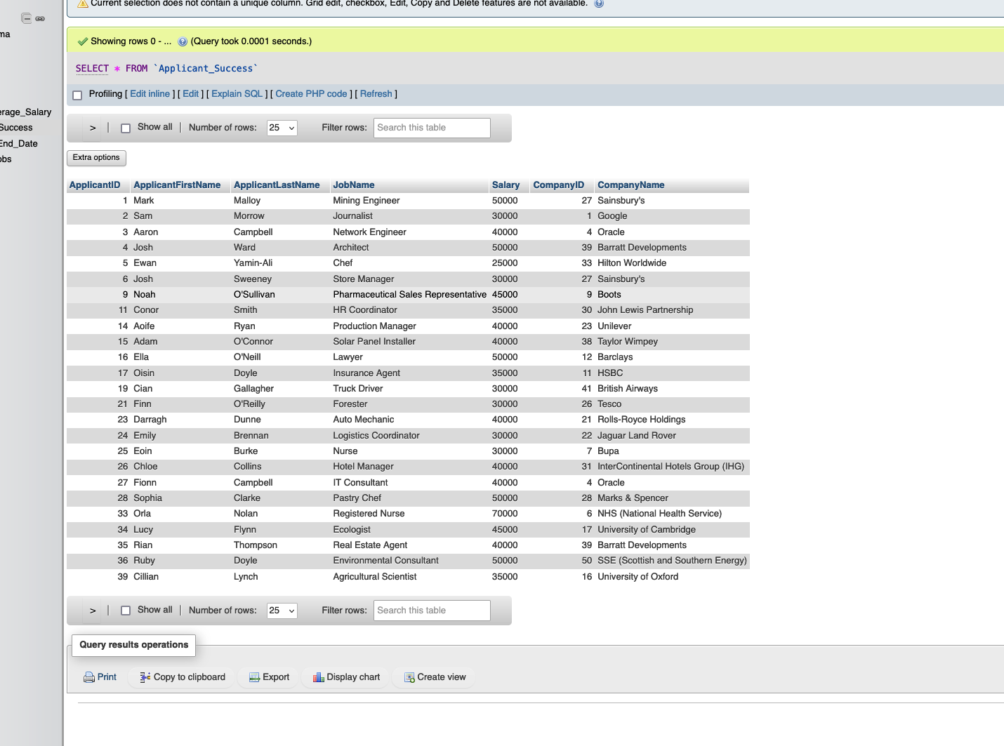

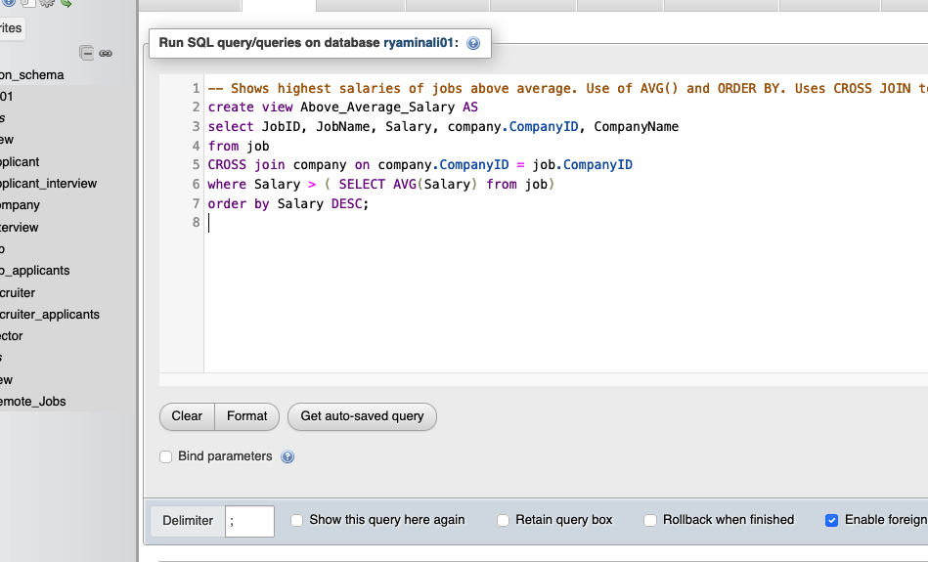

**Above_Average_Salary**

Shows the highest paying jobs above average salary of job list. The business purpose is to make aware which companies and jobs pay the most, so that more investment would be made in those companies. Uses AVG() and ORDER BY, as well as CROSS JOIN to incorporate CompanyName.

**OUTPUT:**

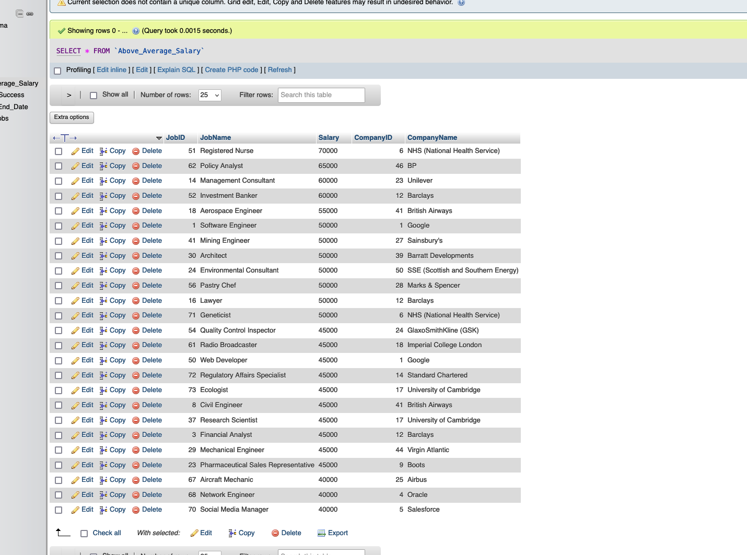

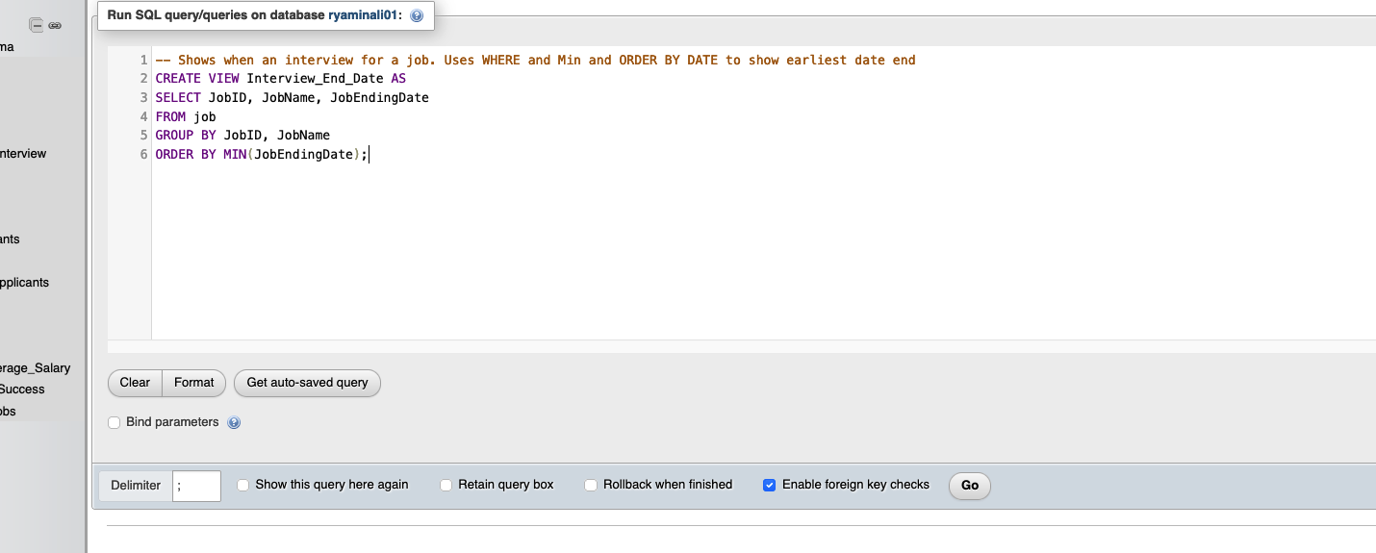**Interview_End_Date**

Shows when job listings end. The business purpose of this is to know what jobs end first so that companies can add more job openings when available. Uses WHERE and MIN() to show the earliest job ending date.

**OUTPUT:**

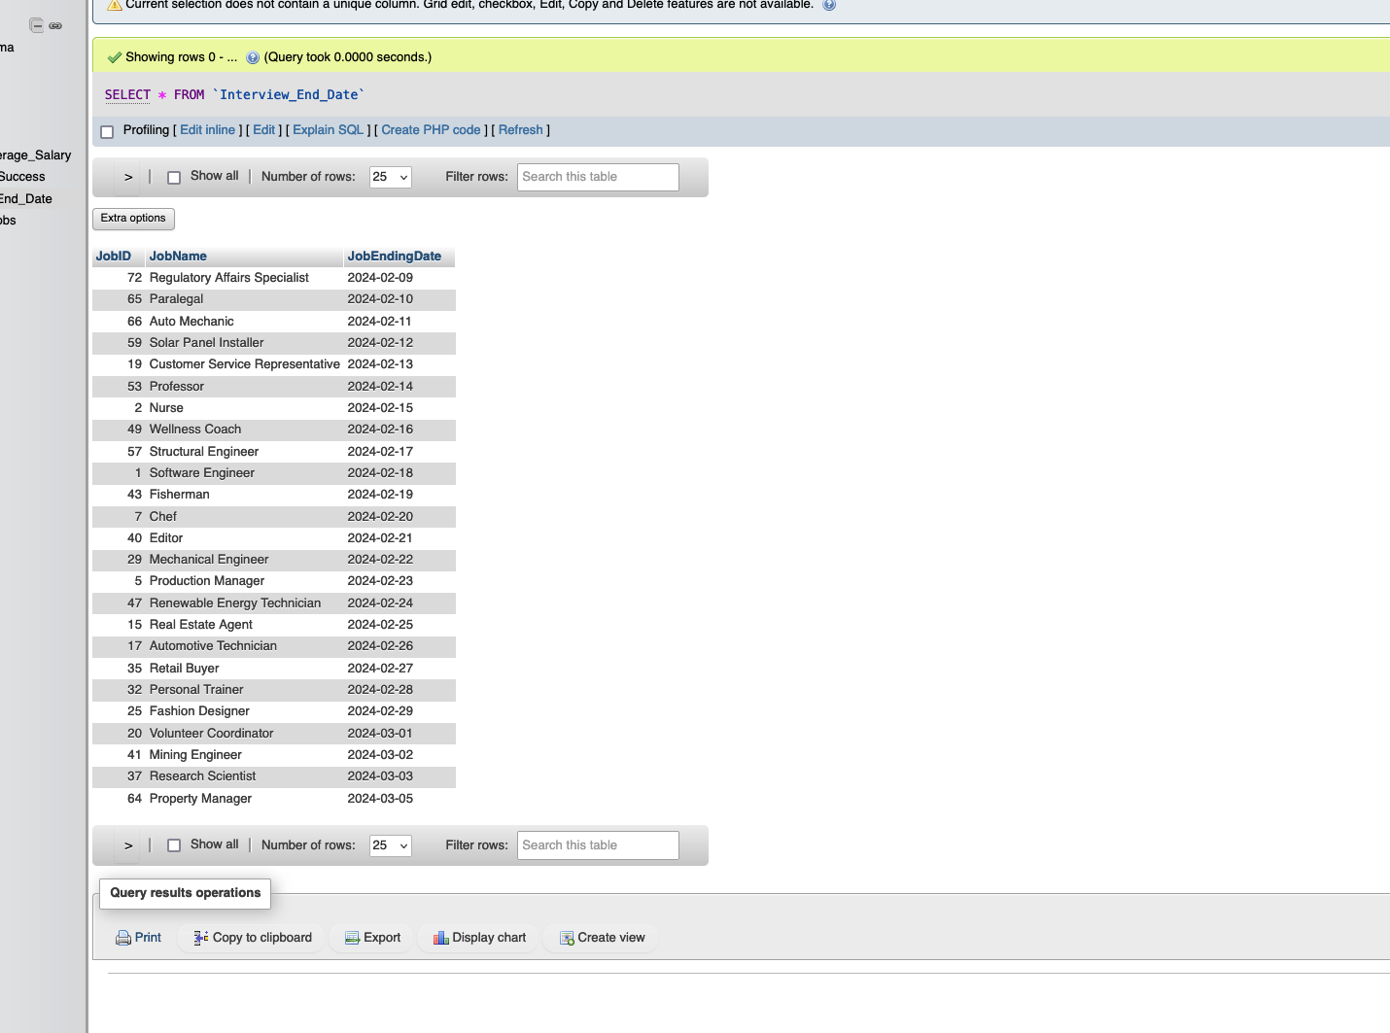

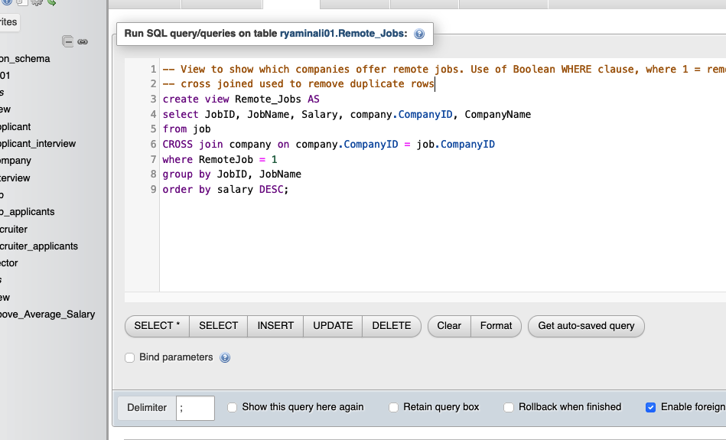

**Remote_Jobs**

Shows which jobs and companies have remote jobs. The business purpose of this shows which companies offer remote jobs. Uses Boolean to determine whether a job is remote. Uses WHERE clause. Uses Cross JOIN to eliminate Duplicate rows.

**OUTPUT:**

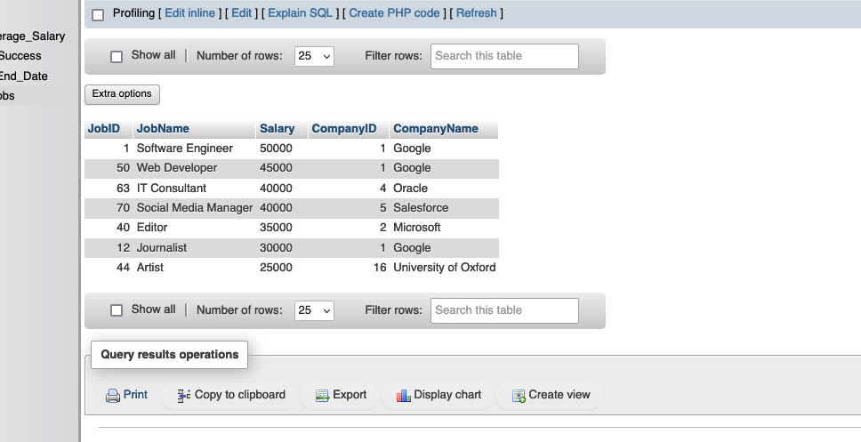

**SQL View and Outport**

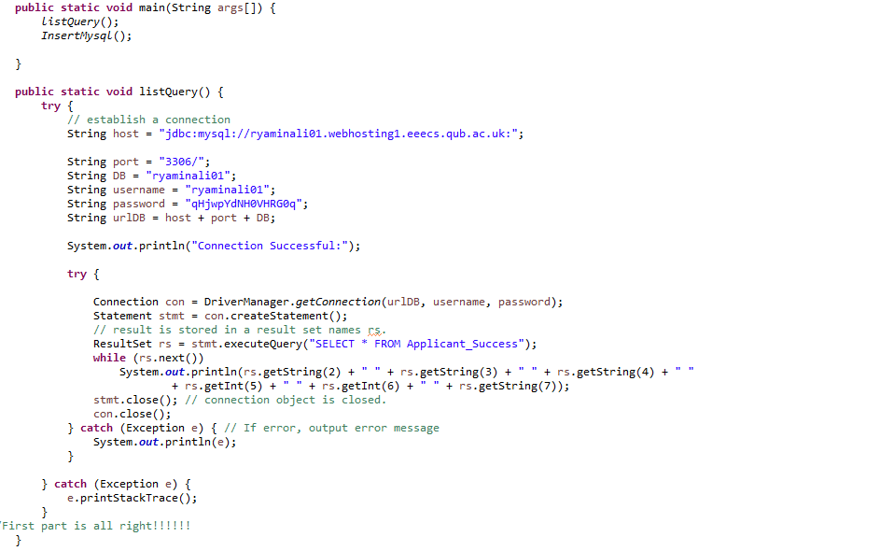

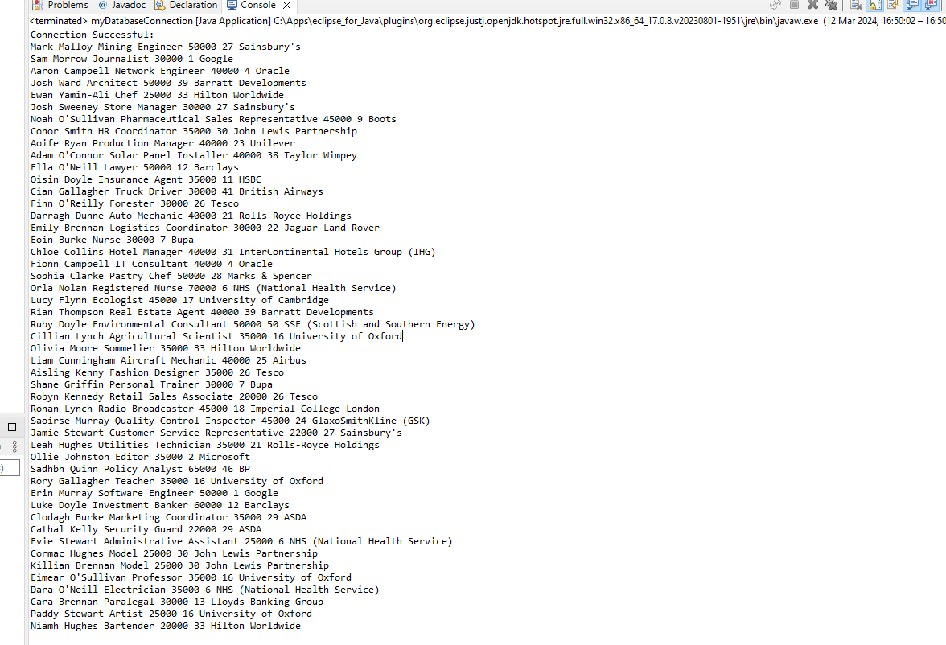

**New record code and output #**

