DOCUMENTATION

Applications

- Data consistency checks
- Cohort Validations
- Drug Monitoring tools

A. Data Consistency Checks

Given a working setup of updated bart2 or bart1

1. Open terminal
ctrl+alt+t

2. Navigate to application folder, this is where all the commands are to be run from. Refer the diagram below.

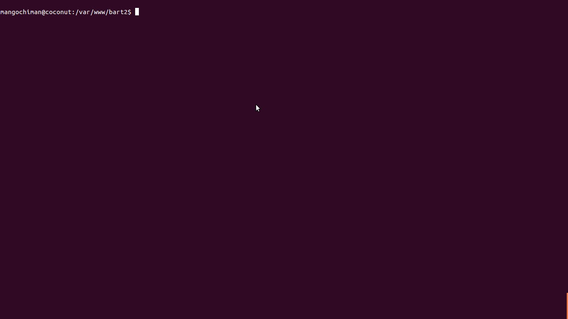

3. Check if the database has the following tables
validation_rules
validation_results

mysql -u user -p db

run sql query below to check tables if available

> SHOW TABLES LIKE "validation_r%";
If tables exist you will see something like this below:
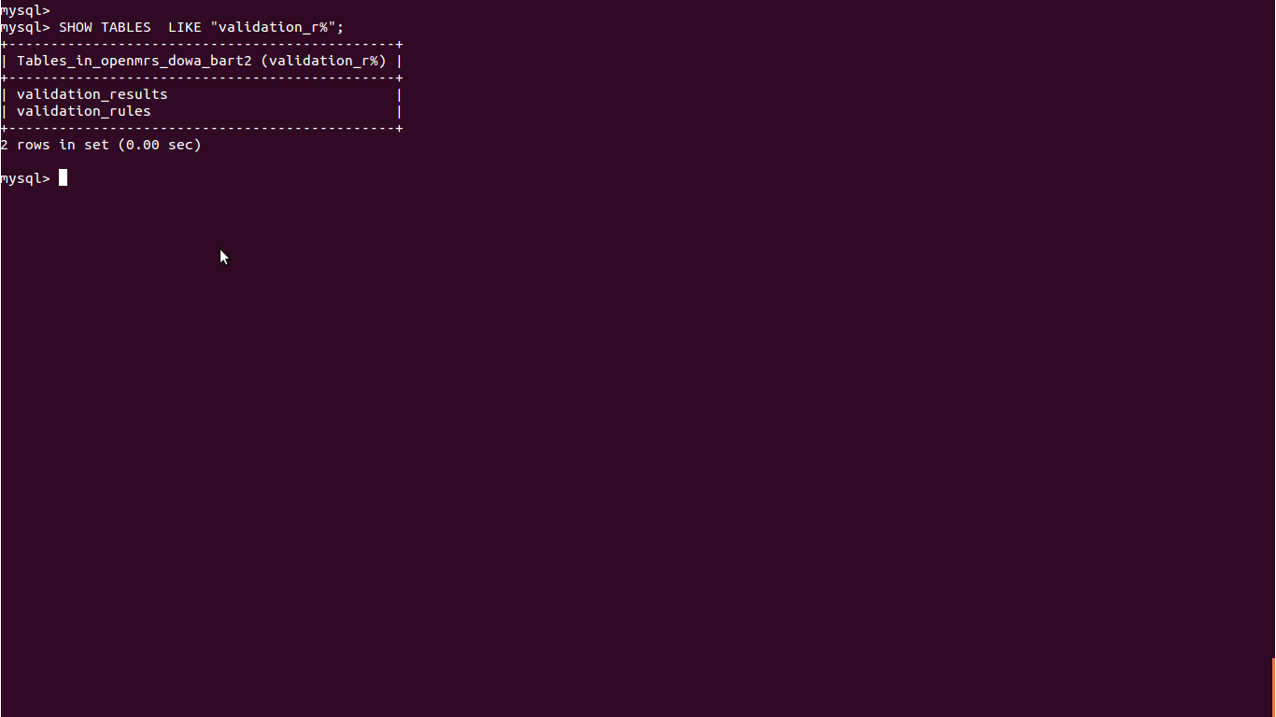

If tables are not there, you will see something like this below:

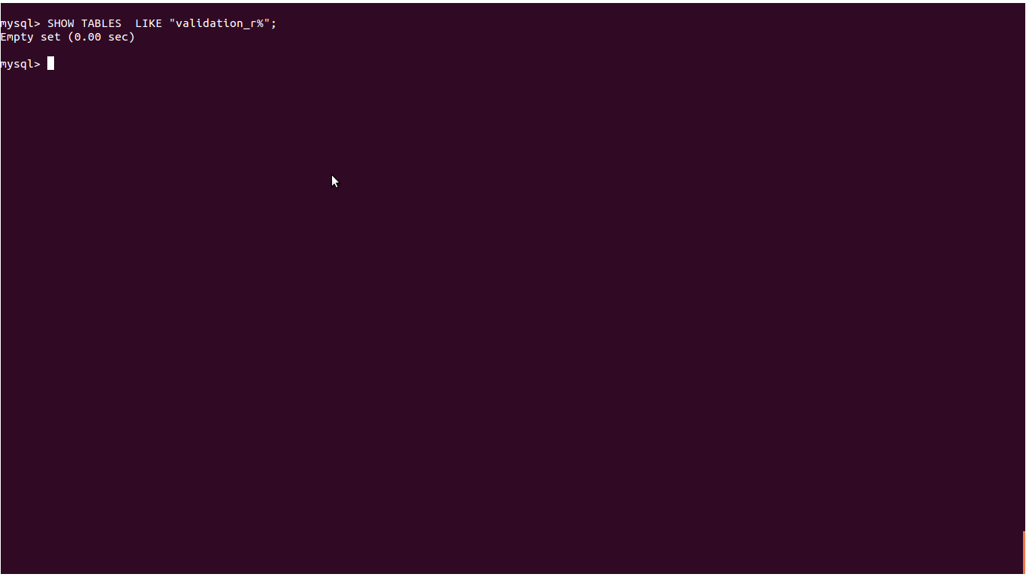

If the tables are not there, run

bundle exec rake db:migrate

Refer the diagram below

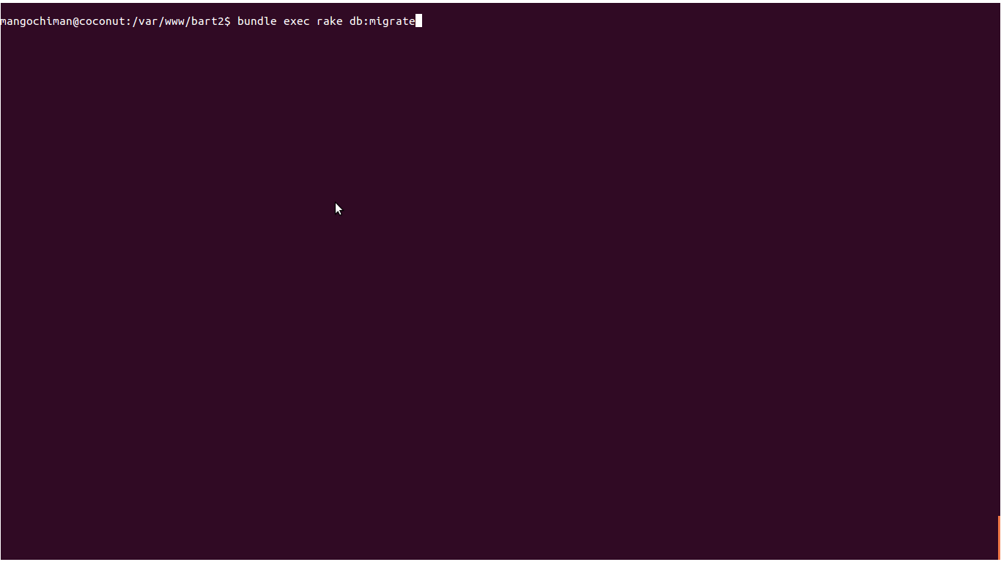

bundle exec rake db:seed (for BART2 only).
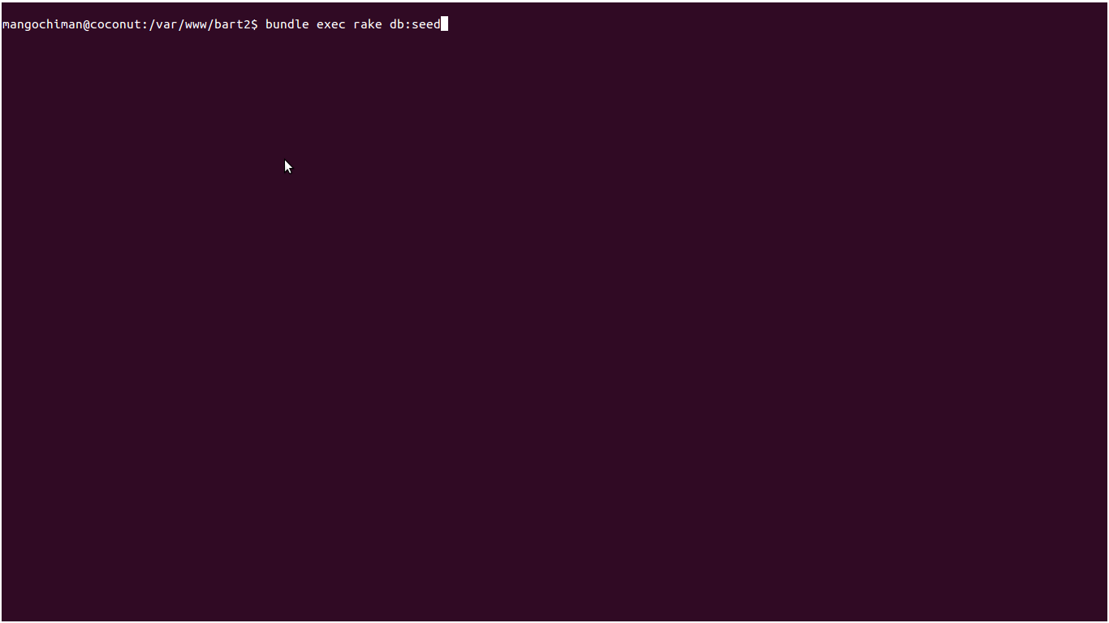

When you are in BART1 instead of rake db:seed type the following command,
bundle exec script/runner db/seeds.rb

Refer the diagram below:

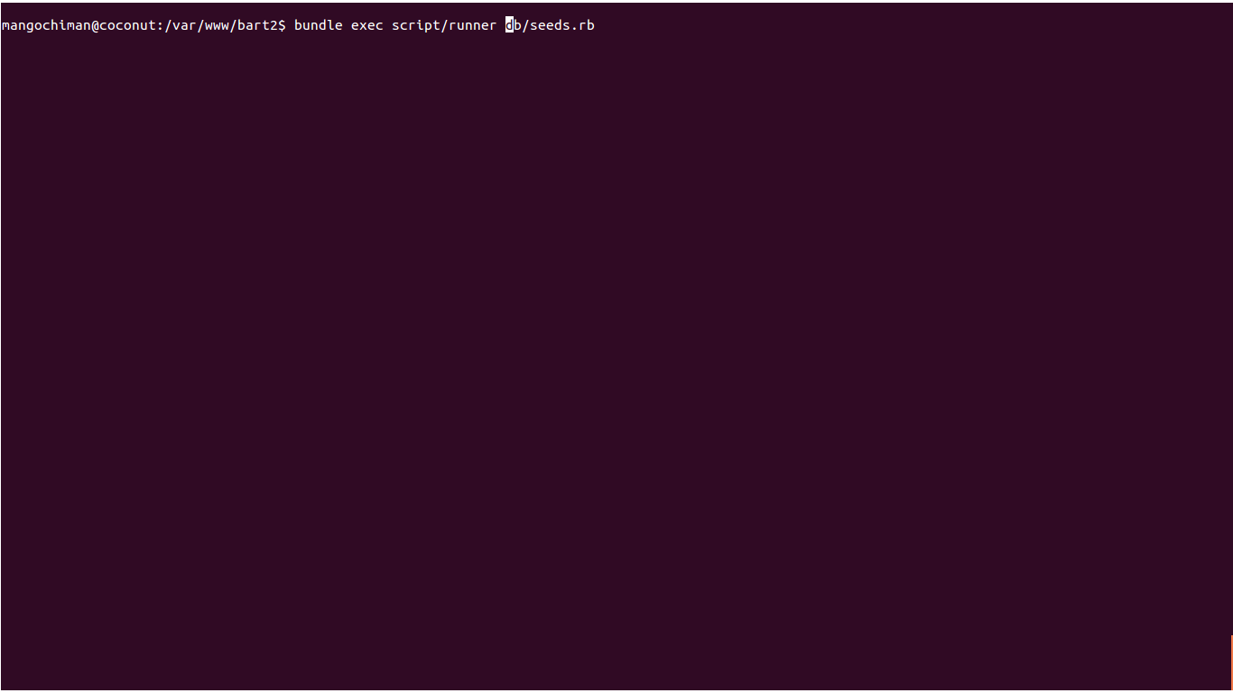
If the tables are already there, skip to 5. below

5. Run the following command to load application resources

script/console

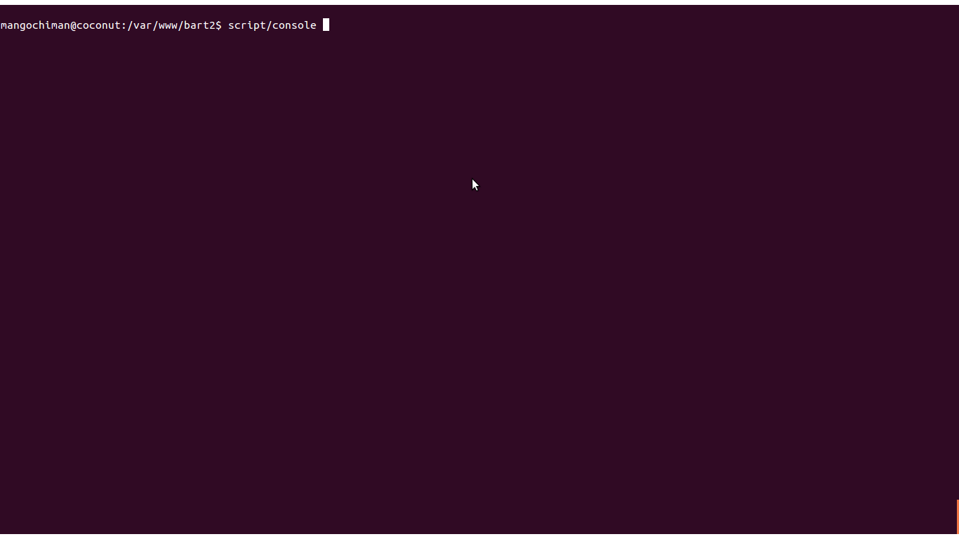

6. Run data consistency checks and observe progress in output

ValidationRule.data_consistency_checks("2009-12-26")

Refer the diagram below:

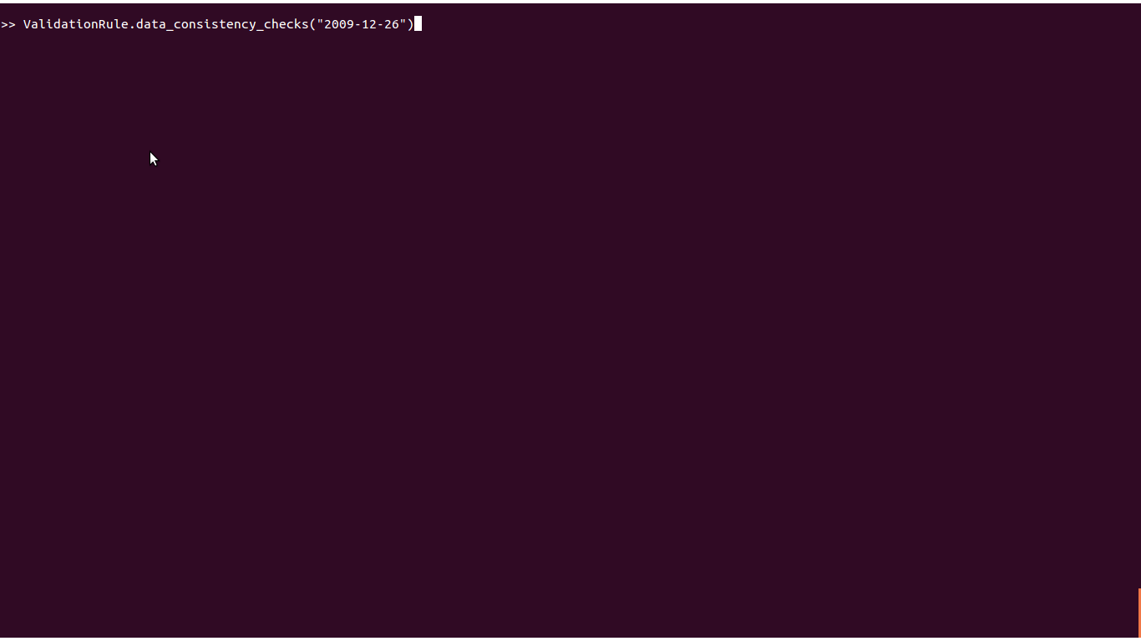
This checks data consistency from period of system installation/deployment up to the date specified in brackets based on pre-defined validation rules.

NB: Output lines in red indicate that there is a data inconsistency while output lines in green indicate that relevant data is consistent.

B. Cohort Validations

1. Open terminal
ctrl+alt+t

2. Navigate to application folder, this is where all the commands are to be run from

3. Check if the database has the following tables
validation_rules
validation_results

mysql -u user -p db

run sql query below to check tables if available

> SHOW TABLES LIKE "validation_r%";

If the tables are not there, run

rake db:migrate
rake db:seed

4. Run cohort report to verify setup

5. A header will appear at the top summarizing the status of cohort,
All inconsistencies in the cohort will be represented by red rows in the header table.

Refer the diagram below

