Instagrammable Leicester
CO2104 CW2: Prototype description document
Yamin Ohmar (yo53)
2024

Introduction

Leicester being the city where I study in the UK and photography being one of the things I love, I was motivated to design the “Instagrammable Leicester” tourism website for hobbyists like me. I aimed to build a platform for users who are interested in photography and/or in sightseeing rather than doing activities. Taking inspirations from the current trend of sharing experiences on social media platforms like Instagram, this website can offer users with a selection of Leicester’s most photo-worthy locations together with insightful descriptions about them and inspirational Instagram posts. The key user requirements for this website include visually pleasing content to inspire photo ideas, intuitive navigation for easy exploration within the website, and interactive features for community engagements through the review section.

Prototype Functionality

During this project, I will be developing a high fidelity Vertical Prototype (Vertical Slice) of my tourism website to demonstrate the depth of functionality for a selected set of features rather than attempting to showcase the entirety of the website’s potential features.

- Common Function (Login and Signup)

Two generic features, login and signup, will be integrated into the prototype. The decision to include these functions comes from their essential role in user authentication and account creation. The login functionality is crucial for the unique feature that I intended to design. Additionally, the signup feature offers users a seamless way to create accounts, facilitating engagement and testing of the website's functionality across various user profiles.

In addition, I will also be developing accessibility function for font size with two buttons to switch between smaller font and bigger font.

During my design for wireframe, I added all the potential features that my website could provide in addition to my unique feature. However, since I will be developing a Vertical Prototype, I won’t be developing all the potential features that I designed in my wireframe.

Features that I won’t be developing are as follows:
- Location add to favourite – the Favourite Locations page won’t be there as well.
- Embedded Instagram post and Interactive photo slideshow – instead there will just be a display of photo(s) that links to respective Instagram post(s).
- Google Maps display – instead only the location address will be displayed.

- Unique Feature (Reviews for each location)

The unique feature that I designed in Coursework 1 was to have a review section for each location.

Features that are a part of my unique feature I’ve included in my wireframe but won’t be able to develop due to time and technical constraints are as follows:
- Dynamic user profile display – because I won’t be developing a profile page and therefore I won’t be able to store the profile display of each user.
- Review Timestamp – format change to display date and time uniquely instead.
- Review Likes – I had to let this feature go due to the time constraint for development since I want to add some buffer time for necessary functions those might arise from Heuristic Evaluations.

However, I will still be developing my initial concept of a unique feature for review section of each location with a combination of following features:
- Reviews count – update for each location
- Login Privilege – only by logging in user can leave a review (or) read other reviews
- Review word count limit – restriction of 250 words per review
- Review Display – with a restriction of 3 reviews per display in corporation with “Load more reviews” and “Show lesser reviews” options.

Background Technologies

In combination with HTML/CSS/JavaScript, an external CSS framework named Bootstrap, with its CSS file, JavaScript file and jQuery library, is used in the development of my high fidelity website’s user interface prototype.

To make the website visually appealing and to be responsive, I’ve used the help of pre-styled components and layouts from Bootstrap framework by linking to its CSS file (https://stackpath.bootstrapcdn.com/bootstrap/4.3.1/css/bootstrap.min.css) hosted on a CDN (Content Delivery Network). I’ve also used Bootstrap JavaScript file (https://stackpath.bootstrapcdn.com/bootstrap/4.3.1/js/bootstrap.min.js) and its jQuery library (https://code.jquery.com/jquery-3.3.1.slim.min.js) for functionality such as responsive navigation bar with toggling upon resizing of window and other UI elements such as forms with interactive buttons for Login, Signup and Review sections.

I also used external CSS file which is Font Awesome CSS by linking to this file (https://cdnjs.cloudflare.com/ajax/libs/font-awesome/4.7.0/css/font-awesome.min.css) to utilize its scalable vector icons such as hamburger menu and delete icons. Additionally, I’ve also linked to my own customized CSS and JavaScript files (MyCSS.css, AlternativeCSS.css, login.js, imageDisplay.js, review.js) located in my project directory for custom styles and scripts that can attend to my website’s specific design needs and functionalities.

Walkthroughs with Annotated Screenshots

- Home page (before logged in)

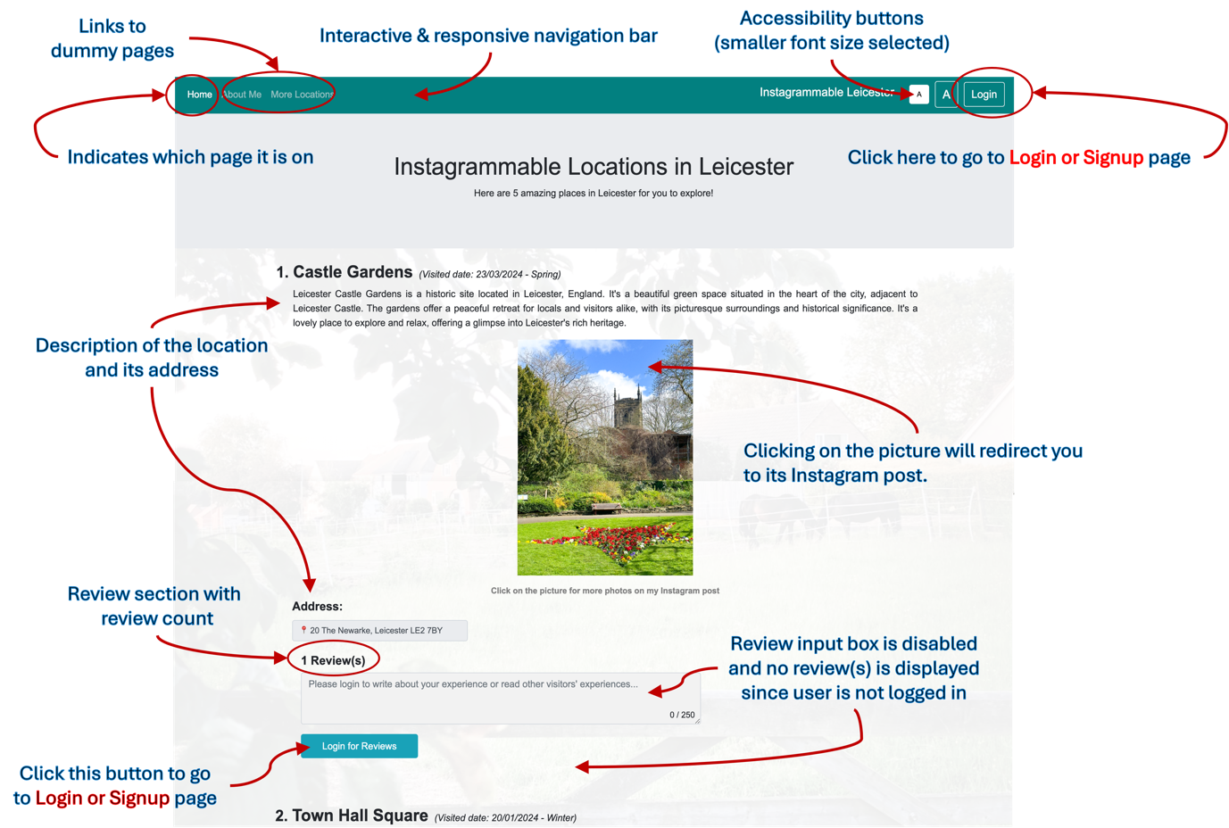

Figure 1 – Annotated screenshot of Home page before logged in with Review(s) not visible

This view of Home page is where the user will be landed on when they open the website link (or open the index.html file from the project folder). On this page, user will see a list of Instagrammable locations in Leicester. Refer to Figure 1 for functions/features that can be found on Home page before logged in. But, they won’t be able to post a review or read other people’s reviews yet since they’re not logged in. Navigation to Login or Signup page is indicated in red. Accessibility feature for font size is available on top right corner of every page, and in this screenshot, it was set to smaller font.

- Login or Signup page
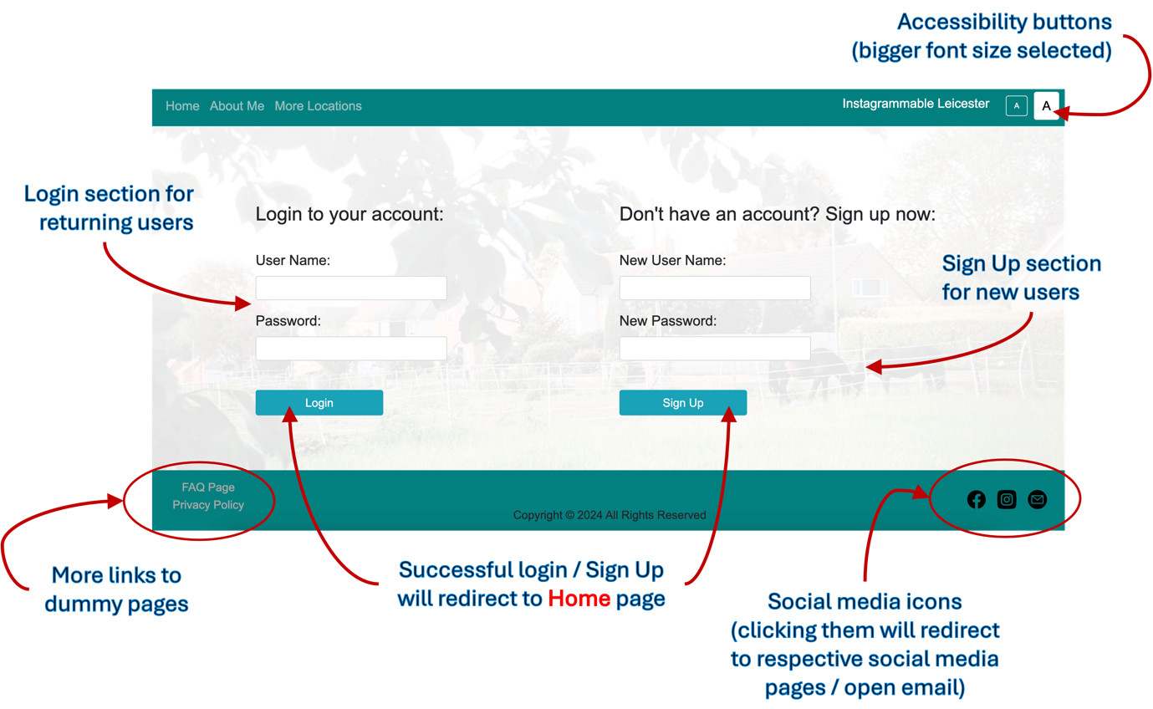

Figure 2 – Annotated screenshot of Login or Signup page

Login or Signup page is where the user will be directed to from any of the pages by clicking on the Login button on the top right corner of the page. On this page, user will see 2 sets of forms; one is Login section for returning users and another is Sign Up section for new users. Refer to Figure 2 for functions/features that can be found on Login or Signup page. Navigation to Home page is indicated in red. Accessibility feature for font size in this screenshot was set to bigger font.

- Home page (after logged in)

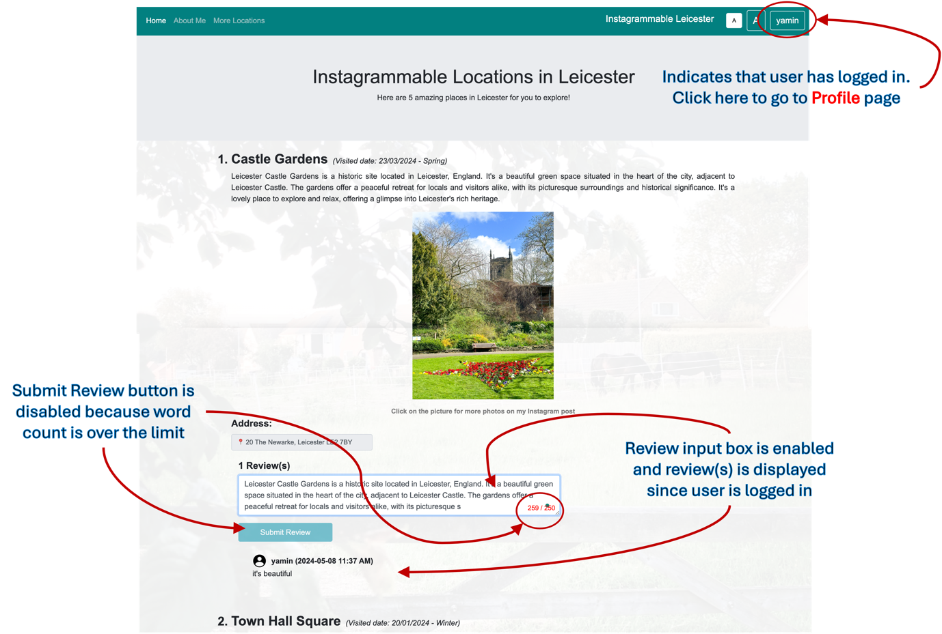

Figure 3 – Annotated screenshot of Home page after user logged in with review(s) visible

This view of Home page is where the user will be landed on after they’ve logged in or signed up with their user name visible on top right corner of the page which can take them to their Profile page. On this page, user will see a list of Instagrammable locations in Leicester together is the reviews available under each location. Refer to Figure 3 for functions/features that can be found on Home page after logged in.

The Figure 4 below showcases the functionality of Submit Review button on Home page after user logged in. And, the Figure 5 below showcases the functionality of Load more reviews and Show lesser reviews buttons when there are more than 3 reviews under each location.
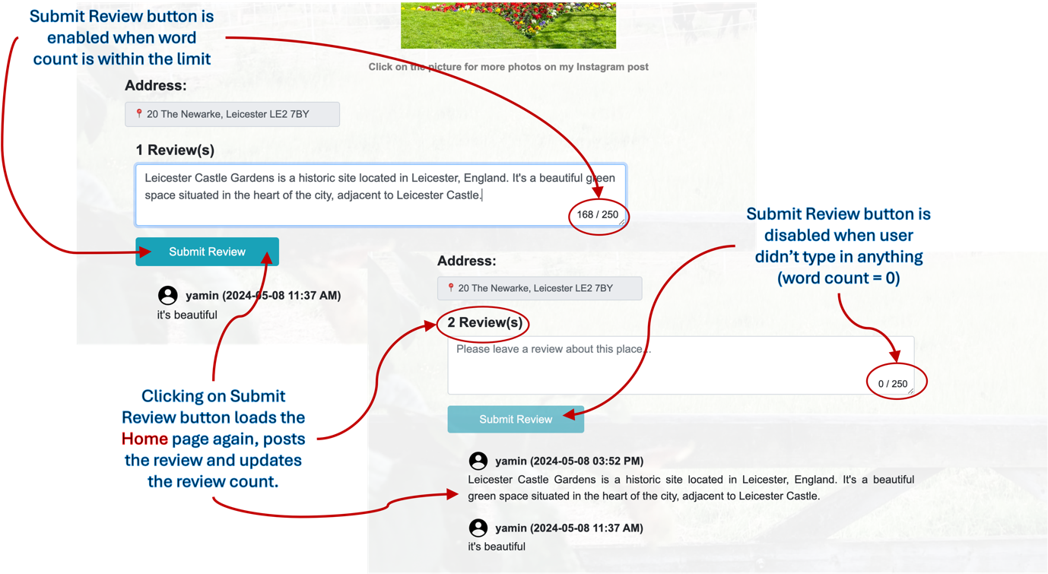

Figure 4 – Annotated screenshot of Home page after user posted the review

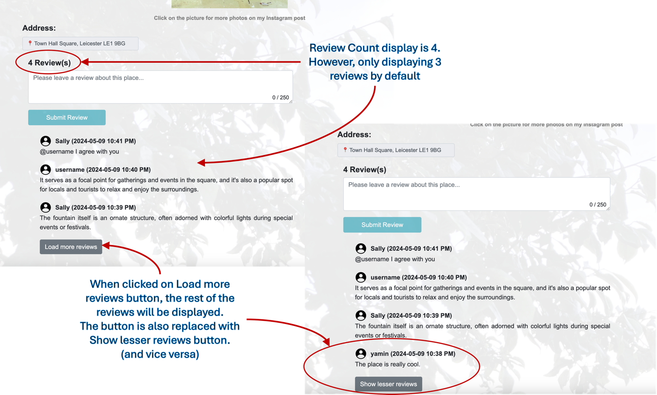

Figure 5 – Annotated screenshot of review section on Home page with Load more reviews and Show lesser reviews buttons

- Profile page
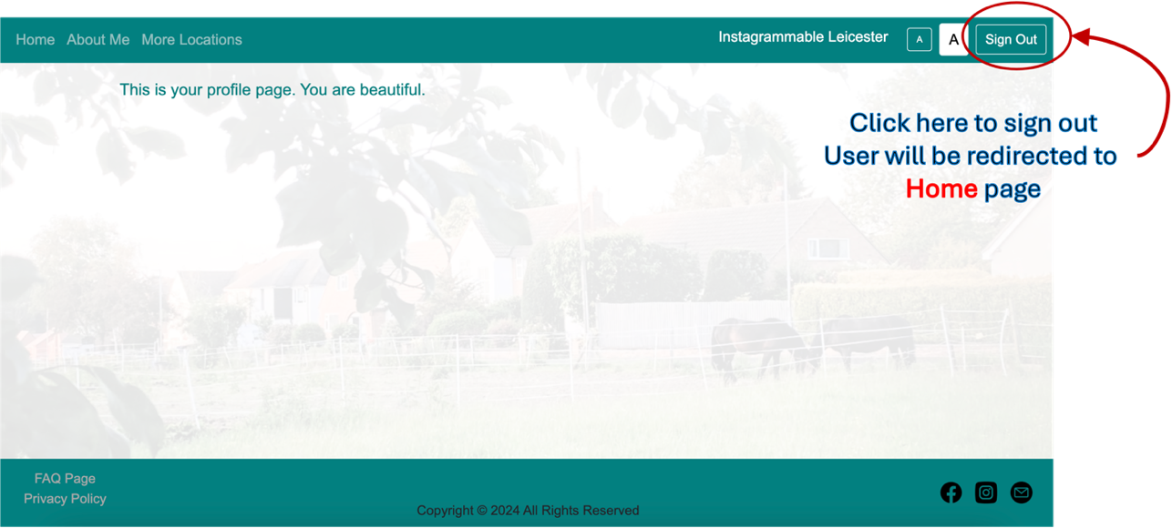

Figure 6 – Annotated screenshot of Profile page where user can sign out

Profile page is where the user will be directed to from any of the pages by clicking on the button with user name on the top right corner of the page after the user has logged in. This is mostly just a dummy page, however there is a Sign Out button which will lead user to Home page after sign out was successful.

Heuristic Evaluation and Usability Testing Results

I’ve deployed my Instagrammable Leicester website prototype on Netlify with a walkthrough document and used Google Forms to get the Heuristic Evaluation and Usability Testing executed by the users. The details of the evaluation and test are clearly stated in the forms together with a link to the website and a walkthrough document. I’ve also mentioned that this website prototype works best only on PC/desktop browsers.

So far, I’ve collected their consent and feedbacks from a total of 6 users including 3 of my class peers and 3 other individuals who are interested in either photography or visiting Leicester.

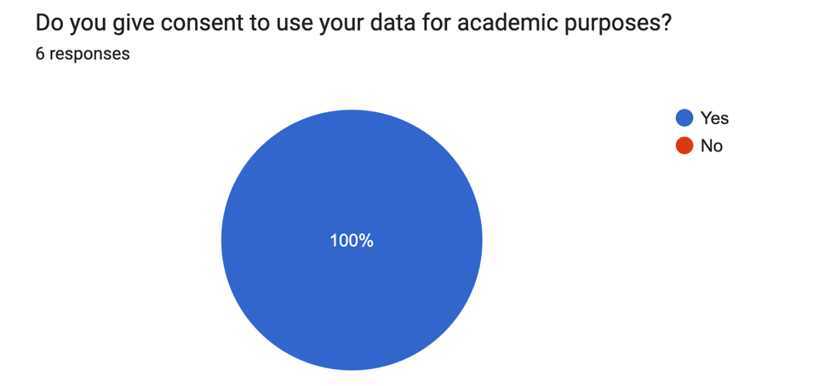
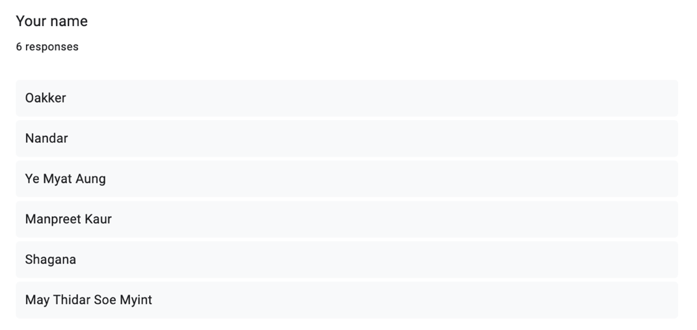
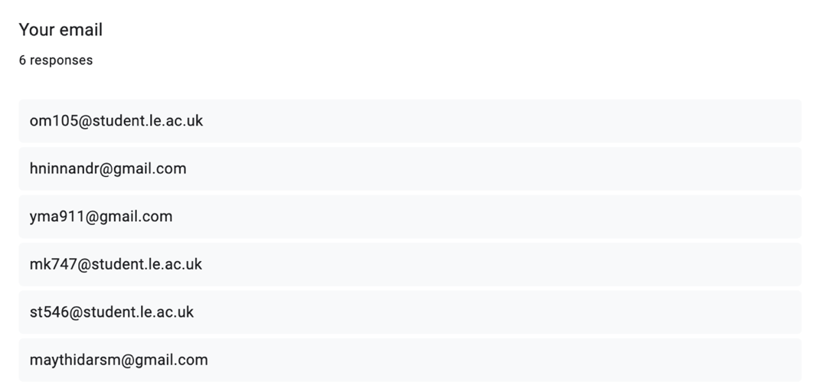
Figure 7 – User’s personal data and their consent

- Results of Heuristic Evaluation

The link to the Evaluation form is here https://forms.gle/pnN6TUmF1vLj1NT26. 10 Heuristic Evaluations that we’ve learnt during the lectures is used and the results are as follows:
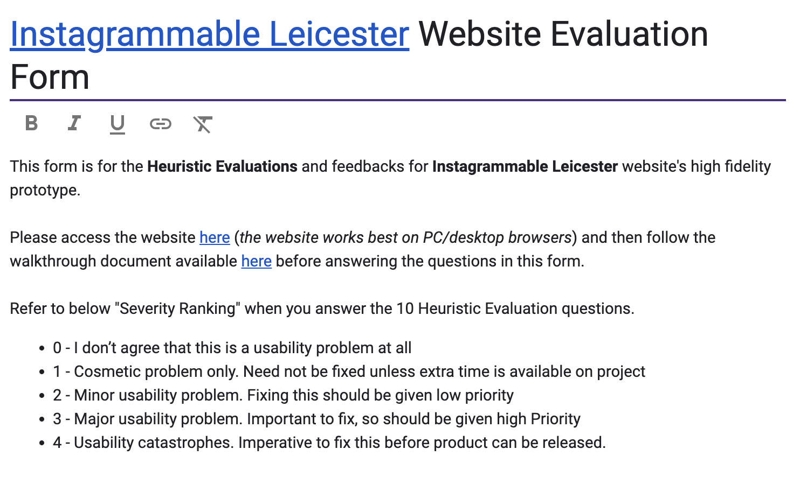

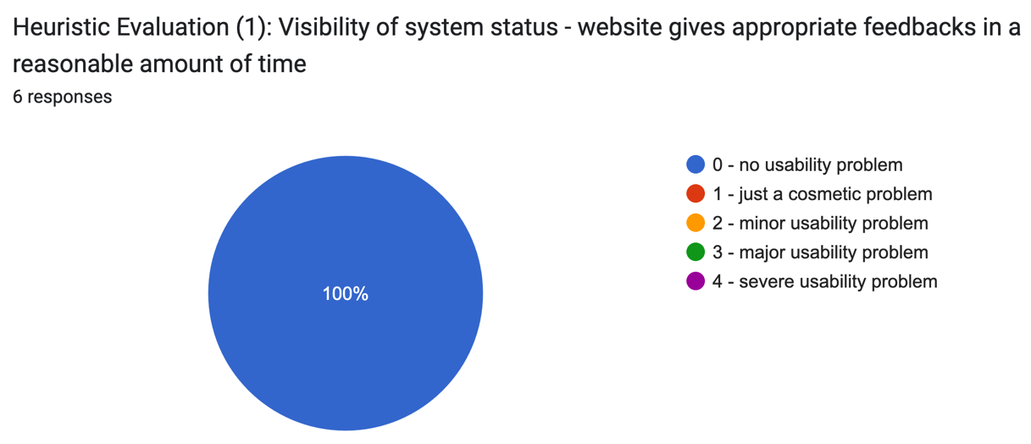
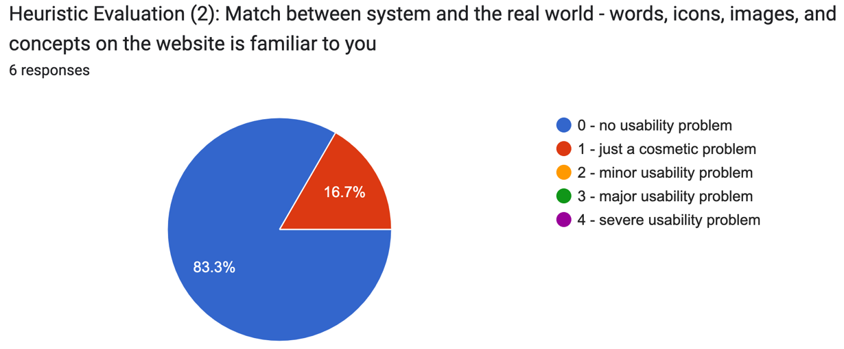
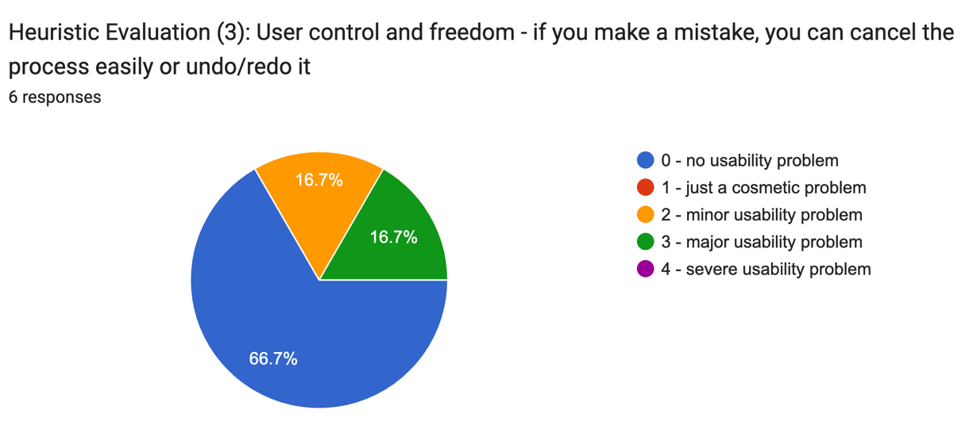
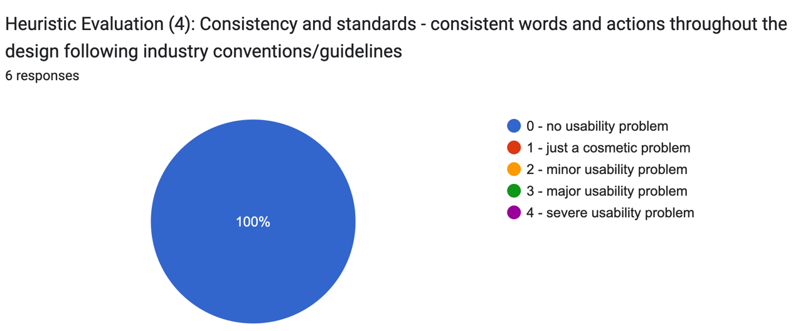
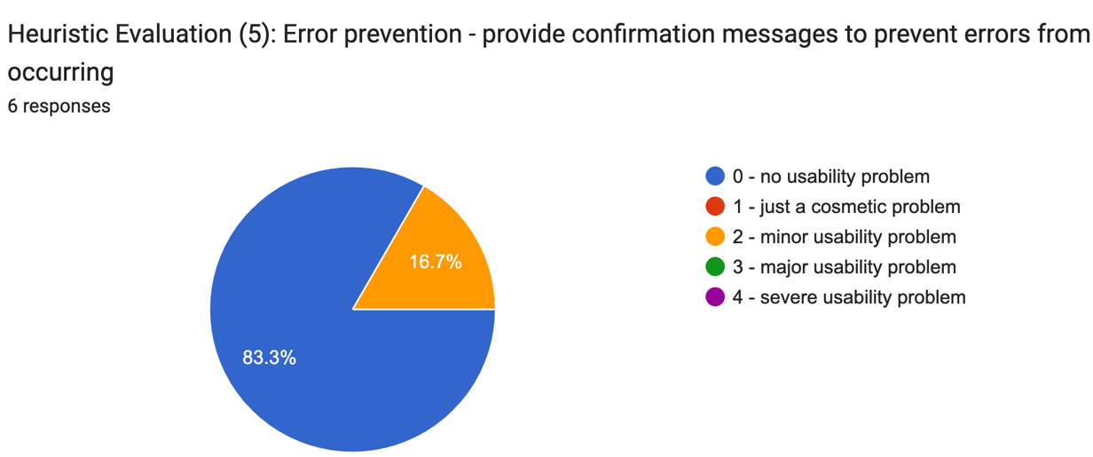
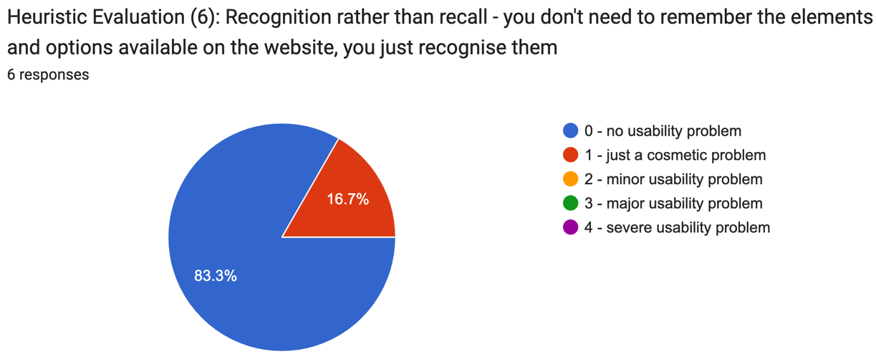
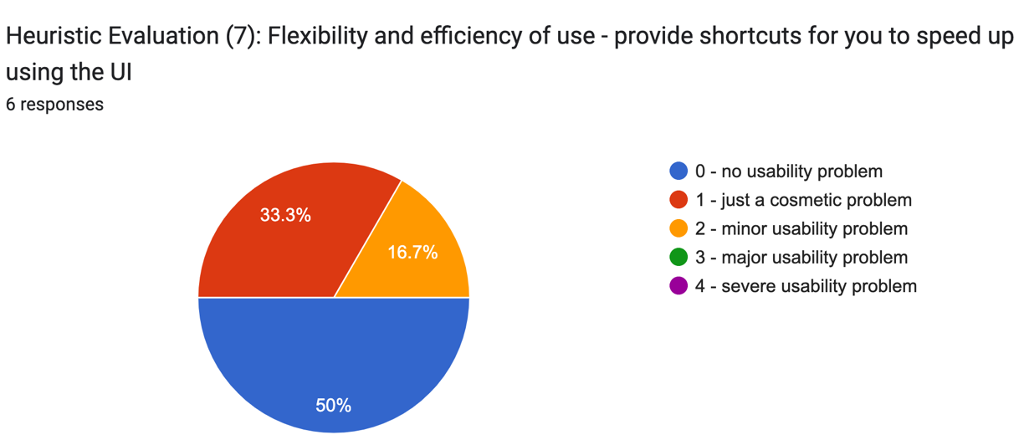
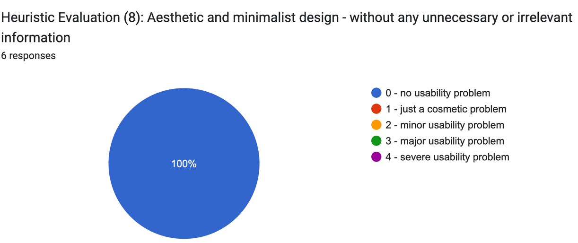
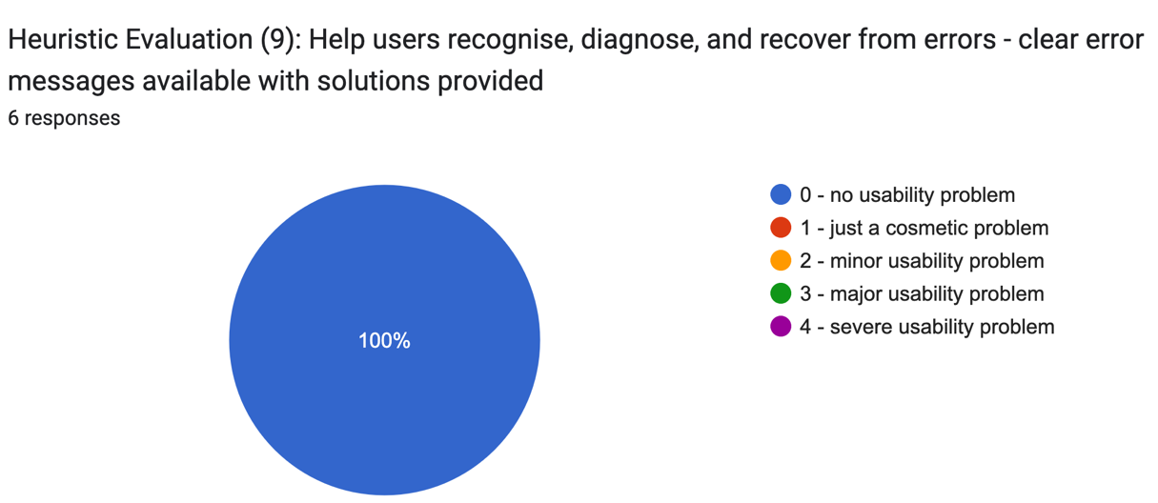
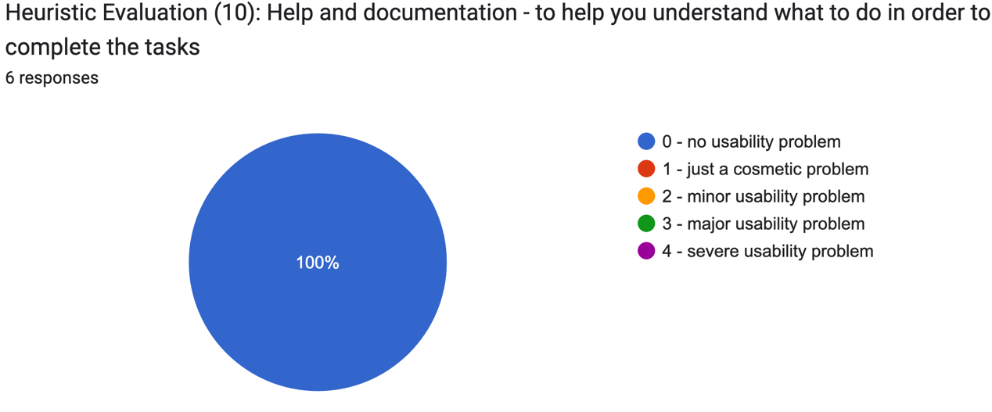
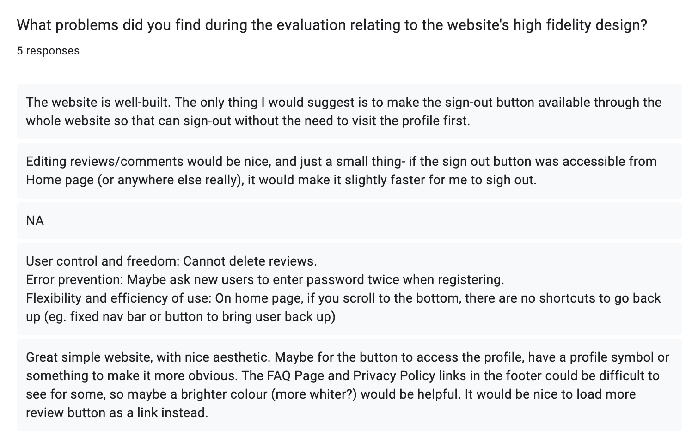
Figure 8 – Heuristic Evaluation results and feedbacks from users

- Results of Usability Testing

Link to the Usability Testing form is here: https://forms.gle/FTuQ7d4ViFXsAmMW6. The System Usability Scale (SUS) questionnaires that we’ve learnt during the lectures is used and the results are as follows:

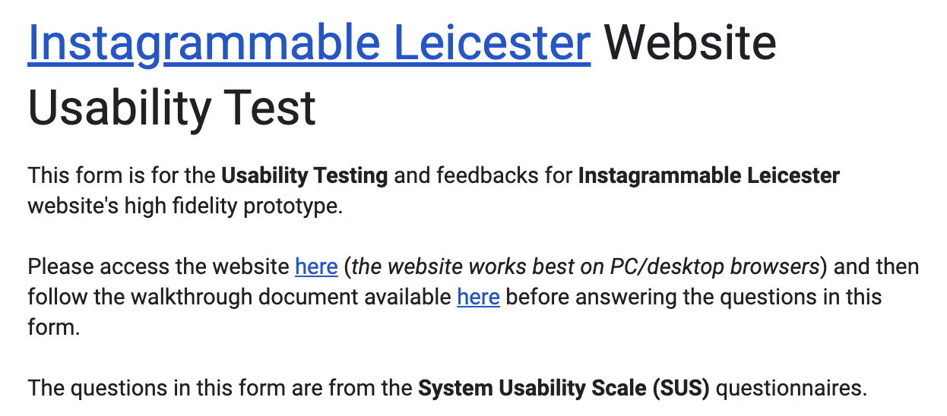
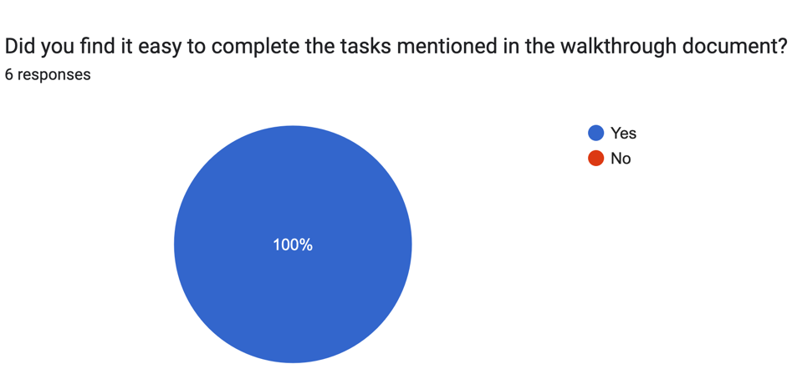

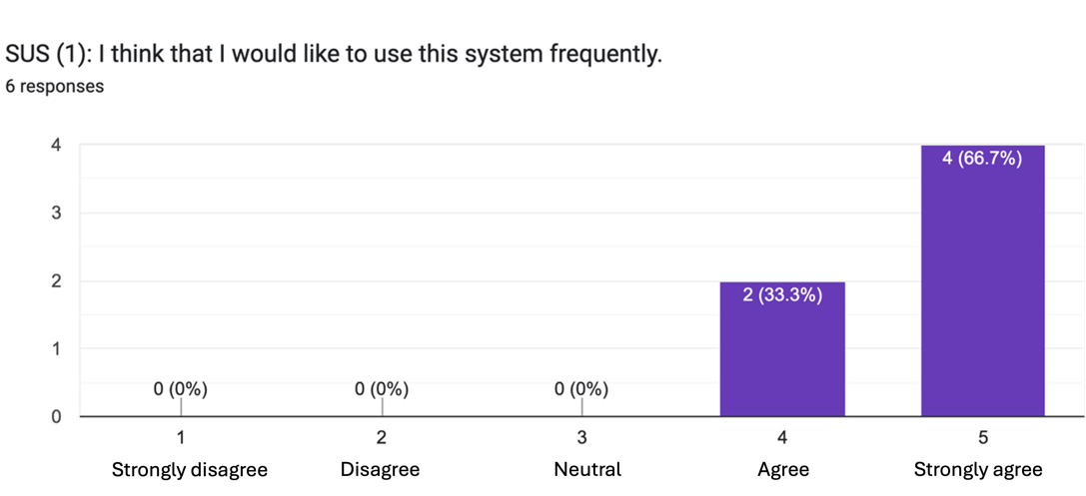

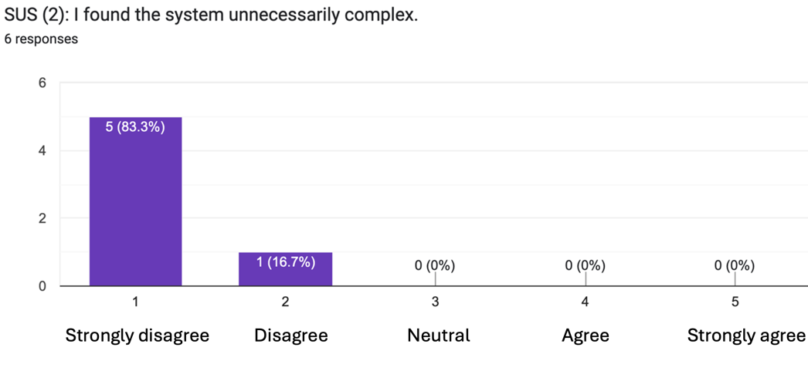
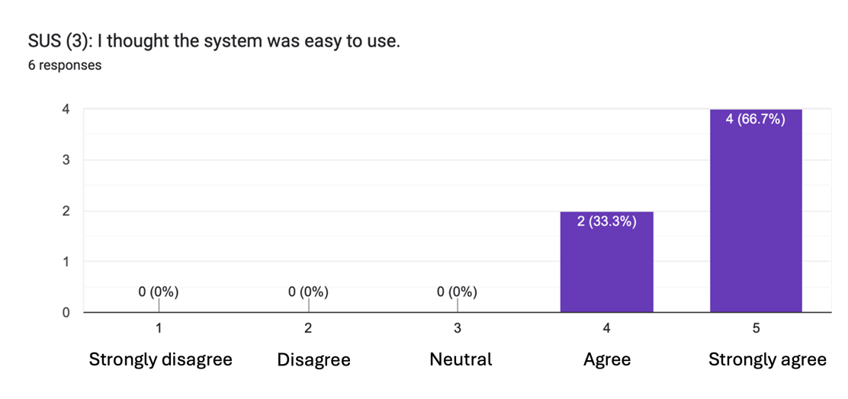
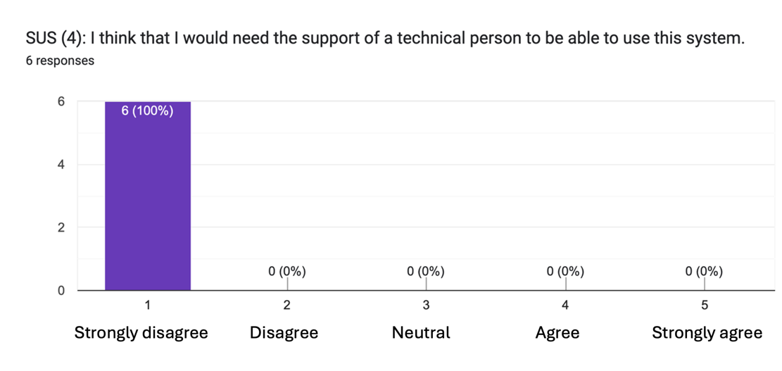
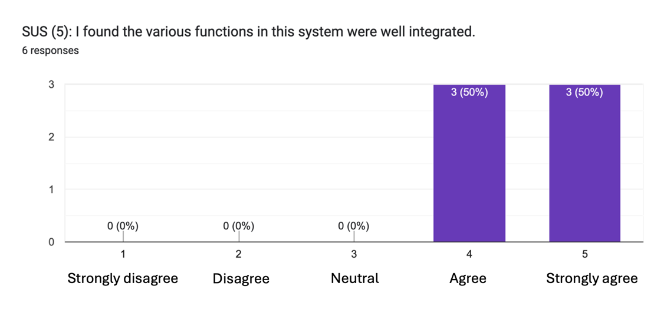
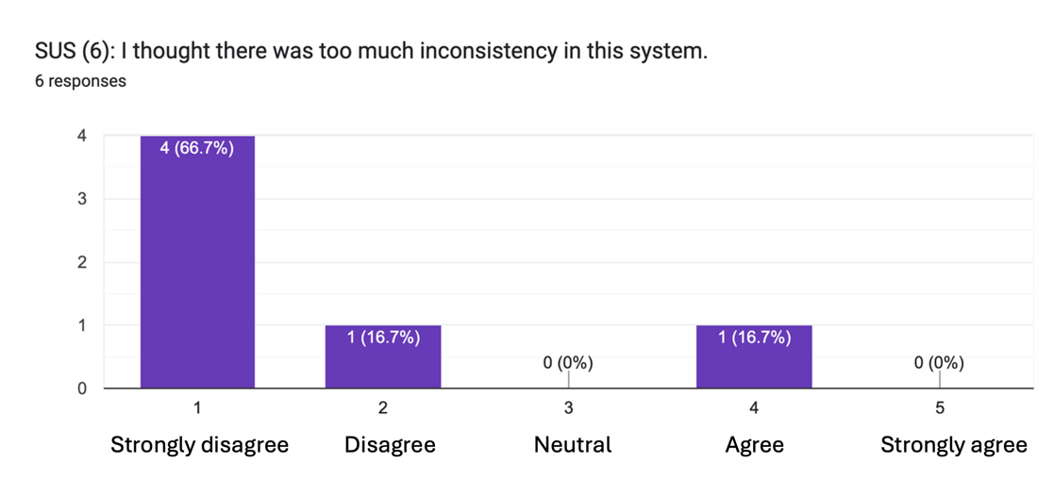

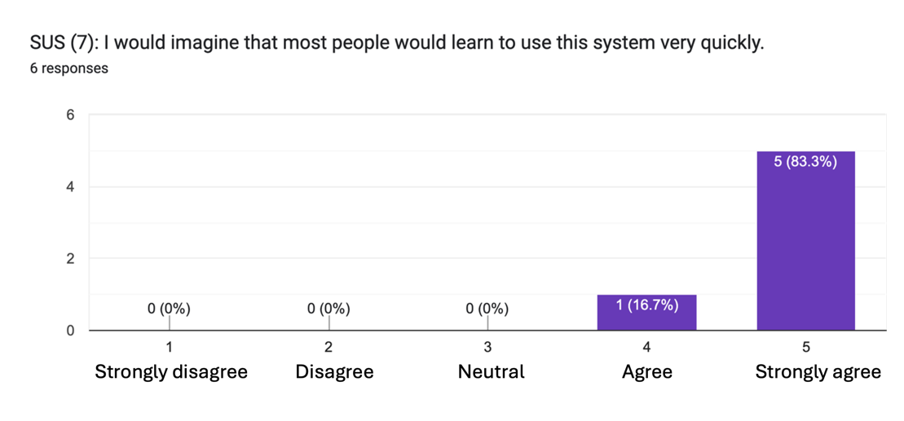
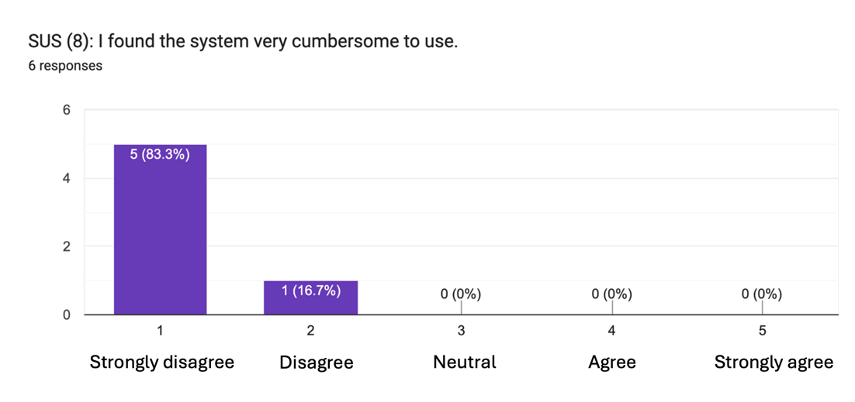
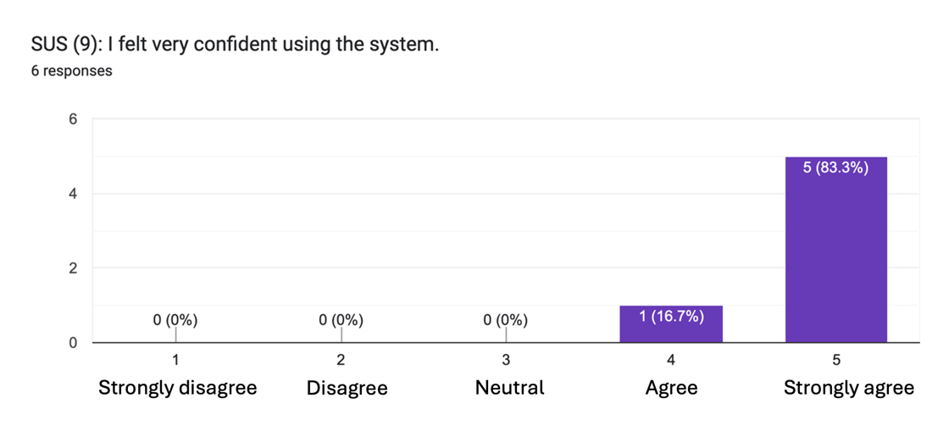
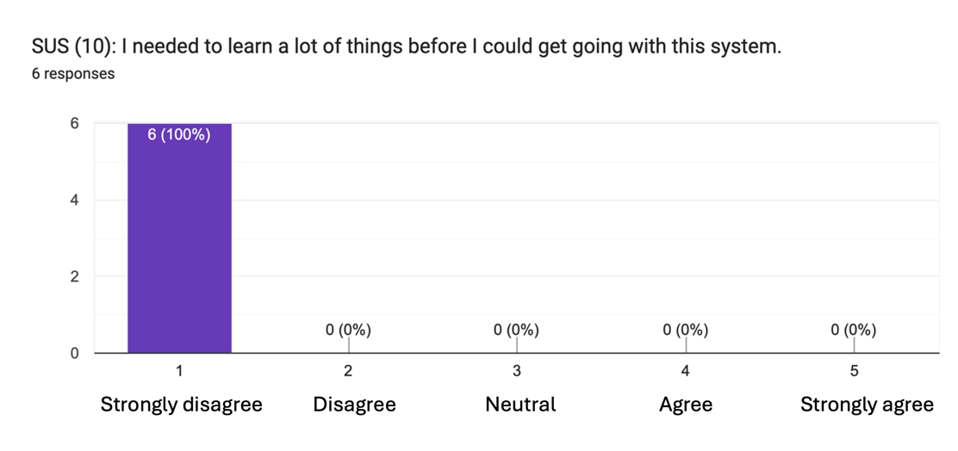

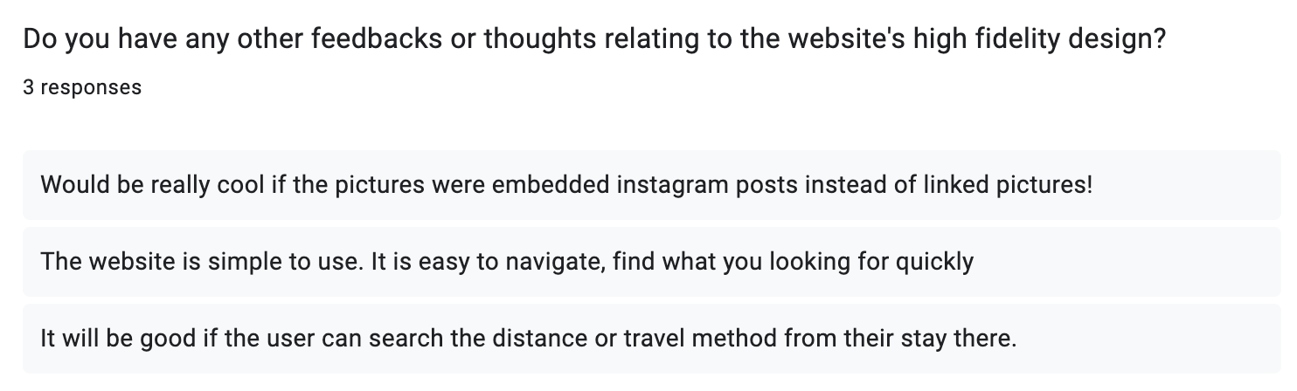

Figure 9 – Usability Testing (using SUS) results and feedbacks from users

Feedback and Discussion

- Heuristic Evaluation Feedbacks

Based on the results of Heuristic Evaluations from Figure 8, there were some issues found for the website while doing the following Heuristic points:

- No. 2 (Match between system and the real world) – cosmetic problem only
  - FAQ page and Privacy Policy links to be brighter for easy spotting
  - Load more reviews and Show less reviews buttons to show as link instead

- No. 3 (User control and freedom) – major usability problem
  - Edit or Delete option to be available for reviews

- No. 5 (Error Prevention) – minor usability problem
  - To ask new users to enter password twice during sign up

- No. 6 (Recognition rather than recall) – cosmetic problem only
  - Profile button to have profile symbol next to it
  - Sign Out button to be available throughout the website

- No. 7 (Flexibility and efficiency of use) – minor usability problem
  - To have a fixed navigation bar for easy access or shortcut to other pages

- Prototype Design Changes

The major usability problem takes priority in changing my prototype design followed by minor usability problems. My revised prototype with some design changes is available only from the zip file that I’m submitting and will not be deployed again on Netlify because I would like to maintain the previous version before any evaluations and tests being conducted.

- Delete review option (Major usability problem)

The only major usability problem that the user has reported is to have an option for Edit or Delete for their own reviews. This is to give the user control and freedom in their actions. However, due to both technical and time constraint, I only changed added the Delete review option. So, whenever the user has made a mistake with their reviews, they could always delete it and post it again instead of editing. Detail walkthrough can be seen in below Figure 10 annotated screenshot.

- Confirm Password during Sign Up (Minor usability problem)

This is to prevent error such as forgetting the password as soon as they’ve created due to misremembering during sign up. As can be seen in below Figure 11, a new input box for Confirm Password is added during the sign up to check for password matching before letting the user register into the system.

- Fixed Navigation Bar (Minor usability problem)

This is for users to have flexibility and to be efficiently able to navigate the website. Previously the top navigation bar always goes out of sight when user scrolled down on Home page. Now, the design has changed to have the top navigation bar fixed on top of the screen all the time despite the scrolling as can be seen in Figure 10 below.

- Load more and Show lesser reviews button appearance (Cosmetic problem)

This is to match with the real world usage of Load more comments button appearing as links in most websites. The change is done as can be seen in Figure 10 below and the design change was quite simple as well with Bootstrap.

- Brighter colour for FAQ and Privacy Policy links (Cosmetic problem)

Since this is a very easy change, I’ve accommodated the change for this cosmetic problem in below Figure 11.

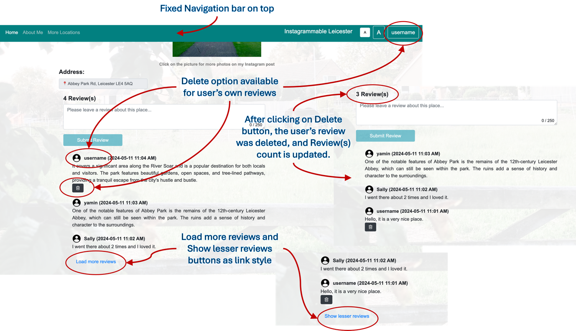

Figure 10 – Home page changes with fixed navigation bar and Delete review option

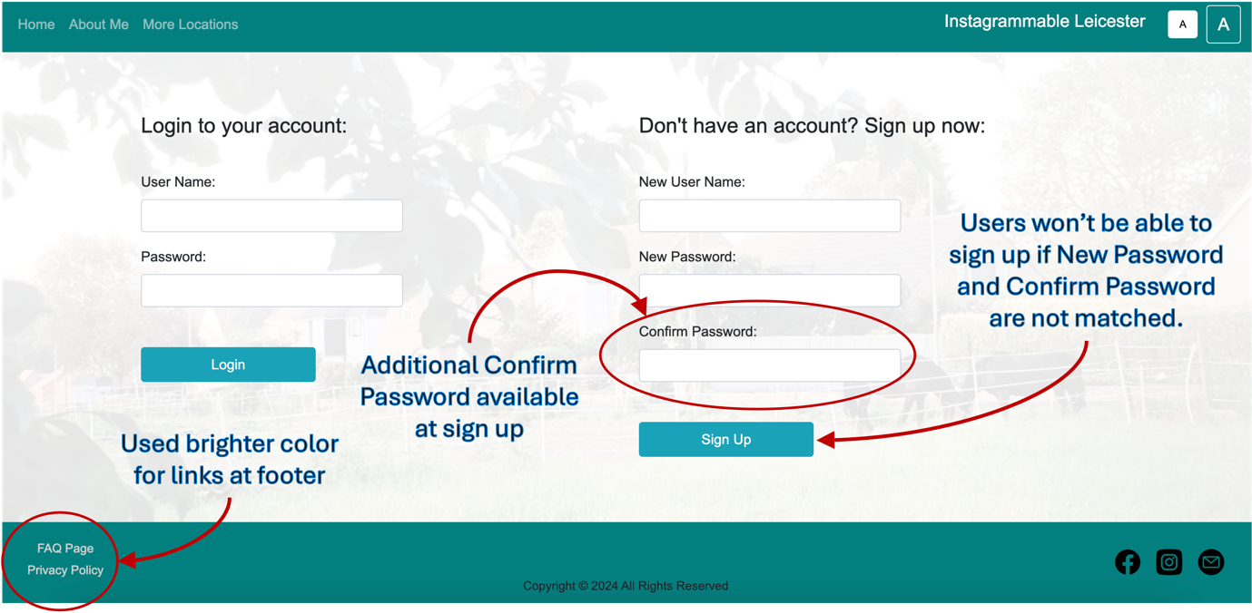

Figure 11 – Login or Signup page changes with additional Confirm Password

Other cosmetic problems such as profile button with user name on it to have also a user icon accompanied and sign out button to be available throughout all the pages, were not changed since the website still can function without them and the design changes required for them might need additional research and this could lead to feature creep while I’m only designing a vertical prototype.

- Usability Test Feedbacks

Referring to additional feedbacks towards the end of usability test in Figure 9, both feature requests were originally in my wireframe design. According to my research, having embedded Instagram posts need a third part app or tool and therefore I decided not to implement it for this project. Regarding the feedback to have the distance calculated or travel method from their location, having a google map can accommodate this request. However, due to prioritization of unique feature, this feature had also been removed from my developing features list.

- Calculating Usability Test Score

The System Usability Scale (SUS) scores from Figure 9 will be calculated based on the method found in the article "What Every UXC Client Should Know About SUS Scores" by Katharine Betteridge (link) as shown in the Figure 12 below.

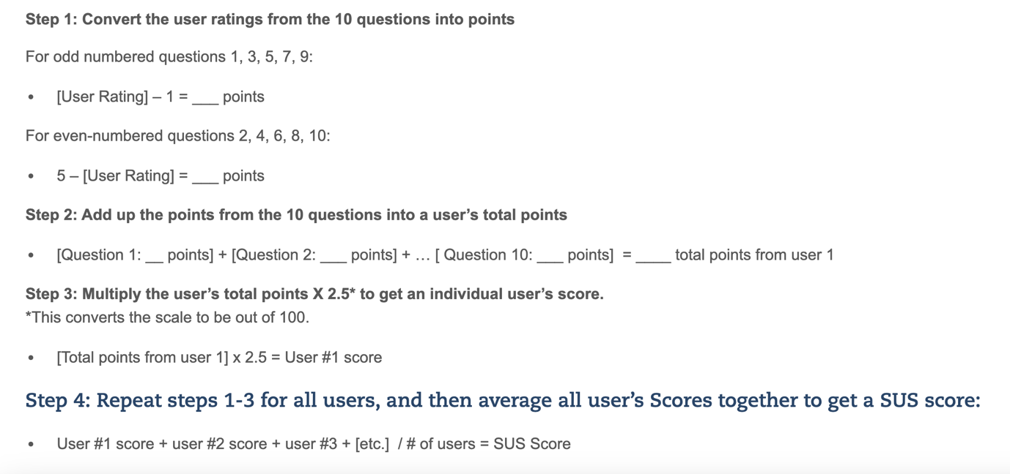

Figure 12 – Method to calculate SUS score from a number of users

List of users and their calculated SUS scores:
  - Manpreet Kaur – SUS score = 95
  - Nandar – SUS score = 100
  - Ye Myat Aung – SUS score = 95
  - Shagana – SUS score = 100
  - May Thidar Soe Myint – SUS score = 87.5
  - Oakker – SUS score = 85

Getting the average from there, the total SUS score from 6 users is 93.75 which is considered to be above average and even a Grade A for usability.

Conclusion

I initially crafted this project with just a pure combination of HTML, CSS and JavaScript and only when near to completion, I enhanced the design by integrating BootStrap and other external UI frameworks. This has made the design much more dynamic and responsive. One of the technical things that I’ve learnt during this project is the utilization of local storage when we’re not implementing the database yet. I’ve also witnessed the value of having potential users to do the evaluations and tests, which helped me spot a few usability issues that I’ve missed during the design. Overall, the project was a success with initial key user requirements being fulfilled, the major and minor usability issues being taken care of, and the usability SUS score for the prototype was above average.

