Cloud Security Threat Detection System
📌 1. Introduction:
Cloud Security Threat Detection System is a basic cybersecurity project designed to identify suspicious login activities in cloud environments. The system analyzes login details such as cloud platform, user, login time, location, and failed login attempts. Based on these factors, it calculates a risk score and classifies the activity as Low, Medium, or High risk. The project also displays possible security threats and recommended actions to improve cloud security.
🎯 2. Objectives:
The main objectives of this project are:
• To detect suspicious login activities in cloud environments.
• To analyze login time, location, and failed login attempts.
• To calculate a risk score for each login activity.
• To classify security risks as Low, Medium, or High.
• To identify possible security threats and display recommended actions.
• To provide a simple dashboard for viewing security information.
💻 3. Technologies Used:
The following technologies and tools are used in this project:
• Python – Used to develop the threat detection and risk scoring logic.
• HTML – Used to create the web-based security dashboard.
• CSS – Used to improve the appearance and layout of the dashboard.
• Python IDLE – Used to write, save, and execute the Python program.
⚙️ 4. Working of the Project:
The project works in the following steps:
- Sample login details are collected from different cloud platforms such as AWS, Azure, and GCP.
- The system checks important login factors such as location, login time, and failed login attempts.
- A risk score is calculated based on the detected suspicious conditions.
- The login activity is classified as Low, Medium, or High risk.
- Possible security threats and recommended actions are displayed for high-risk activities.
- The security dashboard presents the login details, risk levels, alerts, and summary in a simple format.
📊 5. Project Output:
The system was tested using sample login data from AWS, Azure, and GCP.
• AWS – Ravi: Risk Score: 0 → LOW RISK
• Azure – Sita: Risk Score: 100 → HIGH RISK
• GCP – Krishna: Risk Score: 0 → LOW RISK
The Azure login was identified as high risk because it had an unknown location, an unusual login time, and multiple failed login attempts. The system displayed the possible threats and recommended security actions.
The project also provides a simple web dashboard to display the login details, risk levels, alerts, and security summary.
🏁 6. Conclusion:
The Cloud Security Threat Detection System demonstrates a simple approach to identifying suspicious login activities in cloud environments. By analyzing login time, location, and failed login attempts, the system calculates a risk score and classifies the activity into different risk levels. It also displays possible threats and recommended security actions through a simple dashboard.
This project provides a basic foundation for understanding cloud security, threat detection, and risk assessment. The current version uses sample data and is designed as a prototype for learning and demonstration.
💻 7. Python Source Code :
# CLOUD SECURITY PROJECT
# Multi-Cloud Threat Detection

logs = [
{
"cloud": "AWS",
"user": "Ravi",
"login_time": 10,
"location": "India",
"failed_attempts": 1
},
{
"cloud": "Azure",
"user": "Sita",
"login_time": 3,
"location": "Unknown",
"failed_attempts": 6
},
{
"cloud": "GCP",
"user": "Krishna",
"login_time": 14,
"location": "India",
"failed_attempts": 2
}
]

high = 0
medium = 0
low = 0

print("CLOUD SECURITY DASHBOARD")
print("========================")

for log in logs:

risk_score = 0
reasons = []

if log["location"] == "Unknown":
risk_score += 30
reasons.append("Unknown Location")

if 2 <= log["login_time"] <= 5:
risk_score += 30
reasons.append("Unusual Login Time")

if log["failed_attempts"] >= 5:
risk_score += 40
reasons.append("Multiple Failed Attempts")

if risk_score >= 70:
risk_level = "HIGH"
high += 1

actions = [
"Require Identity Verification",
"Review Login Activity",
"Recommend Temporary Login Block"
]

elif risk_score >= 40:
risk_level = "MEDIUM"
medium += 1

actions = [
"Send Security Alert",
"Monitor User Activity"
]

else:
risk_level = "LOW"
low += 1

actions = [
"No Immediate Action Required",
"Continue Normal Monitoring"
]

print("\nCloud:", log["cloud"])
print("User:", log["user"])
print("Risk Score:", risk_score)
print("Risk Level:", risk_level)

if reasons:
print("Security Alerts:")
for reason in reasons:
print("-", reason)
else:
print("Security Alerts: None")

print("Recommended Actions:")
for action in actions:
print("-", action)

print("------------------------")

print("\nDASHBOARD SUMMARY")
print("========================")
print("Total Login Records:", len(logs))
print("High Risk Logins:", high)
print("Medium Risk Logins:", medium)
print("Low Risk Logins:", low)
print("========================")
print("SECURITY SCAN COMPLETED")

📸 8. Project Screenshots 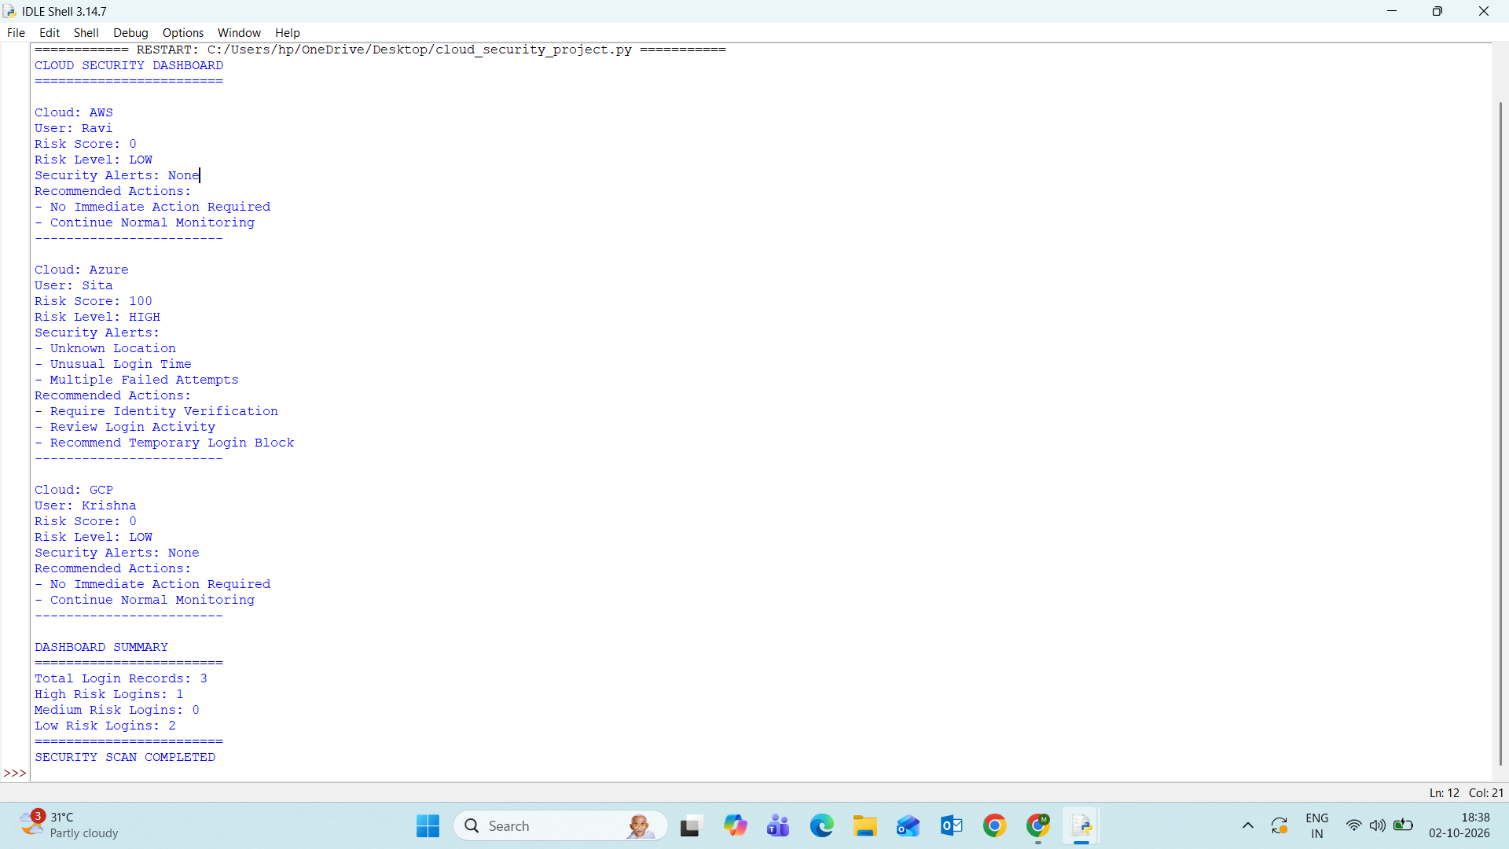
🌐 Cloud Security Dashboard
