# 

# Prediction Challenge 1 – Deep Learning

Name: Yamini Sai Ratnam Peketi

Student ID: 21147160

Course: MSC AI

Module: Deep Learning

**Prediction Challenge 1 – Deep Learning**

**Introduction:**

The Fashion-MNIST dataset is an important dataset used in image classification tasks. The purpose of this project was to design a feed forward deep neural network using the RELU activation function and the Adam optimizer to achieve high accuracy in classifying images from the Fashion-MNIST dataset. The goal was to tune the other parameters of the network and hyperparameters to achieve the best accuracy possible.

**Model Architecture:**

The deep neural network was designed to have three dense layers with 128, 64, and 32 neurons respectively, each with a RELU activation function. The input layer had 784 neurons representing each pixel in the input image, and the output layer had 10 neurons, each representing a different class in the Fashion-MNIST dataset. Dropout regularization was also applied to avoid overfitting.

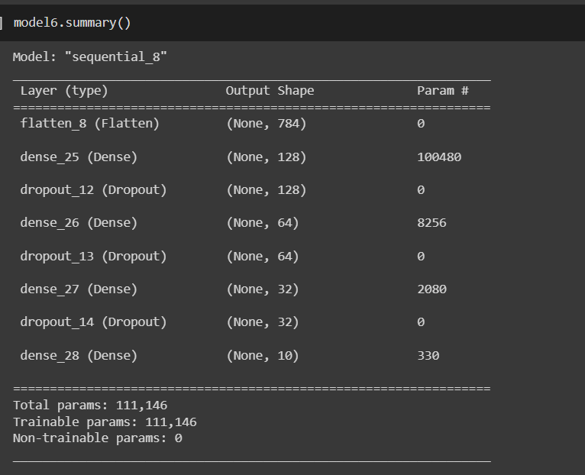

**Hyperparameters:**

The learning rate was set to 0.001, the batch size was 50, and the number of epochs was set to 100. These hyperparameters were chosen based on experimentation and were found to provide the best accuracy during training.

**Training and Evaluation:**

The model was trained using the Adam optimizer and the sparse-categorical-cross entropy loss function. The validation accuracy achieved during training was 0.8937. The Keras summary of the deep neural network is attached below.

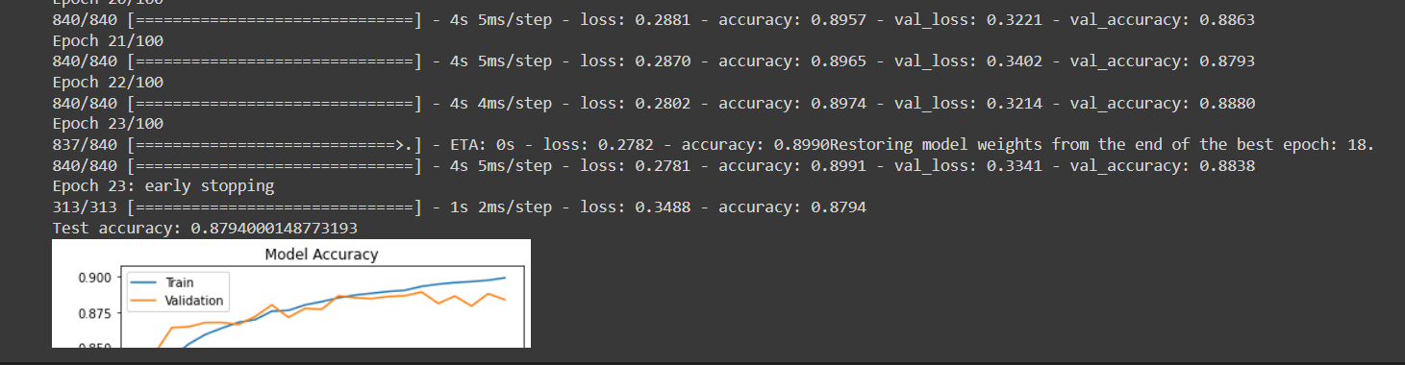

**Results:**

The model achieved an accuracy of 0.8794 on the test dataset, which is a good performance given the complexity of the Fashion-MNIST dataset. The accuracy and loss plots are shown in the figure below.

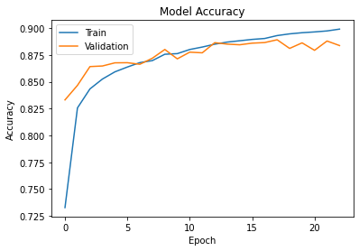

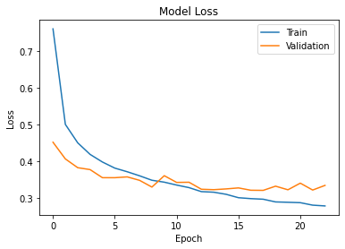

**Conclusion:**

In conclusion, we designed a feed forward deep neural network to classify images from the Fashion-MNIST dataset, achieving an accuracy of 0.8794 on the test dataset. The model performed well, but further improvements could be made for certain classes. Overall, this project demonstrates the potential of deep neural networks for image classification tasks and provides insight into the factors that influence their performance.

Word Count:

Link: