ASSIGNMENT- 22.3
Shivayamini
2303A52475
Batch-38

Task 1 – Bias Detection in AI Suggestions (Alternative Example)
Example Scenario:
Ask AI to generate a resume shortlisting algorithm multiple times.
- Change prompt wording (e.g., “select best candidate” vs “ensure diversity”).
- Compare outputs and logic. Discussion Points:
- Does the AI favor certain qualifications, backgrounds, or experiences?
- How could biased shortlisting algorithms affect equal employment opportunities?
PROMPT 1:
Create a Python program that shortlists the best candidate from a list of resumes based on skills, experience, and education.
CODE:
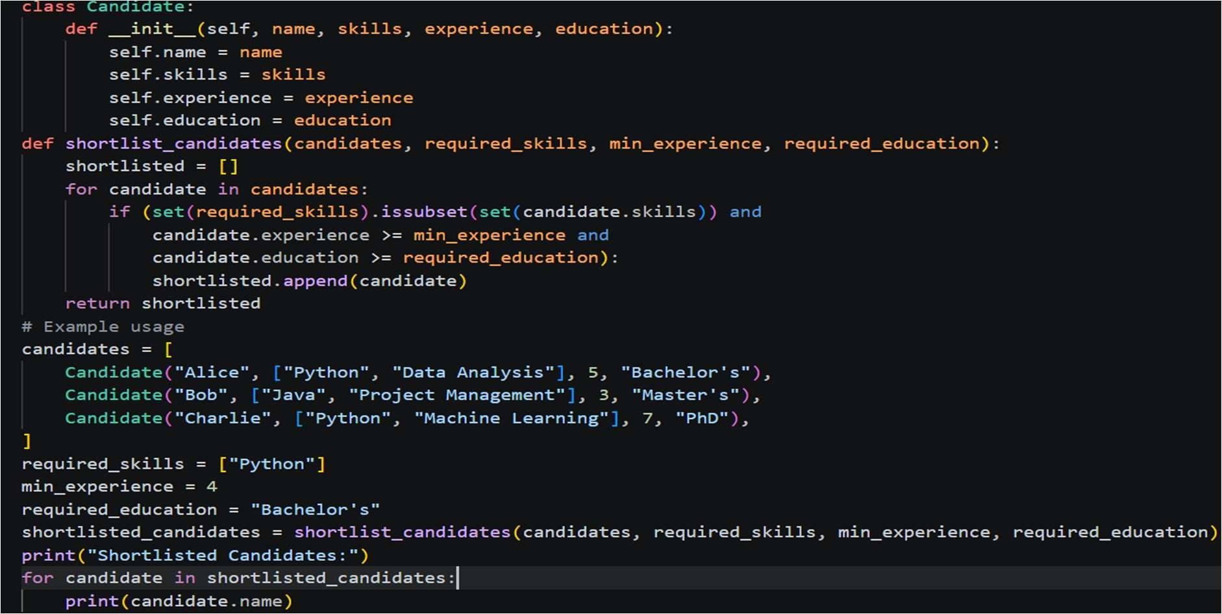
OUTPUT:

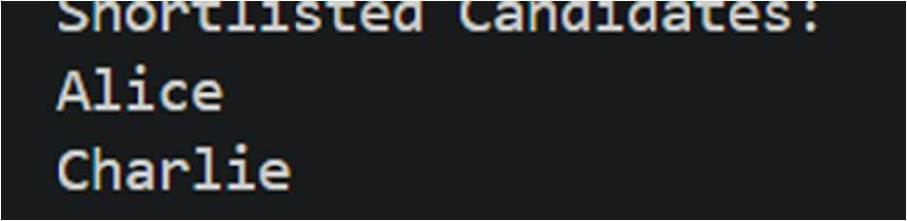
PROMPT 2:
Create a Python program that selects the most suitable candidate for a job based on qualifications, experience, and achievements.
CODE:
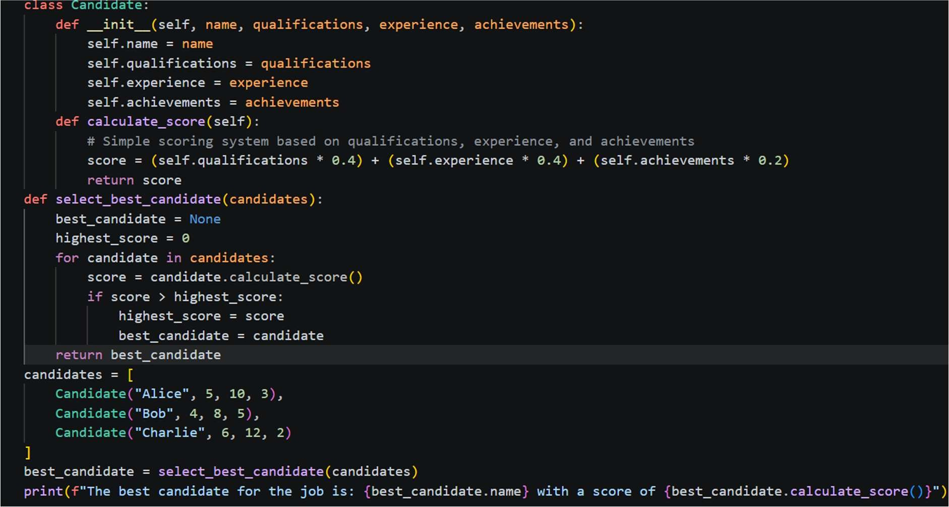
OUTPUT:
PROMPT 3:
Create a Python program that shortlists candidates while ensuring diversity and equal opportunity, considering skills, experience, and background.
CODE:
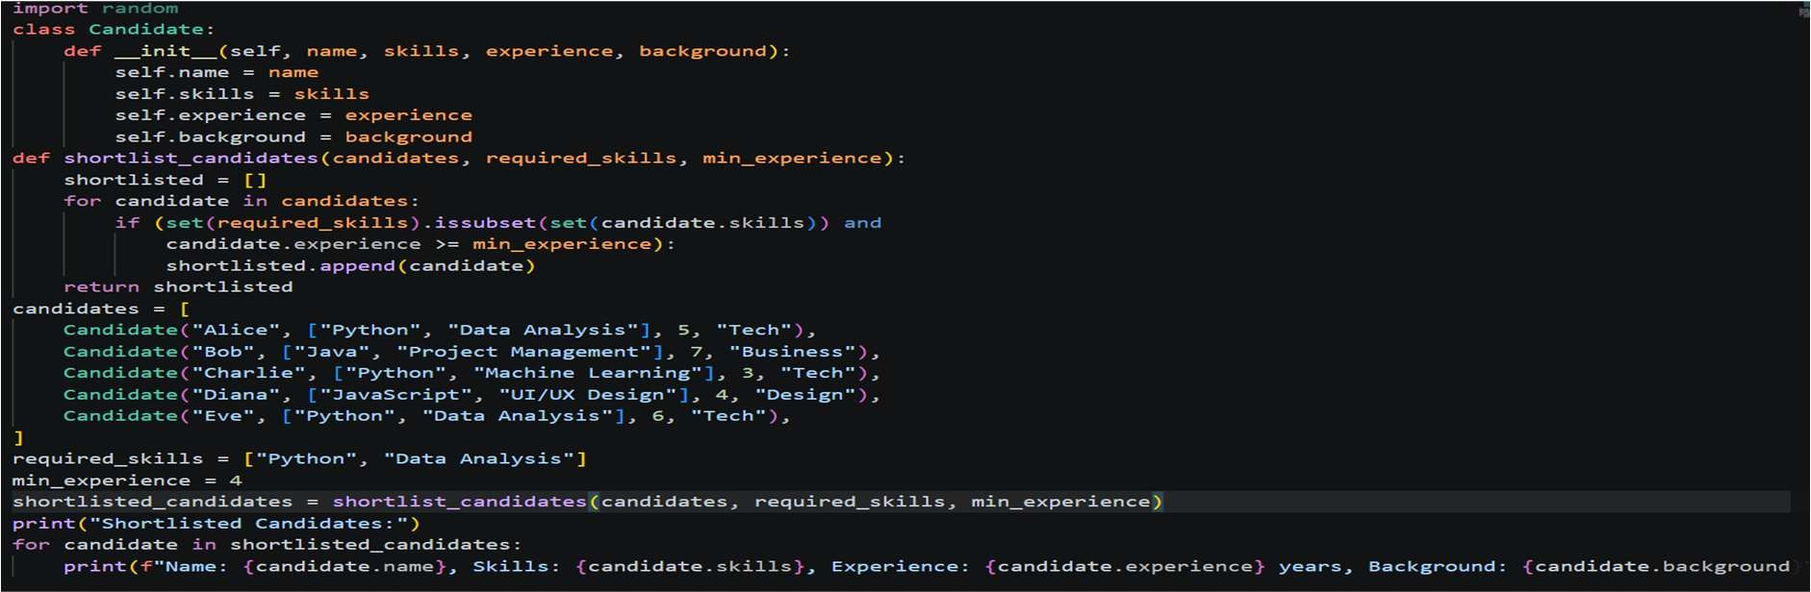

OUTPUT:
PROMPT4:
Create a fair and unbiased resume shortlisting algorithm in Python that avoids discrimination and considers equal opportunity along with skills and experience.
CODE:
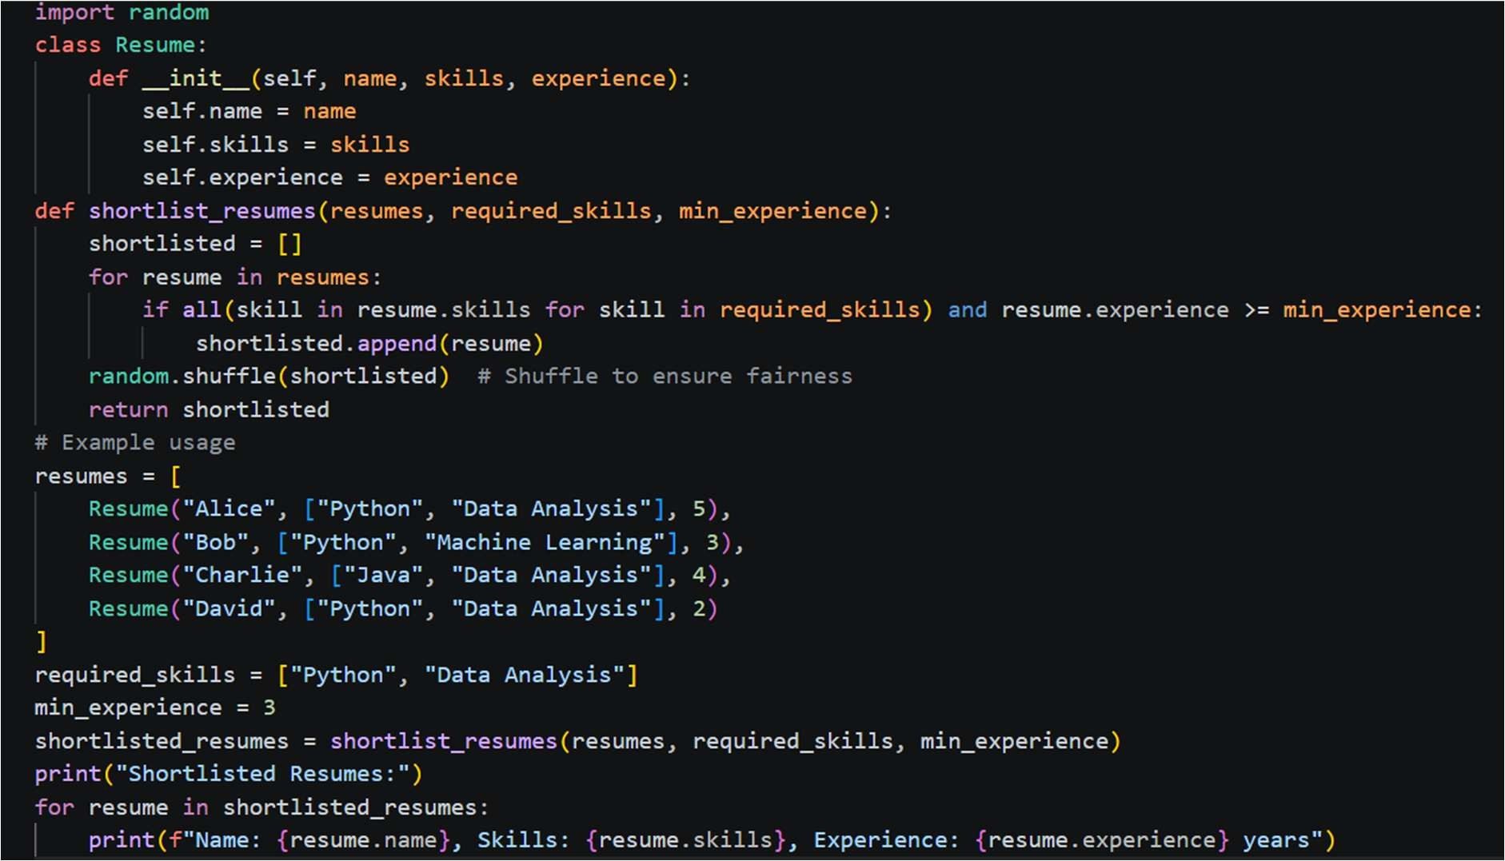
OUTPUT:
PROMPT 5:
Write a Python program for resume shortlisting that prioritizes skills and experience while minimizing bias related to gender, location, or education background.
CODE:

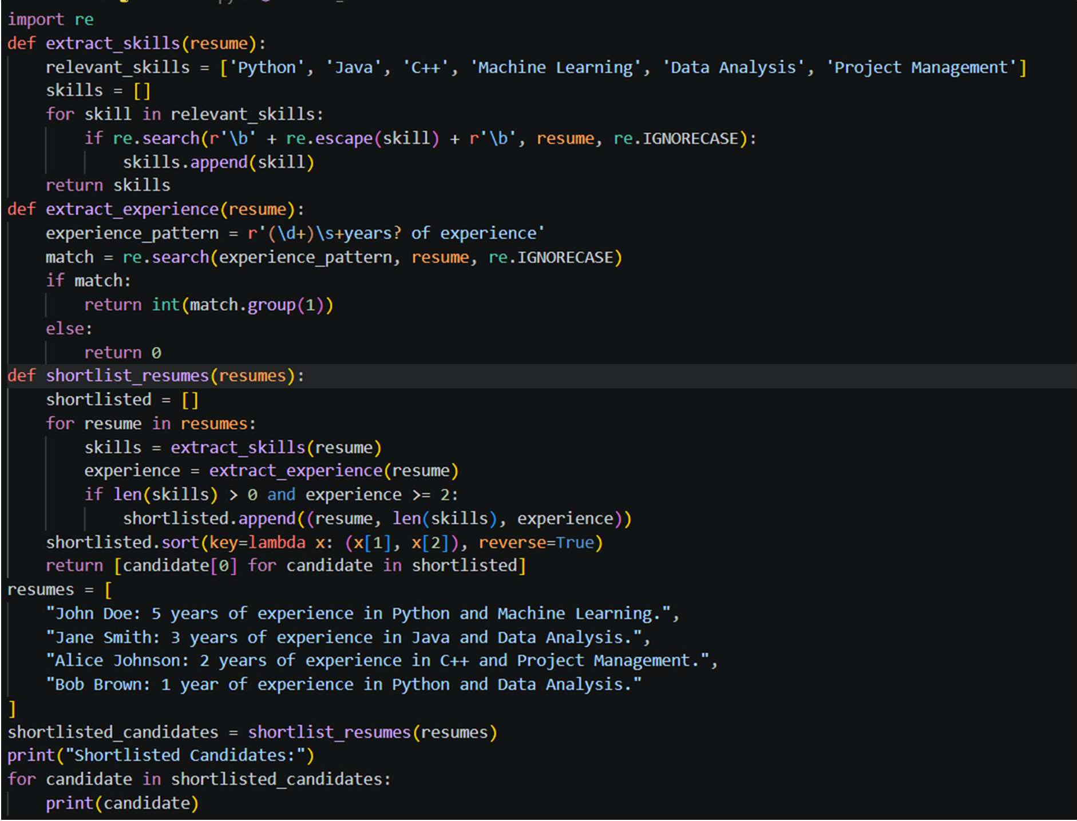
OUTPUT:
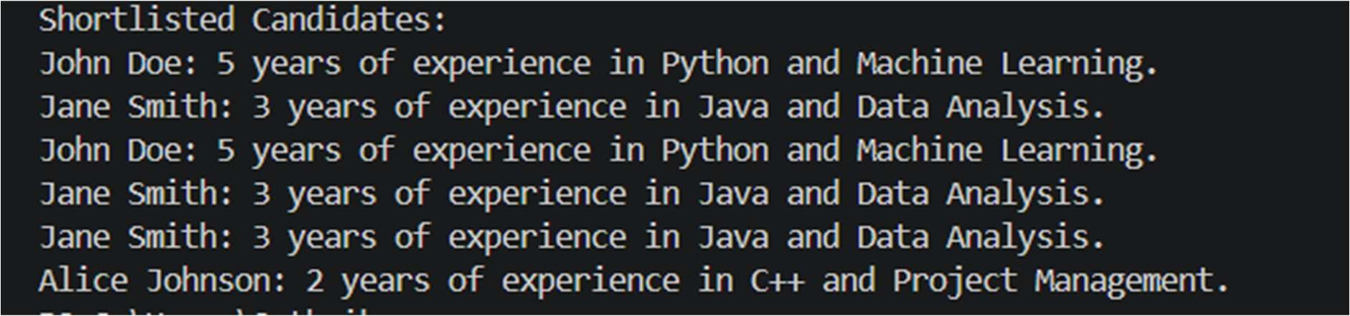
EXPLANATION:
This task shows that AI responses can change based on how a prompt is written. When we ask for the “best candidate,” the AI may favor people from top colleges or with more experience, which can introduce bias. However, when we include words like “diversity” or “fairness,” the AI tries to consider equal opportunities and avoid discrimination. This means the wording of prompts directly affects the decision-making process. Biased algorithms can reduce equal job opportunities and exclude deserving candidates. Therefore, careful and ethical prompt design is important to make AI systems fair.

Task 2 – Privacy and Sensitive Data Handling (Alternative Example)
Example Scenario:
Ask AI to write code for processing student academic records (roll

number, marks, email). Discussion Points:
- How should student identity data be masked or encrypted?
- What privacy laws (e.g., FERPA, GDPR-like principles) are relevant?
- What ethical responsibility does the programmer have when using AI-generated code?
CODE:
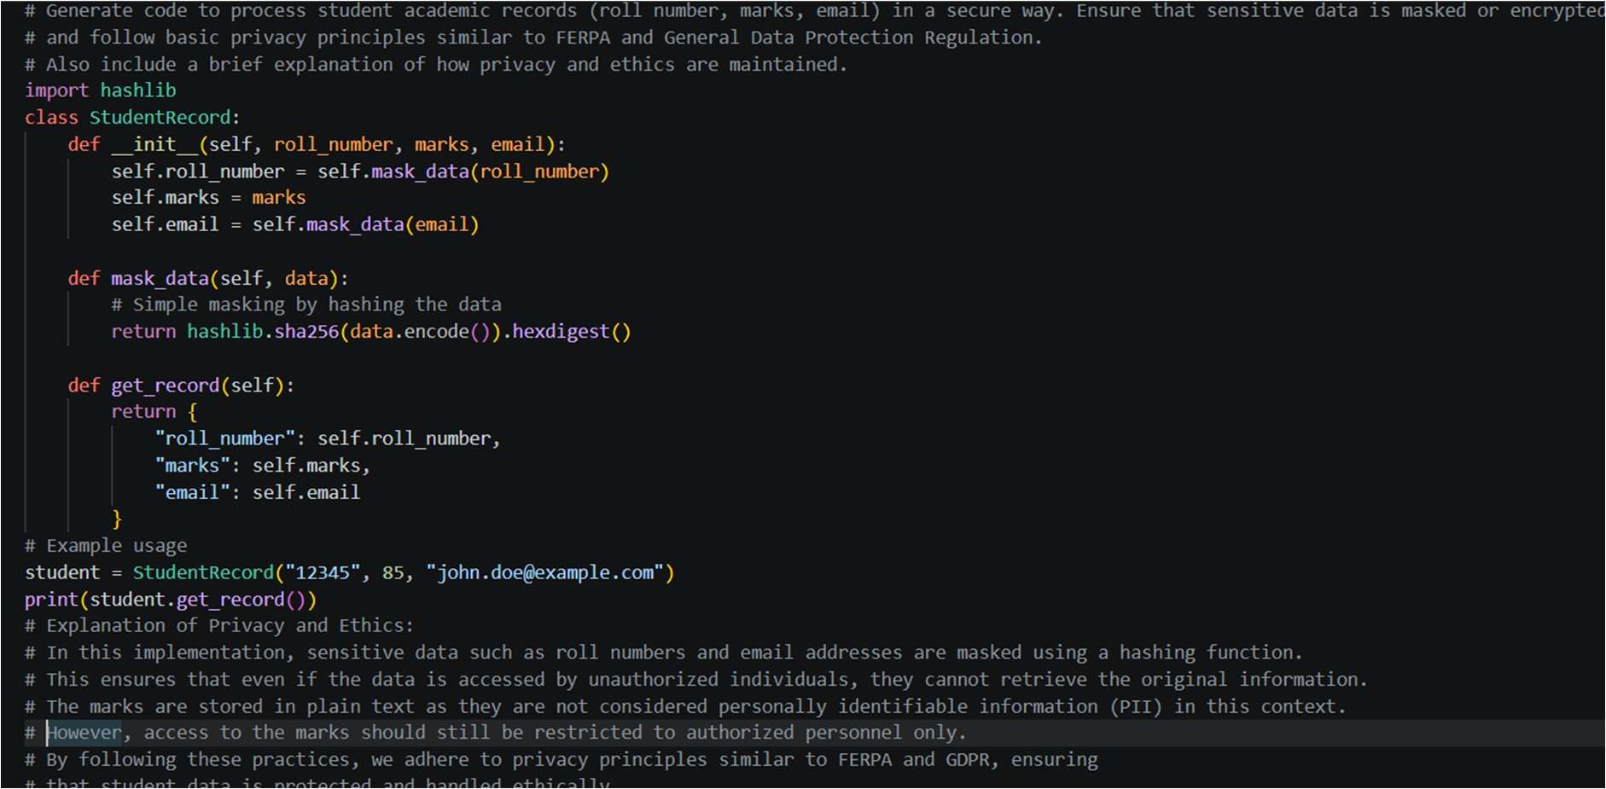
OUTPUT:
EXPLANATION:
This code securely stores student data by protecting sensitive information like roll number and email. It uses hashing to convert this data into an unreadable format, so the original values cannot be easily accessed. Marks are stored normally since they are less sensitive.
When the data is retrieved, only the masked (hashed) values are shown. This helps maintain privacy and follows principles similar to FERPA and General Data Protection Regulation.

Task 3 – AI-Generated Security Risks (Alternative Example)
Example Scenario:
Use AI to generate a payment processing script for an online shopping system.
Student Tasks:

- Identify risks such as:
- Plain-text card data storage
- Missing input validation
- Propose ethical coding standards to prevent financial fraud and misuse.
PROMPT:
Generate a payment processing script for an online shopping system. Identify possible security risks such as storing card details in plain text and lack of input validation. Also suggest ethical coding practices to prevent financial fraud and misuse, following basic security and privacy principles.
CODE:
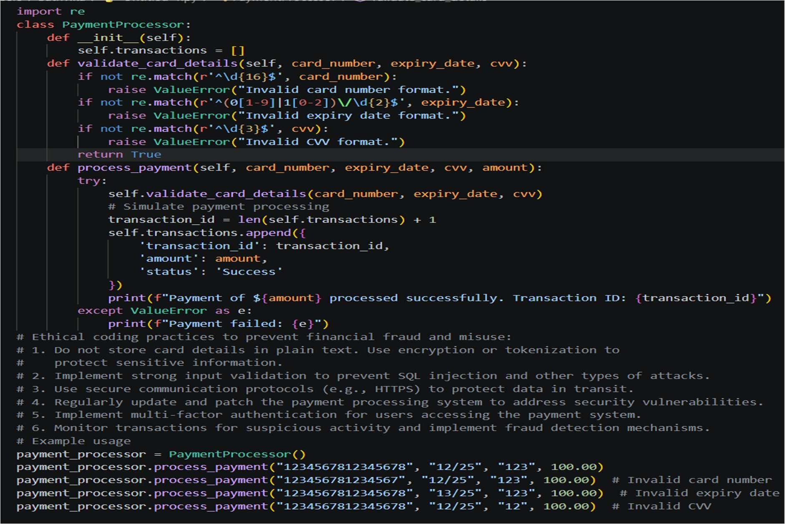
OUTPUT:
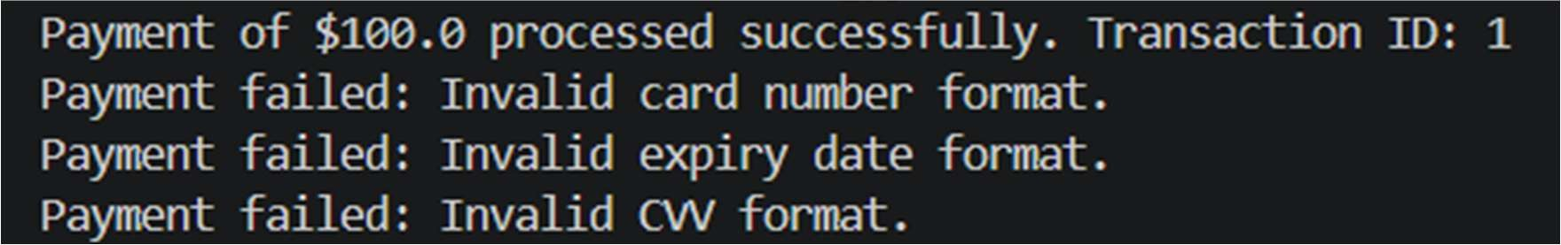
EXPLANATION:
The code is testing a payment processing system by giving different card details. It checks for errors like invalid card number, wrong expiry date, and incorrect CVV. This helps ensure that only valid

payment information is accepted. Such validation prevents fraud and protects user financial data. It also highlights the importance of secure handling of sensitive payment details.

Task 4 – Accountability in Human–AI Collaboration (Alternative Example) Scenario:
AI generates code for an autonomous traffic signal control system. Discussion Questions:
- If a software error causes accidents, who is accountable? Should responsibility lie with:
- AI tool developers
- Software engineers
- Government authorities deploying the system? Students submit a short reflection on accountability. OUTPUT:
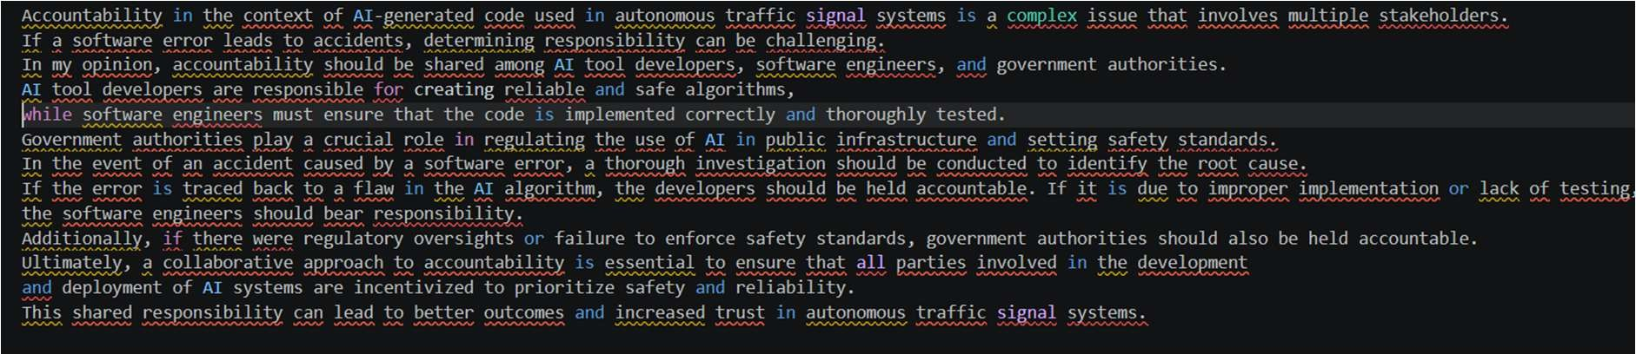
EXPLANATION:
This answer says that responsibility for accidents in AI-based traffic systems should be shared.AI developers are responsible if there is a problem in the algorithm.
Software engineers are responsible if the code is not properly tested or implemented. Government authorities are responsible for setting rules and ensuring safety standards. Overall, everyone must work together to ensure safety and prevent accidents.

Task 5 – Limitations of AI in Critical Systems (Alternative Example)
Example Scenario:
Ask AI to generate code for an aircraft maintenance fault detection system.
Discussion Points:
- Can AI-generated code be trusted without expert validation?
- What human oversight is essential in aviation software?
- How should safety-critical code be reviewed and certified?

PROMPT:
Generate code for an aircraft maintenance fault detection system. Along with the code, explain the limitations of using AI-generated code in such safety-critical systems. Discuss whether the code can be trusted without expert validation, what kind of human oversight is required in aviation software, and how safety-critical systems should be properly tested, reviewed, and certified before deployment.
CODE:
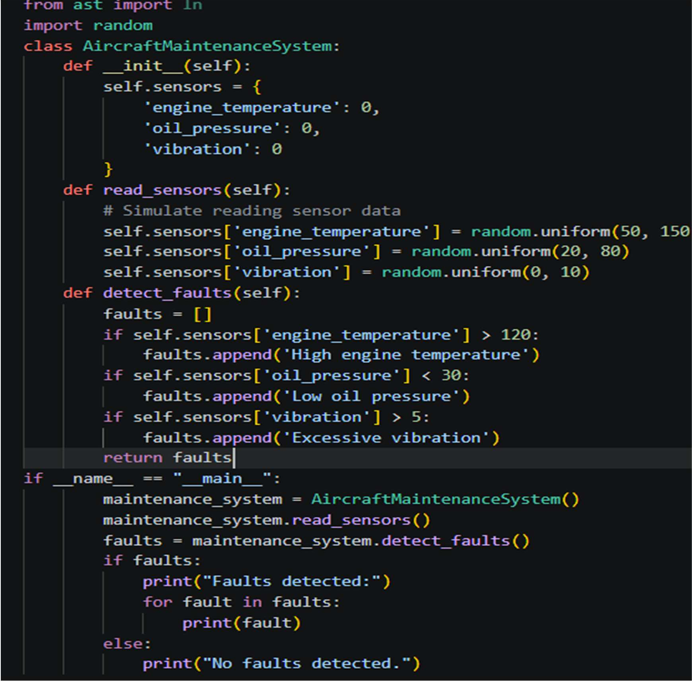
OUTPUT:
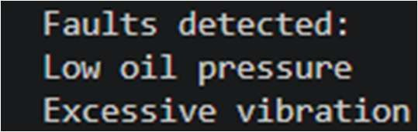
EXPLANATION:
This code simulates an aircraft maintenance system that monitors sensor data like engine temperature, oil pressure, and vibration. It randomly generates sensor values and checks if they exceed safe limits. If any value is abnormal, it detects faults such as high temperature or low oil

pressure. The system then prints the detected faults or shows “No faults detected” if everything is normal. This demonstrates how faults can be identified, but real systems need expert validation for safety.

Task 6 – Ethical Use of AI-Generated Code (Alternative Example)
Example Scenario:
Students analyze cases where AI-generated code is used in academic assignments or startups.
Discussion Points:
- Risks of submitting AI code without understanding it
- Copyright and license violations Best practices:
- Proper citation
- Manual verification
- Ethical reuse of AI outputs
PROMPT:
Analyze the ethical issues of using AI-generated code in academics and startups. Cover the risks of submitting code without understanding it, copyright and license violations, and best practices like proper citation, manual verification, and ethical reuse. Give one real-world example and a short checklist a developer can follow.
OUTPUT:
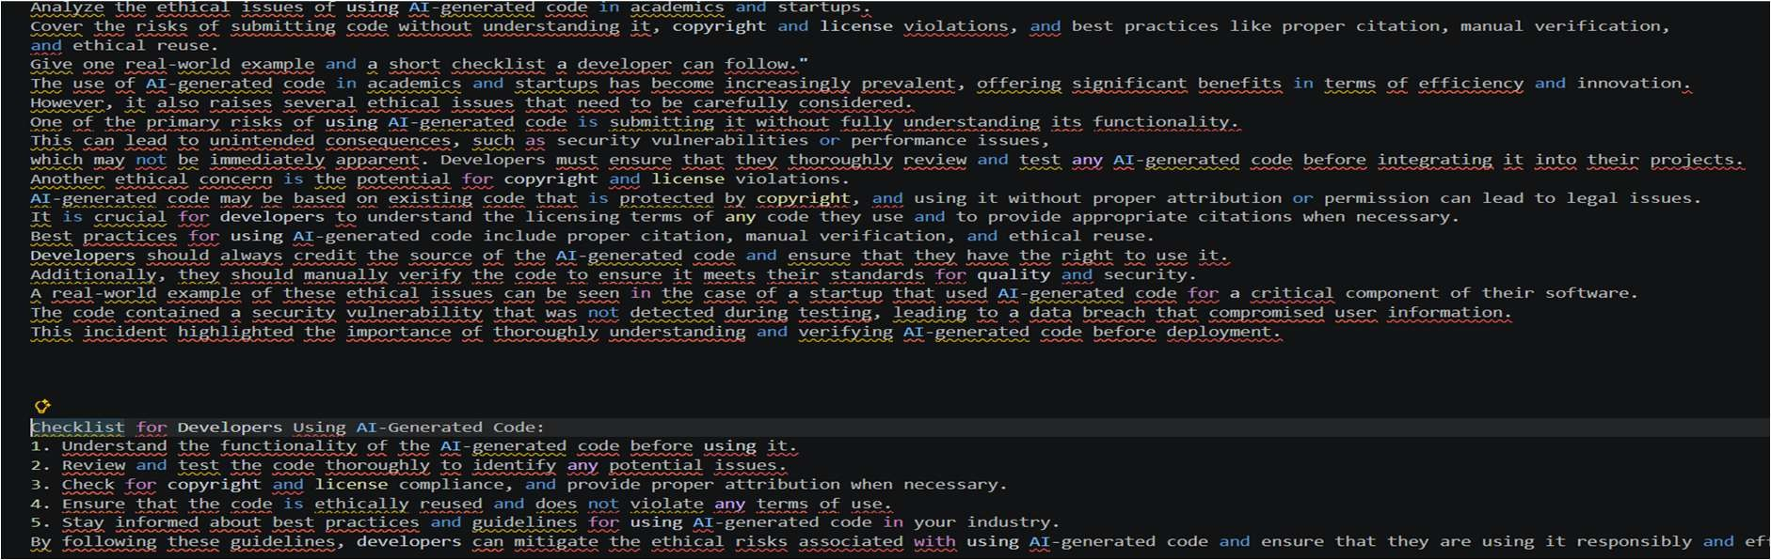
EXPLANATION:
This answer explains that using AI-generated code is helpful but can create ethical problems. If developers use code without understanding it, it may cause errors or security issues.
There can also be legal problems if the code violates copyright or licenses.
So, developers should always check, test, and give proper credit when using AI code. Following these steps helps in using AI-generated code safely and responsibly.

