AI Assistant Coding
Assignment – 7

Shivayamini
2303A52475
Batch : 38

Lab 7: Error Debugging with AI: Systematic approaches to finding and fixing bugs
Lab Objectives
• To identify and correct syntax, logic, and runtime errors in Python programs using AI tools
Week4 -
Wednesday
• To understand common programming bugs and AI-assisted debugging suggestions
• To evaluate how AI explains, detects, and fixes different types of coding errors
• To build confidence in using AI for structured debugging practices
Lab Outcomes (LOs)
After completing this lab, students will be able to:
• Use AI tools to detect and correct syntax, logic, and runtime errors
• Interpret AI-suggested bug fixes and explanations
• Apply systematic debugging strategies using AI-generated insights
• Refactor buggy code using reliable programming patterns
Task 1: Fixing Syntax Errors
Scenario
You are reviewing a Python program where a basic function definition contains a syntax error.
Requirements
• Provide a Python function add(a, b) with a missing colon
• Use an AI tool to detect the syntax error
• Allow AI to correct the function definition
• Observe how AI explains the syntax issue
Expected Output
• Corrected function with proper syntax
• Syntax error resolved successfully
• AI-generated explanation of the fix
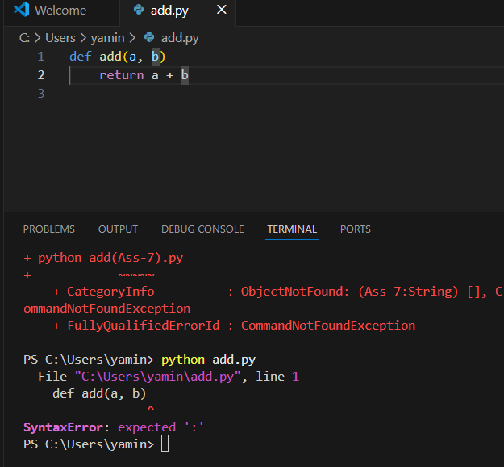
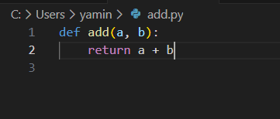

Explanation:
The colon : was missing after the function definition. Adding it fixes the syntax error.

Task 2: Debugging Logic Errors in Loops
Scenario
You are debugging a loop that runs infinitely due to a logical mistake.
Requirements
• Provide a loop with an increment or decrement error
• Use AI to identify the cause of infinite iteration
• Let AI fix the loop logic
• Analyze the corrected loop behavior
Expected Output
• Infinite loop issue resolved
• Correct increment/decrement logic applied
• AI explanation of the logic error
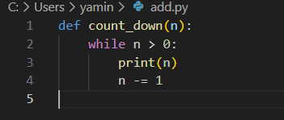
Explanation:
The loop was running infinitely because n was increasing (n += 1) instead of decreasing.
Changing it to n -= 1 makes n move toward 0, so the loop ends correctly.

Task 3: Handling Runtime Errors (Division by Zero)
Scenario
A Python function crashes during execution due to a division by zero error.
Requirements
• Provide a function that performs division without validation
• Use AI to identify the runtime error
• Let AI add try-except blocks for safe execution
• Review AI’s error-handling approach
Expected Output
• Function executes safely without crashing
• Division by zero handled using try-except
• Clear AI-generated explanation of runtime error handling
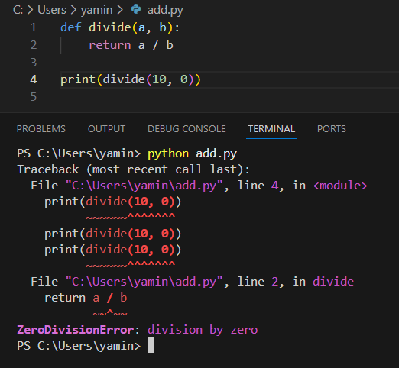
Explanation:
The runtime error occurs when dividing by zero.
Using a try-except block catches the ZeroDivisionError and prevents the program from crashing.

Task 4: Debugging Class Definition Errors
Scenario
You are given a faulty Python class where the constructor is incorrectly defined.
Requirements
• Provide a class definition with missing self-parameter
• Use AI to identify the issue in the __init__() method
• Allow AI to correct the class definition
• Understand why self is required
Expected Output
• Corrected __init__() method
• Proper use of self in class definition
• AI explanation of object-oriented error
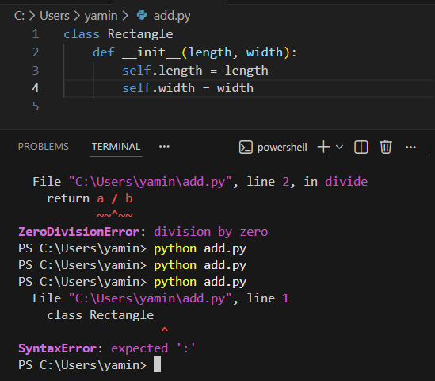
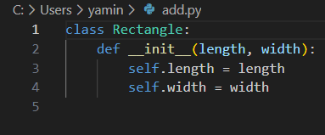
Explanation:
The constructor __init__ was missing the self parameter.
self refers to the current object and is required to store and access instance variables inside a class.

Task 5: Resolving Index Errors in Lists
Scenario
A program crashes when accessing an invalid index in a list.
Requirements
• Provide code that accesses an out-of-range list index
• Use AI to identify the Index Error
• Let AI suggest safe access methods
• Apply bounds checking or exception handling
Expected Output
• Index error resolved
• Safe list access logic implemented
• AI suggestion using length checks or exception handling
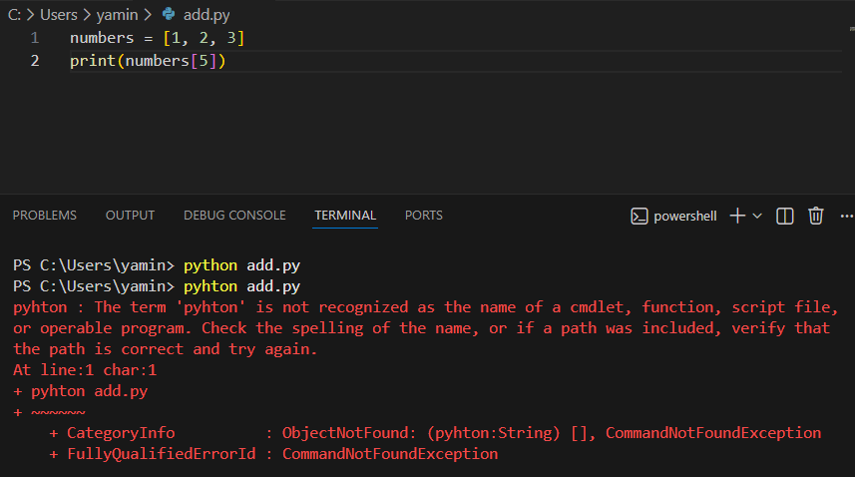

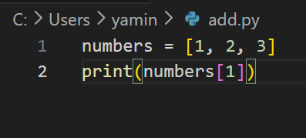
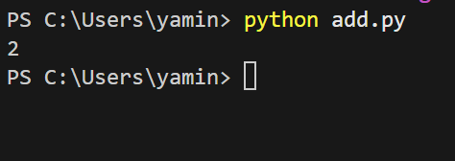
Explanation:
The error occurs because index 5 does not exist in the list.
Using try-except catches the Index Error and prevents the program from crashing.

