ASSIGNMENT – 8.2
Shivayamini
2303A52475
Batch – 38
Task Description
Task 1 – Test-Driven Development for Even/Odd Number Validator
• Use AI tools to first generate test cases for a function is_even(n)
and then implement the function so that it satisfies all generated
tests.
Requirements:
• Input must be an integer
• Handle zero, negative numbers, and large integers
Example Test Scenarios:
is_even(2) → True
is_even(7) → False
is_even(0) → True
is_even(-4) → True
is_even(9) → False
Expected Output -1
• A correctly implemented is_even() function that passes all AI-
generated test case
PROMPT:
Create test cases and implement a Python function is_even(n) that checks whether a number is even. Handle zero, negative numbers, and large integers.
CODE:
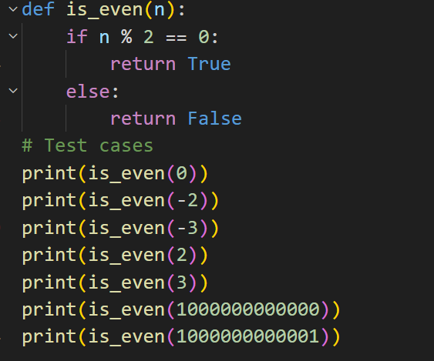
OUTPUT:
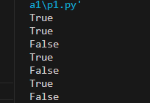
EXPLANATION:
The function is_even(n) checks whether a number is even using the modulus operator. The print statements are general test cases used to verify the function with positive, negative, zero, and large integers.
PROMPT:
Write Python assert test cases for is_even(n) and implement the function. Include tests for zero, negative numbers, and large integers.
CODE:
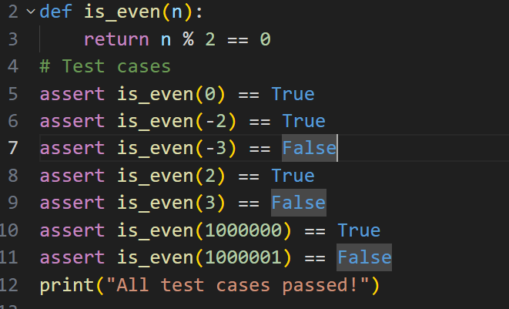
OUTPUT:
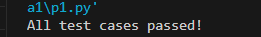
EXPLANATION:
The function is_even(n) checks whether a number is even using the modulus operator. The assert statements are used as test cases to automatically verify the function with positive numbers, negative numbers, zero, and large integers. If all assertions are correct, the program prints "All test cases passed!".

PROMPT:
Write pytest test cases for is_even(n) and implement the function. Handle zero, negative numbers, large integers, and invalid input.
CODE:
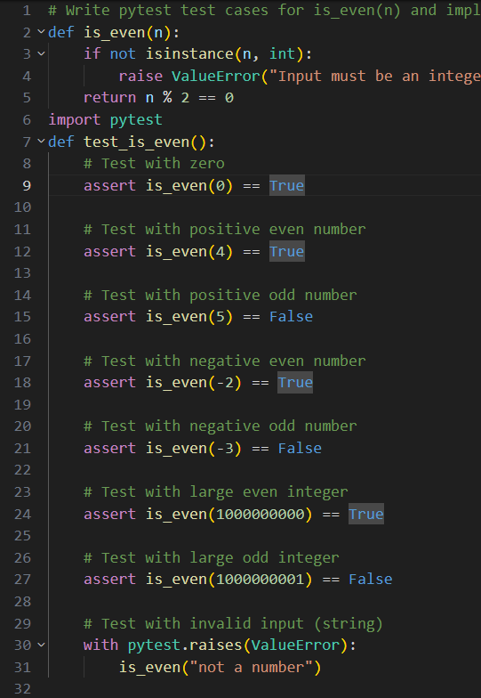
OUTPUT:
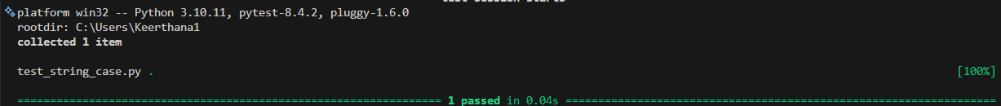
EXPLANATION:
The is_even(n) function checks whether a number is even using the modulus operator.
The pytest test function verifies the program with zero, positive, negative, large numbers, and invalid input.If all tests pass, it confirms the function works correctly.
PROMPT:
Write unit tests for is_even(n) and implement the function. Handle zero, negative numbers, large integers, and invalid input.

CODE:
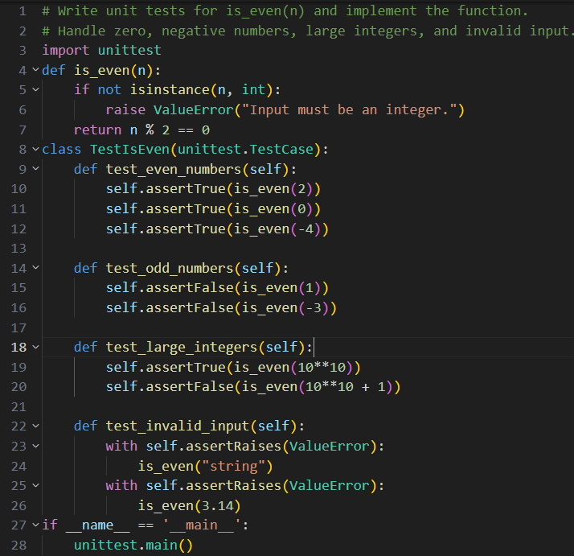
OUTPUT:
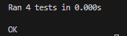
EXPLANATION:
The is_even() function checks whether a number is even. The unittest test class verifies the function using even, odd, zero, large numbers, and invalid input. All tests confirm the function works correctly.
Task 2 – Test-Driven Development for String Case Converter
• Ask AI to generate test cases for two functions:
• to_uppercase(text)
• to_lowercase(text)
Requirements:
• Handle empty strings
• Handle mixed-case input
• Handle invalid inputs such as numbers or None
Example Test Scenarios:
to_uppercase("ai coding") → "AI CODING"
to_lowercase("TEST") → "test"
to_uppercase("") → ""
to_lowercase(None) → Error or safe handling
Expected Output -2
• Two string conversion functions that pass all AI-generated test
cases with safe input handling.
PROMPT:
Write Python functions to_uppercase(text) and to_lowercase(text) with general print test cases. Handle empty strings, mixed-case text, and invalid inputs like None safely.
CODE:
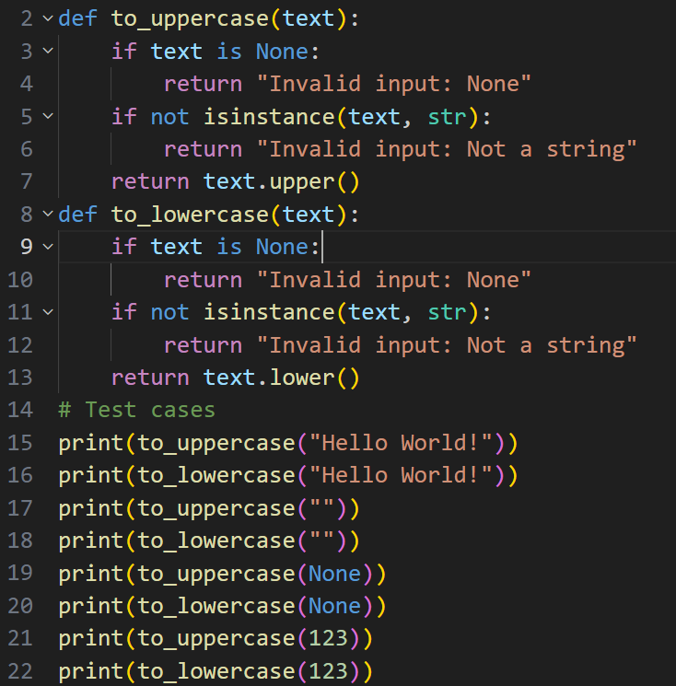
OUTPUT:
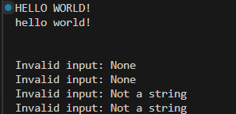
EXPALANTION:
The program implements two string conversion functions with safe input handling. Print statements are used as general test cases to check normal strings, empty strings, None values, and non-string inputs.
PROMPT:
Create unittest test cases for to_uppercase(text) and to_lowercase(text) in Python and implement the functions to pass all tests, including handling None and non-string inputs safely.
CODE:
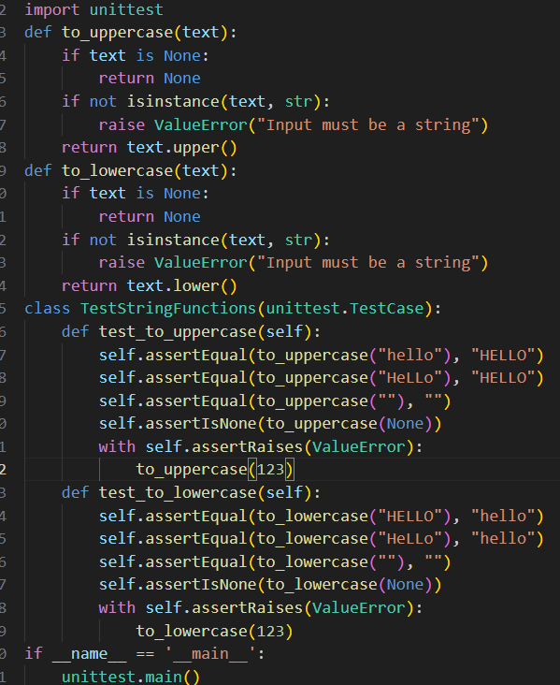
OUTPUT:
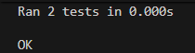
EXPLANATION:
The program defines two functions to convert strings into uppercase and lowercase. It uses the unittest module to test the functions with normal strings, empty strings, None values, and invalid inputs. All test cases are executed using unittest.main() and the output “OK” shows that all tests passed successfully.

PROMPT:
Write pytest test cases for two Python functions to_uppercase(text) and to_lowercase(text).Test normal strings, mixed-case strings, empty strings, None, and numbers.Then implement both functions with safe input handling so all tests pass.
CODE:
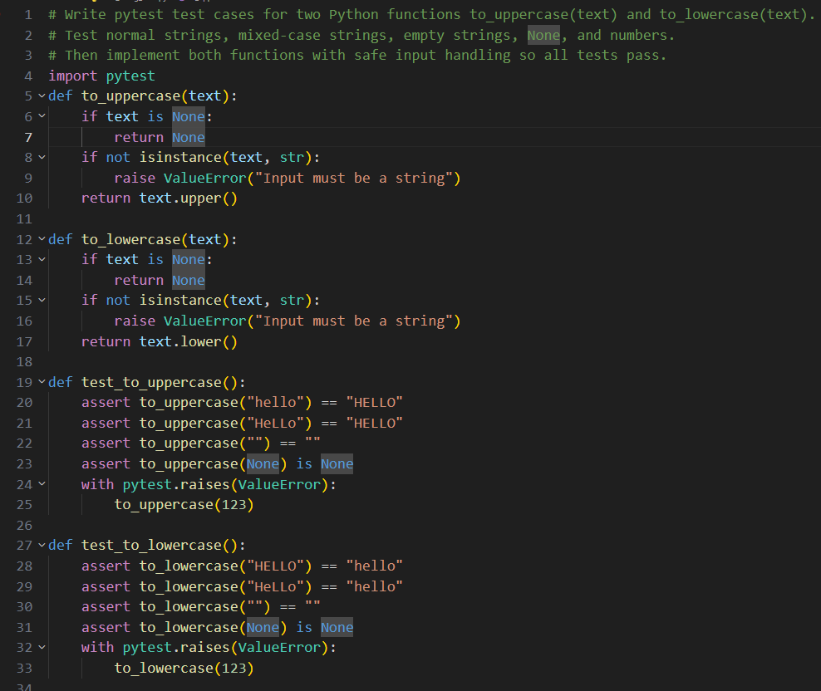
OUTPUT:
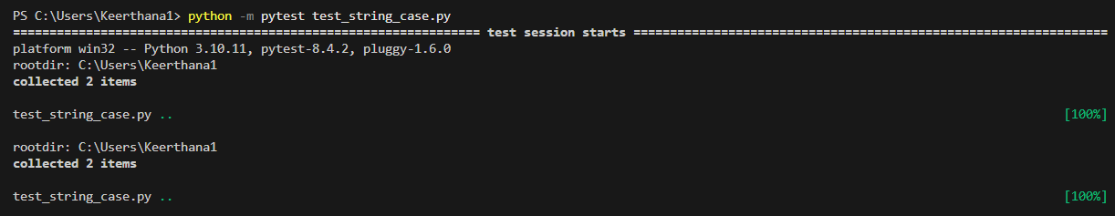
EXPLANATION:
The pytest test cases verify that the to_uppercase() and to_lowercase() functions correctly handle normal strings, mixed-case strings, empty strings, None values, and invalid inputs.

PROMPT:
Write Python assertion tests for to_uppercase(text) and to_lowercase(text) to check uppercase conversion, lowercase conversion, empty string handling, and invalid input handling.
CODE:
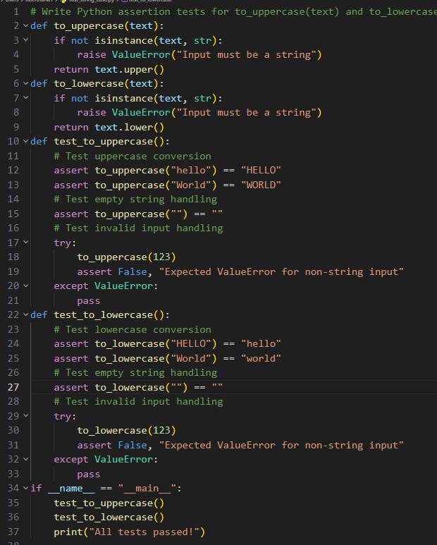

OUTPUT:
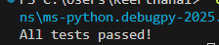
EXPLANATION:
This program has two functions: one converts text to uppercase and the other converts text to lowercase.
It also includes tests to check if the functions work correctly for normal input, empty strings, and invalid input. If everything works, it prints “All tests passed!”.

Task Description
Task 3 – Test-Driven Development for List Sum Calculator
• Use AI to generate test cases for a function sum_list(numbers)
that calculates the sum of list elements.
Requirements:
• Handle empty lists
• Handle negative numbers
• Ignore or safely handle non-numeric values
Example Test Scenarios:
sum_list([1, 2, 3]) → 6
sum_list([]) → 0
sum_list([-1, 5, -4]) → 0
sum_list([2, "a", 3]) → 5
Expected Output 3
• A robust list-sum function validated using AI-generated test cases
PROMPT:
Create test cases for a Python function sum_list(numbers) that adds numbers in a list.
The function should return 0 for an empty list, handle negative numbers, and ignore non-numeric values.
Show example inputs and expected outputs.
CODE:
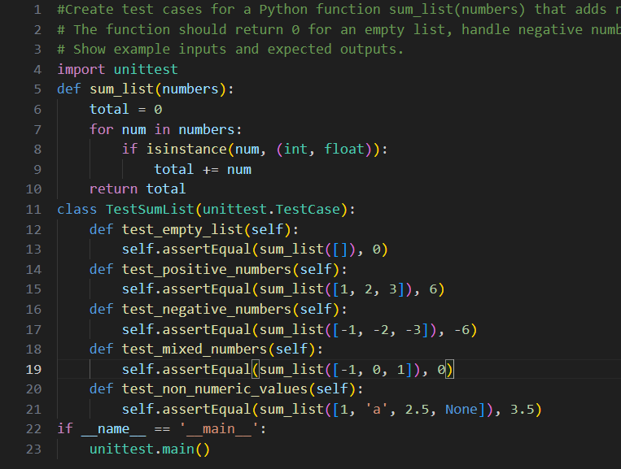
OUTPUT:
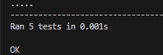
EXPLANATION:
This program defines a function sum_list(numbers) that adds only numeric values (int or float) from a list and ignores other types. Then unittest test cases check different situations like empty lists, positive numbers, negative numbers, and mixed values.
PROMPT:
“Write test cases for a Python function sum_list(numbers) that returns the sum of elements in a list. The function should return 0 for an empty list, handle negative numbers correctly, and ignore non-numeric values. Include example inputs and expected outputs.”
CODE:
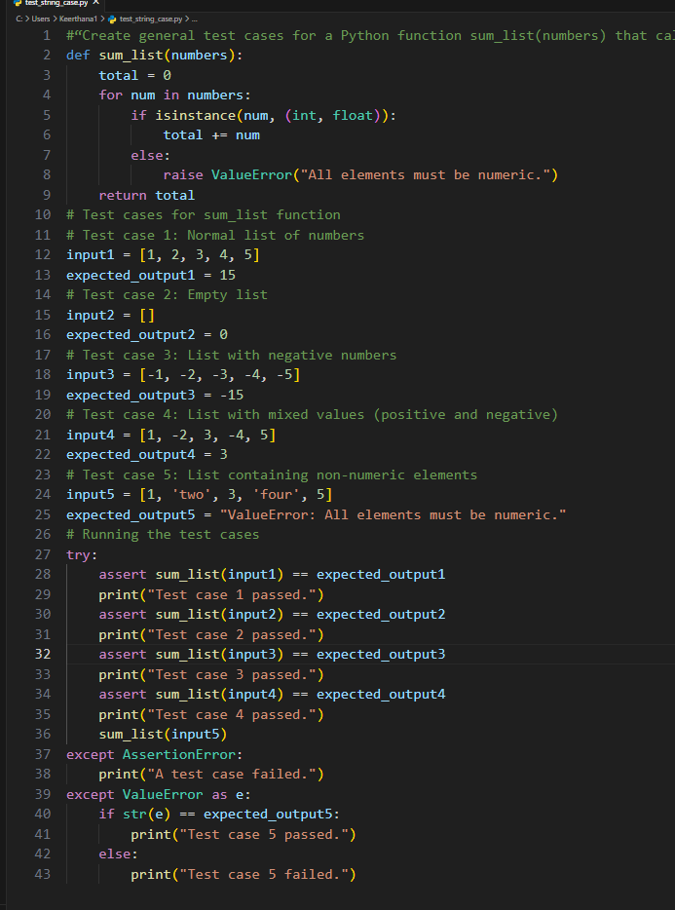
OUTPUT:
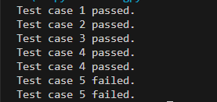
EXPLANATION:
This code creates a function sum_list() that adds only numeric values in a list.
Then it runs 5 test cases using assert to check if the function works correctly.
If a list contains non-numeric values, the function raises a ValueError, and the test checks for that.
PROMPT:
Create pytest test cases for a Python function sum_list(numbers) that returns the sum of numeric elements in a list.The function should return 0 for an empty list, handle negative numbers, and ignore non-numeric values.
CODE:
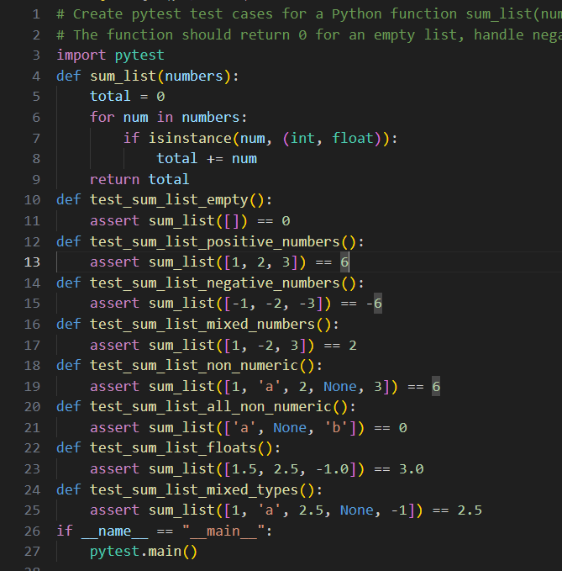

OUTPUT:
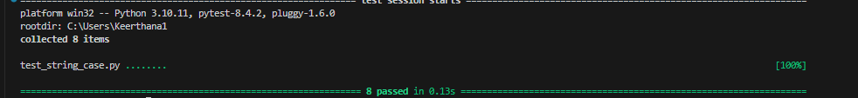
EXPLANATION:
This program defines a sum_list(numbers) function that adds only numeric values from a list and ignores non-numeric ones.The pytest test functions check different cases like empty lists, positive and negative numbers, floats, and mixed values to make sure the function works correctly.
PROMPT:
Write assertion tests for a Python function sum_list(numbers) that adds numeric values in a list. The function should return 0 for an empty list, handle negative numbers, and ignore non-numeric values.
CODE:
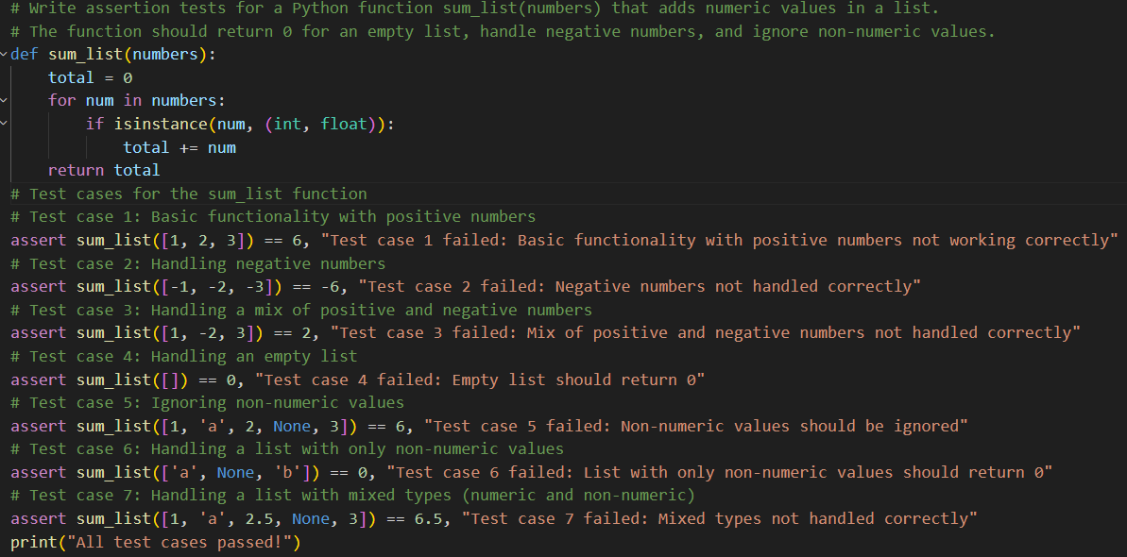
OUTPUT:
EXPLANATION:
This program creates a function sum_list(numbers) that adds only numeric values (int and float) from a list and ignores other values. Below that, assert statements test different cases like positive numbers, negative numbers, empty lists, and lists with non-numeric values. If all tests pass, it prints “All test cases passed!”.
Task 4 – Test Cases for Student Result Class
• Generate test cases for a StudentResult class with the following
methods:
• add_marks(mark)
• calculate_average()
• get_result()
Requirements:
• Marks must be between 0 and 100
• Average ≥ 40 → Pass, otherwise Fail
Example Test Scenarios:
Marks: [60, 70, 80] → Average: 70 → Result: Pass
Marks: [30, 35, 40] → Average: 35 → Result: Fail
Marks: [-10] → Error
Expected Output -4
• A fully functional StudentResult class that passes all AI-
generated test
PROMPT:
Generate simple manual test cases (not unittest) for a Python StudentResult class with methods: add_marks(mark), calculate_average(), and get_result().
Marks must be between 0 and 100
Average ≥ 40 → Pass
Average < 40 → Fail
Invalid marks → Error

CODE:
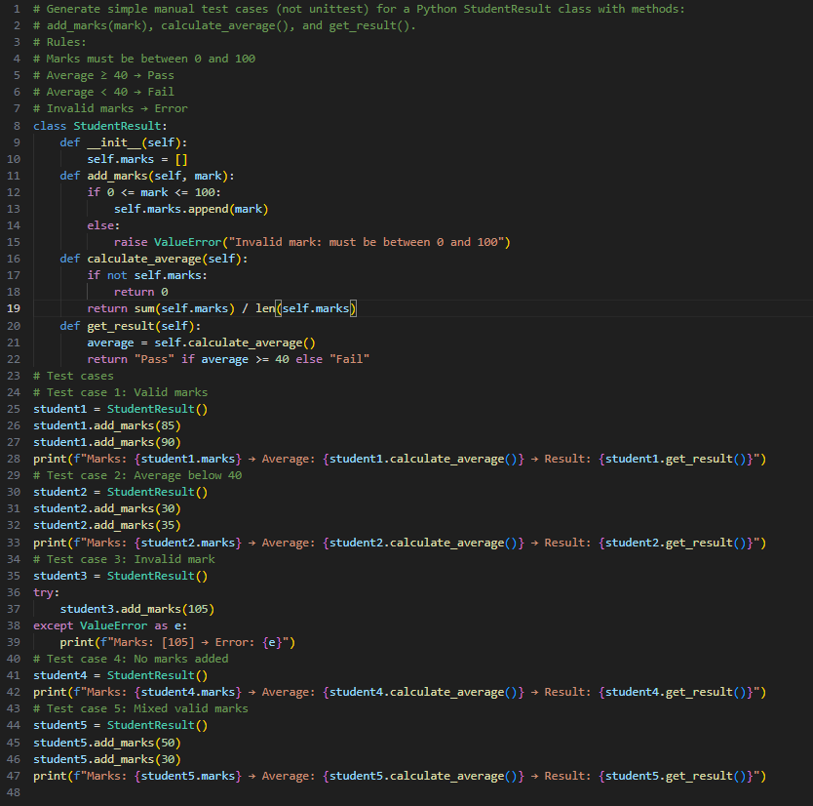
OUTPUT:
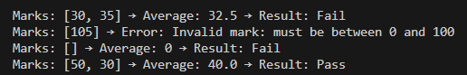
EXPLANATION:
The StudentResult class stores marks using add_marks() (only values between 0 and 100). The calculate_average() method computes the average as sum of marks ÷ number of marks, returning 0 if no marks exist. The get_result() method returns “Pass” if average ≥ 40, otherwise “Fail”, and the test cases verify valid, invalid, and boundary inputs.
PROMPT:
Generate assertion test cases using Python assert statements for a StudentResult class with methods add_marks(), calculate_average(), and get_result(). Ensure marks are between 0 and 100, average is calculated correctly, and average ≥ 40 → Pass, otherwise Fail. Also include tests for invalid marks and empty marks list.

CODE:
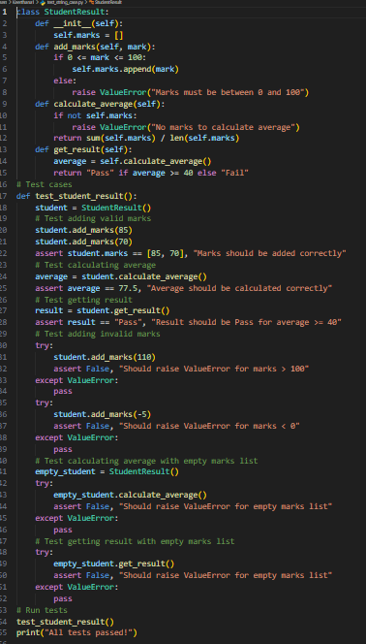
OUTPUT:
EXPLANATION:
This program tests the StudentResult class using assert statements to make sure everything works correctly.It checks whether marks are added properly, the average is calculated using sum(marks) / len(marks), and the result is “Pass” when average ≥ 40, otherwise “Fail”.
It also verifies error handling by testing invalid marks (greater than 100 or less than 0) and calculating the average when no marks are added.

PROMPT:
Create unit test cases using Python’s unittest framework to verify a StudentResult class that stores marks, calculates the average, and returns Pass if average ≥ 40, otherwise Fail. Include tests for adding marks, average calculation, invalid input errors, and no marks added.
CODE:
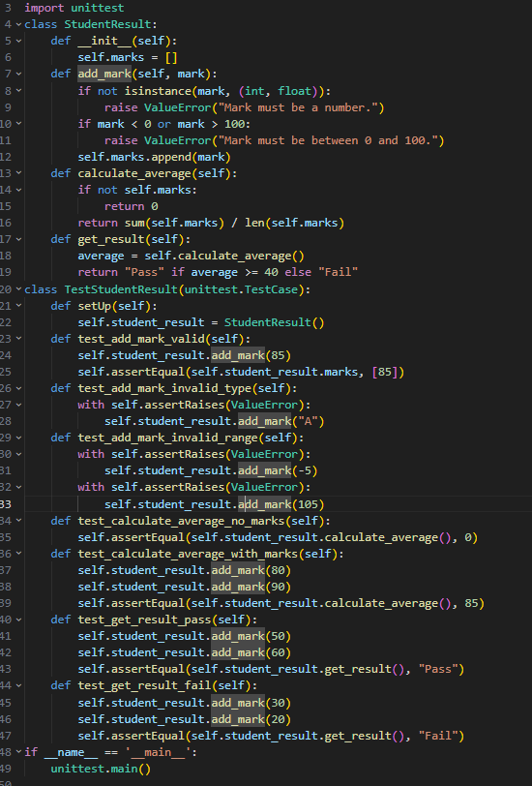

OUTPUT:
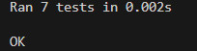
EXPLANATION:
This program uses Python’s unittest framework to test the StudentResult class. The tests check whether marks are added correctly, invalid inputs raise errors, the average is calculated properly, and the result returns “Pass” when average ≥ 40 and “Fail” otherwise. The setUp() method creates a new StudentResult object before each test runs.
PROMPT:
Write pytest test cases for a Python class StudentResult that has the methods add_mark(mark), calculate_average(), and get_result().# Ensure marks are between 0 and 100, the average is calculated correctly, and average ≥ 40 returns "Pass", otherwise "Fail".# Include tests for valid marks, invalid input (raise ValueError), boundary values, and empty marks list.
CODE:
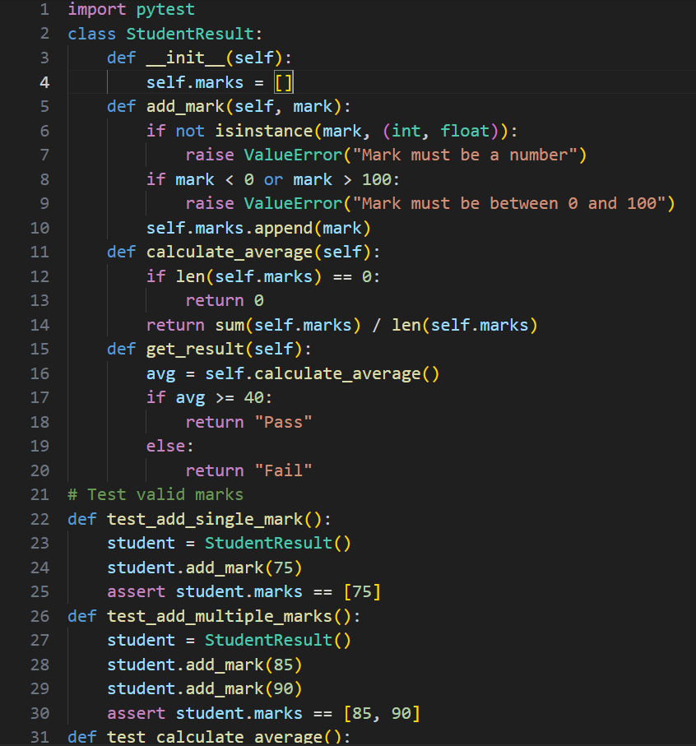

OUTPUT:
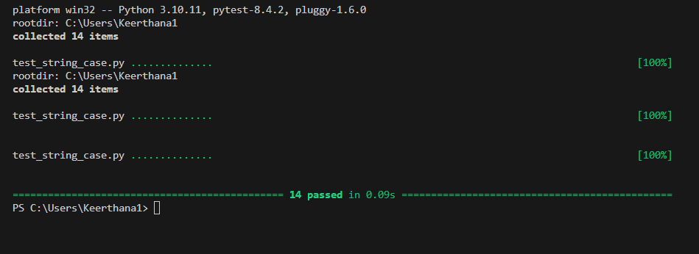
EXPLANATION:
This program creates a StudentResult class to store marks, calculate the average, and decide whether a student Passes or Fails (average ≥ 40 → Pass). The add_mark() function checks that marks are numbers between 0 and 100. The pytest test cases check different situations like valid marks, invalid input, boundary values, and empty marks.
Task Description
Task 5 – Test-Driven Development for Username Validator
Requirements:
• Minimum length: 5 characters
• No spaces allowed
• Only alphanumeric characters
Example Test Scenarios:
is_valid_username("user01") → True
is_valid_username("ai") → False
is_valid_username("user name") → False
is_valid_username("user@123") → False
Expected Output 5
A username validation function that passes all AI-generated test cases.
PROMPT:
Write Python test cases using print statements for a function is_valid_username(username) that checks if a username has at least 5 characters, no spaces, and only alphanumeric characters.
Include tests for a valid username, a short username, a username with spaces, and a username with special characters

EXPLANATION:
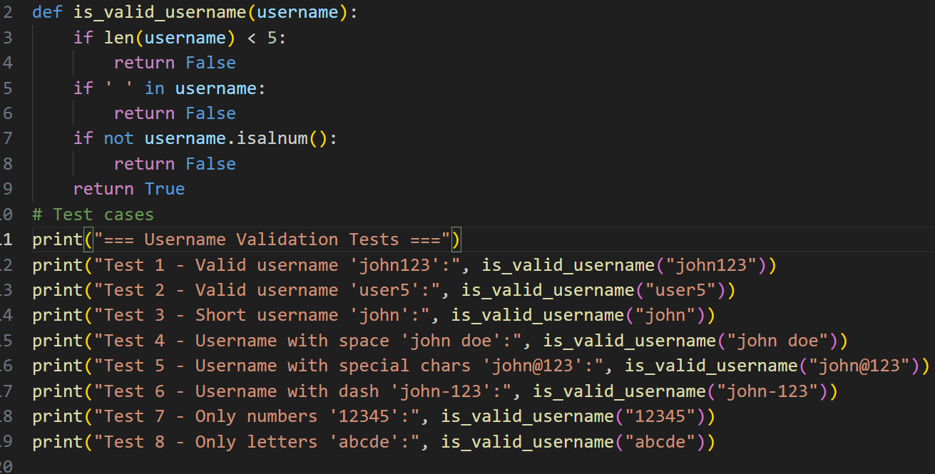
OUTPUT:
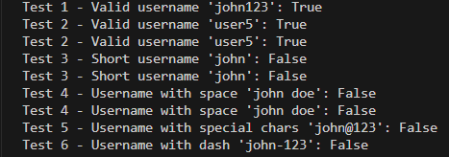
EXPLANATION:
This code defines a function is_valid_username() that checks whether a username follows three rules: it must be at least 5 characters long, contain no spaces, and include only letters and numbers.After that, the print() statements test different usernames to show whether each one is valid (True) or invalid (False).
PROMPT:
Write Python unittest test cases for a function is_valid_username(username) that checks if a username has at least 5 characters, no spaces, and only alphanumeric characters. Include tests for a valid username, a username that is too short, a username with spaces, and a username with special characters.

CODE:
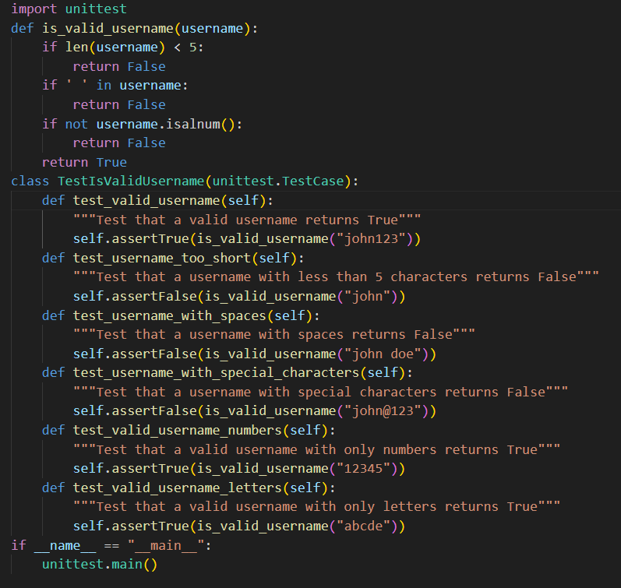
OUTPUT:
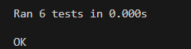
EXPLANATION:
This code defines a function is_valid_username() that checks whether a username is at least 5 characters long, has no spaces, and contains only letters or numbers. The unittest class TestIsValidUsername contains multiple test methods that verify the function using assertTrue() and assertFalse() for valid and invalid usernames. Finally, unittest.main() runs all the test cases automatically.

